Tên: Lê Thanh Tịnh 1150080160
BÀI LÀM
LAB 3:
WINDOWS FORMS APPLICATION NÂNG CAO
A. Mục tiêu
− Hướng dẫn sinh viên xây dựng chương trình Windows Form nâng cao hơn.
− Hướng dẫn làm quen môi trường lập trình C# với phần mềm Microsoft
Visual Studio 2022.
− Hướng dẫn sinh viên tập làm quen mới soạn thảo, chỉnh sửa mã nguồn,
biên dịch, gỡ lỗi (debug), thực thi chương trình.
− Làm quen với các control dạng bảng và lưới trên Winform như:
+ Sử dụng DataTable để chứa thông tin dạng bảng.
+ Sử dụng DataGridView để hiện thị nội dung chứa trong DataTable.
+ Sử dụng ListView để hiển thị thông tin dạng bảng.
+ GroupBox: Nhóm các đối tượng về cùng nhóm.
+ DateTimePicker: Control hiện và chọn giá trị ngày/tháng/năm.
+ PictureBox: Đối tượng chưa hình ảnh.
− Làm quen khai báo và xử lý các sự kiện với các control khác nhau.
− Làm quen với cách đặt tên biến lập trình của các control.
B. Nội dung
Thực hành 1: Thiết kế và lập trình ứng dụng Winform theo mô tả sau:
1. Tạo Project Windows Forms Application trên Microsoft visualstudio 2022
Bước 1: Khởi động chương trình visual studio 2022. Hình ảnh dưới đây là màn
hình khởi động của ứng dụng:
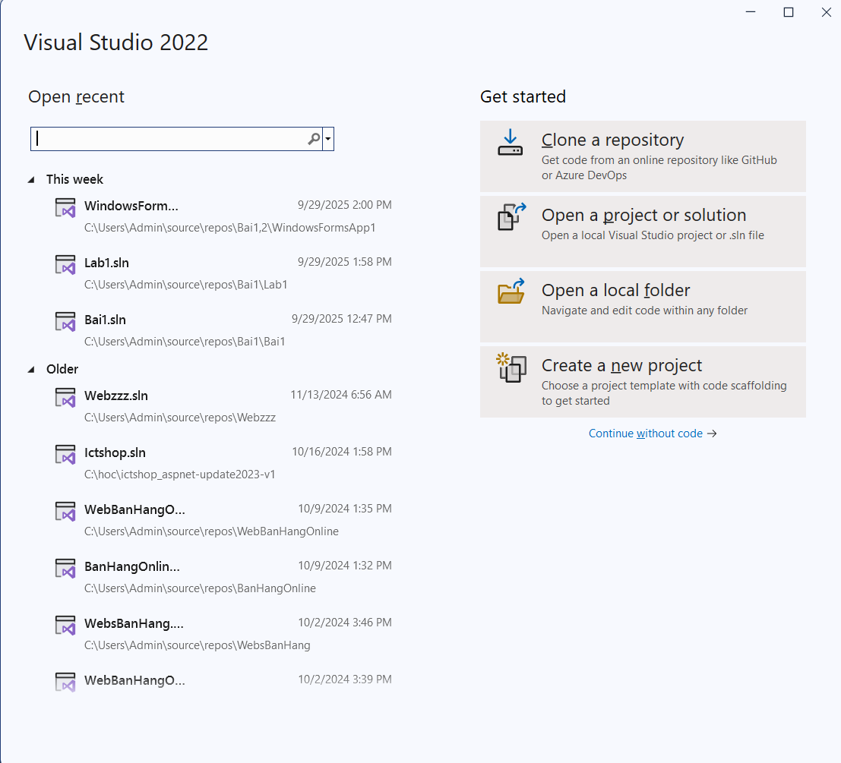
Bước 2: Chọn Create a new project trên màn hình khởi động. Trong màn hình
tiếp theo, ở mục All languages → chọn C# trong danh sách ngôn ngữ lập trình.
Mục All platforms → chọn Windows. Ở mục All project types → chọn Desktop
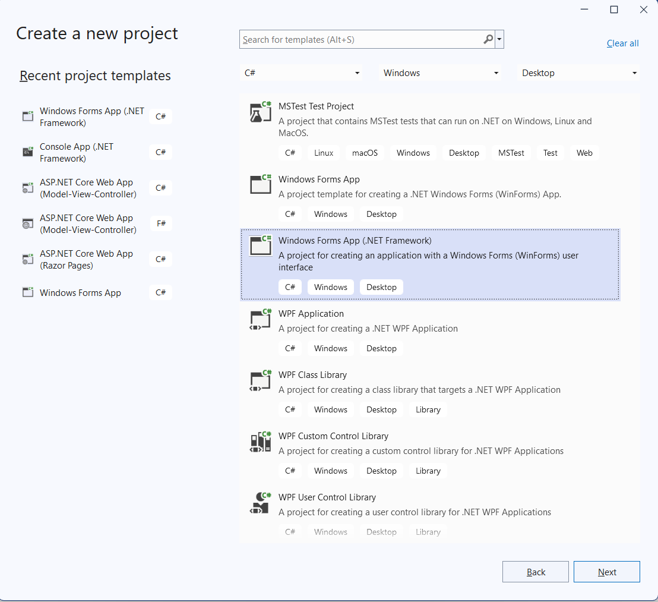
Bước 3: Trong cửa sổ tiếp theo, bạn điền đầy đủ các thông tin về Project.
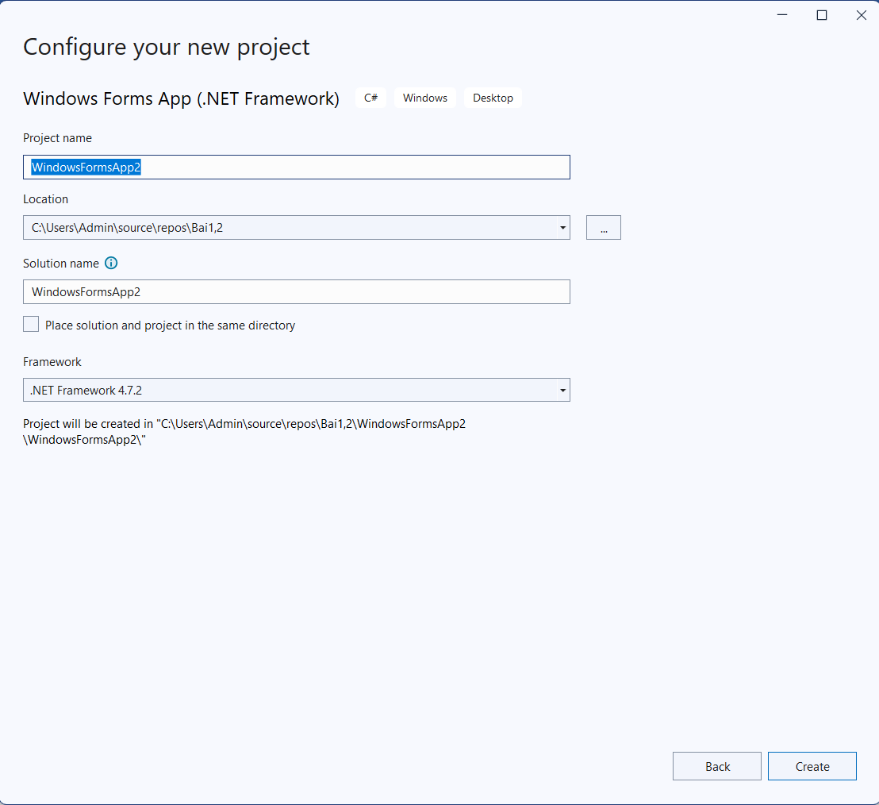
Đây là kết quả!
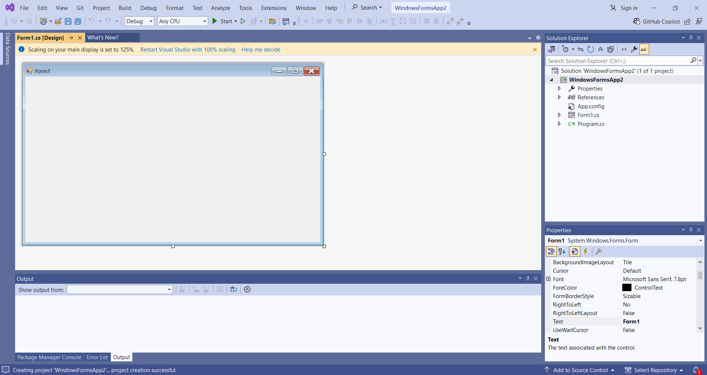
Kết quả
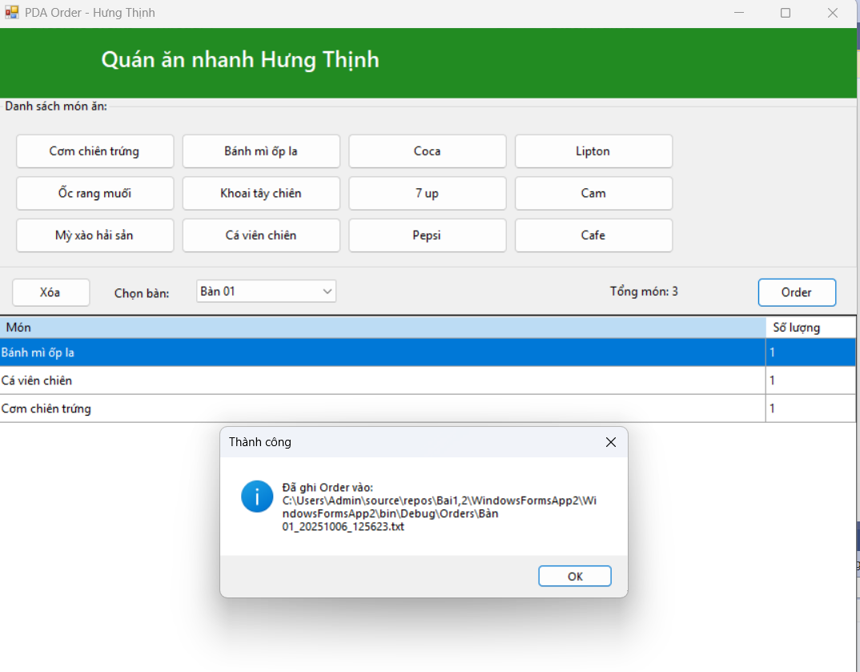
Code Form1.cs
using System;
using System.Collections.Generic;
using System.IO;
using System.Linq;
using System.Windows.Forms;

namespace RestaurantOrderPDA
{
public partial class Form1 : Form
{
// Lưu tạm thời order hiện tại: Tên món -> Số lượng
private readonly Dictionary<string, int> _currentOrder = new Dictionary<string, int>(StringComparer.CurrentCultureIgnoreCase);

public Form1()
{
InitializeComponent();
InitTables();
WireItemButtons();
InitGrid();
}

private void InitTables()
{
// Ví dụ 10 bàn
cboTable.Items.AddRange(Enumerable.Range(1, 10).Select(i => $"Bàn {i:00}").ToArray());
cboTable.SelectedIndex = 0;
}

private void WireItemButtons()
{
// Gắn 1 handler chung cho toàn bộ button món (đã đặt Tag = tên món ở Designer)
foreach (Control c in flpMenu.Controls)
{
if (c is Button btn && btn.Tag is string)
btn.Click += BtnItem_Click;
}
}

private void InitGrid()
{
dgvOrder.AutoGenerateColumns = false;
dgvOrder.Columns.Clear();

var colName = new DataGridViewTextBoxColumn
{
HeaderText = "Món",
DataPropertyName = "Name",
Name = "colName",
ReadOnly = true,
AutoSizeMode = DataGridViewAutoSizeColumnMode.Fill
};
var colQty = new DataGridViewTextBoxColumn
{
HeaderText = "Số lượng",
DataPropertyName = "Quantity",
Name = "colQty",
Width = 90,
ReadOnly = true
};

dgvOrder.Columns.Add(colName);
dgvOrder.Columns.Add(colQty);

RefreshGrid();
}

private void BtnItem_Click(object sender, EventArgs e)
{
if (sender is Button btn && btn.Tag is string itemName)
{
if (_currentOrder.ContainsKey(itemName))
_currentOrder[itemName]++;
else
_currentOrder[itemName] = 1;

RefreshGrid();
}
}

private void RefreshGrid()
{
var data = _currentOrder
.OrderBy(kv => kv.Key)
.Select(kv => new RowItem { Name = kv.Key, Quantity = kv.Value })
.ToList();

dgvOrder.DataSource = data;
lblTotalItems.Text = $"Tổng món: {_currentOrder.Values.Sum()}";
}

private void btnClear_Click(object sender, EventArgs e)
{
_currentOrder.Clear();
RefreshGrid();
}

private void btnOrder_Click(object sender, EventArgs e)
{
if (_currentOrder.Count == 0)
{
MessageBox.Show("Chưa có món nào trong danh sách!", "Thông báo",
MessageBoxButtons.OK, MessageBoxIcon.Information);
return;
}
if (cboTable.SelectedItem == null)
{
MessageBox.Show("Hãy chọn bàn trước khi Order!", "Thiếu thông tin",
MessageBoxButtons.OK, MessageBoxIcon.Warning);
return;
}

var table = cboTable.SelectedItem.ToString();
var ts = DateTime.Now.ToString("yyyyMMdd_HHmmss");
var folder = Path.Combine(Application.StartupPath, "Orders");
Directory.CreateDirectory(folder);

var filePath = Path.Combine(folder, $"{table}_{ts}.txt");

using (var sw = new StreamWriter(filePath, false, System.Text.Encoding.UTF8))
{
sw.WriteLine("=== ORDER QUÁN ĂN NHANH ===");
sw.WriteLine($"Bàn: {table}");
sw.WriteLine($"Thời gian: {DateTime.Now:dd/MM/yyyy HH:mm:ss}");
sw.WriteLine(new string('-', 32));
foreach (var kv in _currentOrder.OrderBy(kv => kv.Key))
{
sw.WriteLine($"{kv.Key} - SL: {kv.Value}");
}
sw.WriteLine(new string('-', 32));
sw.WriteLine($"Tổng món: {_currentOrder.Values.Sum()}");
}

MessageBox.Show($"Đã ghi Order vào:\n{filePath}", "Thành công",
MessageBoxButtons.OK, MessageBoxIcon.Information);

// Sau khi gửi xuống “bếp” thì dọn phiếu
_currentOrder.Clear();
RefreshGrid();
}

// Model hiển thị cho DataGridView
private class RowItem
{
public string Name { get; set; } = "";
public int Quantity { get; set; }
}
}
}

Code Form1.Designer.cs
namespace RestaurantOrderPDA
{
partial class Form1
{
private System.ComponentModel.IContainer components = null;

private System.Windows.Forms.Panel panelHeader;
private System.Windows.Forms.PictureBox pictureBox1;
private System.Windows.Forms.Label lblTitle;
private System.Windows.Forms.GroupBox groupBoxMenu;
private System.Windows.Forms.FlowLayoutPanel flpMenu;
private System.Windows.Forms.Panel panelBottom;
private System.Windows.Forms.Button btnClear;
private System.Windows.Forms.Label label1;
private System.Windows.Forms.ComboBox cboTable;
private System.Windows.Forms.Button btnOrder;
private System.Windows.Forms.DataGridView dgvOrder;
private System.Windows.Forms.Label lblTotalItems;

// Các button món (tạo sẵn như ảnh minh hoạ)
private System.Windows.Forms.Button bComChienTrung;
private System.Windows.Forms.Button bBanhMyOpla;
private System.Windows.Forms.Button bCoca;
private System.Windows.Forms.Button bLipton;
private System.Windows.Forms.Button bOcRangMuoi;
private System.Windows.Forms.Button bKhoaiTayChien;
private System.Windows.Forms.Button b7up;
private System.Windows.Forms.Button bCam;
private System.Windows.Forms.Button bMyXaoHaiSan;
private System.Windows.Forms.Button bCaVienChien;
private System.Windows.Forms.Button bPepsi;
private System.Windows.Forms.Button bCafe;
private System.Windows.Forms.Button bBurgerBoNuong;
private System.Windows.Forms.Button bDuiGaRan;
private System.Windows.Forms.Button bBunBoHue;

protected override void Dispose(bool disposing)
{
if (disposing && (components != null))
components.Dispose();
base.Dispose(disposing);
}

private void InitializeComponent()
{
this.panelHeader = new System.Windows.Forms.Panel();
this.pictureBox1 = new System.Windows.Forms.PictureBox();
this.lblTitle = new System.Windows.Forms.Label();
this.groupBoxMenu = new System.Windows.Forms.GroupBox();
this.flpMenu = new System.Windows.Forms.FlowLayoutPanel();
this.bComChienTrung = new System.Windows.Forms.Button();
this.bBanhMyOpla = new System.Windows.Forms.Button();
this.bCoca = new System.Windows.Forms.Button();
this.bLipton = new System.Windows.Forms.Button();
this.bOcRangMuoi = new System.Windows.Forms.Button();
this.bKhoaiTayChien = new System.Windows.Forms.Button();
this.b7up = new System.Windows.Forms.Button();
this.bCam = new System.Windows.Forms.Button();
this.bMyXaoHaiSan = new System.Windows.Forms.Button();
this.bCaVienChien = new System.Windows.Forms.Button();
this.bPepsi = new System.Windows.Forms.Button();
this.bCafe = new System.Windows.Forms.Button();
this.bBurgerBoNuong = new System.Windows.Forms.Button();
this.bDuiGaRan = new System.Windows.Forms.Button();
this.bBunBoHue = new System.Windows.Forms.Button();
this.panelBottom = new System.Windows.Forms.Panel();
this.lblTotalItems = new System.Windows.Forms.Label();
this.btnClear = new System.Windows.Forms.Button();
this.label1 = new System.Windows.Forms.Label();
this.cboTable = new System.Windows.Forms.ComboBox();
this.btnOrder = new System.Windows.Forms.Button();
this.dgvOrder = new System.Windows.Forms.DataGridView();
this.panelHeader.SuspendLayout();
((System.ComponentModel.ISupportInitialize)(this.pictureBox1)).BeginInit();
this.groupBoxMenu.SuspendLayout();
this.flpMenu.SuspendLayout();
this.panelBottom.SuspendLayout();
((System.ComponentModel.ISupportInitialize)(this.dgvOrder)).BeginInit();
this.SuspendLayout();
//
// panelHeader
//
this.panelHeader.BackColor = System.Drawing.Color.ForestGreen;
this.panelHeader.Controls.Add(this.pictureBox1);
this.panelHeader.Controls.Add(this.lblTitle);
this.panelHeader.Dock = System.Windows.Forms.DockStyle.Top;
this.panelHeader.Location = new System.Drawing.Point(0, 0);
this.panelHeader.Name = "panelHeader";
this.panelHeader.Size = new System.Drawing.Size(860, 70);
this.panelHeader.TabIndex = 0;
//
// pictureBox1
//
this.pictureBox1.Dock = System.Windows.Forms.DockStyle.Left;
this.pictureBox1.Location = new System.Drawing.Point(0, 0);
this.pictureBox1.Name = "pictureBox1";
this.pictureBox1.Size = new System.Drawing.Size(90, 70);
this.pictureBox1.SizeMode = System.Windows.Forms.PictureBoxSizeMode.Zoom;
this.pictureBox1.TabIndex = 1;
this.pictureBox1.TabStop = false;
// (Bạn có thể gán 1 ảnh burger 64x64 ở thời gian thiết kế nếu muốn)
//
// lblTitle
//
this.lblTitle.Dock = System.Windows.Forms.DockStyle.Fill;
this.lblTitle.Font = new System.Drawing.Font("Segoe UI Semibold", 16F, System.Drawing.FontStyle.Bold);
this.lblTitle.ForeColor = System.Drawing.Color.White;
this.lblTitle.Location = new System.Drawing.Point(0, 0);
this.lblTitle.Name = "lblTitle";
this.lblTitle.Padding = new System.Windows.Forms.Padding(100, 15, 0, 0);
this.lblTitle.Size = new System.Drawing.Size(860, 70);
this.lblTitle.TabIndex = 0;
this.lblTitle.Text = "Quán ăn nhanh Hưng Thịnh";
//
// groupBoxMenu
//
this.groupBoxMenu.Controls.Add(this.flpMenu);
this.groupBoxMenu.Dock = System.Windows.Forms.DockStyle.Top;
this.groupBoxMenu.Location = new System.Drawing.Point(0, 70);
this.groupBoxMenu.Name = "groupBoxMenu";
this.groupBoxMenu.Padding = new System.Windows.Forms.Padding(10);
this.groupBoxMenu.Size = new System.Drawing.Size(860, 170);
this.groupBoxMenu.TabIndex = 1;
this.groupBoxMenu.TabStop = false;
this.groupBoxMenu.Text = "Danh sách món ăn:";
//
// flpMenu
//
this.flpMenu.Dock = System.Windows.Forms.DockStyle.Fill;
this.flpMenu.Location = new System.Drawing.Point(10, 26);
this.flpMenu.Margin = new System.Windows.Forms.Padding(6);
this.flpMenu.Name = "flpMenu";
this.flpMenu.Padding = new System.Windows.Forms.Padding(6);
this.flpMenu.Size = new System.Drawing.Size(840, 134);
this.flpMenu.TabIndex = 0;
this.flpMenu.WrapContents = true;

// Style mặc định cho các button món
System.Drawing.Size itemSize = new System.Drawing.Size(160, 36);

//
// Tạo & thêm các button món
//
this.bComChienTrung.Text = "Cơm chiên trứng"; this.bComChienTrung.Size = itemSize; this.bComChienTrung.Tag = "Cơm chiên trứng";
this.bBanhMyOpla.Text = "Bánh mì ốp la"; this.bBanhMyOpla.Size = itemSize; this.bBanhMyOpla.Tag = "Bánh mì ốp la";
this.bCoca.Text = "Coca"; this.bCoca.Size = itemSize; this.bCoca.Tag = "Coca";
this.bLipton.Text = "Lipton"; this.bLipton.Size = itemSize; this.bLipton.Tag = "Lipton";
this.bOcRangMuoi.Text = "Ốc rang muối"; this.bOcRangMuoi.Size = itemSize; this.bOcRangMuoi.Tag = "Ốc rang muối";
this.bKhoaiTayChien.Text = "Khoai tây chiên"; this.bKhoaiTayChien.Size = itemSize; this.bKhoaiTayChien.Tag = "Khoai tây chiên";
this.b7up.Text = "7 up"; this.b7up.Size = itemSize; this.b7up.Tag = "7 up";
this.bCam.Text = "Cam"; this.bCam.Size = itemSize; this.bCam.Tag = "Cam";
this.bMyXaoHaiSan.Text = "Mỳ xào hải sản"; this.bMyXaoHaiSan.Size = itemSize; this.bMyXaoHaiSan.Tag = "Mỳ xào hải sản";
this.bCaVienChien.Text = "Cá viên chiên"; this.bCaVienChien.Size = itemSize; this.bCaVienChien.Tag = "Cá viên chiên";
this.bPepsi.Text = "Pepsi"; this.bPepsi.Size = itemSize; this.bPepsi.Tag = "Pepsi";
this.bCafe.Text = "Cafe"; this.bCafe.Size = itemSize; this.bCafe.Tag = "Cafe";
this.bBurgerBoNuong.Text = "Burger bò nướng"; this.bBurgerBoNuong.Size = itemSize; this.bBurgerBoNuong.Tag = "Burger bò nướng";
this.bDuiGaRan.Text = "Đùi gà rán"; this.bDuiGaRan.Size = itemSize; this.bDuiGaRan.Tag = "Đùi gà rán";
this.bBunBoHue.Text = "Bún bò Huế"; this.bBunBoHue.Size = itemSize; this.bBunBoHue.Tag = "Bún bò Huế";

this.flpMenu.Controls.AddRange(new System.Windows.Forms.Control[] {
this.bComChienTrung, this.bBanhMyOpla, this.bCoca, this.bLipton,
this.bOcRangMuoi, this.bKhoaiTayChien, this.b7up, this.bCam,
this.bMyXaoHaiSan, this.bCaVienChien, this.bPepsi, this.bCafe,
this.bBurgerBoNuong, this.bDuiGaRan, this.bBunBoHue
});

//
// panelBottom
//
this.panelBottom.Controls.Add(this.lblTotalItems);
this.panelBottom.Controls.Add(this.btnClear);
this.panelBottom.Controls.Add(this.label1);
this.panelBottom.Controls.Add(this.cboTable);
this.panelBottom.Controls.Add(this.btnOrder);
this.panelBottom.Dock = System.Windows.Forms.DockStyle.Top;
this.panelBottom.Location = new System.Drawing.Point(0, 240);
this.panelBottom.Name = "panelBottom";
this.panelBottom.Padding = new System.Windows.Forms.Padding(10, 6, 10, 6);
this.panelBottom.Size = new System.Drawing.Size(860, 46);
this.panelBottom.TabIndex = 2;
//
// lblTotalItems
//
this.lblTotalItems.AutoSize = true;
this.lblTotalItems.Location = new System.Drawing.Point(610, 15);
this.lblTotalItems.Name = "lblTotalItems";
this.lblTotalItems.Size = new System.Drawing.Size(83, 21);
this.lblTotalItems.TabIndex = 4;
this.lblTotalItems.Text = "Tổng món: 0";
//
// btnClear
//
this.btnClear.Location = new System.Drawing.Point(15, 9);
this.btnClear.Name = "btnClear";
this.btnClear.Size = new System.Drawing.Size(80, 30);
this.btnClear.TabIndex = 0;
this.btnClear.Text = "Xóa";
this.btnClear.UseVisualStyleBackColor = true;
this.btnClear.Click += new System.EventHandler(this.btnClear_Click);
//
// label1
//
this.label1.Location = new System.Drawing.Point(115, 12);
this.label1.Name = "label1";
this.label1.Size = new System.Drawing.Size(84, 25);
this.label1.TabIndex = 1;
this.label1.Text = "Chọn bàn:";
this.label1.TextAlign = System.Drawing.ContentAlignment.MiddleLeft;
//
// cboTable
//
this.cboTable.DropDownStyle = System.Windows.Forms.ComboBoxStyle.DropDownList;
this.cboTable.FormattingEnabled = true;
this.cboTable.Location = new System.Drawing.Point(200, 11);
this.cboTable.Name = "cboTable";
this.cboTable.Size = new System.Drawing.Size(140, 29);
this.cboTable.TabIndex = 2;
//
// btnOrder
//
this.btnOrder.Anchor = ((System.Windows.Forms.AnchorStyles)((System.Windows.Forms.AnchorStyles.Top | System.Windows.Forms.AnchorStyles.Right)));
this.btnOrder.Location = new System.Drawing.Point(760, 9);
this.btnOrder.Name = "btnOrder";
this.btnOrder.Size = new System.Drawing.Size(80, 30);
this.btnOrder.TabIndex = 3;
this.btnOrder.Text = "Order";
this.btnOrder.UseVisualStyleBackColor = true;
this.btnOrder.Click += new System.EventHandler(this.btnOrder_Click);
//
// dgvOrder
//
this.dgvOrder.AllowUserToAddRows = false;
this.dgvOrder.AllowUserToDeleteRows = false;
this.dgvOrder.BackgroundColor = System.Drawing.Color.White;
this.dgvOrder.ColumnHeadersHeightSizeMode = System.Windows.Forms.DataGridViewColumnHeadersHeightSizeMode.AutoSize;
this.dgvOrder.Dock = System.Windows.Forms.DockStyle.Fill;
this.dgvOrder.Location = new System.Drawing.Point(0, 286);
this.dgvOrder.MultiSelect = false;
this.dgvOrder.Name = "dgvOrder";
this.dgvOrder.ReadOnly = true;
this.dgvOrder.RowHeadersVisible = false;
this.dgvOrder.RowTemplate.Height = 28;
this.dgvOrder.SelectionMode = System.Windows.Forms.DataGridViewSelectionMode.FullRowSelect;
this.dgvOrder.Size = new System.Drawing.Size(860, 364);
this.dgvOrder.TabIndex = 3;
//
// Form1
//
this.AutoScaleDimensions = new System.Drawing.SizeF(8F, 20F);
this.AutoScaleMode = System.Windows.Forms.AutoScaleMode.Font;
this.ClientSize = new System.Drawing.Size(860, 650);
this.Controls.Add(this.dgvOrder);
this.Controls.Add(this.panelBottom);
this.Controls.Add(this.groupBoxMenu);
this.Controls.Add(this.panelHeader);
this.Font = new System.Drawing.Font("Segoe UI", 9F);
this.Name = "Form1";
this.StartPosition = System.Windows.Forms.FormStartPosition.CenterScreen;
this.Text = "PDA Order - Hưng Thịnh";
this.panelHeader.ResumeLayout(false);
((System.ComponentModel.ISupportInitialize)(this.pictureBox1)).EndInit();
this.groupBoxMenu.ResumeLayout(false);
this.flpMenu.ResumeLayout(false);
this.panelBottom.ResumeLayout(false);
this.panelBottom.PerformLayout();
((System.ComponentModel.ISupportInitialize)(this.dgvOrder)).EndInit();
this.ResumeLayout(false);
}
}
}
Thực hành 2: Tạo mới 1 project có tên là “ThucHanh2” với form chính được minh họa như sau:
Từ Project đã tạo chuột phải vào dự án và Add -> New Project
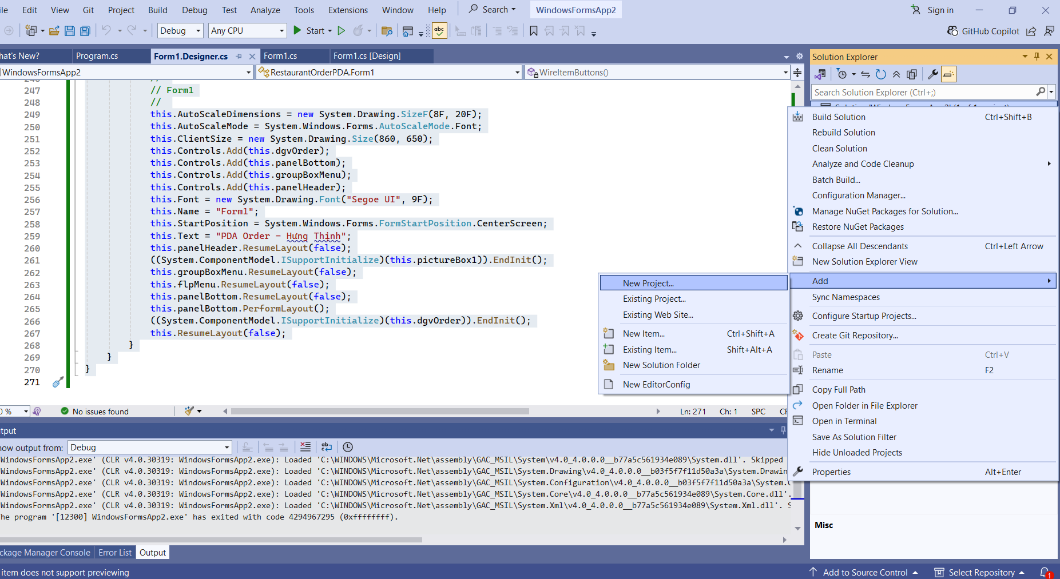
Chọn vào Windows Forms App như lúc đầu tạo
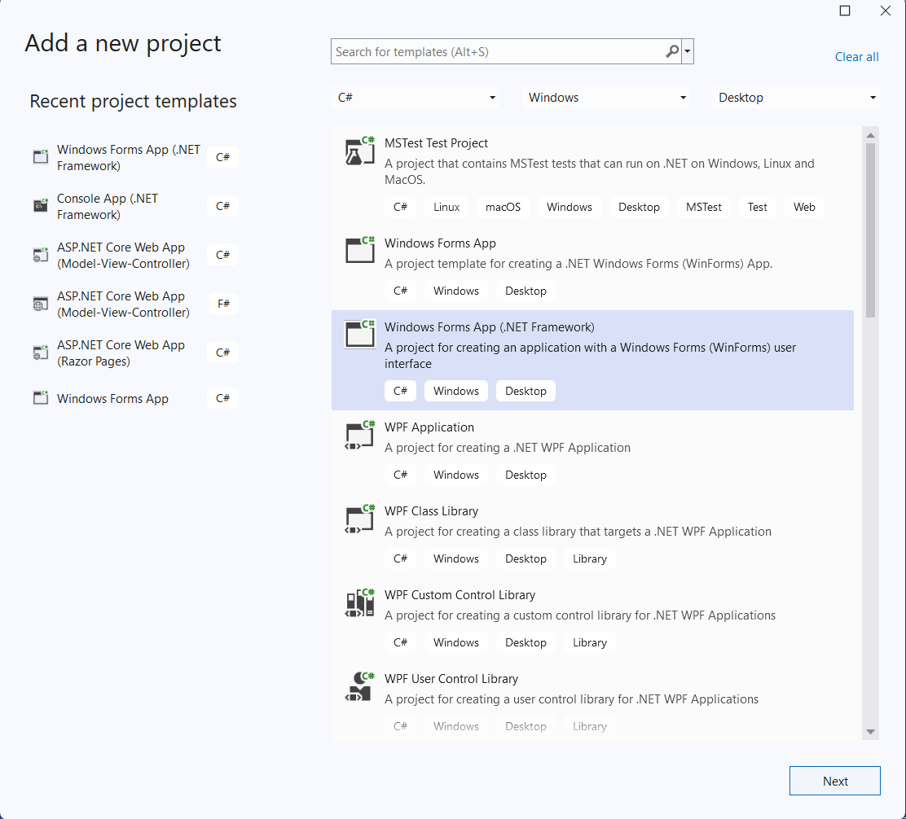
Sau đó đặt tên ThucHanh2 như trong hình
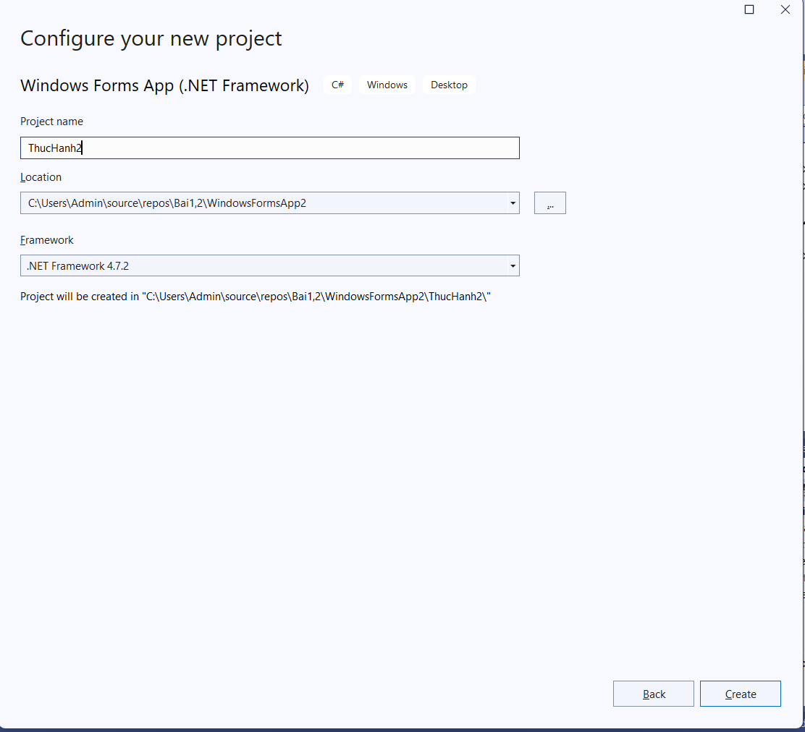
Kết quả
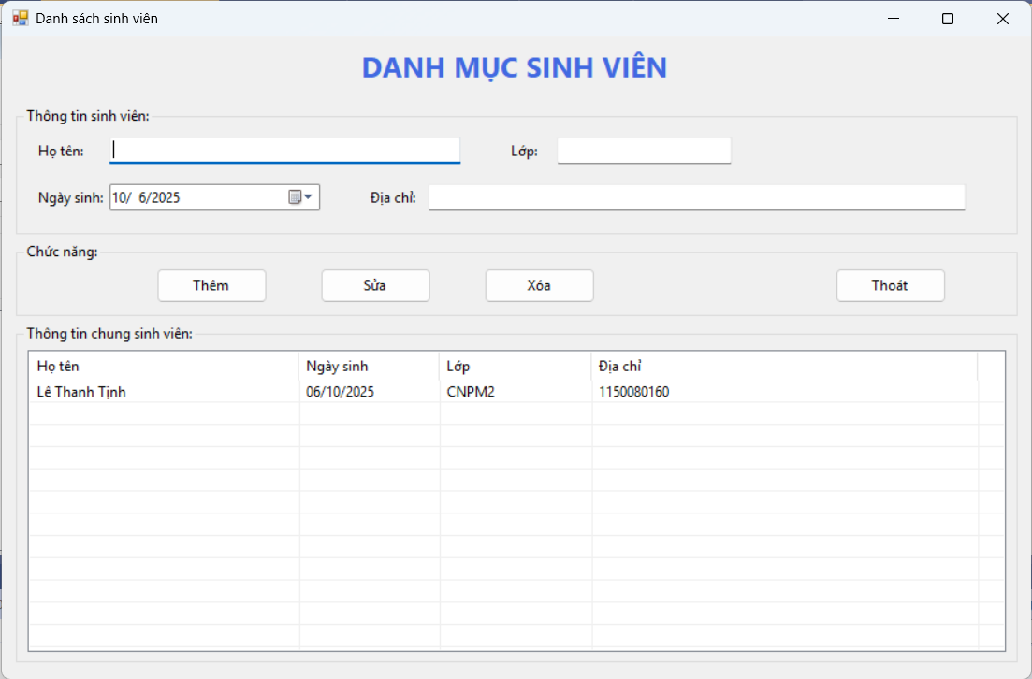
Code Form1.cs
using System;
using System.Globalization;
using System.Windows.Forms;

namespace StudentCatalog
{
public partial class Form1 : Form
{
public Form1()
{
InitializeComponent();
// Thiết lập mặc định
lvStudents.FullRowSelect = true;
lvStudents.View = View.Details;
lvStudents.GridLines = true;
dtpNgaySinh.Format = DateTimePickerFormat.Short;
}

private void btnThem_Click(object sender, EventArgs e)
{
if (string.IsNullOrWhiteSpace(txtHoTen.Text))
{
MessageBox.Show("Họ tên không được rỗng!", "Thiếu thông tin",
MessageBoxButtons.OK, MessageBoxIcon.Warning);
txtHoTen.Focus();
return;
}

var item = new ListViewItem(txtHoTen.Text.Trim());
item.SubItems.Add(dtpNgaySinh.Value.ToString("dd/MM/yyyy", CultureInfo.InvariantCulture));
item.SubItems.Add(txtLop.Text.Trim());
item.SubItems.Add(txtDiaChi.Text.Trim());

lvStudents.Items.Add(item);
ClearInputs();
}

private void btnXoa_Click(object sender, EventArgs e)
{
if (lvStudents.SelectedItems.Count == 0)
{
MessageBox.Show("Hãy chọn 1 dòng để xóa!", "Chưa chọn dòng",
MessageBoxButtons.OK, MessageBoxIcon.Information);
return;
}
if (MessageBox.Show("Bạn có chắc muốn xóa dòng đã chọn?", "Xác nhận",
MessageBoxButtons.YesNo, MessageBoxIcon.Question) == DialogResult.Yes)
{
lvStudents.Items.Remove(lvStudents.SelectedItems[0]);
ClearInputs();
}
}

private void btnSua_Click(object sender, EventArgs e)
{
if (lvStudents.SelectedItems.Count == 0)
{
MessageBox.Show("Hãy chọn 1 dòng để sửa!", "Chưa chọn dòng",
MessageBoxButtons.OK, MessageBoxIcon.Information);
return;
}
if (string.IsNullOrWhiteSpace(txtHoTen.Text))
{
MessageBox.Show("Họ tên không được rỗng!", "Thiếu thông tin",
MessageBoxButtons.OK, MessageBoxIcon.Warning);
txtHoTen.Focus();
return;
}

var sel = lvStudents.SelectedItems[0];
sel.Text = txtHoTen.Text.Trim();
sel.SubItems[1].Text = dtpNgaySinh.Value.ToString("dd/MM/yyyy", CultureInfo.InvariantCulture);
sel.SubItems[2].Text = txtLop.Text.Trim();
sel.SubItems[3].Text = txtDiaChi.Text.Trim();
}

private void btnThoat_Click(object sender, EventArgs e)
{
Close();
}

private void lvStudents_SelectedIndexChanged(object sender, EventArgs e)
{
if (lvStudents.SelectedItems.Count == 0) return;

var sel = lvStudents.SelectedItems[0];
txtHoTen.Text = sel.SubItems[0].Text;

// parse an toàn, nếu sai format thì giữ nguyên ngày hiện tại
if (DateTime.TryParseExact(sel.SubItems[1].Text, "dd/MM/yyyy",
System.Globalization.CultureInfo.InvariantCulture,
System.Globalization.DateTimeStyles.None, out var d))
{
dtpNgaySinh.Value = d;
}

txtLop.Text = sel.SubItems[2].Text;
txtDiaChi.Text = sel.SubItems[3].Text;
}

private void ClearInputs()
{
txtHoTen.Clear();
txtLop.Clear();
txtDiaChi.Clear();
dtpNgaySinh.Value = DateTime.Today;
txtHoTen.Focus();
}
}
}

Code Form1.Designer.cs
namespace StudentCatalog
{
partial class Form1
{
private System.ComponentModel.IContainer components = null;

private System.Windows.Forms.Label lblTitle;
private System.Windows.Forms.GroupBox gbInfo;
private System.Windows.Forms.Label lblHoTen;
private System.Windows.Forms.TextBox txtHoTen;
private System.Windows.Forms.Label lblLop;
private System.Windows.Forms.TextBox txtLop;
private System.Windows.Forms.Label lblNgaySinh;
private System.Windows.Forms.DateTimePicker dtpNgaySinh;
private System.Windows.Forms.Label lblDiaChi;
private System.Windows.Forms.TextBox txtDiaChi;

private System.Windows.Forms.GroupBox gbActions;
private System.Windows.Forms.Button btnThem;
private System.Windows.Forms.Button btnSua;
private System.Windows.Forms.Button btnXoa;
private System.Windows.Forms.Button btnThoat;

private System.Windows.Forms.GroupBox gbList;
private System.Windows.Forms.ListView lvStudents;
private System.Windows.Forms.ColumnHeader colHoTen;
private System.Windows.Forms.ColumnHeader colNgaySinh;
private System.Windows.Forms.ColumnHeader colLop;
private System.Windows.Forms.ColumnHeader colDiaChi;

protected override void Dispose(bool disposing)
{
if (disposing && (components != null)) components.Dispose();
base.Dispose(disposing);
}

private void InitializeComponent()
{
this.lblTitle = new System.Windows.Forms.Label();
this.gbInfo = new System.Windows.Forms.GroupBox();
this.lblHoTen = new System.Windows.Forms.Label();
this.txtHoTen = new System.Windows.Forms.TextBox();
this.lblLop = new System.Windows.Forms.Label();
this.txtLop = new System.Windows.Forms.TextBox();
this.lblNgaySinh = new System.Windows.Forms.Label();
this.dtpNgaySinh = new System.Windows.Forms.DateTimePicker();
this.lblDiaChi = new System.Windows.Forms.Label();
this.txtDiaChi = new System.Windows.Forms.TextBox();

this.gbActions = new System.Windows.Forms.GroupBox();
this.btnThem = new System.Windows.Forms.Button();
this.btnSua = new System.Windows.Forms.Button();
this.btnXoa = new System.Windows.Forms.Button();
this.btnThoat = new System.Windows.Forms.Button();

this.gbList = new System.Windows.Forms.GroupBox();
this.lvStudents = new System.Windows.Forms.ListView();
this.colHoTen = new System.Windows.Forms.ColumnHeader();
this.colNgaySinh = new System.Windows.Forms.ColumnHeader();
this.colLop = new System.Windows.Forms.ColumnHeader();
this.colDiaChi = new System.Windows.Forms.ColumnHeader();

this.gbInfo.SuspendLayout();
this.gbActions.SuspendLayout();
this.gbList.SuspendLayout();
this.SuspendLayout();

// lblTitle
this.lblTitle.Dock = System.Windows.Forms.DockStyle.Top;
this.lblTitle.Font = new System.Drawing.Font("Segoe UI", 18F, System.Drawing.FontStyle.Bold);
this.lblTitle.ForeColor = System.Drawing.Color.RoyalBlue;
this.lblTitle.Location = new System.Drawing.Point(0, 0);
this.lblTitle.Name = "lblTitle";
this.lblTitle.Size = new System.Drawing.Size(880, 50);
this.lblTitle.TabIndex = 0;
this.lblTitle.Text = "DANH MỤC SINH VIÊN";
this.lblTitle.TextAlign = System.Drawing.ContentAlignment.MiddleCenter;

// gbInfo
this.gbInfo.Controls.Add(this.lblHoTen);
this.gbInfo.Controls.Add(this.txtHoTen);
this.gbInfo.Controls.Add(this.lblLop);
this.gbInfo.Controls.Add(this.txtLop);
this.gbInfo.Controls.Add(this.lblNgaySinh);
this.gbInfo.Controls.Add(this.dtpNgaySinh);
this.gbInfo.Controls.Add(this.lblDiaChi);
this.gbInfo.Controls.Add(this.txtDiaChi);
this.gbInfo.Location = new System.Drawing.Point(12, 60);
this.gbInfo.Name = "gbInfo";
this.gbInfo.Size = new System.Drawing.Size(856, 110);
this.gbInfo.TabIndex = 1;
this.gbInfo.TabStop = false;
this.gbInfo.Text = "Thông tin sinh viên:";

// Họ tên
this.lblHoTen.AutoSize = true;
this.lblHoTen.Location = new System.Drawing.Point(16, 30);
this.lblHoTen.Name = "lblHoTen";
this.lblHoTen.Size = new System.Drawing.Size(51, 15);
this.lblHoTen.Text = "Họ tên:";
this.txtHoTen.Location = new System.Drawing.Point(80, 26);
this.txtHoTen.Name = "txtHoTen";
this.txtHoTen.Size = new System.Drawing.Size(300, 23);

// Lớp
this.lblLop.AutoSize = true;
this.lblLop.Location = new System.Drawing.Point(420, 30);
this.lblLop.Name = "lblLop";
this.lblLop.Size = new System.Drawing.Size(30, 15);
this.lblLop.Text = "Lớp:";
this.txtLop.Location = new System.Drawing.Point(462, 26);
this.txtLop.Name = "txtLop";
this.txtLop.Size = new System.Drawing.Size(150, 23);

// Ngày sinh
this.lblNgaySinh.AutoSize = true;
this.lblNgaySinh.Location = new System.Drawing.Point(16, 70);
this.lblNgaySinh.Name = "lblNgaySinh";
this.lblNgaySinh.Size = new System.Drawing.Size(65, 15);
this.lblNgaySinh.Text = "Ngày sinh:";
this.dtpNgaySinh.Location = new System.Drawing.Point(80, 66);
this.dtpNgaySinh.Name = "dtpNgaySinh";
this.dtpNgaySinh.Size = new System.Drawing.Size(180, 23);

// Địa chỉ
this.lblDiaChi.AutoSize = true;
this.lblDiaChi.Location = new System.Drawing.Point(300, 70);
this.lblDiaChi.Name = "lblDiaChi";
this.lblDiaChi.Size = new System.Drawing.Size(47, 15);
this.lblDiaChi.Text = "Địa chỉ:";
this.txtDiaChi.Location = new System.Drawing.Point(352, 66);
this.txtDiaChi.Name = "txtDiaChi";
this.txtDiaChi.Size = new System.Drawing.Size(460, 23);

// gbActions
this.gbActions.Controls.Add(this.btnThem);
this.gbActions.Controls.Add(this.btnSua);
this.gbActions.Controls.Add(this.btnXoa);
this.gbActions.Controls.Add(this.btnThoat);
this.gbActions.Location = new System.Drawing.Point(12, 176);
this.gbActions.Name = "gbActions";
this.gbActions.Size = new System.Drawing.Size(856, 64);
this.gbActions.TabIndex = 2;
this.gbActions.TabStop = false;
this.gbActions.Text = "Chức năng:";

// Buttons
this.btnThem.Location = new System.Drawing.Point(120, 22);
this.btnThem.Name = "btnThem";
this.btnThem.Size = new System.Drawing.Size(95, 30);
this.btnThem.Text = "Thêm";
this.btnThem.UseVisualStyleBackColor = true;
this.btnThem.Click += new System.EventHandler(this.btnThem_Click);

this.btnSua.Location = new System.Drawing.Point(260, 22);
this.btnSua.Name = "btnSua";
this.btnSua.Size = new System.Drawing.Size(95, 30);
this.btnSua.Text = "Sửa";
this.btnSua.UseVisualStyleBackColor = true;
this.btnSua.Click += new System.EventHandler(this.btnSua_Click);

this.btnXoa.Location = new System.Drawing.Point(400, 22);
this.btnXoa.Name = "btnXoa";
this.btnXoa.Size = new System.Drawing.Size(95, 30);
this.btnXoa.Text = "Xóa";
this.btnXoa.UseVisualStyleBackColor = true;
this.btnXoa.Click += new System.EventHandler(this.btnXoa_Click);

this.btnThoat.Location = new System.Drawing.Point(700, 22);
this.btnThoat.Name = "btnThoat";
this.btnThoat.Size = new System.Drawing.Size(95, 30);
this.btnThoat.Text = "Thoát";
this.btnThoat.UseVisualStyleBackColor = true;
this.btnThoat.Click += new System.EventHandler(this.btnThoat_Click);

// gbList
this.gbList.Controls.Add(this.lvStudents);
this.gbList.Location = new System.Drawing.Point(12, 246);
this.gbList.Name = "gbList";
this.gbList.Size = new System.Drawing.Size(856, 290);
this.gbList.TabIndex = 3;
this.gbList.TabStop = false;
this.gbList.Text = "Thông tin chung sinh viên:";

// lvStudents
this.lvStudents.Columns.AddRange(new System.Windows.Forms.ColumnHeader[] {
this.colHoTen, this.colNgaySinh, this.colLop, this.colDiaChi
});
this.lvStudents.HideSelection = false;
this.lvStudents.Location = new System.Drawing.Point(10, 22);
this.lvStudents.Name = "lvStudents";
this.lvStudents.Size = new System.Drawing.Size(836, 258);
this.lvStudents.TabIndex = 0;
this.lvStudents.UseCompatibleStateImageBehavior = false;
this.lvStudents.SelectedIndexChanged += new System.EventHandler(this.lvStudents_SelectedIndexChanged);

// columns
this.colHoTen.Text = "Họ tên";
this.colHoTen.Width = 230;
this.colNgaySinh.Text = "Ngày sinh";
this.colNgaySinh.Width = 120;
this.colLop.Text = "Lớp";
this.colLop.Width = 130;
this.colDiaChi.Text = "Địa chỉ";
this.colDiaChi.Width = 330;

// Form1
this.AutoScaleDimensions = new System.Drawing.SizeF(7F, 15F);
this.AutoScaleMode = System.Windows.Forms.AutoScaleMode.Font;
this.ClientSize = new System.Drawing.Size(880, 550);
this.Controls.Add(this.gbList);
this.Controls.Add(this.gbActions);
this.Controls.Add(this.gbInfo);
this.Controls.Add(this.lblTitle);
this.Font = new System.Drawing.Font("Segoe UI", 9F);
this.Name = "Form1";
this.StartPosition = System.Windows.Forms.FormStartPosition.CenterScreen;
this.Text = "Danh sách sinh viên";

this.gbInfo.ResumeLayout(false);
this.gbInfo.PerformLayout();
this.gbActions.ResumeLayout(false);
this.gbList.ResumeLayout(false);
this.ResumeLayout(false);
}
}
}
LAB 4:
WINFORM KẾT NỐI CƠ SỞ DỮ LIỆU CƠ BẢN
A. Mục tiêu
− Hướng dẫn sinh viên xây dựng chương trình Windows Form có tương tác
với cơ sở dữ liệu.
− Hướng dẫn làm quen môi trường lập trình C# với phần mềm Microsoft
Visual Studio 2022.
− Hướng dẫn sinh viên tập làm quen mới soạn thảo, chỉnh sửa mã nguồn,
biên dịch, gỡ lỗi (debug), thực thi chương trình.
− Thiết kế form nhập liệu cho các bảng thông tin trong CSDL.
− Thực thi các câu lệnh SQL truy vấn dữ liệu cơ bản.
− Làm quen khai báo và xử lý các sự kiện với các control khác nhau.
− Làm quen với cách đặt tên biến lập trình của các control.
B. Nội dung
Thực hành 1: Tạo kết nối giữa Winform và CSDL.
Đầu tiên, ta phải có được Server name của máy local mình đang sử dụng:
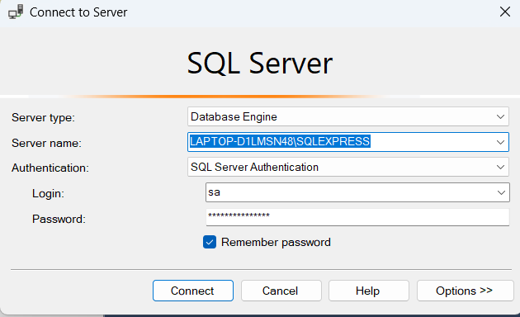
Tiếp theo, trong VS, check trong TOOLS/Connect to database...
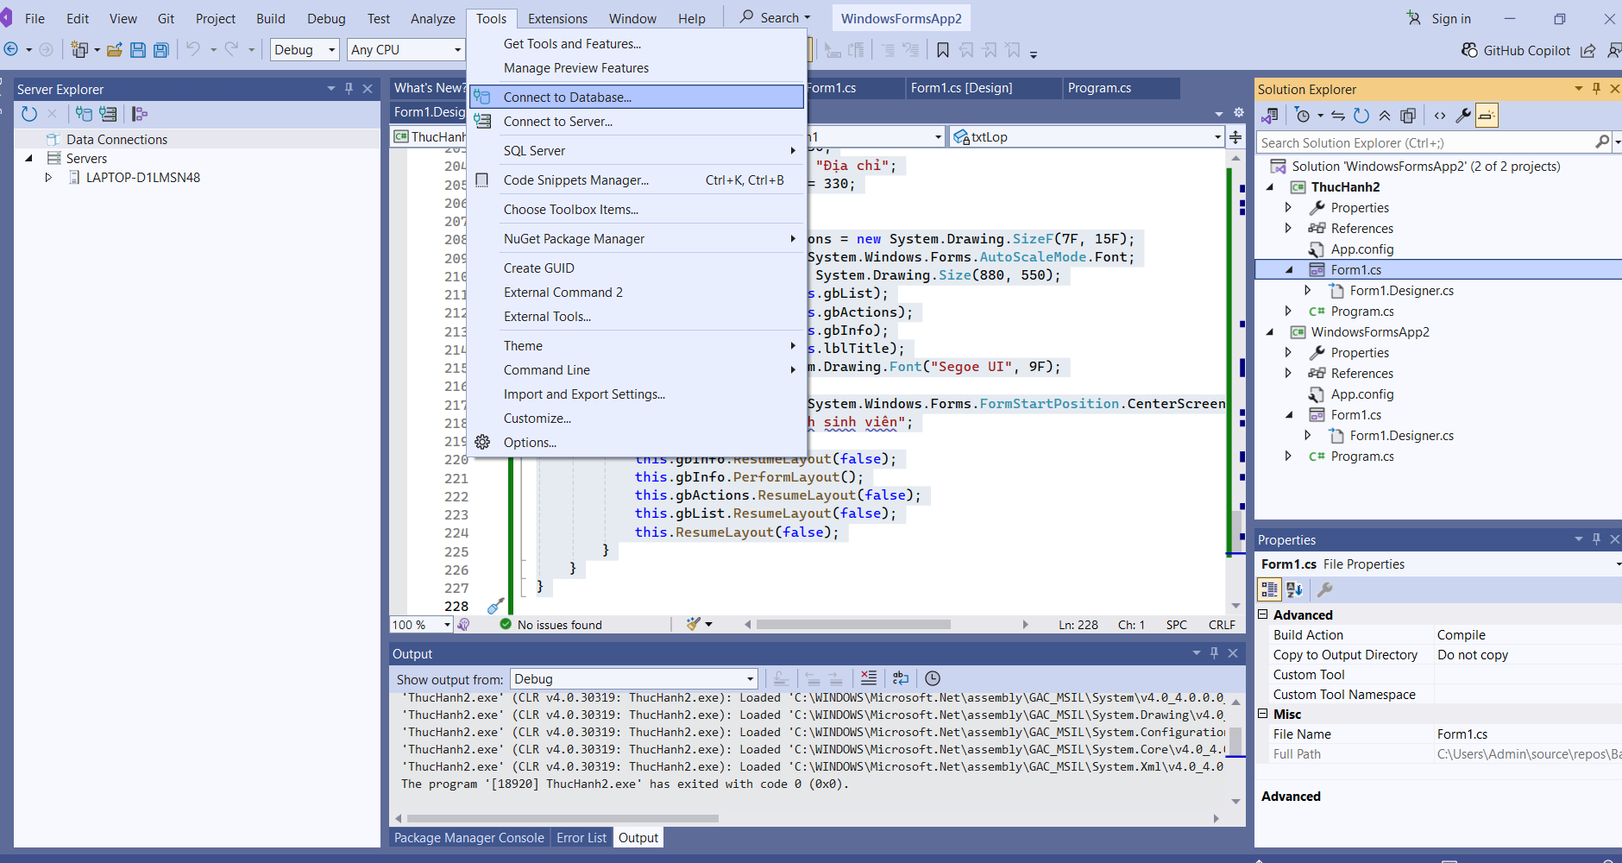

Paste Server name vào (1) → chọn databse đã có trên máy local trong (2)
Nhấn (3) để lấy chuỗi kết nối:

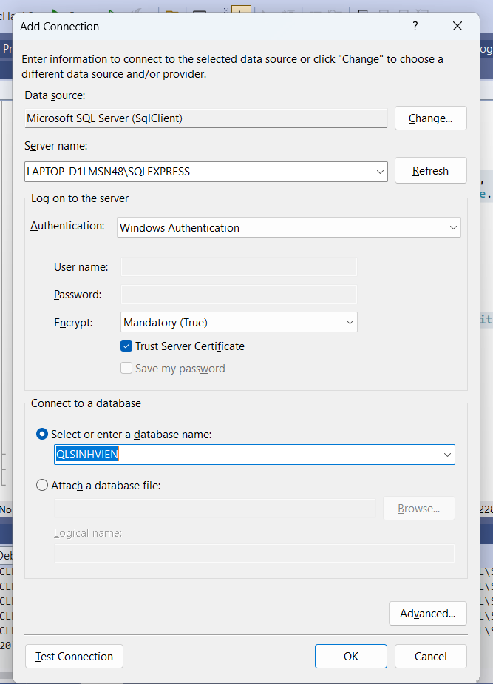
Nhấn (4) để kiểm tra kết nối:

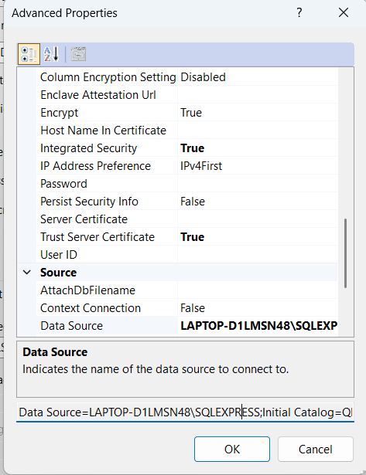
Nhấn (5) để hoàn tất kết nối!
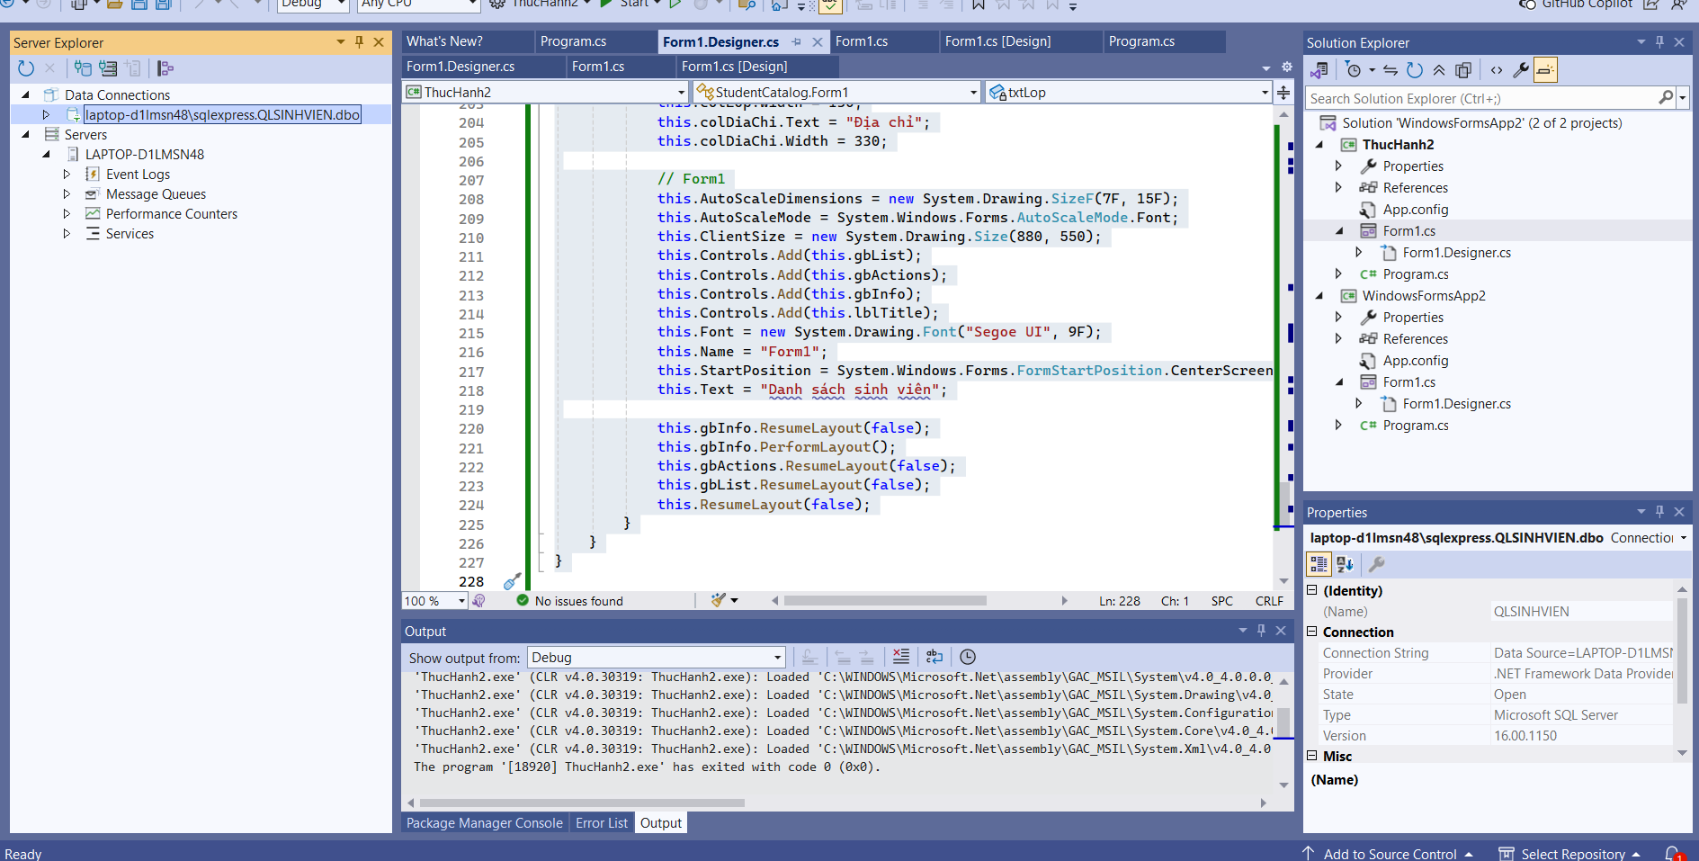
App.config – khai báo chuỗi kết nối (fix lỗi SSL)
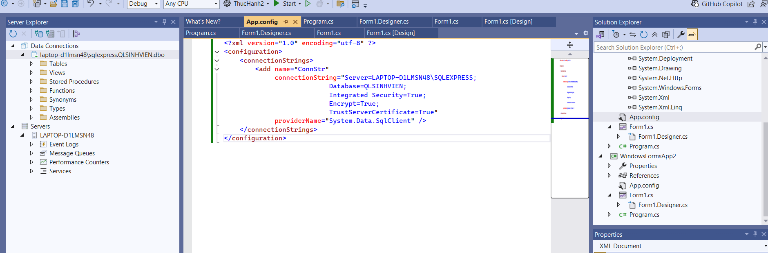
<?xml version="1.0" encoding="utf-8" ?>
<configuration>
<connectionStrings>
<add name="ConnStr"
connectionString="Server=LAPTOP-D1LMSN48\SQLEXPRESS;
Database=QLSINHVIEN;
Integrated Security=True;
Encrypt=True;
TrustServerCertificate=True"
providerName="System.Data.SqlClient" />
</connectionStrings>
</configuration>

Thực hành 2: Truy vấn dữ liệu
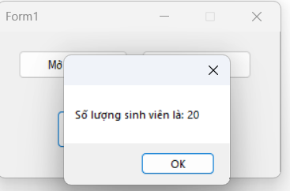
Code Form1.cs
using System;
using System.Configuration;
using System.Data;
using System.Data.SqlClient;
using System.Windows.Forms;

namespace YourNamespace
{
public partial class Form1 : Form
{
private SqlConnection sqlCon; // dùng lại 1 connection
private readonly string strCon;

public Form1()
{
InitializeComponent();
strCon = ConfigurationManager.ConnectionStrings["ConnStr"].ConnectionString;
}

// MỞ KẾT NỐI
private void btnMoKetNoi_Click(object sender, EventArgs e)
{
try
{
if (sqlCon == null)
sqlCon = new SqlConnection(strCon);

if (sqlCon.State == ConnectionState.Closed)
{
sqlCon.Open();
MessageBox.Show("Kết nối thành công");
}
else
{
MessageBox.Show("Kết nối đang mở.");
}
}
catch (Exception ex)
{
MessageBox.Show(ex.Message, "Lỗi mở kết nối");
}
}

// ĐÓNG KẾT NỐI
private void btnDongKetNoi_Click(object sender, EventArgs e)
{
if (sqlCon != null && sqlCon.State == ConnectionState.Open)
{
sqlCon.Close();
MessageBox.Show("Đóng kết nối thành công!");
}
else
{
MessageBox.Show("Chưa mở kết nối!");
}
}

// ĐẾM SỐ LƯỢNG SINH VIÊN (ExecuteScalar)
private void btnCount_Click(object sender, EventArgs e)
{
try
{
// Mở nếu đang đóng
if (sqlCon == null)
sqlCon = new SqlConnection(strCon);
if (sqlCon.State == ConnectionState.Closed)
sqlCon.Open();

using (var sqlCmd = new SqlCommand())
{
sqlCmd.CommandType = CommandType.Text;
// LƯU Ý: viết đúng COUNT(*), có thể thêm dbo. tùy schema
sqlCmd.CommandText = "SELECT COUNT(*) FROM dbo.SinhVien";
sqlCmd.Connection = sqlCon;

int soLuongSV = Convert.ToInt32(sqlCmd.ExecuteScalar());
MessageBox.Show("Số lượng sinh viên là: " + soLuongSV);
}
}
catch (SqlException ex)
{
MessageBox.Show(ex.Message, "SQL Error");
}
catch (Exception ex)
{
MessageBox.Show(ex.ToString(), "Error");
}
}

protected override void OnFormClosed(FormClosedEventArgs e)
{
if (sqlCon != null)
{
if (sqlCon.State != ConnectionState.Closed) sqlCon.Close();
sqlCon.Dispose();
}
base.OnFormClosed(e);
}
}
}
Code Form1.Designer.cs
namespace YourNamespace
{
partial class Form1
{
/// <summary>
/// Required designer variable.
/// </summary>
private System.ComponentModel.IContainer components = null;

private System.Windows.Forms.Button btnMoKetNoi;
private System.Windows.Forms.Button btnDongKetNoi;
private System.Windows.Forms.Button btnCount;

/// <summary>
/// Clean up any resources being used.
/// </summary>
protected override void Dispose(bool disposing)
{
if (disposing && (components != null))
components.Dispose();
base.Dispose(disposing);
}

#region Windows Form Designer generated code

/// <summary>
/// Required method for Designer support.
/// </summary>
private void InitializeComponent()
{
this.btnMoKetNoi = new System.Windows.Forms.Button();
this.btnDongKetNoi = new System.Windows.Forms.Button();
this.btnCount = new System.Windows.Forms.Button();
this.SuspendLayout();
//
// btnMoKetNoi
//
this.btnMoKetNoi.Location = new System.Drawing.Point(24, 22);
this.btnMoKetNoi.Name = "btnMoKetNoi";
this.btnMoKetNoi.Size = new System.Drawing.Size(130, 34);
this.btnMoKetNoi.TabIndex = 0;
this.btnMoKetNoi.Text = "Mở kết nối";
this.btnMoKetNoi.UseVisualStyleBackColor = true;
this.btnMoKetNoi.Click += new System.EventHandler(this.btnMoKetNoi_Click);
//
// btnDongKetNoi
//
this.btnDongKetNoi.Location = new System.Drawing.Point(170, 22);
this.btnDongKetNoi.Name = "btnDongKetNoi";
this.btnDongKetNoi.Size = new System.Drawing.Size(130, 34);
this.btnDongKetNoi.TabIndex = 1;
this.btnDongKetNoi.Text = "Đóng kết nối";
this.btnDongKetNoi.UseVisualStyleBackColor = true;
this.btnDongKetNoi.Click += new System.EventHandler(this.btnDongKetNoi_Click);
//
// btnCount
//
this.btnCount.Font = new System.Drawing.Font("Segoe UI", 10F, System.Drawing.FontStyle.Regular, System.Drawing.GraphicsUnit.Point);
this.btnCount.Location = new System.Drawing.Point(70, 92);
this.btnCount.Name = "btnCount";
this.btnCount.Size = new System.Drawing.Size(200, 44);
this.btnCount.TabIndex = 2;
this.btnCount.Text = "Số lượng sinh viên";
this.btnCount.UseVisualStyleBackColor = true;
this.btnCount.Click += new System.EventHandler(this.btnCount_Click);
//
// Form1
//
this.AutoScaleDimensions = new System.Drawing.SizeF(7F, 15F);
this.AutoScaleMode = System.Windows.Forms.AutoScaleMode.Font;
this.ClientSize = new System.Drawing.Size(334, 171);
this.Controls.Add(this.btnCount);
this.Controls.Add(this.btnDongKetNoi);
this.Controls.Add(this.btnMoKetNoi);
this.FormBorderStyle = System.Windows.Forms.FormBorderStyle.FixedDialog;
this.MaximizeBox = false;
this.Name = "Form1";
this.StartPosition = System.Windows.Forms.FormStartPosition.CenterScreen;
this.Text = "Form1";
this.ResumeLayout(false);
}

#endregion
}
}

2. Truy vấn lấy 1 dòng dữ liệu
Để thực hiện truy vấn lấy 1 dòng dữ liệu, ta dùng hàm ExecuteReader.
Ví dụ: Lấy thông tin của sinh viên có mã là 0200000004.
Code SQl: select * from SinhVien where MaSV='0200000004'
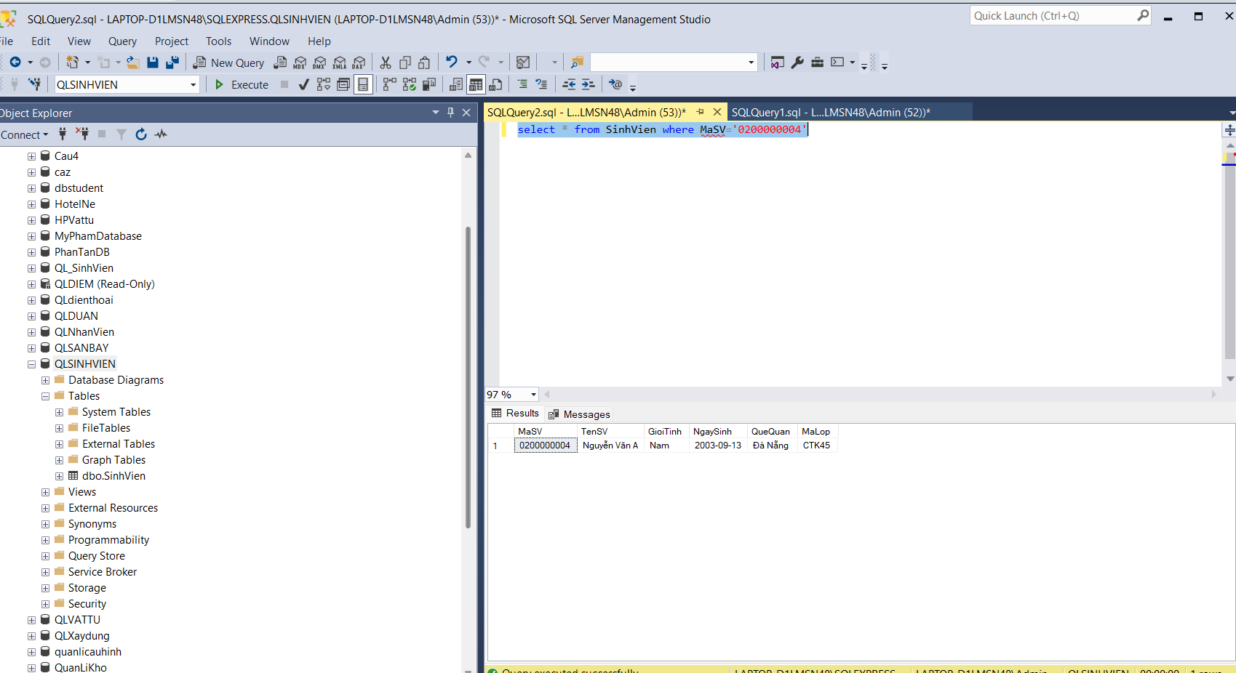
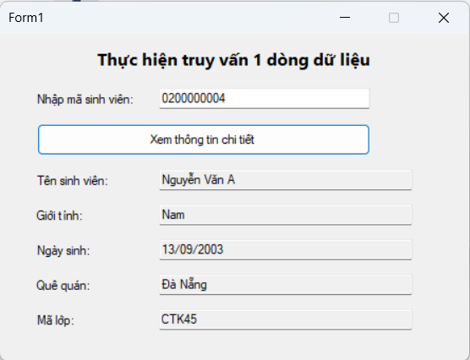
Code Form1.cs
using System;
using System.Configuration;
using System.Data;
using System.Data.SqlClient;
using System.Windows.Forms;

namespace QLSV_ExecuteReader_OneRow
{
public partial class Form1 : Form
{
private SqlConnection sqlCon;
private readonly string strCon;

public Form1()
{
InitializeComponent();
strCon = ConfigurationManager.ConnectionStrings["ConnStr"].ConnectionString;

// Enter để tìm nhanh
txtNhapMaSV.KeyDown += (s, e) =>
{
if (e.KeyCode == Keys.Enter)
{
btnXemThongTin.PerformClick();
e.SuppressKeyPress = true;
}
};
}

private void EnsureOpen()
{
if (sqlCon == null) sqlCon = new SqlConnection(strCon);
if (sqlCon.State == ConnectionState.Closed) sqlCon.Open();
}

private void ClearDetail()
{
txtTenSV.Clear();
txtGioiTinh.Clear();
txtNgaySinh.Clear();
txtQueQuan.Clear();
txtMaLop.Clear();
}

// ====== Nút Xem thông tin chi tiết (ExecuteReader) ======
private void btnXemThongTin_Click(object sender, EventArgs e)
{
string maSV = txtNhapMaSV.Text.Trim();
if (string.IsNullOrWhiteSpace(maSV))
{
MessageBox.Show("Vui lòng nhập Mã sinh viên!");
txtNhapMaSV.Focus();
return;
}

try
{
EnsureOpen();

// Truy vấn có tham số (an toàn, chính xác)
string sql = @"SELECT MaSV, TenSV, GioiTinh, NgaySinh, QueQuan, MaLop
FROM dbo.SinhVien
WHERE MaSV = @MaSV";

using (var cmd = new SqlCommand(sql, sqlCon))
{
cmd.CommandType = CommandType.Text;
cmd.Parameters.AddWithValue("@MaSV", maSV);

using (var reader = cmd.ExecuteReader())
{
if (reader.Read())
{
// Đọc theo tên cột để không phụ thuộc thứ tự
txtTenSV.Text = reader["TenSV"] == DBNull.Value ? "" : reader["TenSV"].ToString();
txtGioiTinh.Text = reader["GioiTinh"] == DBNull.Value ? "" : reader["GioiTinh"].ToString();

if (reader["NgaySinh"] != DBNull.Value)
txtNgaySinh.Text = Convert.ToDateTime(reader["NgaySinh"]).ToString("dd/MM/yyyy");
else
txtNgaySinh.Text = "";

txtQueQuan.Text = reader["QueQuan"] == DBNull.Value ? "" : reader["QueQuan"].ToString();
txtMaLop.Text = reader["MaLop"] == DBNull.Value ? "" : reader["MaLop"].ToString();
}
else
{
MessageBox.Show($"Không tìm thấy sinh viên có mã: {maSV}");
ClearDetail();
}
}
}
}
catch (SqlException ex)
{
MessageBox.Show(ex.Message, "SQL Error");
}
catch (Exception ex)
{
MessageBox.Show(ex.ToString(), "Error");
}
}

protected override void OnFormClosed(FormClosedEventArgs e)
{
if (sqlCon != null)
{
if (sqlCon.State != ConnectionState.Closed) sqlCon.Close();
sqlCon.Dispose();
}
base.OnFormClosed(e);
}
}
}
Code Form1.Designer.cs
namespace QLSV_ExecuteReader_OneRow
{
partial class Form1
{
private System.ComponentModel.IContainer components = null;

private System.Windows.Forms.Label lblTitle;
private System.Windows.Forms.Label labelNhap;
private System.Windows.Forms.TextBox txtNhapMaSV;
private System.Windows.Forms.Button btnXemThongTin;

private System.Windows.Forms.Label labelTen;
private System.Windows.Forms.TextBox txtTenSV;
private System.Windows.Forms.Label labelGT;
private System.Windows.Forms.TextBox txtGioiTinh;
private System.Windows.Forms.Label labelNS;
private System.Windows.Forms.TextBox txtNgaySinh;
private System.Windows.Forms.Label labelQQ;
private System.Windows.Forms.TextBox txtQueQuan;
private System.Windows.Forms.Label labelML;
private System.Windows.Forms.TextBox txtMaLop;

protected override void Dispose(bool disposing)
{
if (disposing && (components != null))
components.Dispose();
base.Dispose(disposing);
}

private void InitializeComponent()
{
this.lblTitle = new System.Windows.Forms.Label();
this.labelNhap = new System.Windows.Forms.Label();
this.txtNhapMaSV = new System.Windows.Forms.TextBox();
this.btnXemThongTin = new System.Windows.Forms.Button();
this.labelTen = new System.Windows.Forms.Label();
this.txtTenSV = new System.Windows.Forms.TextBox();
this.labelGT = new System.Windows.Forms.Label();
this.txtGioiTinh = new System.Windows.Forms.TextBox();
this.labelNS = new System.Windows.Forms.Label();
this.txtNgaySinh = new System.Windows.Forms.TextBox();
this.labelQQ = new System.Windows.Forms.Label();
this.txtQueQuan = new System.Windows.Forms.TextBox();
this.labelML = new System.Windows.Forms.Label();
this.txtMaLop = new System.Windows.Forms.TextBox();
this.SuspendLayout();
//
// lblTitle
//
this.lblTitle.Font = new System.Drawing.Font("Segoe UI", 12F, System.Drawing.FontStyle.Bold);
this.lblTitle.Location = new System.Drawing.Point(12, 9);
this.lblTitle.Name = "lblTitle";
this.lblTitle.Size = new System.Drawing.Size(420, 28);
this.lblTitle.TabIndex = 0;
this.lblTitle.Text = "Thực hiện truy vấn 1 dòng dữ liệu";
this.lblTitle.TextAlign = System.Drawing.ContentAlignment.MiddleCenter;
//
// labelNhap
//
this.labelNhap.AutoSize = true;
this.labelNhap.Location = new System.Drawing.Point(30, 55);
this.labelNhap.Name = "labelNhap";
this.labelNhap.Size = new System.Drawing.Size(102, 15);
this.labelNhap.TabIndex = 1;
this.labelNhap.Text = "Nhập mã sinh viên:";
//
// txtNhapMaSV
//
this.txtNhapMaSV.Location = new System.Drawing.Point(150, 51);
this.txtNhapMaSV.Name = "txtNhapMaSV";
this.txtNhapMaSV.Size = new System.Drawing.Size(200, 23);
this.txtNhapMaSV.TabIndex = 0;
//
// btnXemThongTin
//
this.btnXemThongTin.Location = new System.Drawing.Point(33, 85);
this.btnXemThongTin.Name = "btnXemThongTin";
this.btnXemThongTin.Size = new System.Drawing.Size(317, 30);
this.btnXemThongTin.TabIndex = 1;
this.btnXemThongTin.Text = "Xem thông tin chi tiết";
this.btnXemThongTin.UseVisualStyleBackColor = true;
this.btnXemThongTin.Click += new System.EventHandler(this.btnXemThongTin_Click);
//
// labelTen
//
this.labelTen.AutoSize = true;
this.labelTen.Location = new System.Drawing.Point(30, 132);
this.labelTen.Name = "labelTen";
this.labelTen.Size = new System.Drawing.Size(80, 15);
this.labelTen.TabIndex = 4;
this.labelTen.Text = "Tên sinh viên:";
//
// txtTenSV
//
this.txtTenSV.Location = new System.Drawing.Point(150, 128);
this.txtTenSV.Name = "txtTenSV";
this.txtTenSV.ReadOnly = true;
this.txtTenSV.Size = new System.Drawing.Size(240, 23);
this.txtTenSV.TabIndex = 2;
//
// labelGT
//
this.labelGT.AutoSize = true;
this.labelGT.Location = new System.Drawing.Point(30, 165);
this.labelGT.Name = "labelGT";
this.labelGT.Size = new System.Drawing.Size(53, 15);
this.labelGT.TabIndex = 6;
this.labelGT.Text = "Giới tính:";
//
// txtGioiTinh
//
this.txtGioiTinh.Location = new System.Drawing.Point(150, 161);
this.txtGioiTinh.Name = "txtGioiTinh";
this.txtGioiTinh.ReadOnly = true;
this.txtGioiTinh.Size = new System.Drawing.Size(240, 23);
this.txtGioiTinh.TabIndex = 3;
//
// labelNS
//
this.labelNS.AutoSize = true;
this.labelNS.Location = new System.Drawing.Point(30, 198);
this.labelNS.Name = "labelNS";
this.labelNS.Size = new System.Drawing.Size(63, 15);
this.labelNS.TabIndex = 8;
this.labelNS.Text = "Ngày sinh:";
//
// txtNgaySinh
//
this.txtNgaySinh.Location = new System.Drawing.Point(150, 194);
this.txtNgaySinh.Name = "txtNgaySinh";
this.txtNgaySinh.ReadOnly = true;
this.txtNgaySinh.Size = new System.Drawing.Size(240, 23);
this.txtNgaySinh.TabIndex = 4;
//
// labelQQ
//
this.labelQQ.AutoSize = true;
this.labelQQ.Location = new System.Drawing.Point(30, 231);
this.labelQQ.Name = "labelQQ";
this.labelQQ.Size = new System.Drawing.Size(60, 15);
this.labelQQ.TabIndex = 10;
this.labelQQ.Text = "Quê quán:";
//
// txtQueQuan
//
this.txtQueQuan.Location = new System.Drawing.Point(150, 227);
this.txtQueQuan.Name = "txtQueQuan";
this.txtQueQuan.ReadOnly = true;
this.txtQueQuan.Size = new System.Drawing.Size(240, 23);
this.txtQueQuan.TabIndex = 5;
//
// labelML
//
this.labelML.AutoSize = true;
this.labelML.Location = new System.Drawing.Point(30, 264);
this.labelML.Name = "labelML";
this.labelML.Size = new System.Drawing.Size(45, 15);
this.labelML.TabIndex = 12;
this.labelML.Text = "Mã lớp:";
//
// txtMaLop
//
this.txtMaLop.Location = new System.Drawing.Point(150, 260);
this.txtMaLop.Name = "txtMaLop";
this.txtMaLop.ReadOnly = true;
this.txtMaLop.Size = new System.Drawing.Size(240, 23);
this.txtMaLop.TabIndex = 6;
//
// Form1
//
this.AutoScaleDimensions = new System.Drawing.SizeF(7F, 15F);
this.AutoScaleMode = System.Windows.Forms.AutoScaleMode.Font;
this.ClientSize = new System.Drawing.Size(444, 310);
this.Controls.Add(this.txtMaLop);
this.Controls.Add(this.labelML);
this.Controls.Add(this.txtQueQuan);
this.Controls.Add(this.labelQQ);
this.Controls.Add(this.txtNgaySinh);
this.Controls.Add(this.labelNS);
this.Controls.Add(this.txtGioiTinh);
this.Controls.Add(this.labelGT);
this.Controls.Add(this.txtTenSV);
this.Controls.Add(this.labelTen);
this.Controls.Add(this.btnXemThongTin);
this.Controls.Add(this.txtNhapMaSV);
this.Controls.Add(this.labelNhap);
this.Controls.Add(this.lblTitle);
this.FormBorderStyle = System.Windows.Forms.FormBorderStyle.FixedDialog;
this.MaximizeBox = false;
this.Name = "Form1";
this.StartPosition = System.Windows.Forms.FormStartPosition.CenterScreen;
this.Text = "Form1";
this.ResumeLayout(false);
this.PerformLayout();
}
}
}

3. Truy vấn lấy nhiều dòng dữ liệu
− Để thực hiện truy vấn lấy nhiều dòng dữ liệu, ta dùng hàm ExecuteReader.
− Ví dụ: Hiển thị danh sách thông tin các sinh viên trong bảng SinhVien.
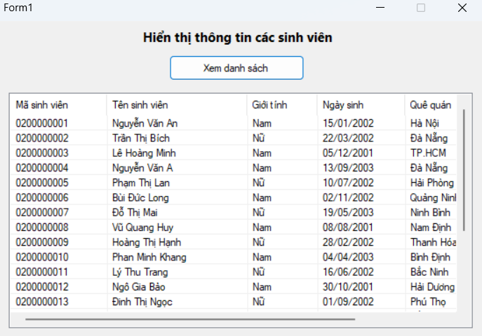
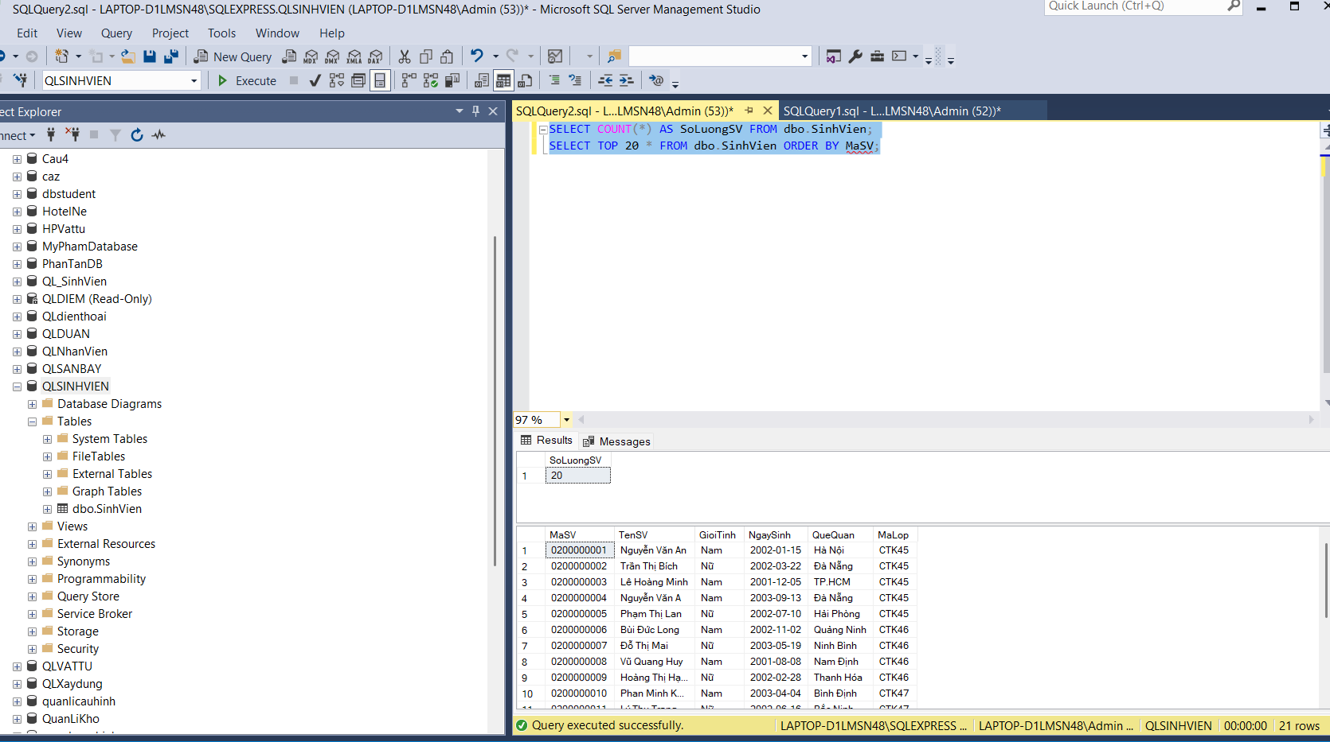
Code Form1.cs.
using System;
using System.Configuration;
using System.Data;
using System.Data.SqlClient;
using System.Windows.Forms;

namespace QLSV_ListView
{
public partial class Form1 : Form
{
private SqlConnection sqlCon;
private readonly string strCon;

public Form1()
{
InitializeComponent();
strCon = ConfigurationManager.ConnectionStrings["ConnStr"].ConnectionString;

// ListView hiển thị đẹp hơn
lsvList.FullRowSelect = true;
lsvList.GridLines = true;
lsvList.View = View.Details;
}

// ===== Nút "Xem danh sách" =====
private void btnListView_Click(object sender, EventArgs e)
{
try
{
// Mở kết nối
if (sqlCon == null) sqlCon = new SqlConnection(strCon);
if (sqlCon.State == ConnectionState.Closed) sqlCon.Open();

// Xoá dữ liệu cũ trước khi nạp mới
lsvList.Items.Clear();

// Đối tượng thực thi truy vấn
using (var sqlCmd = new SqlCommand())
{
sqlCmd.CommandType = CommandType.Text;
sqlCmd.CommandText = @"
SELECT MaSV, TenSV, GioiTinh, NgaySinh, QueQuan, MaLop
FROM dbo.SinhVien
ORDER BY MaSV";
sqlCmd.Connection = sqlCon;

using (SqlDataReader reader = sqlCmd.ExecuteReader())
{
while (reader.Read())
{
// Đọc dữ liệu theo index như yêu cầu
string maSV = reader.IsDBNull(0) ? "" : reader.GetString(0);
string tenSV = reader.IsDBNull(1) ? "" : reader.GetString(1);
string gioiTinh = reader.IsDBNull(2) ? "" : reader.GetString(2);
string ngaySinh = reader.IsDBNull(3) ? "" : reader.GetDateTime(3).ToString("dd/MM/yyyy");
string queQuan = reader.IsDBNull(4) ? "" : reader.GetString(4);
string maLop = reader.IsDBNull(5) ? "" : reader.GetString(5);

// Hiển thị trên ListView
var lvi = new ListViewItem(maSV);
lvi.SubItems.Add(tenSV);
lvi.SubItems.Add(gioiTinh);
lvi.SubItems.Add(ngaySinh);
lvi.SubItems.Add(queQuan);
lvi.SubItems.Add(maLop);
lsvList.Items.Add(lvi);
}
}
}
}
catch (SqlException ex)
{
MessageBox.Show(ex.Message, "SQL Error");
}
catch (Exception ex)
{
MessageBox.Show(ex.ToString(), "Error");
}
}

protected override void OnFormClosed(FormClosedEventArgs e)
{
if (sqlCon != null)
{
if (sqlCon.State != ConnectionState.Closed) sqlCon.Close();
sqlCon.Dispose();
}
base.OnFormClosed(e);
}
}
}

Code Form1.Designer.cs
namespace QLSV_ListView
{
partial class Form1
{
private System.ComponentModel.IContainer components = null;

private System.Windows.Forms.Label lblTitle;
private System.Windows.Forms.Button btnListView;
private System.Windows.Forms.ListView lsvList;
private System.Windows.Forms.ColumnHeader colMaSV;
private System.Windows.Forms.ColumnHeader colTenSV;
private System.Windows.Forms.ColumnHeader colGioiTinh;
private System.Windows.Forms.ColumnHeader colNgaySinh;
private System.Windows.Forms.ColumnHeader colQueQuan;
private System.Windows.Forms.ColumnHeader colMaLop;

protected override void Dispose(bool disposing)
{
if (disposing && (components != null)) components.Dispose();
base.Dispose(disposing);
}

private void InitializeComponent()
{
this.lblTitle = new System.Windows.Forms.Label();
this.btnListView = new System.Windows.Forms.Button();
this.lsvList = new System.Windows.Forms.ListView();
this.colMaSV = new System.Windows.Forms.ColumnHeader();
this.colTenSV = new System.Windows.Forms.ColumnHeader();
this.colGioiTinh = new System.Windows.Forms.ColumnHeader();
this.colNgaySinh = new System.Windows.Forms.ColumnHeader();
this.colQueQuan = new System.Windows.Forms.ColumnHeader();
this.colMaLop = new System.Windows.Forms.ColumnHeader();
this.SuspendLayout();
//
// lblTitle
//
this.lblTitle.Font = new System.Drawing.Font("Segoe UI", 11F, System.Drawing.FontStyle.Bold);
this.lblTitle.Location = new System.Drawing.Point(12, 9);
this.lblTitle.Name = "lblTitle";
this.lblTitle.Size = new System.Drawing.Size(620, 24);
this.lblTitle.TabIndex = 0;
this.lblTitle.Text = "Hiển thị thông tin các sinh viên";
this.lblTitle.TextAlign = System.Drawing.ContentAlignment.MiddleCenter;
//
// btnListView
//
this.btnListView.Location = new System.Drawing.Point(230, 45);
this.btnListView.Name = "btnListView";
this.btnListView.Size = new System.Drawing.Size(180, 34);
this.btnListView.TabIndex = 1;
this.btnListView.Text = "Xem danh sách";
this.btnListView.UseVisualStyleBackColor = true;
this.btnListView.Click += new System.EventHandler(this.btnListView_Click);
//
// lsvList
//
this.lsvList.Anchor = ((System.Windows.Forms.AnchorStyles)((((System.Windows.Forms.AnchorStyles.Top | System.Windows.Forms.AnchorStyles.Bottom)
| System.Windows.Forms.AnchorStyles.Left)
| System.Windows.Forms.AnchorStyles.Right)));
this.lsvList.Columns.AddRange(new System.Windows.Forms.ColumnHeader[] {
this.colMaSV, this.colTenSV, this.colGioiTinh, this.colNgaySinh, this.colQueQuan, this.colMaLop});
this.lsvList.HideSelection = false;
this.lsvList.Location = new System.Drawing.Point(16, 95);
this.lsvList.Name = "lsvList";
this.lsvList.Size = new System.Drawing.Size(616, 310);
this.lsvList.TabIndex = 2;
this.lsvList.UseCompatibleStateImageBehavior = false;
this.lsvList.View = System.Windows.Forms.View.Details;
//
// Columns
//
this.colMaSV.Text = "Mã sinh viên";
this.colMaSV.Width = 110;
this.colTenSV.Text = "Tên sinh viên";
this.colTenSV.Width = 160;
this.colGioiTinh.Text = "Giới tính";
this.colGioiTinh.Width = 80;
this.colNgaySinh.Text = "Ngày sinh";
this.colNgaySinh.Width = 100;
this.colQueQuan.Text = "Quê quán";
this.colQueQuan.Width = 110;
this.colMaLop.Text = "Mã lớp";
this.colMaLop.Width = 80;
//
// Form1
//
this.AutoScaleDimensions = new System.Drawing.SizeF(7F, 15F);
this.AutoScaleMode = System.Windows.Forms.AutoScaleMode.Font;
this.ClientSize = new System.Drawing.Size(648, 420);
this.Controls.Add(this.lsvList);
this.Controls.Add(this.btnListView);
this.Controls.Add(this.lblTitle);
this.FormBorderStyle = System.Windows.Forms.FormBorderStyle.FixedDialog;
this.MaximizeBox = false;
this.Name = "Form1";
this.StartPosition = System.Windows.Forms.FormStartPosition.CenterScreen;
this.Text = "Form1";
this.ResumeLayout(false);
}
}
}

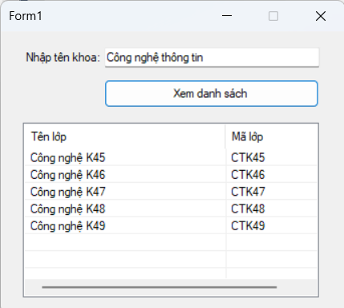
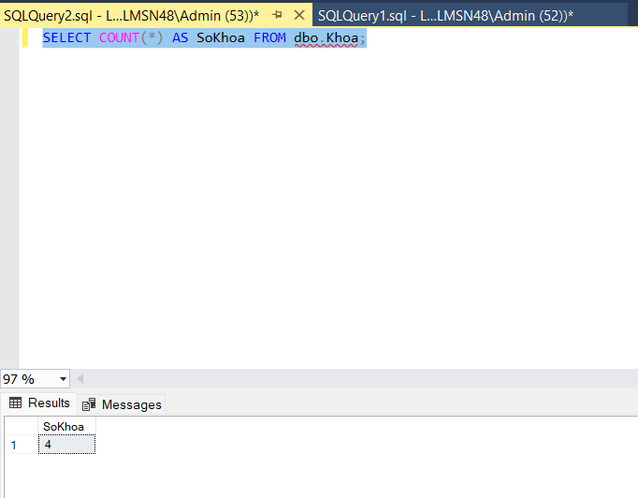
Code Form1.cs
using System;
using System.Configuration;
using System.Data;
using System.Data.SqlClient;
using System.Globalization;
using System.Text;
using System.Windows.Forms;

namespace QLSV_Param_LopTheoKhoa
{
public partial class Form1 : Form
{
private SqlConnection sqlCon;
private readonly string strCon;

public Form1()
{
InitializeComponent();
strCon = ConfigurationManager.ConnectionStrings["ConnStr"].ConnectionString;

// ListView hiển thị đẹp
lsvDanhSach.FullRowSelect = true;
lsvDanhSach.GridLines = true;
lsvDanhSach.View = View.Details;

// Enter để tìm nhanh
txtNhapTenKhoa.KeyDown += (s, e) =>
{
if (e.KeyCode == Keys.Enter)
{
btnXemDS.PerformClick();
e.SuppressKeyPress = true;
}
};
}

// ======= Nút "Xem danh sách" =======
private void btnXemDS_Click(object sender, EventArgs e)
{
string tenKhoa = txtNhapTenKhoa.Text.Trim();
if (string.IsNullOrWhiteSpace(tenKhoa))
{
MessageBox.Show("Vui lòng nhập tên khoa (ví dụ: Công nghệ thông tin)!");
txtNhapTenKhoa.Focus();
return;
}

// Map tên khoa -> mã khoa theo DB của bạn
string maKhoa = MapMaKhoa(tenKhoa);
if (string.IsNullOrEmpty(maKhoa))
{
MessageBox.Show("Không nhận diện được mã khoa từ tên đã nhập. Hãy nhập: Công nghệ thông tin / Cơ khí / Điện tử / Kinh tế.");
return;
}

try
{
if (sqlCon == null) sqlCon = new SqlConnection(strCon);
if (sqlCon.State == ConnectionState.Closed) sqlCon.Open();

lsvDanhSach.Items.Clear();

using (var cmd = new SqlCommand())
{
cmd.Connection = sqlCon;
cmd.CommandType = CommandType.Text;
cmd.CommandText = @"SELECT MaLop, TenLop
FROM dbo.Lop
WHERE MaKhoa = @maKhoa
ORDER BY TenLop";
// Parameter an toàn
cmd.Parameters.Add("@maKhoa", SqlDbType.NVarChar, 20).Value = maKhoa;

using (var reader = cmd.ExecuteReader())
{
while (reader.Read())
{
string maLop = reader.IsDBNull(0) ? "" : reader.GetString(0);
string tenLop = reader.IsDBNull(1) ? "" : reader.GetString(1);

var lvi = new ListViewItem(tenLop);
lvi.SubItems.Add(maLop);
lsvDanhSach.Items.Add(lvi);
}
}
}
}
catch (SqlException ex)
{
MessageBox.Show(ex.Message, "SQL Error");
}
catch (Exception ex)
{
MessageBox.Show(ex.ToString(), "Error");
}
}

// Map tên khoa -> mã khoa (điều chỉnh cho đúng với CSDL của bạn)
private string MapMaKhoa(string input)
{
string s = RemoveDiacritics(input).ToLower().Trim();

if (s == "cong nghe thong tin" || s == "cntt") return "CNTT";
if (s == "co khi" || s == "ck") return "CK";
if (s == "dien tu" || s == "dt") return "DT";
if (s == "kinh te" || s == "kt") return "KT";

return string.Empty; // không khớp
}

// Bỏ dấu tiếng Việt để so khớp linh hoạt
private string RemoveDiacritics(string text)
{
var formD = text.Normalize(NormalizationForm.FormD);
var sb = new StringBuilder();

foreach (var ch in formD)
{
var uc = CharUnicodeInfo.GetUnicodeCategory(ch);
if (uc != UnicodeCategory.NonSpacingMark)
sb.Append(ch);
}
return sb.ToString().Normalize(NormalizationForm.FormC);
}

protected override void OnFormClosed(FormClosedEventArgs e)
{
if (sqlCon != null)
{
if (sqlCon.State != ConnectionState.Closed) sqlCon.Close();
sqlCon.Dispose();
}
base.OnFormClosed(e);
}
}
}
Code Form1.Designer.cs
namespace QLSV_Param_LopTheoKhoa
{
partial class Form1
{
private System.ComponentModel.IContainer components = null;

private System.Windows.Forms.Label lblNhap;
private System.Windows.Forms.TextBox txtNhapTenKhoa;
private System.Windows.Forms.Button btnXemDS;
private System.Windows.Forms.ListView lsvDanhSach;
private System.Windows.Forms.ColumnHeader colTenLop;
private System.Windows.Forms.ColumnHeader colMaLop;

protected override void Dispose(bool disposing)
{
if (disposing && (components != null)) components.Dispose();
base.Dispose(disposing);
}

private void InitializeComponent()
{
this.lblNhap = new System.Windows.Forms.Label();
this.txtNhapTenKhoa = new System.Windows.Forms.TextBox();
this.btnXemDS = new System.Windows.Forms.Button();
this.lsvDanhSach = new System.Windows.Forms.ListView();
this.colTenLop = new System.Windows.Forms.ColumnHeader();
this.colMaLop = new System.Windows.Forms.ColumnHeader();
this.SuspendLayout();
//
// lblNhap
//
this.lblNhap.AutoSize = true;
this.lblNhap.Location = new System.Drawing.Point(26, 22);
this.lblNhap.Name = "lblNhap";
this.lblNhap.Size = new System.Drawing.Size(82, 15);
this.lblNhap.TabIndex = 0;
this.lblNhap.Text = "Nhập tên khoa:";
//
// txtNhapTenKhoa
//
this.txtNhapTenKhoa.Location = new System.Drawing.Point(120, 18);
this.txtNhapTenKhoa.Name = "txtNhapTenKhoa";
this.txtNhapTenKhoa.Size = new System.Drawing.Size(250, 23);
this.txtNhapTenKhoa.TabIndex = 0;
//
// btnXemDS
//
this.btnXemDS.Location = new System.Drawing.Point(120, 55);
this.btnXemDS.Name = "btnXemDS";
this.btnXemDS.Size = new System.Drawing.Size(250, 32);
this.btnXemDS.TabIndex = 1;
this.btnXemDS.Text = "Xem danh sách";
this.btnXemDS.UseVisualStyleBackColor = true;
this.btnXemDS.Click += new System.EventHandler(this.btnXemDS_Click);
//
// lsvDanhSach
//
this.lsvDanhSach.Columns.AddRange(new System.Windows.Forms.ColumnHeader[] {
this.colTenLop, this.colMaLop});
this.lsvDanhSach.HideSelection = false;
this.lsvDanhSach.Location = new System.Drawing.Point(26, 105);
this.lsvDanhSach.Name = "lsvDanhSach";
this.lsvDanhSach.Size = new System.Drawing.Size(344, 200);
this.lsvDanhSach.TabIndex = 2;
this.lsvDanhSach.UseCompatibleStateImageBehavior = false;
this.lsvDanhSach.View = System.Windows.Forms.View.Details;
//
// columns
//
this.colTenLop.Text = "Tên lớp";
this.colTenLop.Width = 200;
this.colMaLop.Text = "Mã lớp";
this.colMaLop.Width = 120;
//
// Form1
//
this.AutoScaleDimensions = new System.Drawing.SizeF(7F, 15F);
this.AutoScaleMode = System.Windows.Forms.AutoScaleMode.Font;
this.ClientSize = new System.Drawing.Size(400, 325);
this.Controls.Add(this.lsvDanhSach);
this.Controls.Add(this.btnXemDS);
this.Controls.Add(this.txtNhapTenKhoa);
this.Controls.Add(this.lblNhap);
this.FormBorderStyle = System.Windows.Forms.FormBorderStyle.FixedDialog;
this.MaximizeBox = false;
this.Name = "Form1";
this.StartPosition = System.Windows.Forms.FormStartPosition.CenterScreen;
this.Text = "Form1";
this.ResumeLayout(false);
this.PerformLayout();
}
}
}

Áp dụng: Hiển thị danh sách sinh viên theo mã lớp.
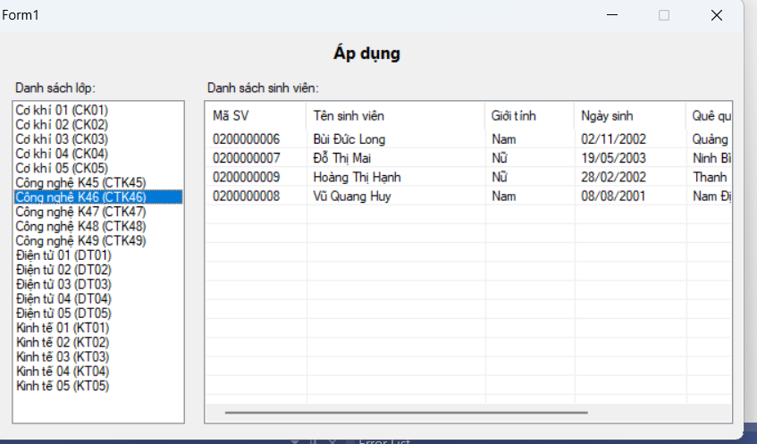
Code Form1.cs
using System;
using System.Configuration;
using System.Data;
using System.Data.SqlClient;
using System.Windows.Forms;

namespace QLSV_ApDung_Lop_SinhVien
{
public partial class Form1 : Form
{
private SqlConnection sqlCon;
private readonly string strCon;

public Form1()
{
InitializeComponent();
strCon = ConfigurationManager.ConnectionStrings["ConnStr"].ConnectionString;

// ListView hiển thị đẹp
lsvSinhVien.FullRowSelect = true;
lsvSinhVien.GridLines = true;
lsvSinhVien.View = View.Details;
}

// --------- MODEL NHỎ CHO LISTBOX ----------
private class LopItem
{
public string MaLop { get; set; } = "";
public string TenLop { get; set; } = "";
public override string ToString() => $"{TenLop} ({MaLop})";
}

// --------- LOAD LỚP KHI MỞ FORM ----------
protected override void OnLoad(EventArgs e)
{
base.OnLoad(e);
try
{
EnsureOpen();

using (var cmd = new SqlCommand("SELECT MaLop, TenLop FROM dbo.Lop ORDER BY TenLop", sqlCon))
using (var rd = cmd.ExecuteReader())
{
lsbDSLop.Items.Clear();
while (rd.Read())
{
var item = new LopItem
{
MaLop = rd["MaLop"].ToString(),
TenLop = rd["TenLop"].ToString()
};
lsbDSLop.Items.Add(item);
}
}
}
catch (Exception ex)
{
MessageBox.Show(ex.Message, "SQL Error");
}
}

private void EnsureOpen()
{
if (sqlCon == null) sqlCon = new SqlConnection(strCon);
if (sqlCon.State == ConnectionState.Closed) sqlCon.Open();
}

// --------- CHỌN 1 LỚP -> HIỂN THỊ SINH VIÊN ----------
private void lsbDSLop_SelectedIndexChanged(object sender, EventArgs e)
{
if (lsbDSLop.SelectedItem is LopItem lop)
{
try
{
EnsureOpen();
lsvSinhVien.Items.Clear();

using (var cmd = new SqlCommand(@"
SELECT MaSV, TenSV, GioiTinh, NgaySinh, QueQuan, MaLop
FROM dbo.SinhVien
WHERE MaLop = @MaLop
ORDER BY TenSV", sqlCon))
{
cmd.Parameters.Add("@MaLop", SqlDbType.NVarChar, 20).Value = lop.MaLop;

using (var rd = cmd.ExecuteReader())
{
while (rd.Read())
{
string maSV = rd["MaSV"]?.ToString();
string tenSV = rd["TenSV"]?.ToString();
string gioiTinh = rd["GioiTinh"]?.ToString();
string ngaySinh = rd["NgaySinh"] == DBNull.Value
? ""
: Convert.ToDateTime(rd["NgaySinh"]).ToString("dd/MM/yyyy");
string queQuan = rd["QueQuan"]?.ToString();
string maLop = rd["MaLop"]?.ToString();

var lvi = new ListViewItem(maSV);
lvi.SubItems.Add(tenSV);
lvi.SubItems.Add(gioiTinh);
lvi.SubItems.Add(ngaySinh);
lvi.SubItems.Add(queQuan);
lvi.SubItems.Add(maLop);
lsvSinhVien.Items.Add(lvi);
}
}
}
}
catch (Exception ex)
{
MessageBox.Show(ex.Message, "SQL Error");
}
}
}

protected override void OnFormClosed(FormClosedEventArgs e)
{
if (sqlCon != null)
{
if (sqlCon.State != ConnectionState.Closed) sqlCon.Close();
sqlCon.Dispose();
}
base.OnFormClosed(e);
}
}
}
Code Form1.Designer.cs
namespace QLSV_ApDung_Lop_SinhVien
{
partial class Form1
{
private System.ComponentModel.IContainer components = null;

private System.Windows.Forms.Label lblTitle;
private System.Windows.Forms.Label lblDSLop;
private System.Windows.Forms.Label lblDSSV;
private System.Windows.Forms.ListBox lsbDSLop;
private System.Windows.Forms.ListView lsvSinhVien;
private System.Windows.Forms.ColumnHeader colMaSV;
private System.Windows.Forms.ColumnHeader colTenSV;
private System.Windows.Forms.ColumnHeader colGioiTinh;
private System.Windows.Forms.ColumnHeader colNgaySinh;
private System.Windows.Forms.ColumnHeader colQueQuan;
private System.Windows.Forms.ColumnHeader colMaLop;

protected override void Dispose(bool disposing)
{
if (disposing && (components != null)) components.Dispose();
base.Dispose(disposing);
}

private void InitializeComponent()
{
this.lblTitle = new System.Windows.Forms.Label();
this.lblDSLop = new System.Windows.Forms.Label();
this.lblDSSV = new System.Windows.Forms.Label();
this.lsbDSLop = new System.Windows.Forms.ListBox();
this.lsvSinhVien = new System.Windows.Forms.ListView();
this.colMaSV = new System.Windows.Forms.ColumnHeader();
this.colTenSV = new System.Windows.Forms.ColumnHeader();
this.colGioiTinh = new System.Windows.Forms.ColumnHeader();
this.colNgaySinh = new System.Windows.Forms.ColumnHeader();
this.colQueQuan = new System.Windows.Forms.ColumnHeader();
this.colMaLop = new System.Windows.Forms.ColumnHeader();
this.SuspendLayout();
//
// lblTitle
//
this.lblTitle.Font = new System.Drawing.Font("Segoe UI", 11F, System.Drawing.FontStyle.Bold);
this.lblTitle.Location = new System.Drawing.Point(12, 9);
this.lblTitle.Name = "lblTitle";
this.lblTitle.Size = new System.Drawing.Size(760, 24);
this.lblTitle.TabIndex = 0;
this.lblTitle.Text = "Áp dụng";
this.lblTitle.TextAlign = System.Drawing.ContentAlignment.MiddleCenter;
//
// lblDSLop
//
this.lblDSLop.AutoSize = true;
this.lblDSLop.Location = new System.Drawing.Point(20, 50);
this.lblDSLop.Name = "lblDSLop";
this.lblDSLop.Size = new System.Drawing.Size(76, 15);
this.lblDSLop.TabIndex = 1;
this.lblDSLop.Text = "Danh sách lớp:";
//
// lblDSSV
//
this.lblDSSV.AutoSize = true;
this.lblDSSV.Location = new System.Drawing.Point(220, 50);
this.lblDSSV.Name = "lblDSSV";
this.lblDSSV.Size = new System.Drawing.Size(101, 15);
this.lblDSSV.TabIndex = 2;
this.lblDSSV.Text = "Danh sách sinh viên:";
//
// lsbDSLop
//
this.lsbDSLop.FormattingEnabled = true;
this.lsbDSLop.ItemHeight = 15;
this.lsbDSLop.Location = new System.Drawing.Point(20, 70);
this.lsbDSLop.Name = "lsbDSLop";
this.lsbDSLop.Size = new System.Drawing.Size(180, 334);
this.lsbDSLop.TabIndex = 3;
this.lsbDSLop.SelectedIndexChanged += new System.EventHandler(this.lsbDSLop_SelectedIndexChanged);
//
// lsvSinhVien
//
this.lsvSinhVien.Columns.AddRange(new System.Windows.Forms.ColumnHeader[] {
this.colMaSV, this.colTenSV, this.colGioiTinh, this.colNgaySinh, this.colQueQuan, this.colMaLop});
this.lsvSinhVien.HideSelection = false;
this.lsvSinhVien.Location = new System.Drawing.Point(220, 70);
this.lsvSinhVien.Name = "lsvSinhVien";
this.lsvSinhVien.Size = new System.Drawing.Size(552, 334);
this.lsvSinhVien.TabIndex = 4;
this.lsvSinhVien.UseCompatibleStateImageBehavior = false;
this.lsvSinhVien.View = System.Windows.Forms.View.Details;
//
// Columns
//
this.colMaSV.Text = "Mã SV"; this.colMaSV.Width = 90;
this.colTenSV.Text = "Tên sinh viên"; this.colTenSV.Width = 160;
this.colGioiTinh.Text = "Giới tính"; this.colGioiTinh.Width = 80;
this.colNgaySinh.Text = "Ngày sinh"; this.colNgaySinh.Width = 100;
this.colQueQuan.Text = "Quê quán"; this.colQueQuan.Width = 120;
this.colMaLop.Text = "Mã lớp"; this.colMaLop.Width = 80;
//
// Form1
//
this.AutoScaleDimensions = new System.Drawing.SizeF(7F, 15F);
this.AutoScaleMode = System.Windows.Forms.AutoScaleMode.Font;
this.ClientSize = new System.Drawing.Size(784, 421);
this.Controls.Add(this.lsvSinhVien);
this.Controls.Add(this.lsbDSLop);
this.Controls.Add(this.lblDSSV);
this.Controls.Add(this.lblDSLop);
this.Controls.Add(this.lblTitle);
this.FormBorderStyle = System.Windows.Forms.FormBorderStyle.FixedDialog;
this.MaximizeBox = false;
this.Name = "Form1";
this.StartPosition = System.Windows.Forms.FormStartPosition.CenterScreen;
this.Text = "Form1";
this.ResumeLayout(false);
this.PerformLayout();
}
}
}

