Tên Lê Thanh Tịnh 1150080160
LAB 7:

WINFORM KẾT NỐI CƠ SỞ DỮ LIỆU NÂNG CAO
A. Mục tiêu
- Hướng dẫn sinh viên xây dựng chương trình Windows Form có tương tác
- với cơ sở dữ liệu.
- Hướng dẫn làm quen môi trường lập trình C# với phần mềm Microsoft
- Visual Studio 2022.
- Hướng dẫn sinh viên tập làm quen mới soạn thảo, chỉnh sửa mã nguồn,
- biên dịch, gỡ lỗi (debug), thực thi chương trình.
- Thiết kế form nhập liệu cho các bảng thông tin trong CSDL.
- Thực thi các câu lệnh SQL tương tác với CSDL với cách sử dụng
- SQLDataAdapter.
- Làm quen khai báo và xử lý các sự kiện với các control khác nhau.
- Làm quen với cách đặt tên biến lập trình của các control.
B. Nội dung
Thực hành 1: Hiển thị dữ liệu trên control DataGridView
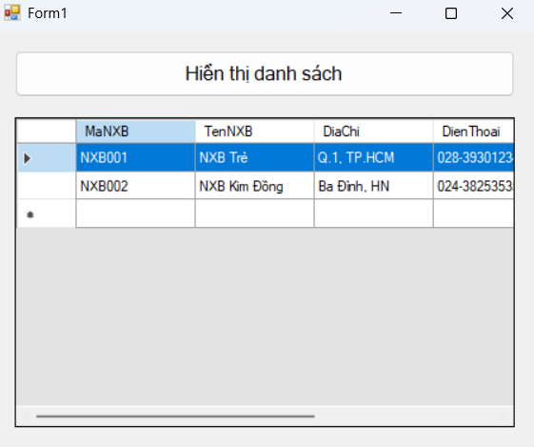
Chuỗi kết nối
@"Data Source=(LocalDB)\MSSQLLocalDB;AttachDbFilename=C:\Users\Admin\source\repos\Bai1,2\Lab7,8\Lab7,8\QuanLyBanSach.mdf;Integrated Security=True;Connect Timeout=30";
Code Form1.cs
using System;
using System.Data;
using System.Data.SqlClient;
using System.Windows.Forms;

namespace QuanLyBanSachLab7
{
public partial class FrmHienThi : Form
{
private readonly string strCon =
@"Data Source=(LocalDB)\MSSQLLocalDB;AttachDbFilename=C:\Users\Admin\source\repos\Bai1,2\Lab7,8\Lab7,8\QuanLyBanSach.mdf;Integrated Security=True;Connect Timeout=30";
private SqlConnection sqlCon = null;

public FrmHienThi() { InitializeComponent(); }

private void MoKetNoi()
{
if (sqlCon == null) sqlCon = new SqlConnection(strCon);
if (sqlCon.State == ConnectionState.Closed) sqlCon.Open();
}
private void DongKetNoi()
{
if (sqlCon != null && sqlCon.State == ConnectionState.Open) sqlCon.Close();
}

private void btnHienThi_Click(object sender, EventArgs e)
{
try
{
MoKetNoi();
string sql = "SELECT MaNXB, TenNXB, DiaChi FROM dbo.NhaXuatBan";
var adapter = new SqlDataAdapter(sql, sqlCon);
var ds = new DataSet();
adapter.Fill(ds, "tblNhaXuatBan");
dgvDanhSach.DataSource = ds.Tables["tblNhaXuatBan"];
}
catch (Exception ex)
{
MessageBox.Show("Lỗi: " + ex.Message);
}
finally { DongKetNoi(); }
}
}
}
Code Form1.Designer.cs
using System.Windows.Forms;

namespace QuanLyBanSachLab7
{
partial class FrmHienThi
{
private System.ComponentModel.IContainer components = null;
private Button btnHienThi;
private DataGridView dgvDanhSach;

protected override void Dispose(bool disposing)
{ if (disposing && (components != null)) components.Dispose(); base.Dispose(disposing); }

private void InitializeComponent()
{
this.btnHienThi = new System.Windows.Forms.Button();
this.dgvDanhSach = new System.Windows.Forms.DataGridView();
((System.ComponentModel.ISupportInitialize)(this.dgvDanhSach)).BeginInit();
this.SuspendLayout();
// btnHienThi
this.btnHienThi.Anchor = ((AnchorStyles)(((AnchorStyles.Top | AnchorStyles.Left) | AnchorStyles.Right)));
this.btnHienThi.Font = new System.Drawing.Font("Microsoft Sans Serif", 12F);
this.btnHienThi.Location = new System.Drawing.Point(36, 24);
this.btnHienThi.Name = "btnHienThi";
this.btnHienThi.Size = new System.Drawing.Size(520, 48);
this.btnHienThi.Text = "Hiển thị danh sách";
this.btnHienThi.UseVisualStyleBackColor = true;
this.btnHienThi.Click += new System.EventHandler(this.btnHienThi_Click);
// dgvDanhSach
this.dgvDanhSach.Anchor = ((AnchorStyles)((((AnchorStyles.Top | AnchorStyles.Bottom) | AnchorStyles.Left) | AnchorStyles.Right)));
this.dgvDanhSach.ColumnHeadersHeightSizeMode = DataGridViewColumnHeadersHeightSizeMode.AutoSize;
this.dgvDanhSach.Location = new System.Drawing.Point(36, 92);
this.dgvDanhSach.Size = new System.Drawing.Size(520, 320);
// FrmHienThi
this.AutoScaleDimensions = new System.Drawing.SizeF(8F, 16F);
this.ClientSize = new System.Drawing.Size(592, 438);
this.Controls.Add(this.dgvDanhSach);
this.Controls.Add(this.btnHienThi);
this.StartPosition = FormStartPosition.CenterScreen;
this.Text = "Form1";
((System.ComponentModel.ISupportInitialize)(this.dgvDanhSach)).EndInit();
this.ResumeLayout(false);
}
}
}
Thực hành 2: Thêm dữ liệu cho bảng Nhà xuất bản
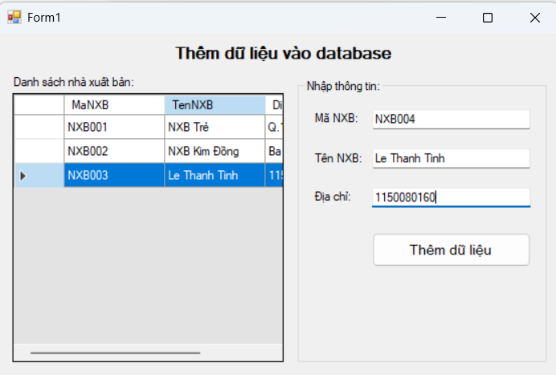
Code Form1.cs
using System;
using System.Data;
using System.Data.SqlClient;
using System.Windows.Forms;

namespace QuanLyBanSachLab7
{
public partial class FrmThem : Form
{
private readonly string strCon =
@"Data Source=(LocalDB)\MSSQLLocalDB;AttachDbFilename=C:\Users\Admin\source\repos\Bai1,2\Lab7,8\Lab7,8\QuanLyBanSach.mdf;Integrated Security=True;Connect Timeout=30";
private SqlConnection sqlCon = null;
private SqlDataAdapter adapter = null;
private DataSet ds = null;

public FrmThem() { InitializeComponent(); }

private void MoKetNoi(){ if (sqlCon == null) sqlCon = new SqlConnection(strCon); if (sqlCon.State==ConnectionState.Closed) sqlCon.Open(); }
private void DongKetNoi(){ if (sqlCon!=null && sqlCon.State==ConnectionState.Open) sqlCon.Close(); }
private void XoaDuLieuForm(){ txtMaNXB.Clear(); txtTenNXB.Clear(); txtDiaChi.Clear(); txtMaNXB.Focus(); }

private void HienThiDuLieu()
{
MoKetNoi();
string query = "SELECT MaNXB, TenNXB, DiaChi FROM dbo.NhaXuatBan";
adapter = new SqlDataAdapter(query, sqlCon);
adapter.MissingSchemaAction = MissingSchemaAction.AddWithKey;
_ = new SqlCommandBuilder(adapter);
ds = new DataSet();
adapter.Fill(ds, "tblNhaXuatBan");
dgvDanhSach.DataSource = ds.Tables["tblNhaXuatBan"];
DongKetNoi();
}

private void FrmThem_Load(object sender, EventArgs e){ HienThiDuLieu(); XoaDuLieuForm(); }

private void btnThemDL_Click(object sender, EventArgs e)
{
try
{
var ma = txtMaNXB.Text.Trim();
var ten = txtTenNXB.Text.Trim();
var dia = txtDiaChi.Text.Trim();
if (string.IsNullOrWhiteSpace(ma) || string.IsNullOrWhiteSpace(ten))
{ MessageBox.Show("Mã NXB/Tên NXB không được để trống!"); return; }
if (ma.Length != 6){ MessageBox.Show("Mã NXB phải 6 ký tự (VD: NXB001)."); return; }
if (ds.Tables["tblNhaXuatBan"].Rows.Find(ma) != null)
{ MessageBox.Show("Mã NXB đã tồn tại!"); return; }

var row = ds.Tables["tblNhaXuatBan"].NewRow();
row["MaNXB"] = ma; row["TenNXB"] = ten; row["DiaChi"] = dia;
ds.Tables["tblNhaXuatBan"].Rows.Add(row);

int kq = adapter.Update(ds.Tables["tblNhaXuatBan"]);
if (kq > 0){ MessageBox.Show("Thêm dữ liệu thành công!"); HienThiDuLieu(); XoaDuLieuForm(); }
else MessageBox.Show("Thêm dữ liệu không thành công!");
}
catch (Exception ex){ MessageBox.Show("Lỗi: " + ex.Message); }
}
}
}
Code Form1.Designer.cs
using System.Windows.Forms;

namespace QuanLyBanSachLab7
{
partial class FrmThem
{
private System.ComponentModel.IContainer components = null;
private Label lblList; private DataGridView dgvDanhSach;
private GroupBox grpNhap; private Label lblMa; private Label lblTen; private Label lblDiaChi;
private TextBox txtMaNXB; private TextBox txtTenNXB; private TextBox txtDiaChi;
private Button btnThemDL; private Label lblTitle;

protected override void Dispose(bool disposing){ if (disposing && (components!=null)) components.Dispose(); base.Dispose(disposing); }

private void InitializeComponent()
{
this.lblTitle = new System.Windows.Forms.Label();
this.lblList = new System.Windows.Forms.Label();
this.dgvDanhSach = new System.Windows.Forms.DataGridView();
this.grpNhap = new System.Windows.Forms.GroupBox();
this.lblMa = new System.Windows.Forms.Label();
this.lblTen = new System.Windows.Forms.Label();
this.lblDiaChi = new System.Windows.Forms.Label();
this.txtMaNXB = new System.Windows.Forms.TextBox();
this.txtTenNXB = new System.Windows.Forms.TextBox();
this.txtDiaChi = new System.Windows.Forms.TextBox();
this.btnThemDL = new System.Windows.Forms.Button();
((System.ComponentModel.ISupportInitialize)(this.dgvDanhSach)).BeginInit();
this.grpNhap.SuspendLayout();
this.SuspendLayout();
// lblTitle
this.lblTitle.Anchor = System.Windows.Forms.AnchorStyles.Top;
this.lblTitle.AutoSize = true; this.lblTitle.Font = new System.Drawing.Font("Microsoft Sans Serif", 12F, System.Drawing.FontStyle.Bold);
this.lblTitle.Location = new System.Drawing.Point(220, 10); this.lblTitle.Text = "Thêm dữ liệu vào database";
// lblList
this.lblList.AutoSize = true; this.lblList.Location = new System.Drawing.Point(16, 48); this.lblList.Text = "Danh sách nhà xuất bản:";
// dgvDanhSach
this.dgvDanhSach.Location = new System.Drawing.Point(19, 70); this.dgvDanhSach.Size = new System.Drawing.Size(360, 320);
this.dgvDanhSach.ReadOnly = true; this.dgvDanhSach.SelectionMode = DataGridViewSelectionMode.FullRowSelect;
// grpNhap
this.grpNhap.Controls.Add(this.lblMa); this.grpNhap.Controls.Add(this.lblTen); this.grpNhap.Controls.Add(this.lblDiaChi);
this.grpNhap.Controls.Add(this.txtMaNXB); this.grpNhap.Controls.Add(this.txtTenNXB); this.grpNhap.Controls.Add(this.txtDiaChi);
this.grpNhap.Controls.Add(this.btnThemDL);
this.grpNhap.Location = new System.Drawing.Point(400, 52); this.grpNhap.Size = new System.Drawing.Size(330, 338); this.grpNhap.Text = "Nhập thông tin:";
// labels + inputs
this.lblMa.AutoSize = true; this.lblMa.Location = new System.Drawing.Point(18, 38); this.lblMa.Text = "Mã NXB:";
this.lblTen.AutoSize = true; this.lblTen.Location = new System.Drawing.Point(18, 86); this.lblTen.Text = "Tên NXB:";
this.lblDiaChi.AutoSize = true; this.lblDiaChi.Location = new System.Drawing.Point(18, 134); this.lblDiaChi.Text = "Địa chỉ:";
this.txtMaNXB.Location = new System.Drawing.Point(98, 35); this.txtMaNXB.MaxLength = 6; this.txtMaNXB.Size = new System.Drawing.Size(210, 22);
this.txtTenNXB.Location = new System.Drawing.Point(98, 83); this.txtTenNXB.Size = new System.Drawing.Size(210, 22);
this.txtDiaChi.Location = new System.Drawing.Point(98, 131); this.txtDiaChi.Size = new System.Drawing.Size(210, 22);
// btnThemDL
this.btnThemDL.Font = new System.Drawing.Font("Microsoft Sans Serif", 10F);
this.btnThemDL.Location = new System.Drawing.Point(98, 188); this.btnThemDL.Size = new System.Drawing.Size(210, 42);
this.btnThemDL.Text = "Thêm dữ liệu"; this.btnThemDL.Click += new System.EventHandler(this.btnThemDL_Click);
// FrmThem
this.ClientSize = new System.Drawing.Size(752, 410);
this.Controls.Add(this.grpNhap); this.Controls.Add(this.dgvDanhSach); this.Controls.Add(this.lblList); this.Controls.Add(this.lblTitle);
this.StartPosition = FormStartPosition.CenterScreen; this.Text = "Form1";
this.Load += new System.EventHandler(this.FrmThem_Load);
((System.ComponentModel.ISupportInitialize)(this.dgvDanhSach)).EndInit(); this.grpNhap.ResumeLayout(false); this.grpNhap.PerformLayout();
this.ResumeLayout(false); this.PerformLayout();
}
}
}
Thực hành 3: Cập nhật dữ liệu cho bảng Nhà xuất bản
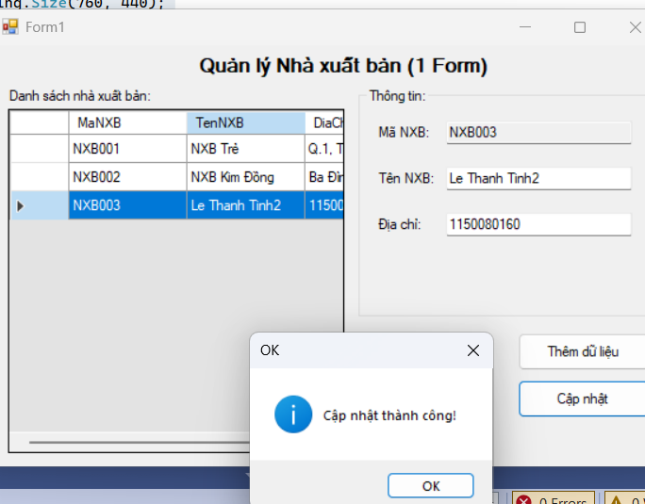
Code Form1.cs
using System;
using System.Data;
using System.Data.SqlClient;
using System.Windows.Forms;

namespace QuanLyBanSachLab7
{
public partial class FrmCapNhat : Form
{
private readonly string strCon =
@"Data Source=(LocalDB)\MSSQLLocalDB;AttachDbFilename=C:\Users\Admin\source\repos\Bai1,2\Lab7,8\Lab7,8\QuanLyBanSach.mdf;Integrated Security=True;Connect Timeout=30";
private SqlConnection sqlCon = null;
private SqlDataAdapter adapter = null;
private DataSet ds = null;

public FrmCapNhat() { InitializeComponent(); }

private void MoKetNoi(){ if (sqlCon==null) sqlCon=new SqlConnection(strCon); if (sqlCon.State==ConnectionState.Closed) sqlCon.Open(); }
private void DongKetNoi(){ if (sqlCon!=null && sqlCon.State==ConnectionState.Open) sqlCon.Close(); }

private void HienThiDuLieu()
{
MoKetNoi();
string query = "SELECT MaNXB, TenNXB, DiaChi FROM dbo.NhaXuatBan";
adapter = new SqlDataAdapter(query, sqlCon);
adapter.MissingSchemaAction = MissingSchemaAction.AddWithKey;
_ = new SqlCommandBuilder(adapter);
ds = new DataSet();
adapter.Fill(ds, "tblNhaXuatBan");
if (ds.Tables["tblNhaXuatBan"].PrimaryKey.Length==0)
ds.Tables["tblNhaXuatBan"].PrimaryKey = new[] { ds.Tables["tblNhaXuatBan"].Columns["MaNXB"] };
dgvDanhSach.DataSource = ds.Tables["tblNhaXuatBan"];
DongKetNoi();
txtMaNXB.ReadOnly = true;
}

private void FrmCapNhat_Load(object sender, EventArgs e){ HienThiDuLieu(); }

private void dgvDanhSach_CellClick(object sender, DataGridViewCellEventArgs e)
{
if (e.RowIndex < 0) return;
var ma = dgvDanhSach.Rows[e.RowIndex].Cells["MaNXB"].Value?.ToString();
if (string.IsNullOrWhiteSpace(ma)) return;
var dr = ds.Tables["tblNhaXuatBan"].Rows.Find(ma);
if (dr == null) return;
txtMaNXB.Text = dr["MaNXB"].ToString().Trim();
txtTenNXB.Text = dr["TenNXB"]?.ToString().Trim();
txtDiaChi.Text = dr["DiaChi"]?.ToString().Trim();
}

private void btnChinhSuaThongTin_Click(object sender, EventArgs e)
{
try
{
var ma = txtMaNXB.Text.Trim();
var ten = txtTenNXB.Text.Trim();
var dia = txtDiaChi.Text.Trim();
if (string.IsNullOrWhiteSpace(ma)){ MessageBox.Show("Chọn một dòng trước khi sửa!"); return; }
if (string.IsNullOrWhiteSpace(ten)){ MessageBox.Show("Tên NXB không được để trống!"); return; }

var dr = ds.Tables["tblNhaXuatBan"].Rows.Find(ma);
if (dr == null) { MessageBox.Show("Không tìm thấy bản ghi!"); return; }

dr.BeginEdit(); dr["TenNXB"]=ten; dr["DiaChi"]=dia; dr.EndEdit();
int kq = adapter.Update(ds.Tables["tblNhaXuatBan"]);
if (kq>0){ MessageBox.Show("Chỉnh sửa dữ liệu thành công!"); HienThiDuLieu(); txtTenNXB.Focus(); }
else MessageBox.Show("Chỉnh sửa dữ liệu không thành công!");
}
catch (Exception ex){ MessageBox.Show("Lỗi: " + ex.Message); }
}
}
}
Code Form1.Designer.cs
using System.Windows.Forms;

namespace QuanLyBanSachLab7
{
partial class FrmCapNhat
{
private System.ComponentModel.IContainer components = null;
private Label lblTitle, lblList;
private DataGridView dgvDanhSach;
private GroupBox grpChinhSua;
private Label lblMa, lblTen, lblDiaChi;
private TextBox txtMaNXB, txtTenNXB, txtDiaChi;
private Button btnChinhSuaThongTin;

protected override void Dispose(bool disposing){ if (disposing && (components!=null)) components.Dispose(); base.Dispose(disposing); }

private void InitializeComponent()
{
this.lblTitle = new Label(); this.lblList = new Label();
this.dgvDanhSach = new DataGridView(); this.grpChinhSua = new GroupBox();
this.lblMa = new Label(); this.lblTen = new Label(); this.lblDiaChi = new Label();
this.txtMaNXB = new TextBox(); this.txtTenNXB = new TextBox(); this.txtDiaChi = new TextBox();
this.btnChinhSuaThongTin = new Button();
((System.ComponentModel.ISupportInitialize)(this.dgvDanhSach)).BeginInit(); this.grpChinhSua.SuspendLayout(); this.SuspendLayout();
// lblTitle
this.lblTitle.Anchor = AnchorStyles.Top; this.lblTitle.AutoSize = true;
this.lblTitle.Font = new System.Drawing.Font("Microsoft Sans Serif", 12F, System.Drawing.FontStyle.Bold);
this.lblTitle.Location = new System.Drawing.Point(230, 10); this.lblTitle.Text = "Chỉnh sửa thông tin dữ liệu";
// lblList
this.lblList.AutoSize = true; this.lblList.Location = new System.Drawing.Point(16, 48); this.lblList.Text = "Danh sách nhà xuất bản:";
// dgv
this.dgvDanhSach.Location = new System.Drawing.Point(19, 70); this.dgvDanhSach.Size = new System.Drawing.Size(360, 320);
this.dgvDanhSach.ReadOnly = true; this.dgvDanhSach.SelectionMode = DataGridViewSelectionMode.FullRowSelect;
this.dgvDanhSach.CellClick += new DataGridViewCellEventHandler(this.dgvDanhSach_CellClick);
// group
this.grpChinhSua.Text = "Chỉnh sửa thông tin:"; this.grpChinhSua.Location = new System.Drawing.Point(400, 52); this.grpChinhSua.Size = new System.Drawing.Size(330, 338);
// labels + inputs
this.lblMa.AutoSize = true; this.lblMa.Location = new System.Drawing.Point(18, 38); this.lblMa.Text = "Mã NXB:";
this.lblTen.AutoSize = true; this.lblTen.Location = new System.Drawing.Point(18, 86); this.lblTen.Text = "Tên NXB:";
this.lblDiaChi.AutoSize = true; this.lblDiaChi.Location = new System.Drawing.Point(18, 134); this.lblDiaChi.Text = "Địa chỉ:";
this.txtMaNXB.Location = new System.Drawing.Point(98, 35); this.txtMaNXB.MaxLength = 6; this.txtMaNXB.ReadOnly = true; this.txtMaNXB.Size = new System.Drawing.Size(210,22);
this.txtTenNXB.Location = new System.Drawing.Point(98,83); this.txtTenNXB.Size = new System.Drawing.Size(210,22);
this.txtDiaChi.Location = new System.Drawing.Point(98,131); this.txtDiaChi.Size = new System.Drawing.Size(210,22);
// button
this.btnChinhSuaThongTin.Font = new System.Drawing.Font("Microsoft Sans Serif", 10F);
this.btnChinhSuaThongTin.Location = new System.Drawing.Point(98, 188); this.btnChinhSuaThongTin.Size = new System.Drawing.Size(210,42);
this.btnChinhSuaThongTin.Text = "Chỉnh sửa thông tin";
this.btnChinhSuaThongTin.Click += new EventHandler(this.btnChinhSuaThongTin_Click);
// add to group
this.grpChinhSua.Controls.Add(this.lblMa); this.grpChinhSua.Controls.Add(this.lblTen); this.grpChinhSua.Controls.Add(this.lblDiaChi);
this.grpChinhSua.Controls.Add(this.txtMaNXB); this.grpChinhSua.Controls.Add(this.txtTenNXB); this.grpChinhSua.Controls.Add(this.txtDiaChi);
this.grpChinhSua.Controls.Add(this.btnChinhSuaThongTin);
// form
this.ClientSize = new System.Drawing.Size(752, 410);
this.Controls.Add(this.grpChinhSua); this.Controls.Add(this.dgvDanhSach); this.Controls.Add(this.lblList); this.Controls.Add(this.lblTitle);
this.StartPosition = FormStartPosition.CenterScreen; this.Text = "Form1";
this.Load += new EventHandler(this.FrmCapNhat_Load);
((System.ComponentModel.ISupportInitialize)(this.dgvDanhSach)).EndInit(); this.grpChinhSua.ResumeLayout(false); this.grpChinhSua.PerformLayout();
this.ResumeLayout(false); this.PerformLayout();
}
}
}
Thực hành 4: Xóa dữ liệu cho bảng Nhà xuất bản
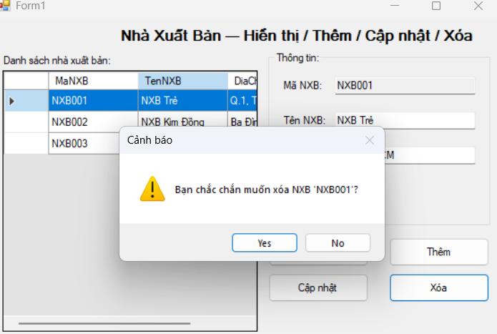
Code Form1.cs
using System;
using System.Data;
using System.Data.SqlClient;
using System.Windows.Forms;

namespace QuanLyBanSachLab7
{
public partial class FrmXoa : Form
{
private readonly string strCon =
@"Data Source=(LocalDB)\MSSQLLocalDB;AttachDbFilename=C:\Users\Admin\source\repos\Bai1,2\Lab7,8\Lab7,8\QuanLyBanSach.mdf;Integrated Security=True;Connect Timeout=30";
private SqlConnection sqlCon = null;
private SqlDataAdapter adapter = null;
private DataSet ds = null;
private int vt = -1;

public FrmXoa() { InitializeComponent(); }

private void MoKetNoi(){ if (sqlCon==null) sqlCon=new SqlConnection(strCon); if (sqlCon.State==ConnectionState.Closed) sqlCon.Open(); }
private void DongKetNoi(){ if (sqlCon!=null && sqlCon.State==ConnectionState.Open) sqlCon.Close(); }

private void HienThiDuLieu()
{
MoKetNoi();
string query = "SELECT MaNXB, TenNXB, DiaChi FROM dbo.NhaXuatBan";
adapter = new SqlDataAdapter(query, sqlCon);
adapter.MissingSchemaAction = MissingSchemaAction.AddWithKey;
_ = new SqlCommandBuilder(adapter);
ds = new DataSet();
adapter.Fill(ds, "tblNhaXuatBan");
dgvDanhSach.DataSource = ds.Tables["tblNhaXuatBan"];
DongKetNoi();
}

private void FrmXoa_Load(object sender, EventArgs e){ HienThiDuLieu(); }

private void dgvDanhSach_CellClick(object sender, DataGridViewCellEventArgs e)
{ vt = e.RowIndex; }

private void btnXoaDuLieu_Click(object sender, EventArgs e)
{
if (vt == -1){ MessageBox.Show("Bạn chưa chọn dữ liệu để xóa!"); return; }

var result = MessageBox.Show("Bạn có thực sự muốn xóa hay không?",
"Cảnh báo", MessageBoxButtons.YesNo, MessageBoxIcon.Warning);
if (result != DialogResult.Yes) return;

try
{
DataRow row = ds.Tables["tblNhaXuatBan"].Rows[vt];
row.Delete();
int kq = adapter.Update(ds.Tables["tblNhaXuatBan"]);
if (kq > 0){ MessageBox.Show("Xóa dữ liệu thành công!"); HienThiDuLieu(); vt = -1; }
else MessageBox.Show("Xóa dữ liệu không thành công!");
}
catch (SqlException ex){ MessageBox.Show("SQL error: " + ex.Message); }
catch (Exception ex){ MessageBox.Show("Lỗi: " + ex.Message); }
}
}
}
Code Form1.Designer.cs
using System.Windows.Forms;

namespace QuanLyBanSachLab7
{
partial class FrmXoa
{
private System.ComponentModel.IContainer components = null;
private Label lblTitle, lblList;
private DataGridView dgvDanhSach;
private Button btnXoaDuLieu;

protected override void Dispose(bool disposing){ if (disposing && (components!=null)) components.Dispose(); base.Dispose(disposing); }

private void InitializeComponent()
{
this.lblTitle = new Label(); this.lblList = new Label();
this.dgvDanhSach = new DataGridView(); this.btnXoaDuLieu = new Button();
((System.ComponentModel.ISupportInitialize)(this.dgvDanhSach)).BeginInit(); this.SuspendLayout();
// lblTitle
this.lblTitle.Anchor = AnchorStyles.Top; this.lblTitle.AutoSize = true;
this.lblTitle.Font = new System.Drawing.Font("Microsoft Sans Serif", 12F, System.Drawing.FontStyle.Bold);
this.lblTitle.Location = new System.Drawing.Point(240, 10); this.lblTitle.Text = "Xóa dữ liệu trong database";
// lblList
this.lblList.AutoSize = true; this.lblList.Location = new System.Drawing.Point(16, 48); this.lblList.Text = "Danh sách nhà xuất bản:";
// dgv
this.dgvDanhSach.Location = new System.Drawing.Point(19, 70); this.dgvDanhSach.Size = new System.Drawing.Size(600, 260);
this.dgvDanhSach.ReadOnly = true; this.dgvDanhSach.SelectionMode = DataGridViewSelectionMode.FullRowSelect;
this.dgvDanhSach.CellClick += new DataGridViewCellEventHandler(this.dgvDanhSach_CellClick);
// btnXoa
this.btnXoaDuLieu.Font = new System.Drawing.Font("Microsoft Sans Serif", 10F);
this.btnXoaDuLieu.Location = new System.Drawing.Point(210, 350); this.btnXoaDuLieu.Size = new System.Drawing.Size(220, 44);
this.btnXoaDuLieu.Text = "Xóa dữ liệu";
this.btnXoaDuLieu.Click += new System.EventHandler(this.btnXoaDuLieu_Click);
// form
this.ClientSize = new System.Drawing.Size(640, 410);
this.Controls.Add(this.btnXoaDuLieu); this.Controls.Add(this.dgvDanhSach); this.Controls.Add(this.lblList); this.Controls.Add(this.lblTitle);
this.StartPosition = FormStartPosition.CenterScreen; this.Text = "Form1";
this.Load += new System.EventHandler(this.FrmXoa_Load);
((System.ComponentModel.ISupportInitialize)(this.dgvDanhSach)).EndInit(); this.ResumeLayout(false); this.PerformLayout();
}
}
}
LAB 8:
IN ẤN DỮ LIỆU
A. Mục tiêu
− Hướng dẫn sinh viên xây dựng chương trình Windows Form có tương tác
với cơ sở dữ liệu.
− Hướng dẫn làm quen môi trường lập trình C# với phần mềm Microsoft
Visual Studio 2022.
− Hướng dẫn sinh viên cách thiết kế trang in ấn dữ liệu với tiện ích của
Microsoft trên Visual Studio 2022.
B. Nội dung
Thực hành 1: Cài đặt tiện tích Report Viewer trên Visual Studio 2022.
− Thêm Extensions Reporting.
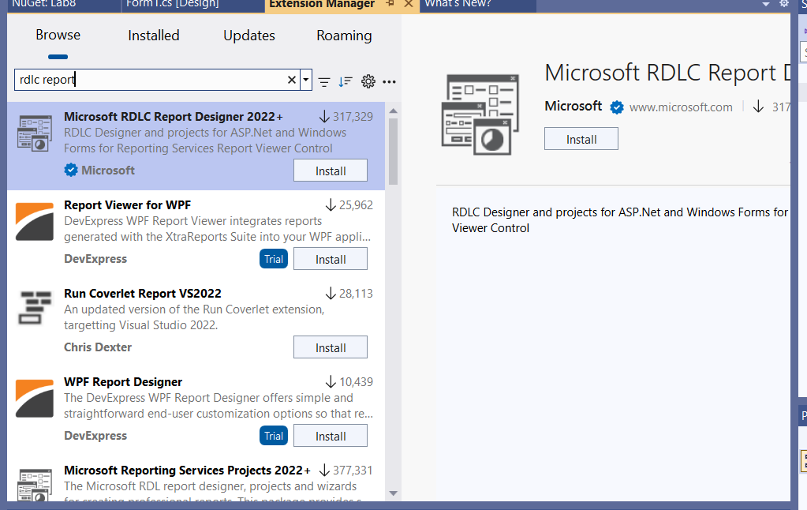
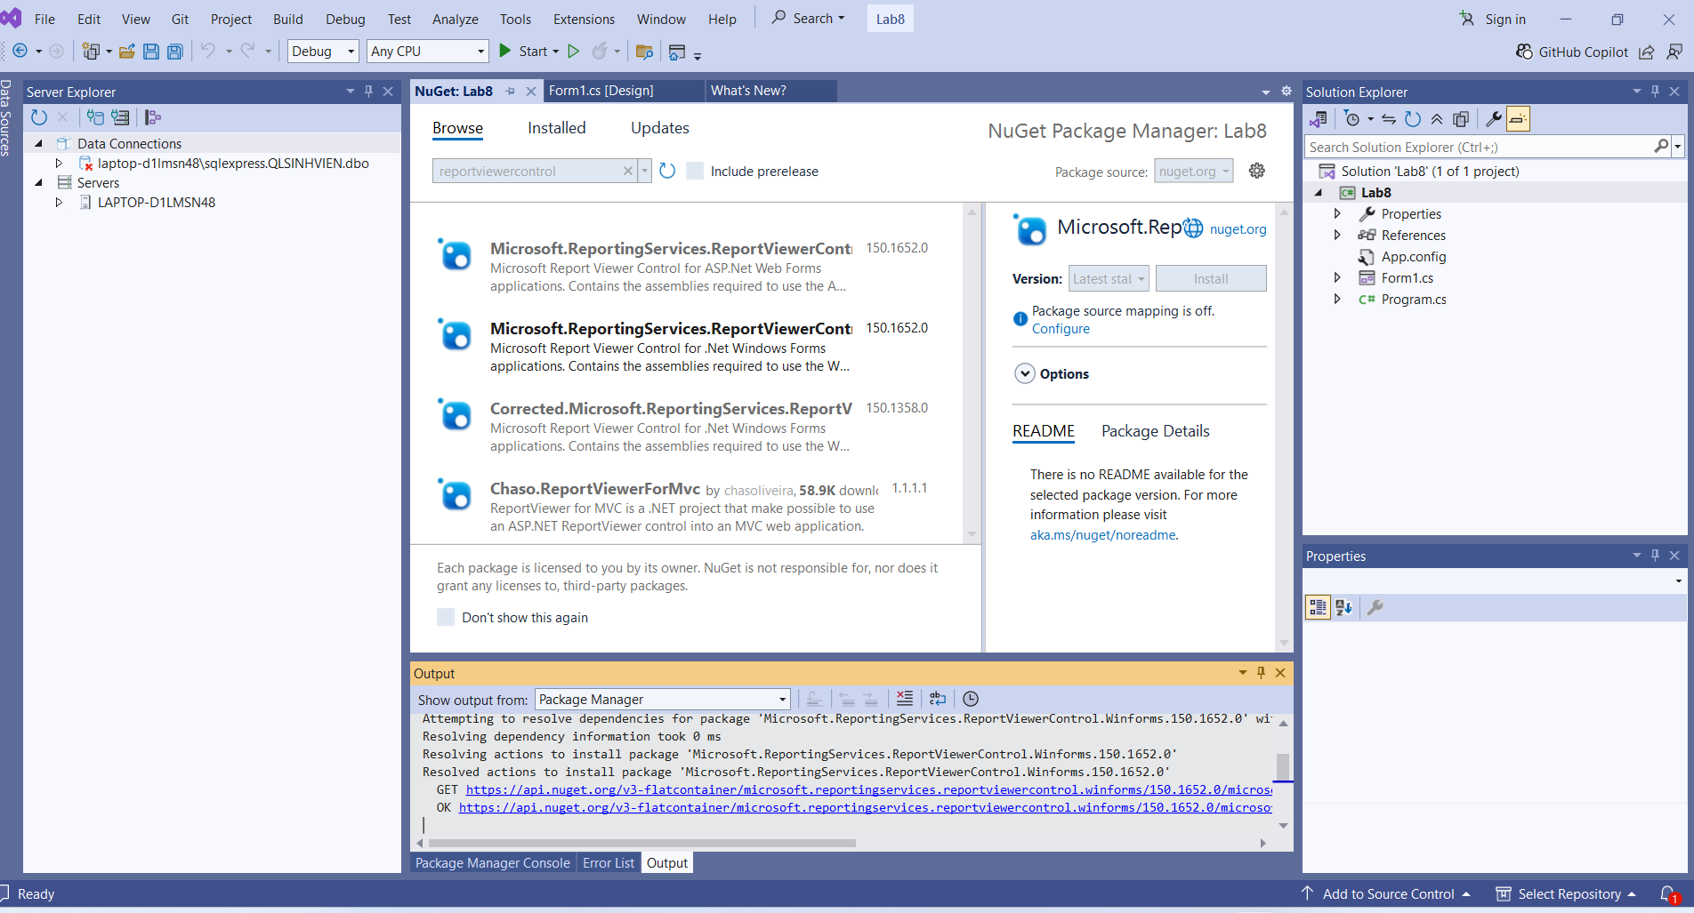
Thực hành 2: Thiết kế trang báo cáo danh sách các sinh viên được lưu trong
CSDL Quản lý sinh viên.
− Thêm control Report Viewer từ Toolbox vào form.
− Thêm Item DataSet vào project. Sau đó đổi tên của DataSet thành
dsSinhVien.xsd.
− Chuột phải vào vùng thiết kế DataSet, chọn Add > DataTable ...

