**Infinite Scroll**

**Problem description:** Infinite scrolling is a design technique that loads more content as you scroll. It allows a user to scroll indefinitely as long as there is more data to render.

**Assignment:** Please develop a single web page that implements an infinite scroll. Your page may use html, css, javascript, and any additional libraries or files necessary. Pseudo code is acceptable. Upload your project content to github and provide a link for accessing it. The following is example of a page that will keep rendering more colored boxes as you scroll.

**Example:**

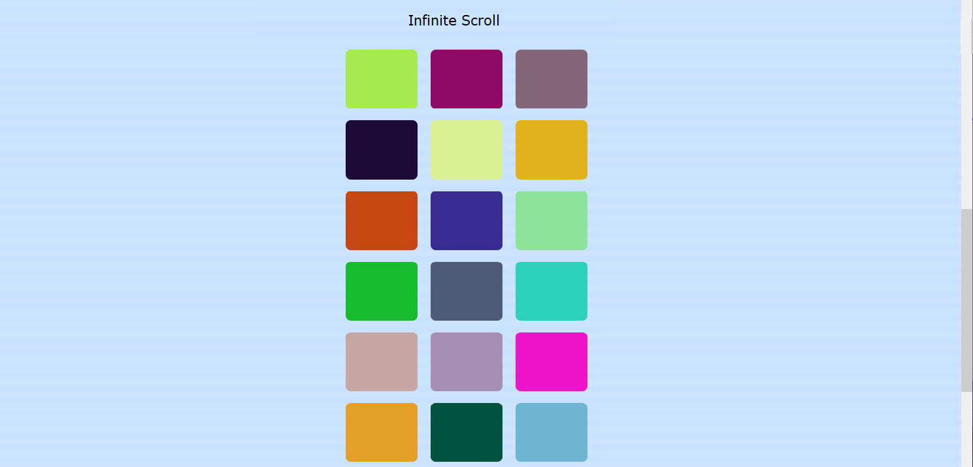

**Evaluation:** We are interested in your thought process and how you go about problem solving. Be prepared to discuss what you did, how you did it, and why it was done that way. Below are a handful of the type of questions you may be asked regarding your work:

* How would you approach this type of task working with a team of software engineers?
* Compare and contrast an infinite scroll design versus alternatives and when you may choose one over another.
* If this page were part of a web application accessible to a lot of users, how might it be improved to handle the additional load on it?
* Bugs happen! How might you code to facilitate debugging when bugs occur in production and testing?