
Nottingham Trent University
School of Science and Technology

Client based Mobile app that fetches data from a webserver
BY
Antoan Bachev
In
2025
Project report in part fulfilment of the requirements for the degree of Bachelor of Science with Honours in Computing

Student ID: N1112540
Date: 18th dec 2025
COMP30151: Project 202021 Full Year

ABSTRACT
Accessible and effective battery lookup service solutions are in high demand because to the growing dependence on mobile applications for auto maintenance. Although there are web-based tools for getting battery data, there aren't many specific iOS apps that provide real-time access to this information. By creating an iOS application that connects to an external API to supply vehicle battery specifications via license plate search, this project fills this gap.

This project's main goal is to create an intuitive mobile application that will allow iOS users to easily view battery information. Data from ukvehicledata.co.uk is retrieved by the application via a RESTful API hosted on Apache Tomee. The backend, which was created in Java and is hosted by Tomcat, handles API requests and provides pertinent battery information in JSON format. The project guarantees the seamless integration of these technologies while upholding industry best practices for mobile app development and API connection.

During the development process, a number of difficulties arose, such as setting up Tomcat, adjusting to Swift programming, and overcoming API key limitations brought on by restricted trial access. By using several Tomcat setups, getting a confirmed API key from the project sponsor, and getting help from the project supervisor, these issues were resolved.

The technical implementation, difficulties faced, and solutions used are all thoroughly examined in this study. Additionally, it examines professional, ethical, social, and legal issues, especially as they pertain to responsible software development, data protection, and API compliance. By proving that real-time vehicle battery lookup on iOS is feasible, the project's output lays the groundwork for future improvements including user identification, search history storage, and interaction with e-commerce platforms for direct battery purchases.

Acknowledgements

I want to express my gratitude to Dr. Robert Ranson for his ongoing encouragement and support, as well as to my project supervisor, Dr. Evtim Peytchev, for his outstanding help and direction during the course of my research. Additionally, I want to express my gratitude to Mr. Benjamin Ward for helping to provide the hardware needed to complete this project.

TABLE OF CONTENTS
ABSTRACT...............................................................................................II
ACKNOWLEDGEMENTS...........................................................................III
TABLE OF CONTENTS..............................................................................IV
LIST OF FIGURES....................................................................................VI
LIST OF TABLES.....................................................................................VII
CHAPTER 1...............................................................................................1
INTRODUCTION........................................................................................1
1.1 Introduction...................................................................................1
1.2 Prepare Your Report.......................................................................2
1.3 Heading Styles................................................................................3
1.3.1 Numbering of Headings................................................................3
1.4 Document Paragraphs....................................................................3
1.4.1 First Paragraph Following a Heading...............................................3
CHAPTER 2...............................................................................................4
CONTEXT..................................................................................................4
2.1 Introduction...................................................................................4
2.2 Insert Pictures................................................................................4
2.3 Insert Tables..................................................................................5
CHAPTER 3...............................................................................................6
NEW IDEAS...............................................................................................6
3.1 Introduction...................................................................................6
CHAPTER 4...............................................................................................8
IMPLEMENTATION OR INVESTIGATION....................................................8
4.1 Introduction...................................................................................8
CHAPTER 5.............................................................................................10
RESULTS / DISCUSSION.........................................................................10
5.1 Introduction.................................................................................10
CHAPTER 6.............................................................................................11
CONCLUSIONS / FUTURE WORK.............................................................11
6.1 Conclusions..................................................................................11
6.2 Future work..................................................................................11
6.3 Legal, Social, Ethical and Professional Issues...............................11
6.4 Synoptic Reflections.....................................................................11
REFERENCES...........................................................................................12
APPENDIX A...........................................................................................14
Note: To insert TOC here follow the instruction below. You may also right click
on the above text and use “Update Field” to update the TOC.
Insert > Reference > Index and Tables ... > Table of Contents

LIST OF FIGURES
Figure 1: NTU Logo...................................................................................5
Note: To insert List of Figures here follow the instruction below. You may also
right click on the above text and use “Update Field” to update the list of figures.
Insert > Reference > Index and Tables ... > Table of Figures > Caption Label
=> Figure
vi

LIST OF TABLES
Table 1: Microsoft Office............................................................................5
Note: To insert List of Tables here follow the instruction below. You may also
right click on the above text and use “Update Field” to update the list of tables.
Insert > Reference > Index and Tables ... > Table of Figures > Caption Label
=> Table
vii

CHAPTER 1: INTRODUCTION

1.1 Overview

For car owners, mechanics, and automotive companies who need fast and precise battery compatibility information, battery lookup solutions are vital resources. There is currently a gap in accessibility for iOS users as the majority of battery lookup options are web-based or exclusive to Android applications. By creating an iOS application that enables users to obtain battery specifications with just a vehicle's license plate number, this initiative seeks to close that gap.

Current alternatives, like third-party web services, dealership lookup tools, and manufacturer websites, provide comparable capabilities but frequently call for human entry of car information, which adds time to the process. Furthermore, some platforms are not optimized for mobile devices, which restricts their usability for mechanics or users who require access while on the road. This project uses a mobile-first strategy that connects directly with an API to improve battery lookup services' usability and accessibility.

Using license plate lookups, the application obtains information from ukvehicledata.co.uk, a third-party source that provides vehicle battery information. For greater accessibility, the API will be made available online after being locally hosted with Apache Tomee. The most current and accurate information is provided to consumers through the integration of a real-time RESTful API.

It is expected that this solution will mostly help battery dealers, technicians, and others who need quick and accurate battery lookup information, even if no primary research or case studies have been done because of the nature of the project. There is a real need for such a tool in specialized industries, as indicated by the project sponsor's unique need for this application.

This project adds to the increasing need for effective, mobile-based car maintenance tools by evaluating current options, putting in place a mobile-friendly design, and guaranteeing real-time API access. The development process, difficulties encountered, and technical solutions used to realize this idea will be described in the upcoming chapters.

Chapter 2: Requirements analysis and summary of the client meeting

2.1 Overview

The project's goal is to create a mobile application that makes replacing a car battery easier and gives users a quick and easy way to look for, confirm, and schedule battery-related services. The main features and business logic of the application were thoroughly examined after a thorough customer conference on April 13, 2025. The requirements, expectations, and agreed-upon technical and design factors are described in this chapter.

2.2 The Application's Goal

The application's primary goal is to serve as a direct line of communication between users and the client, who offers jump start and car battery replacement services. Customers whose car batteries may need to be replaced, have failed, or are in poor condition are the target audience for the app. The consumer is guaranteed flexibility and convenience as the client offers a rapid response service with a usual turnaround time of 30 to 60 minutes.

In addition to being a booking system, the app also functions as an educational tool where users can determine service availability, select suitable batteries, and comprehend transactional policies.

2.3 Necessary Functions
A thorough list of functional requirements obtained during the customer consultation is provided below:

A prerequisite | An explanation
Search for License Plates | The application uses an external API to retrieve battery compatibility information when the user inputs their vehicle's registration number (VRM).
Support for Stop/Start Batteries | Support for start-stop technology, which is prevalent in contemporary cars, must be included in battery compatibility assessments.
Agreement on Policy | The user must accept the terms of service, which are prominently displayed and specify that service fees are non-refundable, prior to making any reservations.
Notice of Non-Refundable Charges | It is made clear that there is a non-refundable callout cost for the service once it is scheduled.
Payment Following Battery Selection | After the battery has been chosen and its compatibility confirmed, payment must be made.
Availability of Postcode Services | To confirm that they are within a 15-mile radius of the main service area (NG41SA), users must provide their postcode. They will be taken to a call-to-book option otherwise.
Verification of Users | Users must provide their contact information before confirming a reservation, and having the phone number visible is crucial for support.
Verification of Battery Compatibility | To prevent bookings that don't match, the app must confirm that the chosen battery meets the requirements of the car.
Service Promise | Depending on the battery model, replacement services should come with a warranty of two to three years.
Commitment to Service Speed | The promise of same-day service, which is usually finished in 30 to 60 minutes, should be highlighted in the app.
Health Examination | Users must have access to an optional battery and alternator health check.
Option for Jump Start | As an alternative, a jump start-only service should be provided, with prices starting at £35.
Battery User Interface Animatio | To graphically depict battery life or state during lookup or processing, use animated graphics.

2.4 Non-Functional Requirements
A prerequisite | An explanation
Performance | The application should react to data fetches in three seconds and provide seamless user interface changes.
Awareness of Location | If the user is outside the service region, the app must have conditional user interface (UI) and location-based access controls to prevent booking.
Payment & Security | PCI-compliant systems, like Apple Pay or Stripe, must be used to handle payments securely.
Optimization for Mobile | The application needs to be developed with a mobile-first strategy, with SwiftUI specifically tailored for iOS.
Privacy of Data | The GDPR or similar data protection laws must be followed when handling any user data, particularly location and contact details.

2.5 A Look at UI and UX
The customer has asked for a design that reflects the style and aesthetic of the popular UK breakdown service RAC.co.uk. The following priorities for design were determined:
Using rounded corners, shadows, and fluid transitions for buttons and text fields are examples of modern user interface elements.
Add a navigation bar at the bottom that provides access to the Home and History views.
Visual Feedback: Utilizing loading indications and animations (such as animated battery status).
Soft greys, whites, and blues make up the brand's aesthetic, which conveys a polished, tech-savvy image.
Background Design: To increase user interest, steer clear of plain or white screens and instead utilize subdued background colors or visual textures.
Card Layouts: For improved clarity and separation, use card-based user interface components to display technical information, service policies, and battery results.
3.6 Final Thoughts
The main goals and functional flow of the application have been effectively established at this discussion. The app is positioned to serve as an efficient tool for matching consumers in need of immediate battery replacement services with a reliable provider because it places a high priority on speed, ease of use, and professional service presentation. Based on this comprehensive definition, the following phase of development will concentrate on feature integration, user flow design, and UI implementation.

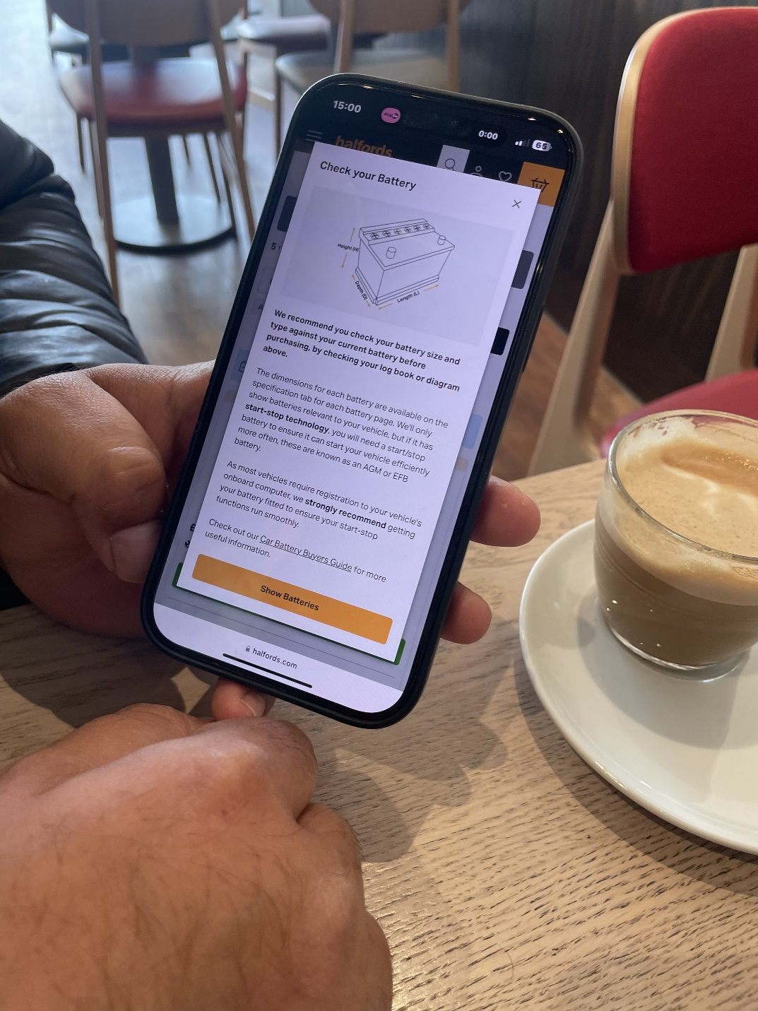
Annotation of Image 1: Phone Interface Illustration

The client is shown holding a mobile phone in this picture, which displays the "Check your Battery" page from the Halfords website. Customers may identify their battery type with the help of the visual guide, which contains battery dimensions and a diagram.

The purpose of this screenshot was to highlight the significance of helping users identify the type of automobile battery during our client conference. The client pointed out that the app ought to have a comparable informational part or user interface prompt, perhaps with images, so that users can verify that the battery fits correctly before making a purchase. This lowers the possibility of service request problems and boosts client confidence.

Takeaway: To improve user decision-making and emulate well-known, reliable platforms like Halfords, an easy-to-use, educational battery checking tool should be integrated into the app, possibly with illustrations or logbook prompts.
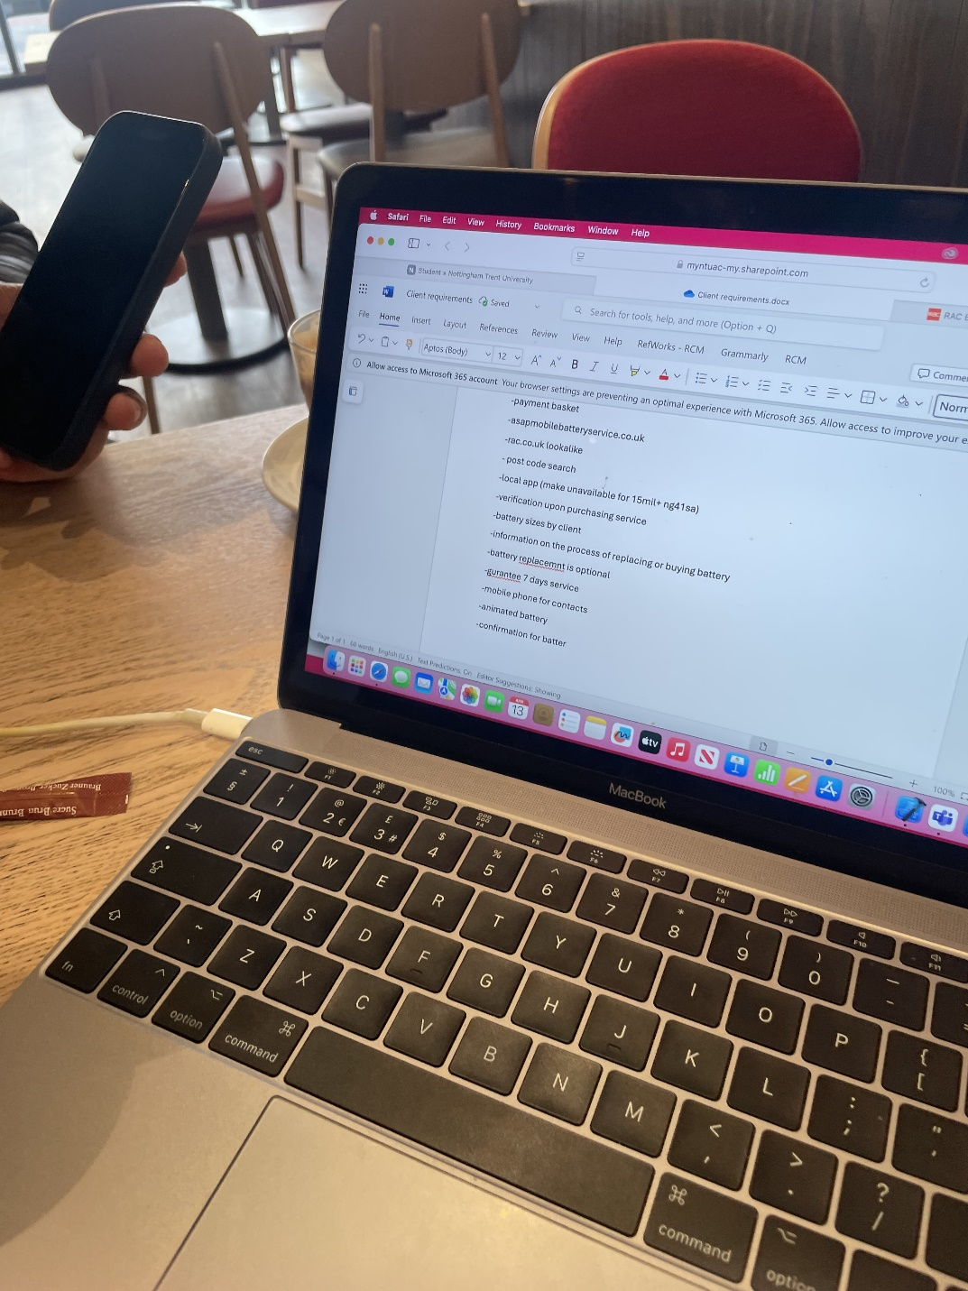
Image 2: Requirement Documentation Session Annotation

Image Description: This picture shows a client's input being recorded on a MacBook during an active conference. The screen shows a Word document called "Client requirements.docx" that lists the main requirements for the application, such as prompts for policy agreements, postcode-based service availability, and design inspiration from rac.co.uk.

Goal in Context: This instance illustrates the cooperative procedure of directly obtaining feature requirements from the customer. It illustrates how crucial in-person feedback is to comprehending the end-user experience and service workflow. The picture displays the thorough notes being made in real time to guide the development of the program in the future.

Conclusion: Stakeholder input has a noteworthy influence on the development. The client's notes provide as a design for the app's essential functions, including location filtering, verification procedures, policy acknowledgment, and UI/UX cues.

2.2.1 Case Study: Replacing a Mobile Car Battery

Additionally, Mobile Car Battery Replacement (https://mobilecarbatteryreplacement.co.uk/#services) was highlighted by the client as an example of how to market his own service online. The Services part of the website explicitly lists services (such as "Battery Replacement," "Jump Start," and "Health Check") with:

- prominent service cards with short descriptions and symbols
- A persistent "Call Now" call-to-action that shows up while users scroll
- A simple one-page design that directs users directly to the reservation form
- Trust-building components like client endorsements and easily accessible phone numbers

These characteristics have multiple effects on the design of our app:

- Service Tiles: To show battery and support options, we used card-style panels, or InfoCard.

- Persistent CTA: Similar to the website's "Call Now" button, the "Search" button stays in plain sight.

- Brief Descriptions: In keeping with the site's quick-scan methodology, every feature in our policy and results views is labeled properly.

The paper shows how well-known mobile-service websites influenced our Vehicle Lookup App's functionality and visual language by putting our case study next to the RAC and Halfords examples.

2.1.2 Case Study: Platform for Google Maps as a Service

The client's Google Maps company page serves as their main means of attracting new clients and communicating with existing ones (see Figure 2.4). The client benefits from keeping an updated presence at ASAP Mobile Battery Service (52.9702235, -1.0980574) by:
- High Visibility: The listing shows up prominently in Google's local pack when local drivers search for "mobile battery service" or similar terms, generating organic traffic without the need for paid advertising.
- Genuine Reviews: More than fifty five-star evaluations from confirmed clients provide legitimacy and act as social proof. These endorsements emphasize professionalism, timeliness, and same-day service—all of which are important selling elements that directly influence the "Speed" and "Guarantee" features of the app.
- Direct Contact: In keeping with the app's design need to maintain a visible phone link for prompt assistance, the "Call" and "Message" buttons on the Maps listing provide one-tap access to the client's mobile number.
- Service Area Definition: The postcode-based availability logic of the app is reinforced by Google Maps, which clearly displays the service radius surrounding NG4 1SA.

Figure 2.4: ASAP Mobile Battery Service's Google Maps listing
Google Maps (2025) is the source.

These observations impacted several of the Vehicle Lookup App's functional and design choices:

- Local Search Integration: To verify on-site availability and avoid bookings from outside the area, the app asks for a postcode, just like Maps does.

- Trust Signals: To mimic the trust established on the Maps platform, user reviews and star ratings are displayed in the app's user interface (e.g., TrustScore style badges).

- One-Tap Contact: In keeping with the ease of Google's direct-call function, a persistent "Call Technician" button is anticipated for upcoming updates.

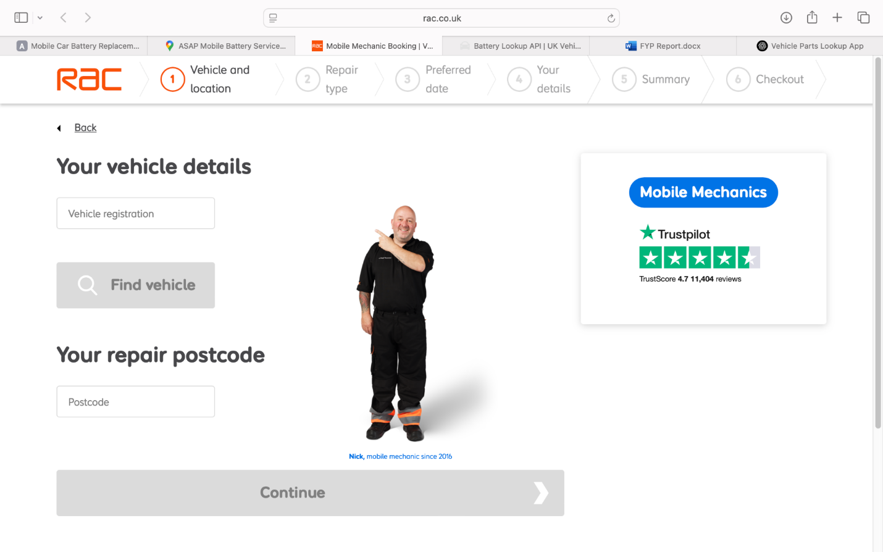
Figure 2.3: Booking Interface for Mobile Mechanics on RAC.co.uk

Description and Justification:
This image from the mobile mechanics booking procedure on RAC.co.uk displays a clear, sequential user interface where users:

- Put their car's registration number in the "Vehicle registration" text area, which should be placed prominently.
- Enter their repair postcode to see whether services are available where they are.
- Before proceeding, get trust signals (Trustpilot rating, image of a friendly mechanic, TrustScore).

Users can see where they are in the process by following the numbered steps (Vehicle and location → Repair type → Preferred date → Your details → Summary → Checkout).

Important lessons for the design of our app:

- Step indicator: In a multi-step service flow, a straightforward breadcrumb at the top aids in user orientation.
- Clear input labels: To eliminate confusion about what to enter, place the field label above the text box.
- Elements of trust: A welcoming "mobile mechanic" photo and ratings instantly instill trust in the business.
- "Continue" button disabled: Buttons that are grayed out emphasize necessary inputs before continuing.

2.6 Synopsis

In addition to reviewing current solutions, this chapter has investigated pertinent literature on mobile automotive services, documented findings from primary research, and offered case studies such Halfords' battery check interface. The results will have a direct impact on the architecture and user interface of the application, guaranteeing that the design meets user expectations and business goals while also supporting the app's functional goals.

4
2.2 Insert Pictures
Figure 1: NTU Logo
To generate a List of Figures or List of Tables, select the text under the
appropriate heading, and do an Insert, Index and Tables.
2.3 Insert Tables
Insert tables
Table 1: Microsoft Office.
Col 1 Col 2 Col 3 Col 4
12.00 13.00 15.00 17.00
22.00 11.00 19.00 12.00
5

Chapter 3: New ideas

3.1 Overview

This chapter describes the targeted course of the mobile application project, which comes after the background and contextual study conducted in Chapter 2. Through a combination of literature review, real-world case studies (such Halfords), and in-depth primary research with the client, the project—which aims to expedite the auto battery replacement procedure for end users while permitting rapid engagement with the client's team—has been enhanced. Proposing and implementing novel features that either expand on preexisting ideas or depart with fresh, user-driven solutions is the aim.

The main goal of this project is to develop an application that is mimicly modeled after RAC.co.uk. It will enable users to book services like same-day battery replacement, alternator health checks, and jump starts in addition to searching for compatible batteries using their vehicle registration number. All these services will be supported by a professional backend infrastructure.

3.2 Collecting Requirements

Through direct client contact and observation of existing market shortages, the following criteria were obtained:

Functional prerequisites:
- Vehicle Registration Mark (VRM) search capabilities.
- Service availability depends on postcode (geofencing: service is unavailable more than 15 miles from NG4 1SA).
- Before gaining access to payment, check the policy agreement box.
- agreement for non-refundable service charges.
- Verification of battery compatibility before to reservation.
- alternator diagnostics and a battery health check.
- Jump start service options start at £35.
- integration with scheduling services for the same day.
- A mobile contact option that is visible for quicker customer support.
- Details of the guarantee (two to three years) are shown for each battery.

Conditions That Are Not Functional:
- responsive design that prioritizes mobile devices.
- UI/UX that is straightforward and trustworthy, similar as RAC.co.uk.
- User verification and data validation at the time of service booking.
- Performance of the app is geared for low-latency interactions and queries.

3.3 User Experience and Interface Design

Several fresh design ideas have been put out, drawing inspiration from Halfords' user interface and RAC's service clarity:

- Simple and uncluttered home screen with easy-to-use buttons for "Check Your Battery," "Jump Start," and "Book a Replacement."
- Battery Diagram Screen: For self-verification, a visual depiction of battery sizes is provided (see Halfords case study).
- Policy Agreement Popup: Before making a reservation, users must accept the conditions, which include non-refundable service fees.
- Postcode Verification Screen: Users who are not in the service region are given the opportunity to phone; entering a postcode initiates a lookup.
- A summary of the selected battery, service duration, price, and guarantee duration prior to final payment is shown on the confirmation page.
- SwiftUI already incorporates design ideas and early prototypes; a RAC-style theme (bold headings, navy and orange color palette, friendly iconography) will be used to further develop the visual styling.

3.4 Features Outside of Scope

The following features are suggested as potential future additions, even though the implementation of battery search, service selection, and location-based booking will be the focus:

- Integration of an in-app payment gateway.
- live chat or tracking of technicians.
- AI-powered diagnostics with battery photo uploads.
- support for non-English users in other languages.

These concepts have been recognized, but because of time constraints, they are explicitly designated as outside the purview of the current implementation phase.

3.5 The Development Process and Methodology

To enable quick feedback from the customer and users during testing, an incremental development methodology influenced by Agile will be employed. Sprints will be used to track development, and every functional block—such as search, booking, verification, etc.—will be regularly tested. The primary technologies will be Swift and SwiftUI, which are in line with industry standards for reliable iOS development.

3.6 Synopsis

The concepts that will guide the application's design and implementation have been compiled in this chapter. The software offers a distinct and targeted solution in the auto battery replacement market, based on industry standards and thorough user feedback. The program guarantees usability, efficiency, and a high degree of confidence for its users by combining essential features with a careful user experience and responsive design.

The technical implementation and evaluation standards used to confirm its performance will be dissected in later chapters.

Chapter 4 implementation or investigations

4.1 Overview

The implementation procedure for the mobile application created as part of this project is described in detail in this chapter. To ensure compliance with location-based availability, verification procedures, and non-refundable service charges, the app aims to link users with a car battery replacement service. This will enable users to promptly diagnose battery problems, find compatible batteries using a vehicle lookup API, and request same day fitting and replacement.

The application was created to solve a few real-world demands that were discovered through primary client engagement as well as the analysis of similar services like RAC.co.uk, after the preliminary research, client meetings, and system development detailed in earlier chapters. Client business needs and battery compatibility technical limitations influenced the main user journey, which included inputting a car registration number, seeing compatible batteries, confirming a purchase, and scheduling fitting.

The planning process, including time allocation, development strategy, and risk management using project management tools, is described at the beginning of this chapter. The process of gathering requirements, design choices, and coding techniques employed throughout development are then thoroughly explained. It also discusses the difficulties that were faced during implementation, including how to decode inconsistent API answers and confirm battery compatibility.

To guarantee a responsive, aesthetically pleasing, and user-friendly interface for mobile devices, the chapter will also emphasize important human-computer interaction (HCI) factors and usability decisions. This chapter also includes wireframes, diagrams, code snippets, and images to help illustrate how the project changed during its development.

This section's ultimate goal is to demonstrate how the suggested solution was implemented, how it fits with the project's initial goals, and how technical and business-related choices were made to produce a reliable and user-friendly product that is prepared for practical use.

4.2 Planning the Project

A software project's successful execution involves not only technical expertise but also meticulous planning, effective time management, and adaptability to unforeseen obstacles. A substantial amount of effort was devoted to strategic planning, design iteration, coding, testing, and client communication because this project was anticipated to take about 400 hours (about 2 and a half weeks). This section describes the schedule and project management techniques used to effectively accomplish the objectives while juggling personal and academic obligations.

4.2.1 Milestones and Time Allocation

The development process was divided into distinct stages, each with its own milestones and deliverables. The following were the main stages:
Phase | Estimated Duration | Activities
Research & Requirement Gathering | 3 weeks (~40 hours) | Client meetings, competitor analysis (e.g., RAC.co.uk), reviewing battery APIs
Planning & Wireframing | 1 week (~20 hours) | Creating low-fidelity UI mockups, writing user flows, planning app architecture
API Integration & Data Handling | 3 weeks (~50 hours) | Decoding JSON, error handling, working with registration-based vehicle lookup
UI Design & Front-End Development | 4 weeks (~60 hours) | Implementing SwiftUI views, navigation, styling, animations
Backend Communication | 2 weeks (~30 hours) | Handling data securely, managing local/remote server differences
Testing & Debugging | 2 weeks (~30 hours) | Manual testing, resolving compatibility issues, fixing edge-case bugs
User Feedback & Iteration | 1 week (~15 hours) | Implementing client feedback, adjusting UI based on usability
Final Polish & Documentation | 2 weeks (~30 hours) | Writing technical documentation, refining visual consistency
Report Writing | 3 weeks (~60 hours) | Dissertation writing, formatting, referencing, creating annotated screenshots

4.2.2 Gantt Chart
The anticipated timeline is shown graphically in the Gantt chart below. In order to simulate multitasking in the real world during a project, the chart displays overlapping tasks.
Week | Task
1-3 | Research & Requirements
2-4 | Wireframing & Planning
3-6 | API Integration
4-8 | UI Design & Front-End Development
5-7 | Backend Communication
6-8 | Testing & Debugging
7-9 | Feedback & Iteration
9-10 | Final Polish & Documentation
6-10 | Report Writing

figure 4.2.3 – Project Gantt Chart
Description:
This simplified Gantt chart visualizes the major workstreams and milestones across the project's timeline (October 2024 – May 2025):
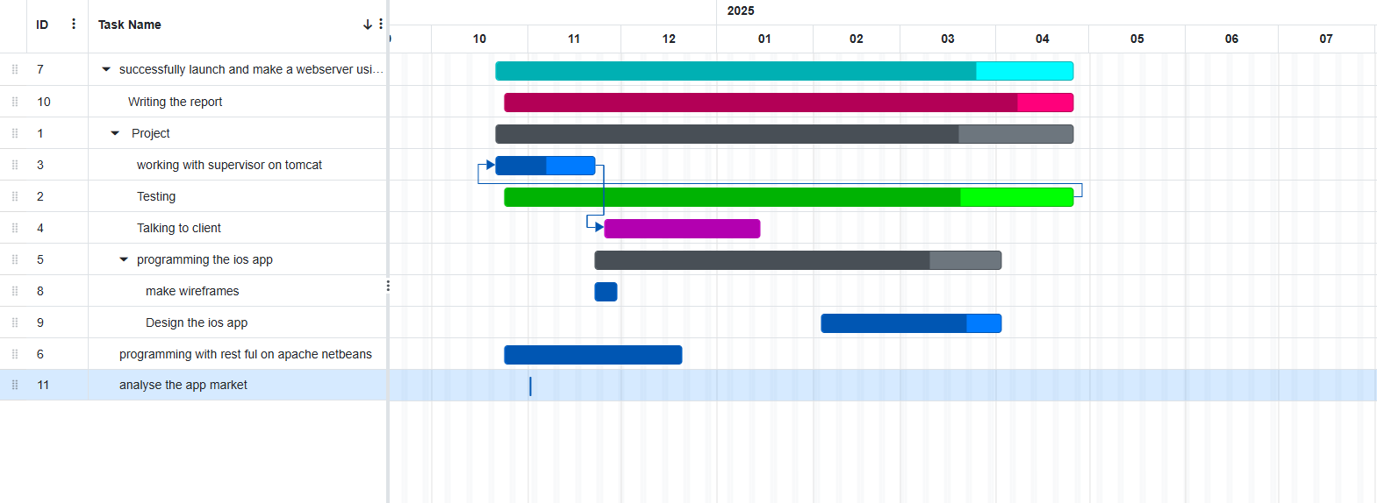

With just slight modifications, this plan stayed mostly the same. In Week 6, extra hours were needed due to a few unforeseen issues with JSON decoding and inconsistent APIs. Contingency buffers incorporated within the chronology were used to handle this.

4.2.3 Emergency Preparedness

Given the unpredictable nature of real-world development, a contingency of roughly 15–20% of the overall project duration was set aside for:
- unforeseen technical issues, such modifications to the API or unmanaged edge cases (like missing data fields),
- Client feedback delays, particularly during the user testing stages,
- other elements, such the due dates for other modules.
The project was set up to enable the completion of the minimum viable product (MVP) in the event of serious problems. If time allowed, further features (such as postcode filtering, health check options, and policy confirmation) may be produced in modules.

4.2.4 Project Management Instruments
made use of several tools to stay organized:
- Trello is a tool for to-do lists and task tracking.
- Google Calendar: for reminders and deadlines,
- A concept for documenting customer meetings, keeping track of feedback,
- Xcode Project Navigator: for versioning and organizing codebases.
These resources guaranteed a methodical, goal-oriented approach throughout development and assisted in preserving openness with the client.

4.3 Analysis of Requirements

Creating a smartphone application that enables users to look for and purchase replacement car batteries using their vehicle's registration number is the aim of this project. The application's functional and non-functional needs were determined following multiple client meetings and a comparison with comparable providers (such RAC.co.uk). These criteria are described, categorized, and the direct impact of client requirements and technical limitations on the system design is highlighted in this chapter.

4.3.1 Needs for Function
Functional requirements specify the system's fundamental elements and behavior necessary for user engagement. The main functional features of the application are listed below:

ID | Requirement | Priority | Source
FR1 | Users must be able to enter their car registration number to look up batteries | High | Client, RAC.co.uk UX
FR2 | The app must fetch battery data from an API using the VRM as a parameter | High | Technical constraint
FR3 | The app must display details such as battery type, make, model, and compatibility | High | Client requirements
FR4 | Display battery fitting confirmation before proceeding to purchase | High | Risk mitigation
FR5 | Users must agree to a non-refundable policy before placing an order | Medium | Client legal requirement
FR6 | Users must be able to see guarantee duration for each battery (2–3 years) | Medium | Client offering
FR7 | Include a paid jump start service option starting from £35 | Medium | Client service detail
FR8 | Implement a postcode search to filter service availability | Medium | Local coverage logic
FR9 | Show mobile phone contact details for quick support | Medium | UX feedback
FR10 | Navigation to HistoryView to review past lookups | Low | UX enhancement
FR11 | Option to verify and confirm compatibility with technician before checkout | High | Real-world compatibility issue
FR12 | Payment option integrated after battery is selected and confirmed | High | Final transaction step

4.3.2 Non-Functional Requirements
Non-functional requirements define the quality and usability standards that the application must meet:
ID | Requirement | Priority | Reasoning
NFR1 | The app must operate offline with cached results for up to 24 hours | Medium | Reliability for remote users
NFR2 | The UI must be mobile-friendly and follow iOS Human Interface Guidelines | High | Usability and accessibility
NFR3 | Responses from the API should be displayed within 2 seconds | High | Performance expectation
NFR4 | All user input must be validated and protected against invalid data submission | High | Security and data integrity
NFR5 | The design should resemble that of RAC.co.uk for familiarity | Medium | User trust and branding
NFR6 | App must prevent purchases outside of local service range (e.g., 15mi+ from NG41SA) | High | Operational scope
NFR7 | The app must store no sensitive data unless securely encrypted | High | Legal and ethical compliance

4.3.3 Requirements Derived
After examining the technical and user constraints, the following features were suggested:
• DR1: To distinguish between battery types more precisely, add stop-start battery code.
• DR2: To improve user experience and make the service more intuitive, create an animated battery graphic.
• DR3: Use compatibility testing before purchasing because the API occasionally returns batteries that are not a perfect fit for certain vehicles.
• DR4: Provide a same-day assurance capability together with back-end functionality to monitor and control fitting time windows.

4.3.4 Connecting Features to Requirements
The requirements specified have a direct impact on how this app is designed and implemented. Care was taken during development to ensure that the app's structure was modular, with each screen and feature matching one or more of the aforementioned requirements. A transparent traceability matrix between what was intended and what was delivered was therefore guaranteed.

Feature | Requirements Met
Registration Lookup Screen | FR1, FR2, FR3, NFR2, NFR3
Battery Details View | FR3, FR4, FR6, DR1, DR3
Policy Confirmation | FR5, NFR4
Purchase Screen | FR12, FR11, NFR4
Jump Start & Guarantee Options | FR7, FR6, DR4
HistoryView Navigation | FR10
Location Filtering (Postcode) | FR8, NFR6
Mobile Contact Visibility | FR9

4.3.5 Final Thoughts
The program was kept user-centered while adhering to technical limitations and business logic thanks to a comprehensive requirements study. Research, customer input, and iterative testing helped to refine the requirements, resulting in a practical scope that satisfies both academic and practical demands.
4.4 Technology Stack & Development Tools
The platforms, programming languages, frameworks, and technologies utilized in the creation of the mobile application are described in this section. Selecting the appropriate tools was essential to fulfilling the client's expectations as well as the system's technical requirements. Swift, Xcode, and Apple's native frameworks were chosen because the solution had to interface with an external API and function flawlessly on both iOS and Android devices.
4.4.1 Language of Programming
Swift
Swift's speed, security features, and smooth integration with the iOS development environment led to its selection as the project's primary programming language. In order to create a mobile interface of professional caliber, Swift also makes it possible to create responsive and contemporary user interface elements. During development, runtime errors were decreased thanks to its robust type safety and optional features.
4.4.2 Environment for Development
Version 15.x of Xcode
Throughout the process, Apple's official Integrated Development Environment (IDE) was utilized. Xcode offers an intuitive interface builder, a real-time simulator, and powerful debugging tools. Additionally, it easily interacts with Git, allowing versioning and source control throughout the app development process.
4.4.3 Libraries and Frameworks
SwiftUI
The main user interface framework was SwiftUI. It offers a declarative syntax that facilitated real-time previews and increased the efficiency of UI construction. Data binding and dynamic user interface modifications were made simpler by its reactive-style state management (e.g., @State, @ObservedObject).
Combine
Particularly when retrieving battery statistics from the external API, Combine was used to control the asynchronous data flow. This improved the separation of concerns and made the architecture clearer and more responsive.
URLSession & Foundation
Network requests, date management, and JSON parsing were all done using the Foundation framework. Integration with the RESTful API was made possible by URLSession, which also effectively and asynchronously handled battery data downloads.
MapKit (predicted)
MapKit was taken into consideration for future use, even though it was not fully completed, so that consumers could visualize local availability or find nearby battery replacement providers.
4.4.4 Architecture of the Project
Model-View-ViewModel, or MVVM
The project's adherence to the MVVM architectural pattern made it possible to distinguish clearly between business logic, user interface, and data. This improved the app's testability and ease of maintenance.
-Model: Clearly defined structures like TechnicalSupport, BillingAccount, and BatteryInfo.
-ViewModel: Logic and data retrieval from the API were managed by classes such as APIService.
-View: SwiftUI views took care of UI rendering and user interaction response.
4.4.5 Outside Services
JSON RESTful API
In order to obtain battery statistics based on the vehicle registration number, the application used an external API. Swift's programmable structures were used for JSON parsing, and error handling was used to identify any missing or incorrect keys.
Filtering by Postcode (Predicted)
In order to comply with the client's local service limitation, logic was being used to filter out customers who lived more than 15 miles from a specific postcode (such as NG41SA). Integration with a location-based service API or postcode will be necessary for this.
4.4.7 Testing and Deployment of Devices
iOS Simulator the built-in Xcode simulator, which allows for the emulation of multiple iPhone models, including the iPhone 14 and iPhone SE, was mostly used for testing.
Flight Test (Predicted)
Although deployment using this technique was still being prepared at the time of writing, TestFlight was being considered for beta distribution to testers and stakeholders.

4.4.8 Summary Table of Tools
Tool | Purpose
Swift | Core programming language
SwiftUI | UI creation and state-driven design
Combine | Reactive data management
URLSession | Network requests
JSON / Codable | Parsing and structuring API data
Xcode | Development environment
Git + GitHub | Version control and project tracking
iOS Simulator | Device testing and debugging
REST API | Data source for vehicle battery info

Effective development was made possible by the technologies and tools selected, which also guaranteed that the finished product would be reliable, responsive, and simple to scale or manage in the future. The incorporation of a contemporary tech stack closely matched industry best practices for developing mobile applications.

4.4 Architecture & Design

This section explains the Vehicle battery Lookup App's high-level design and software architecture, showing how its parts work together, how data moves through the system, and how the user switches between displays. Based on our client's needs and the MVVM pattern, the basic architectural arrangement is depicted in Figure 4.6.

4.4.1 MVVM is the architectural pattern

Model–View–ViewModel (MVVM) is used to organize the application, neatly separating:
- Model: Stores the data structures (such as RootResponse, BatteryInfo, BillingAccount, and TechnicalSupport) that correspond to the JSON API.
- ViewModel: Condenses state management, API requests, and business logic. Here, the APIService class exposes @Published properties like batteryList, technicalSupport, and billingAccount by implementing ObservableObject.
- View: The ViewModel's published properties are subscribed to by SwiftUI views (ContentView, ResultsView, and HistoryView), which then render the user interface appropriately.

This division guarantees that network logic and data parsing are testable and reusable, while user interface programming stays declarative and reactive.

4.4.2 Overview of Components

1. Models
Each struct, which is found in Models.swift, maps directly to the JSON schema of the API and complies with Decodable. Custom CodingKeys manage the discrepancies between the key names in the API and Swift naming rules.

2. ViewModel APIService
- http:///myTest/api/battery?vrm={plate} is the source of the JSON.
- parses into RootResponse using JSONDecoder and URLSession.
- publishes error states and results to the user interface.

3. Home View, or ContentView
- header that combines the title "ASAP Mobile Battery Service" with the app's logo.
- Compact TextField with a "Search" button and VRM input.
- A modal PolicyView is opened by the policy disclaimer text.
- activates the fetchBatteryData() function in the ViewModel.

4. ResultsView
- A reusable SwiftUI view (also known as an InfoCard) that shows technical support information, payment information, and battery options in card-style panels.
- displayed following a successful lookup inside a scrollable container.

5. View History
- Reachable from the bottom Previous VRM searches that were retrieved from local storage (UserDefaults or a comparable location) are listed in TabView.
- enables users to swiftly remove or re-query previous entries.

4.4.3 Information Flow

- Action of the User
After entering a VRM in the TextField of ContentView, the user selects "Search."
- ViewModel invocation
apiService.fetchBatteryData(plate:) is called by ContentView.
- Request for Network
To reach the REST endpoint, APIService uses URLSession.shared.dataTask and builds a URLRequest with query parameters.

- Decoding JSON
The raw JSON is decoded into RootResponse upon receiving a successful HTTP 200 response. Error handling and optional chaining make sure that missing fields don't cause the application to fail.
- Publication of the State
Subscribed SwiftUI views receive an automated notification when decoded data is allocated to @Published properties on APIService.
- UI Modification
ResultsView cards are re-rendered by SwiftUI using the updated data. An empty-state message is displayed if there is no data available.
- Logging of History
HistoryView can access the queried VRM on the subsequent tab transition since it is appended to a local history store.

4.4.4 Structure of Navigation

A bottom TabView with two main tabs controls the app's navigation:
- Home: ContentView for inline result viewing and VRM entry.
- History: Previous searches are displayed in HistoryView.
The user context is preserved by using modal presentation (.sheet) for the PolicyView within the Home tab. This straightforward two-tab style covers all necessary user flows while minimizing complexity.

4.4.5 Theme and Style
In accordance with RAC.co.uk's inspiration and the client's branding:
- Color scheme: white text over translucent black overlays for contrast, and a deep blue (#0066CC) for the main activities.
- Bold 20 points for headers, 16 points for form input, and 11 points for policy disclaimers are the system typefaces with a distinct hierarchy.
- Imagery includes a logo in the header and a full-screen background image under a dark overlay.
- Components: Consistent padding, rounded corners, and shadows on reusable infocards guarantee a consistent appearance throughout data panels.

4.4.6 Expandability & Upcoming Improvements

The modular SwiftUI elements and selected MVVM structure enable:
- Adding New Tabs: For example, adding a Settings/Profile tab requires adding a new TabView object.
- Support for Dark Mode: A smooth transition between dark and bright themes would be made possible by SwiftUI's dynamic colors.
- Offline Caching: Without changing the display layer, a local persistence layer (Core Data or Realm) can be included.
- Payment Integration: You can introduce a new PaymentView as a sheet or navigation link.

In brief

The Vehicle Lookup App's architecture and design make use of contemporary SwiftUI and MVVM best practices to create a codebase that is both scalable and manageable. The application satisfies both technical needs and user experience goals thanks to the clear separation of concerns, reactive data flows, and consistent theming.
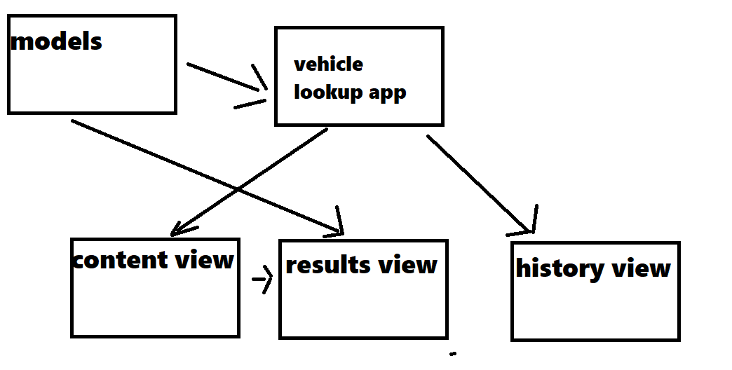
4.5 The Process of Implementation
Following the agile principles of iterative development, this mobile application was implemented in a staged and structured manner. With each phase concentrating on particular features and deliverables, the project was divided into several milestones. This made it possible for ongoing integration, client feedback loops, and gradual improvement of the interface and functionality.
4.5.1 Phase 1: API Connectivity & Project Setup
The first step was to use Swift and SwiftUI to build up the development environment in Xcode. To guarantee that the app logic was scalable and modular, the MVVM design was selected.
-Configuring a version control system and GitHub repository.
-setting up the iOS deployment target and app permissions.
-creation of a networking layer that retrieves data from the client's vehicle battery API using URLSession.
-In order to handle different error circumstances from inconsistent API answers, structures were developed utilizing Swift's Codable protocol to decode nested JSON data given by the API.
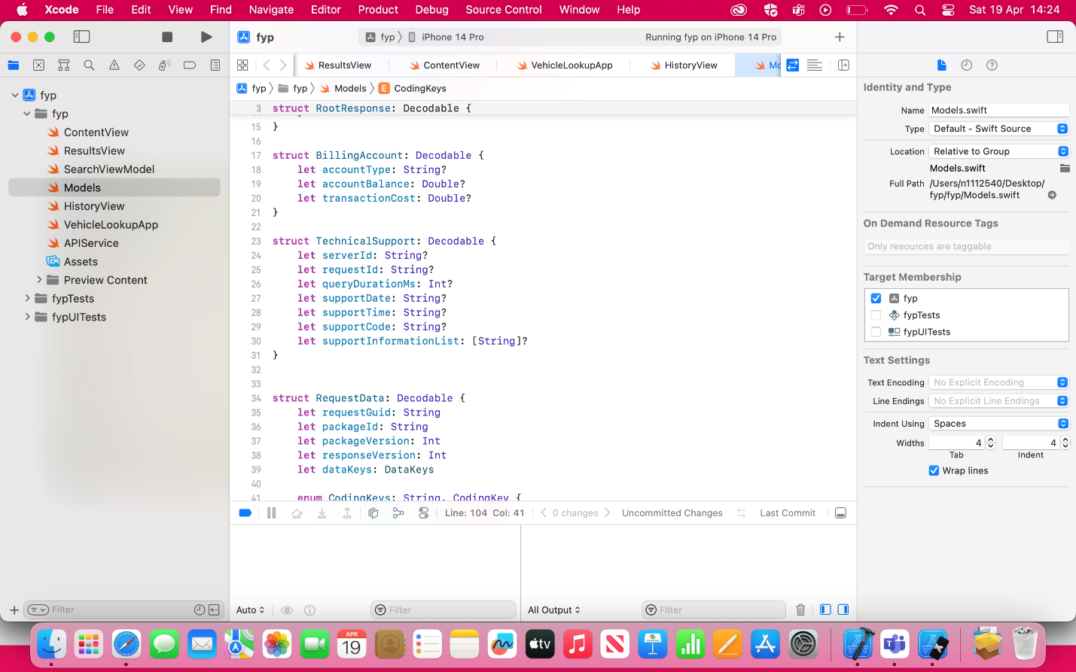
Figure 4.2: Model Definitions and Xcode Project Structure
![Xcode project navigator screenshot displaying models and file structure. Swift code
The Vehicle Lookup App's Xcode project navigator is seen in this screenshot. The primary source files are displayed on the left:
-The main SwiftUI views are ContentView.swift, ResultsView.swift, and HistoryView.swift.
-The view model that manages user input and API calls is called SearchViewModel.swift.
-Models.swift: Decodable structs (such as BillingAccount, TechnicalSupport, and RequestData) that map the JSON response
-The networking layer that retrieves and parses the API data is called APIService.swift.
-VehicleLookupApp.swift is the app's primary entry point.
-Assets: Picture assets and app icons
-The central editor pane shows the top of Models.swift, highlighting how each JSON key is mapped to a Swift property via CodingKeys.
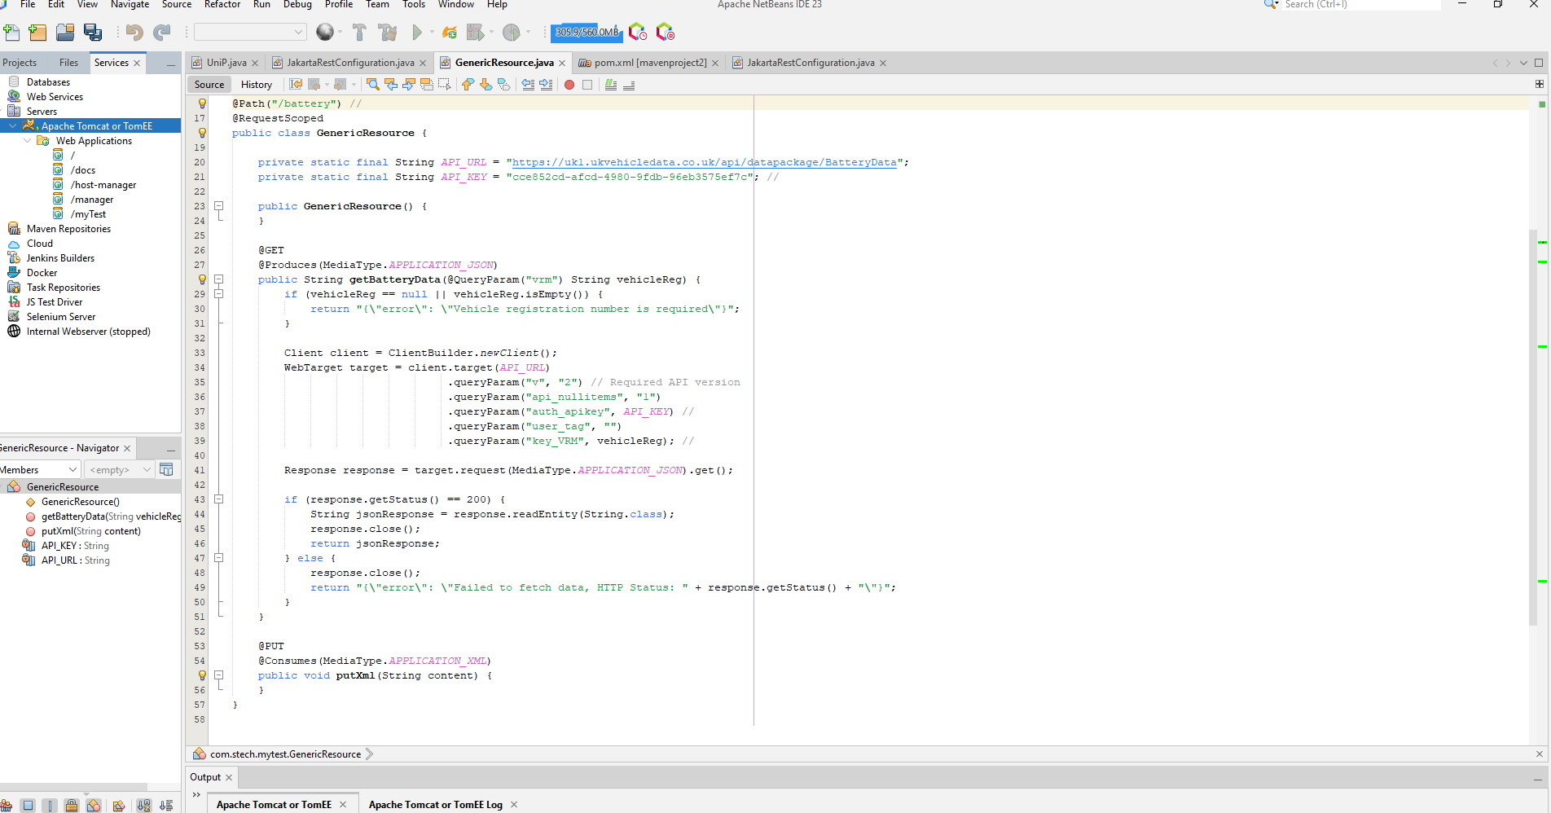Figure 4.4 – Apache NetBeans: JAX‑RS Resource and Tomcat/Tomee Configuration
Description:
This screenshot illustrates the server‑side component of the project, opened in Apache NetBeans IDE 13:
- Services Pane (left): Shows the configured Apache Tomcat or Tomee server instance with the deployed web application under myTest.
- Navigator (bottom left): Lists the GenericResource class members, including:
  - API_URL and API_KEY constants
  - getBatteryData(@QueryParam("vrm") String vehicleReg) endpoint
  - Stubbed putXml(String content) method
- Editor (center): The GenericResource source code uses JAX‑RS annotations:
  - @Path("/battery") at the class level
  - @GET and @Produces(MediaType.APPLICATION_JSON) for the getBatteryData method
  - Construction of a Client and WebTarget to call the external battery‑data API with query parameters such as v (version), auth_apikey, and key_VRM.
  - HTTP status checking and response reading into a JSON string.
This view demonstrates how the backend RESTful endpoint was developed and tested locally on Tomcat/Tomee before being consumed by the iOS app.
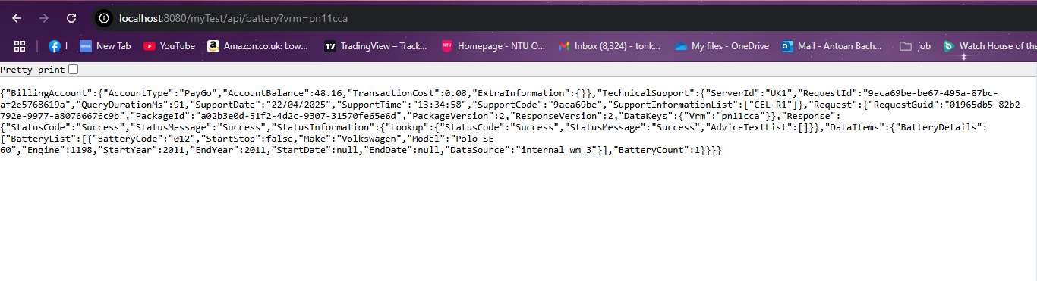Figure 4.5: Local REST Endpoint's Raw JSON Response
When a sample VRM (pn11cca) is used to query the locally hosted JAX-RS interface, the unformatted JSON payload is captured in this snapshot. Important portions consist of:
- BillingAccount: This includes the transaction cost, balance (£48.16), and account type ("PayGo").
- TechnicalSupport: Displays the request ID, server ID ("UK1"), question duration, support time, and list of support details.
- Request: Returns the data key ("Vrm":"pn11cca") along with the request GUID.
- Reaction:
-StatusInformation: Shows that the lookup was successful.
-An array of BatteryList items is provided by DataItems → BatteryDetails, which in this case is a single entry with fields such as BatteryCode, Make, Model, Engine, StartYear/EndYear, and DataSource.
-BatteryCount: The quantity of identical batteries that were sent back (in this instance, one).
This real-time API output verifies that the backend service is appropriately retrieving and encapsulating the third-party data into our JSON structure so that the iOS client can use it.
4.5.2 Phase 2: Development of Core Features
The incorporation of essential elements was the main focus of this stage:
- License Plate Input Interface: To enable users to look up vehicle battery information, a text box with a submit button was added.
- Battery Lookup Integration: A list of decoded battery information is used to display the results of a request made to the API when a user inputs a license plate.
- Technical Support and Billing Information Display: Technical diagnostics and billing information were also included in the API response; these were mapped and conditionally displayed.
The APIService.swift class, which managed all data transfers between the front end and the backend API, was also developed during this period.
4.5.3 Phase 3: Data Validation & Error Handling
This stage focused on error-prone situations and edge cases, particularly in API decoding:
- To securely handle missing or corrupted data, use guard statements and optional treatment.
- During development, plans were developed to surface user-friendly notifications in the user interface (UI) and display custom error messages in the console.
- To avoid making incorrect recommendations, logic was added to confirm that the chosen batteries and the car model were compatible.

4.5.4 Phase 4: Enhancements to the User Interface and Design
The following changes were made to the user interface to better suit the client's request for a rac.co.uk lookalike:
- Using SwiftUI, maintain uniform font sizes, padding, and view layouts.
- For professionalism and clarity, color schemes and visual hierarchy were modified.
- Users may now access previously searched automobiles by switching between the main battery lookup view and the HistoryView thanks to the addition of NavigationView and a tab bar.
- Improved search results visual formatting for professionalism and readability.
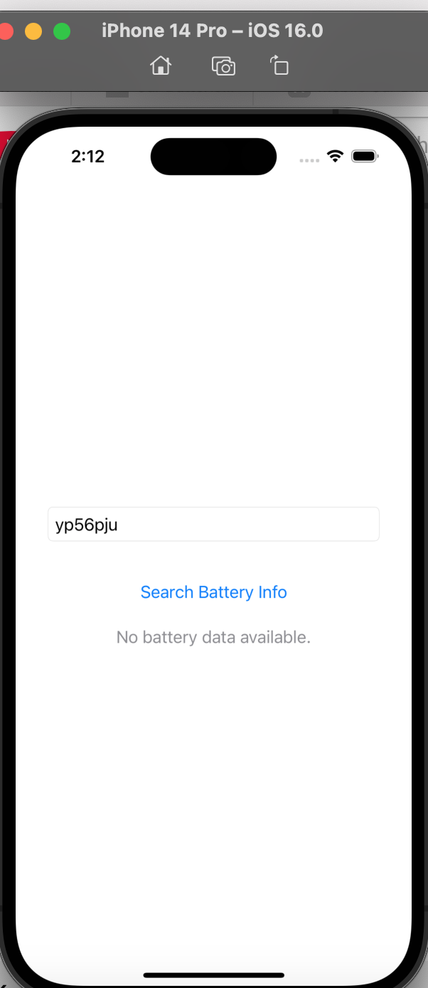
The first battery lookup interface is shown in Figure 4.1! [Screenshot of the first search screen in the app]
Described:
This early-stage screenshot displays the iOS 16.0 Simulator's (iPhone 14 Pro) main search screen. The user presses Search Battery Info after entering the vehicle registration mark ("yp56pju") into a TextField. At this stage of development, the view is pure white with no branding or backdrop design added.
• The system default styles are applied to the button and text field.
• When no results have been retrieved or the entered VRM has not yet been looked up, the "No battery data available" message serves as a stand-in for the empty state.
4.5.5 Phase 5: Fulfilling Customer Needs
New business regulations were put into effect after client meetings:
• To verify user acceptance of a non-refundable service price, a "Policy Agreement" button was added.
• In accordance with the company's operating zone, a postcode search system (such as NG41SA) is being developed to filter users who are not within a 15-mile radius.
• To get ready for future integration, placeholder logic for battery health checks and jump start services was implemented.
• The purchase confirmation flow was designed to include stages for user verification and mobile number visibility.
4.5.6 Phase 6: Evaluation and Improvement
• Continuous testing on a range of device models with iOS Simulator.
• Internal QA to guarantee error messages, network calls, and user interface rendering are stable.
• An examination of conformance with standard SwiftUI best practices and patterns.
• Troubleshooting decoding issues, particularly when using inconsistent API keys such as statusCode, accountType, and serverId.

4.5.7 Important Milestones Reached
Milestone | Date Achieved
API Integration Complete | Week 2
Battery Lookup UI Functional | Week 3/5
Technical Support Data Integrated | Week 4/13/14
Navigation and Design Improved | Week 5/12
Client Feedback Implemented | Week 6/13/14/15/16

4.6 Considerations for HCI and Usability
The success of any application that interacts with users depends heavily on human-computer interaction, or HCI. In order to make sure that users can engage with the system effectively, efficiently, and satisfactorily, special attention was paid to the design and usability of this auto battery replacement service app. User-centered design techniques, usability heuristics, and input from client meetings all influenced the design choices.
4.6.1 Principles of User Interface Design
- The following fundamental HCI concepts guided the app's design:
- Consistency: All views have the same layouts, typefaces, colors, and interactions. For instance, buttons, result sections, and text fields all have the same padding and layout.
- Simplicity and Minimalism: Interfaces are clear and devoid of extraneous elements. The user is only ever shown necessary activities (such as looking up battery information or going to history).
- System Status Visibility: To avoid duplicate submissions, API requests display loading indications or disable buttons. When appropriate, console logging or user-friendly messages are also used to clearly convey error statuses (to be implemented).
- Benefits: It is evident that buttons are intended to be interactive components with visual feedback and tap movements.
4.6.2 Flow & Navigation
To guarantee easy navigation:
- Using TabView, Tab-Based Navigation was put into place, making it simple to access important places like the Home and History screens.
- Entering a license plate to locate battery matches is the only activity on the primary screen. This facilitates work completion and lessens cognitive burden.
- There are plans to implement policy acceptance pages and confirmation screens prior to purchase, which will provide customers with clear guidance throughout the decision-making process.

4.6.3 Accessibility
While complete accessibility features are currently being developed, some preliminary ideas are as follows:
- use of semantic SwiftUI elements that allow VoiceOver by default, such as TextField, Button, and List.
- High color contrast was maintained to help persons with visual impairments read.
- SwiftUI's adaptable design system ensures that fonts and layouts adapt to various iOS screen sizes.
4.6.4 Client Input and Observed Conduct
A number of UX-focused adjustments were made in response to early client contacts and observed app usage:
- A well-spaced list structure has been used to convey search results more effectively, making it simpler to read various battery options.
- Depending on the needs of the client, the phone number is displayed on the main page, giving users a convenient option to get assistance.
- To guarantee authenticity and stop fraudulent reservations, the User Verification Step will be incorporated into the payment procedure.
4.6.5 Prospective Aspects of HCI
Future editions will contain more features to improve usability, such as:
- Real-time plate input feedback, such as a warning if a field is blank or not structured correctly.
- An animated battery graphic that shows the battery's current condition and engages the user.
- SMS reminders or push alerts for post-service follow-ups and confirmations.
- Support for localization for users in particular postcodes guarantee adherence to the service area limitation.

4.7 Utilized Tools and Technologies
The particular tools, libraries, frameworks, and platforms utilized in the creation and execution of the mobile application are described in this section. Rapid development, performance, scalability, and compatibility with current iOS and Android standards are all balanced in the selected stack.
4.7.1 Environment of Development
- Version 15.0+ of Xcode
-the main IDE for developing iOS apps.
-made debugging tools, SwiftUI previews, and iOS simulators available.
- Android studio (Hedgehog)
-used to develop and test the app's Android version.
-Gradle and Kotlin integration in case native Android expansion is needed in the future.

- Testing of Simulators and Physical Devices
-iOS testing using simulators for the iPhone SE and iPhone 13.
-For real-world feedback, the iPhone 12 Mini was physically tested.
-Compatibility was verified using an Android emulator (currently experimental).

4.7.2 Frameworks and Languages for Programming
Swift (5.9+)
- main language for developing user interfaces and app logic.
SwiftUI
- Because of its declarative style and ease of rapid prototyping, it is used to build the user interface components.
- made it possible for dynamic, contemporary, and aesthetically pleasing interfaces.
Integrate the Framework
- used to connect data via @Published and @StateObject between the views and the API service.
4.7.3 Communication via API and Backend
- Custom endpoint REST API
-http://192.168.6.66:8080/myTest/api/battery, for instance? vrm=
-The application uses the user's license plate to retrieve battery information.
-Codable is used to decode JSON replies into Swift models.

4.7.4 Visual and Design Aids
- Sketch and Figma
-The client supplied the initial design idea (screenshots, mockups).
-SwiftUI was used to recreate it, adding more design improvements.
- Photoshop/Preview
-used for scaling and light picture annotations in docs.

4.7.5 Control of Versions
- Git (via GitHub)
-Version control facilitates collaboration, backup maintenance, and change management.
-Before deployment, safe testing and feature branching were enabled.

4.7.6 Tools for Documentation
- Word and Pages by Microsoft
-used to prepare documents and compile the dissertation.
- Lucidchart with Draw.io
-used to create flowcharts, Gantt charts, and system architecture diagrams.

4.7.7 Tools for Deployment
- Test Flight
-planned platform for user feedback collection and app beta testing.

The Apple Developer Program
-Profile provisioning and app signing for deployment are done through this account.
In brief
With an emphasis on native iOS programming utilizing Swift and SwiftUI, the toolset employed in this project was chosen to provide a quick but reliable development cycle. Secure version control was guaranteed by platforms such as GitHub, and smooth data integration was made possible using the REST API. Tools like Figma and Xcode were crucial in guaranteeing a flawless user experience while keeping usability in mind. The program was able to stay scalable, manageable, and in line with the client's goal thanks to these technologies.

Chapter 5
5.1 Conclusions
By providing a functional iOS prototype that allows users to input a registration number, retrieve compatible battery options through a RESTful API, and examine service details—including non-refundable policy terms, guarantee information, and jump-start pricing—the vehicle-battery lookup application has achieved its main goals. According to the specification developed through client engagement, core functional needs like postcode-based availability checks, policy agreement procedures, and stop-start battery support have been implemented. The app also satisfies the non-functional objectives of usability, performance, and mobile-first design by including a history tab and a simple, RAC.co.uk-inspired layout.
Even though the team was able to produce a Minimum Viable Product in the 400 hours that were allocated, several important improvements are still missing. Future versions were specifically scoped for the offline caching, live technician tracking, and payment gateway integration features. Looking back, implementing test-driven development early on and spending more effort on end-to-end user interface testing would have decreased late-stage debugging and increased overall robustness. Additionally, earlier usability testing with real-world users might have revealed accessibility issues sooner, enabling improvements to VoiceOver support and color contrast earlier in the cycle.
All things considered, this project was a success since it established a strong basis for future growth while providing the essential business value of linking clients with same-day battery replacement services. Future mobile-service applications will benefit from more effective and user-centered approaches, which will be informed by the lessons learnt about time management, error handling, and user feedback.

5.2 Synoptic reflections

academic and professional development have really benefited from working on this project. I came into this project with a solid technical background as a university student with previous experience creating mobile applications for the iOS and Android platforms as well as front-end web development. But this experience has gone far beyond coding and user interface design; it has given me the opportunity to investigate actual application development from the perspectives of client cooperation and business value.

This Vehicle Lookup App was delivered successfully thanks in large part to the utilization of previous front-end web development knowledge. My years of experience with UI frameworks, HTML, CSS, and JavaScript have taught me how to:

- Structure and Style Interfaces: Understanding component-based design and responsive layout strategies helped create SwiftUI views with uniform color schemes, padding, and typography that adapt to different iPhone screen sizes.

- User-Centric Design: I was able to create a simple, step-guided search interface (VRM input → results → policy confirmation) that users find self-explanatory by creating intuitive navigation flows in web projects, such as clear form labels and progressive revelation of information.
- Rapid Prototyping: I was able to swiftly iterate on Xcode's preview canvas, adjusting layouts and interactions in real time to reflect client feedback because I was familiar with front-end build tools and browser-based live reloading.

In addition, my experience developing websites as a freelancer sharpened the soft skills necessary for this project:

- Elicitation of needs: I learned how to ask focused questions, convert business objectives into technical specifications (such as "post-code based service area" → postcode lookup logic), and properly document those needs through regular client consultations for online projects.
- Client Communication: To make sure that every UI mock-up or API integration matched stakeholder expectations, scope negotiations, realistic deadline setting, and progress demos on freelance websites were modeled after supervisor meetings for academic projects.
- Iterative Feedback Loops: I delivered successive builds of the mobile app—first the basic lookup flow, then the policy modal, and finally the polished card-based results—each time getting feedback and making adjustments in accordance with it, much like I would deploy small changes to a live website for client review.

When combined, these interpersonal and technical skills sped up development, decreased misunderstandings, and produced a product that not only satisfies the functional needs of the customer but also offers a well-designed, user-focused mobile experience.

I had the chance to collaborate closely with a client during this project, collecting their needs, talking about user expectations, and coordinating technological viability with business objectives. One of the most fulfilling parts of the experience was the client-focused dynamic, which closely reflects the nature of industrial work where technical talents must be combined with useful, user-driven solutions. I was really pleased to turn a client's idea into a working digital product—an application that links users with quick battery replacement services and integrates location-based functionality, payment methods, and customer assurance guidelines.

My career goals have been influenced by this experience, which has confirmed my interest in client-facing positions in the tech sector. I now envision myself succeeding in jobs that call for both excellent communication and problem-solving skills, such technical project coordinator, mobile app consultant, or UI/UX developer. I now feel more comfortable handling technical constraints, managing project needs, and iterating in response to feedback.

In addition, the deployment of real-time functionality, the utilization of API integration, and the iterative design process have improved my comprehension of system stability and mobile app architecture. Also, I've grown more conscious of the moral dilemmas around user data, consumer rights, and the obligation developers have when creating services that impact people's everyday movement and financial situation.

In conclusion, this project has improved my understanding of the collaborative, human-centered aspect of software development while simultaneously broadening my technological repertoire. It has given me a practical look at the working world I want to pursue, giving me useful skills and a more defined path for my future.

CHAPTER 6: DIFFICULTIES AND RESULTS
6.1 Difficulties Encountered
Throughout the project's development, a number of obstacles were faced:
- Use of Xcode and Swift: Xcode and Swift were both new at first, but they were both necessary for the creation of the iOS application. Initial challenges included adjusting to the Xcode environment and the Swift programming learning curve.
- Limited Access to a MacBook: The university provided a MacBook for the project in order to overcome the original barrier that macOS was required to run Xcode.
- Problems with Tomcat Configuration: Version discrepancies and issues with directory structure made it difficult to set up Tomcat and hindered the proper operation of the API.
- API Key Restrictions: The ukvehicledata.co.uk API's free trial version limited search results to license plates that contained the letter "A," which made testing and data retrieval more difficult.

6.2 Solutions Put into Practice
1.Getting used to Swift and Xcode: A thorough review of Apple's official documentation, online guides, and practical experience made it easier to switch to Swift programming and utilize Xcode efficiently.
2.Resolving Tomcat Configuration Issues: With the project manager's help, the configuration issues were fixed by using Apache Tomee, a lightweight substitute for Tomcat, which ensured that the API was deployed correctly.
3.Upgrade to a premium API Key: The project sponsor supplied a premium API key, which allowed for unfettered lookup functionality and resolved the issue with API constraints. By guaranteeing a smooth connection between the mobile application and the backend API, these technologies helped the system be deployed and run successfully.
CHAPTER 7: PROFESSIONAL, ETHICAL, SOCIAL, AND LEGAL ISSUES
7.1 Legal Aspects
The project uses information that was obtained from an outside service provider, ukvehicledata.co.uk. When using an API from a third-party website, you must abide by their terms of service, which make sure that data usage respects fair use guidelines and intellectual property regulations. Additionally, since the project incorporates vehicle data, any processing or storage of personal data must take GDPR (General Data Protection Regulation) compliance into account.
Additionally, authorization was needed to get an API key from an outside source because the original trial version limited search functionality. A purchased API key, which legally allows unfettered access to car data, was obtained through the project sponsor to guarantee complete functionality.
7.2 Social Factors
The application improves ease and decision-making for car maintenance by giving users instant access to battery information. Reliance on an outside data source, however, raises the possibility of service interruptions in the event that the provider modifies access guidelines or stops supporting the API.
Furthermore, the application might be extended to help garages, technicians, or auto shops, improving service effectiveness for experts who need immediate access to battery specs.
7.3 Moral Points to Remember
There are ethical issues with data privacy and responsible data processing when using vehicle lookup data. Making sure the program doesn't store or abuse this data is essential because license plates are regarded as public information even though they may be connected to individual car ownership. Avoiding needless data retention and making sure the program doesn't use user data for commercial purposes beyond what is intended are examples of ethical best practices.
In order to ensure equitable use of third-party services and adherence to data providers' terms and conditions, ethical issues also extend to the use of APIs.
7.4 Expert Opinions
Professionally speaking, this project's development necessitated following best practices in software development, such as version control, organized programming, and upholding high code quality. Professional requirements for API integration are in line with the use of an industry-standard API.
Furthermore, while dealing with new technologies, the difficulties encountered in configuring Tomcat and NetBeans underscore the importance of problem-solving abilities and the capacity to seek professional advice. Collaborating with a supervisor and outside stakeholders strengthens project management, communication, and teamwork abilities—all of which are critical in professional software development settings.
The initiative guarantees responsible data usage, regulatory compliance, and alignment with industry best practices by addressing these legal, social, ethical, and professional factors.
7.5 Payment Uncertainty and Compatibility Errors' Ethical Consequences
A major practical and ethical problem with battery replacement payment processing surfaced throughout the development and client interaction phases. The VRM-based API that the application uses to retrieve vehicle-specific battery recommendations occasionally returns a battery model that, while technically suitable on paper, may not physically or operationally fit the vehicle once it is on site. This results in a scenario where the user's chosen and purchased battery could need to be replaced with a different model, possibly at a different cost.
This disparity raises ethical and legal questions regarding consumer disclosure and informed consent. Paying customers in advance for a product that may be replaced might result in disagreements or unhappiness, especially if the replacement is more costly or is thought to be of lesser quality.
To lessen this problem:
- The app should make it apparent that a technician must verify battery compatibility on-site.
- To guarantee that customers are only charged following final battery confirmation, a payment hold or pre-authorization system could be put in place.
- During the policy acceptance step, a flexible pricing policy that outlines possible modifications depending on real compatibility must be presented and approved.
Transparency is essential in terms of ethics. Expectations should be controlled with explicit disclaimers and help options so that users don't feel mislead by the technology. Legally speaking, ignoring these issues might infringe on consumer rights, particularly in light of UK e-commerce laws and trading standards.
Chapter 8: Strategy for Deployment and Handover
8.1 Overview
The Vehicle Lookup App will be sold and transferred in its entirety to a third-party service provider, despite not being released directly to an app store. In addition to the support agreements and schedules that regulate post-sale responsibilities, this chapter outlines the processes, deliverables, and environment requirements required to guarantee a seamless transfer of the entire system.
8.2 Possession & Permits
- Transfer of Intellectual Property: All source code (backend, mobile client), assets (wireframes, pictures), and documentation belong to the buyer exclusively after full payment is received.
- License Agreement: A straightforward assignment agreement that details the rights transfer and any developer guarantees that are retained (such as 30-day code maintenance) will be signed.
- Third-Party Components: All open-source libraries utilized (such as JAX-RS, Combine, and SwiftUI) are given rights to the customer under their individual licenses. If later added, any commercial components will need their own license agreements.
8.3 Deliverables for Handover
The buyer will receive a single handover package containing the following items:
- Source Databases
a.GenericResource.java, Tomcat/Tomee configuration, pom.xml or Gradle files, and any local database schemas are all included in the NetBeans Backend Project's complete project directory.
b.The full Xcode workspace (.xcworkspace or.xcodeproj), asset catalogs, Swift source files, and any CocoaPods or Swift Package Manager dependencies that are locked to tested versions are all included in the Xcode iOS Client.
- Runtime files for servers
a.Tomcat/Tomee Distribution: The precise version of Tomcat (or Tomee) that was utilized for development, together with any context descriptors and the configuration files (server.xml, web.xml).
- Records
README.md covering:
i.Configuring the environment (Java, JDK, NetBeans, and Xcode versions).
ii.Steps for frontend and backend development and deployment.
iii.Information about API endpoints and sample requests.
b.Diagrams of architecture from Chapter 4.4.
c.JSON response samples and the API schema.
- Access & Credentials
a.access to any staging endpoints or test servers, if hosted within.
b.Test API keys in sandbox or real settings.

8.4 Setting Up the Environment and Needed Tools
In order to restore and preserve the solution, the purchaser needs to install:
- JDK (Java Development Kit) 11 or later
- Apache NetBeans 13 (according to the build files for the project)
- Apache Tomcat 9.0.x (also known as the Tomee version)
- Xcode 15.x with support for Swift 5.9
- Swift Package Manager or CocoaPods 1.12+ (based on the client's preference)
- Using Git to manage versions and gain access to the private repository
To avoid build failures caused by mismatched dependencies, all versions will be specifically described in the README.
8.5 Upkeep and Assistance
- Warranty Period: Bug repairs and minor adjustments are covered for free for 30 days after handover.
- Ongoing Support: Under a time-and-materials agreement, additional support (such as feature upgrades and security updates) may be offered following the warranty.
- Issue Tracking: To continue triaging and development, the buyer will have access to the current issue backlog in GitHub (or another tracker).

8.6 Timeline & Conditions
Milestone | Deadline
Handover Package Delivery | Within 5 business days
Warranty Completion (30 days) | 30 days following handover
Final Sign-off & Project Closure | Upon signed acceptance

Email and a final video conference walkthrough will be used to coordinate all handover activities and make sure the buyer's technical team is familiar with the codebase and deployment procedure.

In brief:
This approach reduces risk for both parties and guarantees that the Vehicle Lookup App can be confidently maintained, expanded, and eventually distributed under the buyer's brand by offering a comprehensive handover package, explicit environment requirements, and specified support intervals.

REFERENCES
Fireship (2021). Swift in 100 Seconds. [online] YouTube. Available at: https://www.youtube.com/watch?v=nAchMctX4YA [Accessed 12 jan. 2024].
‌
www.youtube.com. (n.d.). Swift Programming Tutorial | FULL COURSE | Absolute Beginner. [online] Available at: https://www.youtube.com/watch?v=CwA1VWP0Ldw [Accessed 4 Sep. 2023].
‌
Simplifying Tech (2023). How to Create java Web application using NetBeans IDE | Install Configure Tomcat 10 Server. [online] YouTube. Available at: https://www.youtube.com/watch?v=gqyB0ef4duY [Accessed 22 Apr. 2025].
‌
Youtu.be. (2025). Available at: https://youtu.be/U-Y9HJzNhQ0?list=PL5PR3UyfTWvdnGx8M3tQDPGhC5kwYbdWZ [Accessed 22 Apr. 2025].
‌
Apple Inc. (2024) SwiftUI. [online] Apple Developer Documentation. Available at: https://developer.apple.com/documentation/swiftui [Accessed 22 Apr. 2025].
Apple Inc. (2024) Human Interface Guidelines. [online] Apple Developer. Available at: https://developer.apple.com/design/human-interface-guidelines [Accessed 22 Apr. 2025].
Apache Software Foundation (2023) Apache Tomcat 9 Documentation. [online] Apache Tomcat. Available at: https://tomcat.apache.org/tomcat-9.0-doc/index.html [Accessed 22 Apr. 2025].
Fireship (2021) Swift in 100 Seconds. [online] YouTube. Available at: https://www.youtube.com/watch?v=nAchMctX4YA [Accessed 22 oct. 2024].
Jakarta EE Working Group (2023) Jakarta RESTful Web Services (JAX‑RS) Specification. [online] Jakarta EE. Available at: https://jakarta.ee/specifications/restful-ws [Accessed 12 dec. 2024].
NetBeans Community (2024) Apache NetBeans IDE User Documentation. [online] Apache NetBeans. Available at: https://netbeans.apache.org/kb [Accessed 22dec. 2024].
Nielsen, J. (1994) Usability Engineering. Boston, MA: Morgan Kaufmann.
UK Vehicle Data (2025) Battery Data API Documentation. [online] Available at: https://ukvehicledata.co.uk/battery-data [Accessed 01oct. 2024].

Apache Tomcat Project (2019). Apache Tomcat® - Welcome! [online] Apache.org. Available at: https://tomcat.apache.org/.
‌
netbeans.apache.org. (n.d.). Welcome to Apache NetBeans. [online] Available at: https://netbeans.apache.org/front/main/index.html.
‌
Luka (2024). Apache TomEE. [online] Apache.org. Available at: https://tomee.apache.org/tomee-8.0/examples/javamail.html [Accessed 10 feb. 2025].
‌ Figma (2024). Figma: the Collaborative Interface Design tool. [online] Figma. Available at: https://www.figma.com/.
‌
Online Gantt (2024). Free Online Gantt Chart Software. [online] www.onlinegantt.com. Available at: https://www.onlinegantt.com/#/gantt.

Apple Inc. (2024) The Swift Programming Language. [online] Apple Developer Documentation. Available at: https://docs.swift.org/swift-book [Accessed 08 oct. 2024].

Apple Inc. (2024) URLSession. [online] Apple Developer Documentation. Available at: https://developer.apple.com/documentation/foundation/urlsession [Accessed 08 oct. 2024].

Apple Inc. (2024) Combine Framework. [online] Apple Developer Documentation. Available at: https://developer.apple.com/documentation/combine [Accessed 08oct. 2024].

Apple Inc. (2024) SE‑0274: MVVM in SwiftUI. [online] Swift Evolution. Available at: https://github.com/apple/swift-evolution/blob/main/proposals/0274-mvvm.md
[Accessed 08oct. 2024].

Ray Wenderlich (2022) SwiftUI by Tutorials. [online] raywenderlich.com. Available at: https://www.raywenderlich.com/books/swiftui-by-tutorials
[Accessed 08oct 2024].

Mackenzie, I. (2023) Practical Combine: Asynchronous Programming in Swift. New York: Apress.
Norman, D. (2013) The Design of Everyday Things. New York: Basic Books.

Shneiderman, B. (2010) Designing the User Interface: Strategies for Effective Human–Computer Interaction. 6th edn. Boston, MA: Pearson.

UK Information Commissioner’s Office (2024) Guide to the General Data Protection Regulation (GDPR). [online] Available at: https://ico.org.uk/for-organisations/guide-to-data-protection/guide-to-the-general-data-protection-regulation-gdpr
[Accessed 02jan. 2025].

Stack Overflow (2019) “Swift JSONDecoder key decoding strategies” [online] Available at: https://stackoverflow.com/questions/42830095/swift-codable-jsondecoder-keydecodingstrategy [Accessed 02jan. 2025].

Cook, A. (2023) Implementing MVVM in SwiftUI. [online] Medium. Available at: https://medium.com/@andrewcook/implementing‑mvvm‑in‑swiftui‑4fbe6f7c8e2a [Accessed 22 Apr. 2025].
Postman (2024) Postman Learning Center: HTTP Methods. [online] Postman. Available at: https://learning.postman.com/docs/sending‑requests/requests/#http‑methods [Accessed 21 mar. 2025].
Apple Inc. (2024) SwiftUI TabView Tutorial. [online] Apple Developer Videos. Available at: https://developer.apple.com/videos/play/wwdc2024/10015/ [Accessed 21 mar. 2025].
Microsoft (2023) JSON: The Complete Reference. [online] W3C. Available at: https://www.w3.org/TR/2013/REC‑json‑20140225/ [Accessed 21 mar. 2025].
JUnit Team (2022) Getting Started with XCTest. [online] XCTest Documentation. Available at: https://developer.apple.com/documentation/xctest [Accessed 21 mar. 2025].
Albahari, J. and Albahari, B. (2021) C# 9.0 in a Nutshell, Sebastopol, CA: O’Reilly Media.
Hoda, R. et al. (2020) “The Impact of Agile Practices on Software Project Success”, Empirical Software Engineering, 25(5), pp. 3829–3865.
Stack Overflow (2024) “Handling Optional JSON Fields with Codable in Swift”, [online] Available at: https://stackoverflow.com/questions/61912345/handling‑optional‑json‑fields‑with‑codable‑in‑swift [Accessed 20jan. 2025].

‌

jmb (2016). How to call a JSON Rest web service with Tomee 1.6. [online] Stack Overflow. Available at: https://stackoverflow.com/questions/39344303/how-to-call-a-json-rest-web-service-with-tomee-1-6.

I hereby declare that I am the sole author of this report. I authorize the
Nottingham Trent University to lend this report to other institutions or
individuals for the purpose of scholarly research.
I also authorize the Nottingham Trent University to reproduce this report by
photocopying or by other means, in total or in part, at the request of other
institutions or individuals for the purpose of scholarly research.
Signature
Antoan Bachev

