Arcan – Getting Started
This document provides you with a short route to getting Arcan up and running -- making sure that it is compatible with your computer and setup, along with a brief primer of terminology and structure useful when developing your own theme.

1. Test-Run
.1 – Welcome theme
Assuming you have already installed the program package as such, you should be able to just launch the program to be presented with the 'Welcome' theme.
Note: For OSX / Linux, this is preferably done from a console since it will be helpful later on. For Windows users, the various shortcuts added to the start menu should suffice for now.
This theme provides you with some basic information about your specific configuration, and will be shown if you launch the program without specifying a theme, or specifying a theme that is missing or incomplete and is thus also to provide some basic troubleshooting support.
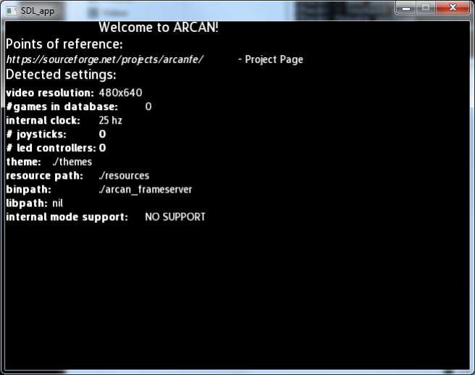
The welcome theme looks something like the screen-shot above. Worth to note here is the “#games in database”, “theme”, “resource path” and “libpath” values, particularly for OSX/Linux users as the path where the program binaries, resources and themes are placed is determined dynamically and may depend on distribution, configuration and environmental variables. These search-paths can also be overridden with command-line switches.

Troubleshooting:
If this window does not appear, there are a few options (ordered likely to unlikely)
- OpenGL drivers (make sure you have the latest ones, particularly for those running on Win/Lin)
- Damaged theme resources (<resourcepath>\fonts\default.ttf could not be found)
- Damaged theme script, redownload and reinstall, check <themepath>\welcome\welcome.lua
There is usually some troubleshooting trace data to be found on ”stderr”. For some windows versions, this is silenced by some builds of external dependencies. To force tracing error data to a file, use the -2 filename command-line argument.
.2 – eventtest theme
This theme allows you to test all different kinds of keyboards, mice, joysticks etc. that might be hooked up to your system. When you first launch however, you'll likely see something like:
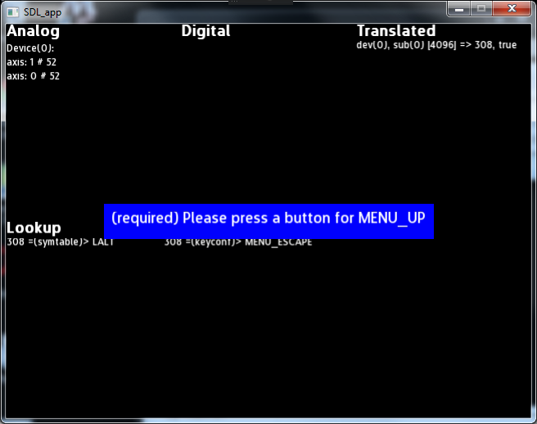

The blue box will reappear in most themes, and is part of a support script found in <resources>/scripts/keyconf.lua and is used to query a user for inputs matching different events
MENU_ESCAPE is always the first label this script will try to define, as that can be used to skip other options (not marked as 'required'). You can map many labels to the same button, their actual effect will depend on the theme it is used in.
Now you can make sure that all the devices you like to be able to use are actually detected and work.

Troubleshooting:
If, after you have defined a few labels, the dialog doesn't disappear, this means that the script could not save the configuration. This happens when you don't have write- access to your theme- folder (and subdirectories). Change permissions for both your resources and your themes subtrees.If you want to reset the keyconfig, delete the <themepath>/<current theme>/keysym.lua
.3 – soundtest theme
This theme is provided to make sure that your system can handle both music playback and sound samples. Launch the theme, press 'c' on your keyboard and listen for a familiar sound ;-)
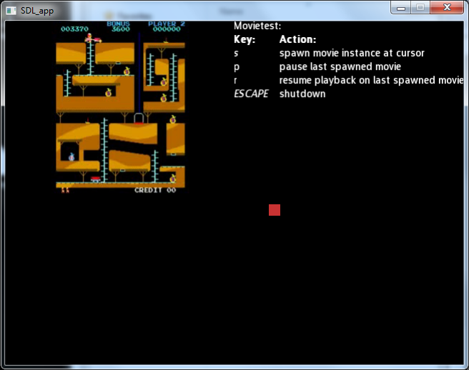
If that works, proceed to press 'd' and make sure that you hear music playing.

Troubleshooting:
Make sure that sound works in other parts of your system (so we can exclude wiring, speakers, drivers, volume, ...) check the themefolder so that both the samplefile and the musicfile is included. If all that checks out OK, remaining culprits would be sound-card drivers + OpenAL combination (check for new drivers) along with permissions and possible conflicts with various sound daemons (important for the Linux- crowd).
.4 – movietest theme
Immediately upon launch, you should see a video-clip playing in the topleft corner of the screen and a red box acting as mouse cursor. Let the clip loop once and make sure it restarts properly. Spawn a few more movie playback sessions by pressing S (these will not loop).

Note that the movie playback is not as robust in terms of supported formats (huge topic) and is indended for small video snaps, not being a full-on movie player. There is a known issue with frameserver and audio buffering on some windows configurations when audio starts repeatedly playing the last second of audio on high load and certain Window Manager events.
Troubleshooting:
Make sure that the frameserver was found properly, this can be seen in the display from the Welcome theme. Check that the permissions on the arcan_frameserver binary are correct (albeit it won't launch properly outside the confines of the main program).

2. Configuration
For remaining tests, and getting any use out of the program, we now need to set up an emulator to launch, some games and some media to present alongside. It is assumed that you have some experience as to how this works for mame- dedicated frontends (regarding roms, video-snaps and screenshots).
Locate the resource folder- for your installation.
Note the folders marked 'targets', 'games', 'movies', 'screenshots'.
There is a strong connection between file-system layout, database and how Arcan behaves. A 'target' is simply a launchable binary residing in <resources\targets\targetname>. For each target, there should be a corresponding folder in <resources\games>. These then have to be entered into the database <resources\arcandb.sqlite> for which there is a helper script (”romman”).
.1 – mame
First, copy or link your precompiled mame binary into <resources\targets> as 'mame'.
Second, create a subfolder in <resources\games> also called 'mame'.
Copy some romsets into the <resources\games\mame> folder.
Copy matching screenshots into <resources\screenshots> and movieclips (avi) into <resources\movies>.
Now we want to use the romman tool to scan, verify, import etc. these roms into the database.

Windows
For the prebuilt Windows installation package, there's a Build DB shortcut that will do this for you, click it, and if your folders, mame etc. all were layed out correctly, you'll see them being added in the terminal window.

Linux / Mac OSX
For Linux/OSX, make sure that you have ruby (preferably 1.9) installed, and that the two gems 'nokogiri' and 'sqlite3' are also installed ( running gem install nokogiri sqlite3 as administrator should do the trick). If you installed from the Ubuntu/Debian .deb package, this should be fixed already. This is the point where aforementioned terminal is useful.
Change directory to your resource folder (or write the full path and use the --dbname, --rompath, --targetpath arguments).
arcan_romman.rb builddb --mamegood --mameskipclone --mameshorttitle
Suffice it to say that there is a large number of arguments that this tool accepts, and while most of them are fairly obvious, note that [gamepath] and [romset] as part of an argument will expand into <resourcepath\games> and the 'setname' field for the game in arcan_db.c when launching a target. To expand upon this tool, look into <resourcepath\scripts\importers> and look at generic.rb, mame.rb and scummvm.rb for the general patterns on how, as the romman_base.rb is quite messy.

Command-line arguments
With any luck, you should now be able to relaunch the Welcome theme, and the # of games detected should correspond to what you placed in games\mame.
Now you have two sample themes are your disposal, dishwater and space (note: these will not launch unless there are games found in the database). Linux and Mac users also have a more esoteric 'internaltest' that demonstrates the basics of the internal launch mode.
When things work the way you want them to, there is a set of command-line arguments that can be used to tweak general behavior regarding video, paths etc. for tighter integration with your project, for troubleshooting and testing different video resolutions etc. These are currently:
[Video Options]
-w, --width force specific width
-h, --height force specific height
-f, --fullscreen toggle full-screen mode, this might not work properly on all platforms
versions and driver- combinations as it will also switch resolution to
-w <width> -h <height>
-s, --windowed set width/height to your desktop resolution (faked fullscreen)
-m, --conservative reduce memory usage in favor of more disk I/O
-r, --scalemode change the default (themes can override as well) for how textures are
managed when they do not have a power-of-two dimension;
0 means that your graphics card supports non-power-of-two textures
1 means that images are forcibly scaled (become slightly less sharp)
2 means that we waste some memory and tweak texture coordinates

[ Input / Output options]
-p, --rpath set a specific resource- path
-1, --stdout filename redirect stdout to filename (might be needed on windows)
-2, --stderr filename redirect stderr to filename (might be needed on windows)

Currently, the LUA API is sparsly documented, there is a small cheat-sheet of functions added in <resourcepath>/doc/cheatsheet.pdf

