Lab5. Using UCSC Genome Browser to explore DNA sequence and to generate a gene model (annotation).

Learning Objectives:

You will learn to:
1. Visualize genes and gene predictions using UCSC genome browser.
2. Distinguish transcript sequence and coding DNA sequence (CDS).
3. Test the hypothesis that a newly sequenced genome has a gene homologous to one found in the annotated genome of a closely related species.
a. Predict location of a CDS (one coding exon) and test your prediction.
b. Retrieve the corresponding DNA sequence from the UCSC genome browser.
c. Translate the DNA sequence using ExPASy Translate tool.
d. Compare the predicted protein to a database of known proteins using blastp.

Goals:
1. Use UCSC Genome Browser and other tools to test the hypothesis that the unannotated D. erecta genome has a gene homologous to the D. erecta CG11077 gene.
2. Predict the location of its coding DNA sequence within the D. erecta genome.

Introduction

Genome annotation includes (among other things) finding genes and describing their structure. We will construct a putative gene model in Drosophila erecta based on high quality manual annotations available from a closely-related species (D. melanogaster). The first step is to visualize D. erecta genomic sequence in the context of the D. melanogaster expression data and sequence alignment, and in the context of computational predictions available. The UCSC Genome Browser (http://genome.ucsc.edu/) provides a convenient way to visualize the DNA sequence and other important information about the genome.

For annotation and practice, we will use a custom version of the UCSC Genome Browser hosted at Washington University in St. Louis (http://gander.wustl.edu). At this site, genomic sequences from several species of fruit flies have been partitioned into overlapping segments (contigs or fosmids) that correspond to different annotation projects.

1.1 How do I find a specific contig and a gene of interest?

Open the browser: go to http://gander.wustl.edu/
Click on “Genome Browser” from the blue menu on the left of the screen

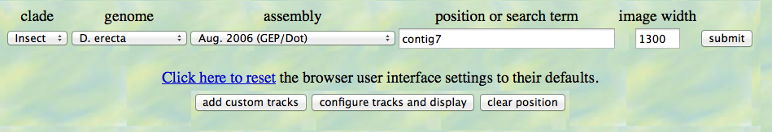
From the pull down menu on this page choose:
genome : D. erecta
assembly: Aug 2006 (GEP/Dot)
position: contig7
click “submit” button
You will see a very busy intimidating page, which can be divided into 3 parts: Navigation area, the Track Display Window, and the Track Menu. Be sure you can distinguish these three sections on the browser page.

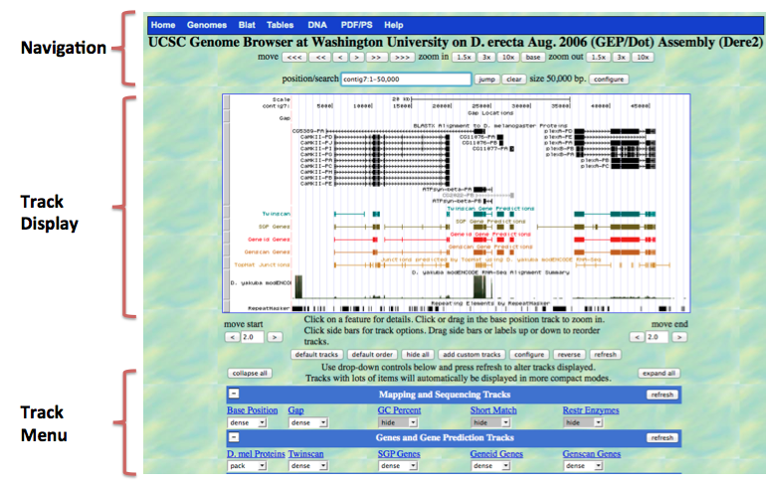

Track Display Window
The top of the track display window starts with a scale and a Base Position track that indicates the base position (i.e. nucleotide number) of the region being displayed. This is similar to an X-axis with coordinates (base position). The various colorful lines and boxes below the sequence are evidence tracks and experimental data that have been mapped to the genomic location indicated by the base position track.

You can change what you see in this display window using two types of controls: navigation controls and track menu.

NAVIGATION CONTROLS
Above the track display window, navigation controls allow you to move along the chromosome and zoom in and out. Buttons next to “move” allow you to move left or right along the sequence in small (>) or large (>>>) steps.

Find the small black gene model for CG11077 near the center of the row of BLASTX alignment results. Use the various navigation controls in a trial and error fashion until you display the gene CG11077 in the track display window (no other genes).

Question 1: Write down the information you now have in the position/search window of the navigation section. Contig7:____________________

Now, we will zoom all the way to the “base” level. (First, make sure that the Base Position track in the Track Menu is set to “full.” If it isn’t, change it to full using the drop down menu, and then click on the refresh button.) To zoom to the base level, keep zooming in by 3X or 10X steps, or just use the “base” button until you see the letters CGAT etc. displayed just under the base position bar. Notice the arrow in the top left corner of the display window (just under words “contig 7” – if you click on the arrow, you will change which DNA strand is displayed (forward or reverse).

Question 2: What is the meaning of the alternating dark and light grey rectangles under the base sequence in the display window?

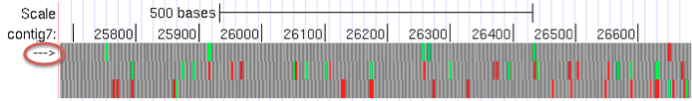

TRACK MENU
Below the display window, there is a menu that allows you to choose what type of information you want to view. (The lines of information are referred to as “tracks”.)

Tracks are grouped into categories: Mapping and Sequencing tracks, Gene and Gene prediction tracks, etc…. If you want to see the description of a track – click on the name of the track (blue, underlined).

Question 3. Look at the description for the Genescan track. This track predicts the protein coding regions of genes using only clues in the genomic sequence being displayed, in the case D. erecta. List the sequence clues the software uses.

You can control how compactly the information for each track is presented or whether it is hidden. Setting “full” – displays each feature on a new line. “Dense” displays all the features of the track on a single line, irrespective of whether they overlap with each other. After modifying the track display options, always update the track display image by clicking on the “refresh” button.

1.2 How do I predict the location of the CDS?

Changing the display: Start by hitting “hide all”, then “refresh.” Your display now is not very informative!

Next, change the track settings to the following (from top to bottom on the track menu): Under “Mapping and Sequencing Tracks”, change Base Position to full
Under “Genes and Gene Prediction Tracks”, change D. mel Proteins to full, and the remaining tracks in this section (e.g. Twinscan, Genscan Genes) to dense. Click the “refresh” button.

Sequence tracks: At the top of the Track Display you will see a nucleotide sequence, and immediately below, a translation in three reading frames in the orientation indicated by the arrow at the top left corner. Because the arrow is pointing from left to right, the translations correspond to the three reading frames in the positive strand, i.e., the strand in which the amino acids are decoded in the direction of increasing base position number. We will refer to these as +1 (top), +2 (middle) and +3 (bottom). You can see the other three reading frames (-1, -2, -3) by clicking on the arrow at the top left of display window. Methionines (start codons) are highlighted in green, and stop codons are in red.

Gene and Gene Prediction tracks: Below the base position track, the “D. mel Proteins” track shows the regions of the contig that have sequence similarity to proteins found in D. melanogaster. Zoom out 10X. The solid black rectangles show matches between amino acid sequences that would be encoded by the D. erecta genome and known proteins from D. melanogaster. Gene prediction tracks below (in color) show connected rectangles (exons) where protein coding genes have been predicted in the D. erecta DNA sequence by the various gene predictors (e.g. Twinscan and Genscan) . Note that there can be differences in gene models predicted by the different programs.

Question 4. Is the Genescan prediction shorter than, longer than, or the same as the Twinscan prediction?

In the gene prediction tracks, coding exons are represented by rectangles connected with horizontal lines representing introns. In full display mode, arrowheads on the connecting intron lines indicate the predicted direction of transcription.

Gene Annotation: When we annotate a putative D. erecta gene, we will use gene prediction tracks, the D. mel Proteins track and other evidence tracks to define the precise location of the coding DNA sequences (CDS) within the genomic sequence. Note that “gene” is not synonymous with transcript or CDS. Gene includes regulatory regions of the genome in addition to the region that is transcribed to make the primary transcript, which can be processed to make alternative transcripts (isoforms) that are derived from alternative splicing of the primary transcript. A mature mRNA transcript includes the CDS and the 5’ and 3’ untranslated regions (UTR). However, the non-coding regions of a gene are more difficult to define and we are not going to annotate them at this time.

Use the navigation features of the genome browser to identify the location of the CG11077 CDS
Zoom in and out on both strands to predict the location of the CG11077 CDS:

Question 5. Reading frame ___________________ (e.g. +1, -1)

Location of start codon _____________ (specify nucleotide position)

Location of the last coding nucliotidet________ Stop codon________(range)

Write the sequence within reading frame _____

Notice that there are three possible start codons to consider:
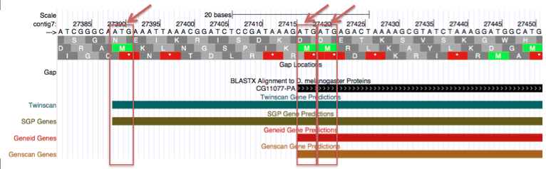

When we construct a gene model, we are actually testing a hypothesis – the hypothesis that the D. erecta genome has a gene homologous to one found in the D. melanogaster genome. Hence we need to collect evidence that supports the conclusion that the exon coordinates are correct. To do this, we will retrieve predicted coding DNA sequence, translate it, and compare it to D. melanogaster protein sequence. It is usually a good strategy to start with the largest plausible exon, but be aware that this model may require modification!

1.3. How do I retrieve DNA sequence using the UCSC Genome Browser.

On the Blue menu across the top of the page (just above the words “UCSC Genome Browser”) click on “DNA”
↓
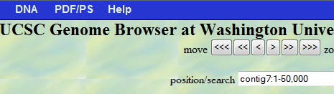

It is possible to get the DNA sequence of any portion of a contig or of the entire contig. You will retrieve the DNA sequence of just the portion that you have predicted to be the CDS of a D. erecta gene. To do this, following the “contig7:” type in the location/coordinate of your start codon, and of the last nucleotide of the stop codon from section your answer to question 5. Click on “get DNA” to see the sequence in FASTA format. (Details on the FASTA format are found at: http://blast.ncbi.nlm.nih.gov/blastcgihelp.shtml .) Copy and paste this sequence into a text file and save it - this is your predicted CDS.

1.4. How do I translate CDS?

Go to ExPASy website and find and launch the Translate tool (http://www.ebi.ac.uk/Tools/emboss/transeq; an alternative translator can be found at http://www.fr33.net/translator.php)

Paste your DNA sequence into the window and translate.
Copy and paste and save your predicted protein sequence into a text file.

1.5. How do I check whether I chose the best Start codon?

Let’s compare your predicted protein sequence to known proteins using protein BLAST at NCBI (http://www.ncbi.nlm.nih.gov/blast/Blast.cgi). The purpose for doing this is to determine whether or not there is additional supporting, but not conclusive, evidence from other sources for the existence in D. erecta of the protein you have predicted.

Choose a protein blast program to run. Paste your predicted protein into the Query window; choose “Non-redundant protein sequences (nr)” under the “Database” field; then enter “Drosophila melanogaster (taxid: 7227)” under the “Organism” field and click on the BLAST button (see arrows on the screen shot below).
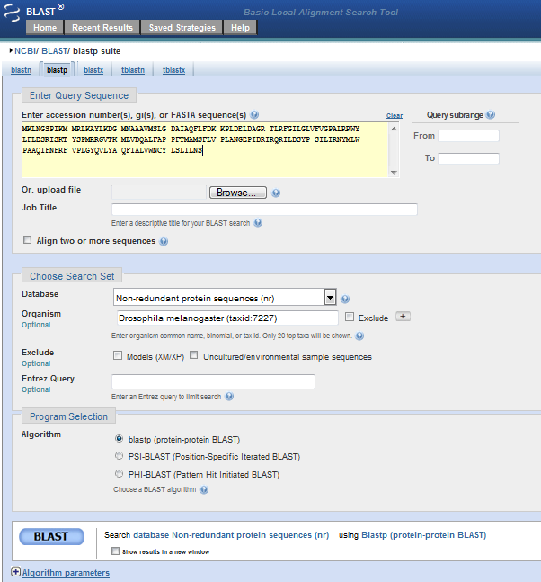

Examine the BLAST output and answer the following questions.
Note that the BLAST help pages can be found at the top navigation bar of the BLAST output page or through the NCBI Bookshelf at http://www.ncbi.nlm.nih.gov/books/NBK21097/.

6. How long is your query sequence? _______________
(Hint: find the number of aa at the top of the output page)

7. Is the top D. melanogaster match CG11077? YES or NO

8. Conclusion: Record the coordinates for your final gene model below.

D. erecta gene model for homolog to CG11077
Strand: + or -

Coordinates of the CDS: ___________(range). Stop codon______________(range).

