UVEN 2 mk3 – Assembly Instructions
Version: v1.0
Date: 29.11.2025
Author: Simon Trendel

1. Purpose & Scope
Describe what this document covers.

2. Safety Information
- Warning: [Example warning]
- Caution: [Example caution]
- PPE: [Safety glasses, gloves]

3. Required Tools
Tool | Notes

4. Bill of Materials (BOM)
Item No. | Part Name | Qty | Notes

5. Assembly Overview
1. [Prepare workspace]
2. [Assemble base]
3. [Install wiring]
4. [Close enclosure]

6. Step-by-Step Assembly Instructions

Step 1: Interlock switches
Goal: Connect the cables to the interlock switches. Mount the interlock switches into their covers. The cables need to be sufficiently long for later connection. Polarity does not matter.
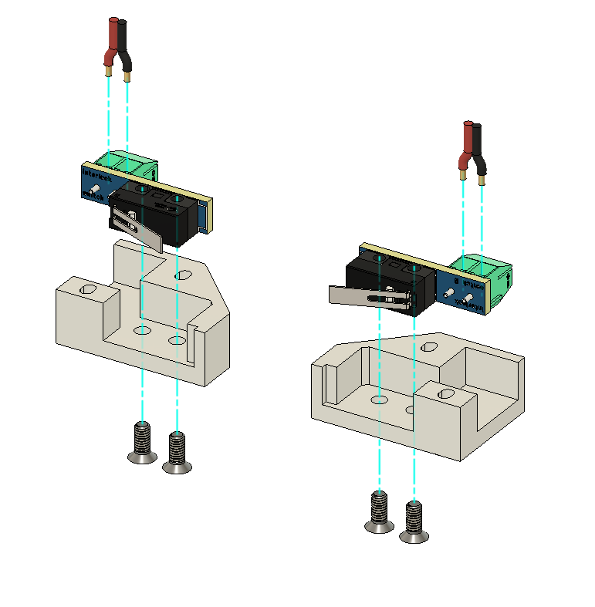

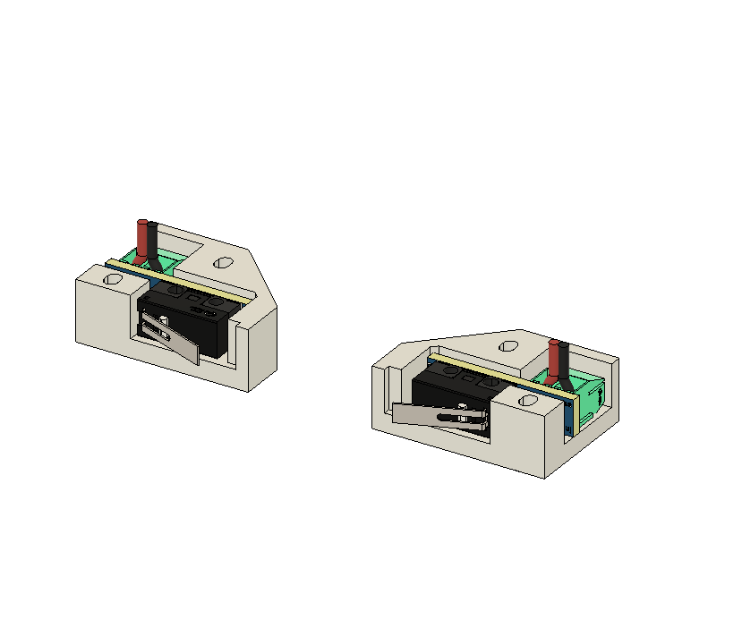

Step 2: Chamber fans, interlock switches, Magnets
Goal: Mount the 4 chamber fans using 16 x M4x18mm screws. Glue the magnets in. Mount the interlock switches from Step1 on either side using 2 x M2.5x12mm screws each. Glue in the 4 magnets.

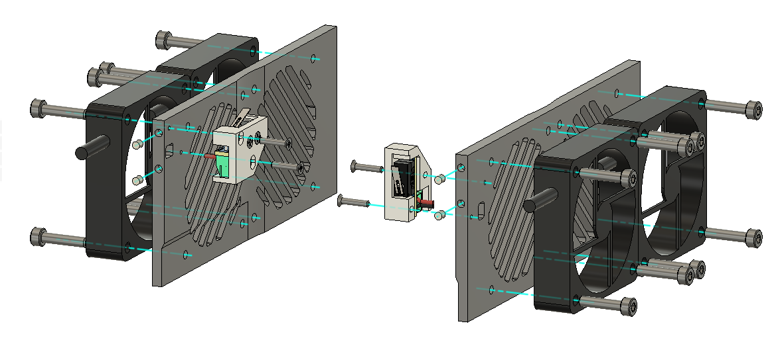

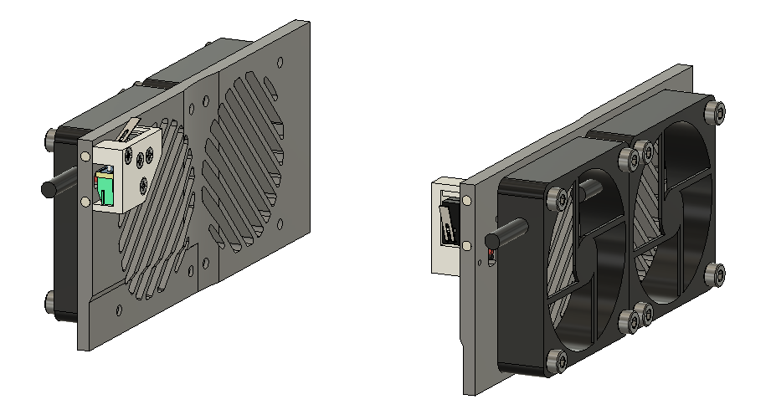

Step 3: Quartz glass, chamber sides
Goal: Glue in the quartz plate. Mount the chamber sides.
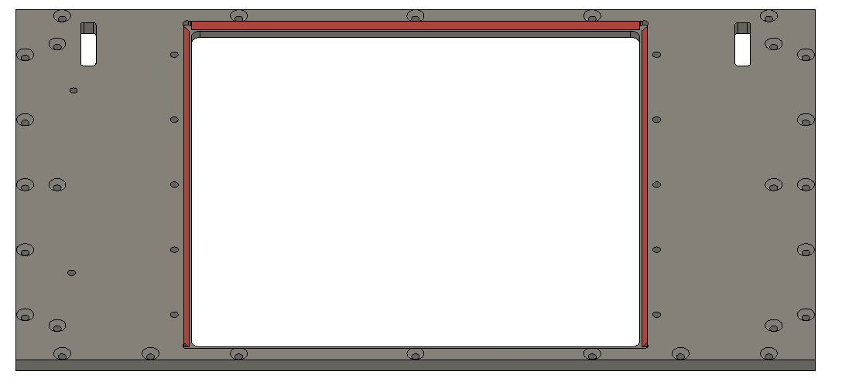
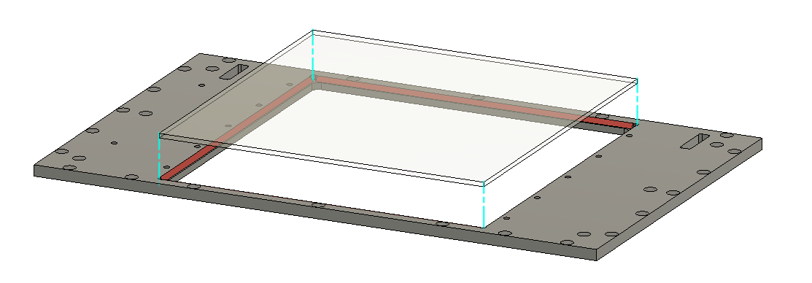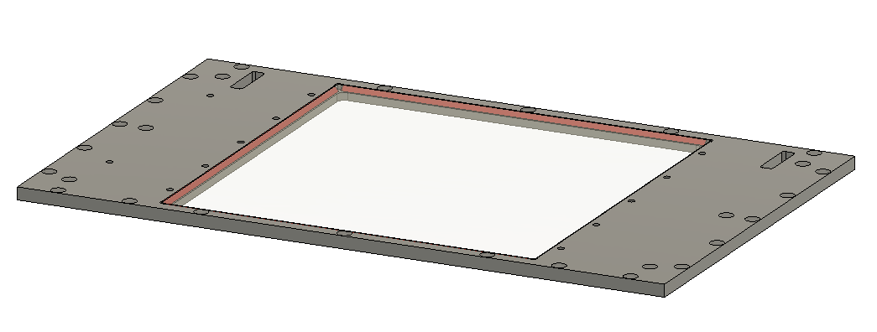

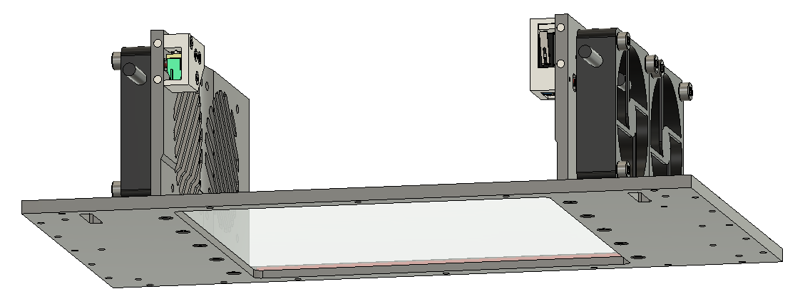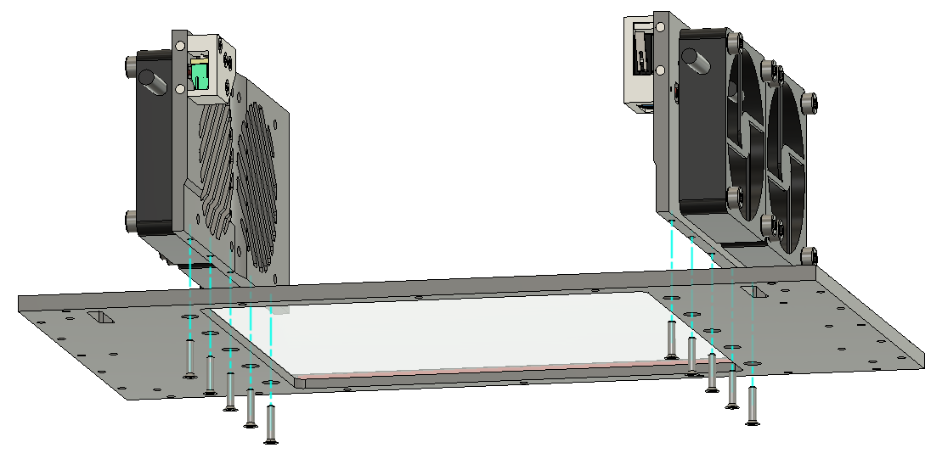

Step 4: Chamber plugs, hinges, endstop
Goal: Mount the chamber plugs using 8 x M2.5x12mm screws. Mount the hinges using 6 x M2x10mm screws. Mount the endstop using 5 x M2x6mm screws.
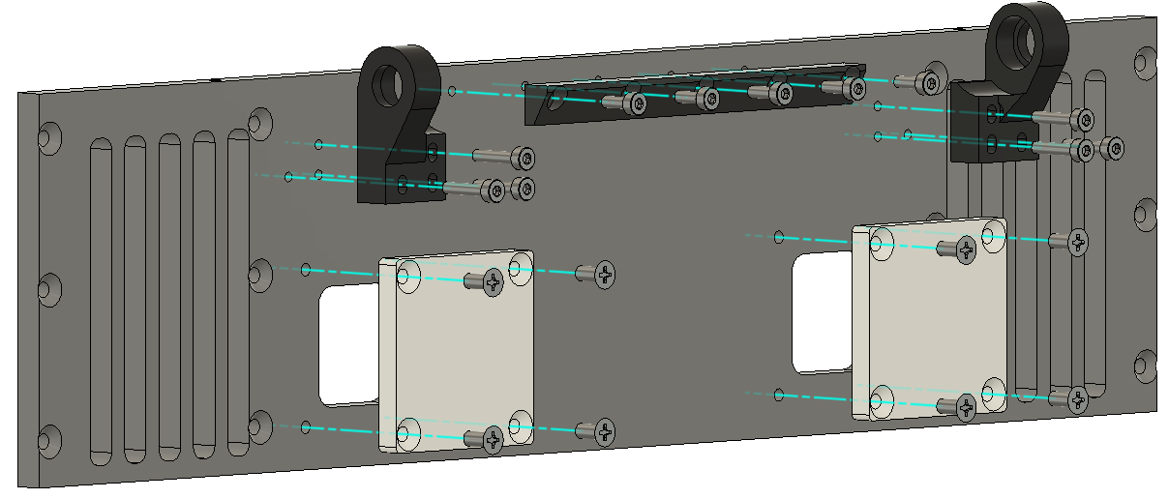
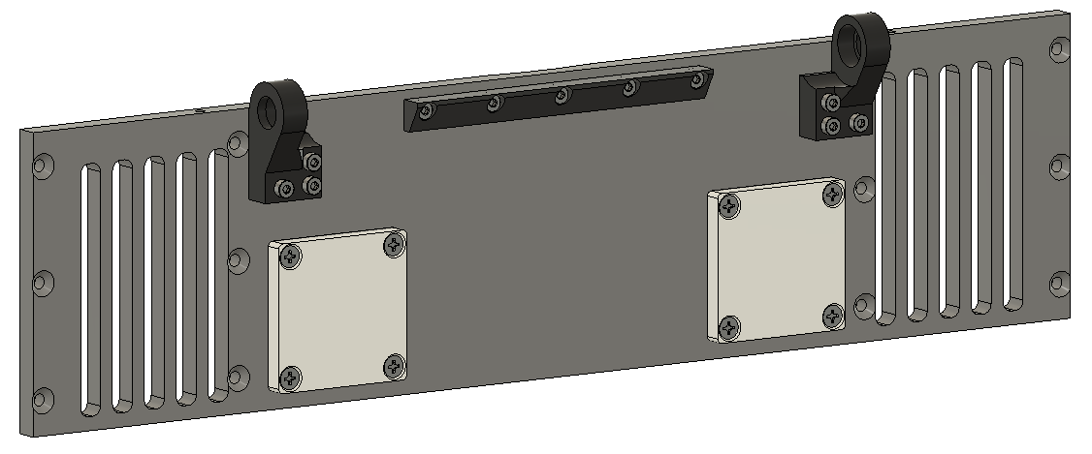

Step 5: Bearing/Bushing
Goal: Press fit the bearing/bushing.
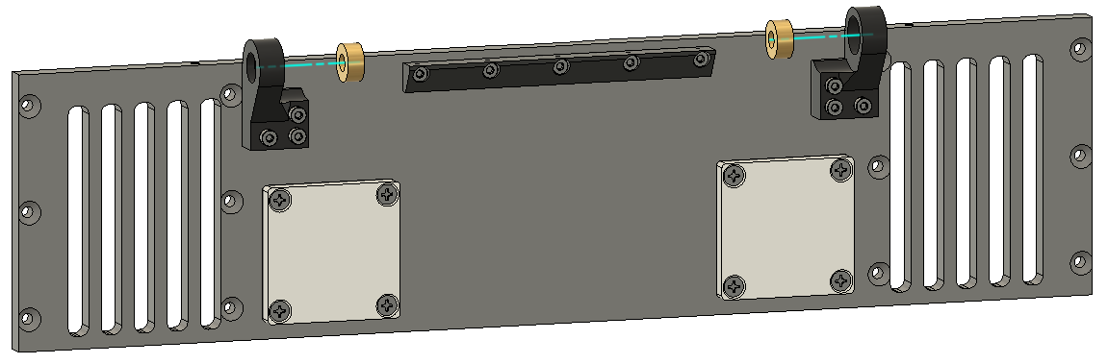

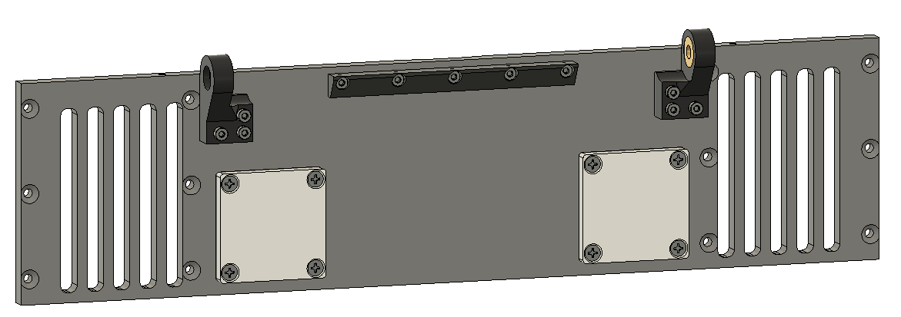

Step 6: Power switch, 12V power supplies
Goal: Mount the power switch using 2 x M3x8mm screws. Connect plug to switch (if not already connected). Attach GND, L, N cables. Use Wago 5x splitter to distribute four sets (one for each of the four 12V power supplies). Connect all four 12V power supplies to one of the power line sets. Connect the 12V power supply output cables 3xGND(black) and 3x12V(red) cables each. The cables should be long enough to reach one LED driver each.
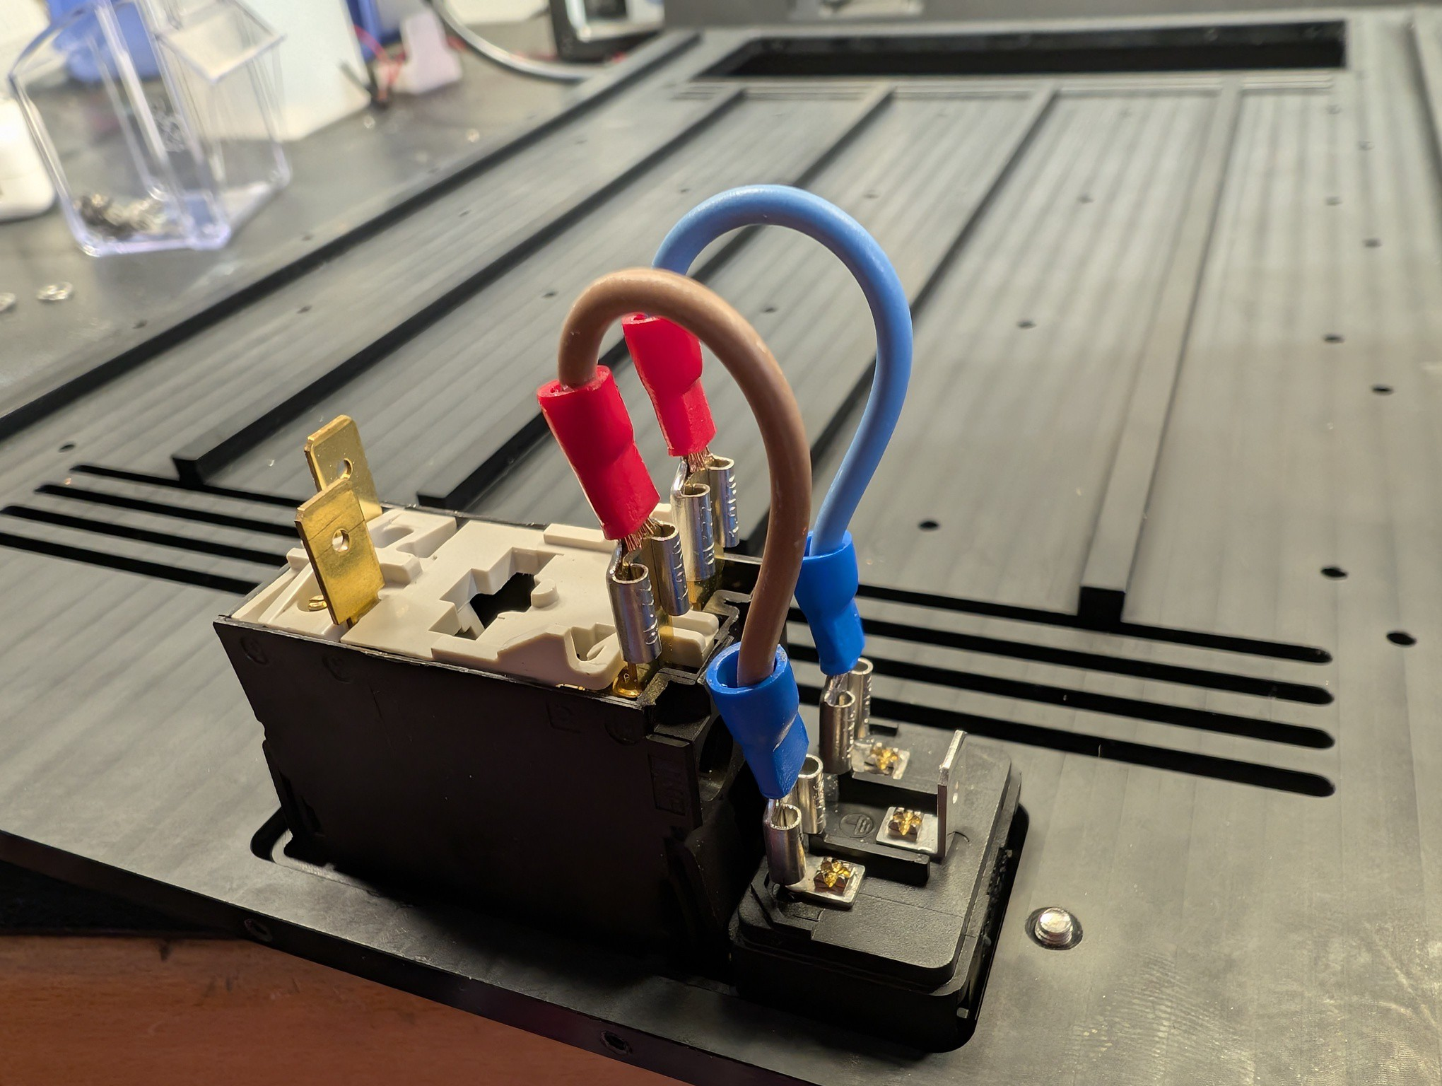
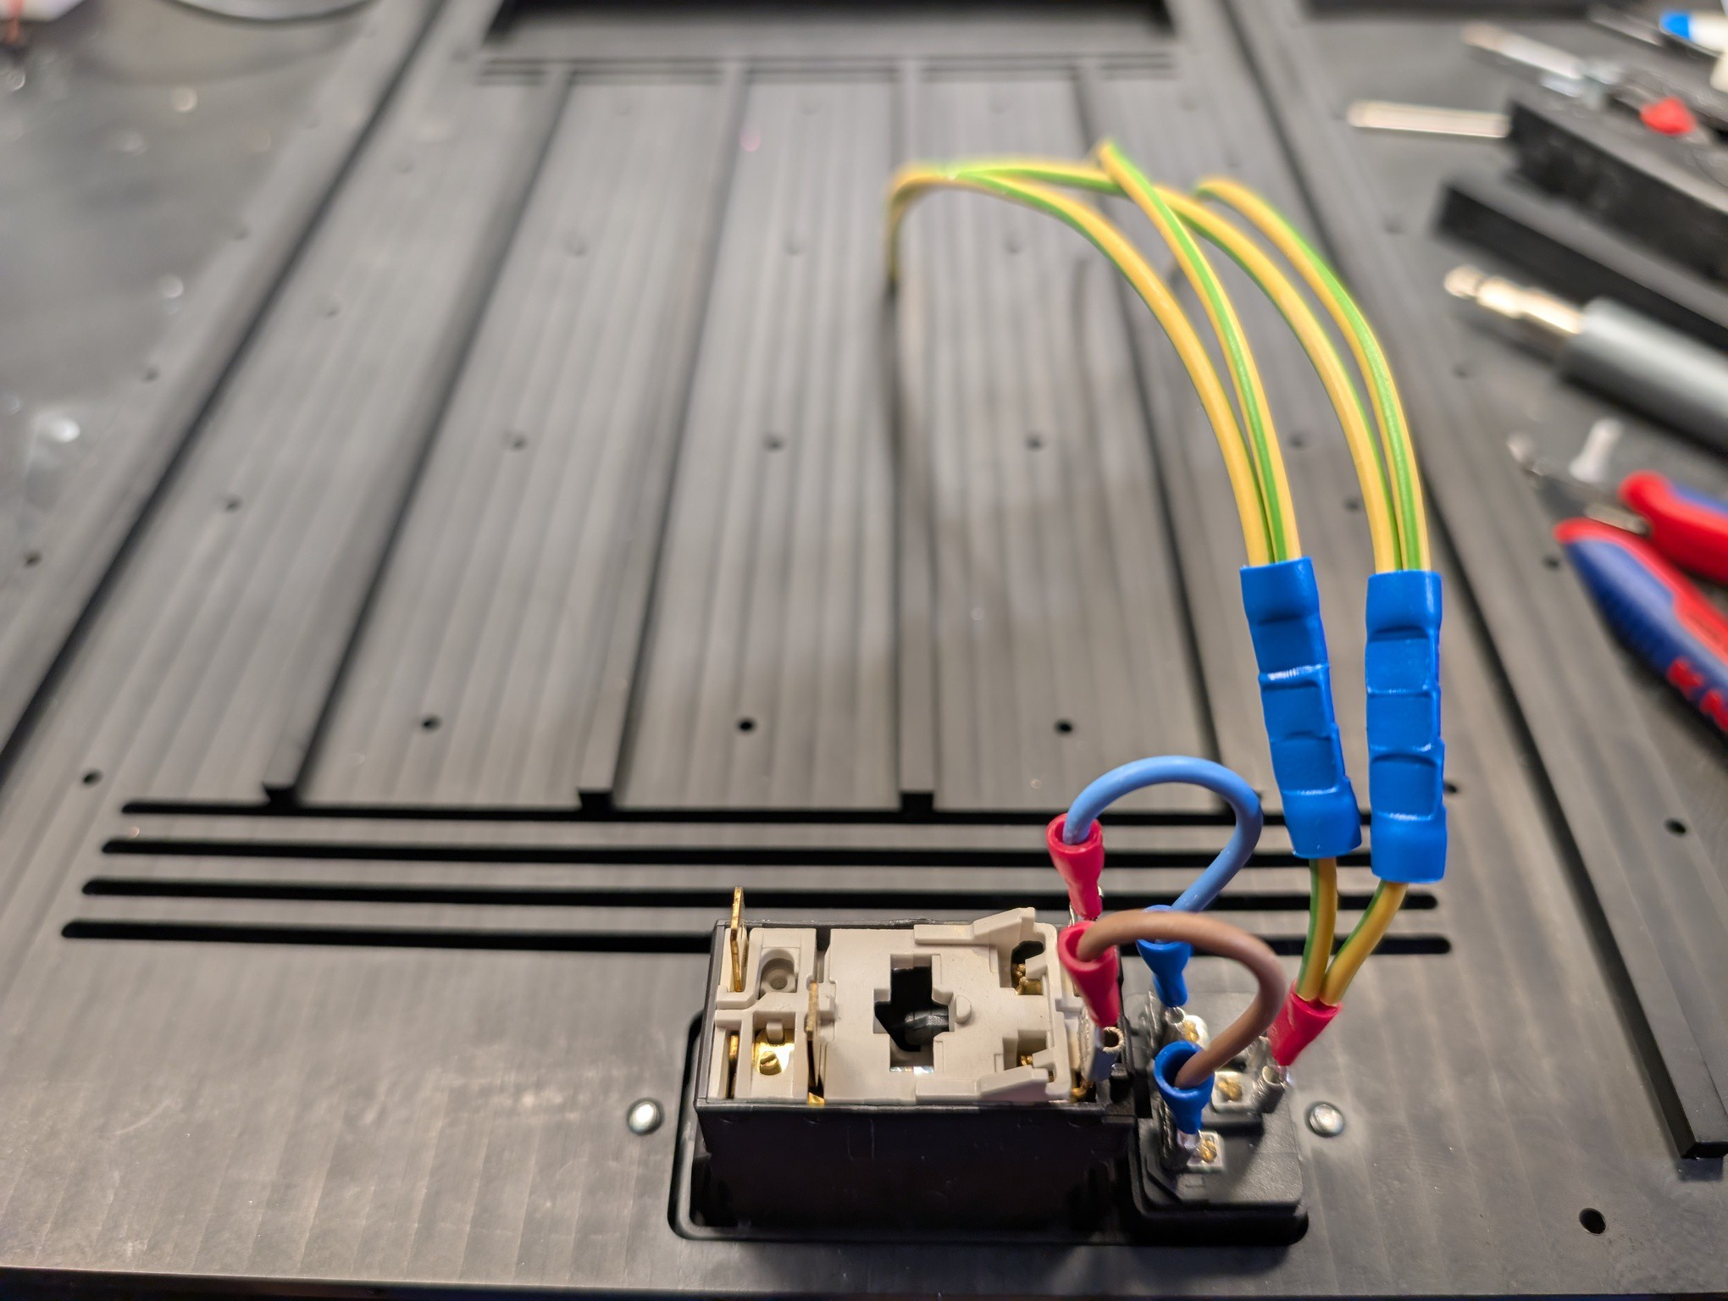
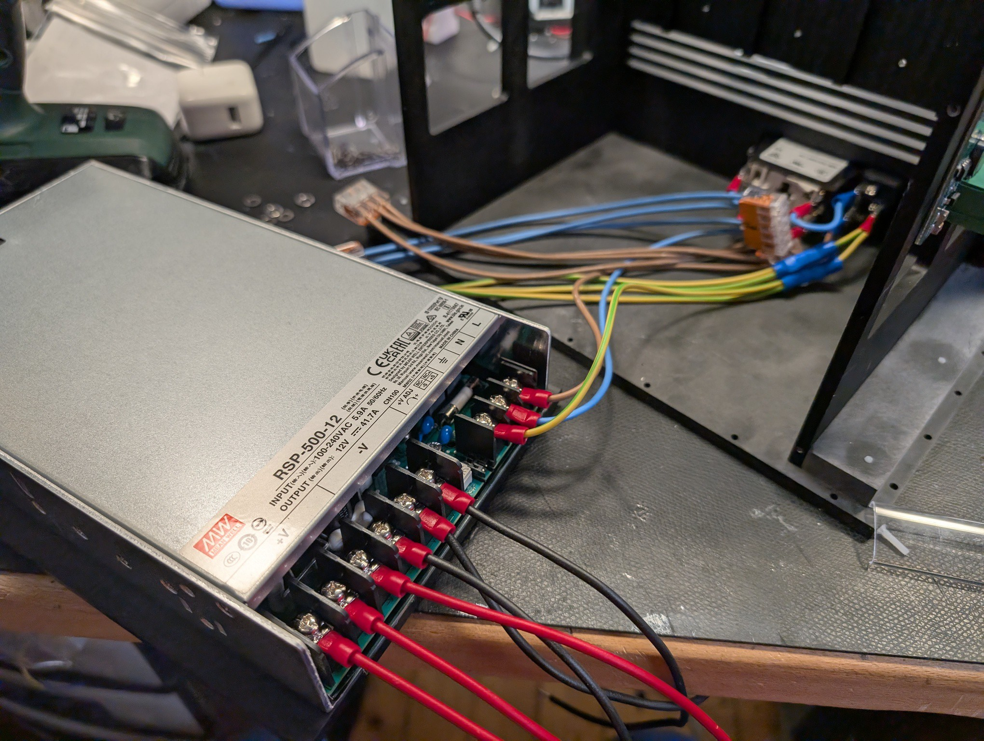

Step 7: Power supplies
Goal: Mount the power supplies to their holders using 4 x M4x8mm screws. Mount the holders to the backside using 4 x M2.5x12mm screws. Mount all four power supplies. Prepare each output cables such that they can reach their respective LED driver.
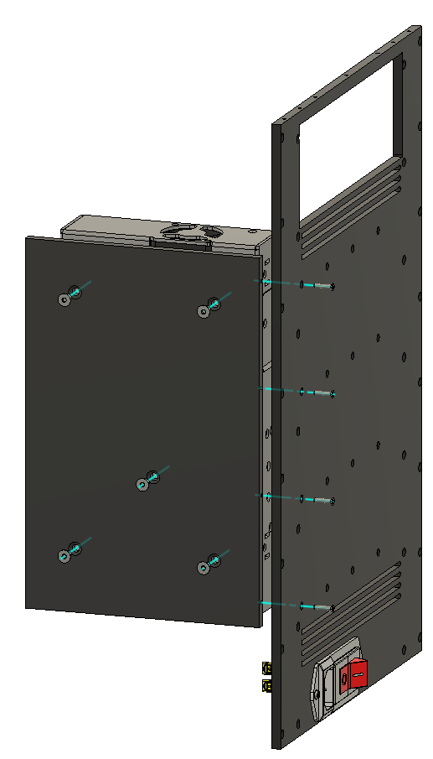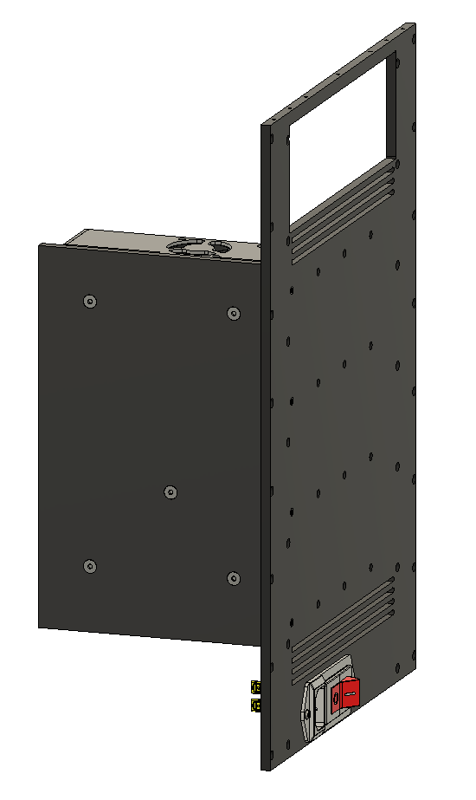
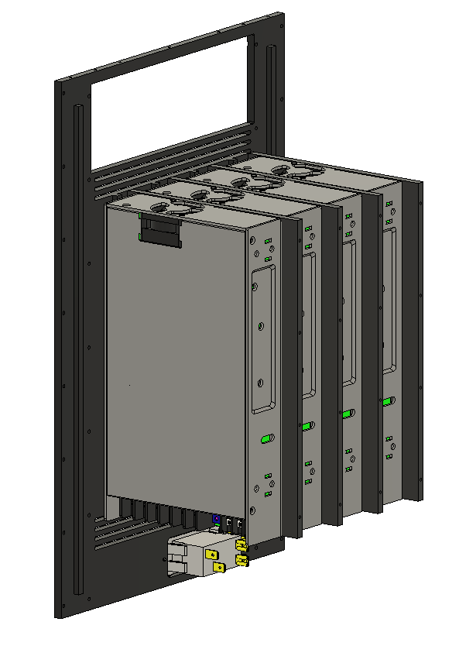

Step 8: Driver Sides
Goal: Mount the driver holders to the heat sink using 8 x M3X12mm screws.
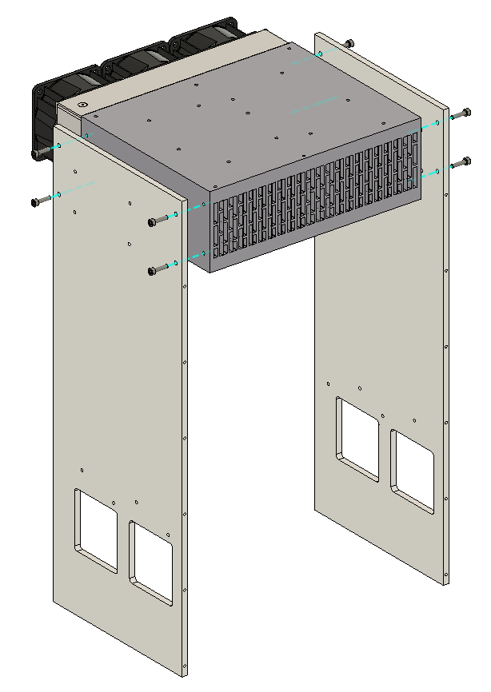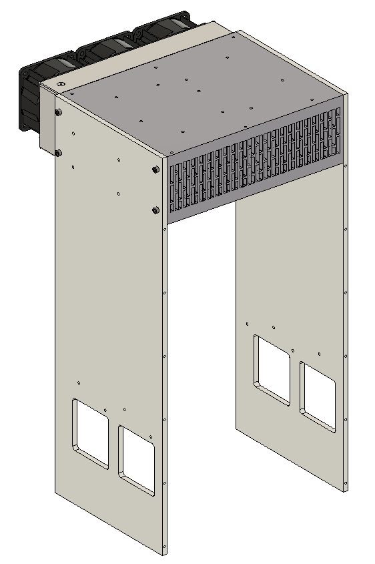

Step 9: Thermal paste and LED array
Goal: Apply a thin continuous layer of thermal paste. Mount the LED array using 15 x M3x6mm screws.
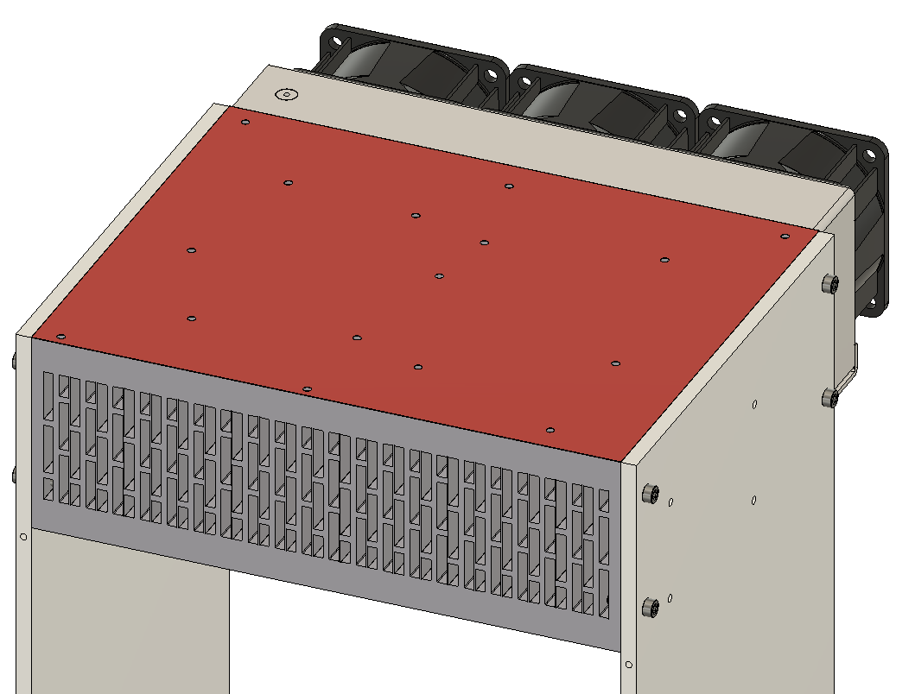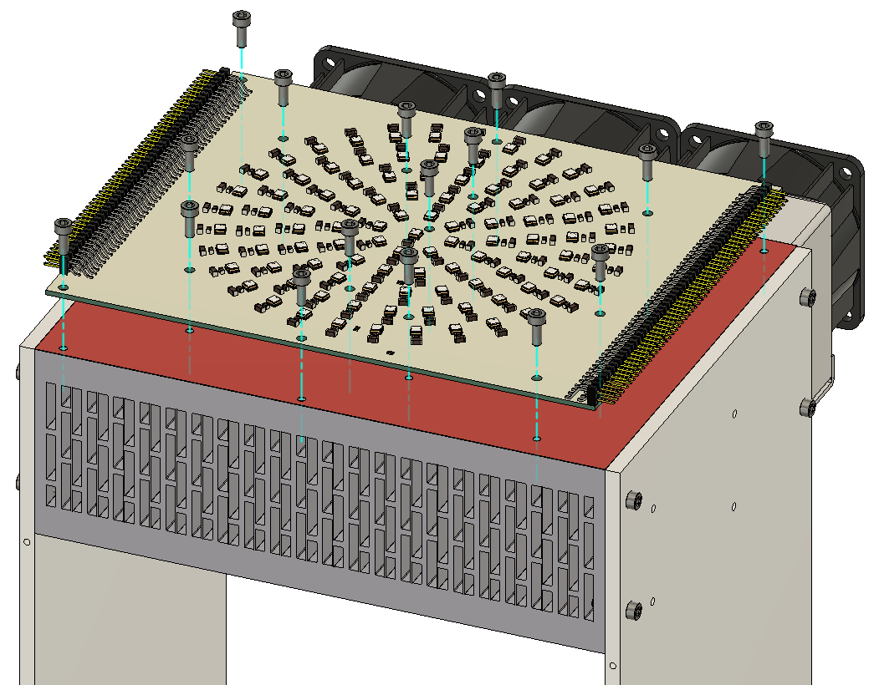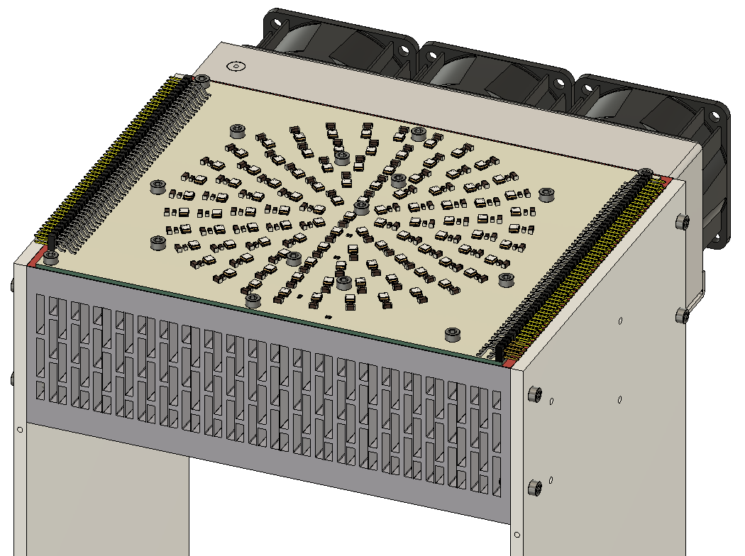

Step 10: Thermal tape and driver mount
Goal: Apply thermal tape to the driver sides or the LED drivers. Mount the four LED drivers using 4 x M3x6mm screws each.
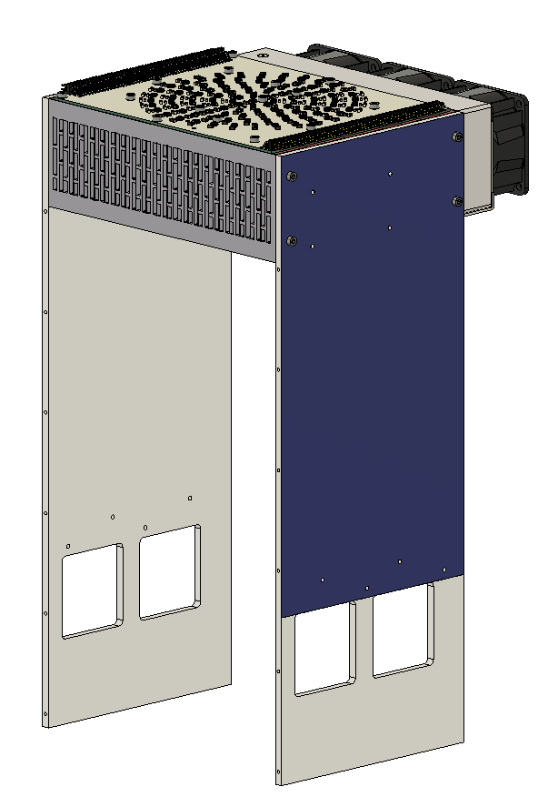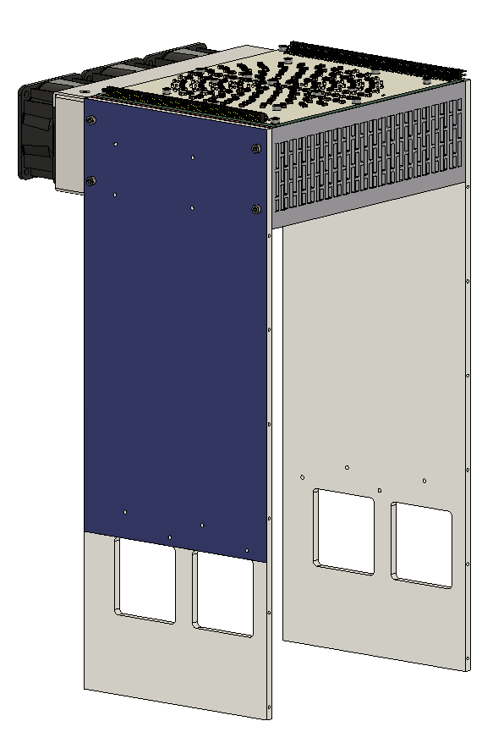
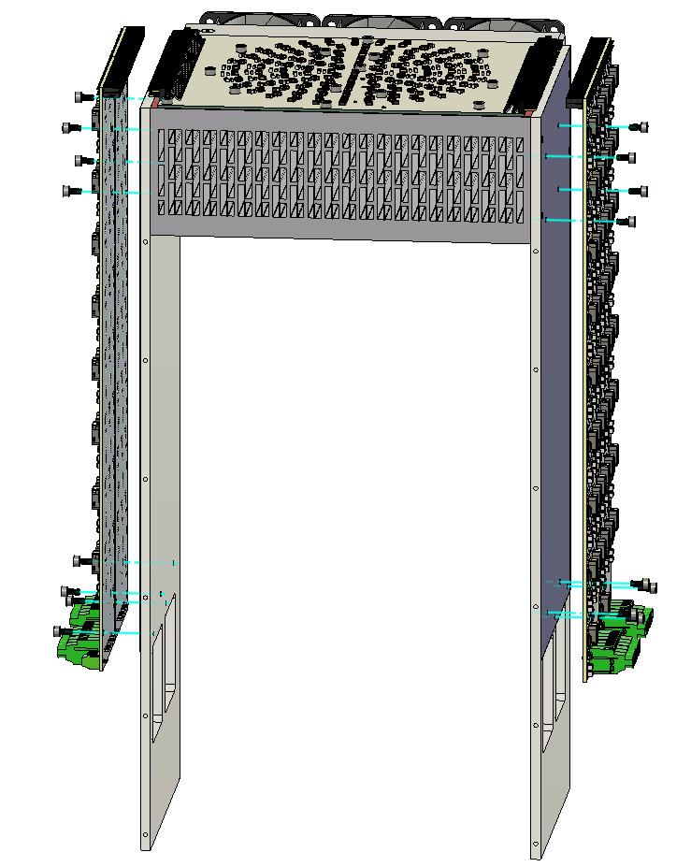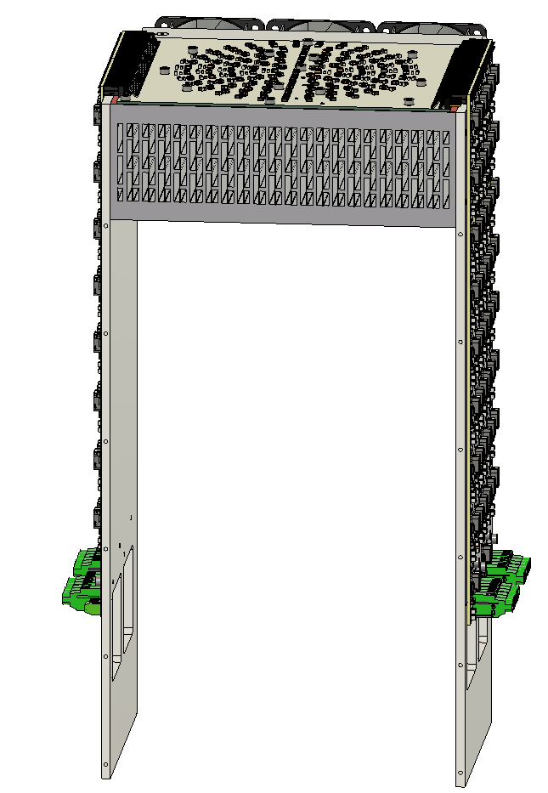

Step 11: Connect 12V supplies
Goal: Connect one 12V output to each LED driver using the screw terminals.
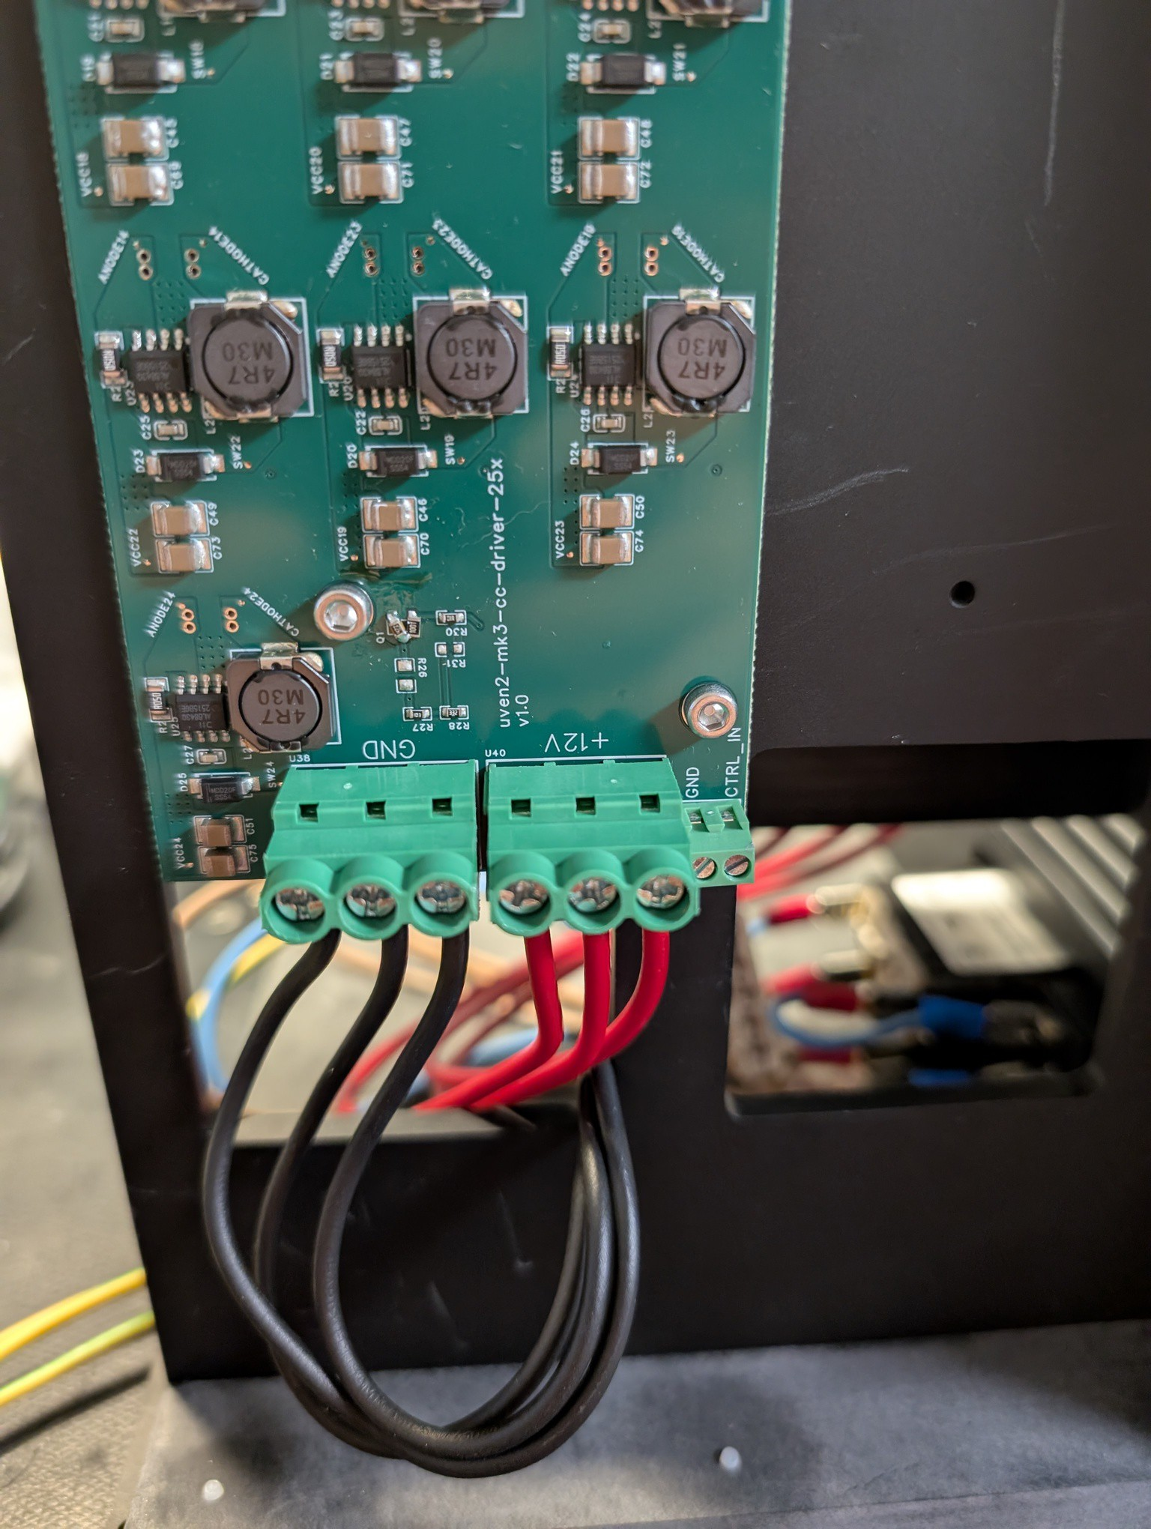
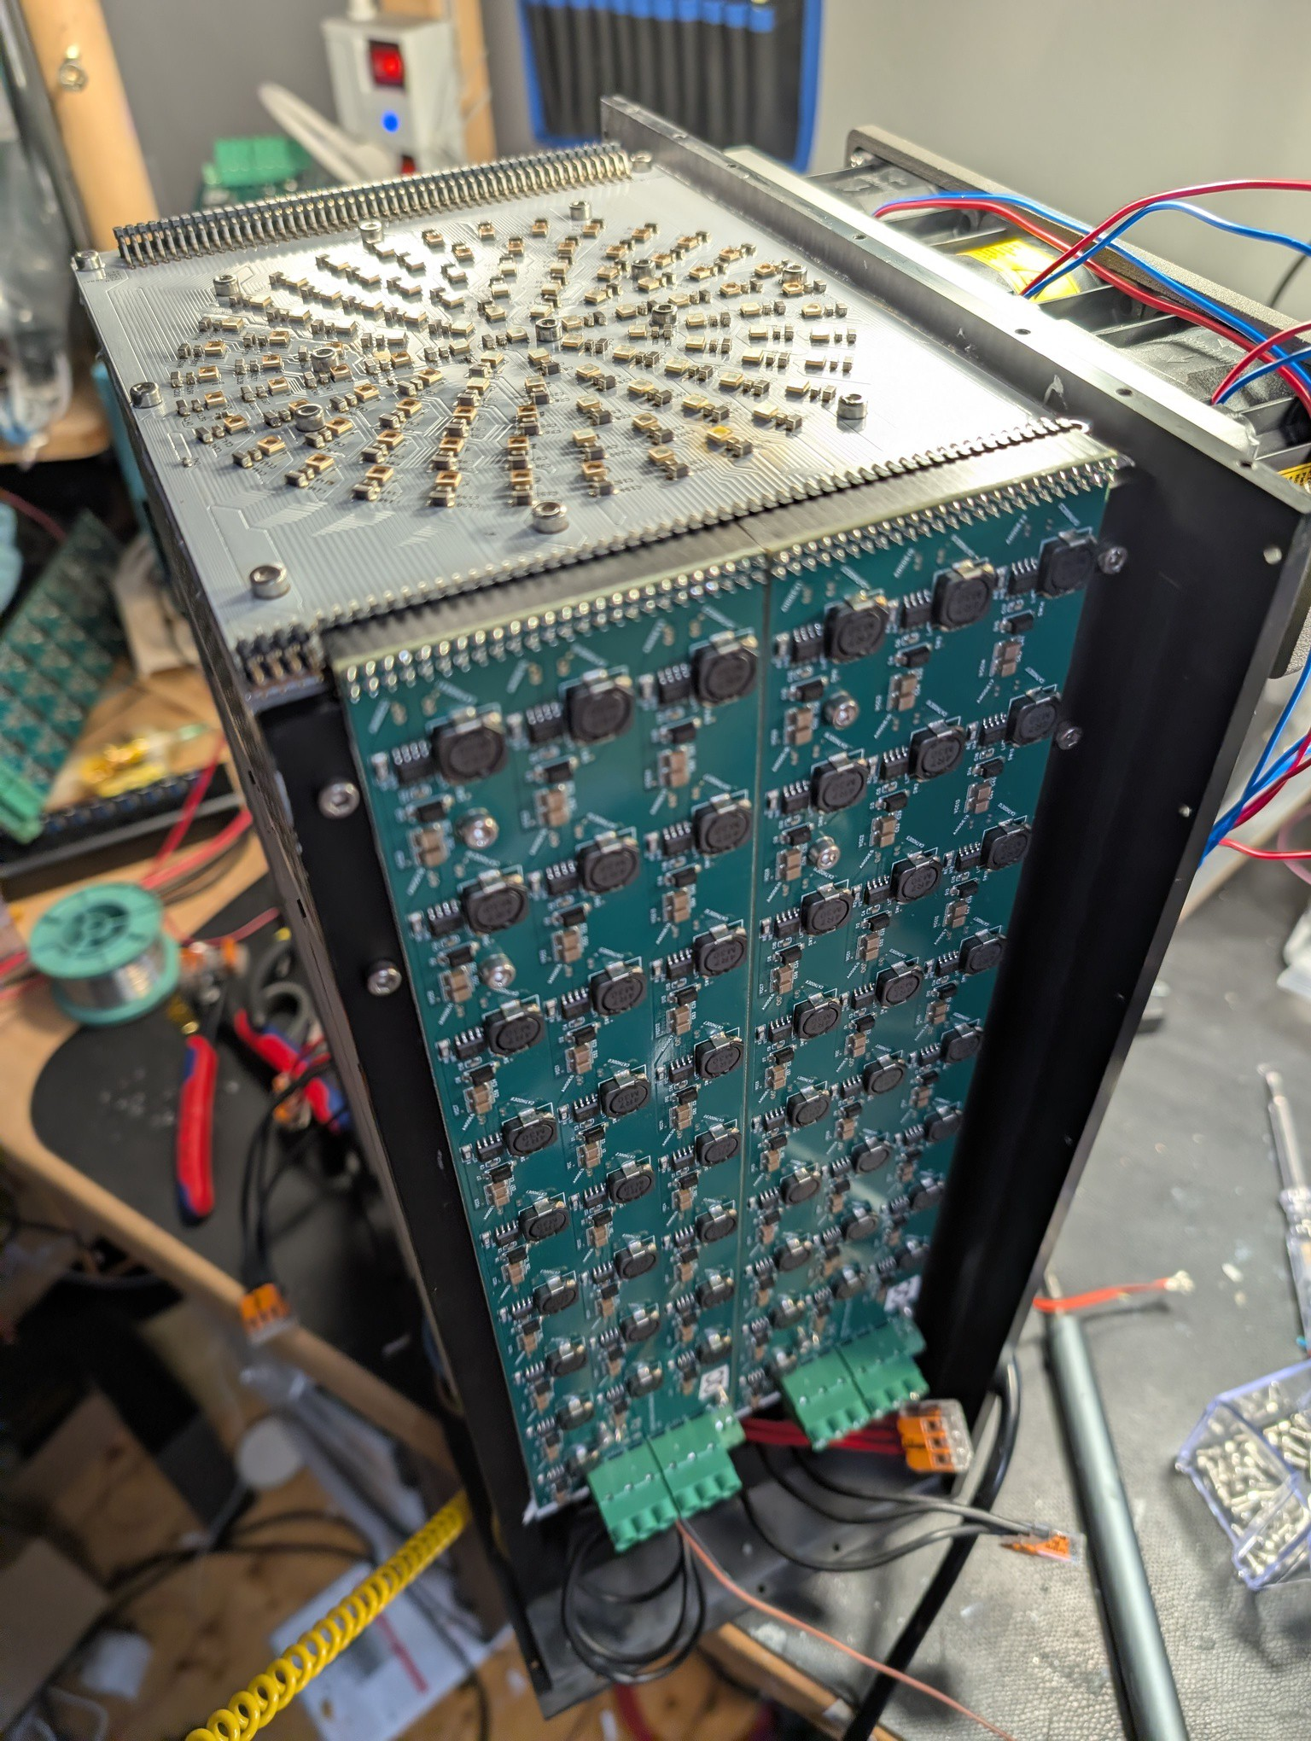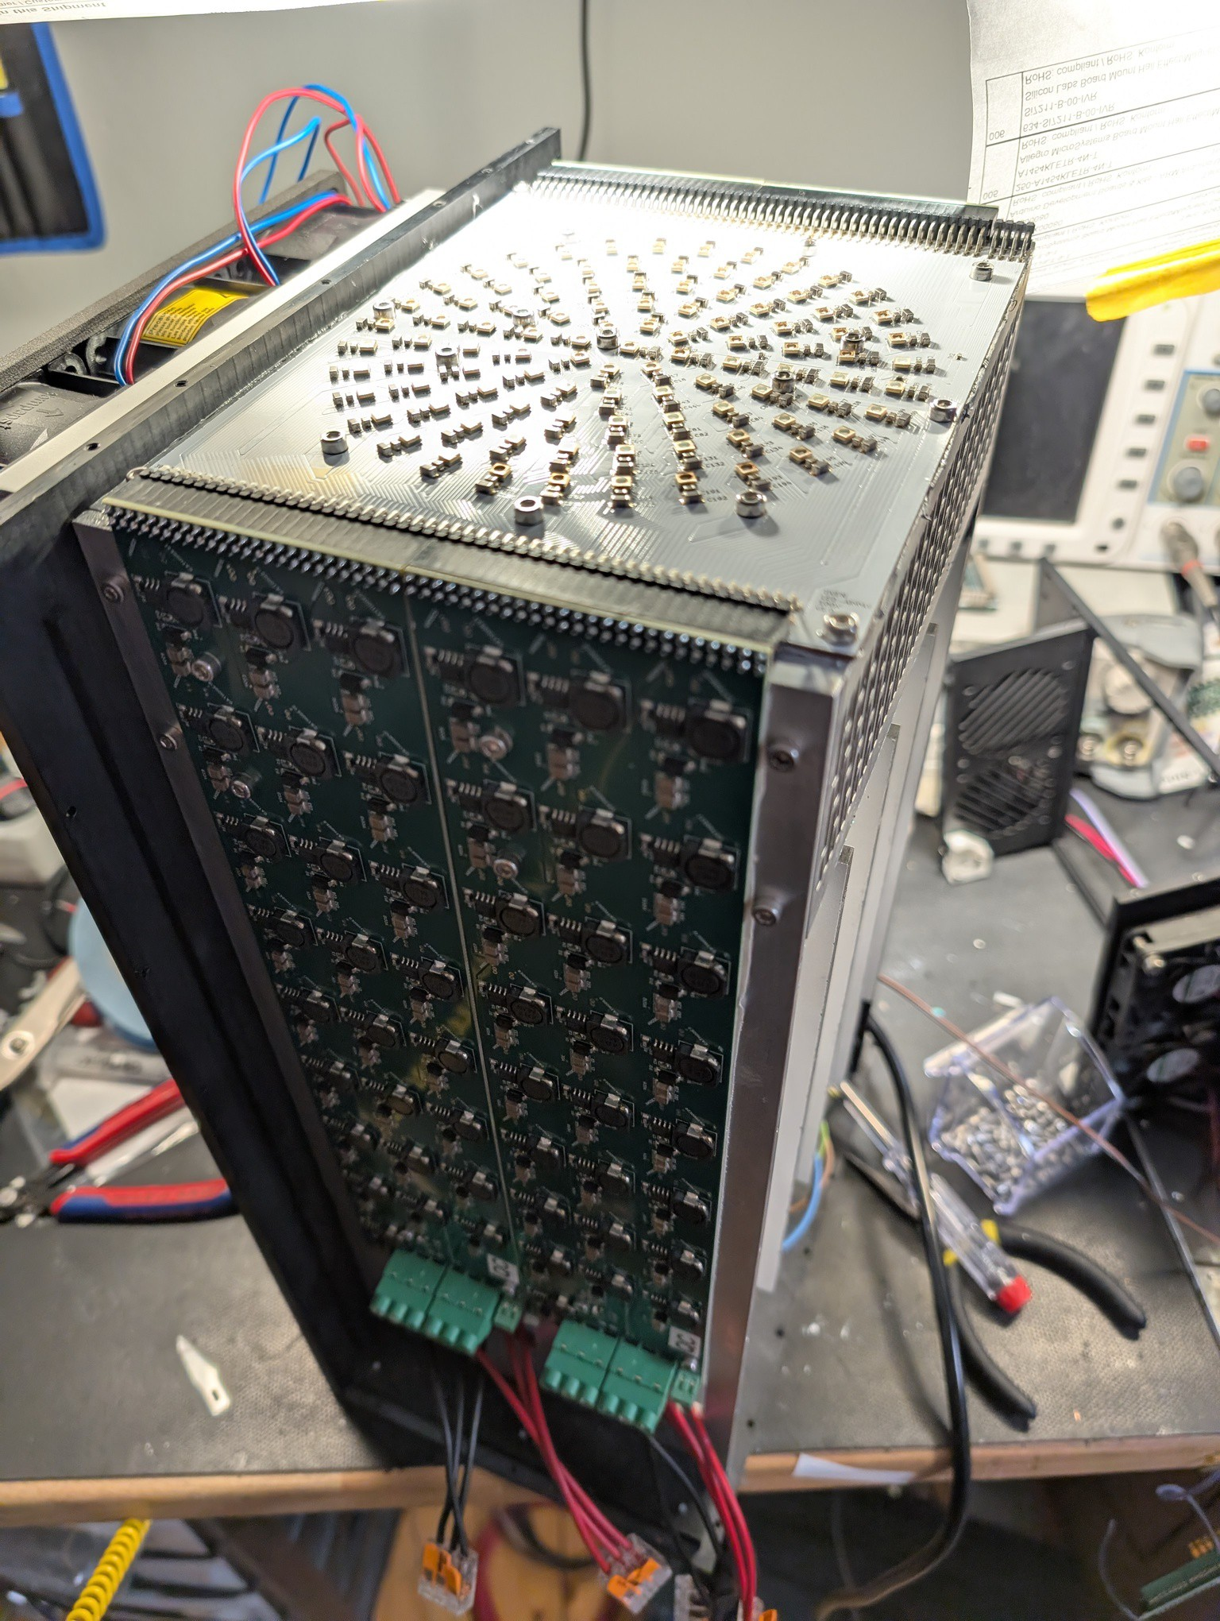

Step 12: Thermal tape and driver mount
Goal: Apply thermal tape to the driver sides. Mount the four LED drivers using 4 x M3x6mm screws each.

Step 10: Thermal tape and driver mount
Goal: Apply thermal tape to the driver sides. Mount the four LED drivers using 4 x M3x6mm screws each.

Step 10: Thermal tape and driver mount
Goal: Apply thermal tape to the driver sides. Mount the four LED drivers using 4 x M3x6mm screws each.

Step 10: Thermal tape and driver mount
Goal: Apply thermal tape to the driver sides. Mount the four LED drivers using 4 x M3x6mm screws each.

Step 10: Thermal tape and driver mount
Goal: Apply thermal tape to the driver sides. Mount the four LED drivers using 4 x M3x6mm screws each.

Step 10: Thermal tape and driver mount
Goal: Apply thermal tape to the driver sides. Mount the four LED drivers using 4 x M3x6mm screws each.

7. Electrical / Wiring Instructions
Wire ID | From | To | Color | Notes

8. Final Assembly
1. [...]
2. [...]
3. [...]

9. Functional Checks
Test ID | Description | Expected Result | Pass/Fail

10. Revision History
Version | Date | Author | Description

