UVen
mk2
user manual
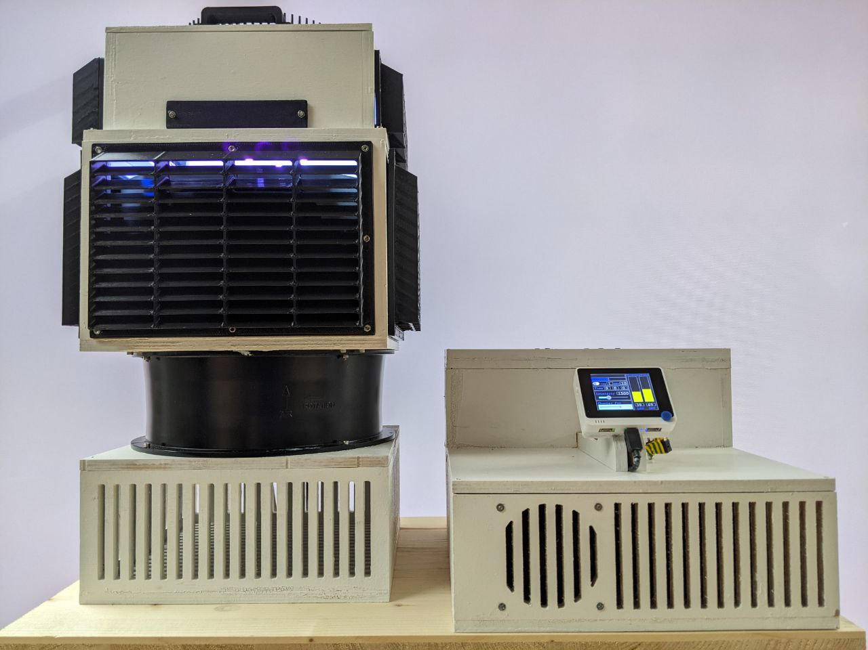

LEGAL DISCLAIMER

THE UVEN LAMP IS A PROTOTYPE!

THE CREATORS OF THE DEVICE DISCLAIM ANY WARRANTY, EXPRESS OR IMPLIED, INCLUDING THOSE OF QUALITY, MERCHANTABILITY OR FITNESS FOR A PARTICULAR PURPOSE AND WILL NOT BE LIABLE FOR ANY LOSSES OR DAMAGES IN CONNECTION WITH THE USE OF THE DEVICE DESCRIBED HEREIN.

USE AT YOUR OWN RISK!

Safety Information

WARNING! Disregard of the safety regulations or improper operation of the UV lamp may lead to injuries and material damage.
This device is a special purpose lamp not suitable for household room illumination.

The owner of a UVen lamp must provide a procedure-specific operating manual with instructions for the operating personnel.

DANGER! ULTRAVIOLET RADIATION
This product emits strong UV radiation at 365nm and can be harmful to both eyes and skin.
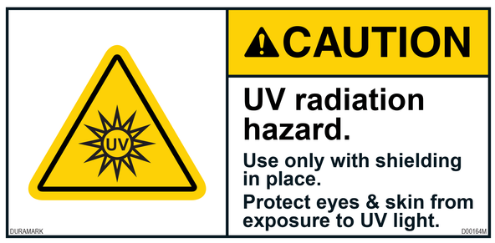
Take appropriate safety precautions to protect yourself against direct contact with the dangerous UV radiation (wear eye protection and protective clothes, mark the working area, etc.).

Recommended protective goggles:

Uvex F22P1G04
- Thorlabs LG6

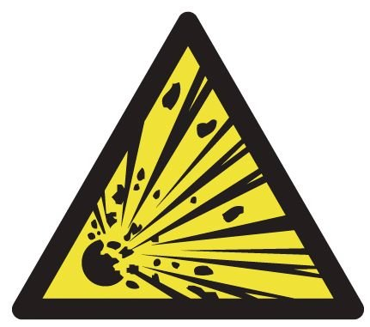
DANGER! EXPLOSION HAZARD
The UV lamp must not be operated in an atmosphere where there is a danger of explosion.

DANGER! FIRE HAZARD
The Lamp produces high power UV radiation that can easily ignite flammable substances placed inside the specimen chamber.
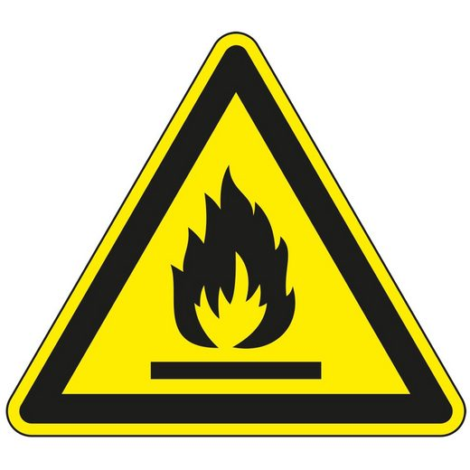
Never under any circumstances leave the Lamp unattended.

Allow proper cooling of the device by keeping the air in and outlets of both the Lamp and the Control Unit unobstructed.

Use proper fire hazard precautions ( do not store flammable substance in the vicinity of the lamp )

Hardware

Lamp
The main unit consists of the specimen chamber with a transparent quartz glass floor. Just below the quartz glass plate are 16 high power UV LEDs. The LEDs are mounted to a heat sink. The heat sink is cooled by the fan below. The air in and outlets need to be kept free for proper cooling of the LEDs. On top of the specimen chamber is another heat sink that helps reducing excess heating of the specimen chamber. Additionally there are two fans on the side of the chamber, allowing for additional specimen cooling.

Control Unit
The Control Unit contains power supplies and the LED drivers. A display allows control of the lamp.
The LED drivers and power supplies need cooling and the air in and outlets need to be kept free. A minimum distance to obstacles of 30cm to all sides needs to be respected to allow proper cooling.
Installation
The Control Unit needs to be connected to 230V AC using the provided cable. The system consumes up to 2.1kW and a suitable power line needs to be used that is able to provide this power.
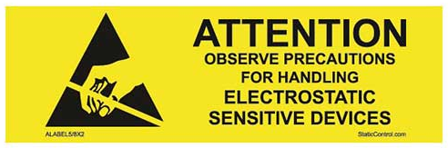
WARNING!
The Lamp needs to be connected to the Control Unit using the provided Dsub cable and the LED cable.

The LEDs are very sensitive to electro static discharge. The Lamp has ESD protection diodes integrated that protect each LED. However, this protection only works when the Dsub cable is connected. So the Dsub cable always needs to be connected first!
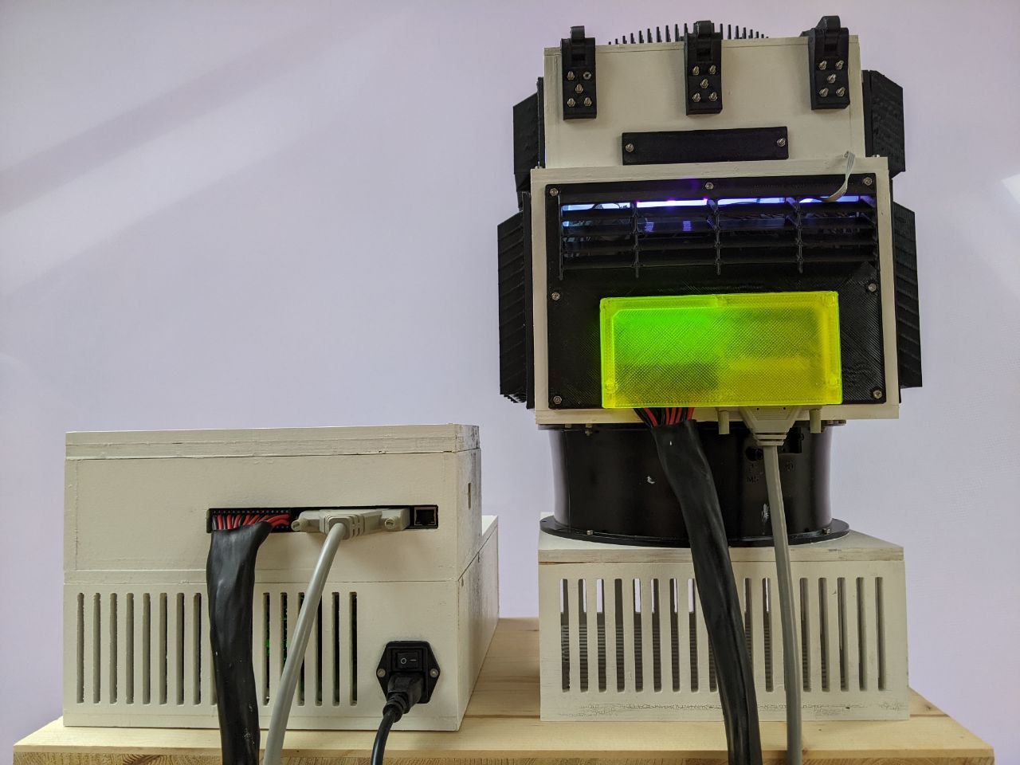
The cables should then be secured using the screws of each connector.
Usage

Turn the system on by using the switch on the back of the Control Unit.
The fans turn on and the Display shows the Control Interface.
Open the lid of the Lamp and place your specimen on the quartz plate above the LEDs.
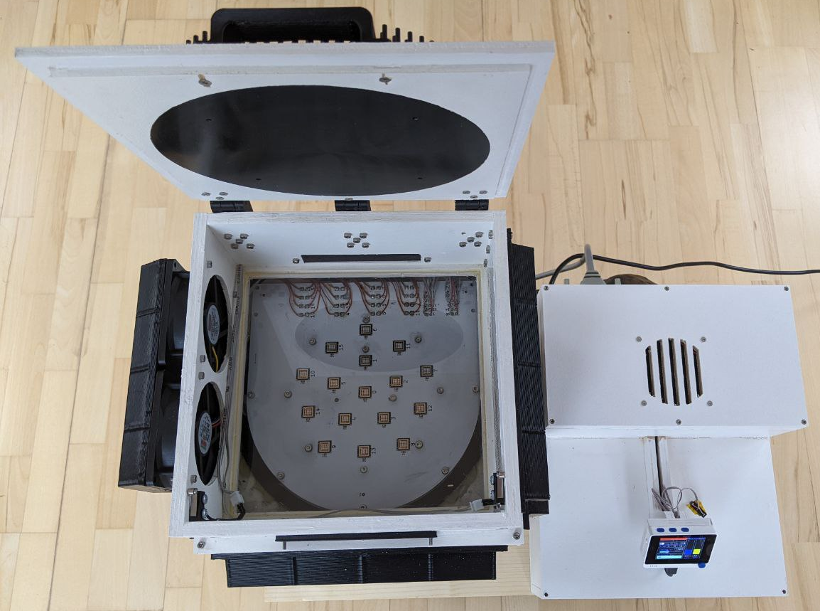
- INTERLOCK: The specimen chamber contains two tactile buttons, but disable the Lamp when the lid is open. An additional switch on the control unit allows for turning the lamp off. The lamp can only be enabled, when all interlock switches are closed. Any open interlock switch is indicated by this red field.
- FIRE: Lamp enable is indicated with this field.
- Repetitions:
  - REP_ENABLE: This switch enables repetitions. It can only be enabled when a time>0 was chosen.
  - REP: Number of repetitions
  - SEC: Select the seconds to turn the Lamp off between repetitions
- Turn on time. If 0 when the lamp is turned on, these fields indicate for how long. If a time is selected when the lamp is turned on, these fields indicate the remaining turn on time.
  - hours
  - minutes
  - seconds
- INTENSITY: This slider controls the lamp intensity in percent
- CHAMBER FAN: The chamber fan speed can be controlled with this slider
- LED TEMP: Each LED temperature is measured using a thermistor next to it. This field shows the average temperature of all LEDs.
- DRV TEMP: the LED driver temperature is shown here.
- TEMP: The lamp temperature is monitored. In case of an over temperature event ( any LED or driver temperature >90℃ ), the lamp turns off automatically and will only allow turn on again, when the temperature has fallen below 35℃ for all LEDs and the driver. This field indicates overtemperature.
- Decrease value
- Turn Lamp ON/OFF
- Increase value
- Menu navigation + push for REP_ENABLE

