**1. Team members**

Our team have 4 members:

1. Name: Lê Trọng Anh Tú ID: 20127091 Email: letronganhtu@gmail.com

2. Name: Nguyễn Thiện Nhân ID: 20127265 Email: ngthiennhan2002@gmail.com

3. Name: Phan Tuấn Khải ID: 20127524 Email: ptkhai1203@gmail.com

4. Name: Lê Đăng Khoa ID: 20127533 Email: ldkhoa.11402@gmail.com

**2. Introduction**

In this project, we decided to develop a food website that includes some features for clients such as suggesting trending foods, recipes, and cooks, posting and seeking foods or recipes, filtering and sorting the found results, etc. to help them cook better. Furthermore, they can also calculate daily nutritional consumption to better control their body intake.

**3. Target users and environments**

About target users, we would like to build a free website application for all genders and ages who have a passion for cooking and sharing delicious meals. Nevertheless, we would bias local Vietnamese users rather than those from other nations because of not comprehending their unique tastes and interests. Moreover, we also want to approach all inhabitants; as a result, we will use luxurious ingredients with wealthy groups while we will choose suitable ingredients with affordable and poorer people.

About target environments, on the server side, we are building a Python server and a suitable database consisting of much information such as user accounts and their information, posts, likes, comments, some admin accounts, a list of foods, a list of cooking recipes, and a list of cooks. We also support at maximum 10 users.

**4. Key features**

# **4.1. Brief process of our web application: How does it work?**

To get started, we will build an HTTP connection based on the client-server architecture. Whenever the clients want to use any functions of the application, it sends an HTTP request to the server, then, the server throws back appropriate responses with or without accessing the database.

On the client-side, we are about to design sign-up and log in features as an initial requirement before a user enters their account’s interface, which contains the main pages of the web application.

Furthermore, there are admin accounts to manage websites by deleting violated posts, comments and accounts.

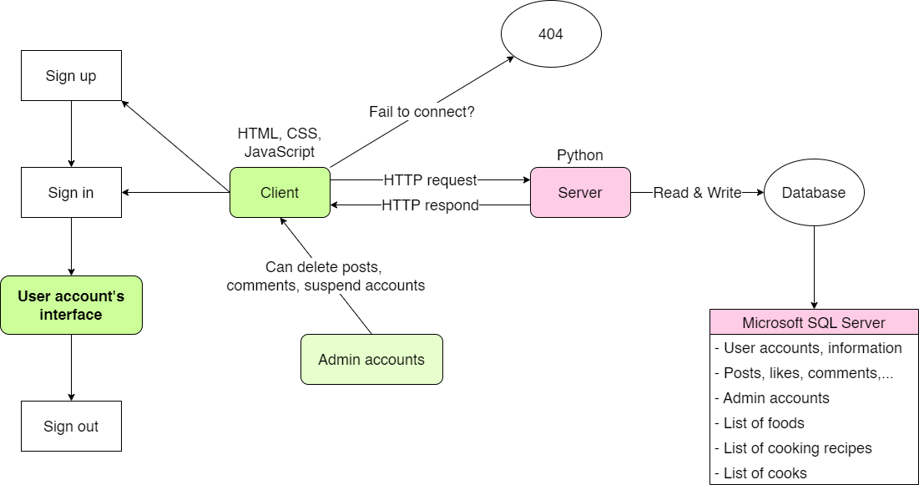

Figure 1: A brief relational flowchart presenting the links between client and server

# **4.2. Key features of our web application**

1. Account function:
   * Sign in, sign up, sign out
   * Edit information, avatar, cover, etc
   * Change username, password
   * Follow other cooks, users
   * Initialize some recipes, add recipes to “My favorite”
   * Like, comment, notification
   * List of my likes, comments, posts
2. Admin’s functions: delete posts, comments, suspend accounts.
3. Report posts to admins.
4. Share posts, recipes to some social media (Facebook, Instagram, Youtube, etc.).
5. Detailed description of cooking steps.
6. Foods, recipes, cooks trending now.
7. Search and show food recipes:
   * By input ***keywords***
   * By input ***ingredients*** the user has to cook.
8. Filter input requirements.
9. Filter found results
10. Sort found results.
11. A sign to show nutrition in each type of food (how many calories, carbohydrates, fats, proteins, sodium, etc.).
12. Calculate daily comsuming nutrition and calories and visualize data by graphs compared to daily standards.