B1a
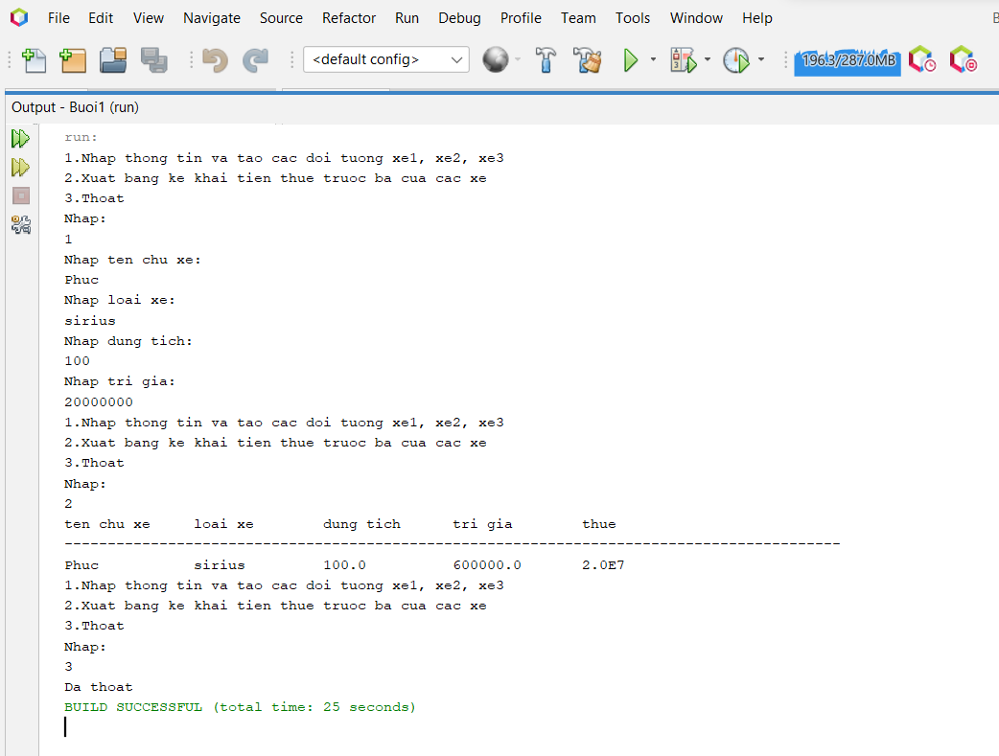
CLASS VEHICLE
package buoi1;
public class Vehicle {
private String tenchuxe, loaixe;
private double dungtich,trigia,thue;

public Vehicle(String tenchuxe, String loaixe, double dungtich, double trigia, double thue) {
this.tenchuxe = tenchuxe;
this.loaixe = loaixe;
this.dungtich = dungtich;
this.trigia = trigia;
this.thue = thue;
}

public String getTenchuxe() {
return tenchuxe;
}

public void setTenchuxe(String tenchuxe) {
this.tenchuxe = tenchuxe;
}

public String getLoaixe() {
return loaixe;
}

public void setLoaixe(String loaixe) {
this.loaixe = loaixe;
}

public double getDungtich() {
return dungtich;
}

public void setDungtich(double dungtich) {
this.dungtich = dungtich;
}

public double getTrigia() {
return trigia;
}

public void setTrigia(double trigia) {
this.trigia = trigia;
}

public double getThue() {
return thue;
}

public void setThue(double thue) {
this.thue = thue;
}

@Override
public String toString() {
return "Vehicle{" + "tenchuxe=" + tenchuxe + ", loaixe=" + loaixe + ", dungtich=" + dungtich + ", trigia=" + trigia + ", thue=" + thue + '}';
}

}

DanhSach
package buoi1;

import java.util.ArrayList;

public class DanhSach {
ArrayList<Vehicle> v = new ArrayList<>();

public void themthongtin(Vehicle ve){
v.add(ve);
}
public void inthongtin(){
System.out.println(String.format("%-15s%-15s%-15s%-15s%-15s", "ten chu xe","loai xe","dung tich","tri gia","thue"));
System.out.println("------------------------------------------------------------------------------------------");
for (Vehicle vehicle : v) {
System.out.println(String.format("%-15s%-15s%-15s%-15s%-15s",vehicle.getTenchuxe(),vehicle.getLoaixe(),vehicle.getDungtich(),vehicle.getThue(),vehicle.getTrigia()));
}
}
public double tinhthue(double trigia, double dungtich){
double thue;
if(dungtich<100){
thue=trigia*0.01;
}
else if(dungtich>=100 && dungtich<=200){
thue=trigia*0.03;
}
else thue = trigia*0.05;
return thue;
}
}Main
package buoi1;

import java.util.Scanner;

public class run {
public static void main(String[] args) {
DanhSach ds = new DanhSach();
Scanner s = new Scanner (System.in);
int menu;
do{
System.out.println("1.Nhap thong tin va tao cac doi tuong xe1, xe2, xe3");
System.out.println("2.Xuat bang ke khai tien thue truoc ba cua cac xe");
System.out.println("3.Thoat");
System.out.println("Nhap: ");
menu= s.nextInt();
switch(menu){
case 1:
s.nextLine();
System.out.println("Nhap ten chu xe: ");
String tenchuxe = s.nextLine();

System.out.println("Nhap loai xe:");
String loaixe = s.nextLine();

System.out.println("Nhap dung tich: ");
double dungtich = s.nextInt();

System.out.println("Nhap tri gia: ");
double trigia = s.nextInt();

double thue =ds.tinhthue(trigia, dungtich);

Vehicle vh = new Vehicle(tenchuxe, loaixe, dungtich, trigia, thue);
ds.themthongtin(vh);
break;
case 2:
ds.inthongtin();
break;
default:
System.out.println("Da thoat");
break;
}
}while (menu != 3);
}
}

