**1/ Hardware**

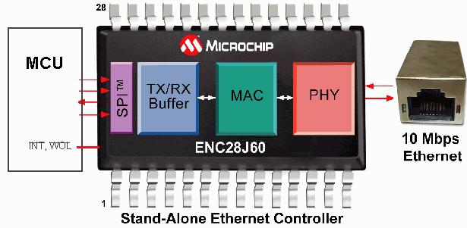

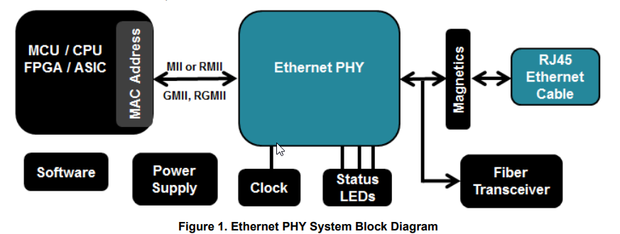

**PHY**

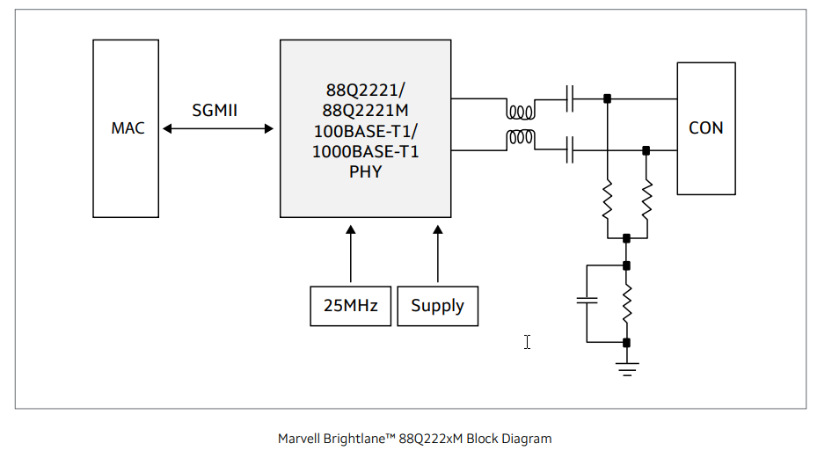

[Marvell Brightlane 88Q222xM Third Generation Automotive 1000Base-T1 PHY Product Brief](https://www.marvell.com/content/dam/marvell/en/public-collateral/automotive-solutions/marvell-automotive-ethernet-phy-88q222xm-product-brief.pdf)

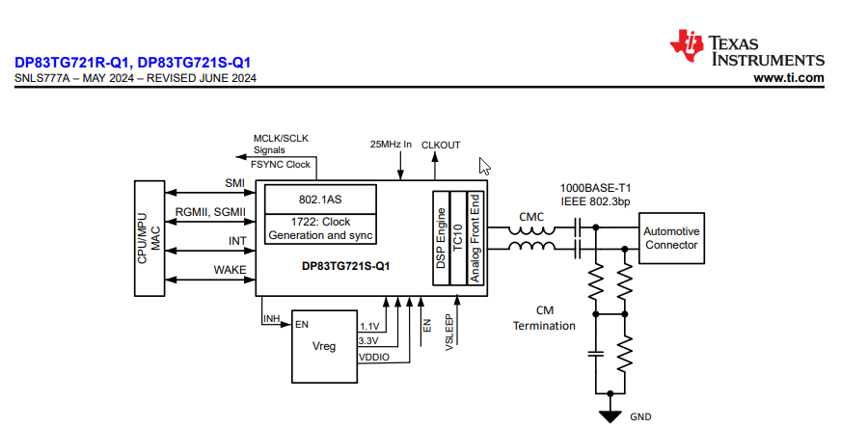

DP83TG721x-Q1 1000BASE-T1 Automotive Ethernet PHY

**MAC- VLAN- AVB**

**Ethernet Controller with SPI Interface**

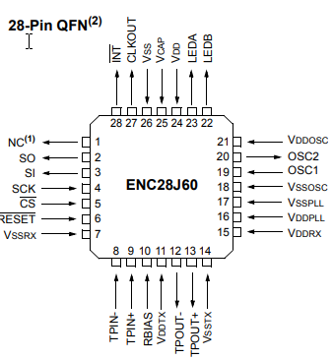

[ENC28J60 Data Sheet](https://ww1.microchip.com/downloads/aemDocuments/documents/OTH/ProductDocuments/DataSheets/39662e.pdf)

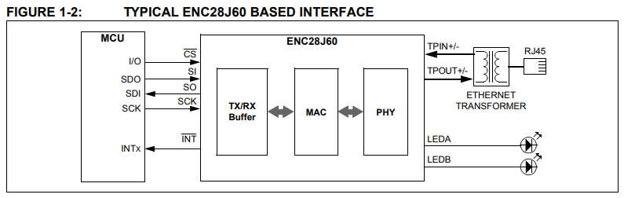

Ethernet Controller with PCIe Interface

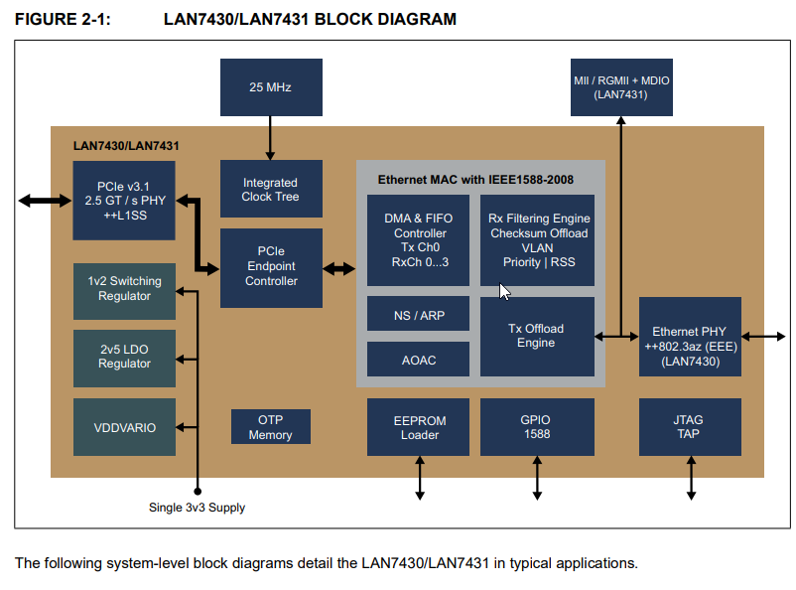

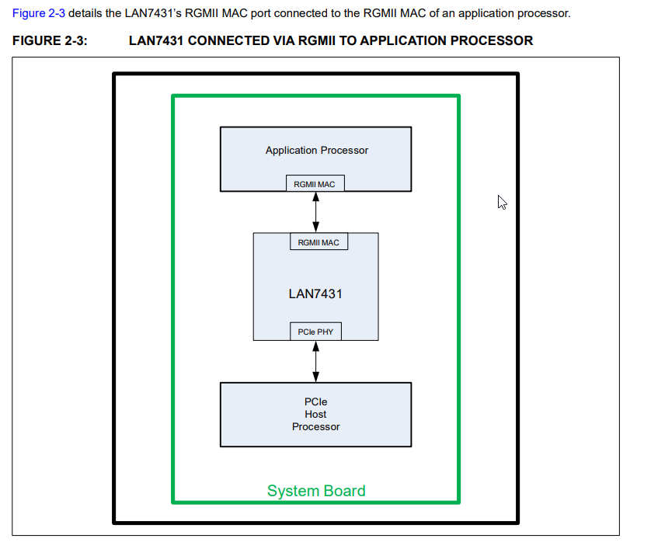

PCIe protocol

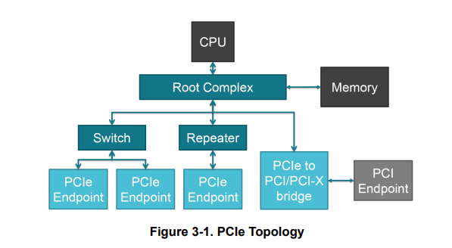

**Network Interface Cards (NICs):** typically include both a Media Access Control (MAC) layer and an Ethernet Physical (PHY) layer.

MAC (Media Access Control) Layer: This layer is responsible for controlling how data is placed on and received from the network medium. It handles addressing and channel access control mechanisms, ensuring that data packets are correctly formatted and sent to the right destination.

Ethernet PHY (Physical) Layer: This layer deals with the physical connection to the network. It converts the digital data from the MAC layer into signals that can be transmitted over the network medium (e.g., electrical signals for copper cables or light signals for fiber optics) and vice versa.

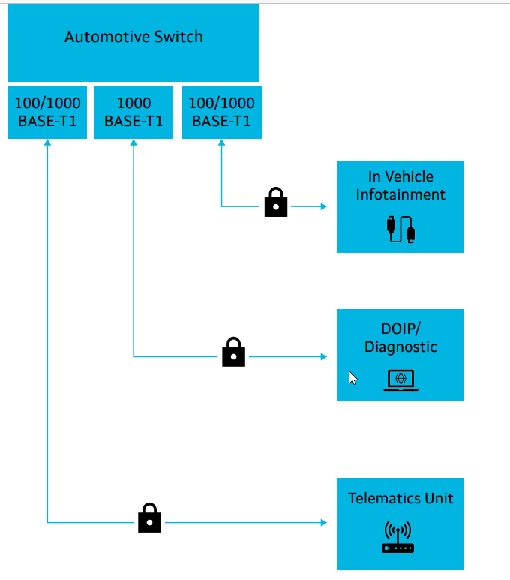

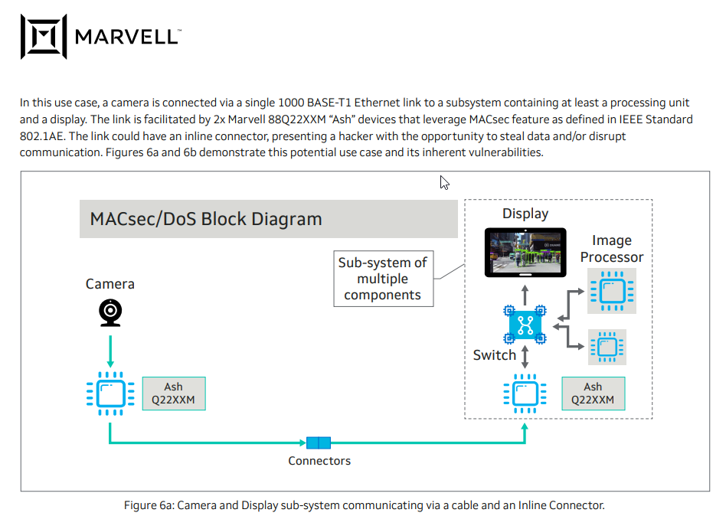

**Schematic RJ45 and SoC**

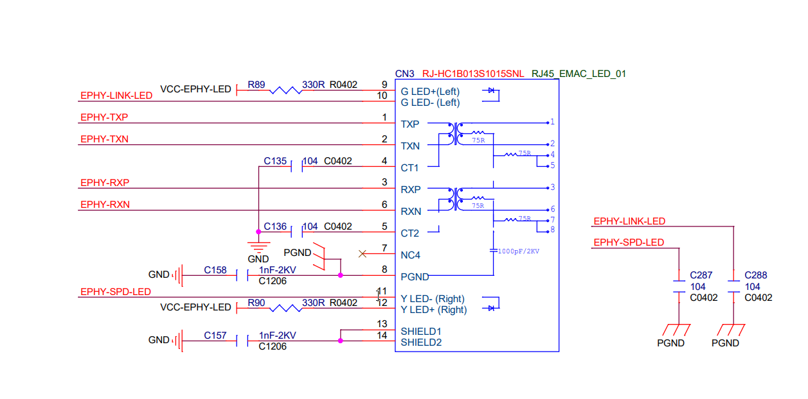https://linux-sunxi.org/images/7/7e/ORANGE_PI-ONE-V1_1.pdf

**2/ Software**

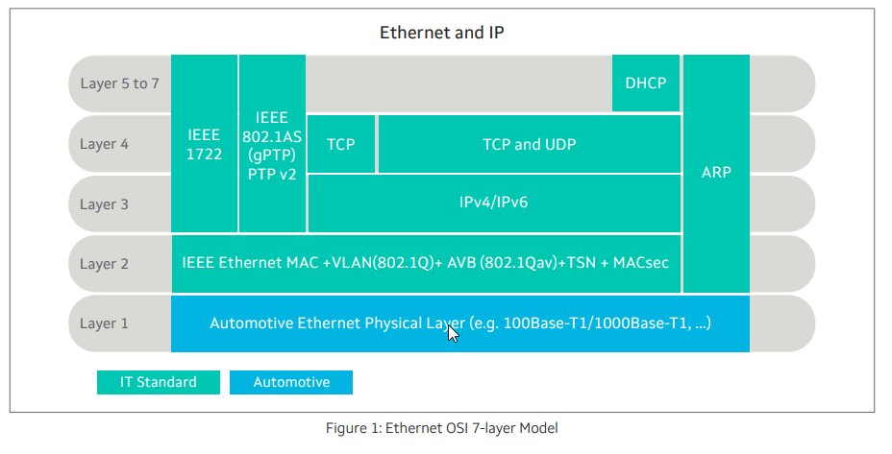

AVB: [Getting Started with AVB on Linux* — TSN Documentation Project for Linux* 0.1 documentation](https://tsn.readthedocs.io/avb.html)

VLAN: [Configuring VLAN Interfaces — TSN Documentation Project for Linux* 0.1 documentation](https://tsn.readthedocs.io/vlan.html)

TSN: [Configuring TSN Qdiscs — TSN Documentation Project for Linux* 0.1 documentation](https://tsn.readthedocs.io/qdiscs.html)

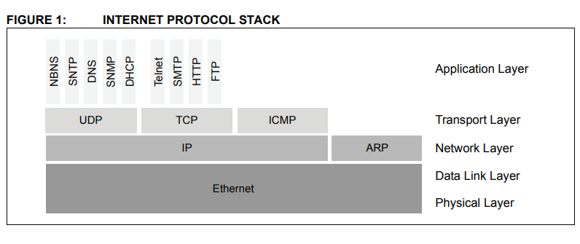

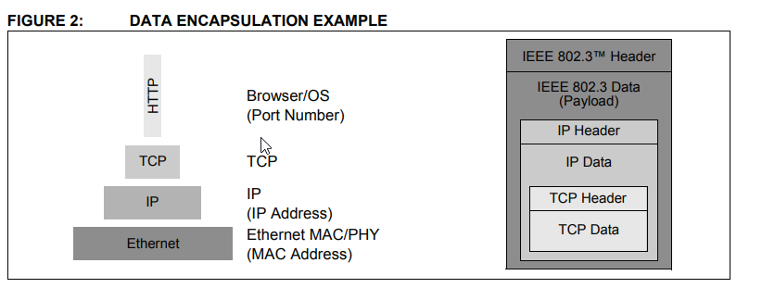

Linux Kernel Network

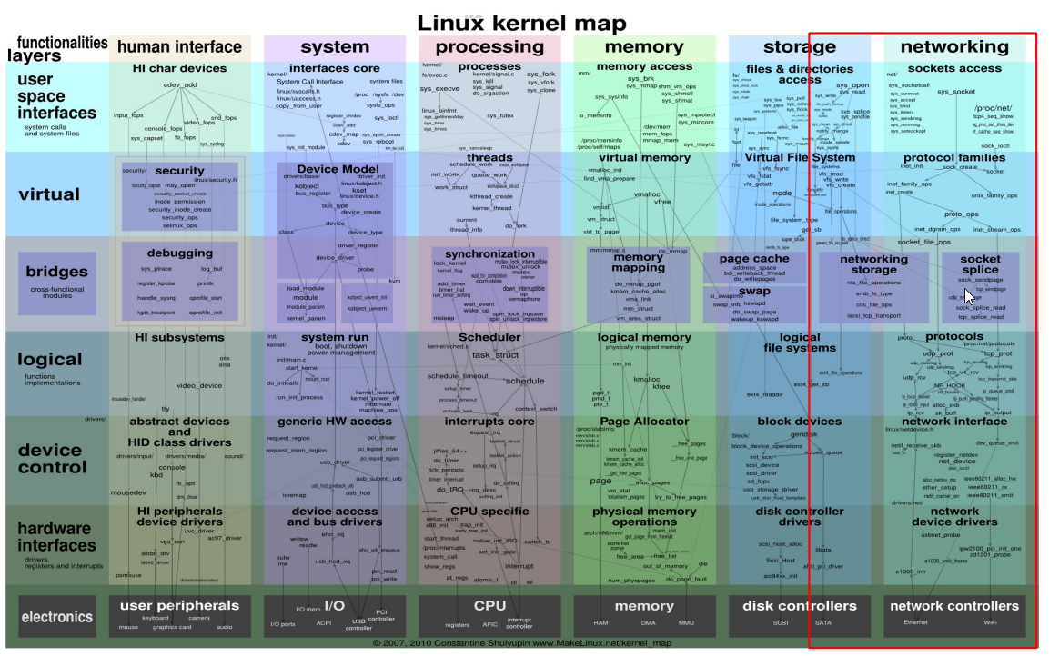

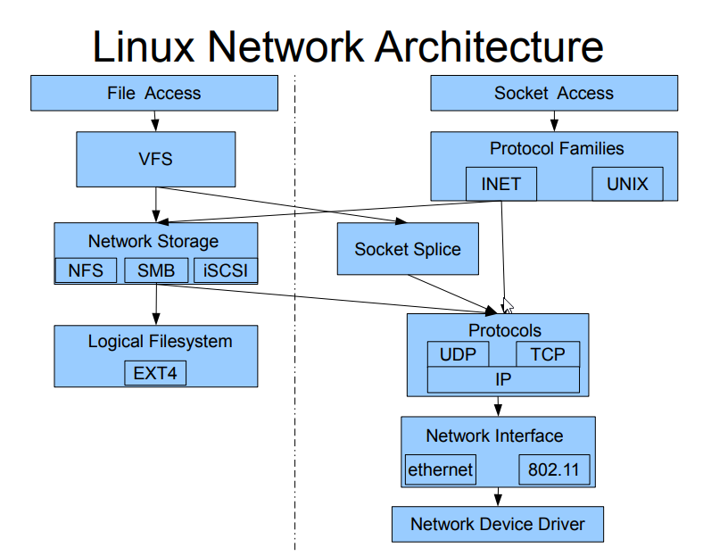

**Synchronizing Time with Linux* PTP**

[Synchronizing Time with Linux* PTP — TSN Documentation Project for Linux* 0.1 documentation](https://tsn.readthedocs.io/timesync.html#:~:text=The%20file%20gPTP.cfg%20%28available%20in%20configs%20folder%20of,network%20interface%20this%20instance%20of%20ptp4l%20is%20controlling.)

[Networking — The Linux Kernel documentation](https://www.kernel.org/doc/html/latest/networking/index.html)

[Linux Kernel Network stack and architecture – The Linux Channel](https://thelinuxchannel.org/2024/07/linux-kernel-network-stack-and-architecture/)

[raoul_kernel_slides.pdf](https://caesar.web.engr.illinois.edu/courses/CS598.S11/slides/raoul_kernel_slides.pdf)

**3/ Ethernet Switch**

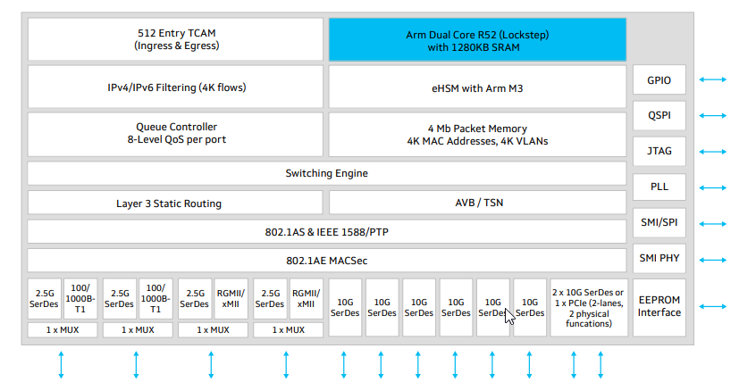

Brightlane™ Q6223 Central Switch

[**Marvell Brightlane Q6223 Central Switch Product Brief**](https://www.marvell.com/content/dam/marvell/en/public-collateral/automotive-solutions/marvell-automotive-brightlane-mvq6223-secure-managed-switch-product-brief.pdf)

**VLAN** [**Catalyst 4500 Series Switch Cisco IOS Software Configuration Guide, 12.2(25)EW - Understanding and Configuring VLANs [Cisco Catalyst 4500 Series Switches] - Cisco**](https://www.cisco.com/c/en/us/td/docs/switches/lan/catalyst4500/12-2/25ew/configuration/guide/conf/vlans.html)

[**l3_int.pdf**](https://www.cisco.com/c/en/us/td/docs/switches/lan/catalyst4500/12-2/25ew/configuration/guide/conf/l3_int.pdf)

* **VLAN Table Unit (VTU)**
* **Address Translation Unit table (ATU)**
* **Ingress Rate Limiting (IRL)**
* **Forwarding Information Database number (FID)**

[**https://www.marvell.com/portal**](https://www.marvell.com/portal)Go to portal and register an account to login

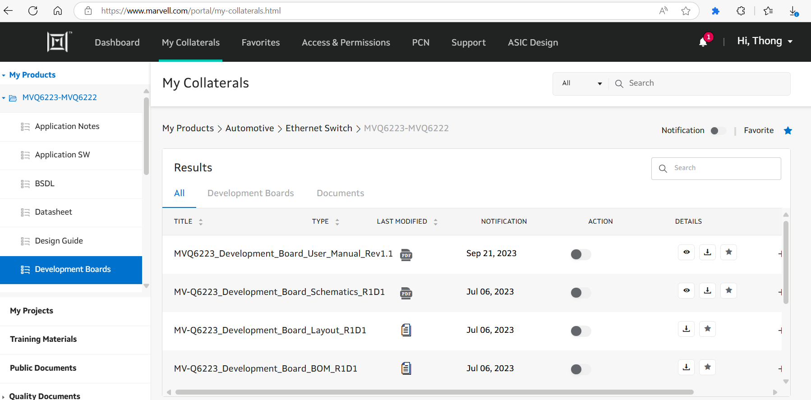

**4/ Zonal Control Module - Zonal Architecture**

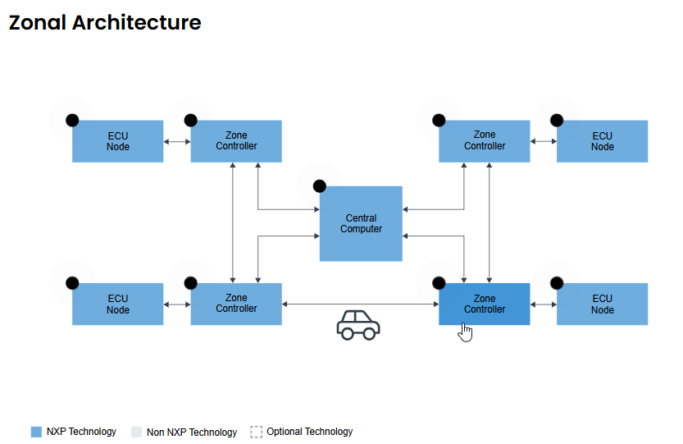

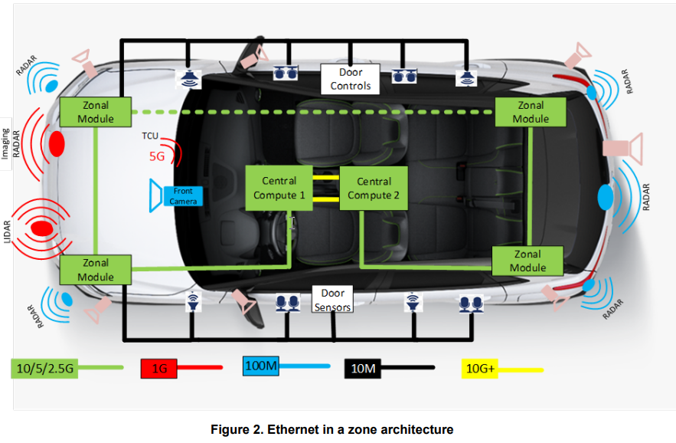

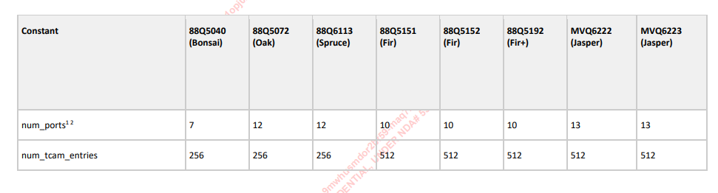

Yes, you **can ping two laptops via an Ethernet cable**, but there are a few steps to ensure it works properly. Here's how you can do it

**What You Need**

* Two laptops with Ethernet ports
* One Ethernet cable (preferably a **crossover cable**, but most modern Ethernet ports support auto MDI-X, so a regular cable usually works)

**Steps to Set It Up**

1. **Connect the Ethernet Cable** between the two laptops.
2. **Assign Static IP Addresses**:
   * On **Laptop A**:
     + IP: 192.168.1.1
     + Subnet Mask: 255.255.255.0
   * On **Laptop B**:
     + IP: 192.168.1.2
     + Subnet Mask: 255.255.255.0
3. **Disable Firewalls Temporarily** (optional but helpful for testing).
4. **Ping from One Laptop to the Other**:
   * On Laptop A, open Command Prompt or Terminal and type:
   * ping 192.168.1.2
   * On Laptop B, try: ping 192.168.1.1

Here is a simple diagram illustrating **Ethernet master-slave mode negotiation**:

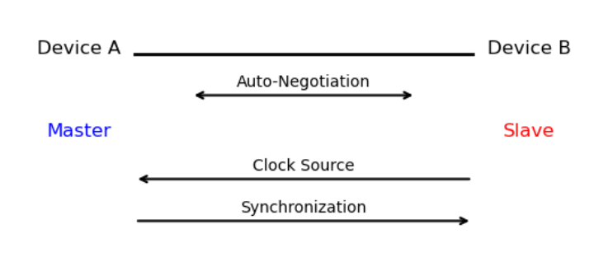

**🔍 Diagram Explanation:**

* **Device A** and **Device B** are connected via an Ethernet cable.
* During **auto-negotiation**, both devices exchange capabilities to decide roles.
* One becomes the **Master** (provides the clock), and the other becomes the **Slave** (synchronizes to the clock).
* Arrows show:
  + **Auto-Negotiation** (bidirectional)
  + **Clock Source** (from Master to Slave)
  + **Synchronization** (Slave aligns with Master's clock)

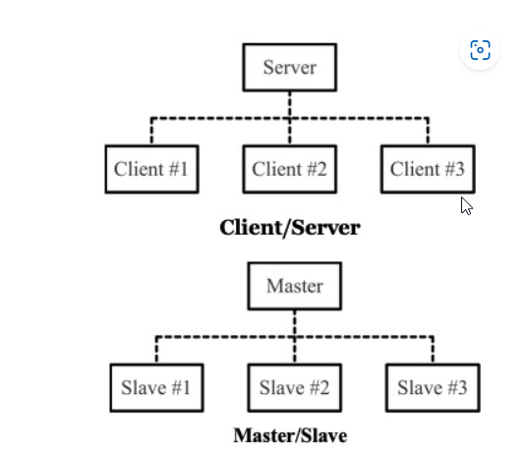

VLan

**Configure VLAN on Windows**

**1. Check Network Adapter Compatibility**

* Open **Device Manager** (Win + X → Device Manager).
* Expand **Network adapters**.
* Right-click your adapter → **Properties** → **Advanced** tab.
* Look for a property like **VLAN ID**, **Priority & VLAN**, or **802.1Q VLAN**.

**Set VLAN ID (If Supported Natively)**

* In the **Advanced** tab, select **VLAN ID** or similar.
* Set the desired VLAN ID (e.g., 10, 20, etc.).
* Click **OK** and restart your network connection.

**VLAN tagging**

**1. Access Ports (Untagged VLAN)**

* If the switch port is configured as an **access port** for a specific VLAN (e.g., VLAN 10), then:
  + The computer **does not need to set a VLAN ID**.
  + The switch automatically tags the traffic with VLAN 10.
  + The computer just sends and receives normal Ethernet frames.

**2. Trunk Ports (Tagged VLAN)**

* If the switch port is configured as a **trunk port**, which carries traffic for multiple VLANs:
  + The computer **must support VLAN tagging** (e.g., via its network adapter or OS).
  + You **must configure the same VLAN ID** on the computer’s interface to match the VLAN you want it to communicate on.
  + This setup is common in virtualized environments or advanced networking setups.

**Summary:**

| **Switch Port Type** | **VLAN ID on Computer Needed?** | **Notes** |
| --- | --- | --- |
| Access Port | ❌ No | Switch handles tagging |
| Trunk Port | ✅ Yes | Computer must tag traffic |

**Untagged VLAN (Access Port)**

* **Used on access ports** (ports connected to end devices like PCs, printers).
* The switch **adds the VLAN tag internally** when traffic enters the port.
* The device (e.g., a computer) **does not see or need to handle VLAN tags**.
* **Only one VLAN** is allowed per access port.

🧠 **Example**:  
If a port is set to VLAN 10 as an access port, any device plugged into it will be part of VLAN 10 automatically, without needing to configure VLAN on the device.

**🔸 Tagged VLAN (Trunk Port)**

* **Used on trunk ports** (ports connecting switches, routers, or VLAN-aware devices like servers or hypervisors).
* The switch **adds a VLAN tag** (802.1Q tag) to each Ethernet frame.
* The connected device **must understand and process VLAN tags**.
* **Multiple VLANs** can be carried over a single trunk port.

🧠 **Example**:  
A trunk port might carry VLANs 10, 20, and 30. A server connected to this port can be configured to handle traffic for all three VLANs using VLAN tags.

**🔁 Quick Comparison Table**

| **Feature** | **Untagged VLAN (Access)** | **Tagged VLAN (Trunk)** |
| --- | --- | --- |
| VLAN Tag in Frame | ❌ No | ✅ Yes |
| Device VLAN Config | ❌ Not needed | ✅ Required |
| Number of VLANs | 1 | Multiple |
| Common Use | PCs, printers | Switches, routers, servers |

[Industrial Ethernet Guide - Client/Server Vs. Master/Slave - Copperhill](https://copperhilltech.com/blog/industrial-ethernet-guide-clientserver-vs-masterslave/)

[Marvell Brightlane 88Q222xM Third Generation Automotive 1000Base-T1 PHY Product Brief](https://www.marvell.com/content/dam/marvell/en/public-collateral/automotive-solutions/marvell-automotive-ethernet-phy-88q222xm-product-brief.pdf)

[The Need for MACsec Security in Ethernet- Based Vehicle E/E Architecture](https://www.marvell.com/content/dam/marvell/en/public-collateral/automotive-solutions/marvell-macsec-security-in-ethernet-based-vehicle-white-paper.pdf)

[ENC28J60 | Microchip Technology](https://www.microchip.com/en-us/product/ENC28J60)

[Ethernet PHYs | TI.com](https://www.ti.com/interface/ethernet/phys/overview.html)

[DP83TG721x-Q1 1000BASE-T1 Automotive Ethernet PHY with Advanced TSN and AVB datasheet (Rev. A)](https://www.ti.com/lit/ds/symlink/dp83tg721r-q1.pdf?ts=1747198551678&ref_url=https%253A%252F%252Fwww.ti.com%252Finterface%252Fethernet%252Fphys%252Fproducts.html)

[Ethernet Theory of Operation](https://ww1.microchip.com/downloads/aemDocuments/documents/OTH/ApplicationNotes/ApplicationNotes/01120a.pdf)

[ORANGE_PI-ONE-V1_1](https://linux-sunxi.org/images/7/7e/ORANGE_PI-ONE-V1_1.pdf)

[Three things you should know about Ethernet PHY](https://www.ti.com/lit/ta/ssztch5/ssztch5.pdf?ts=1747125306397&ref_url=https%253A%252F%252Fwww.bing.com%252F)

[DP83869HM High Immunity 10/100/1000 Ethernet Physical Layer Transceiver With Copper and Fiber Interface datasheet (Rev. C)](https://www.ti.com/lit/ds/symlink/dp83869hm.pdf?ts=1747205445251&ref_url=https%253A%252F%252Fwww.ti.com%252Fproduct%252FDP83869HM)

[Implementing Native PCIe Interconnects Over Automotive Cable Channels](https://www.ti.com/lit/wp/snla380/snla380.pdf?ts=1668049195375&ref_url=https%253A%252F%252Fwww.google.co.jp%252F)