# ESP-WROOM-32

<https://www.deviceplus.com/arduino/lets-play-with-esp-wroom-32-on-arduino-environment-construction-setup-led-blinking/>

# Bo mạch ESP32 DevKit V1 dùng module ESP-WROOM-32 - S1H15

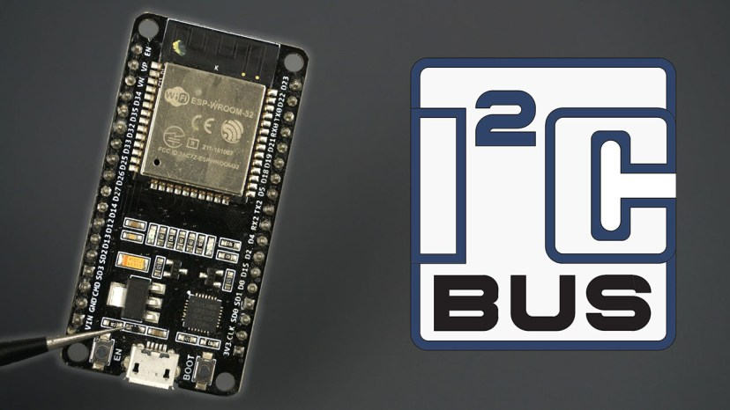 

[https///////////////////////////////////////////////////////////////////////////////////////////////////////==//randomnerdtutorials.com/esp32-i2c-communication-arduino-ide/](https://randomnerdtutorials.com/esp32-i2c-communication-arduino-ide/)

<https://linhkienvietnam.vn/module-node-mcu-32s-esp32-devkitc-dung-module-esp-wroom-32>

**Install ESP32 Add-on in Arduino IDE**

<https://randomnerdtutorials.com/installing-esp32-arduino-ide-2-0/>

Flash code

<https://support.arduino.cc/hc/en-us/articles/4733418441116-Upload-a-sketch-in-Arduino-IDE>

press and keep the boot btn when flashing

<https://linhkienvietnam.vn/module-node-mcu-32s-esp32-devkitc-dung-module-esp-wroom-32>

<https://www.electronicwings.com/esp32/esp32-deep-sleep-mode>

<https://shopee.vn/B%E1%BA%A3ng-M%E1%BA%A1ch-Ph%C3%A1t-Tri%E1%BB%83n-ESP32-TYPE-C-USB-CH340C-WiFi-Bluetooth-Ultra-Low-L%C3%B5i-K%C3%A9p-ESP32-DevKitC-32-ESP-WROOM-32-i.770245757.23825959681>

Mô hình bảng phát triển: ESP32-DevKitC-32

Mô-đun

Mô hình: ESP32-WROOM-32

Chip điều khiển chính: ESP32-DOWDQ6-V3 lõi kép 32bit MCU

Wifi tích hợp, Bluetooth,

Tích hợp 520-kBSRAM,

