BACCARAT GAME

Baccarat Game – Program Design Report

1. Introduction
This project implements a simplified console-based version of the Baccarat card game using object-oriented programming principles. The goal is to model the core components of the game clearly, apply proper class separation, and demonstrate understanding of program flow, UML design, and basic game logic.

2. Program Overview
The program simulates a single round of Baccarat between a Player and a Banker. A standard deck of playing cards is used. Cards are dealt, scores are calculated according to Baccarat rules, and a winner is determined. After each round, the user is prompted to choose whether to play again.
The application runs entirely in a text-based console environment.

3. Class Design
The program is structured using the following classes:
Card – Represents a single playing card, including its suit and rank. It provides a method to return the card’s Baccarat value.
Deck – Manages a collection of Card objects. Responsible for creating the deck, shuffling cards, and dealing cards to players.
Hand – Stores cards held by a player or banker. Provides functionality to add cards, clear the hand, and compute the Baccarat score.
Player – Represents the human player. Owns a Hand object and provides access to the player’s score and cards.
Banker – Represents the banker. Similar to Player but follows predefined drawing rules.
BaccaratGame – Controls the overall game flow. It coordinates card dealing, applies game rules, determines the winner, and manages replay logic.
This design follows separation of concerns and improves readability, maintainability, and extensibility.

4. Game Rules Implemented
• Aces count as 1
• Cards 2–9 keep their face value
• 10, Jack, Queen, and King count as 0
• Hand scores are calculated modulo 10
• The Banker draws additional cards while their score is less than 6
• The winner is determined by comparing the final scores

5. Program Flow
1. The game starts and initializes the deck
2. Cards are shuffled
3. Two cards are dealt to the Player and Banker
4. Scores are calculated and displayed
5. Additional cards are drawn if required by rules
6. The winner is determined and displayed
7. The user is prompted to play again or exit

6. Assumptions and Limitations
• One Player versus the Banker
• No betting system implemented
• Console-based user interface only
• Simplified Baccarat drawing rules

7. Conclusion
This project demonstrates the use of object-oriented design to model a card game effectively. By separating responsibilities into multiple classes and following standard Baccarat rules, the program achieves clarity, correctness, and ease of future expansion.

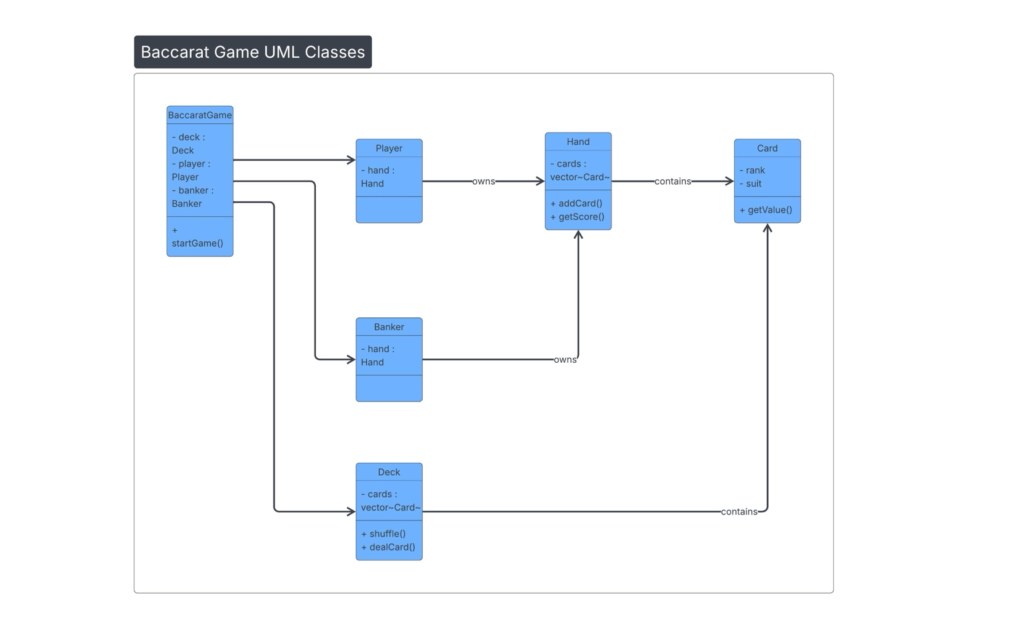
UML Classes

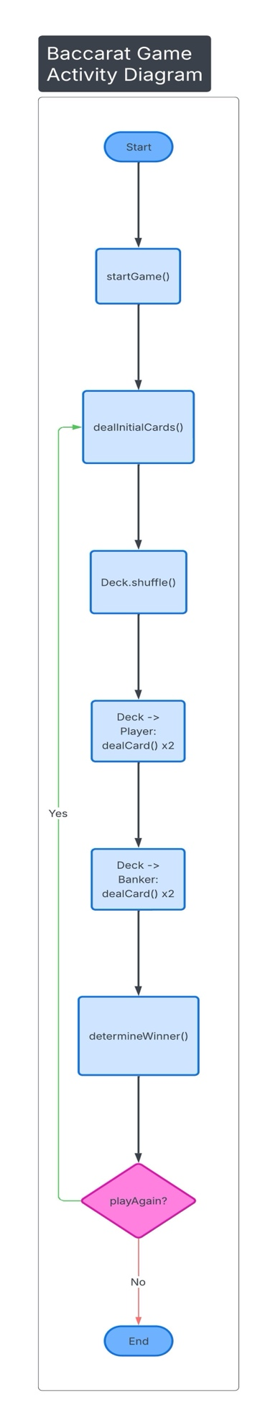
Activity Diagram

