- API Url: https://pricingapi.diamanto.co/api/token
Method: POST
Use: Get User Token for Authentication.
Payload: (Body => x-www-form-urlencoded) ---- Bulk Edit
username:letautomates@gmail.com
password:LetsAuto@2024
grant_type:password
client_id:ngAuthApp
userid:
udid:12345

Response:
{
"access_token": "abc34def……….",
" token": "abc34def243jkhkhjdhdjk",
………..,
……….etc.
}

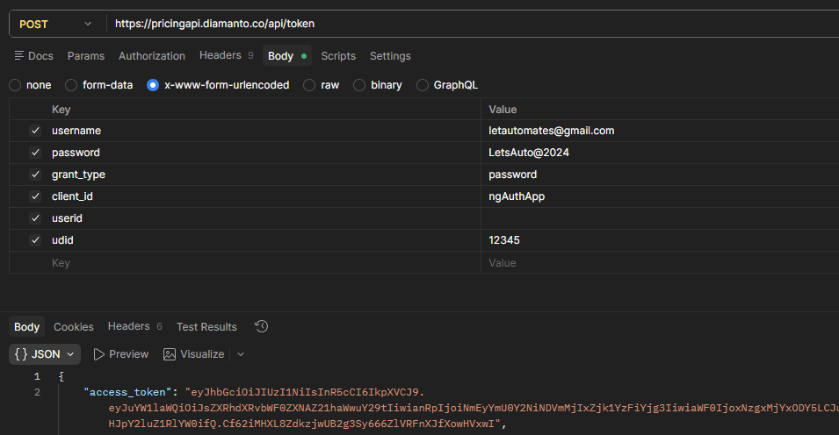

- API Url: https://pricingapi.diamanto.co/api/SpreadSheetCells/GetCellsHistory
Method: POST
Use: Get Date Pricing History in JSON Format.
Payload 1: (Authorization)
- Select Auth Type => Bearer Token
- Enter Token => abcde………. (Use access_token from token API response)
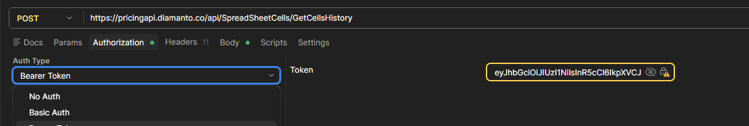

Payload 2: (Body => raw)
- {
"fromDate": "2026-02-01 00:00:00",
"toDate": "2026-02-28 11:00:00"
}
Date Format should be like : 2026-02-01 OR 2026-02-01 00:00:00
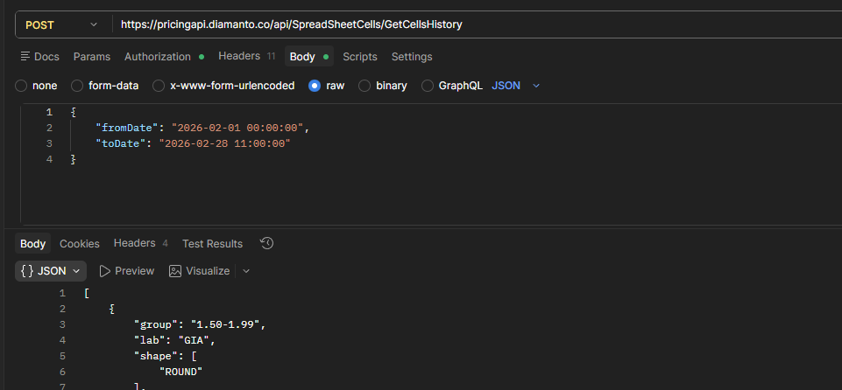
Response:
{
Spreadsheet cell History List in JSON Format.
}
- API Url: https://app.uni.diamonds/api/1.03/free-form-price-analysis/export-report/1
Method: POST
Use: Get Uni Data (Market Data)
Payload 1: (Headers) --- Bulk Edit [Use below token for authentication to call this api]
deviceid:5
token: ec208056c0ca51996341c22009dfb5f7
platform:8

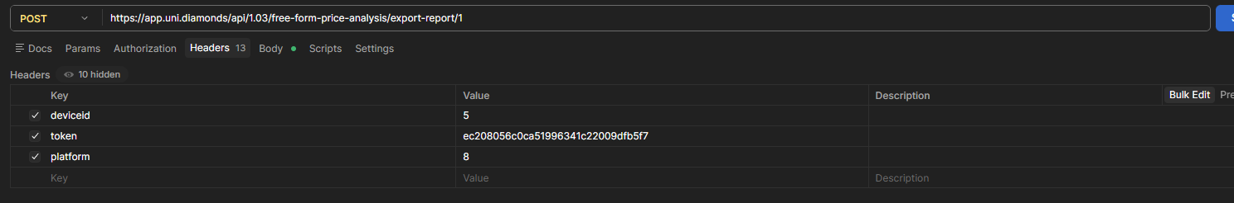

Payload 2: (Body => form-data) --- Bulk Edit
shape:1
size_from:0.30
size_to:0.31
country_id[0]:99
color[0]:1
clarity[0]:1
clarity[1]:2
table_from:
table_to:
length_from:
length_to:
width_from:
width_to:
kts[0]:
kts[1]:
kts_comments[0]:
kts_comments[1]:
search_type:1
lab_ids[0]:1
fluorescence_intensity[0]:7

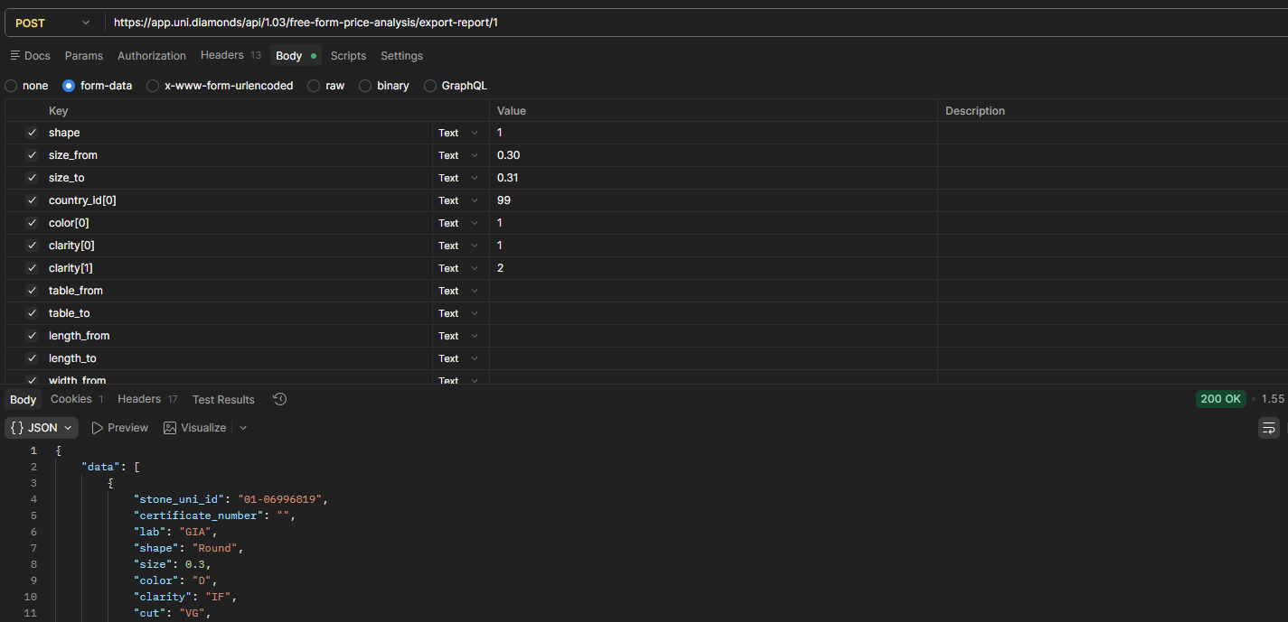

API to get Our Inventory Data
- API Url: https://channelpartnerapi.azurewebsites.net/api/ChannelPartner/GetAllRecord/AKdiam/AKdiam@123
- Method: GET

