---CSS--

For CSS we are going to refer 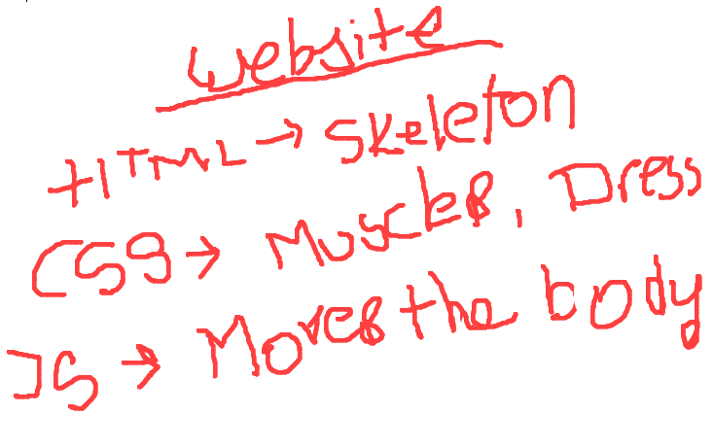**W3School.com**

**Website**

**|**

**HTML ->** Hyper text markup Language

**|**

**CSS ->** Cascading Style sheet

**|**

**JavaScript ->** Programming language

CSS is the language we use to **style an HTML** document.

CSS describes how HTML elements should be displayed.

# CSS Syntax:-

A CSS rule **consists of a selector and a declaration block**.

Selector means which we use to select or target html tags

for this we use tags, class, id

Selectors are:

**tags**-> body, h1, div, p,

**class**-> .mydiv, .any-class-name, .main-body, .container ( dot< **.** > is must)

**id** -> #id1, #my-name, #unique-name

Declaration Block: Any property written inside curly braces ( **{}**) are known as declaration block

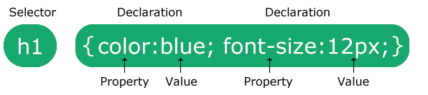

1. The selector points to the HTML element you want to style.
2. The declaration block contains one or more declarations separated by semicolons.
3. Each declaration includes a CSS property name and a value, separated by a colon.
4. Multiple CSS declarations are separated with semicolons, and declaration blocks are surrounded by curly braces.

Example:

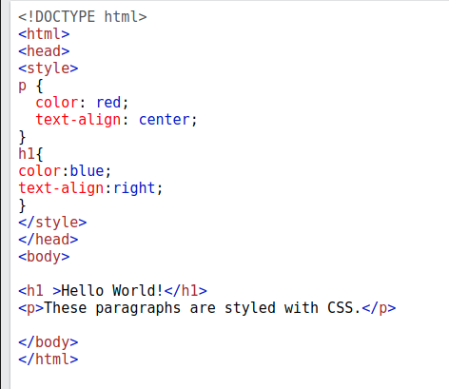In this example i’m using two tag seelctor for styling CSS Selectors

CSS selectors are used to "find" (or select) the HTML elements you want to style.

We can divide CSS selectors into five categories:

* Simple selectors (select elements based on name, id, class)
* [Combinator selectors](https://www.w3schools.com/css/css_combinators.asp) (select elements based on a specific relationship between them)
* [Pseudo-class selectors](https://www.w3schools.com/css/css_pseudo_classes.asp) (select elements based on a certain state)
* [Pseudo-elements selectors](https://www.w3schools.com/css/css_pseudo_elements.asp) (select and style a part of an element)
* [Attribute selectors](https://www.w3schools.com/css/css_attribute_selectors.asp) (select elements based on an attribute or attribute value)

Example:

p{  
 text-align: center; Tag Selector  
 color: red;  
}

#para-1{  
 text-align: center; Id Selector  
 color: blue;  
}

.conainer{  
 background-color: yellow; class Selector  
 color: blue;  
}

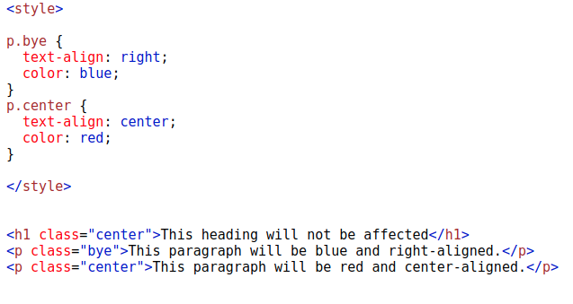

Output:

We can use two class name in a sigle element and we can target them individually

<p class="center large">This paragraph refers to two classes.</p>

^ ^

First classname Second ClassName

**Universal Selector:**

*{  
 text-align: center;  
 color: blue;  
}

it will select all the elements in the html

it will color all the text in blue and aligned them in center

**Grouping :** use to target multiple elements together

h1, h2, p, #root, .container{  
 text-align: center;  
color: red;  
}

# **How To Add CSS:**

3 methods to use style in CSS

1. Inline styling
2. Intaernal Styling
3. External Styling

**Inline Styling:**  we use styling in the tag

<h1 class=”title” style=”color:red; width:100px;”>For heading</h1>

**Internal Styling:**  we use styling inside the .html file with <style> tag

we use style tag **after ending of <head>** tag. **<style> </style>**

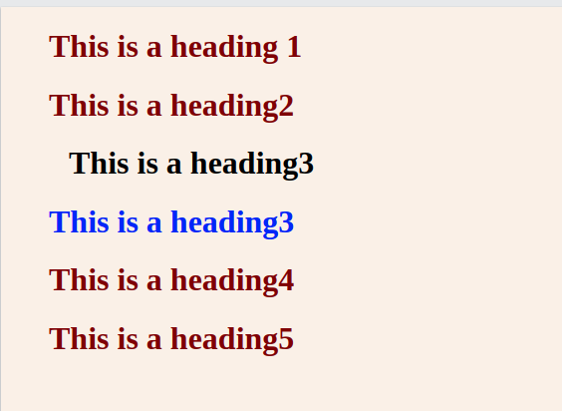

</head>

<style>

h1 {

color: maroon;

margin-left: 40px;

}

h1.title {

color: blue;

margin-left: 40px;

}

h1#title2 {

color: blue;

margin-left: 50px;

}

<style>

<body>

<h1 >This is a heading 1</h1>

<h1>This is a heading2</h1>

<h1 id="title2">This is a heading3</h1>

<h1 class="title">This is a heading3</h1>

<h1>This is a heading4</h1>

<h1>This is a heading5</h1>

**External Styling:**

For External styling we create a new file with extension ( style**.css**) and import this file inside the index**.html**  by using <link> tag inside <head> tag

<link rel=”stylesheet” href=”style.css”/>

then we can just style our elements

h1 {

color: maroon;

margin-left: 40px;

}

h1.title {

color: blue;

margin-left: 40px;

}

h1#title2 {

color: blue;

margin-left: 50px;

}

**Comments:** Comments are use to point or hightlight some particular area for indication while coding /* comment here*/

**single line comments :**

/* This is a to color my paragraph */  
p{  
 color:red;  
}

**inline comment:**

h1{  
 color:red; /* Set heading color to red */  
}

**Multiline comment**

/* This is  
a multi-line  
comment */  
  
p{  
 color: red;  
}

HTML Comment:

<!-- These paragraphs will be red --> HTML comment  
<p>Hello World!</p>

_____________________________________________________________

# CSS Colors:

Colors are specified using predefined color names, or RGB, HEX, HSL, RGBA, HSLA values.

1. CSS RGB Colors- Red-Green-blue

We use color in same formula -> **rgb(red,green, blue)**

rgb(255,255,255) **-> White**

rgb(0,0,0) **-> black**

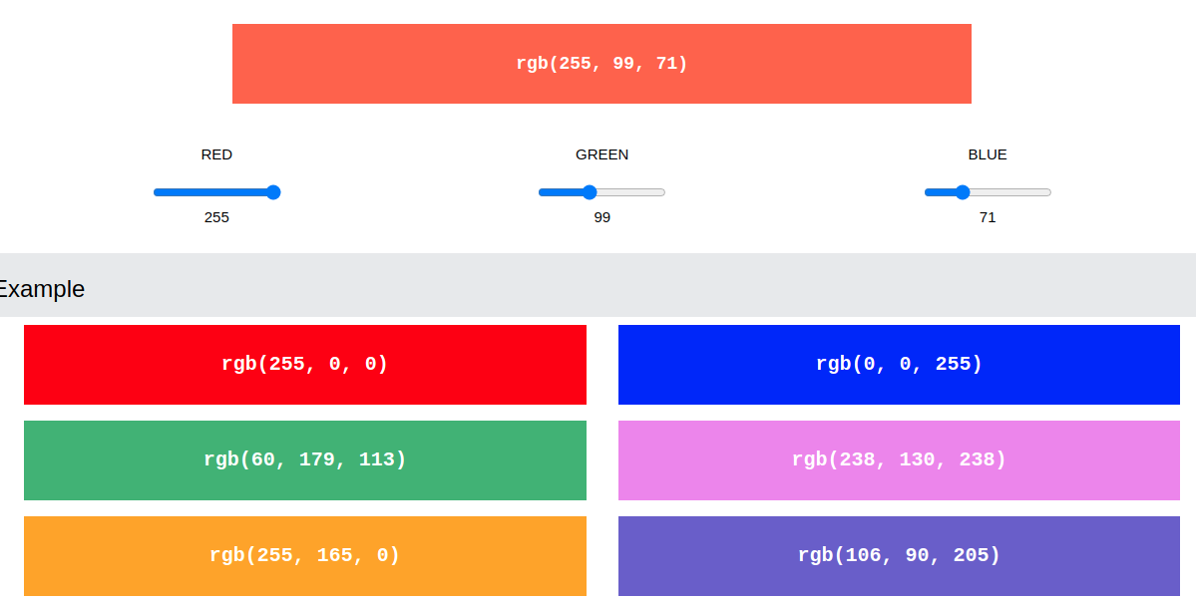



## 

## 1.1 RGBA Value

RGBA color values are an extension of RGB color values with an **alpha** channel - which **specifies the opacity(transparency) for a color**.

An RGBA color value is specified with:

rgba(red,green,blue, alpha)

T*he alpha parameter is a number between 0.0 (fully transparent) and 1.0 (not transparent at all):*

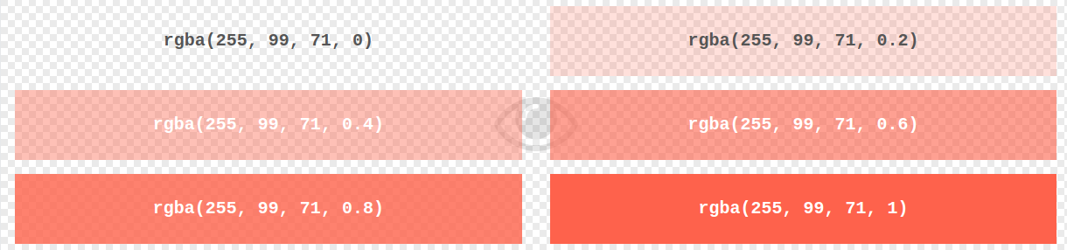In above example you can find the transparency of the same color.

2. **Hex colros:**

A hexadecimal color is specified with: #RRGGBB, where the RR (red), GG (green) and BB (blue) hexadecimal integers specify the components of the color.

## HEX Value

In CSS, a color can be specified using a hexadecimal value in the form:

**#rrggbb**

**hexadecimal (0,1,2,3,4,5,6,7,8,9,a,b,c,d,e,f)**

Where rr (red), gg (green) and bb (blue) are hexadecimal values between 00 and ff (same as decimal 0-255).

For example, **#ff0000 is displayed as red**, because red is set to its highest value (ff) and the others are set to the lowest value (00).

To **display black**, set all **values to 00**, like this: **#000000**.

To **display white**, set all **values to ff**, like this: **#ffffff.**

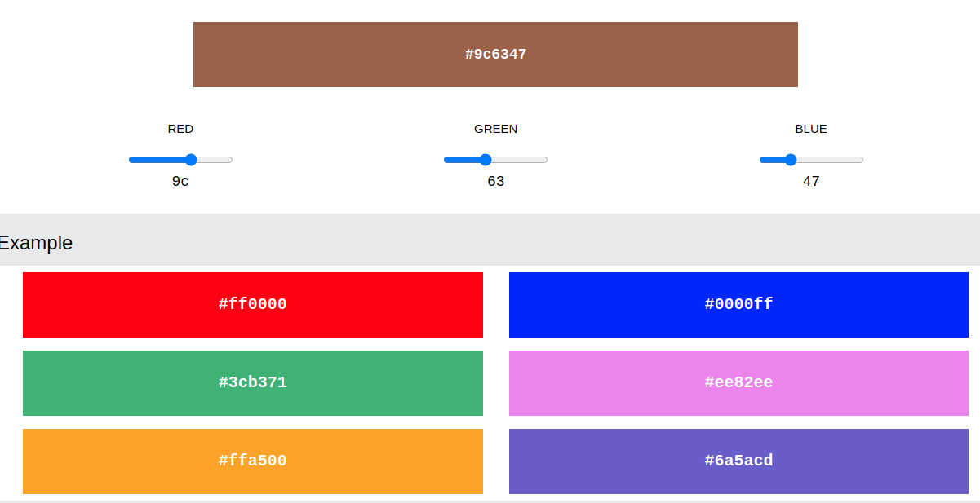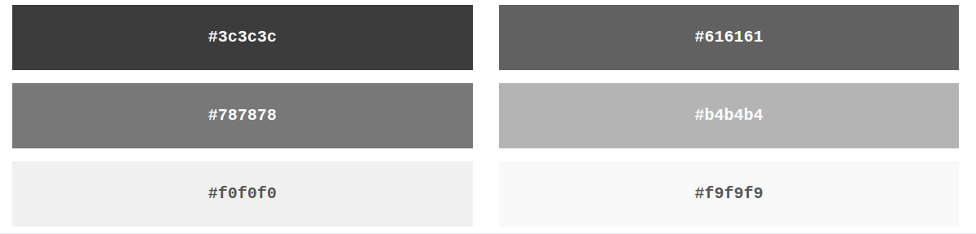

## 2.2 Digit HEX Value

Sometimes you will see a 3-digit hex code in the CSS source.

The 3-digit hex code is a shorthand for some 6-digit hex codes.

The 3-digit hex code has the following form:

#rgb

Where r, g, and b represents the red, green, and blue components with values between 0 and f.

Body {  
 background-color:#fc9; /* same as #ffcc99 */  
}h1 {  
 color:#f0f;/* same as #ff00ff */  
}p{  
 color:#b58;/* same as #bb5588 */  
}