 Job-Po**Rent-Me-Car**

**-** **Rent- Pay- On the way……**

*Project by*  **Vinay Maurya** and **Rahul Abhishek**

**Contributors**

* Vinay Maurya
* Rahul Abhishek
* Manish Mahant :- Instructor
* Amit Pallauri :- Mentor

**About Our Project:**

* Most of students, Job-seekers, workers and tourists face problems in other cities for transportation for a short span or days.
* For temporary period no one wants to purchase vehicle. They seek vehicle on rent in good condition and at low price with or without driver.
* On other hand most of people have their vehicle which are idle or not in use for long time.
* Here they can put their vehicle on rent to genuine customers and can earn some handsome amount.
* **RentMe-Car** is a platform trying to solve this problem by an application that is properly moderated by admin and provides seamless service at both ends
* **RentMe-Car** has all the necessary specifications to meet the challenges of Vehicle-owners and the vehicle-seekers on rent.

**Users of Application**

|  |  |
| --- | --- |
| **Role** | **Rights** |
| Vehicle Owner | Post, Delete, Update his vehicle with vehicle type, model and maker, Can upload photos of vehicle, change profile picture, Password, Forgot password Chat with customer. |
| Customers looking for vehicle | View the vehicle, book vehicle, Pay online, change profile picture & Password, Forgot password Chat with vehicle owner, Feedback or comments and ratings. |
| Admin | change password, Forgot Password, view all posted Users, customers and vehicle, view all booked vehicles, block any user, customer and vehicle. |
| Customer support executives | User and customer can report to CSE, CSE can block user, customer and vehicle. |
|  |  |

**End Points of APIs**

1. Owner's Routes
   1. Add new vehicle
2. Customer's Routes
   1. Get vehicles
   2. Book vehicle
3. Admin Routes

**Features**

REGISTRATION & LOGIN Related:

* Email Verification for Registration.
* Editing Password (After login).
* Resetting Passwords (System Generated Password via mail).
* Password recovery
* Handling errors
* Logout User

User Related

* Vehicle's Owner.
  + Name
  + Profile Picture
  + Add, Delete, Update Vehicles
  + Upload vehicle photos
* Customers can view, filter, search, pay and book vehicle.
* Profile updating ( Profile Picture, Contact Number, Address Change, Adhar no., Driving License, isAdult)
* Instant notification via mail to both Owner and Customer.
* Delete User file appropriately, when requested or violating norms.

Vehicle Related:

1. Aggregations
2. Vehicle Count.
3. Sorting
4. Filtration
5. Searching
6. Pagination
7. Vehicles.
   1. Vehicle Type
   2. Maker
   3. Model
   4. Vehicle Photos
   5. Condition
   6. Daily rent
   7. Sitting capacity
   8. Ratings, Comments or Feedbacks
8. Remove vehicles
9. Update vehicles.

Some security Measures:

1.Rate limit

2.CORS etc

**Technologies used:**

Nodemailer or other service (To send system generated emails)

Fileupload or Multer + Cloudinary (Converting System Image into URL)

Express Js (Framework for node Js)

Json Web token (For Authentication)

Bcrypt Js (For Hashing)

Mongoose (To Connect to NoSQL Database)

Sequelize (PSQL)

Heroku Deployement

Documentation using Swagger or postman doc or Appropriate service available

**Future Goals :**

* Built the frontend for this using React
* Add Stringent Authentication measure
* Create a community for this application and add some Social -Media Features

**Data Flow Diagram:-**

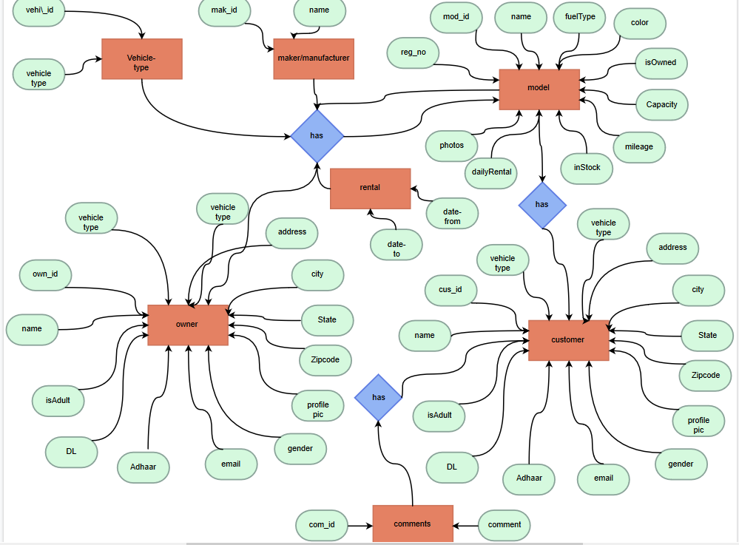

**ER-Diagram :**

