Módulo 10 – Servidores – Atividade 04

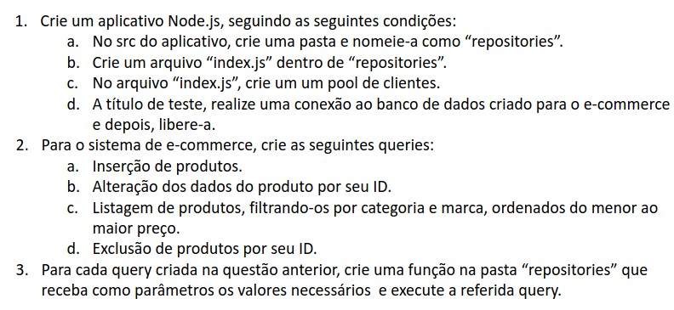
Q2)A) Inserção de produtos:

INSERT INTO products (id, name,category_id,brand_id,price,quant_available,created_at)
VALUES (gen_random_uuid(), 'Roupa adicionada','c451d080-493e-4796-b7f9-770d0b40e3f5','97df59bf-4d9d-4ec2-bace-6e474e75a218',333,5, now())
RETURNING *;

Q2)B) Alteração de dados do produto por seu ID:

UPDATE products SET name = 'Roupa atualizada prod', category_id= 'c451d080-493e-4796-b7f9-770d0b40e3f5',brand_id='97df59bf-4d9d-4ec2-bace-6e474e75a218', price=5000, quant_available=24,
update_at = now() WHERE id = 'a97669d2-de8c-4f81-ac86-9e28c2b83e78' RETURNING *

= ' '
Q2)C)Listagem do preço menor por maior, fazer isso por categoria e marca

Por marca:

SELECT products.id, products.name, products.price,
categories.name AS category_name,product_brands.name AS brand_name
FROM products
JOIN categories ON products.category_id = categories.id
JOIN product_brands ON products.brand_id = product_brands.id
WHERE product_brands.name = 'Gucci'
ORDER BY products.price;

Por categoria:

SELECT products.id, products.name, products.price,
categories.name AS category_name,product_brands.name AS brand_name
FROM products
JOIN categories ON products.category_id = categories.id
JOIN product_brands ON products.brand_id = product_brands.id
WHERE categories.name = 'Camisa'
ORDER BY products.price;

Q2)D) Exclusão informando o ID:

DELETE FROM products WHERE id = ' a97669d2-de8c-4f81-ac86-9e28c2b83e78' RETURNING id;

