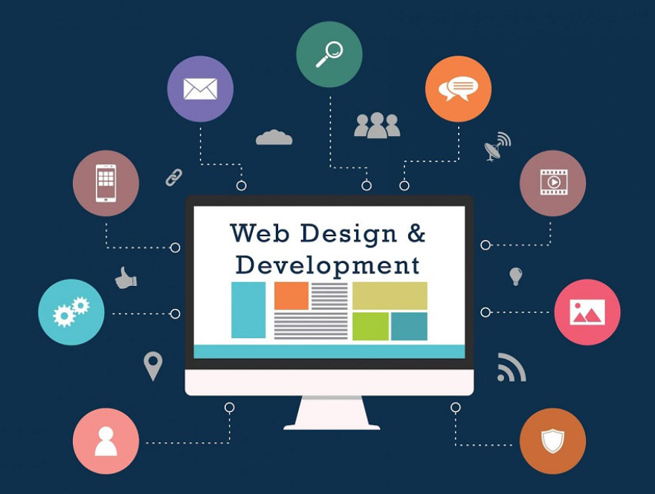

**DrinCup**

One stop to order alcohol or non-alcohol drinks

MALLIKA SUREKHA DWARA|MSC COMPUTING F/T|28/10/22

Table of Contents

Introduction 2

Mission Statement 3

Quality Criteria 3

Measurement of Success 4

Visual Style: 5

Conclusion 7

# Introduction

DrinCup is a web portal can say as online drinks shop where users can buy drinks (can be alcoholic or non-alcoholic) and get delivery service to doorsteps. To create a user friendly while satisfying the client’s demand the project need a profound requirement analysis and current market research. Also, it enhances the product selling or to understand the current market scenario.

Below provided a brief analysis of the websites I visited across to do my initial product research.

* DrinkSuperMarket (<https://www.drinksupermarket.com/>)

This portal allows the users to buy alcoholic drinks online.

I liked:

* The portal appeal is simply amazing and found everything in place.
* The navigation bar is very handy and scrolling of product images is quite attractive.
* Segregation of drink categories, suggestions and popular drinks is impressive.

I disliked:

* The home page looks bit longer than expected and found bit clumsy at footer.
* On each click page takes bit time to load.

I learned:

* I learned the giving enough space and limit options in navbar looks pretty and easy.
* Search bar near right top corner appeals better and I thought of using same like in DrinCup project.
* East London Liquor Company ([https://eastlondonliquorcompany.com/](https://eastlondonliquorcompany.com/%20) )

This website let the users to buy the desired drinks.

I liked:

* Firstly prompting for age validation.
* Site seems simple yet handy to the user choices.
* Site colour choices are light yet elegant.

I disliked:

* The user interface could be enhanced with more user options.
* The images are bit bigger than necessary.

I learned:

* From this site I observed the size or position of the image in horizontal scroll is appealing so, I found the same can be more appealing for DrinCup project.
* Also, simply providing the images/ tiles of the product to order from the home page itself and easy to find. Hence I would like to allow user to order product from home page for DrinCup project.
* SPIRIT STORE (<https://spiritstore.co.uk/> )

This site also let the users to buy the drinks out of their choice and many collections.

I liked:

* This site also has age validation prompt with appealing pop up window.
* Zoom in and zoom out of the sites offers in cards seems eye catchy
* Description about the site in the home page.
* Overall site Google reviews appearing at bottom left corner with fixed position.
* The contact information, Links, Reviews and their payment partners are placed with appropriate segregation and location of the page.

I disliked:

* The Site’s description seems unnecessary as it can put in some ‘About’ section instead of middle of the page.
* The menu/navigation bar looks bit clumsy.
* The best sellers, favourites, sale sections can be presented in a better way.
* Images are bright and clumsy.

I learned:

* Highlighting offers in the home page is important and catches attention of user.
* Images can be simple and eye catchy rather than clumsy and bright. Hence I use simple images for DrinCup Project.

# Mission Statement

“DrinCup” should be a site where user must feel ease and attractive to place his/her bulk order or individual orders without much complications and happily find the enormous quality products. User should be easily navigate, search, authorized using login credentials and avail offers.

# Quality Criteria

To build DrinCup project following ten criteria have been considered.

1. Title of the site:

The title of the project “DrinCup” (derived from thought orders a drink can be poured in Cup) is prominent as it easy to remember ultimately fetches more users to site.

1. The Objective:

From start of the project objective was clear with client (Project requirement documentation) and my understanding that helps for accurate plan and execution of the project without deviations.

1. The Logo design:

The logo has been created such that it has letters of DrinCup in a drunken format and with a image of bottle and glass shows the user what is site about. And banner also designed the same way.

1. Product list in Home page:

Showing the products in home page itself instead of going to menu makes easy for user to order the products and then authenticating if likes to order.

1. Usability:

User finds everything handy and easy navigation as not providing unwanted content allows user to focus on what they want and like to revisit the site.

1. Authentication:

Before ordering a product the user will be authenticated and authorised with age check.

1. Originality:

The DrinCup shows its purpose from it’s logo itself and maintains it’s original product list and secure from any intruders and the content used is all copyrighted and authorised.

1. Attention of user with Site Design:

DrinkCup site is visually appealing, easy navigation, showing offers bar to grab users attention.

1. Product Description:

Writing accurate product information gives a authentic and confident feeling on the product quality to users. Hence, maintaining a space to product description on each product tile.

1. Portability:

DrinCup project can be compatible to be used in any browser and device. Will be implement this using bootstrap reference further.

# Measurement of Success

The following success can be achieved once the project is thoroughly functional.

1. The authentication and secure payment brings more users to buy product from the site that generates more revenue result of **2 times** more sales.
2. User friendly with easy navigation and robust site functionality keeps user longer relationship which brings **2 times** the business sustainability.
3. Quality products, product ratings and product descriptions let user understand the product better that gains user trust and satisfaction which brings **10%** of product and market awareness.
4. DrinCup faster site responsiveness achieved by less complexity of code require less cost of maintenance and frequency of maintenance breaks **by 20%** and content fetches more orders and saves users time.
5. Since the site is portable and available online, more customers likely to buy product from anywhere and anytime that ultimately results **30%** high revenue.

# Visual Style:

DrinCup site has been designed with profound usage of styles and properties for better visibility.

Chosen styles as below:

* Navbar text colour, button background, login, Sign Up and order div colors were given in respective class elements under color attribute as **color: #80ffdf;**
* The size of most of the div sections to fit image has been taken **as Width: 100%;** and respective height attribute for example **height: 120px;**
* Font schema I chosen was **'Lobster', cursive and Gilroy-bold.**
* To display offers used the same colour as menu items and made that with .bar class with properties Position: fixed; width: 100%; top: 100px; z-index: 1; color: #80FFDF; font-size: 15px;
* The offer scrolling left using the below properties

**<marquee behavior="scroll" direction="left" scrollamount="10">**



* The products have been displayed in a menu section format of tiles which were segregated in <div> s in following way

Class .menu{ margin: 0 auto; width: 75%; height: 100%; padding: 5px; margin-left: 50%; transform: translate(-50%, -50%); margin-top: 5%; z-index: 0;}

And tiles were mostly with important styles

.tile{ box-shadow: 0 4px 8px 0 rgba(0, 0, 0, 0.2); transition: 0.3s; width: 30%; margin: 10px; border-radius: 25px;

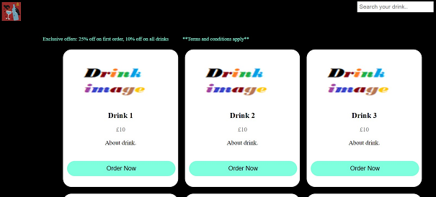

* Provided sample image , product description and price.
* Provided Load more button in support div with button class mentioning few properties.

.button { background-color: #80FFDF; border: none; color: #000000; padding: 15px 32px;

text-align: center; text-decoration: none; cursor: pointer; border-radius: 25px; margin-top: 25px;

}

* On the top right near to menu items placed a search bar of input type “text” including in navbar
* Footer has width: 100% and lie below the content <div> used below properties.

bottom: 0; z-index: 1; padding: 5px;

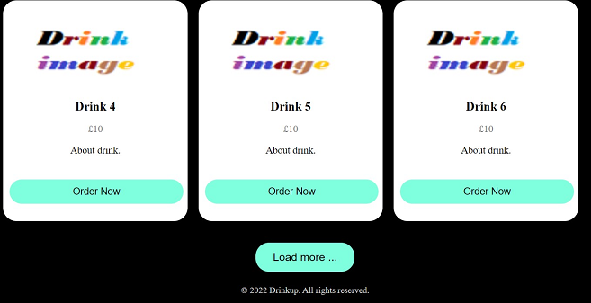

* The Log In, SignUp and order screens are similar and used most common properties as below.

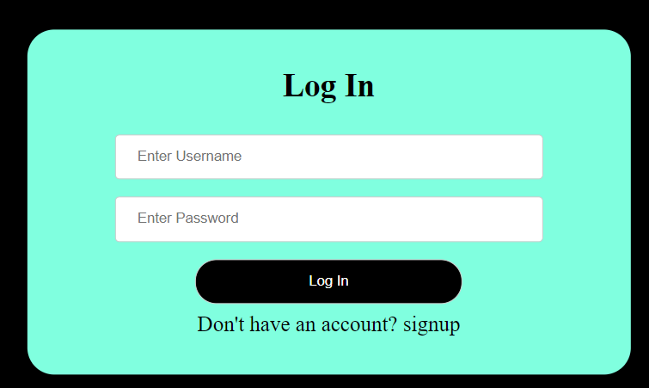

Class login

.login{ background-color: #80FFDF; border: none; color: #000000; padding: 15px 32px; text-align: center; text-decoration: none; display: inline-block; font-size: 20px; margin: 4px 2px; cursor: pointer; border-radius: 25px;

to lie in center : margin-top: 30%; margin-left: 50%; transform: translate(-50%, -50%);}

* Provided “Don’t have an account? Signup” text is a hyper link in anchor tag when user clicks on it navigates to sign up page for hyperlink (href) used below code.

<a href="signup.html">Don't have an account? signup</a>

# Conclusion

The report has been provided with all about project DrinkCup website most of the features, quality criteria, general research conducted to develop the site and understand and analyze the market and requirements reliability. It also has the sites I took as reference, few points on site’s success probability and at the end visual style adopted for the DrinCup.