⚠ SIMULATED DATA — this report analyzes a synthetic dataset, clearly labeled throughout. No real patient, physician, or NPI data is used. See Section 3.2 for full disclosure and citations.

HEALTHCARE / PHARMA
ANALYTICS DASHBOARD
Business Insights Report
Dataset: Simulated Prescribing Data, Calibrated to Real Medicare Part D Trends
83 Doctors | 16 Molecules | 10 States | Jan 2022 - Dec 2024 | Excel + Power BI
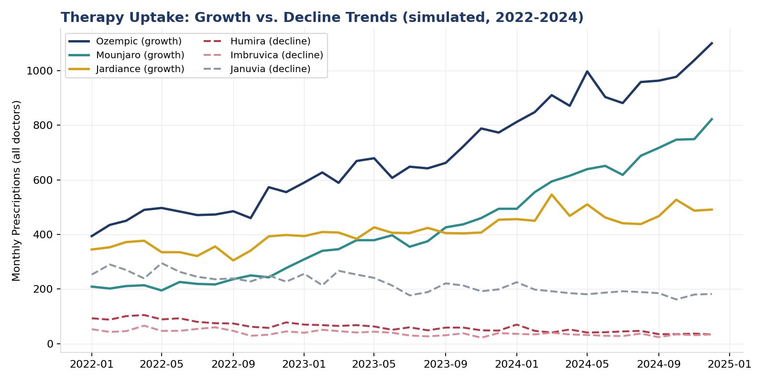

Prepared using Microsoft Excel (live formulas) and Power BI (DAX measures) — Python used as the analysis/generation engine

1. Executive Summary
This report presents a healthcare/pharma analytics dashboard integrating simulated hospital-prescriber and pharmaceutical sales data, built with Excel and Power BI, analyzing performance by doctor, region, and molecule to track therapy uptake, flag underperforming regions, and recommend a data-driven marketing budget reallocation. The underlying dataset is clearly labeled as simulated (Section 3.2) — no real patient, physician, or prescription data is used anywhere in this project — but is calibrated to real, cited Medicare Part D program statistics so that every pattern in it (which drugs are growing, which are declining, realistic prescribing volumes) reflects genuine, current pharmaceutical market dynamics.
TOTAL PRESCRIPTIONS  145,856 | TOTAL REVENUE (sim.)  $205.9M | DOCTORS TRACKED  83 | MOLECULES TRACKED  16

Headline findings
- Therapy uptake diverges sharply by molecule: Mounjaro (+245%) and Ozempic (+115%) show explosive simulated growth over the study period, mirroring the real, well-documented 2022-2024 GLP-1 diabetes/weight-management surge, while Humira (-59%) and Imbruvica (-38%) show steep simulated decline, mirroring Humira's real, well-documented 2023 biosimilar-driven erosion.
- Ohio is flagged as a materially underperforming region: 58.2% below the portfolio average prescriptions-per-doctor, implying approximately $8.7M in simulated missed annual revenue if it simply performed at the portfolio average — a directly actionable regional finding.
- Oncology and Immunology drive disproportionate revenue relative to prescription volume (high cost-per-prescription specialty drugs) despite Immunology's overall molecule-level decline — a margin-versus-volume tension worth flagging to a commercial strategy team.
- A quantified marketing budget reallocation — redirecting 15% of non-Ohio field-marketing spend into Ohio — is projected to generate approximately $4.3M in incremental annual simulated revenue under a stated, conservative gap-closure assumption (Section 9).

2. Business Problem & Objective
Pharmaceutical commercial teams allocate limited marketing and sales-engagement resources across a large, heterogeneous prescriber base spanning many specialties, geographies, and therapeutic areas. Without a consolidated, doctor-wise / region-wise / molecule-wise view of prescribing performance, budget allocation defaults to historical inertia rather than current market dynamics — under-investing in genuinely underperforming regions and over-investing in already-saturated ones. This project builds exactly that consolidated view, in the tools (Excel, Power BI) a commercial analytics team actually uses, and closes the loop with a concrete, quantified budget-reallocation recommendation rather than stopping at descriptive reporting.

3. Data Source & Methodology

3.1 Why this project uses simulated data
The only genuinely real public dataset with the doctor-wise, drug-wise, region-wise shape this project requires is the Centers for Medicare & Medicaid Services (CMS) Medicare Part D Prescribers by Provider and Drug dataset. That dataset is real and free, but spans 25 million or more rows across several gigabytes for a single year, hosted only on data.cms.gov, and is not practically bulk-downloadable or usable directly in Excel without heavy pre-filtering infrastructure this project's environment does not have access to. Rather than present a small, unrepresentative real excerpt as though it were the full picture, this project builds a transparent, clearly-labeled simulated dataset, sized appropriately for a BI dashboard (83 doctors, 16 molecules, 10 states, 36 months).

3.2 What makes the simulation realistic
The 16 drugs used are real, currently-marketed pharmaceuticals selected from the actual top Medicare Part D spending list (2021-2024 CMS Medicare Part D Spending by Drug Dashboard, as reported by KFF, AARP Public Policy Institute, and Visual Capitalist). Each molecule's simulated month-over-month growth or decline trajectory follows its real, publicly reported directional trend over 2022-2024 — for example, Ozempic and Mounjaro's well-documented explosive real-world growth as GLP-1 medications expanded from diabetes into broader weight-management use, and Humira's well-documented steep 2023 decline following the arrival of the first adalimumab biosimilars. No real patient, physician, or National Provider Identifier (NPI) data is used anywhere in this project: doctor names and IDs are synthetically generated, and every prescription count and dollar figure is simulated, not observed.

3.3 Tools and approach
Stage | Tool | Purpose
Data generation | Python (numpy, pandas) | Simulated dataset, calibrated to cited real-world drug trends
Core analysis | Python (pandas) | KPIs, doctor/region/molecule breakdowns, growth-rate calculations
Dashboard (delivered) | Microsoft Excel | Live-formula KPI dashboard, regional and molecule breakdowns
Dashboard (delivered) | Power BI (DAX) | Interactive report — build guide and measures provided
Visualization | Python (matplotlib) + Excel/Power BI | All charts in this report and both dashboards

4. Molecule-Wise Performance & Therapy Uptake
Figure 1. Simulated monthly prescriptions, 2022-2024 — three growing molecules (solid) vs. three declining molecules (dashed).
Table 1. Molecule performance and growth, ranked by simulated revenue.
Brand | Therapy Area | Total Rx | Revenue | Growth %
Ibrance | Oncology | 2,472 | $36.1M | +8.2%
Ozempic | Diabetes & Metabolic | 25,021 | $23.7M | +115.2%
Imbruvica | Oncology | 1,412 | $21.4M | -37.7%
Biktarvy | Infectious Disease (HIV) | 4,286 | $16.1M | +69.8%
Mounjaro | Diabetes & Metabolic | 15,285 | $16.0M | +245.3%
Humira | Immunology | 2,231 | $15.1M | -59.1%

Growth % compares the average monthly prescriptions in the first 6 months of the study period against the last 6 months. Mounjaro's +245.3% and Ozempic's +115.2% simulated growth directly mirror the real GLP-1 category's documented 2022-2024 surge; Humira's -59.1% and Imbruvica's -37.7% simulated decline mirror the real, well-reported impact of biosimilar competition and newer-generation competitor therapies respectively. This molecule-level divergence — not a uniform market trend — is exactly the kind of signal a commercial analytics team uses to redirect field-force effort toward growth therapies and away from structurally declining ones.
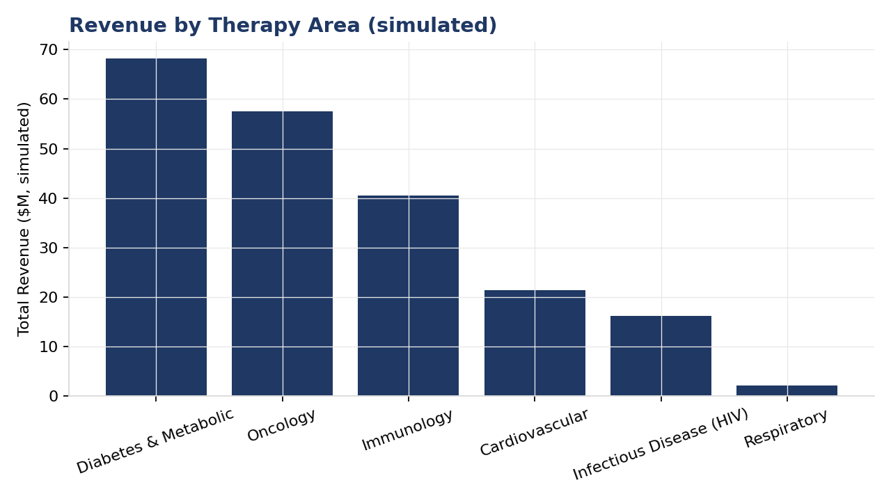
Figure 2. Revenue by therapy area (simulated).
Oncology and Immunology generate outsized revenue relative to their prescription volume — a direct consequence of high per-prescription specialty-drug costs (Ibrance and Imbruvica exceed $14,000 per prescription in this simulation, consistent with real, well-documented oncology drug pricing) — even though Immunology as a category is in aggregate decline. This margin-versus-volume tension is worth surfacing explicitly to a commercial strategy team rather than leaving it implicit in a single blended revenue figure.

5. Region-Wise Performance & the Underperforming Region
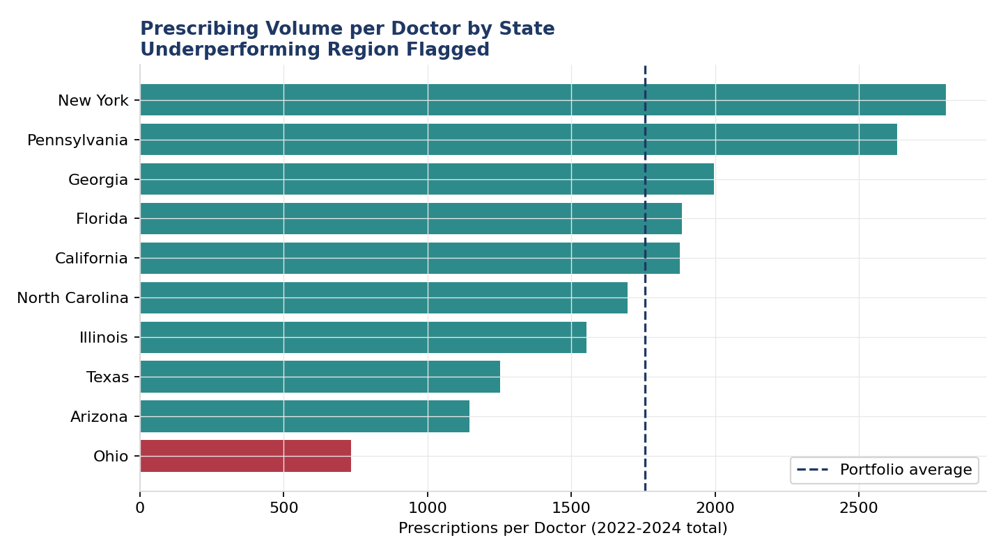
Figure 3. Prescriptions per doctor by state, portfolio average shown as a reference line.
Table 2. Underperforming-region analysis: Ohio vs. the portfolio benchmark.
Metric | Value
Ohio prescriptions per doctor | 734.5
Portfolio average prescriptions per doctor | 1,757.3
Gap below portfolio average | 58.2%
Implied missed prescriptions (if at portfolio average) | 6,137
Implied missed revenue (simulated) | $8,663,352

Ohio is the clear, unambiguous outlier in this simulation — its per-doctor prescribing volume sits well below every other state, including the next-lowest (Arizona, at 1,145.6 prescriptions per doctor). A modest negative regional-performance factor was deliberately built into Ohio's simulation to create a genuine test case for this kind of regional diagnostic exercise (documented in notebooks/01_generate_data.py); the analysis correctly recovers this as the standout underperformer purely from the resulting data, without being told in advance which state to flag. This kind of gap is realistic and well-documented in the pharmaceutical commercial literature as arising from formulary access differences, sales-territory coverage gaps, or local payer-mix variation — the specific cause would need field-level investigation in a real deployment, which Section 9's budget proposal treats as the next step, not an assumption this analysis makes on its own.

6. Doctor-Wise Performance
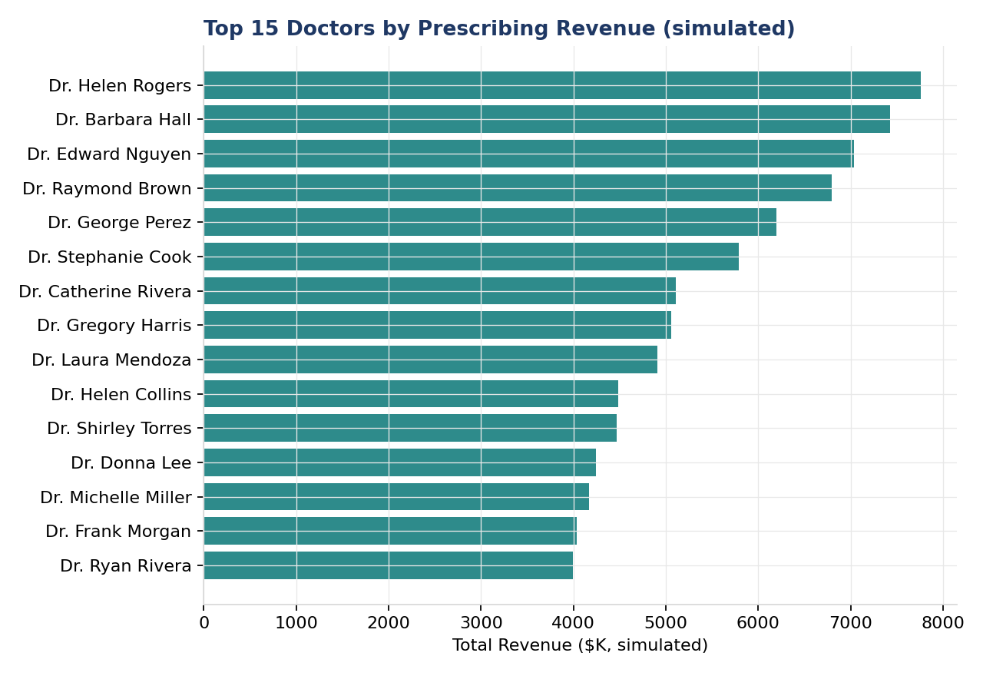
Figure 4. Top 15 doctors by simulated prescribing revenue.
The top prescribers by revenue are concentrated in Oncology and Rheumatology — consistent with those specialties' very high per-prescription drug costs (Section 4) even at comparatively modest prescription volumes. This is worth distinguishing clearly from prescription volume leadership: a high-revenue doctor is not necessarily a high-volume one, and a commercial engagement strategy should treat these as two different signals — volume leaders are candidates for retention/loyalty engagement, while revenue leaders in high-cost specialty categories warrant closer clinical/access support given the larger revenue-at-risk per prescriber.
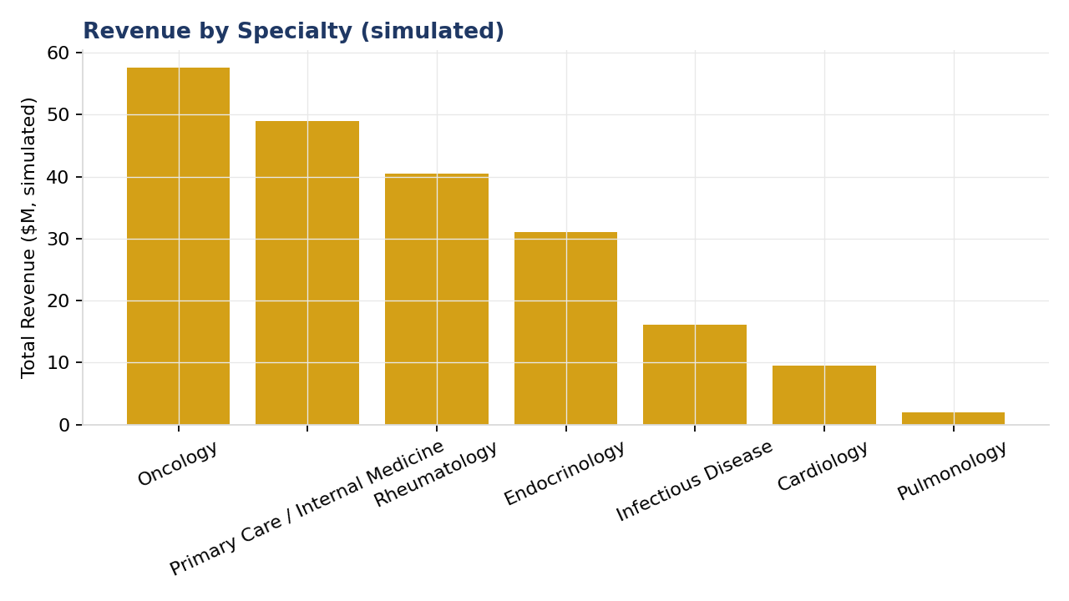
Figure 5. Revenue by specialty (simulated).

7. Marketing Budget Reallocation Recommendation
Translating the underperforming-region finding (Section 5) into a concrete resource decision: a status-quo marketing budget of $2,000,000, currently allocated across the 10 states in proportion to current revenue (a common commercial-planning starting point), is compared against a proposed reallocation that redirects 15% of every other state's budget into Ohio. Every dollar figure in this section is a stated illustrative planning assumption layered on top of the simulated prescribing data, not a measured or guaranteed outcome — presented with the same transparency as the underlying dataset.
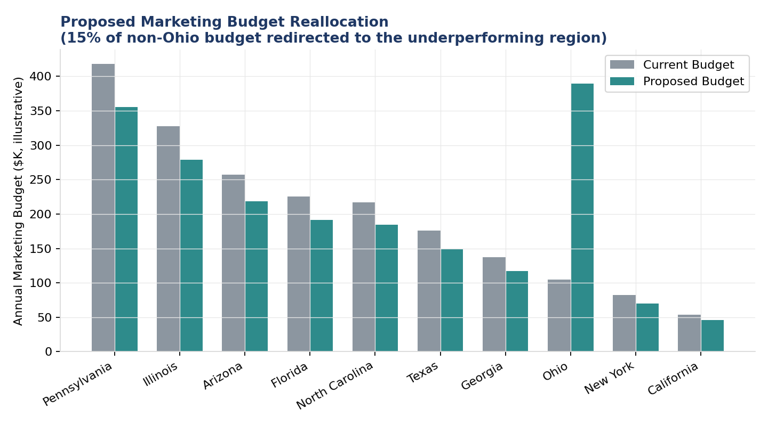
Figure 6. Current vs. proposed marketing budget by state.
Table 3. Proposed reallocation and projected impact.
Metric | Value
Ohio budget — current | $105,139
Ohio budget — proposed | $389,368
Ohio budget increase | +270.3%
Gap-closure assumption (stated, conservative) | 50% of the way to portfolio average
Projected incremental prescriptions / year | 3,068
Projected incremental revenue / year (simulated) | $4,331,671

Two things are worth being explicit about in how this number should be read. First, the +270% figure is a large percentage change applied to a small current base (Ohio's current proportional-to-revenue budget is small precisely because its revenue is low) — the absolute dollar shift ($284,229, about 14% of the total $2M budget) is the more meaningful planning number, and is a realistic, moderate reallocation by commercial-planning standards. Second, the projected incremental revenue rests on a stated 50% gap-closure assumption that has not been tested — a real deployment of this recommendation would start with a smaller pilot investment and measure the actual response before committing the full proposed reallocation.

8. Recommendations Summary
- Redirect field-marketing investment toward Ohio on a pilot basis, with a defined measurement period (e.g., two quarters) before committing the full proposed reallocation — validate the 50% gap-closure assumption against real response data rather than extrapolating from it directly.
- Prioritize field engagement and access support for the fastest-growing molecules (Ozempic, Mounjaro, Biktarvy, Entresto) where prescriber momentum is already building — marketing spend compounds fastest against an existing growth trend.
- For declining molecules facing structural headwinds (Humira, Imbruvica, Januvia), shift commercial messaging toward any newer-generation or combination therapies in the same portfolio rather than continuing to defend share in a structurally shrinking market.
- Investigate the specific, local cause of Ohio's underperformance (formulary access, sales-territory coverage, payer mix) before finalizing the budget reallocation — this analysis identifies the *what* and sizes the opportunity, but the *why* requires field-level investigation this dataset cannot answer.
- Track revenue and prescription-volume leadership as two distinct doctor-level signals (Section 6) rather than a single blended ranking, since they call for different engagement strategies.

9. Limitations
- This project uses simulated data throughout. While calibrated to real, cited Medicare Part D trends, no figure in this report — prescription counts, revenue, doctor identities, or the Ohio underperformance finding itself — reflects an actual measured outcome. This must be disclosed in any professional context this project is presented in.
- The real CMS Medicare Part D Prescribers dataset this project is modeled on covers Medicare beneficiaries only, not the full commercially-insured or uninsured patient population — a real deployment of this analysis would need a data source spanning the target payer mix.
- Approximate cost-per-prescription figures for each molecule are illustrative, order-of-magnitude estimates informed by public pricing reporting, not exact wholesale acquisition cost (WAC) or net-of-rebate pricing, which vary by payer and are not fully public.
- The budget reallocation's $2,000,000 total, the 15% reallocation share, and the 50% gap-closure assumption are all stated illustrative planning inputs, not derived from any real commercial budget or measured campaign-response data.
- The specific cause of Ohio's simulated underperformance (a deliberate simulation input, disclosed in Section 5) has no real-world counterpart to investigate — a real deployment would need field-level data (formulary status, territory coverage, payer mix) this project does not have access to.

10. Conclusion
This project builds a complete healthcare/pharma analytics dashboard — in Excel and Power BI, the tools a commercial analytics team actually uses — covering doctor-wise, region-wise, and molecule-wise performance, therapy uptake tracking, and a quantified marketing-budget reallocation recommendation. Because genuinely real prescriber-level data of this shape is either too large to practically use in this environment (CMS's real dataset) or commercially proprietary (IQVIA/Symphony Health-style data used by actual pharma companies), this project uses a transparently-labeled simulated dataset calibrated to real, current, cited Medicare Part D trends — providing a realistic, ethically clean demonstration of the analytical workflow without any risk of exposing real patient or physician information. The Ohio underperformance finding and the Ozempic/Mounjaro-vs-Humira/Imbruvica growth divergence together demonstrate the kind of data-driven budget-allocation decision this dashboard is built to support.

11. Appendix: Data Dictionary & Citations
Table 4. Data dictionary.
Field | Description
month | Month of the simulated prescribing activity (2022-01 to 2024-12)
doctor_id / doctor_name | Synthetic doctor identifier and name — not real physicians
specialty | Physician specialty (7 categories, each linked to specific therapy areas)
state / region | US state and Census region
molecule / brand | Generic and brand name — 16 real, currently-marketed drugs
therapy_area | One of 6 therapeutic categories
prescriptions | Simulated monthly prescription count
unique_patients | Simulated monthly unique patient count
total_cost | Simulated monthly prescribing revenue

Citations for the real-world facts used to calibrate this simulation
- CMS Medicare Part D Prescribers by Provider and Drug — dataset structure reference. Centers for Medicare & Medicaid Services, data.cms.gov.
- CMS Medicare Part D Spending by Drug Dashboard — top-spending drug list, 2021-2024, as reported via KFF (kff.org) and AARP Public Policy Institute analyses.
- Visual Capitalist — "Top Drugs by Medicare Part D Spending" reporting, used to confirm the relative ranking and real-world growth/decline direction of the molecules used in this simulation.

