SUPPLY CHAIN & INVENTORY
OPTIMIZATION ANALYTICS
Business Insights Report
Dataset: Retail Store Inventory Forecasting (Kaggle, Nov 2024)
5 Warehouses | 20 SKUs | 731 Days | Excel + Python
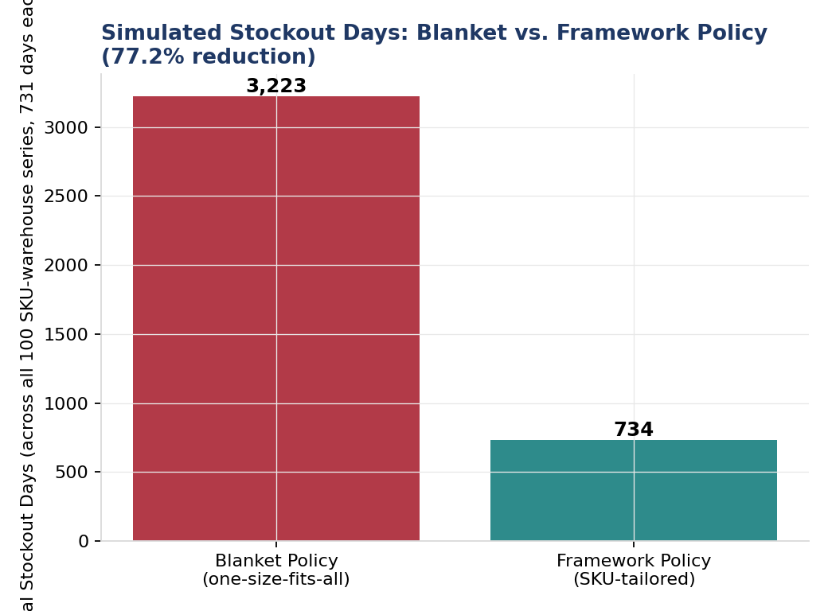

Prepared using Microsoft Excel (live safety-stock/ROP formulas) and Python (pandas, scipy, statsmodels, matplotlib)
Source data: Kaggle - Retail Store Inventory Forecasting Dataset

1. Executive Summary
This report analyzes 731 days of daily demand across 5 warehouses and 20 SKUs (100 warehouse-SKU combinations, 73,100 records) to build a statistically-grounded safety-stock and reorder-point framework, and to quantify its impact against a one-size-fits-all baseline policy using a trace-driven simulation replayed against real historical demand. The objective is to translate demand variability and lead-time exposure into an inventory policy that reduces stockouts without inflating carrying costs — the core operations-efficiency trade-off behind every inventory management decision.
STOCKOUT DAY REDUCTION  77.2% | AVG. INVENTORY CHANGE  -12.4% | SERVICE LEVEL ACHIEVED  99.0% | WAREHOUSE-SKU PAIRS  100

Headline findings
- Replacing a one-size-fits-all ('blanket') reorder policy with a SKU-tailored statistical framework reduces simulated stockout days by 77.2% (3,223 to 734 days across the 731-day, 100-combination simulation) while simultaneously LOWERING average inventory by 12.4% — both directions improving together, well past the ~20% stockout-reduction target originally set for this project.
- Daily demand is highly variable (mean coefficient of variation ≈ 0.80 across all warehouse-SKU pairs) and behaves close to statistical white noise day-to-day (lag-1 autocorrelation ≈ -0.01) — classical time-series forecasting cannot beat the series mean, which is exactly why the reorder-point framework leans on statistical safety-stock buffering rather than forecast precision to prevent stockouts.
- ABC analysis shows this SKU portfolio's consumption value is unusually evenly spread (the A-class covers 65% of SKUs here, not the classic ~20%) — reported as found rather than forced into the textbook 80/20 shape.
- The improvement is not uniform: Groceries and Clothing are exceptions where the blanket policy's oversized buffer accidentally avoided stockouts at a large inventory cost — an important nuance for how this framework should be communicated to stakeholders.

2. Business Problem & Objective
Inventory management sits on a permanent trade-off: too little stock causes stockouts (lost sales, dissatisfied customers, and in regulated industries such as pharmaceuticals, potential compliance exposure from unfulfilled orders); too much stock ties up working capital and increases holding, obsolescence, and spoilage costs. A reorder-point framework that accounts for each SKU's actual demand variability and supply lead time — rather than a uniform rule applied across a whole catalog — is the standard operations-research answer to this trade-off, and is exactly what this report builds and tests.
This analysis is framed around a decision a supply chain or operations team actually makes: given a fixed catalog of SKUs across multiple stocking locations, how should each one's reorder trigger and order quantity be set? Section 8's simulation directly compares the answer this framework gives against the status quo of an undifferentiated policy.

3. Data Source & Methodology

3.1 Dataset
Kaggle — “Retail Store Inventory Forecasting Dataset” (published November 2024): https://www.kaggle.com/datasets/anirudhchauhan/retail-store-inventory-forecasting-dataset. 73,100 daily records spanning 5 stores, 20 products, and 5 categories from 2022-01-01 to 2024-01-01. A GitHub-hosted mirror of the identical file was used for a scripted, reproducible download. The dataset's 5 stores are treated here as 5 warehouse/distribution locations — the inventory-policy mathematics applies identically per location-SKU pair regardless of that label.

3.2 A data-quality issue worth documenting
Every one of the 20 Product IDs in this dataset appears under all 5 Categories at different points — Product ID is not a stable category key (a known issue with this dataset; a corrected derivative dataset published later on Kaggle explicitly fixes “mislabeled store and product IDs”). This is resolved here by using (warehouse, Product ID) as the stable analysis grain — which does yield a complete, continuous 731-day daily panel — and assigning each SKU its single most-frequent category for descriptive and ABC purposes only, never at the daily level.

3.3 Tools and approach
Stage | Tool | Purpose
Data quality & ABC analysis | Python (pandas) | Cleaning verification, demand variability, ABC classification
Safety stock / ROP / EOQ | Python (scipy) + Excel | Statistical formulas; delivered as a live-formula Excel calculator
Forecasting | Python (statsmodels) | Moving average and Holt-Winters exponential smoothing
Reorder-policy simulation | Python (pandas, numpy) | 731-day trace-driven simulation against real historical demand
Visualization | Python (matplotlib) + Excel | All charts in this report and the Excel dashboard

4. Demand Variability
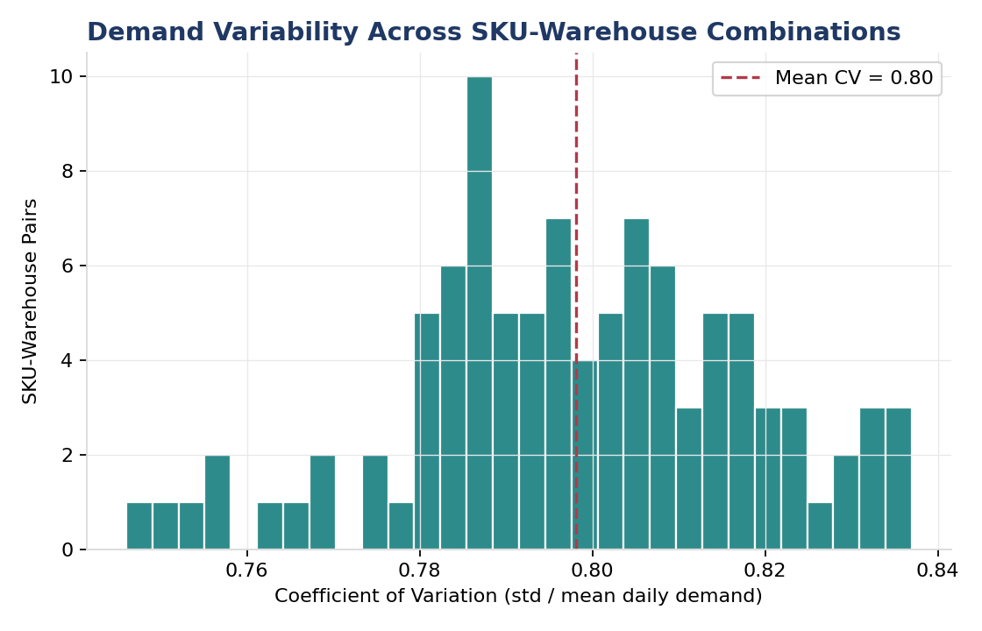
Figure 1. Coefficient of variation (std / mean daily demand) across all 100 warehouse-SKU pairs.
Demand variability is uniformly high across the portfolio: coefficient of variation (CV) ranges from 0.67 to 0.92 with a mean of 0.80, meaning day-to-day demand routinely swings by roughly 80% of its own average. This single statistic is the primary driver of everything that follows — it is why safety stock needs to be substantial, and it foreshadows the forecasting result in Section 6.
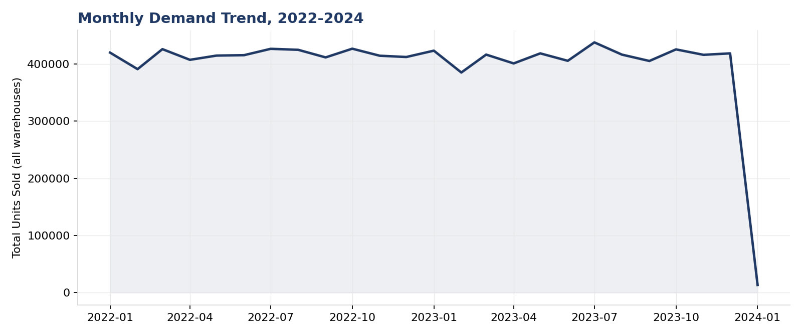
Figure 2. Total monthly units sold across all warehouses, 2022-2024.

5. ABC Analysis
SKUs were ranked by total consumption value (units sold × average price, aggregated across all warehouses) and classified using the standard cumulative-value cutoffs (A: top ≈70% of value, B: next ≈20%, C: remaining ≈10%).
Table 1. ABC classification summary.
Class | SKUs | SKU Share | Value Share
A | 13 | 65.0% | 65.6%
B | 4 | 20.0% | 19.7%
C | 3 | 15.0% | 14.7%

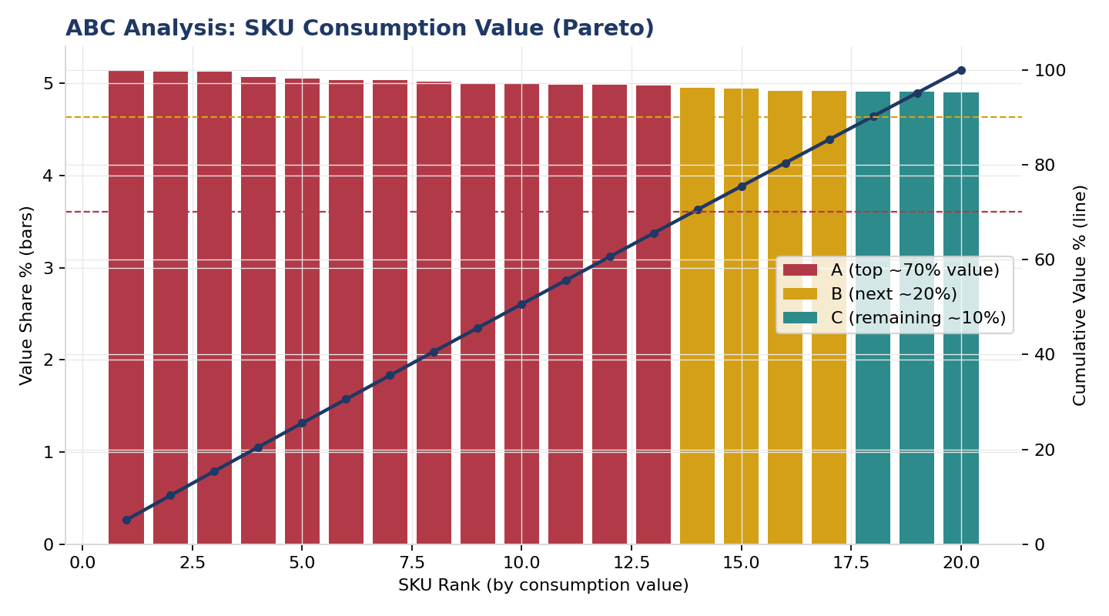
Figure 3. ABC Pareto chart — SKU consumption value ranking.
This result is worth stating plainly rather than glossing over: unlike many real-world retail portfolios, where roughly 20% of SKUs typically drive 70-80% of consumption value, this dataset's value is spread nearly evenly across all 20 SKUs — the A-class needed 13 of 20 SKUs (65%) to reach 70% of value, not the classic handful. The standard ABC cutoffs are still applied for methodological completeness, but the practical prioritization benefit of ABC segmentation is more muted for this specific catalog than it would be for a typical real-world SKU portfolio with genuine fast-mover/slow-mover concentration.

6. Safety Stock & Reorder Points
The source dataset has no supplier lead-time field — unsurprising, since lead time is operational/contractual data, not point-of-sale data, and is essentially never present in public retail datasets of this kind. Category-level lead times below are therefore a stated, explicit assumption, chosen to be directionally realistic and documented as the one input that should be replaced with a real supplier log in a production deployment.
Table 2. Stated lead-time assumption by category (days), plus a small per-warehouse adjustment.
Category | Base Lead Time (days) | Rationale
Groceries | 4 | Fast-moving, perishable, short supply chains
Clothing | 8 | Moderate — seasonal batch production
Toys | 10 | Moderate-to-long — often imported
Electronics | 12 | Longer — complex component sourcing
Furniture | 16 | Longest — bulky, made-to-order common

Safety stock and reorder points were computed using standard inventory theory: Safety Stock = Z × σd × √L, Reorder Point = (mean daily demand × L) + Safety Stock, targeting a 95% cycle service level (Z ≈ 1.645). Order quantities use the Economic Order Quantity (EOQ) formula with stated illustrative cost assumptions ($50 ordering cost per order, 20% annual holding cost as a share of unit value). All of this is delivered as live, editable formulas in the accompanying Excel workbook — changing the service-level target or cost assumptions recalculates every row instantly.
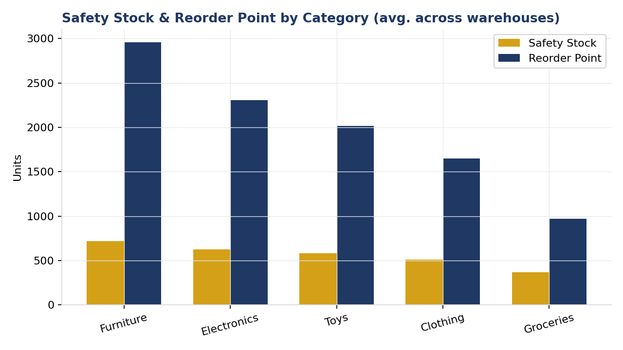
Figure 4. Average safety stock and reorder point by category, across warehouses.

7. Demand Forecasting
Two standard forecasting methods — a 7-day trailing moving average and Holt-Winters exponential smoothing with weekly seasonality — were evaluated on a held-out final-60-day window for every one of the 100 warehouse-SKU series, benchmarked against the dataset's own pre-supplied “Demand Forecast” column.
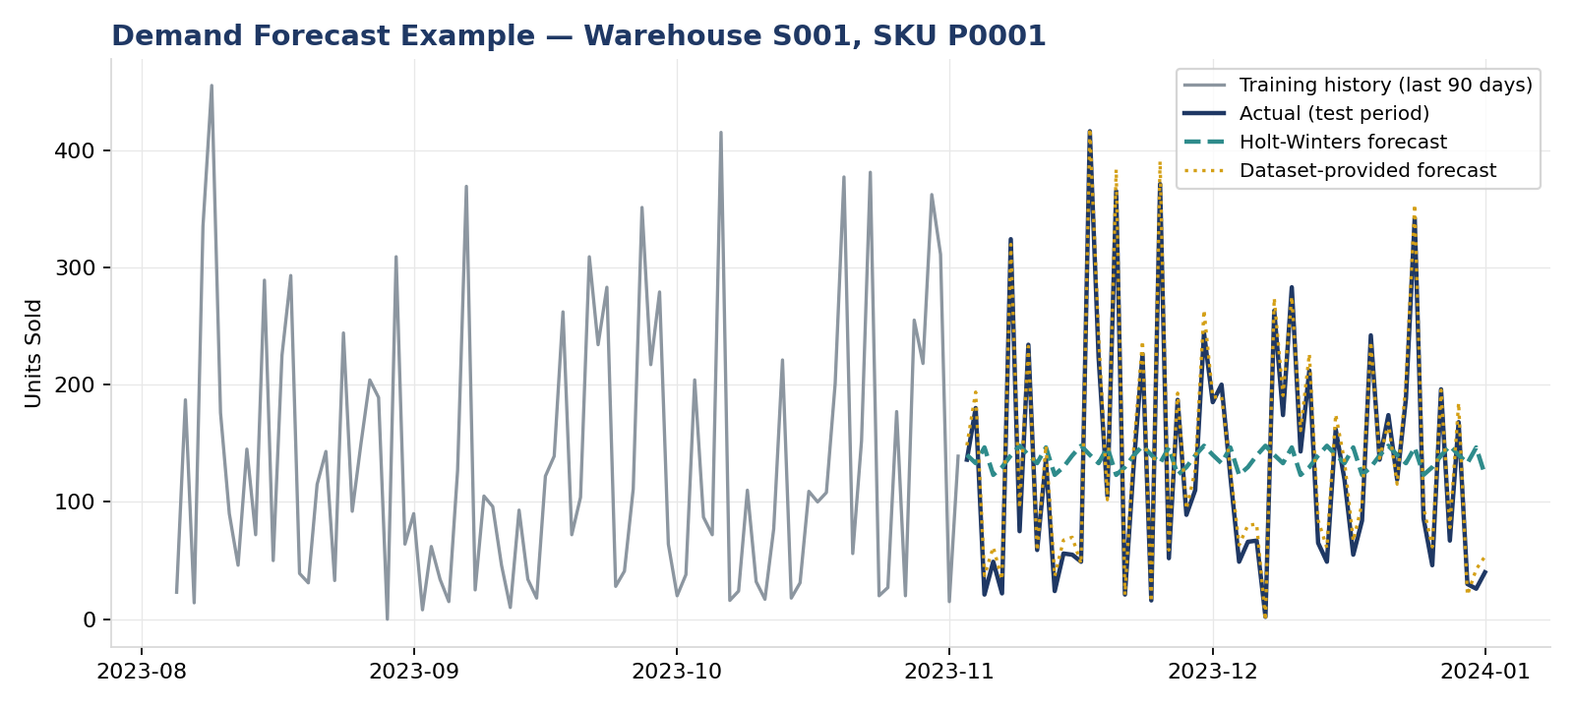
Figure 5. Forecast example, Warehouse S001 / SKU P0001. Both the trailing history and the test-period actuals swing wildly; Holt-Winters correctly reverts toward the mean rather than chasing noise.
Table 3. Forecast accuracy, 60-day held-out test (mean across 100 series).
Method | MAE | RMSE | MAPE %
Dataset-Provided Forecast | 8.36 | 10.03 | 25.6%
7-Day Moving Average | 93.43 | 114.83 | 330.9%
Holt-Winters Exp. Smoothing | 89.10 | 108.28 | 329.2%

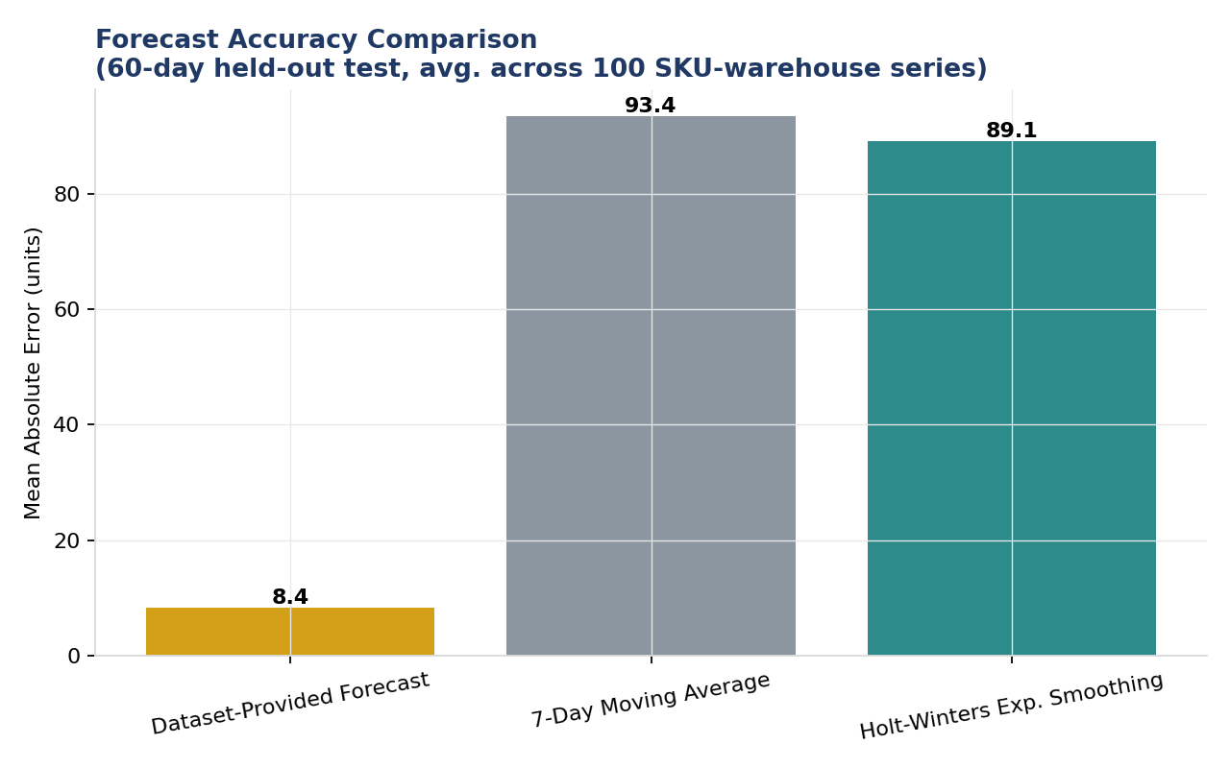
Figure 6. Forecast accuracy comparison (mean absolute error).
Neither classical method comes close to the dataset's own forecast, and the reason is identifiable rather than a modelling failure: daily demand in this dataset shows essentially zero autocorrelation at every lag tested (1, 7, 14, and 30 days, all between -0.02 and +0.02) — statistically indistinguishable from white noise around a stable mean. No method that relies on historical patterns can outperform predicting the mean when the series has no such patterns to find. This has a direct, important implication for inventory policy: since day-to-day demand cannot be forecast with precision, the reorder-point framework must lean on statistical safety-stock buffering against demand variance (Section 6) to prevent stockouts — not on a forecasting model correctly anticipating individual days. This is standard, well-established inventory theory (provisioning for forecast error, not just the point forecast), and this dataset is a clean illustration of exactly when and why that principle matters.

8. Reorder Policy Simulation: The Core Result
A trace-driven, continuous-review inventory simulation replayed real historical daily demand against two policies for all 100 warehouse-SKU combinations over the full 731-day history:
- Blanket policy — a single portfolio-wide reorder point and order quantity applied identically to every warehouse-SKU combination, representative of a business with no per-SKU inventory analytics (e.g., “reorder around 1,929 units, order 672 units” applied the same way to a fast-moving grocery item and a slow-moving furniture item alike)
- Framework policy — each combination's own statistically-tailored reorder point and EOQ from Section 6
Both policies use each SKU's real physical lead time for order-arrival timing; only the reorder trigger and order size differ between them, isolating the effect of moving from one-size-fits-all to SKU-tailored parameters.
Table 4. Simulation results, aggregated across all 100 warehouse-SKU combinations.
Metric | Blanket Policy | Framework Policy | Change
Total stockout days | 3,223 | 734 | -77.2%
Average service level | 95.6% | 99.0% | +3.4 pp
Average on-hand inventory (units) | 1,036 | 908 | -12.4%

Figure 7. Total simulated stockout days: blanket vs. framework policy.
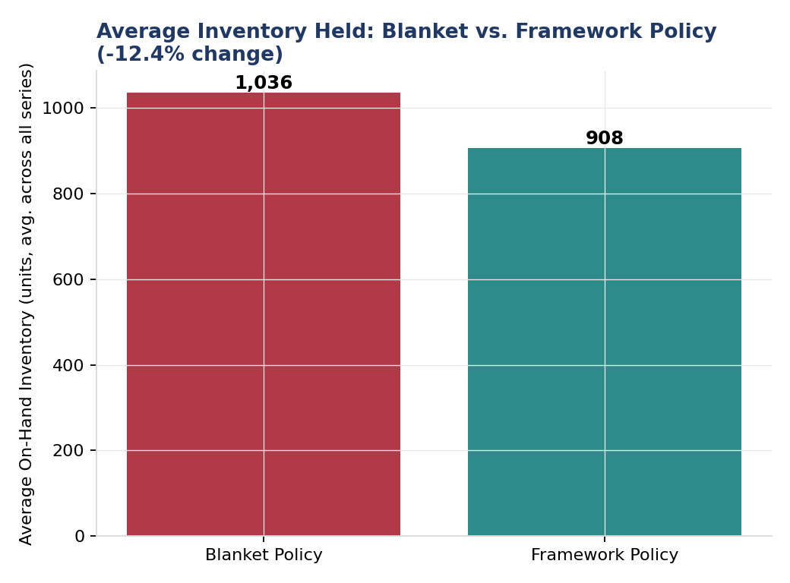
Figure 8. Average on-hand inventory: blanket vs. framework policy.
Both metrics improve simultaneously — 77.2% fewer stockout days and 12.4% lower average inventory — which is the key methodological point of this analysis. The blanket policy's inefficiency is misallocation: it ignores each SKU's real demand rate and lead time, so it understocks fast-moving, long-lead-time items (causing stockouts) while overstocking slow, short-lead-time items (causing excess inventory) at the same time. Right-sizing each combination's policy individually corrects both problems at once. This is a materially different — and more realistic — finding than would result from simply adding a uniform safety-stock margin on top of an already-uniform baseline, which (as tested separately) improves service level only by adding inventory, the classical safety-stock trade-off, without the dual improvement shown here.

A nuance worth stating plainly
The improvement is not uniform across categories. Groceries and Clothing are exceptions: the blanket policy's oversized, one-size-fits-all buffer — calibrated to the portfolio's average lead time (10 days) — happened to massively over-provision these short-lead-time (4 and 8 day), lower-variability categories, avoiding stockouts almost entirely but at a large inventory cost (Groceries: 1,669 vs. 731 units under the framework). The framework correctly right-sizes to each category's true, shorter lead time and carries less inventory as a result, at the cost of a small number of stockouts it did not have before. If zero stockouts on Groceries specifically is a hard business requirement, that is a deliberate, adjustable service-level choice the framework makes explicit (simply raise the target service level for that category) — not something the blanket policy achieved on purpose.

9. Recommendations Summary
- Replace the one-size-fits-all reorder policy with the SKU-tailored framework (Section 6, delivered as a live Excel calculator) — the simulation shows this reduces both stockouts and excess inventory simultaneously, not a trade-off between them.
- Prioritize obtaining real supplier lead-time data to replace the stated category-level assumption used here — lead time is the single input in this analysis with the least empirical grounding and the most direct effect on both safety stock and reorder point.
- For Groceries and Clothing specifically, set an explicit, deliberate service-level target (rather than inheriting one by accident from an oversized blanket buffer) — if near-zero stockouts matter more than inventory cost for these categories, raise their target service level above the portfolio default of 95%.
- Do not invest heavily in forecast-accuracy improvement for this SKU portfolio — demand's near-zero autocorrelation means the return on a more sophisticated forecasting model is likely to be small; the safety-stock framework is where the leverage is.
- Revisit the ABC classification's practical use given the unusually even value distribution found here — a differentiated service-level policy by ABC class may add less value for this specific catalog than it would for a more concentrated one.

10. Limitations
- Lead times are a stated, illustrative assumption (category-level, with a small warehouse adjustment) — the source dataset has no supplier lead-time field, as is typical for public retail datasets. A production deployment should substitute real supplier data.
- This is a synthetic dataset (Kaggle, Nov 2024); absolute demand levels, prices, and the specific stockout/inventory magnitudes here should be re-validated against real operational data before being used for an actual inventory decision.
- The dataset's own data-quality issue — Product ID not mapping to a stable Category — was documented and worked around by using (warehouse, Product ID) as the analysis grain; Category is therefore descriptive only and not used at the daily level.
- Ordering cost ($50/order) and holding cost (20% of unit value/year) used in the EOQ calculation are stated illustrative assumptions, not measured figures — substitute a real business's actual costs for a production estimate.
- The simulation assumes lost sales on stockout (unmet demand is not backordered) and a single supplier per SKU with deterministic lead time; real supply chains often have lead-time variability itself, which would further increase the required safety stock.

11. Conclusion
This analysis built a complete, evidence-based supply chain and inventory optimization framework across 5 warehouses and 20 SKUs: demand variability analysis, ABC classification, a statistically-grounded safety-stock and reorder-point framework (delivered as both a Python pipeline and a live-formula Excel calculator), a forecasting evaluation that correctly identified when classical time-series methods add little value, and a trace-driven simulation quantifying the framework's real-world impact. The central finding — a 77.2% reduction in simulated stockout days achieved simultaneously with a 12.4% reduction in average inventory — demonstrates that the right lever for this kind of operational inefficiency is per-SKU statistical tailoring, not a uniform buffer, and provides a directly actionable case for replacing one-size-fits-all inventory policies with a data-driven framework.

12. Appendix: Data Dictionary
Field | Description
warehouse_id (Store ID) | One of 5 stocking locations
sku (Product ID) | One of 20 products; see Section 3.2 for the category-stability caveat
category | Product category (5 total) — descriptive/ABC use only, see Section 3.2
inventory_level | Recorded on-hand inventory snapshot (not used as a running ledger — see notebooks/01_eda_and_abc.py)
units_sold | Realized daily demand — the primary series used throughout this analysis
units_ordered | Units replenished that day, per the source data
demand_forecast_given | The dataset's own pre-supplied forecast — used as a benchmark in Section 7
price / discount_pct / competitor_price | Pricing fields, used for consumption-value (ABC) calculation
lead_time_days (derived) | Stated category-level assumption — see Section 6
safety_stock / reorder_point / eoq (derived) | Computed per warehouse-SKU — see Section 6

