Exploratory Data Analysis of Student Mental Health and Academic Pressure

Introduction
This report presents an exploratory data analysis (EDA) of a dataset on student mental health and academic pressure. The objective is to understand patterns of academic stress, sleep habits, demographic characteristics, and factors contributing to student stress.

Dataset Description
The dataset contains survey responses from students and includes age group, gender, education level, academic pressure, frequency of stress, sleep duration, and causes of academic stress.

Research Questions
- What age groups experience the highest academic pressure?
- Does academic pressure differ by gender?
- How frequently do students experience study-related stress?
- What are the most common causes of academic stress?
- Is there a relationship between academic pressure and sleep duration?
- Do university students experience more stress than college students?
- Which age group reports the highest stress frequency?
- Do males and females report different stress causes?
- Is higher academic pressure associated with more frequent stress?
- What demographic group appears most vulnerable to academic stress?

Visualizations and Captions
Visualization 1: What age groups experience the highest academic pressure?

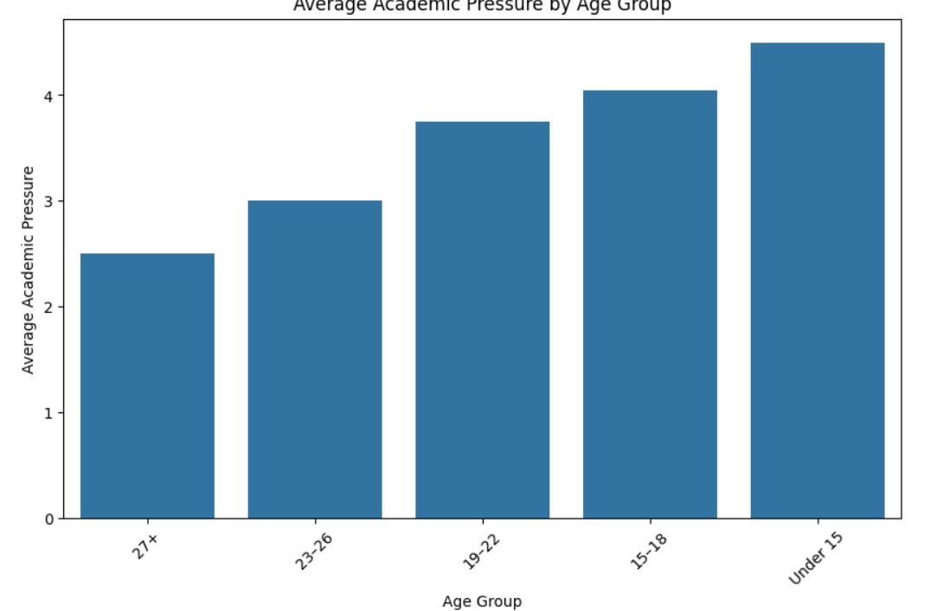Caption: Despite the low representation of the under-15 group in the survey, they are the group most likely to experience a high rate of academic pressure.
Visualization 2: Does academic pressure differ by gender?
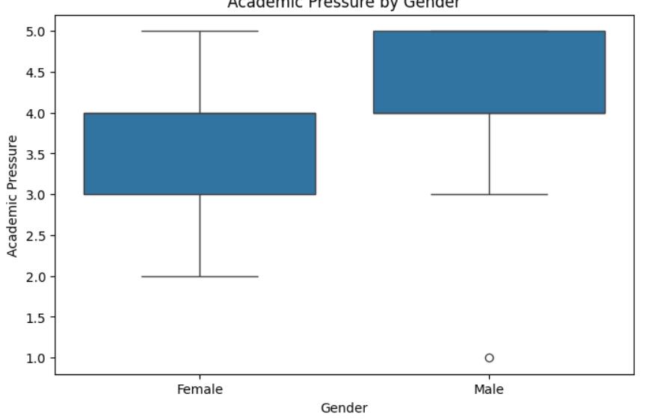Caption: This visualization compares academic pressure levels between male and female students. Differences in average scores and response spread indicate whether one gender experiences greater academic pressure than the other. Male students are experiencing higher academic pressure than their female counterparts. The findings can help identify gender-specific support needs in educational institutions.
Visualization 3: How frequently do students experience study-related stress?
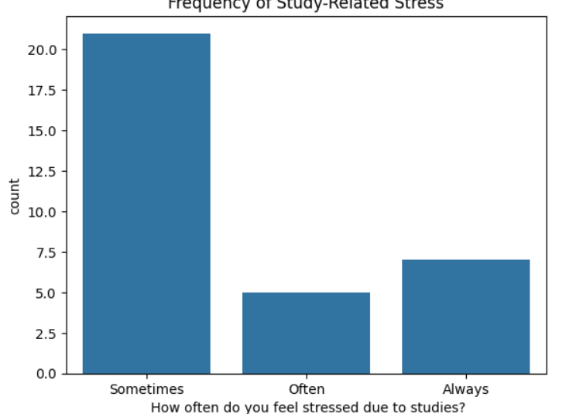Caption: Most students report feeling stressed ‘Sometimes’, while a notable portion report ‘Always’.

Visualization 4: What are the most common causes of academic stress?
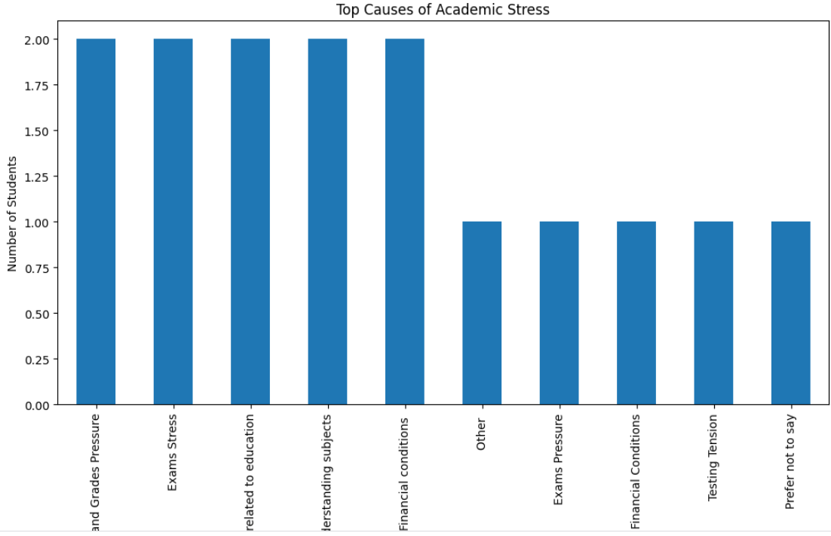Caption: Dominant sources of academic stress among students include exam and grade pressure, exam stress, financial concerns related to education, difficulty understanding the subjects, and financial conditions.
Visualization 5: Is there a relationship between academic pressure and sleep duration?
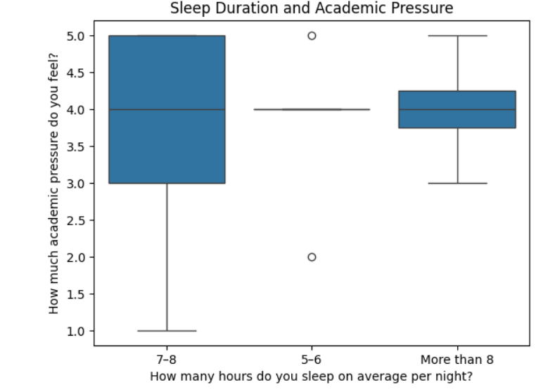Caption:

Summary of Findings

The exploratory analysis revealed that academic pressure and financial stress are strongly associated with student depression. Students reporting higher pressure levels exhibited considerably higher depression rates. Lower study satisfaction and reduced sleep duration were also linked to poorer mental health outcomes. Gender differences were observed, though they were less pronounced than the effects of academic and financial stress. Correlation analysis further indicated that academic pressure and financial stress are among the strongest predictors of depression in the dataset. These findings suggest that institutions should implement interventions to reduce academic stress, improve financial support systems, and promote healthy sleep habits to enhance student well-being.

References
Kaggle Dataset, Pandas Documentation, Matplotlib Documentation, Seaborn Documentation.

