# Sprint #2 Planning

**Sprint:** Sprint 2

**Date:** 12/05/2021

**Scrum master:** Katelyn Knight (s3839920)

**Development team:** Gayan Wijesuriya (s3843584), Zhengchao Sun (s3737536), Huiyu Wang (Tony) (s3737937), Trong Khoa Dang (s3846329), Katelyn Knight (s3839920), Hoang Tran (3720825)

**Product Owner:** Hoang Tran (3720825)

## Sprint Goal

Sprint Goal: The goal of this sprint is to implement four features into our IMDB website*.* These features include making an account badge/type to distinguish the different accounts for the program to accurately provide a way to give different permissions and privileges. Adding in movie submissions is another feature we are aiming to implement, which essentially means that those who want to submit a movie can do so and the said submission will be stored for further inspection from Administrators. Following off the movie submission, administrators will be given the privileges of accepting or rejecting any movie submission when they see fit.

Sprint Capacity: The team is moderately experienced in the areas they wish to undertake. Everyone has worked on another project to some degree as well as just coming off programming the previous sprint, so it should be relatively within reason to assume the team can complete the four functions/tasks detailed in sprint 2.

Special Circumstances: There are no special circumstances for this Sprint.

## Sprint Goal & User Stories

|  |  |  |
| --- | --- | --- |
| Story no | User story | Ranking |
| 25 | As a critic I want to submit a show I positively reviewed so that other critics can give their opinions. | 2 |
| 38 | As an actor, I want to submit an indie show, so that I can spread my name and credentials further. | 2 |
| 41 | As an admin, I want to accept this entry from a viewer as it is not currently shown on the website | 2 |
| 23 | As a regular user I want to submit a movie entry not shown so that I can share a movie I have seen. | 3 |
| 29 | As an admin I want to delete a rejected entry so that I am able to ensure the integrity of the website. | 3 |
| 30 | As an admin I want to delete an unwanted entry so that I am able to keep the website up to standard | 3 |
| 31 | As an admin I want to delete an incorrect entry so that I am able to restore the websites accurate information | 3 |
| 32 | As a production company member, I want my status to be known to other users so they know that any review or information I provide pertaining to a movie/show can be trusted and true. | 3 |
| 33 | As a critic of a movie/show, I want my reviews to be known to others through my user type. My reviews may then hold more weight and be more trusted by other users | 3 |
| 35 | As an admin, I want critics or PCo's to have special user types so i know that their contributions can be more trusted which i would then highlight on the website | 3 |
| 36 | As an admin, I want Critics and PCo's to have specific account types so that regular users can see that the content they contribute and publish can be trusted | 3 |
| 37 | As a regular user, I want critics and PCo's to have verified accounts so that the websites community interaction can grow. | 3 |
| 39 | As an admin, I want to accept this entry so a PCo can have their movie on the website. | 3 |
| 42 | As an admin, I want to accept an entry so that I can properly exercise my privileges. | 3 |
| 24 | As a production company I want to submit a new movie I have produced so that I get maximum publicity. | 4 |
| 26 | As an admin, I want to be able to reject requests to display information on a show, so that it allows me to provide quality assurance for the website. | 4 |
| 27 | As a user of the website, I want live notification on the status of my request to add a show so that I am not blindly waiting. | 4 |
| 28 | As an admin, I want rejected applications to be deleted from my list so that the list of applications doesn't pile up. | 4 |
| 34 | As an admin, i want other users to know i am an admin, so that they can reach out to me for any assistance. | 4 |
| 40 | As an admin, I want to accept this entry so that I can maintain the integrity of the website | 4 |

## Summary

*Define:*

1. The tools that will be used for the project will be: Javalin for code development, Velocity for agile software development, Github for uploading code and teamwork, HTML and CSS for the website design/hosting. Github repository link:  
   Clickup Screenshots: <https://github.com/sef-2021-s1/team-project-n-9>   
   Clickup Settings: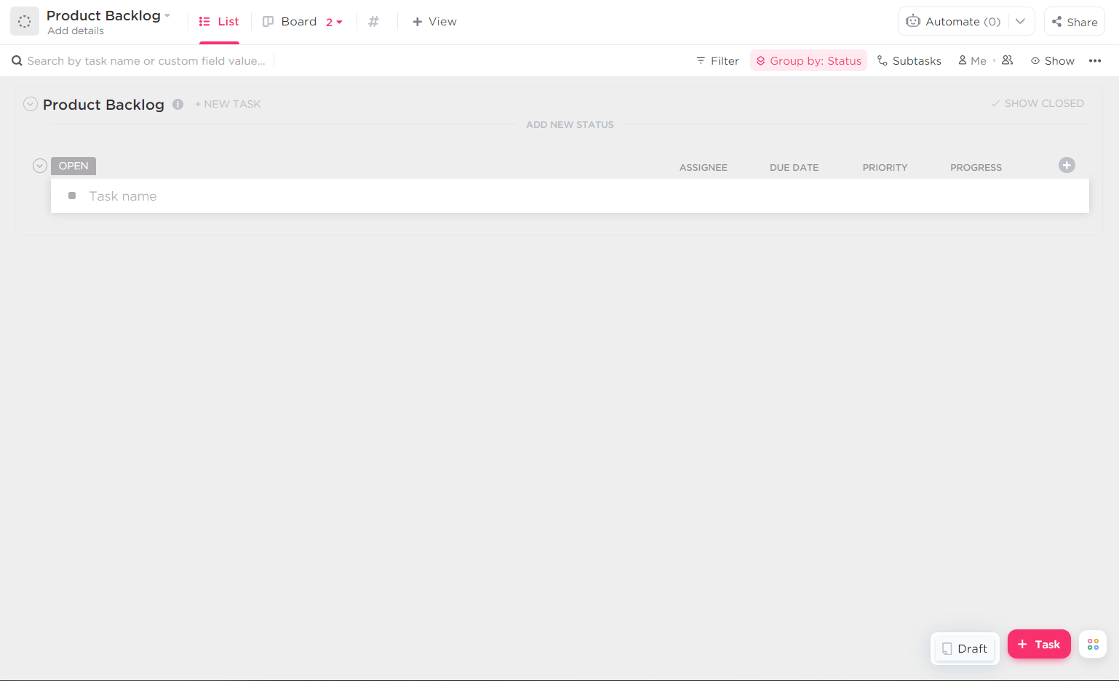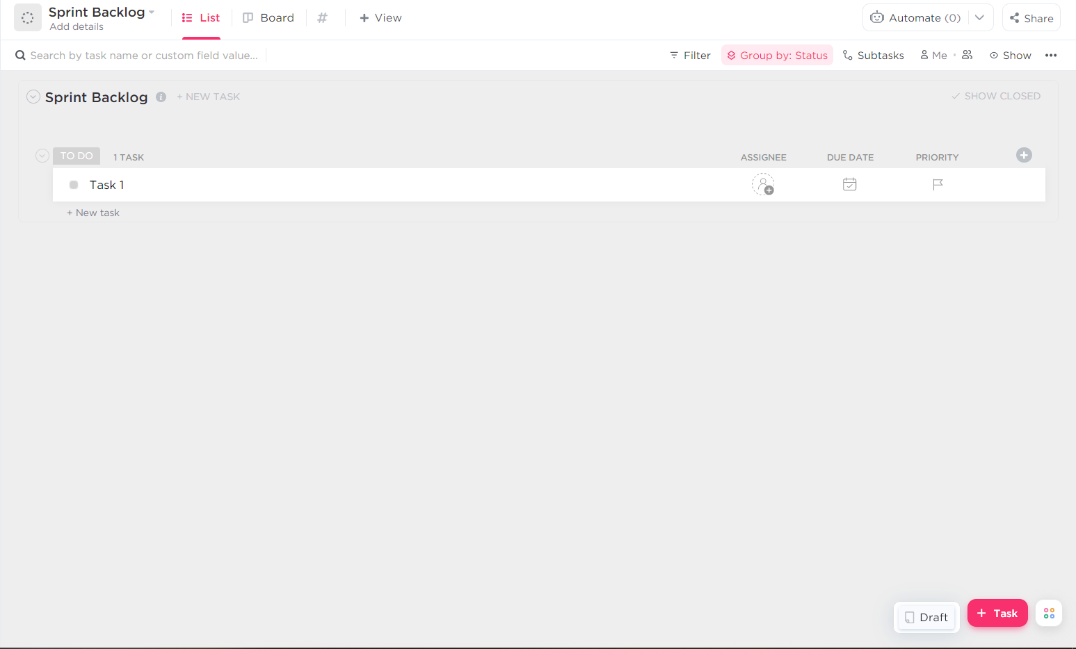
2. Gayan is tasked with working on creating different types of users for the website as well as giving admins the permissions to accept movie submissions from other users. Tony (Huiyu Wang) is tasked with making the methods so that admins can delete or reject movie submissions. Khoa oversees the rejection methods as well as aiding in creating the ability for accounts to submit movies to the website. Zhengchao is responsible for creating the different types of users with Gayan. Katelyn is aiding in the admin movie acceptance. Hoang is in charge of accounts submitting movies with Khoa. All responsibilities include testing and creating the acceptance criteria
3. Issues addressed during the meeting were time constraints and personal timetables