Sprint Review: S#2

Sprint 1

Date: 2/5/2021

Scrum Master: Katelyn Knight (s3839920)

Development Team: Gayan Wijesuriya (s3843584), Trong Khoa Dang(s3846329), Hoang Tran( s3720825), Zhengchao Sun(s3737536), Huiyu Wang(s3737937)

# Sprint Goals

In this sprint we aimed to create and code 4 more features into our website, mostly relating to the privileges of admins and different types of user accounts. Those 4 features are more specifically:

* Admins can reject/delete any entry
* Types of users including, regular, PCo’s, and critics
* Any accounts can submit new entries
* Admins can accept any entry

Surrounding these 4 features, we also planned to continue to use the previously developed UX of the site, present in the previous sprint. All these goals were aimed to be completed by 23/5/2021

# Status Overview

The planned sprint items were met according to the planned deadline and completion was referenced from our definition of done. All 4 features we aimed to create are functioning and have the same consistent UX from the pervious sprint. Although functioning, we have identified some room for improvement which is going to be discussed below.

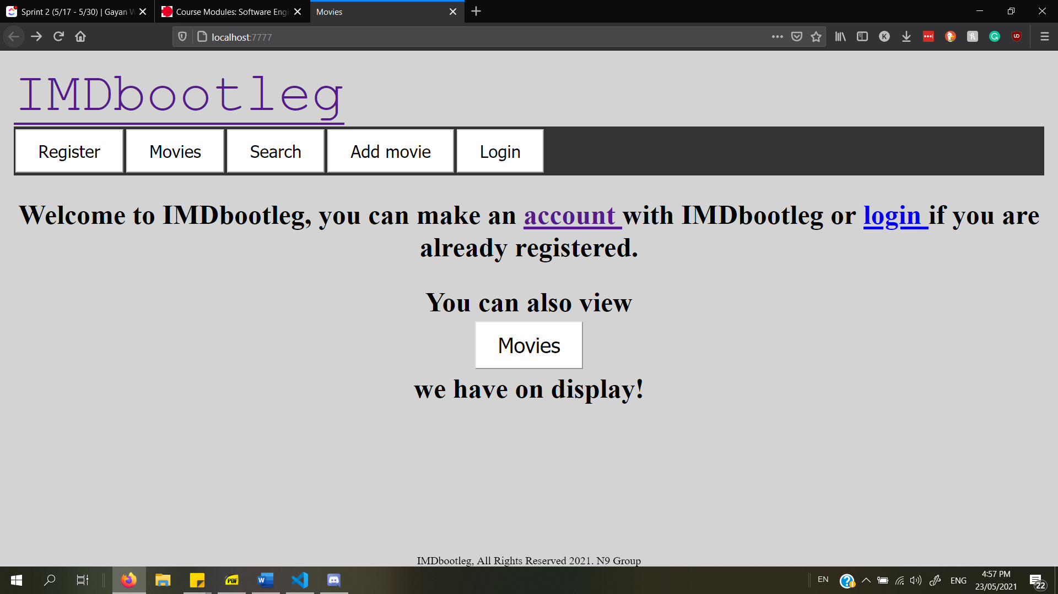

Figure 1- Homepage

Figure 1 shows the home page. On it, the page displays the websites title, a navigation bar with links. Beneath the navigation bar is a link to login or sign up, as well as a link to the movies database.

While the homepage is still looking a little bare, the previous requirements mentioned have been fulfilled, however some more developed UX could be implemented in the future with some more structure.

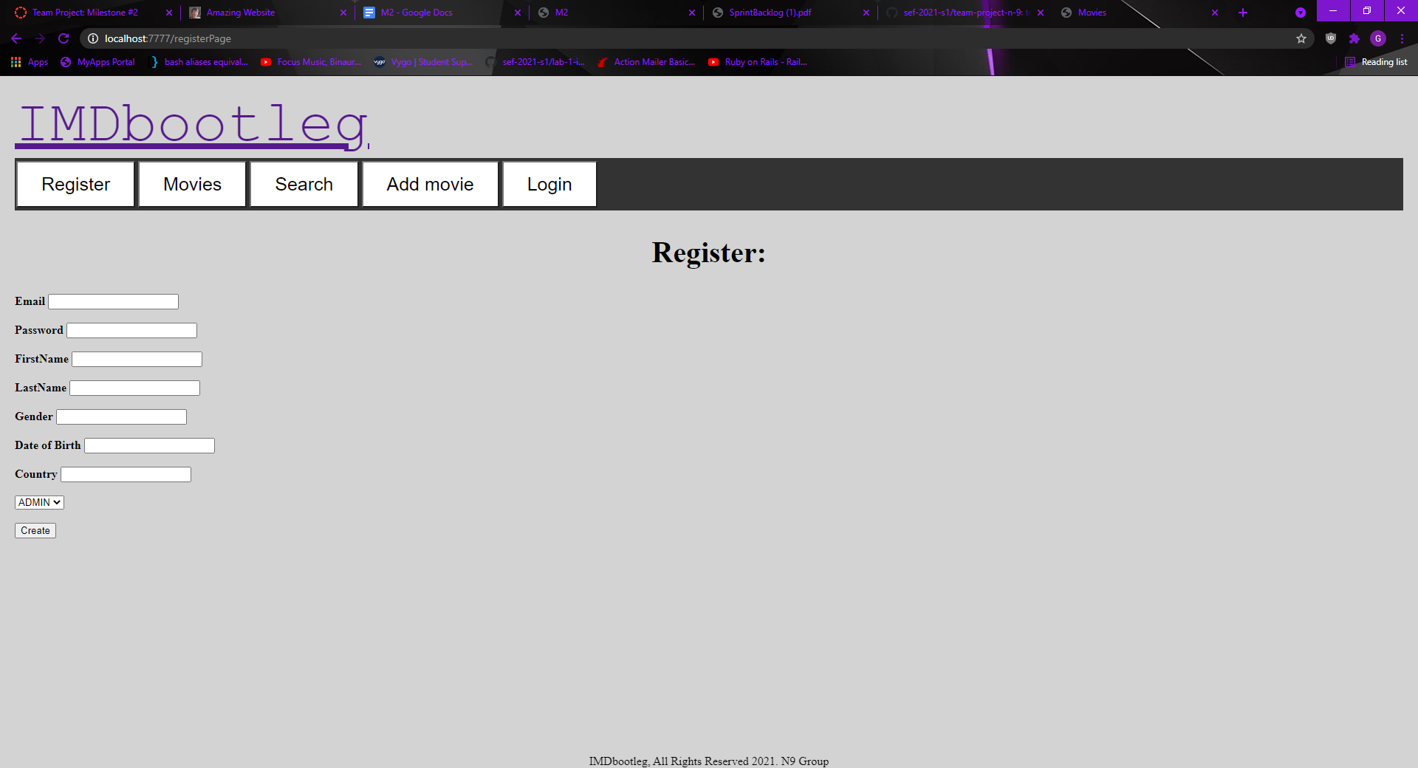

Figure 2- Register account page

In figure 2, users can access this page if they click “register” on the navigation bar, or the “account” hyperlink in figure 1. Figure 2’s page allows users to register an account with the website.

This page/feature exactly as we planned in our goals. It takes the users information and inserts it into a database which can later be used to login. Fulfilling our goal to create account types, the new option of giving the account a type to choose. Account types ranging from “Admin, User, and PCo”. the UX design functions could still be improved on as the text input fields are not aligned and looks rough with the various text appearing and misaligned navigation bar, however, the page functions as desired so we are not focusing on it.

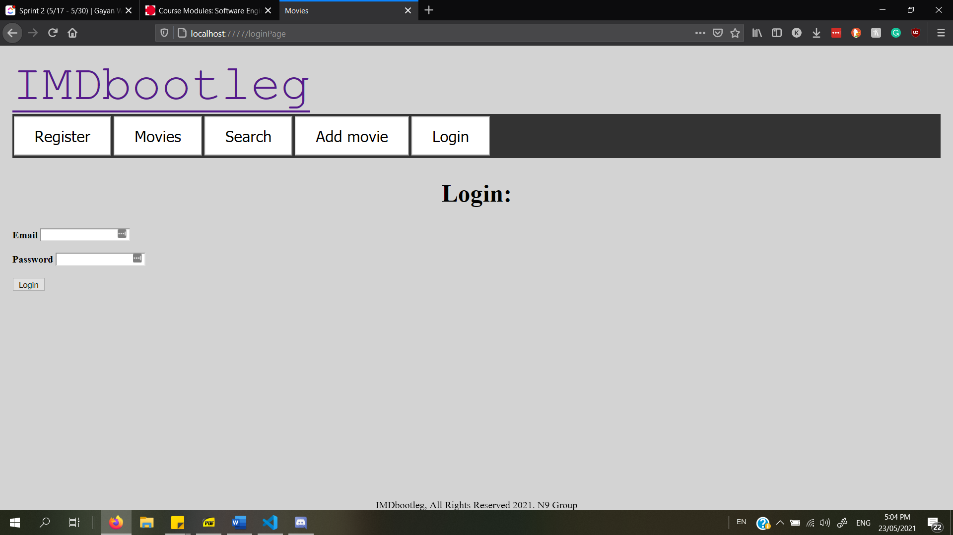

Figure 3- Login

In figure 3, users can click on the ‘login’ button on the navigation bar, or, if they are on the home page (Figure 1), they can also click on the blue ‘login’ hyperlink in the greeting message.

Functionally, mentioned last time was the logout button persisting whether the user was logged in or not and how we wanted to change this, as seen above, we were successful in changing the logout button and it only appears when the user is logged in.

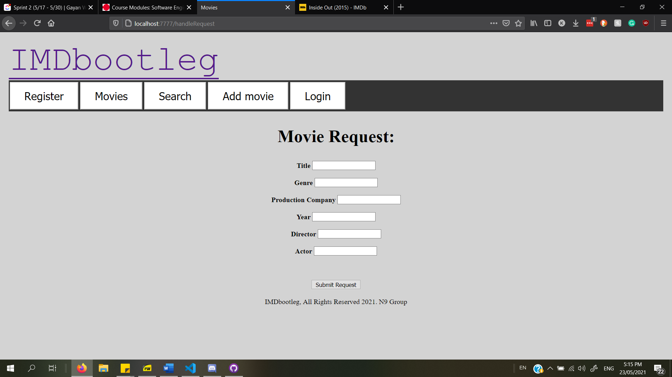

Figure 4A – movie request

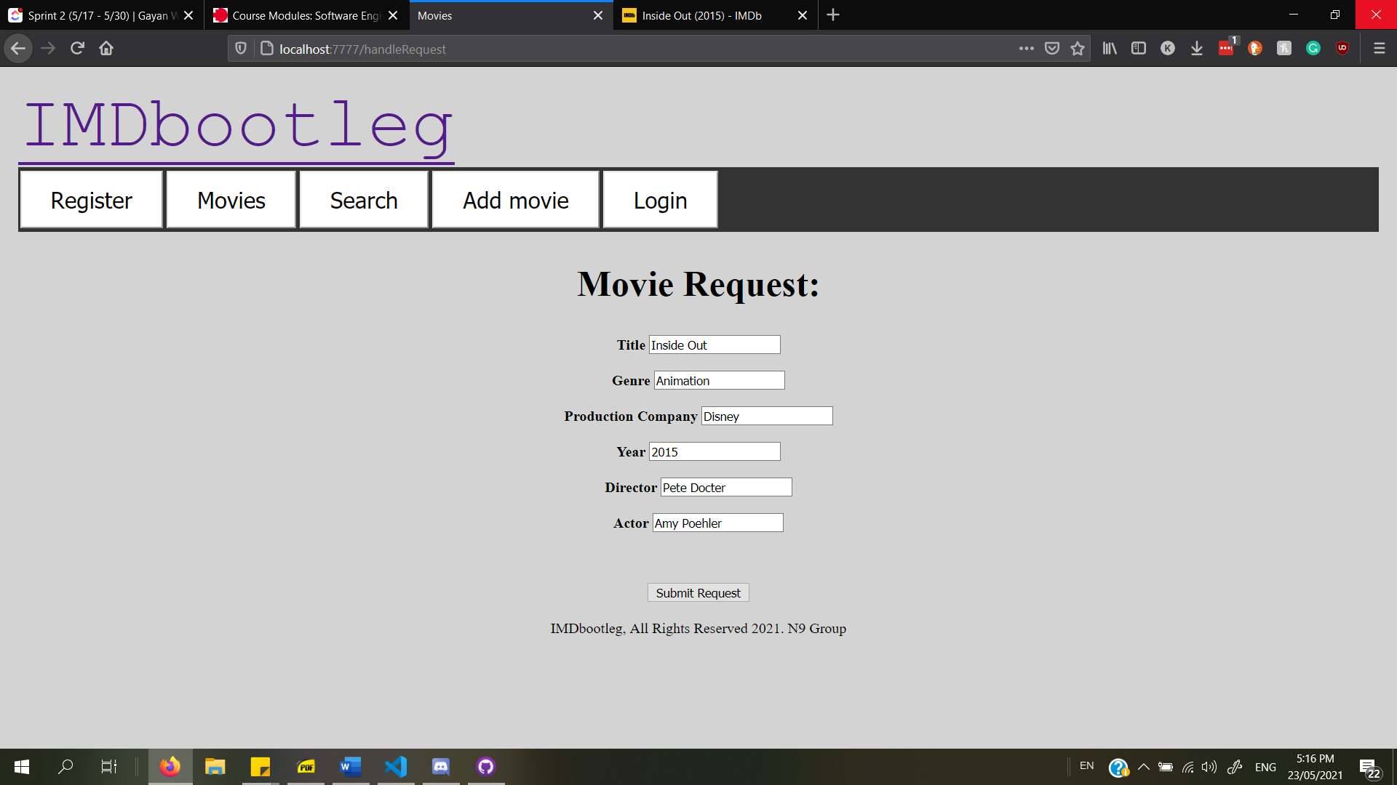

Figure 4B – movie request pt.2

This function is the movie submission page, is accessible from any account, allows users to use this form to request to have a movie shown on the database. This form sends the request to the admins of the website for review and gives the admins the ability to reject or accept the request. The form in 4B shows the text that users can input for the request. Some improvements we wish to have made is making the form a little more aligned for the UX, having the ability to put in multiple directors or lead actors as well as wanting for there to be live updates for the user who originally submitted the request as per our sprint backlog.

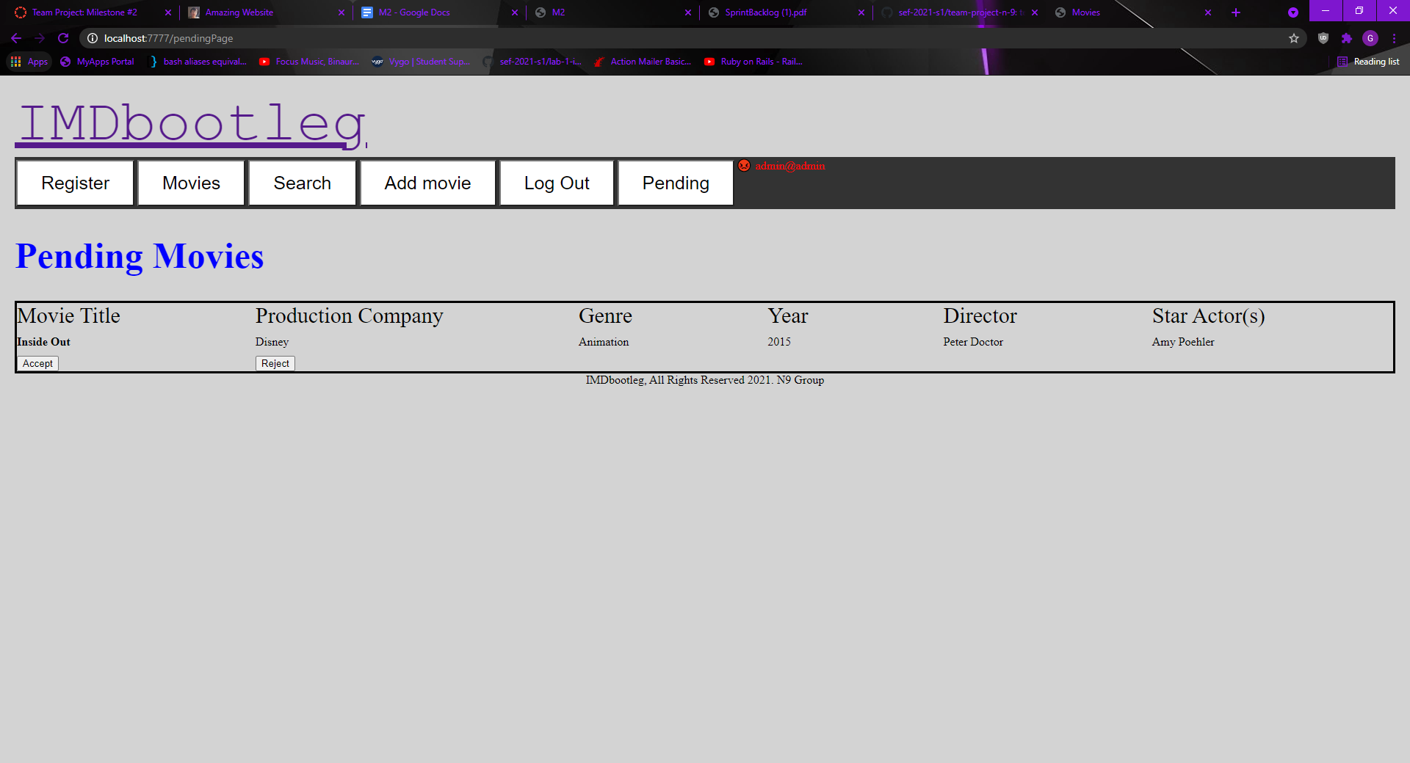

Figure 5 – Movie Acceptation/Rejection

This feature uses the example from the previous function. Here, an admin account has already been logged into and admin accounts have access to the pending tab. In this pending tab we can see the movie ‘Inside Out’ a movie which some user has submitted to be included into the movies database. Each movie has two buttons associated with it, the accept button which removes the movie from this tab and adds it to the general movies database, and the reject button which just removes the movie from the pending tab.

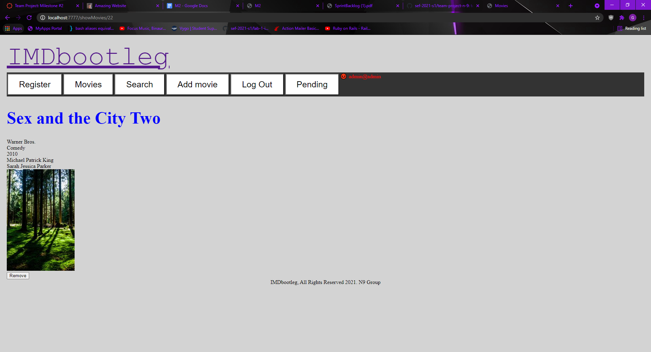

Figure 6 – Deleting a movie that was in the main database.

This new feature lets any logged in admin delete a movie that has already been accepted into the movies database. This is useful as if a movie was incorrectly marked as accepted in the pending tab and pushed to the movies database, then it can be removed from the movies database. Pressing the remove button removes the current movie and then redirects the admin to the “Movies” page, as the page they are on no longer exists. Additional improvement could be in the form of a confirmation message that a movie has already been deleted.

# Sprint Statistics

Figure 7A- Burndown chart for sprint session 1

For Sprint Session 1, we started quicker than last time but still relatively slow, being held back by other commitments, we started development around day 5 or 6. We kept on track and did not necessarily fall behind in development, for the coding however we did fall behind in the report writing and the making of the video. We did end up completing the implementation of our four features.

Figure 7B- Sprint burndown

Overall, we were where we needed to be throughout the duration of the project. The goals we set out to complete are finished and we have created 4 features as per the goal.