GITHUB ACTIONS :
GitOps Fundamentals — Flipkart Case Study
Let's imagine Flipkart has a service called:
Product Catalog Service
This service is responsible for showing products, prices, availability, images, etc.
During Big Billion Days, millions of users may access Flipkart simultaneously.

First understand the problem
Imagine Flipkart has hundreds of Kubernetes services:
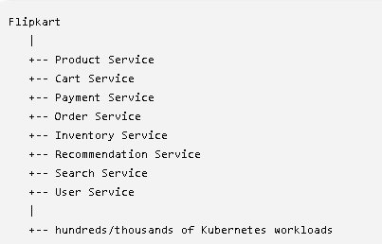
All of these are running inside Kubernetes.
Now imagine the deployment team manually changes something in production.
For example:
Git says:
replicas: 10
But during a traffic spike, an engineer goes directly to Kubernetes:
kubectl scale deployment product-service --replicas=50
Now we have:
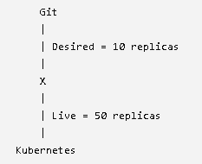
Git says 10.
Kubernetes is running 50.
This is called:
Configuration Drift

Now imagine another problem
Monday morning, a developer changes the application.
They update:
Product Service v1
↓
Product Service v2
The CI pipeline builds the new image.
But suppose the deployment process simply takes whatever is in Git and pushes it to Kubernetes.
Git still says:
replicas: 10
So the deployment process may unintentionally change Kubernetes from:
50 replicas
↓
10 replicas
During a massive Flipkart sale:
Traffic ↑↑↑↑↑
|
↓
Only 10 pods
|
↓
Pods overloaded
|
↓
Response time ↑
|
↓
Users experience slow website
This is the core problem GitOps is designed to address.

So what is GitOps?
The simplest classroom definition:
GitOps means we manage the desired state of our infrastructure and applications through Git, and Git becomes the source of truth for what the environment should look like.
Instead of saying:
"Go to Kubernetes and make it look like this."
We say:
"Define how Kubernetes should look in Git."
Then a GitOps tool such as Argo CD makes the Kubernetes environment match that definition.
Argo CD describes this model as desired configuration being pushed to Git, after which the cluster synchronizes itself to the desired state stored in Git.

2. Why is Git the Single Source of Truth?
Let's go back to Flipkart.
Suppose the repository contains:
product-service:
replicas: 20
image: flipkart/product:v25
cpu: 500m
memory: 1Gi
This is the desired state.
We are saying:
"This is how Product Service SHOULD look."
Git now becomes our source of truth.

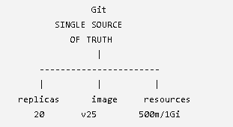
Now suppose somebody manually changes Kubernetes:
kubectl scale deployment product-service --replicas=50
Kubernetes becomes:
Live State
replicas = 50
But Git says:
Desired State
replicas = 20
ArgoCD can detect:
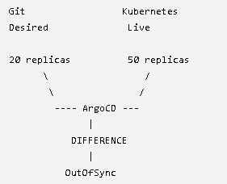
This comparison between desired state in Git and live state in Kubernetes is central to Argo CD's reconciliation model

So what does ArgoCD do?
ArgoCD continuously asks:
"Does the Live State match the Desired State?"
Think of ArgoCD as a supervisor.
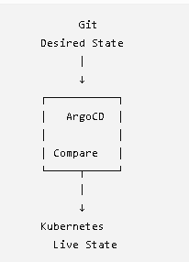

If:
Git = Kubernetes
Then:
SYNCED
If:
Git ≠ Kubernetes
Then:
OUT OF SYNC
And depending on the sync policy, ArgoCD can bring the cluster back toward the desired state.

####Push vs Pull Deployment Model
1. Push Model — Traditional CI/CD
Example: GitHub Actions → Kubernetes
Developer
↓
GitHub
↓
GitHub Actions
↓
Kubernetes
How it works:
- Developer pushes code.
- CI/CD pipeline runs.
- Pipeline connects to Kubernetes.
- It executes something like kubectl apply or helm upgrade.
- Deployment is completed.
- Pipeline finishes.
Key point:
👉 External CI/CD pushes the change INTO the cluster.
The source specifically describes GitHub Actions as running outside the cluster and requiring credentials to access the Kubernetes API
2. Pull Model — ArgoCD
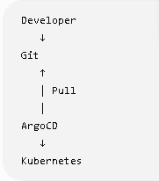

How it works:
- Developer changes the Kubernetes configuration in Git.
- ArgoCD is already running inside Kubernetes.
- ArgoCD connects outward to Git.
- It reads the desired state.
- It compares Git state with the live Kubernetes state.
- If there is a difference, ArgoCD synchronizes the cluster.
Key point:
👉 ArgoCD pulls the desired state FROM Git.

##Main Security Difference
Push:
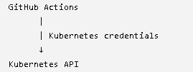
The external CI/CD system needs credentials such as a service-account token or kubeconfig.
PULL:
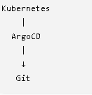
ArgoCD is already inside the cluster, so the external CI/CD system doesn't need direct Kubernetes administrative access.

#### Why does ArgoCD run inside Kubernetes?
Because ArgoCD needs to continuously monitor and manage the live Kubernetes state.
Think of it as:
ArgoCD is the manager sitting inside the building, continuously checking whether the building matches the blueprint stored in Git.

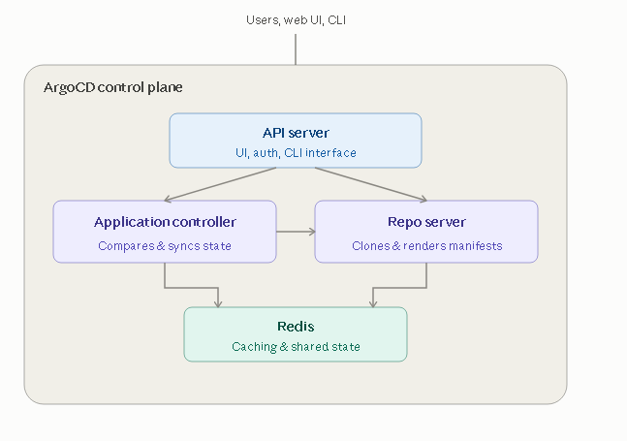
> The API server (blue) is the entry point — it's what the UI, CLI, and any external automation talk to, and it also handles auth.
> It delegates to two core engines (purple): the application controller, which continuously compares the live cluster state to the desired state and drives sync, and the repo server, which clones Git repos and renders manifests
> The application controller asks the repo server for rendered manifests directly, so it can diff them against what's actually running.
> Redis (teal) sits underneath both, caching things like generated manifests, cluster state, and app metadata so the controller and repo server don't redo expensive work on every reconciliation loop.
Reconciliation Loop ⭐⭐⭐
Concept:
Git → Desired State
Kubernetes → Live State
ArgoCD continuously:
- Gets desired state
- Checks live state
- Compares them
- Determines whether they match
- Takes action if required
Important terms:
- Reconciliation : Reconciliation is ArgoCD continuously comparing the Desired State in Git with the Live State in Kubernetes.If there is a difference, ArgoCD detects it as OutOfSync and can synchronize the cluster back to the desired state.
- Desired State — The state/configuration that should exist, as defined in Git.
- Live State — The actual state/configuration currently running in the Kubernetes cluster.
- Sync Status — Indicates whether the Live State matches the Desired State.
- Synced — Git's Desired State and Kubernetes' Live State match.
- OutOfSync — Git's Desired State and Kubernetes' Live State are different.

ArgoCD Application Health vs Sync Status
These are two different things ArgoCD tracks for an Application.
1. Sync Status — "Does Kubernetes match Git?"
It checks whether the Live State matches the Desired State in Git.
- Synced → Git and Kubernetes match.
- OutOfSync → Git and Kubernetes are different.
2. Health Status — "Is the application actually working?"
It checks the operational health of the Kubernetes resources.
- Healthy → Application is running as expected.
- Progressing → Application is still changing/updating.
- Degraded → Resource exists but isn't working correctly.
- Missing → Resource exists in Git but is not present in Kubernetes.
Manual Sync vs Automated Sync
The main question is:
When ArgoCD finds the application is OutOfSync, should a human approve the change, or should ArgoCD do it automatically?
1. Manual Synchronization
In Manual Sync, ArgoCD detects that Git and Kubernetes are different and marks the application OutOfSync, but waits for a human to click "Sync".
Git changes
↓
ArgoCD detects difference
↓
OutOfSync
↓
👨‍💻 Human clicks Sync
↓
Kubernetes updated
Use when: You want human approval before deployment.

2. Automated Synchronization
In Automated Sync, ArgoCD automatically synchronizes the application when it detects a difference.
Git changes
↓
ArgoCD detects difference
↓
OutOfSync
↓
🤖 ArgoCD automatically Syncs
↓
Kubernetes updated
Use when: You want a fully automated GitOps deployment process.

3. automated
This tells ArgoCD:
"Don't wait for me to click Sync; automatically synchronize changes from Git."
Example:
syncPolicy:
automated: {}

4. selfHeal
selfHeal handles manual changes made directly to Kubernetes.
Example:
syncPolicy:
automated:
selfHeal: true
Suppose Git says:
replicas = 5
An engineer manually changes Kubernetes:
replicas = 10
ArgoCD detects the drift and automatically brings Kubernetes back toward the Git state.
Git = 5
K8s = 10
↓
OutOfSync
↓
Self-Heal
↓
K8s = 5
The source specifically describes selfHeal: true as automatically reverting manual Kubernetes changes to match Git.

5. prune
prune handles resources deleted from Git.
Example:
Git originally contains:
deployment.yaml
service.yaml
configmap.yaml
You delete configmap.yaml from Git.
With:
automated:
prune: true
ArgoCD will also remove the corresponding Kubernetes resource.
Delete from Git
↓
ArgoCD detects it
↓
Prune
↓
Delete from Kubernetes
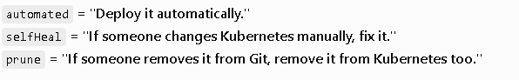
## Git Webhook
By default, ArgoCD periodically checks Git for changes.
The problem is: if a developer pushes a change to Git, we may have to wait for the next check.
Solution → Git Webhook
A Git webhook sends an HTTP request to ArgoCD immediately when a change is pushed.
Developer
↓
Git
↓ Webhook
ArgoCD
↓
Reconciliation
↓
Kubernetes
So instead of:
"ArgoCD, check Git every few minutes."
we get:
"Git, tell ArgoCD immediately when something changes."

