Day 2 : ARGO CD theory

1. App-of-Apps Pattern ⭐⭐⭐
Imagine Flipkart has these applications:
Flipkart
│
├── Product Service
├── Cart Service
├── Payment Service
├── Order Service
├── Inventory Service
├── Search Service
└── Recommendation Service
Each of these needs to be deployed to Kubernetes.
With ArgoCD, each application can be represented by an ArgoCD Application.
Without App-of-Apps:
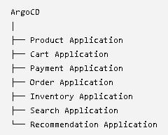

Now imagine you have 50 or 100 applications.
Managing all these Applications individually becomes difficult.
App-of-Apps solves this.
We create one Root Application that manages all these Child Applications.
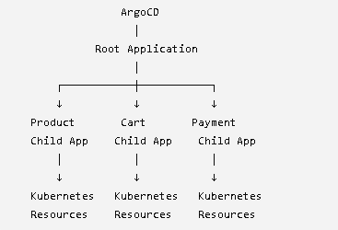
So the simple definition is:
App-of-Apps is a pattern where one ArgoCD Application manages other ArgoCD Applications.

2. Why do we need it?
Let's take Flipkart's scale.
Suppose there are:
20 microservices
And you have:
Dev
Staging
Production
You could end up managing many Application definitions.
Without a pattern:
Developer adds new service
↓
DevOps creates Application YAML
↓
Apply it to ArgoCD
↓
Configure another Application
↓
Repeat...
This becomes repetitive and error-prone.
With App-of-Apps:
Git
↓
Root Application
↓
Child Applications
↓
Services
You manage the structure from Git.

CONTEXT:

Imagine Flipkart has hundreds of microservices. If I create one ArgoCD Application for every microservice and manage every Application manually, it becomes difficult. So we use the App-of-Apps pattern. We create one Root Application. The Root Application points to a Git folder containing Child Application YAMLs. Each Child Application then points to the actual Kubernetes manifests for a particular service. So the hierarchy is Root Application → Child Applications → Kubernetes resources. The Root manages Applications, the Child manages the actual workload, and the Kubernetes manifests define what actually runs.

####
SYNC WAVES

What are Sync Waves?
Sync Waves tell Argo CD the order in which Kubernetes resources should be deployed.
Without waves, Argo CD may try to synchronize many resources together.
With waves, we can say:
"Deploy this first, wait for it to become healthy, then deploy the next thing."

Simple example
Imagine an application has:
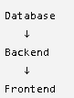
It doesn't make sense to deploy the frontend before the backend/database are ready.
So we can define:
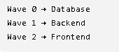
Argo CD processes:
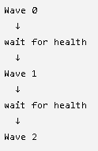
How do we define a Sync Wave?
We add an annotation to the Kubernetes resource:
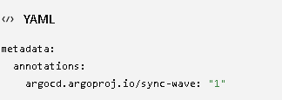
For example:
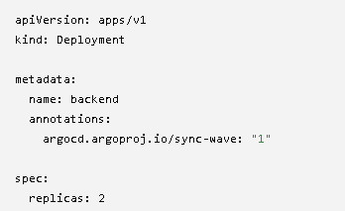
It tells Argo CD:
Deploy this resource in wave 1.
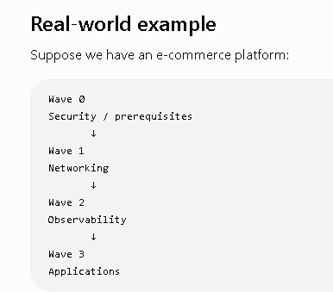

Multi-Cluster Deployment with Argo CD using ApplicationSets
ApplicationSet → the Argo CD feature used to automate creation of Applications across clusters
First: what does Multi-Cluster mean?
Suppose a company has 3 Kubernetes/EKS clusters:
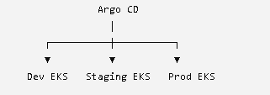
Instead of manually creating an Argo CD Application for each cluster, we can use ApplicationSet to generate Applications automatically.
Why do we need ApplicationSet?
Imagine you have 15 clusters.
Without ApplicationSet:
Application 1 → cluster-1
Application 2 → cluster-2
Application 3 → cluster-3
...
Application 15 → cluster-15
You have lots of repetitive YAML.
With ApplicationSet:
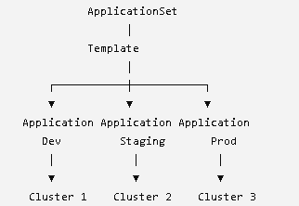
One template → multiple Applications.
The source describes ApplicationSet as a template engine whose generator loops through variables and dynamically creates individual Application CRDs.
The three important generators
1. List Generator
You explicitly provide the clusters:
Dev
staging
prod
Useful for learning and for a fixed set of environments.
2. Cluster Generator
It looks at the clusters registered with Argo CD and can generate Applications for them.
3. Git Generator
It reads folders/configuration from Git and generates Applications based on what's there.
Secret Management in GitOps
GitOps says Git is the source of truth, but we should not put passwords, API keys, database credentials, etc. directly into Git.
The problem
Normally a Kubernetes Secret looks like:
apiVersion: v1
kind: Secret
metadata:
name: db-secret
data:
username: YWRtaW4=
password: cGFzc3dvcmQ=
Someone may think:
"It's encoded, so it's secure."
But Base64 is encoding, not encryption.
So putting raw Kubernetes Secrets in a Git repository is dangerous. Your Day 2 material explicitly says not to commit raw Kubernetes Secrets/Base64 values to Git.
The GitOps Secret Problem
Imagine:
Developer
↓
Git
↓
Argo CD
↓
Kubernetes
For normal configuration, this is great:
Git
└── deployment.yaml
replicas: 3
image: nginx
But what about:
database-password: MySecretPassword123
We don't want this sitting in Git.
So we need a secret-management solution.
# THERE ARE TWO APPROACH VIA WHICH WE CAN MANAGE THE SECRETS
- Sealed secrets: The encrypted secret can be stored in Git, but the actual secret is only decrypted inside the Kubernetes cluster.
- HashiCorp Vault + External Secrets: Here the secret doesn't live in Git at all.
