Why Prometheus?
Flipkart Scenario
Imagine:
1000 Pods Running
Checkout Service Slow
Customer Complaining
How do we know?
- CPU?
- Memory?
- Disk?
- Pod Restarts?
Answer:
Prometheus

Architecture

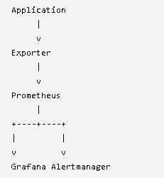
Node Exporter
Provides:
CPU
Memory
Disk
Network
Prometheus
Pulls Metrics
Stores Metrics
Runs Queries
Grafana
Visualization
Alertmanager
Slack
Email
PagerDuty

