REPORT

Introduction
A loan is a financial arrangement where one party lends money to another with the expectation that it will be repaid over time, usually with added interest. The loan process typically involves the borrower applying for a loan, the lender assessing their creditworthiness (using details like CIBIL score, income, employment status, etc.), and then approving or rejecting the application based on this evaluation.

What This Project Is About
In this project, we’re diving into a loan approval dataset where our goal is to uncover insights about how loans are approved by analyzing patterns and relationships within the data.
We’ll be using:
- Data cleaning to prepare the dataset for analysis
- Exploratory Data Analysis (EDA) to identify key trends
- Visualizations to make insights more intuitive
- Statistical testing to validate patterns
- Machine learning models to predict loan approval outcomes
- And finally, testing various hypothesis related to the variables in our dataset.

About columns
- loan_id
- no_of_dependents: Number of Dependents of the Applicant
- education: Education of the Applicant (Graduate/Not Graduate)
- self_employed: Employment Status of the Applicant
- income_annum: Annual Income of the Applicant
- loan_amount: Loan Amount
- loan_term: Loan Term in Years
- cibil_score: Credit Score
- residential_assets_value
- commercial_assets_value
- luxury_assets_value
- bank_asset_value
- loan_status: Loan Approval Status (Approved/Rejected)

By the data cleaning scans, we have confirmed:
- There is no null value and duplicated value in this dataset.
- no_of_dependents, education, self_employed and loan_status are categorical columns.
- There are a total 4269 rows in this dataset, with 13 columns (features).
- There are 2656 data with an approved loan_status, which is about 62.2% compared to the "rejected" group. The dataset is slightly imbalanced but it is acceptable and we don't need to rebalance it.
- Some columns like income_annum, loan_amount, and luxury_assets_value were supposed to be numbers, but when we downloaded the data, they came as text (strings) with commas. Also, there were extra spaces on the left side of these values. To fix this, we removed the spaces and commas, and then converted them into proper numeric values so we could use them for analysis.

DATASET’S BASIC STATISTICS
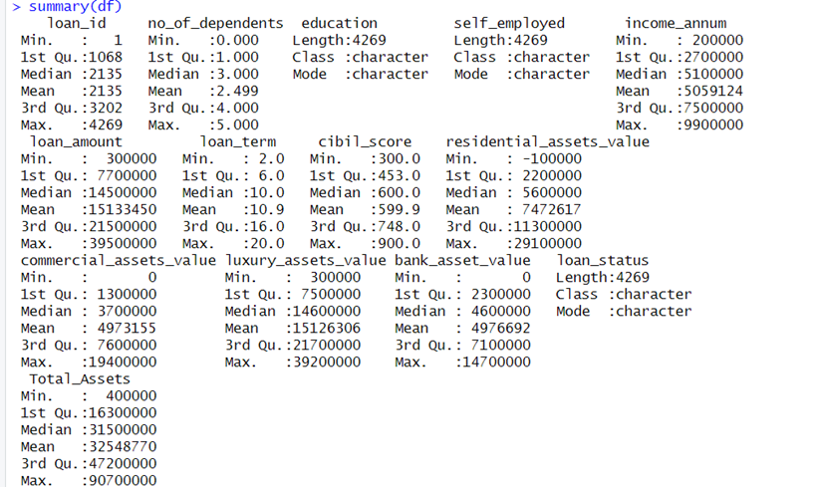

The dataset contains 4,269 observations and includes financial and demographic details of loan applicants. The average annual income is ₹50.6 lakhs, with a median of ₹51 lakhs, indicating a fairly symmetric distribution. The loan amount ranges widely, with a mean of ₹1.51 crores and a median of ₹1.45 crores, suggesting that most applicants apply for high-value loans.
The CIBIL score, a critical indicator of creditworthiness, has a mean and median around 600, with a first quartile at 453 and a third quartile at 748 — showing a mix of low and high credit scores in the applicant pool. The loan term varies from 2 to 20 years, with a median of 10 years, reflecting a mix of short- and long-term loan preferences.
In terms of assets, applicants hold substantial wealth:
- Residential assets: Mean ₹74.7L, Median ₹56L
- Commercial assets: Mean ₹49.7L, Median ₹37L
- Luxury assets: Mean ₹1.51Cr, Median ₹1.46Cr
- Bank asset value: Mean ₹49.7L, Median ₹46L
The total assets average ₹3.25 crores, with a median of ₹3.15 crores, confirming that many applicants are asset-rich.
On the demographic side, the average number of dependents is 2.5, with the middle 50% ranging from 1 to 4 dependents. The dataset also includes categorical variables like education, self-employment status, and loan status, which can be further analyzed for patterns in loan approvals.
Overall, the statistics suggest that higher income, strong asset backing, and a good CIBIL score are likely associated with favorable loan decisions. The spread in values also indicates a diverse applicant base ranging from middle-income individuals to high-net-worth applicants.

SPLITTING INTO TRAIN AND TEST DATA
split <- sample.split(df$loan_status, SplitRatio = 0.75)
This line uses the sample.split() function from the caTools package to randomly split the dataset df into training and testing sets.
🔹 The SplitRatio = 0.75 means 75% of the data will go into the training set, and the remaining 25% into the test set, using the loan_status variable to ensure balanced splitting.
train_data <- subset(df, split == TRUE)
🔹 This creates the training dataset by selecting all rows from df where the split is TRUE (i.e., the 75% part of the split).
test_data <- subset(df, split == FALSE)
🔹 This creates the testing dataset by selecting the remaining 25% of rows (where split == FALSE).

To assess whether certain numerical features have a statistically significant impact on loan approval, we conducted independent two-sample t-tests comparing the means of each variable between approved and rejected loan groups.
The analysis revealed that only CIBIL Score and Loan Term showed statistically significant differences between the two groups (p-values < 0.05). Specifically, approved applicants had significantly higher CIBIL scores and shorter loan terms, indicating these factors are strongly associated with loan approval.
In contrast, the remaining variables — including Income, Loan Amount, Number of Dependents, and various Asset Values — did not exhibit statistically significant differences (p-values > 0.05). This suggests that these features, when considered individually, do not significantly influence the loan approval outcome.

To evaluate whether categorical variables have a statistically significant association with loan_status, Chi-square tests were conducted for the following variables:
- Education (Graduate vs Not Graduate)
- Self Employed (Yes vs No)
Findings:
- Education → p-value = 0.8641
- Self Employed → p-value = 0.9476
Since the p-values for both variables are much greater than 0.05, we fail to reject the null hypothesis, meaning that loan approval is independent of education level and self-employment status in this dataset. In other words, based on the sample, these factors do not significantly influence the likelihood of loan approval.

VISUALIZATIONS
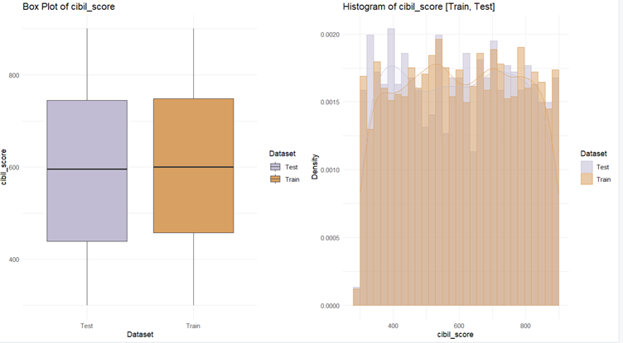

Box Plot Interpretation (Left):
- The median CIBIL score is almost identical for both datasets, centered around 600, suggesting a similar central tendency.
- The interquartile ranges (IQRs) are also very similar, meaning the spread of the middle 50% of scores is nearly equal.
- Both datasets show a similar minimum and maximum range, indicating no major deviation in extremes or outliers.
- Overall, the box plot suggests that the CIBIL scores in the training and testing sets are consistently distributed.

Histogram with Density Plot Interpretation (Right):
- The histogram reveals a fairly uniform distribution of CIBIL scores in both datasets, with no sharp peaks or drops.
- The density curves for Train and Test almost completely overlap, further confirming that the distribution shape is preserved across the split.
- There is a slight dip near the maximum scores, but it occurs similarly in both datasets, suggesting no sampling bias.
- The CIBIL scores span from around 300 to 900, which matches typical real-world credit scoring ranges.

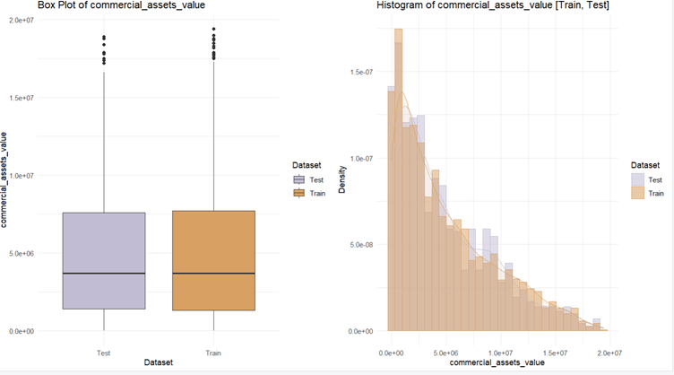

Box Plot Interpretation (Left):
- The medians for both the Train and Test sets are very close, suggesting a similar central tendency for commercial assets value.
- The interquartile ranges (IQRs) are also nearly identical, meaning that the spread of the middle 50% of data is consistent across both datasets.
- A significant number of outliers are present in both datasets, especially above the upper whisker. This is expected in financial variables like asset values due to some borrowers having significantly higher commercial holdings.
- Overall, the box plots indicate that the data distributions are aligned, with no visible skew or shift between Train and Test sets.

Histogram with Density Plot Interpretation (Right):
- Both the Train and Test histograms show right-skewed distributions, which is typical for financial variables (more borrowers have lower asset values, and a few have very high ones).
- The density plots almost completely overlap, reinforcing that the shape and spread of the distributions are nearly identical between Train and Test sets.
- Most values cluster near the lower end, with the frequency dropping as the asset value increases — again, expected in real-world data.
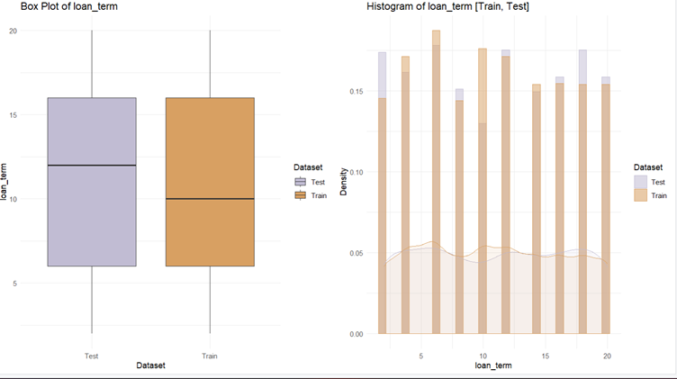

Box Plot Interpretation (Left):
- The median loan term in the Test set is slightly higher than in the Train set (Test ≈ 12, Train ≈ 10).
- Both datasets show a similar range and interquartile spread, suggesting comparable distribution.
- The box plot shows no extreme outliers, indicating that most values fall within a typical range (1–20 years).
- The slightly higher median in the Test set suggests test data contains relatively longer loan durations on average than training data.

Histogram with Density Plot Interpretation (Right):
- The loan term variable is discrete, taking only integer values (e.g., 1, 2, ..., 20 years).
- Both Train and Test sets show almost identical frequency spikes at each loan term value.
- There is no major skew, but the distribution is uniformly spread with frequent peaks, reflecting potentially standardized loan durations (e.g., 5, 10, 15 years).
- The density lines for both datasets follow similar paths, reinforcing that the underlying distribution pattern is consistent.

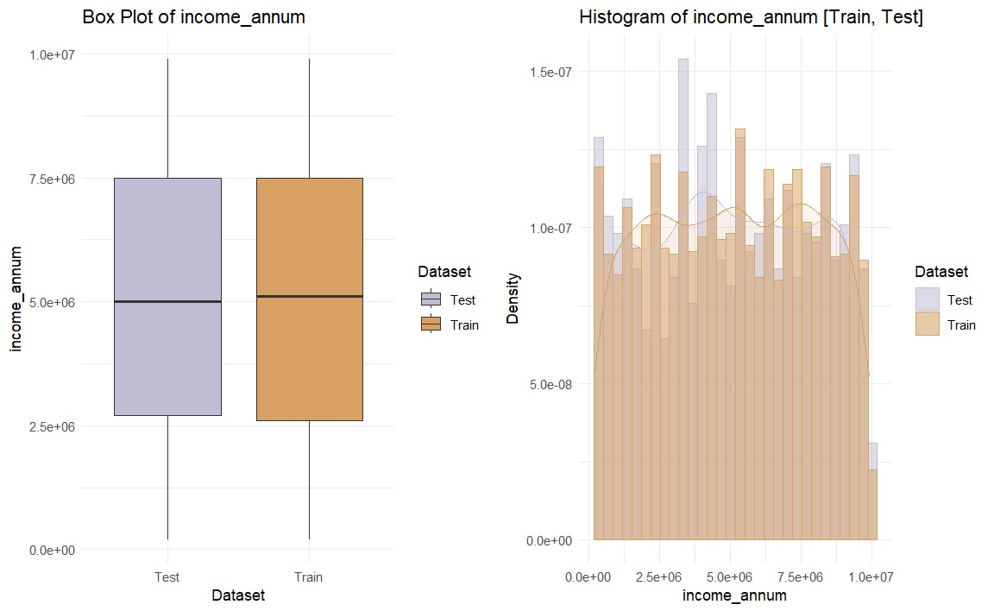
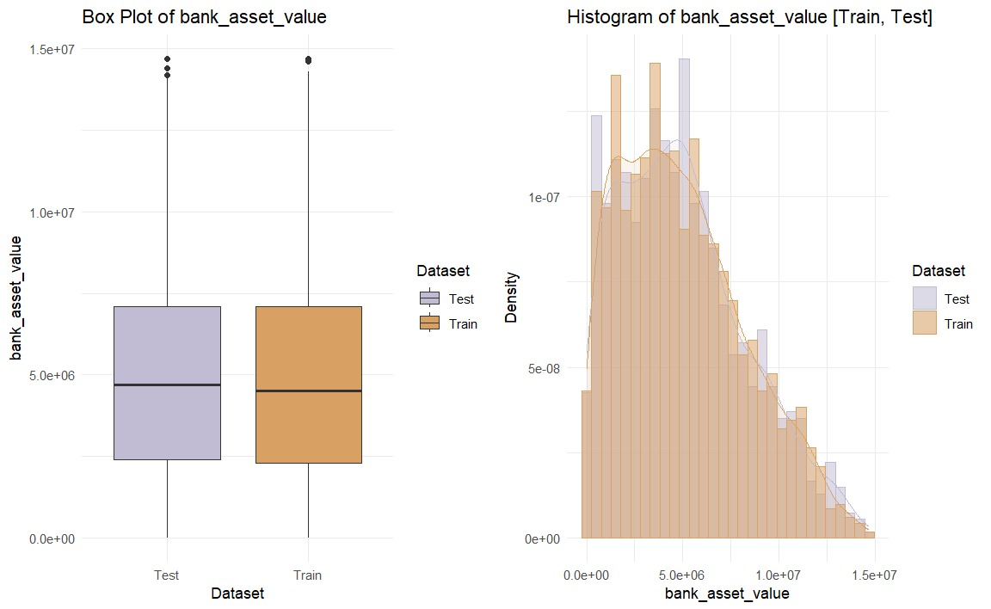
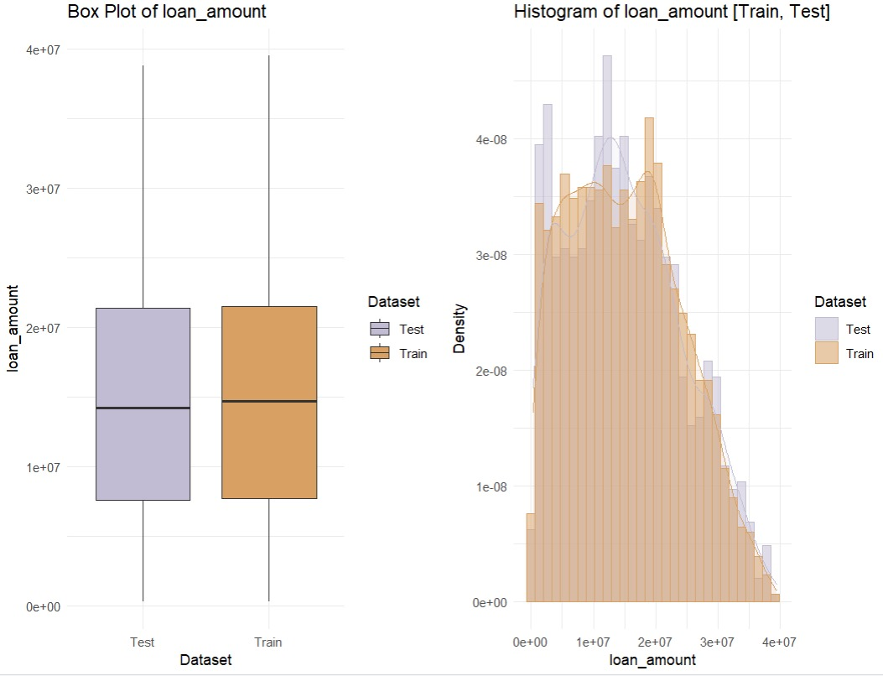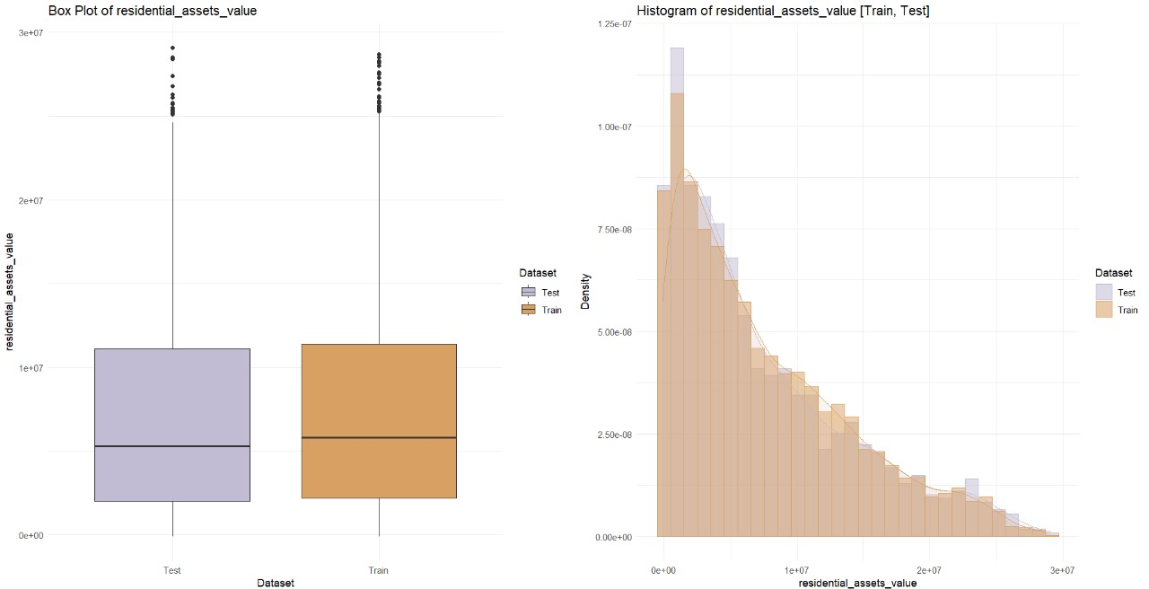

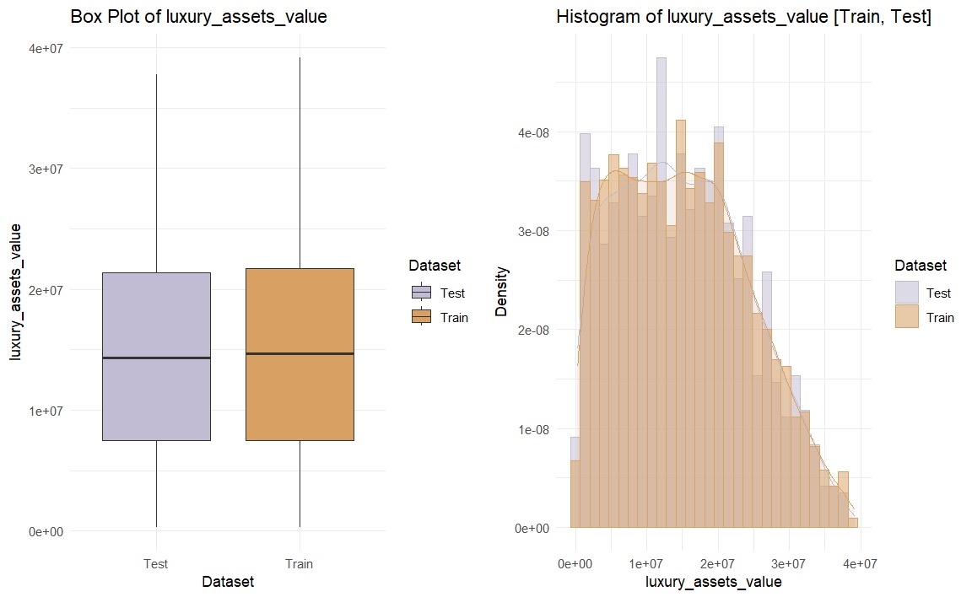
CORRPLOT
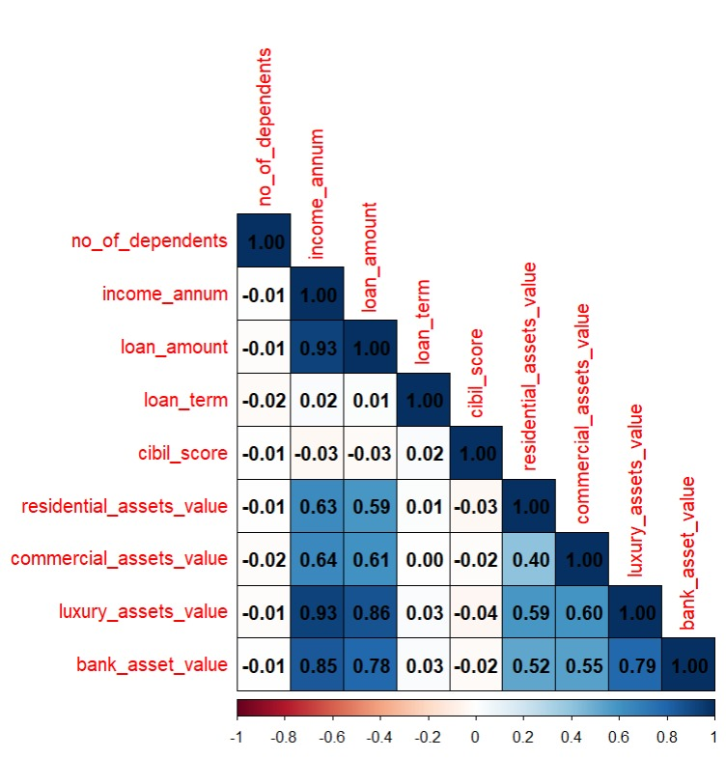

Strong Positive Correlations:
- income_annum & loan_amount (0.93): Higher annual income is strongly associated with higher loan amounts.
- income_annum & bank_asset_value (0.85): Individuals with higher income tend to have higher bank asset values.
- loan_amount & luxury_assets_value (0.86): Applicants taking larger loans tend to have more luxury assets.
- luxury_assets_value & bank_asset_value (0.79): These two asset types tend to increase together.
Moderate Correlations:
- residential_assets_value, commercial_assets_value, and luxury_assets_value show moderate positive correlations with income_annum and loan_amount (around 0.6).
- This implies income and loan size relate positively to types of asset ownership.
Weak or Negligible Correlations:
- no_of_dependents, loan_term, and cibil_score have near-zero correlations with most variables.
- This suggests they vary independently of income, asset values, or loan amount.

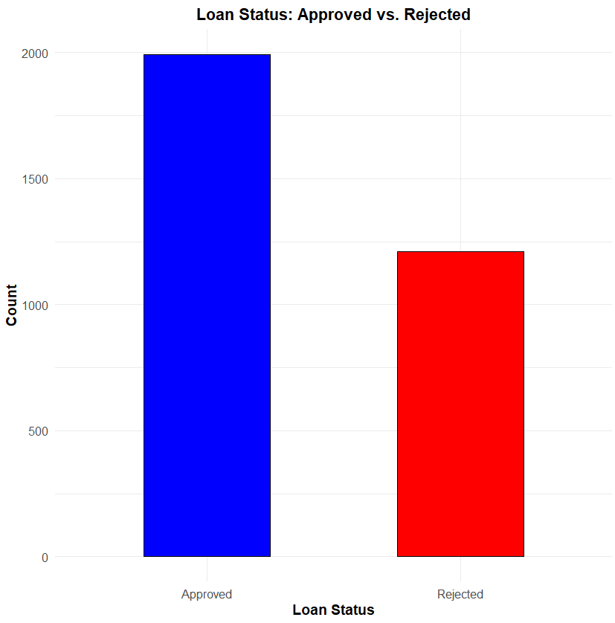

Insight:
- Approved Loans: ~2000 applications
- Rejected Loans: ~1300 applications
The dataset reflects a higher number of approvals compared to rejections.
This could indicate:
- A relatively high acceptance rate in the dataset,
- A dataset that might be skewed toward approved applicants,
- Or a generally favorable applicant profile in terms of income/assets.

MACHINE LEARNING
Model Performance Based on ROC Curve (AUC values)
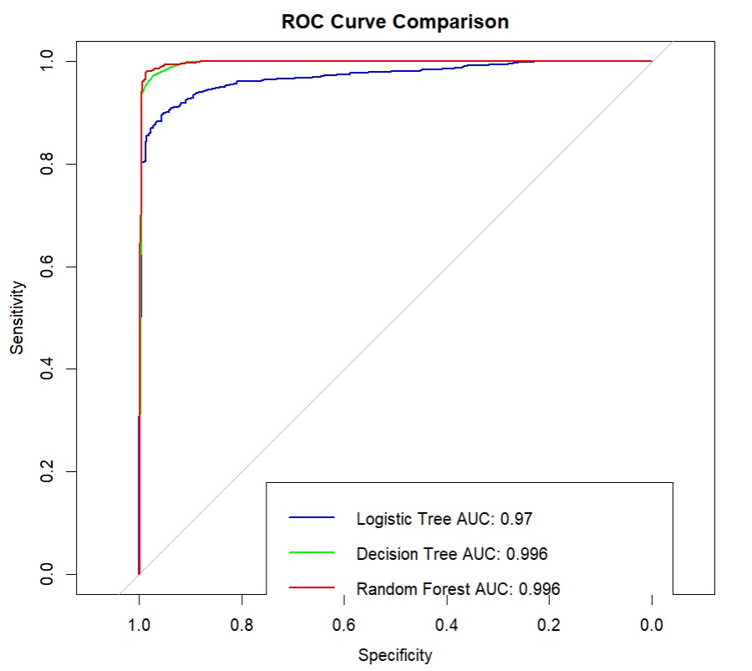
- Logistic Regression (Blue Line)
The AUC (Area Under Curve) is 0.97, which shows the model performs well. It has high sensitivity and specificity, but still slightly lower than the other models.
- Decision Tree (Green Line)
The AUC is 0.996, which indicates excellent performance. It correctly classifies most of the data and is more accurate than logistic regression.
- Random Forest (Red Line)
This model also has an AUC of 0.996, just like the decision tree. However, random forests are generally more stable and robust because they are based on multiple trees (ensemble learning), reducing the risk of overfitting.

Model Accuracy Analysis

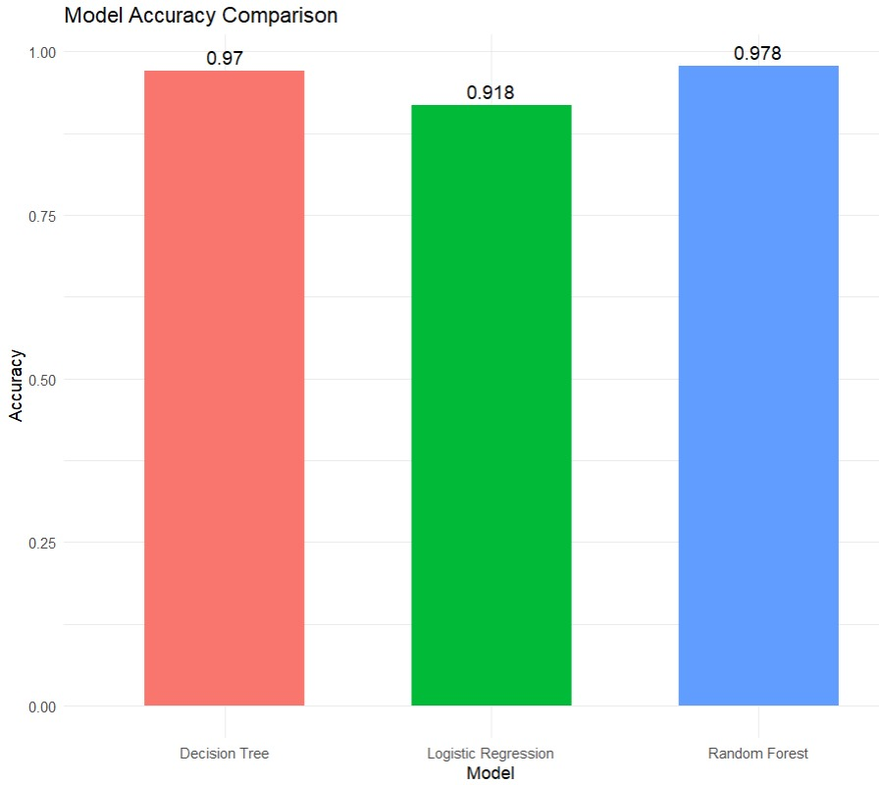

Logistic Regression
Achieved an accuracy of 91.8%. While this is quite good, it is the lowest among the three models tested.
Decision Tree
Reached 97% accuracy, which is significantly better than logistic regression, showing it performs well with the given data.
Random Forest
Has the highest accuracy of 97.8%, making it the best-performing model in terms of accuracy as well.

HYPOTHESIS

- CIBIL Score by Loan Status
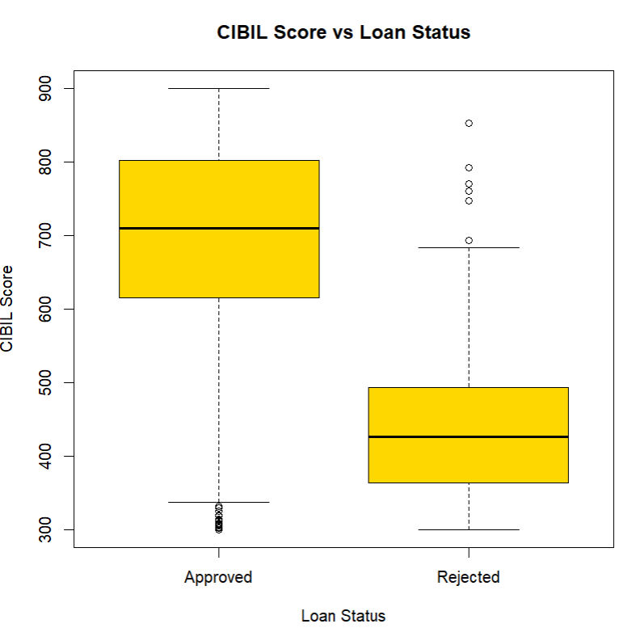

A Two Sample t-test was conducted to compare the mean CIBIL scores between two groups based on loan status — Group 0 (loan not approved) and Group 1 (loan approved).
- Mean CIBIL score (Loan Not Approved): 428.9347
- Mean CIBIL score (Loan Approved): 703.6295
- t-value: 76.105
- Degrees of Freedom: ~3197.8
- p-value: < 2.2e-16 (extremely small)

Interpretation:
The results show a highly significant difference in the average CIBIL scores between approved and not-approved loan applications. The p-value is far below 0.05, indicating that the difference in means is statistically significant.
This suggests that CIBIL score plays a major role in loan approval, with approved applicants having much higher average CIBIL scores than those who were rejected.

ANOVA Test: CIBIL Score by Loan Status
An ANOVA (Analysis of Variance) test was conducted to examine whether there is a significant difference in CIBIL scores between individuals based on their loan status (approved vs not approved).
ANOVA Output Summary:
- F-value = 4669
- p-value < 2e-16
- Significance code: ***, indicating very high statistical significance

Interpretation:
The extremely low p-value (< 0.001) strongly suggests that we should reject the null hypothesis.
Thus, there is strong evidence that CIBIL scores vary significantly based on loan approval status implying creditworthiness plays a major role in loan approval.

- Annual Income by Number of Dependents
An ANOVA (Analysis of Variance) test was conducted to examine whether there is a significant difference in annual income across individuals with different numbers of dependents.

ANOVA Output Summary:
- F-value = 0.867
- p-value = 0.502

Interpretation:
The p-value of 0.502 is much greater than 0.05, indicating that we fail to reject the null hypothesis, which states that the mean annual income is the same across all dependent groups.
In other words, the difference in annual income across people with different numbers of dependents is not statistically significant.
This suggests that annual income does not significantly vary based on how many dependents a person has, at least in this dataset.

Supporting Visualization:
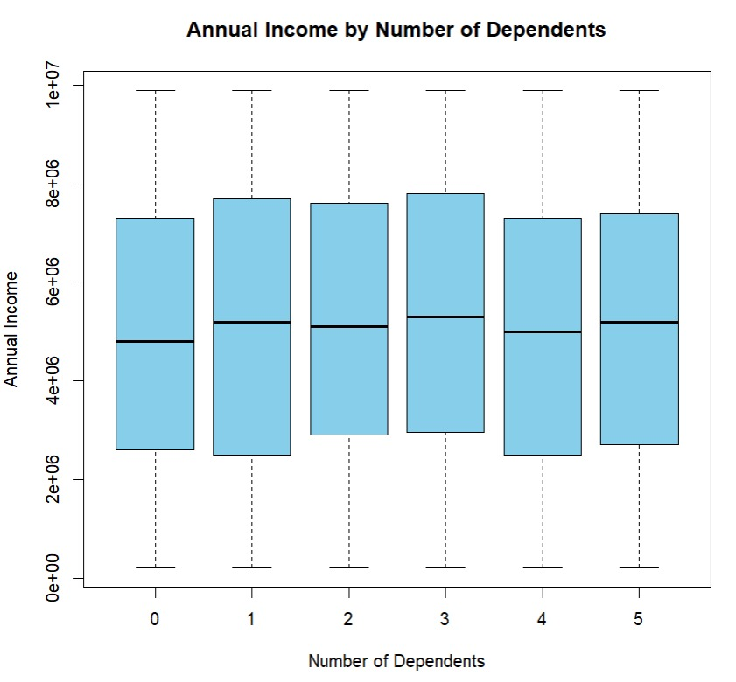

The boxplot reveals that the distribution of annual income is fairly consistent across different numbers of dependents, with similar medians and interquartile ranges.
There is no strong visual trend indicating that annual income systematically increases or decreases with the number of dependents.
This supports the ANOVA test results, reinforcing that annual income does not significantly vary by the number of dependents.

- Total Assets by Loan Status
An ANOVA (Analysis of Variance) test was conducted to examine whether there is a significant difference in total assets between individuals based on their loan status (approved vs not approved).

ANOVA Output Summary:
- F-value = 0.381
- p-value = 0.537
- Significance code: None (not statistically significant)
Interpretation:
Assets alone don’t guarantee loan approval.
The high p-value (0.537) indicates that we fail to reject the null hypothesis, which means there is no statistically significant difference in the mean total assets between approved and rejected loan applicants.
In other words, total assets do not appear to be a key factor influencing loan approval decisions.
Supporting Visualization: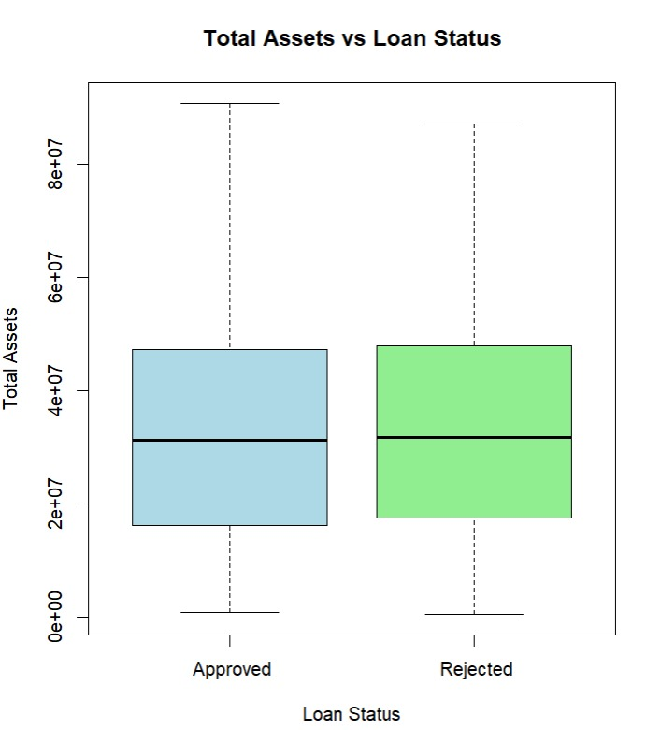
The accompanying boxplot illustrates that the distribution of total assets is quite similar between loan-approved and loan-rejected individuals.
Both groups have comparable medians and interquartile ranges, indicating no substantial visual difference in total assets across loan status.
This graphical evidence supports the ANOVA results, further confirming that total assets are not a significant determinant of loan approval.

