# Introduction

Once regarded as a rising star in India's banking industry, Yes Bank's collapse exposed weaknesses in risk management and regulatory control and signaled a turning point in the financial markets. This project investigates the causes of the collapse, the function of regulatory frameworks including Basel III standards, and the action of the RBI. Additionally, the study examines how norms have changed since the collapse and assesses if these changes are enough to avert future crises of a similar nature.

# Yes Bank: A Timeline of Events

Yes Bank, founded in 2004, grew swiftly by focusing on corporate lending, eventually becoming India's fourth largest private sector bank in 2019. But because of its aggressive lending methods, particularly in high-risk industries like infrastructure and real estate, a pile of non-performing assets (NPAs) developed, which ultimately caused a liquidity crunch and regulatory intervention in 2020.

**Key Events Leading to the Collapse:**

* 2015-2018: Yes Bank aggressively lends to high-risk sectors, under-reporting NPAs during RBI’s Asset Quality Review (AQR).
* 2019: Yes Bank’s credit rating is downgraded due to its growing NPA crisis.
* March 2020: The RBI imposes a moratorium on Yes Bank, capping withdrawals and initiating a bailout plan.

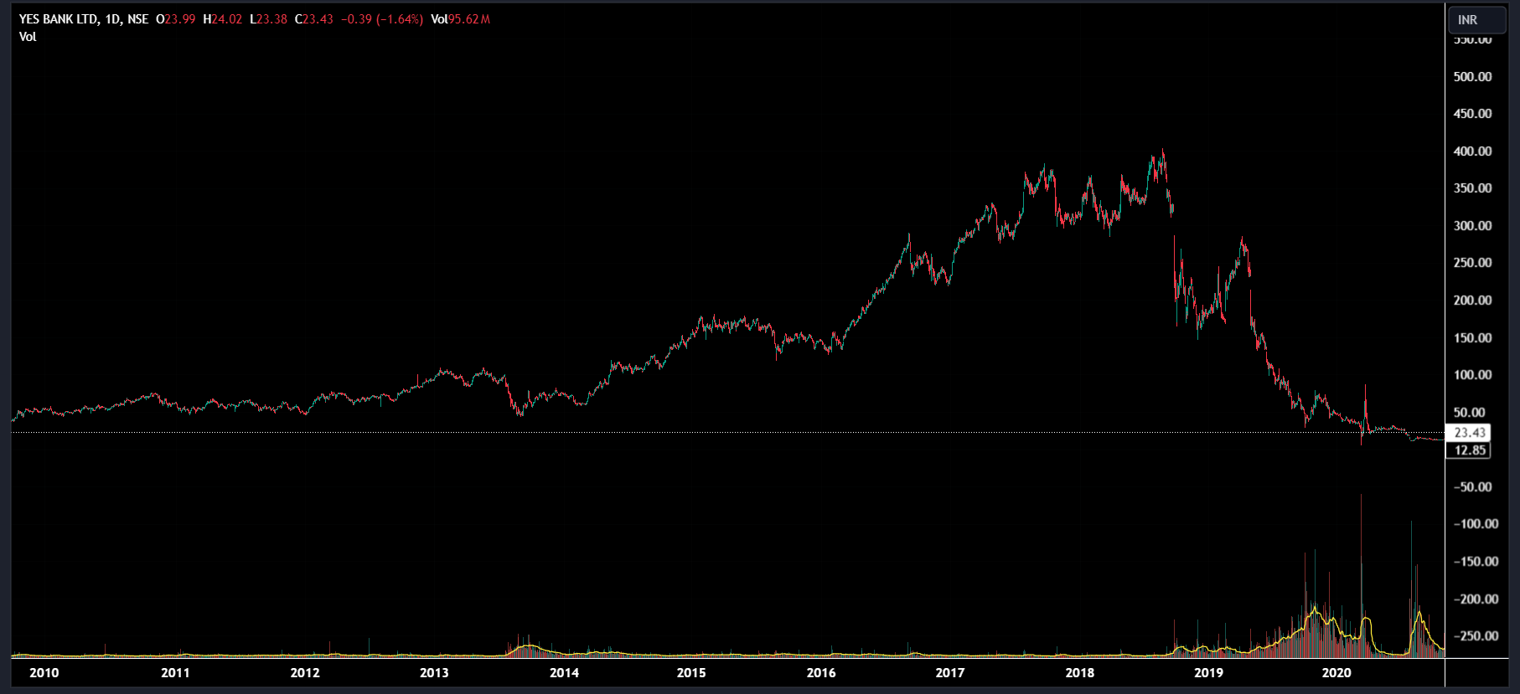

# Failure of Basel Norms:

The **Basel III norms**, introduced to strengthen the banking sector's resilience, require banks to maintain high **Capital Adequacy Ratios (CAR)**, **Common Equity Tier 1 (CET1)** capital, and adhere to **Liquidity Coverage Ratios (LCR)**. Yes Bank, however, failed to comply with these norms:

* **Capital Adequacy Ratio (CAR)**: Basel III norms mandate a minimum CAR of 10.5% (including a 2.5% capital conservation buffer). By 2019, Yes Bank’s CAR dropped to 8%, well below the threshold, as it struggled with rising NPAs and insufficient capital reserves.
* **Liquidity Coverage Ratio (LCR)**: Basel III also requires banks to maintain sufficient high-quality liquid assets to meet short-term obligations. Yes Bank faced severe liquidity issues in 2019-2020, exacerbating the crisis.

**Reasons for Failure of Basel Norms:**

* **Under-Reporting of NPAs**: Yes Bank under-reported its NPAs in previous years, delaying the recognition of bad loans and distorting its capital adequacy ratios.
* **Poor Risk Management**: The bank’s overexposure to risky corporate loans and poor governance practices led to a rapid decline in asset quality.

**Graph**: A comparison of Yes Bank’s CAR and CET1 ratios versus Basel III requirements and other leading banks (HDFC, SBI) during the same period.

# Regulatory Failures and RBI's Role

Despite the RBI’s Asset Quality Reviews (AQRs) in 2015-16, which identified discrepancies in Yes Bank’s NPA reporting, the lack of timely regulatory intervention allowed the crisis to worsen. The Prompt Corrective Action (PCA) framework, designed to monitor banks showing signs of distress, was not invoked early enough for Yes Bank.

**Key Regulatory Failures:**

* **Delayed Action**: The RBI identified the issues in Yes Bank but did not place the bank under the PCA framework until it was too late.
* **Governance Failures**: Yes Bank engaged in risky lending practices and poor corporate governance, which went unchecked for years.

**Graph**: A comparison of Yes Bank’s NPAs with other private sector banks over the years to show its deteriorating asset quality.

# RBI Intervention and Rescue Plan

By March 2020, Yes Bank’s deteriorating financial health prompted the RBI to take drastic action. The central bank imposed a **30-day moratorium** on Yes Bank, capping withdrawals and taking control of the bank’s management.

**Key RBI Actions:**

* **Moratorium**: The RBI imposed a cap on withdrawals, limiting depositors to ₹50,000, which shook public confidence.
* **Rescue Plan**: A reconstruction plan led by **State Bank of India (SBI)** was initiated. SBI, along with other financial institutions, infused ₹10,000 crore into Yes Bank to stabilize its operations.
* **New Management**: The RBI restructured Yes Bank’s board, bringing in new management to restore confidence and ensure regulatory compliance.

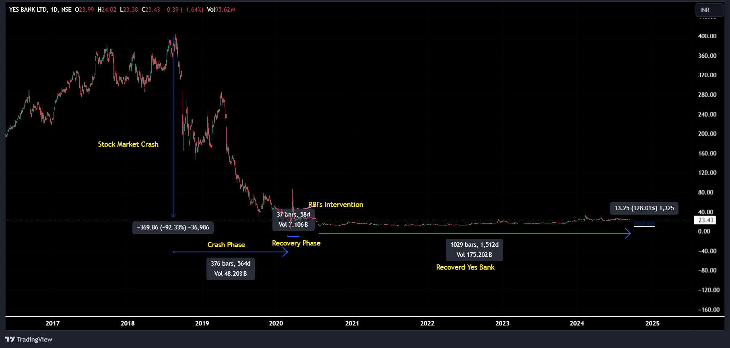

# Changes in Regulations Post Yes Bank Collapse

The **Yes Bank collapse** led to several regulatory reforms aimed at improving governance, risk management, and capital adequacy standards. The RBI, along with other regulatory bodies, introduced several new measures to prevent future crises:

**6.1 Stricter Capital Adequacy Requirements:**

* After the collapse, the RBI enhanced the focus on capital adequacy and liquidity management, mandating stricter compliance with **Basel III norms**.
* The RBI revised its **Prompt Corrective Action (PCA) framework**, introducing tighter triggers for intervention based on capital ratios, NPAs, and leverage ratios.

**6.2 Governance Reforms:**

* The RBI issued new governance guidelines in 2021, including limits on the tenure of CEOs and a stronger emphasis on the role of independent directors.
* Stricter fit-and-proper criteria for board members were introduced to ensure better oversight.

**6.3 Large Exposure Framework (LEF):**

* The RBI revised the **Large Exposure Framework (LEF)**, placing stricter limits on banks’ exposure to individual borrowers and large corporate groups. This was a direct response to Yes Bank’s overexposure to high-risk corporate loans.

# Conclusion

The collapse of Yes Bank was a wake-up call for India’s banking sector and regulators. Despite the existence of **Basel III norms** and RBI’s **AQR process**, the delayed regulatory intervention allowed the crisis to escalate. The collapse revealed significant gaps in governance, risk management, and regulatory oversight. Post-collapse reforms, including stricter capital requirements, improved governance norms, and enhanced regulatory frameworks, aim to prevent future banking failures.

In conclusion, while the reforms have strengthened the Indian banking system, the effectiveness of these measures will depend on their timely implementation and strict adherence by financial institutions.

# References:

1. <https://premium.capitalmind.in/2017/05/yes-bank-stoops-to-a-new-low-hides-its-npas/>
2. <https://www.moneycontrol.com/>
3. RBI Annual Reports
4. Yes Bank Annual Reports
5. Basel III Documentation
6. PCA Framework
7. SEBI Reports
8. Press Releases by RBI
9. Press Releases by Ministry of Finance
10. <https://www.crisilratings.com/en/home/our-business/ratings.html>