3.A.--Find the top3 fastest-speed bird associated with Wingspan, food-token and habitat(s).

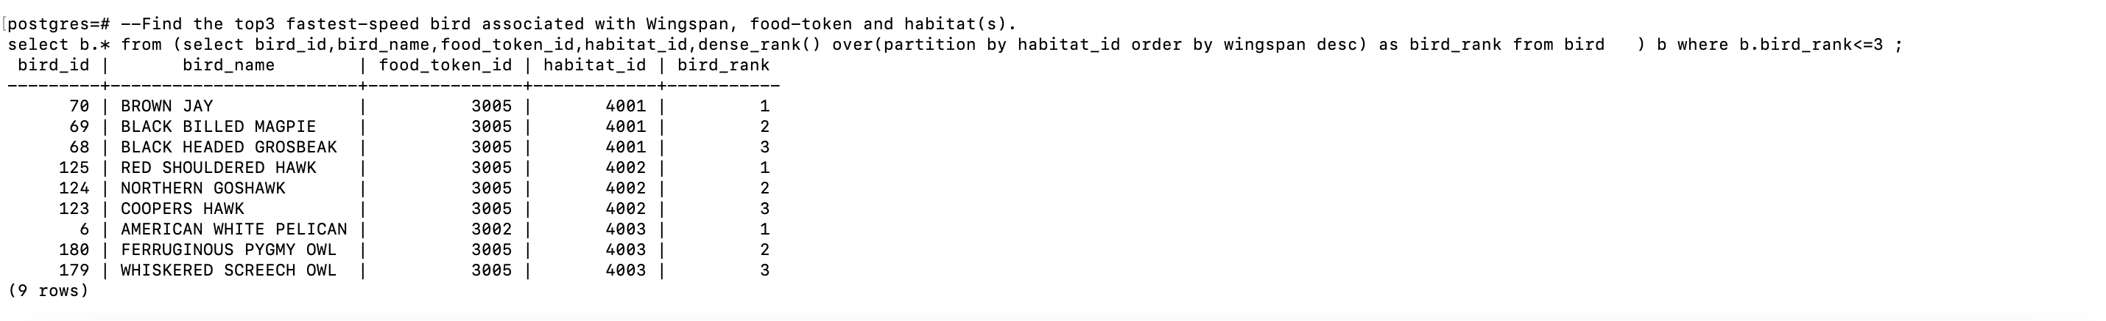

3.B

--DUPLICATES BASED ON BIRD_NAME,FOOD AND HABITAT

select b.* from bird b

join (select bird_name,food_token_id,habitat_id,count(1) from bird group by 1,2,3 having count(1)>=2 ) d

on b.bird_name=d.bird_name;

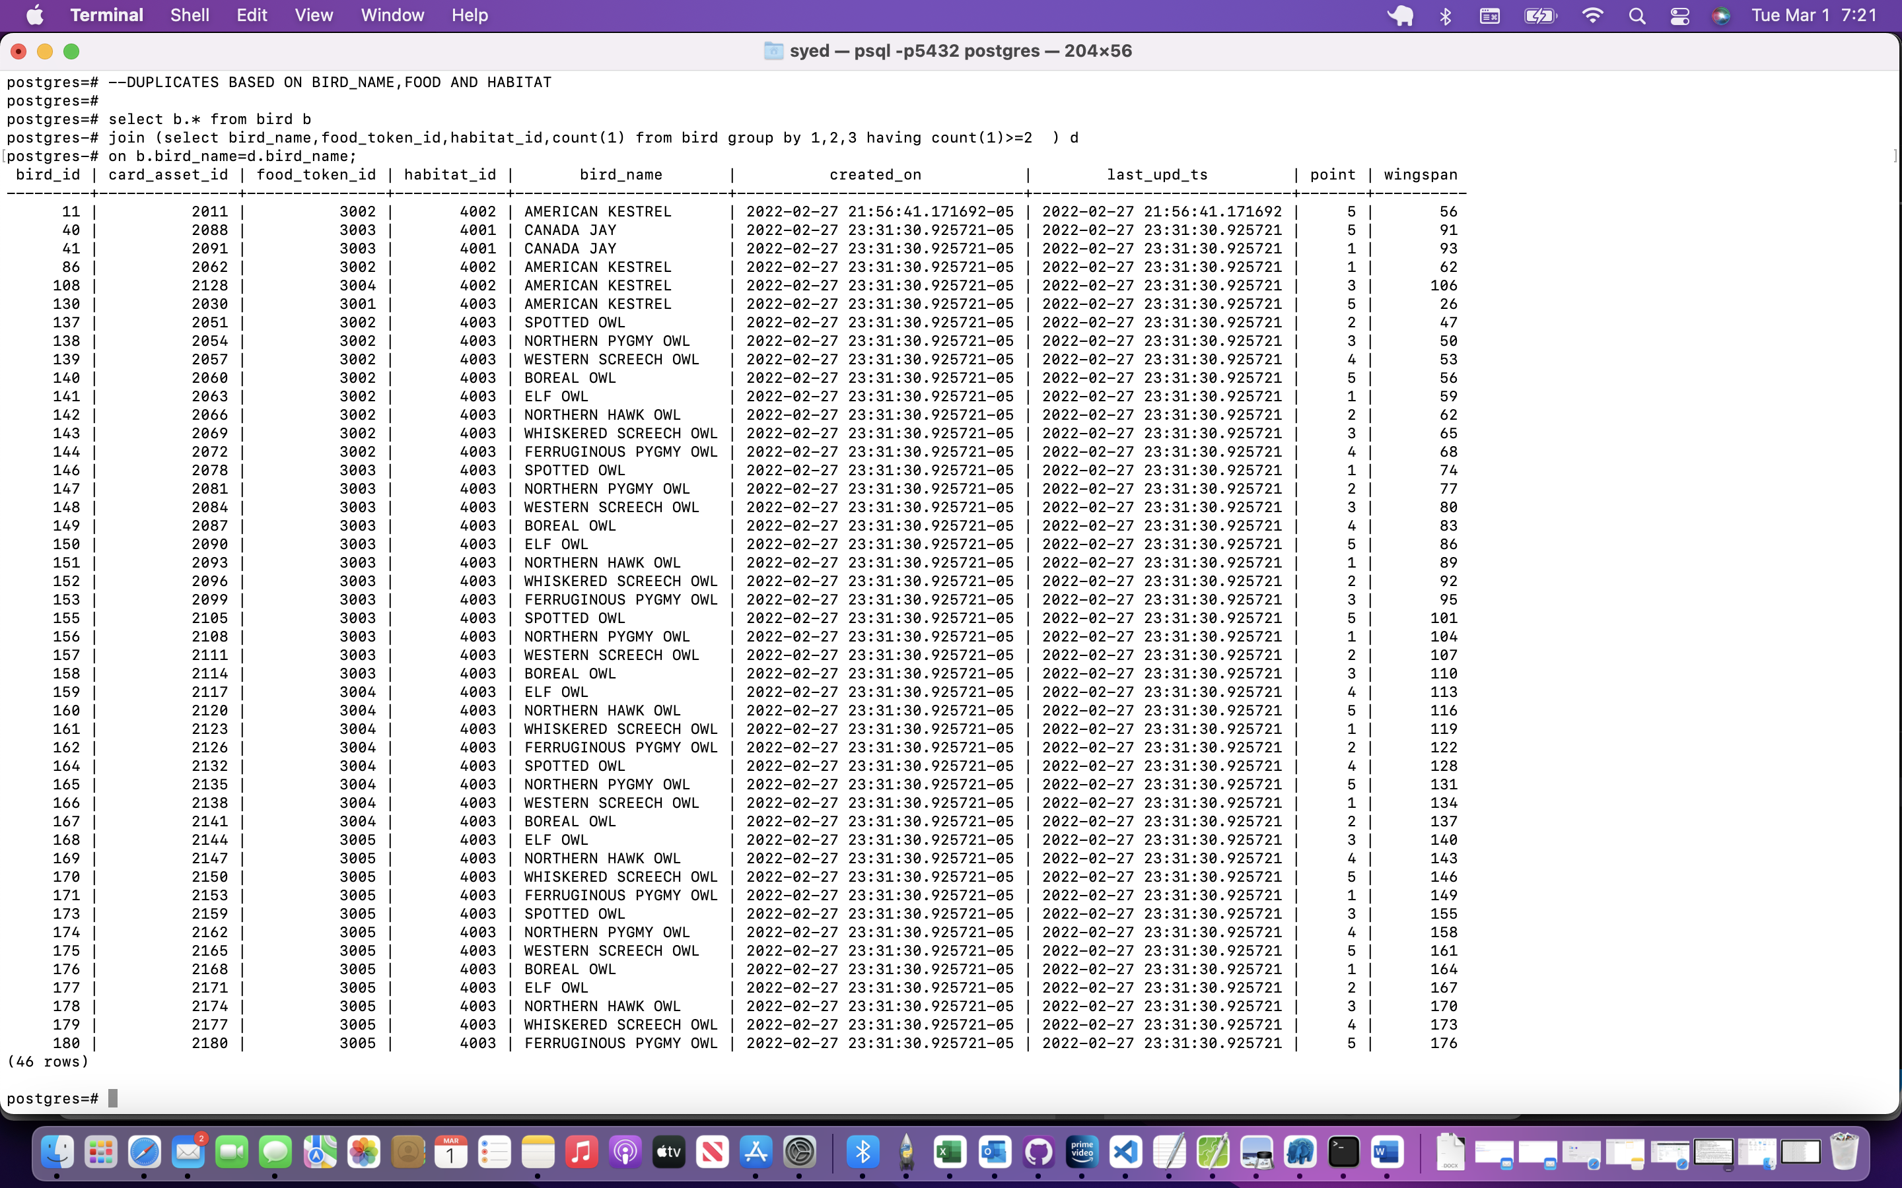

3.C

---TOTAL_POINT AND CREDIT AFTER THE GAME CONSIDERING ALL PLAYER PLAYED TILL END

SELECT AR.GAME_ID,AR.USER_ID,SUM(AR.LAST_POINTS) AS TOTAL_POINTS,DENSE_RANK() OVER (ORDER BY SUM(AR.LAST_POINTS) DESC ) AS CREDIT_RANK

FROM

( --SUM OF POINTS AFTER EACH ROUND

SELECT G.GAME_ID,G.ROUND,G.USER_ID,SUM(B.POINT) AS LAST_POINTS

FROM (SELECT GAME_ID,ROUND,USER_ID,UNNEST(CARD_IN_HAND) AS CARD_ASSET_ID

FROM GAME WHERE GAME_ID IN (

--CONSIDERING THE LATEST COMPLETED GAME

SELECT MAX(GAME_ID) FROM GAME WHERE IS_COMPLETED=TRUE

) ) G

JOIN BIRD B

ON G.CARD_ASSET_ID=B.CARD_ASSET_ID

GROUP BY 1,2,3

) AR

GROUP BY 1,2;

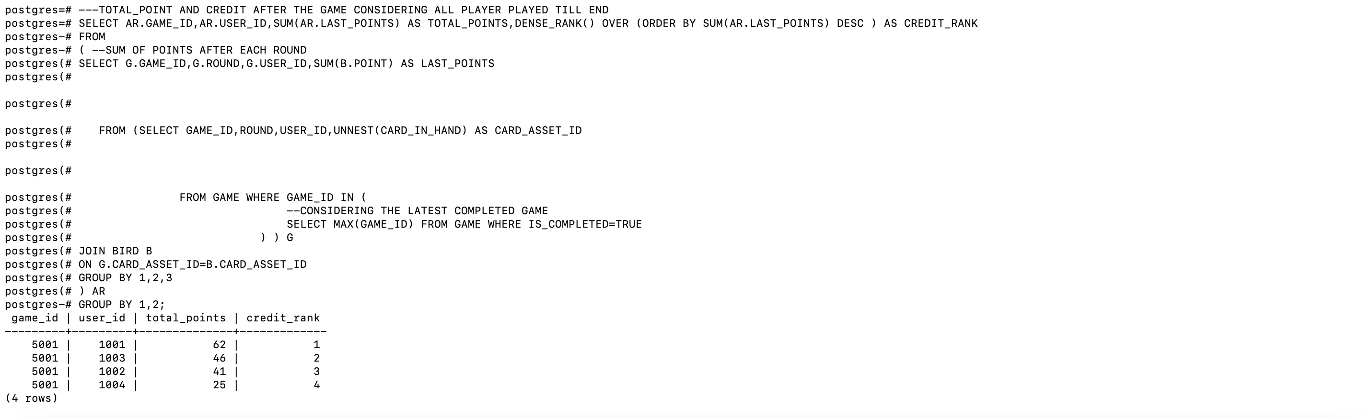

2.E

-----INSERT THE TABLE AFTER THE GAME END

INSERT INTO USERS(USER_ID,USER_NAME,GAME_ID,LAST_POINTS,TOTAL_POINTS,CREDIT,LAST_LOGIN_TS)

-----TOTAL_POINT AND CREDIT AFTER THE EACH GAME WITH AUTO SUM OF ALL PLAYER

SELECT AF.USER_ID,U.USER_NAME,AF.GAME_ID,

AF.TOTAL_POINTS AS LAST_POINTS,

U.PREVIOUS_POINT+AF.TOTAL_POINTS AS TOTAL_POINTS,--AUTO SUM OF ALL PLAYER

DENSE_RANK() OVER (ORDER BY (U.PREVIOUS_POINT+AF.TOTAL_POINTS) DESC ) AS CREDIT,CURRENT_TIMESTAMP

FROM

(---TOTAL_POINT AND CREDIT AFTER THE EACH GAME CONSIDERING ALL PLAYER PLAYED TILL END

SELECT AR.GAME_ID,AR.USER_ID,SUM(AR.LAST_POINTS) AS TOTAL_POINTS,DENSE_RANK() OVER (ORDER BY SUM(AR.LAST_POINTS) DESC ) AS CREDIT_RANK

FROM

( --SUM OF POINTS AFTER EACH ROUND

SELECT G.GAME_ID,G.ROUND,G.USER_ID,SUM(B.POINT) AS LAST_POINTS

FROM (SELECT GAME_ID,ROUND,USER_ID,UNNEST(CARD_IN_HAND) AS CARD_ASSET_ID --STORED AS AN ARRAY TO REDUCE REDUNDENCY

FROM GAME WHERE GAME_ID IN (

--CONSIDERING THE LATEST COMPLETED GAME

SELECT MAX(GAME_ID) FROM GAME WHERE IS_COMPLETED=TRUE

) ) G

JOIN BIRD B

ON G.CARD_ASSET_ID=B.CARD_ASSET_ID

GROUP BY 1,2,3

) AR

GROUP BY 1,2) AF

JOIN (SELECT USER_ID,USER_NAME,MAX(TOTAL_POINTS) AS PREVIOUS_POINT FROM USERS GROUP BY 1,2 )U

ON AF.USER_ID=U.USER_ID;

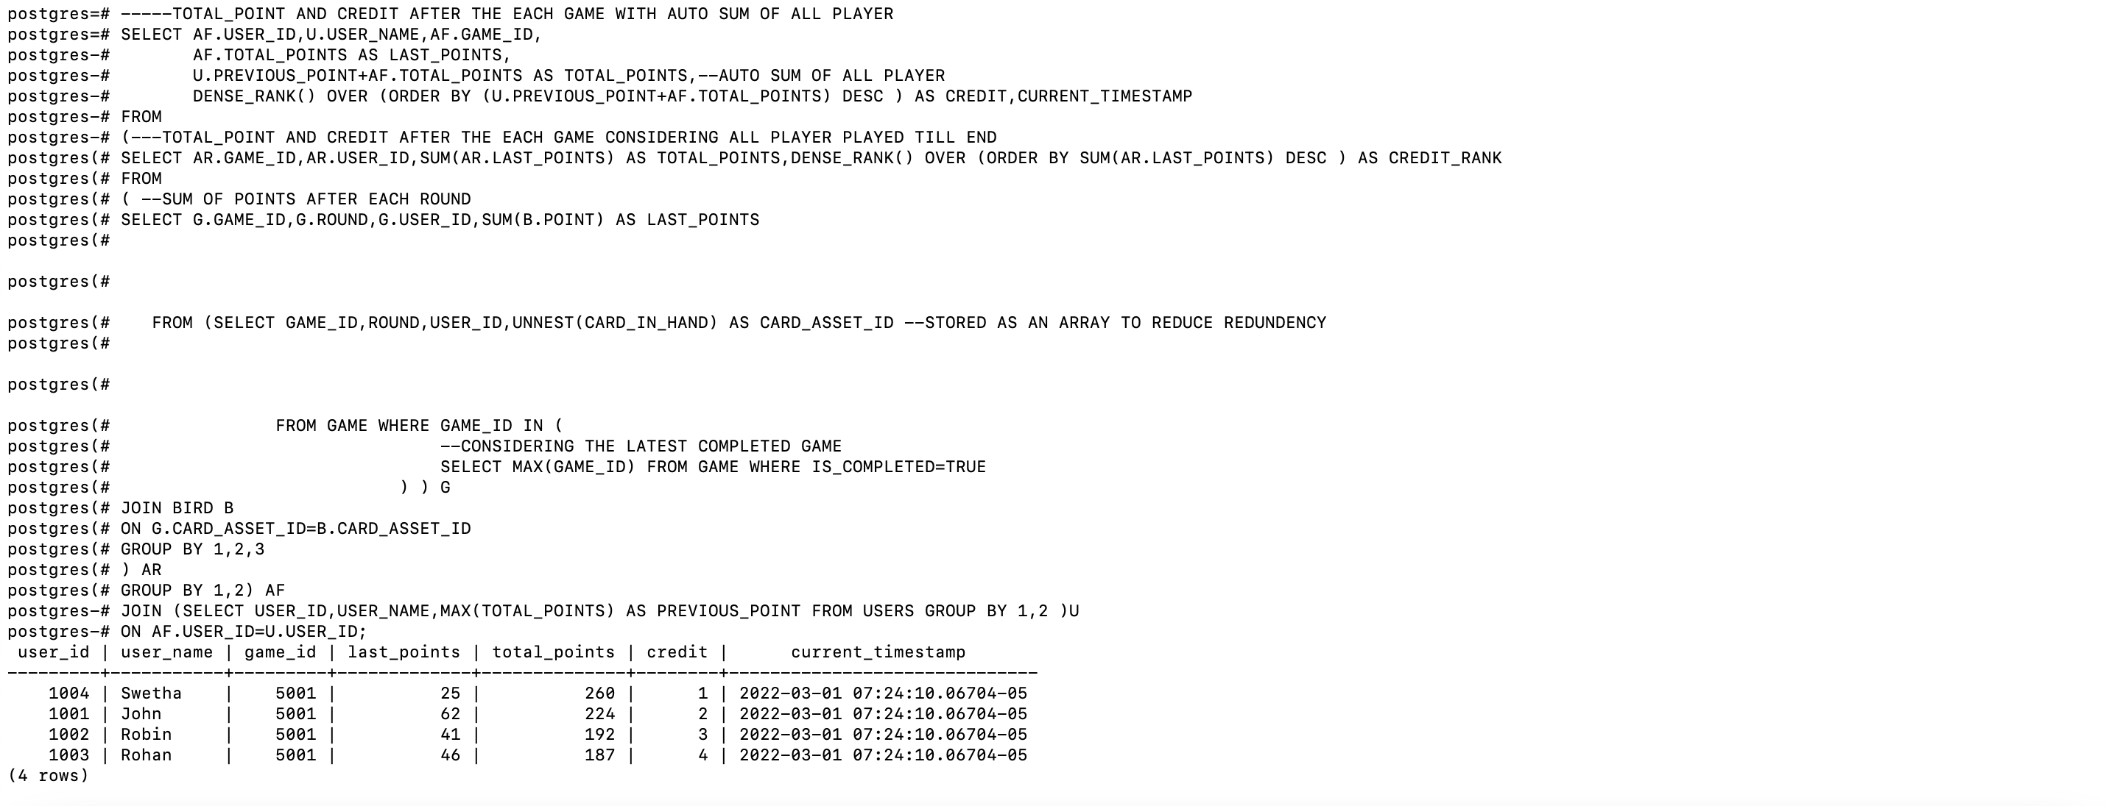

---VIEW CREATED FOR FETCHING THE LATEST STATUS

CREATE VIEW USERS_STATUS AS

SELECT A.* FROM USERS A

JOIN (SELECT USER_ID,MAX(GAME_ID) AS GAME_ID FROM USERS GROUP BY 1) B

ON A.USER_ID=B.USER_ID

AND A.GAME_ID=B.GAME_ID

ORDER BY A.CREDIT;

---SELECT VIEW FOR LATEST CREDIT

SELECT * FROM USERS_STATUS;

