**МІНІСТЕРСТВО ОСВІТИ І НАУКИ  УКРАЇНИ**

**НАЦІОНАЛЬНИЙ УНІВЕРСИТЕТ "ЛЬВІВСЬКА ПОЛІТЕХНІКА"**

**Інститут комп’ютерних технологій, автоматики та метрології**

**Кафедра "Комп'ютеризовані системи автоматики"**



**ЗВІТ**

про виконання **лабораторної роботи № 1**

**«Створення моделі бази даних»**

з навчальної дисципліни**: «Організація баз даних та знань»**

**Виконала:**

Студентка групи ІР-23

Овчаренко Віолета

**Прийняв:**

к. т. н., доц

Лагун Ілона Ігорівна

Львів — 2024

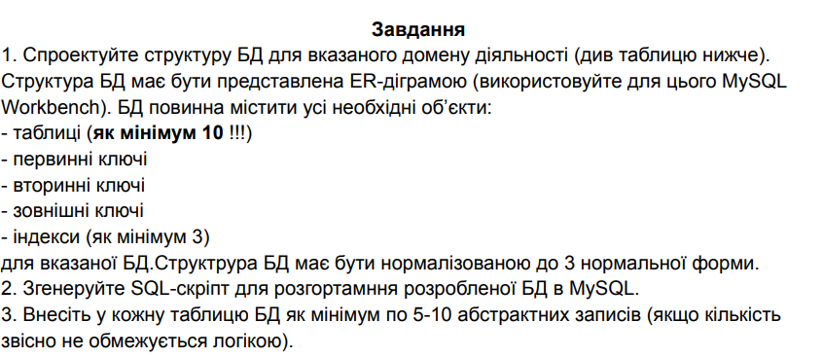

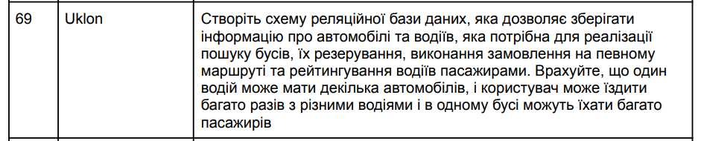

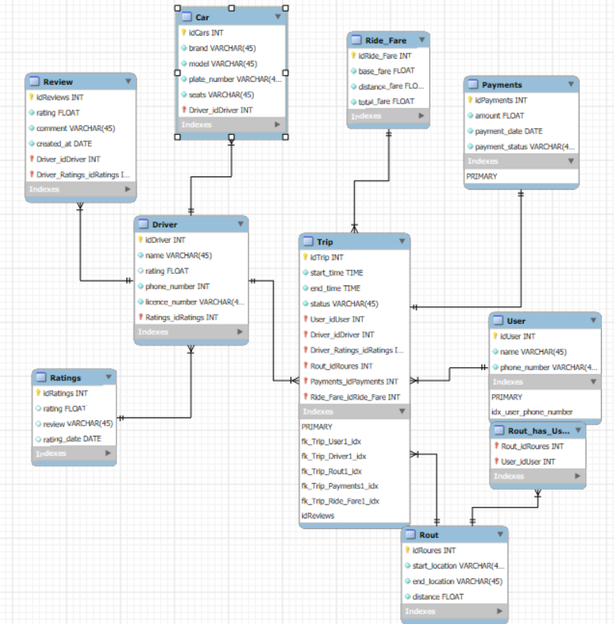

car

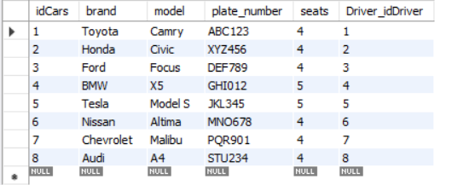

driver

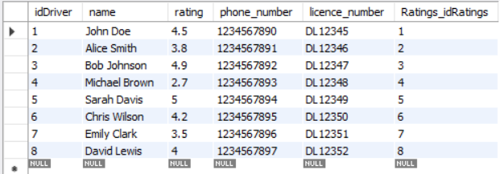

payments

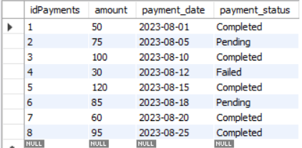

retings

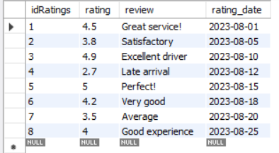

review

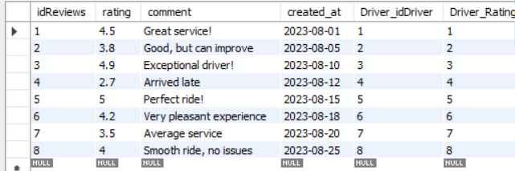

ride_fare

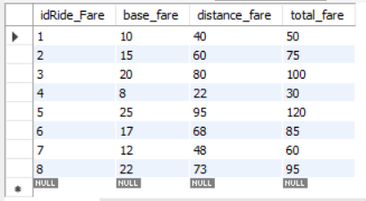

rout

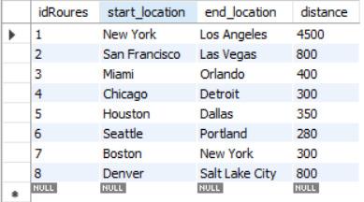

rout_has_user

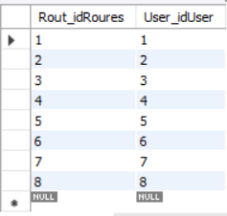

trip

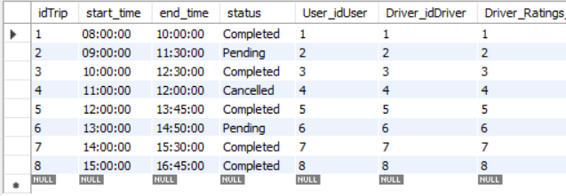

user

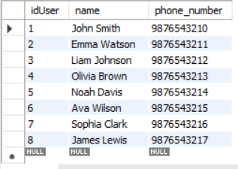

-- MySQL Workbench Forward Engineering

SET @OLD_UNIQUE_CHECKS=@@UNIQUE_CHECKS, UNIQUE_CHECKS=0;

SET @OLD_FOREIGN_KEY_CHECKS=@@FOREIGN_KEY_CHECKS, FOREIGN_KEY_CHECKS=0;

SET @OLD_SQL_MODE=@@SQL_MODE, SQL_MODE='ONLY_FULL_GROUP_BY,STRICT_TRANS_TABLES,NO_ZERO_IN_DATE,NO_ZERO_DATE,ERROR_FOR_DIVISION_BY_ZERO,NO_ENGINE_SUBSTITUTION';

-- -----------------------------------------------------

-- Schema UklonDB

-- -----------------------------------------------------

DROP SCHEMA IF EXISTS `UklonDB` ;

-- -----------------------------------------------------

-- Schema UklonDB

-- -----------------------------------------------------

CREATE SCHEMA IF NOT EXISTS `UklonDB` DEFAULT CHARACTER SET utf8 ;

SHOW WARNINGS;

USE `UklonDB` ;

-- -----------------------------------------------------

-- Table `Ratings`

-- -----------------------------------------------------

DROP TABLE IF EXISTS `Ratings` ;

SHOW WARNINGS;

CREATE TABLE IF NOT EXISTS `Ratings` (

`idRatings` INT NOT NULL AUTO_INCREMENT,

`rating` FLOAT NULL,

`review` VARCHAR(45) NULL,

`rating_date` DATE NULL,

PRIMARY KEY (`idRatings`))

ENGINE = InnoDB;

SHOW WARNINGS;

-- -----------------------------------------------------

-- Table `Driver`

-- -----------------------------------------------------

DROP TABLE IF EXISTS `Driver` ;

SHOW WARNINGS;

CREATE TABLE IF NOT EXISTS `Driver` (

`idDriver` INT NOT NULL AUTO_INCREMENT,

`name` VARCHAR(45) NOT NULL,

`rating` FLOAT NULL,

`phone_number` INT NOT NULL,

`licence_number` VARCHAR(45) NOT NULL,

`Ratings_idRatings` INT NOT NULL,

PRIMARY KEY (`idDriver`, `Ratings_idRatings`))

ENGINE = InnoDB;

SHOW WARNINGS;

-- -----------------------------------------------------

-- Table `Car`

-- -----------------------------------------------------

DROP TABLE IF EXISTS `Car` ;

SHOW WARNINGS;

CREATE TABLE IF NOT EXISTS `Car` (

`idCars` INT NOT NULL AUTO_INCREMENT,

`brand` VARCHAR(45) NOT NULL,

`model` VARCHAR(45) NOT NULL,

`plate_number` VARCHAR(45) NOT NULL,

`seats` VARCHAR(45) NOT NULL,

`Driver_idDriver` INT NOT NULL,

PRIMARY KEY (`idCars`, `Driver_idDriver`))

ENGINE = InnoDB;

SHOW WARNINGS;

-- -----------------------------------------------------

-- Table `User`

-- -----------------------------------------------------

DROP TABLE IF EXISTS `User` ;

SHOW WARNINGS;

CREATE TABLE IF NOT EXISTS `User` (

`idUser` INT NOT NULL AUTO_INCREMENT,

`name` VARCHAR(45) NOT NULL,

`phone_number` VARCHAR(45) NOT NULL,

PRIMARY KEY (`idUser`))

ENGINE = InnoDB;

SHOW WARNINGS;

-- -----------------------------------------------------

-- Table `Rout`

-- -----------------------------------------------------

DROP TABLE IF EXISTS `Rout` ;

SHOW WARNINGS;

CREATE TABLE IF NOT EXISTS `Rout` (

`idRoures` INT NOT NULL AUTO_INCREMENT,

`start_location` VARCHAR(45) NOT NULL,

`end_location` VARCHAR(45) NOT NULL,

`distance` FLOAT NOT NULL,

PRIMARY KEY (`idRoures`))

ENGINE = InnoDB;

SHOW WARNINGS;

-- -----------------------------------------------------

-- Table `Payments`

-- -----------------------------------------------------

DROP TABLE IF EXISTS `Payments` ;

SHOW WARNINGS;

CREATE TABLE IF NOT EXISTS `Payments` (

`idPayments` INT NOT NULL AUTO_INCREMENT,

`amount` FLOAT NOT NULL,

`payment_date` DATE NOT NULL,

`payment_status` VARCHAR(45) NOT NULL,

PRIMARY KEY (`idPayments`))

ENGINE = InnoDB;

SHOW WARNINGS;

-- -----------------------------------------------------

-- Table `Ride_Fare`

-- -----------------------------------------------------

DROP TABLE IF EXISTS `Ride_Fare` ;

SHOW WARNINGS;

CREATE TABLE IF NOT EXISTS `Ride_Fare` (

`idRide_Fare` INT NOT NULL AUTO_INCREMENT,

`base_fare` FLOAT NOT NULL,

`distance_fare` FLOAT NOT NULL,

`total_fare` FLOAT NOT NULL,

PRIMARY KEY (`idRide_Fare`))

ENGINE = InnoDB;

SHOW WARNINGS;

-- -----------------------------------------------------

-- Table `Trip`

-- -----------------------------------------------------

DROP TABLE IF EXISTS `Trip` ;

SHOW WARNINGS;

CREATE TABLE IF NOT EXISTS `Trip` (

`idTrip` INT NOT NULL AUTO_INCREMENT,

`start_time` TIME NOT NULL,

`end_time` TIME NOT NULL,

`status` VARCHAR(45) NOT NULL,

`User_idUser` INT NOT NULL,

`Driver_idDriver` INT NOT NULL,

`Driver_Ratings_idRatings` INT NOT NULL,

`Rout_idRoures` INT NOT NULL,

`Payments_idPayments` INT NOT NULL,

`Ride_Fare_idRide_Fare` INT NOT NULL,

PRIMARY KEY (`idTrip`, `User_idUser`, `Driver_idDriver`, `Driver_Ratings_idRatings`, `Rout_idRoures`, `Payments_idPayments`, `Ride_Fare_idRide_Fare`))

ENGINE = InnoDB;

SHOW WARNINGS;

-- -----------------------------------------------------

-- Table `Rout_has_User`

-- -----------------------------------------------------

DROP TABLE IF EXISTS `Rout_has_User` ;

SHOW WARNINGS;

CREATE TABLE IF NOT EXISTS `Rout_has_User` (

`Rout_idRoures` INT NOT NULL,

`User_idUser` INT NOT NULL,

PRIMARY KEY (`Rout_idRoures`, `User_idUser`))

ENGINE = InnoDB;

SHOW WARNINGS;

-- -----------------------------------------------------

-- Table `Review`

-- -----------------------------------------------------

DROP TABLE IF EXISTS `Review` ;

SHOW WARNINGS;

CREATE TABLE IF NOT EXISTS `Review` (

`idReviews` INT NOT NULL,

`rating` FLOAT NOT NULL,

`comment` VARCHAR(45) NOT NULL,

`created_at` DATE NOT NULL,

`Driver_idDriver` INT NOT NULL,

`Driver_Ratings_idRatings` INT NOT NULL,

PRIMARY KEY (`idReviews`, `Driver_idDriver`, `Driver_Ratings_idRatings`))

ENGINE = InnoDB;

SHOW WARNINGS;

SET SQL_MODE=@OLD_SQL_MODE;

SET FOREIGN_KEY_CHECKS=@OLD_FOREIGN_KEY_CHECKS;

SET UNIQUE_CHECKS=@OLD_UNIQUE_CHECKS;