Họ tên SV: Lê Tuấn Đạt

MSSV: B2113328

**Bài thực hành số: 2**

Ngày: 12/9/2023

**Câu 1:**

clear

echo “This is my first script!!!”



clear

echo “Hello $USER”

echo “Today is \c ”;date

echo “Number of user login: \c” who | wc -l

echo “Calendar”

cal

exit 0

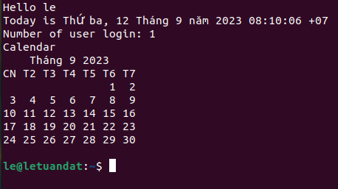

myname=TuanDat

myos=TroubleOS

myno=5

echo “My name is $myname”

echo “My os is $myos”

echo “My number is myno, can you see this number”

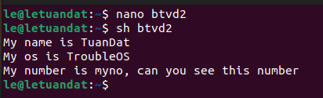

echo -e “\t Khoa CNTT & TT \n\t Dai Hoc Can Tho”

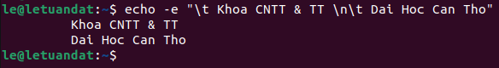

echo “Tong cua 6 va 3 la: `expr 6 + 3`”

echo “Tong cua 6 va 3 la: ‘expr 6 + 3’”

echo “Tong cua 6 va 3 la: “expr 6 + 3””

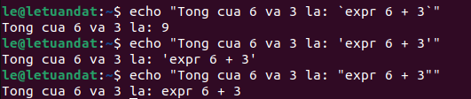

echo “Your first name please:”

read name

echo “Hello $name, Lets be friend!”

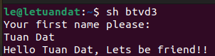

**Câu 2:**

echo "\\****************************************\\”

echo “Today is \c”; date

echo “Your current working directory: $PWD”

echo “Your home directory: $HOME”

echo “Please press any key to finish: ”; read a

echo “\n Thank you very much!!

\\****************************************\\"

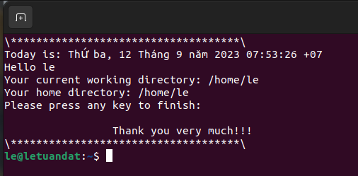

**Câu 3:**

echo “Nhap x:”

read x

echo “Nhap y:”

read y

echo “Tham so ban da truyen vao la 2 so: $x va $y”

echo “Tong: $x + $y = `expr $x + $y`”

echo “Hieu: $x - $y = `expr $x - $y`”

echo “Tich: $x * $y = `expr $x \* $y`”

echo “Thuong: $x / $y = `expr $x / $y`”

echo “So du: $x % $y = `expr $x % $y`”

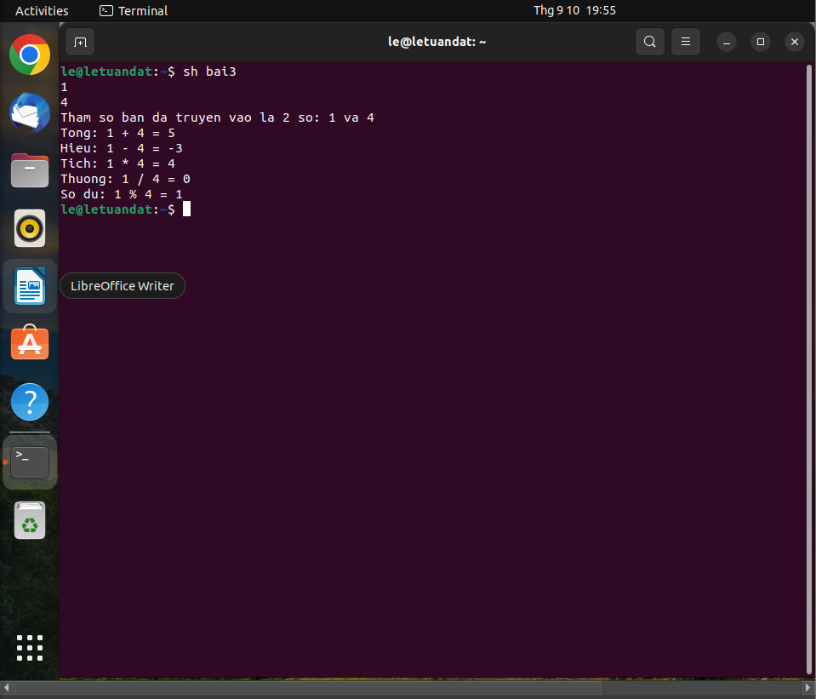

**Câu 4:**

mkdir $1 2> /dev/null

if [ $? -ne 0 ]; then

echo “Khong the tao thu muc!!!”

fi

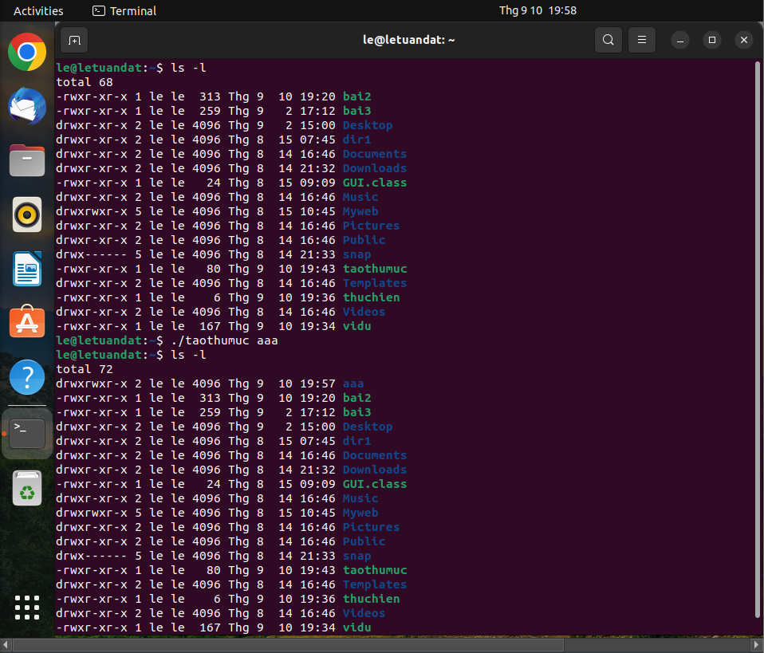

**Câu 5:**

$1 $2

