**Họ và tên:** Lê Tuấn Đạt

**MSSV:** B2113328

**Bài thực hành số:** 3

Ngày: 18/09/2023

**Câu 1:**

|  |
| --- |
| if rm $1  then  echo “$1 is deleted successfully!”  fi |
| if test $1 -gt 0  then  echo “$1 is positive number”  fi |
| if test $1 -gt 0  then  echo “$1 is positive”  else  echo “$1 is negative”  fi |
| for i in 1 2 3 4 5  do  echo “Welcome $i times”  done |
| for (( i = 0 ; i <= 5; i++ ))  do  echo “Welcome $i times”  done |
| for (( i = 1 ; i <= 5; i++ ))  do  for (( j = 1 ; j <= 5; j++ ))  do  echo -n “$i”  done  echo “”  done |
| i=1  while [ $i -le 5 ]  do  echo “Welcome $i times”  i=`expr $i + 1`  done |

|  |
| --- |
| Please choose a number:  echo “1: Fried Eggs”  echo “2: Salad”  echo “3: Noodle”  read f  case $f in  “1”) echo “Thanks, you chose Fried Eggs.”;;  “2”) echo “Thanks, you chose Salad.”;;  “3”) echo “Thanks, you chose Noodle.”;;  *) echo “Sorry, we have only Fried Eggs, Salad, Noodle”;;  esac |

**Câu 2:**

for (( i = 1; i <= 10; i++ ))

do

for (( j = 0; j < i; j++ ))

do

echo -n “*”

done

echo “”

done

for (( i = 1; i <= 5; i++ ))

do

for (( j = 1; j <= 5; j++ ))

do

echo -n “$j ”

done

echo “”

done

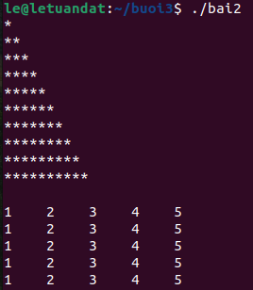

**Câu 3:**

echo “Giai phuong trinh bac nhat: ax + b = 0”

echo -n “Nhap he so a: ”; read a

echo -n “Nhap he so b: ”; read b

if test $a -eq 0

then

if test $b -eq 0

then

echo “VO SO NGHIEM”

else

echo “VO NGHIEM”

fi

else

echo -n “x = ”

echo “scale=3; (-$b)/$a”|bc

fi

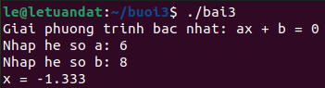

**Câu 4:**

a=1

while [ $a -ne 0 ]

do

echo -n "Nhap n = "; read n

sum=0

for ((i = 1; i <= n; i++))

do

((sum += i))

done

echo "Tong = $sum"

echo "Nhap so <>0 de tiep tuc hoac 0 de ngung"; read a

done

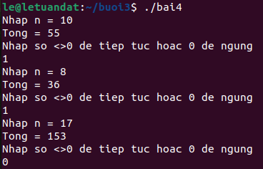

**Câu 5:**

a=1

while [ $a -ne 0 ]

do

echo -n “Nhap n = ”; read n

for ((i = 1; i <= 10; i++))

do

echo “$i x $n = `expr $i \* $n`”

done

echo “Nhap so <>0 de tiep tuc hoac 0 de ngung”; read a

done

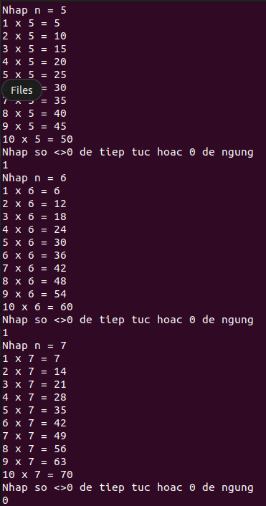

**Câu 6:**

echo -n “Nhap n = ”; read n

for ((i = 1; i <= n; i++))

do

if mkdir user_$i

then

echo “directory \"user_$i\" has been created”

fi

done

