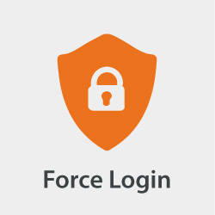

Force Login

for Magento® 2

USER GUIDE

Version 1.0

Table of Contents

Introduction 3

Authors 3

Features 3

Installation 3

How to use 3

How to configure 4

Navigation 4

Overview Grid 5

Detail Form 6

Contribution 6

License 6

# Introduction

The Force Login module for Magento® 2 allows you to restrict which pages a not logged in user is able to see. Not logged in visitors get redirected to the login page. This module is especially useful for merchants serving only a specific group of users, e.g. enterprise related business partners and need to ensure that only those users are able to browse the the website or the product catalog.

# Authors

The authos of the Force Login module for Magento® 2 is the bitExpert AG[1] and is maintained by Stephan Hochdörfer (S.Hochdoerfer@bitExpert.de) and Florian Horn (F.Horn@bitExpert.de).

# Features

* Force your guest visitors to log in first (or register), before allowing them to visit your pages and catalog
* Administration: Manage the whitelist rules by the GUI in the administration area
* ACL: Restrict the administration of whitelist rules to certain backend user groups
* Whitelisting: Define url rules as pattern to define which pages guest visitors can visit without logging in first
* Multistore-Support: Define if whitelist rules either apply globally or for specific stores

# Installation

The preferred way of installing the Force Login module for Magento® 2 is through Composer[2]. Simply add `bitexpert/magento2-force-customer-login` as a dependency:

composer.phar require bitexpert/magento2-force-customer-login

Optional you can download the latest version [here](https://github.com/bitExpert/magento2-force-login/releases) and install the decompressed code in your projects directory under *app/code/bitExpert/ForceCustomerLogin*.

# How to use

The usage of the Force Login module for Magento® 2 is applied implicitly by redirecting visitors if the called URI does not match any configured whitelisted url rules.

# How to configure

## Navigation

As shown in figure 1, navigate through the Magento® 2 backend menu by clicking onto the item **Customers**. You must see a new menu entry **Forced Login Whitelist**.

Enter this menu entry.

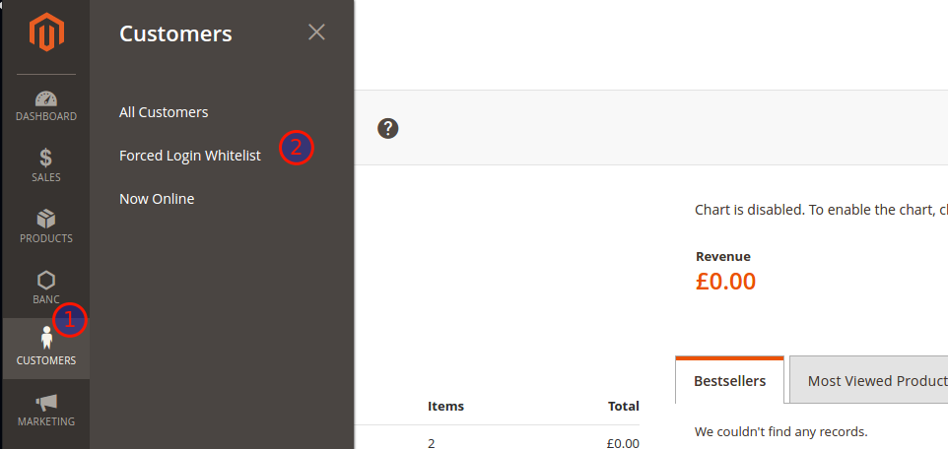  
Figure 1: Force Login Configuration Menu Item

## Overview Grid

A shown in figure 2, you can add new entries by clicking on the *Add Entry* button in the upper right corner (**1**).

The grid (**2**) contains all existing whitelisted *Url Rules*, for which the forced redirect to the *Customer Login Page* is omitted.

The *Url Rules* (**3**) are part of a regular expression checking on the called *Url* and tries to match against the whitelist.

*Url Rules* may be related to all stores or to a specific one (**4**). All rules except some mandatory ones are editable (**5**) and removeable (**6**).

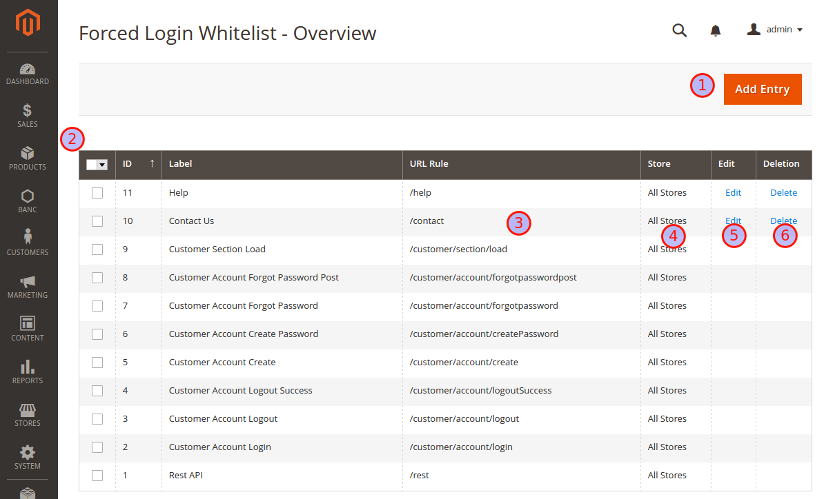  
Figure 2: Force Login Overview of whitelist Url Rules

## Detail Form

As shown in figure 3, you can return to the *Overview Grid* by using the *Back* button (**1**). The *Label* value has only declarative character and is for information purpose only (**2**). The *Url Rule* is part of a regular expression checking on the called

*Url* and tries to match against the whitelist (**3**). *Url Rules* may be related to all stores or to a specific one (**4**).

Persist the rule by using the *Save* button (**5**).

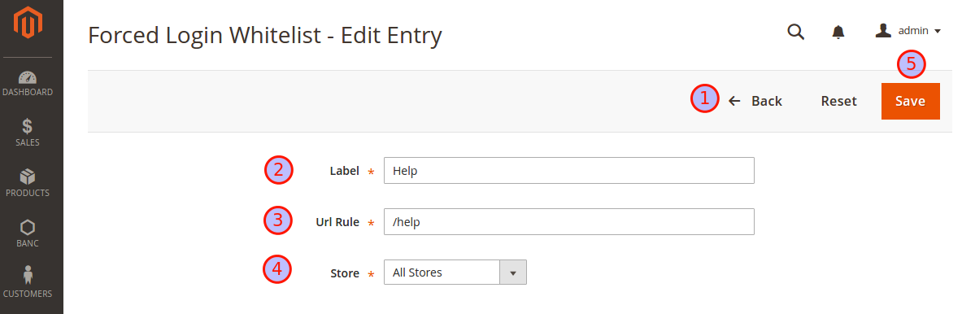  
Figure 3: Force Login Whitelist Rule Detail Form

# Contribution

Feel free to contribute to this module by reporting issues or create some pull requests for improvements on the github page of the Force Login module for Magento® 2[3].

# License

The Force Login module for Magento® 2 is released under the Apache 2.0 license[4].

1. http://www.bitExpert.de
2. https://getcomposer.org/
3. https://github.com/bitExpert/magento2-force-login
4. https://github.com/bitExpert/magento2-force-login/blob/master/LICENSE