**InstaCredit User Guide for iPhone**

1. Tap **InstaCredit app icon** to launch the app and get to the Sign-In page:

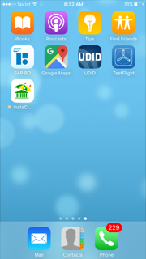 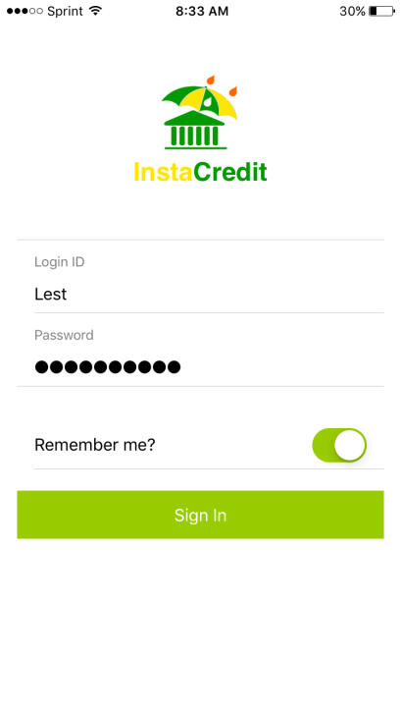

1. On Sign-In page, toggle “**Remember me?**” button to “On” or “Off” to save or not save your user id and password respectively for subsequent sign-ins.
2. Tap **Sign In** button to log in. If successfully signed in, the app home page will show with a tap bar at the bottom with 4 tabs: **Home, Dashboard, Counterparty and About**:

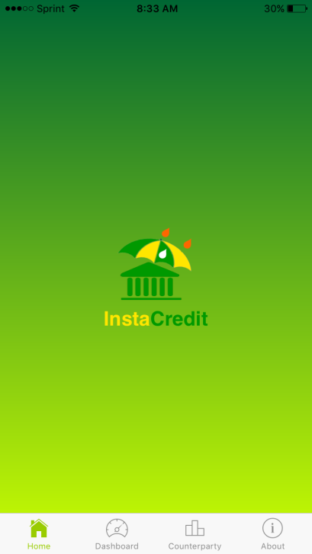

1. Tap ***Dashboard tab*** to go Dashboard Page. Scroll down to see all views on the page:

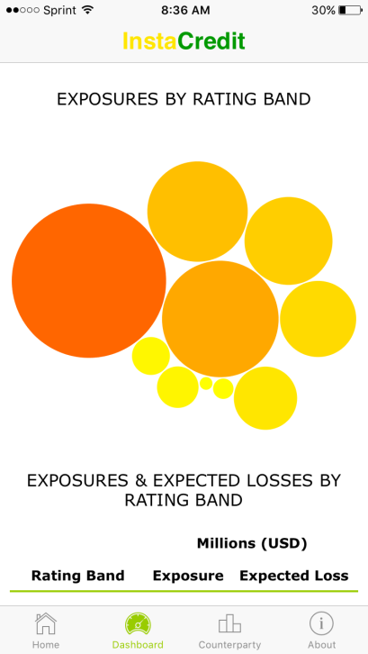 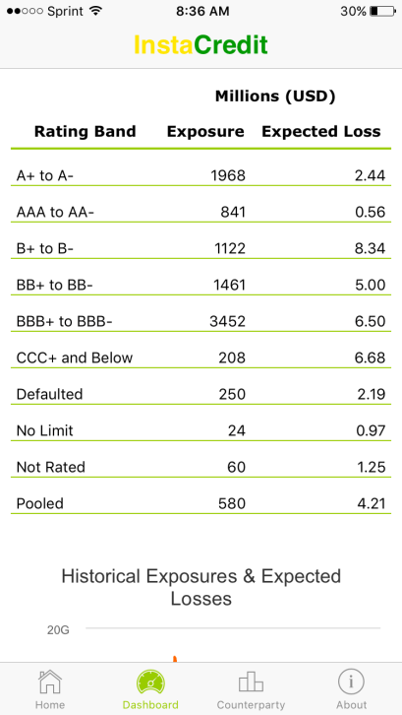 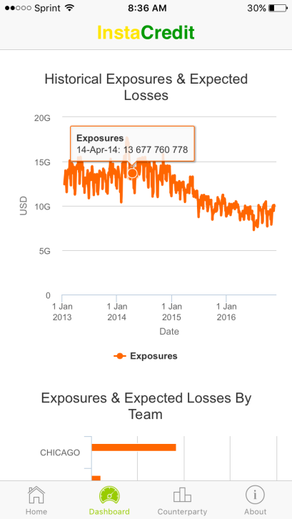

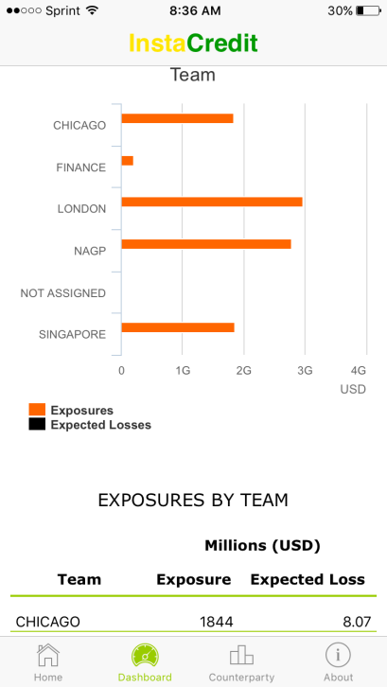 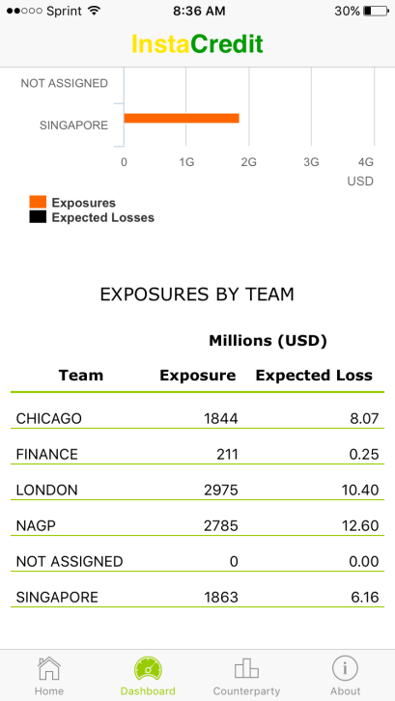

1. Tap ***Counterparty tab*** to go to Counterparty Search page and enter at least 2 characters in the **Search** bar to search for counterparty hierarchies desired. See results below as searching for text token “3M”:

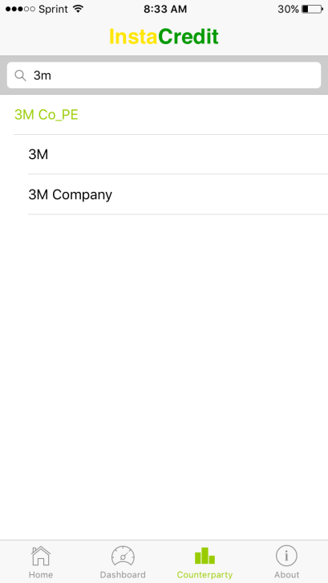

1. Tap a counterparty to display the counterparty information on the Counterparty page. Below is the result for counterparty “3M Company” selected. Scroll down to view all information:

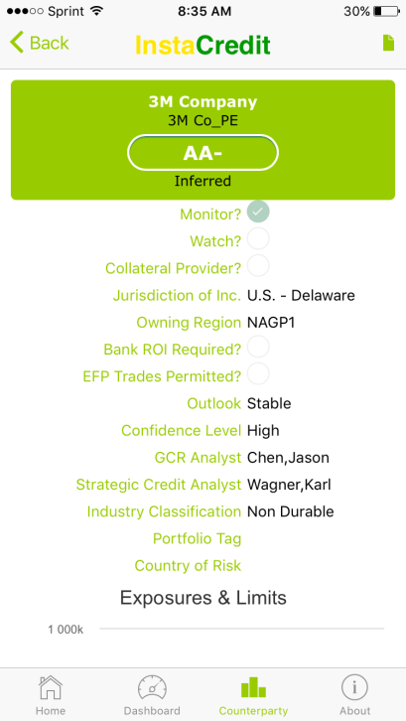 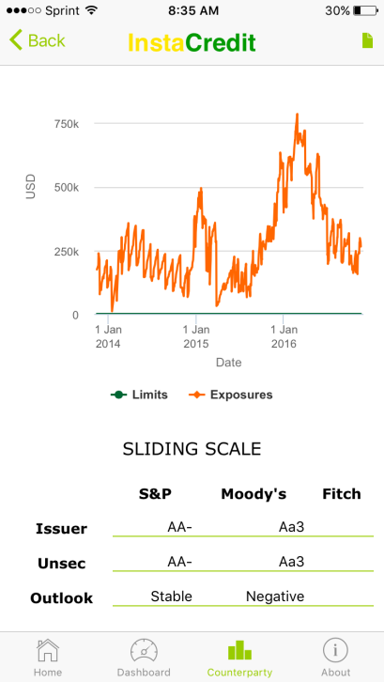

1. On the counterparty page, tap on **Document icon** on the right of the top navigation bar to open document list page as shown below:



1. Tap a document of the following file types in the list for viewing:

* iWork documents
* Microsoft Office documents (Office ‘97 and newer)
* Rich Text Format (RTF) documents
* PDF files
* Images
* Text files whose uniform type identifier (UTI) conforms to the public.text type (see [*Uniform Type Identifiers Reference*](https://developer.apple.com/library/content/documentation/Miscellaneous/Reference/UTIRef/Introduction/Introduction.html#//apple_ref/doc/uid/TP40009257))
* Comma-separated value (csv) files

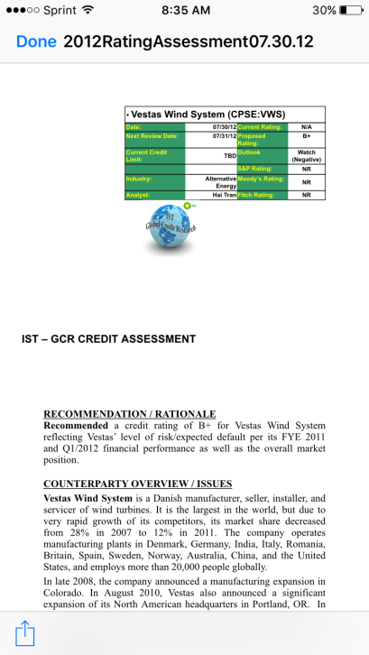

1. For other file types, not listed in 8, such as Outlook files (.msg), an appropriate mobile app would need to be installed on the mobile device in order to view the file correctly.

For example, to view an Outlook file (.msg), install the following “MSG File Viewer” from the Apple app store:

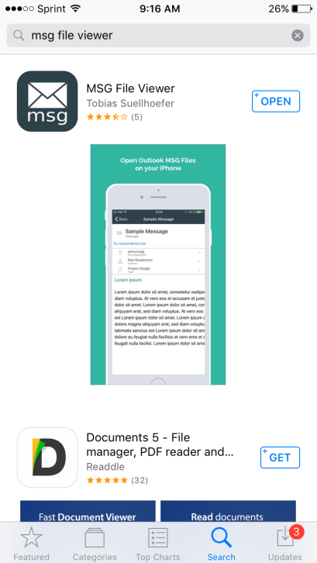

After installing MSG File Viewer, follow the steps below to open an Outlook file (.msg):

1. Tap the .msg file as listed in 9 to show the following page:

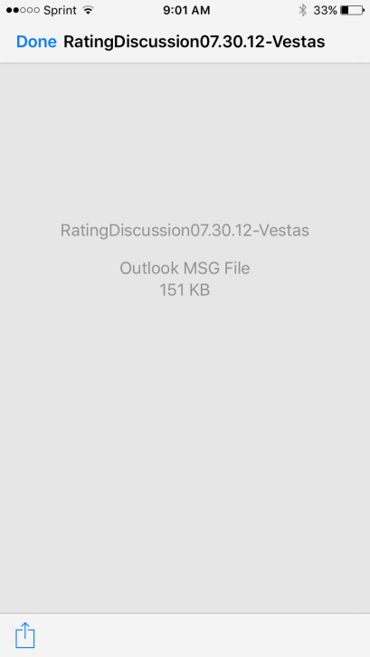

1. Tap the **Launch** icon on the bottom left corner of the screen and then tap **MSG File Viewer** app to view the document as shown below:

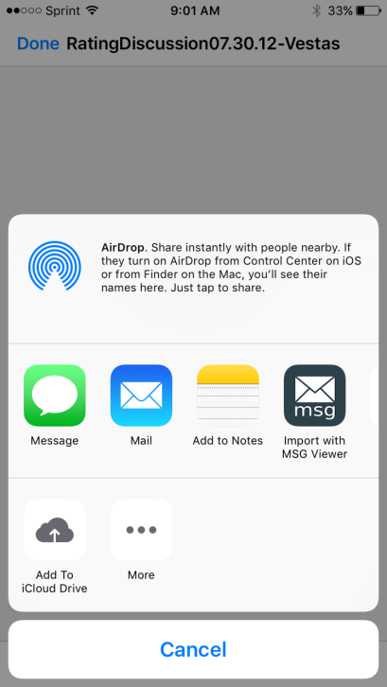 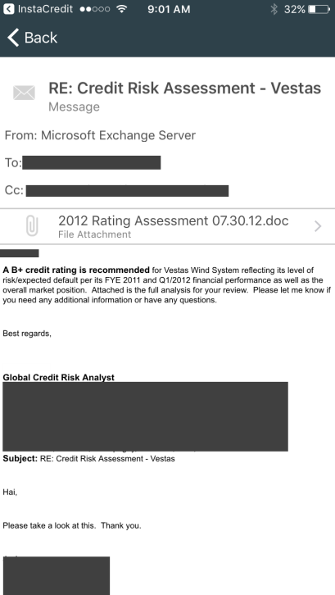

1. Tap ***About*** tab to view the app version, build and description as well as access to support contact via and use manual:
2. Tab Support Email address to open the mail app to send support issues
3. Tab Help button at the bottom of the page to view User Manual document

