Olimp - Zeus LT I/O Control
The main idea of the program is that you can define sequences of commands that program can execute “in parallel”, meaning that if one sequence is for example waiting on some input to become 1 or 0, other sequences can run regardless.

Program supports up to 26 sequences (named a-z), each sequence can have up to 26 commands (with positions marked as a-z).

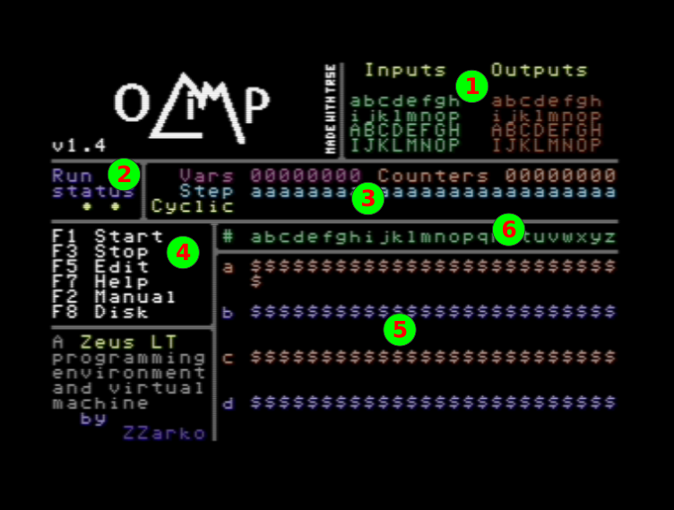

- Current status of inputs and outputs
- Current status of the program (shows EDIT when in Edit mode, MANUAL when in Manual mode, and spinning char when executing sequences)
- Sequences, variables and counters state
  - Vars - value of variables (0 or 1)
  - Counters - value of counters (0-F hex, if greater than F, then up arrow is shown)
  - Step - current step of each sequence (shown when waiting on something)
  - Cyclic - shows if sequence is cyclic or not
- Main commands
  - F1 - Runs the sequences. You may alter outputs with a-p and A-P manually
  - F3 - Stops sequence execution/manual mode/edit mode
  - F5 - Edit sequences
  - F7 - Help
  - F2 - Manual setting of outputs with a-p and A-P
  - F8 - Disk operations
- Sequences
  - First column is sequence name a-z
  - Each sequence has 3 lines, first one shows commands, while other two are for command parameters
- Sequence/command positions for panes 3 and 5

Execution of sequences
Each sequence can be set to be cyclic, which means that program will run it constantly. Commands in non-cyclic sequences can only be called or jumped to. When executing sequences, Olimp runs through all of cyclic ones and executes their commands, and then repeats the process. If some command requires the sequence to wait (for example, waiting for timer to expire, or waiting for some input to become 0 or 1), execution goes to the next cyclic sequence. Execution of sequence finishes either after its last command is executed (step z) or if finish sequence command is encountered.

Inputs, outputs, constants, variables, counters
Interface supports max 32 inputs and max 32 digital 1-bit outputs. In the program they are named using lower case letters a-p for inputs/outputs 1-16 and upper case letters A-P for inputs/outputs 17-32.
Supported constants include 0 and 1 that can be, for example, written directly to some output, and 2-digit hexadecimal numbers that can be used to, for example, set the initial value of counter.
There are 8 1-bit variables, marked with digits 2-9. They are common for all sequences and can be used to communicate between them.
There is also 8 8-bit counters named s-z, also common for all sequences. They can be set to some 8-bit value and can be decreased until 0 is reached.

Sequence editor
Sequence editor is entered by pressing F5. After that, cursor appears, and can be moved using cursor keys. Placing cursor over command line in a sequence allows you to enter a new command in that position. If command has parameters, a question mark is placed in their place and border turns red. That is the indication that you have unfinished commands in a sequence and sequences cannot be run until parameters are filled (using the same logic as with entering the commands).
You can use INS/DEL key to erase a command in a sequence and HOME/CLR to insert a new one in a arbitrary place as long as there is a room to do that (if last command in a sequence is $). These commands will adjust jump targets that are inside the current sequence.
Key RUN/STOP sets/resets the cyclic status of a sequence.
If all commands are defined, you can press F1 to directly execute them.

Run sequences
When sequences start to run, you still have the possibility to change the outputs manually by pressing [a-p] or [A-P]. This is indicated by at Outputs display.
Pressing F1 while in run sequences stops reading of the inputs and allows you to set the inputs manually. This is indicated by at Inputs display and can be used to test the sequence execution without waiting for real inputs. Pressing the F1 again returns to normal state of execution.

Disk operations
On this screen you can save or load a sequence, or you can display current directory. After pressing F1 or F3, you can enter the file name, up to 12 characters (letters, numbers and space). You can use DEL to delete last character, and RUN/STOP to cancel loading or saving.
Drive number can be selected with +/- keys.
All Olimp files are saved with .OLI extension and only those files are displayed when listing a directory.

Commands
Each command consist of only one character, and can have 1 or 2 additional characters as parameters. In the editor, they are written one below another in each sequence.

Set output or variable
This is a 2-character command where first character represents source and can be input, 0, 1 or a variable, and second character is destination and can be output or variable.
1a - write 1 to output a
bC - write value of input b to output C
03 - write 0 to variable 3

Set counter to hexadecimal value
This is a 3-character command where first character represents counter to be set [s-z], and second and third one are hexadecimal digits.
s0F - set counter s to value $0F (15)
z80 - set counter z to value $80 (128)

Wait for input to become 1
This is a 2-character command where first character is and second is input to check, [a-p] or [A-P].
*a - sequence is stopped until input a becomes 1
*P - sequence is stopped until input P becomes 1

Wait for input to become 0
This is a 2-character command where first character is and second is input to check, [a-p] or [A-P].
/a - sequence is stopped until input a becomes 1
/P - sequence is stopped until input P becomes 1

Wait specified number of 1/10 seconds
This is a 3-character command where first character is , and second and third one are hexadecimal digits.
@0A - sequence is stopped for 10 1/10 seconds (1 second)
@32 - sequence is stopped for 50 1/10 seconds (5 seconds)

Jump to another step
This is a 3-character command where first character is , second is step to jump to [a-z] and third is sequence to jump to [a-z]. When entering this command, third parameter is automatically filled with current sequence.
#nb - jump to sequence b, step n
#za - jump to sequence a, step z
Be aware that this can skip execution of some sequences, for example if you jump from sequence a to sequence d and then finish execution, next sequence to be executed will be e, and sequences b and c would not run even if they are set to be cyclic.

Copy counter to another one
This is a 3-character command where first character is , second is copy-from counter [s-z] and third is is copy-to counter [s-z].
!sz - copy value of counter s to counter z

Call sub-sequence
This is a 3-character command where first character is , second is sequence to call [a-z] and third is step in that sequence [a-z]. When entering this command, third parameter is automatically filled with current sequence.
+nb - calls sequence b, step n
+za - calls sequence a, step z
Be aware that there is a 16-position stack that holds return positions (command right after the call) for these calls and that program could crash if there is a mismatch between number of calls and returns from call.

Return from call
This is a 1-character command .
- - returns to a step right after last call

Finish sequence
This is a 1-character command .
$ - finishes execution of the current sequence

Check if input or variable is 1
This is a 3-character command where first character is , second is input to check, [a-p] or [A-P] or variable [2-9], and the third one is step to jump to if condition is true
?af - if input input a is 1, jump to step f, otherwise go to next step
?9m - if variable 9 is 1, jump to step m, otherwise go to next step

Check if input or variable is 0
This is a 3-character command where first character is , second is input to check, [a-p] or [A-P] or variable [2-9], and the third one is step to jump to if condition is true
%af - if input input a is 0, jump to step f, otherwise go to next step
%9m - if variable 9 is 0, jump to step m, otherwise go to next step

Copy inputs to vars
This is a 2-character command where first character is and second represents group of 8 inputs inputs [1-4].
<1 - copy values of inputs a-h to variables 2-9
<4 - copy values of inputs I-P to variables 2-9

Copy vars to inputs
This is a 2-character command where first character is and second represents group of 8 inputs inputs [1-4].
>1 - copy values of variables 2-9 to inputs a-h
>4 - copy values of variables 2-9 to inputs I-P

Bitwise AND
This is a 3-character command where first character is , and second and third ones are input [a-p] or [A-P], variable [2-9] or constant [0-1].
&a2 - perform bitwise AND between input a and variable 2 and puts result in variable 9
&aD - perform bitwise AND between input a and input D and puts result in variable 9

Bitwise OR
This is a 3-character command where first character is , and second and third ones are input [a-p] or [A-P], variable [2-9] or constant [0-1].
=a2 - perform bitwise OR between input a and variable 2 and puts result in variable 9
=aD - perform bitwise OR between input a and input D and puts result in variable 9

Bitwise XOR
This is a 3-character command where first character is , and second and third ones are input [a-p] or [A-P], variable [2-9] or constant [0-1].
a2 - perform bitwise XOR between input a and variable 2 and puts result in variable 9
b1 - perform bitwise XOR between input b and constant 1 and puts result in variable 9 (this efectively inverts value of input b)

Set all vars to hexadecimal value
This is a 3-character command where first character is , and second and third one are hexadecimal digits.
AF - Set variables 2-9 to bit combination 10101111

Set cyclic status for a sqeuence
This is a 3-character command where first character is , and second is sequence [a-z]and third one is cyclic status [0-1] or variable [2-9].
£a1 - set cyclic status of sequence a to 1
£b2 - set cyclic status of sequence b to value of variable 2

Decrease counter and check if it is equal to 0
This is a 3-character command where first character is , second is counter [s-z] and the third one is a step to jump to if counter value is 0. If the counter value is greater than 0, it is decreased and execution goes to next step. If counter value is 0, execution jumps to step from last parameter (similar to checks if input or variable are 0 or 1)
:sk - if counter s is greater than 0, decrease it go to next step, otherwise jump to step k

Copy counter value to variables
This is a 2-character command where first character is , and second is counter [s-z].
[s - copy 8-bit counter s to variables 2-9.

Copy variables to counter
This is a 2-character command where first character is , and second is counter [s-z].
[s - copy variables 2-9 to 8-bit counter s.

Sequence examples
All examples assume that sequence is set to be cyclic. This also means that the sequence is repeated once it is finished.

Copy inputs to outputs
ab ba $
Copy input a to output b
Copy input b to output a

Blink output with 2s period
1a @0A 0a @0A $
Put 1 to output a
Wait 1 second
Put 0 to output a
Wait 1 second

Blink output with 0.4s period only if input is set to 1
*a 1a @02 0a @02 $
Wait for input a to become 1
Put 1 to output a
Wait 1 second
Put 0 to output a
Wait 1 second

Wait for 5 impulses on input
a b c d e f g <- positions in a sequence
s05 *a /a :sf #ba 1b $
Put 5 to counter s
Wait for input a to become 1
Wait for input a to become 0
If counter s is greater than 0, decrease it and if it reached 0, go to position f that puts 1 to output b. If counter s is greated than 0, go to next position, e, which jumps to position b.

