Solution: AdventureWorks – Draft 3.0

Owner: Catherine Warren

Date: 2016-12-03 & on

Change Log

|  |  |  |
| --- | --- | --- |
| **Who** | **When** | **What** |
| **Catherine Warren** | 2016-12-03 to 08 | Multiple changes to underlying data structure |
| **Catherine Warren** | 2016-12-08 to 11 | Created ETL process with SSIS |

Summary

This BI solution is being created for Adventure Works, a small business that is interested in gaining more insight into its customer sales. The number of users of the solution will be less than ten employees. So, performance tuning is not considered an issue at this time.

**Data Warehouse Structure**

The source database is simplified into a modified star design with two fact tables: FactSales and FactCustomerAddresses. Each fact table has several dimension tables extending from it, but none extending more than one table “deep” away from the fact table.

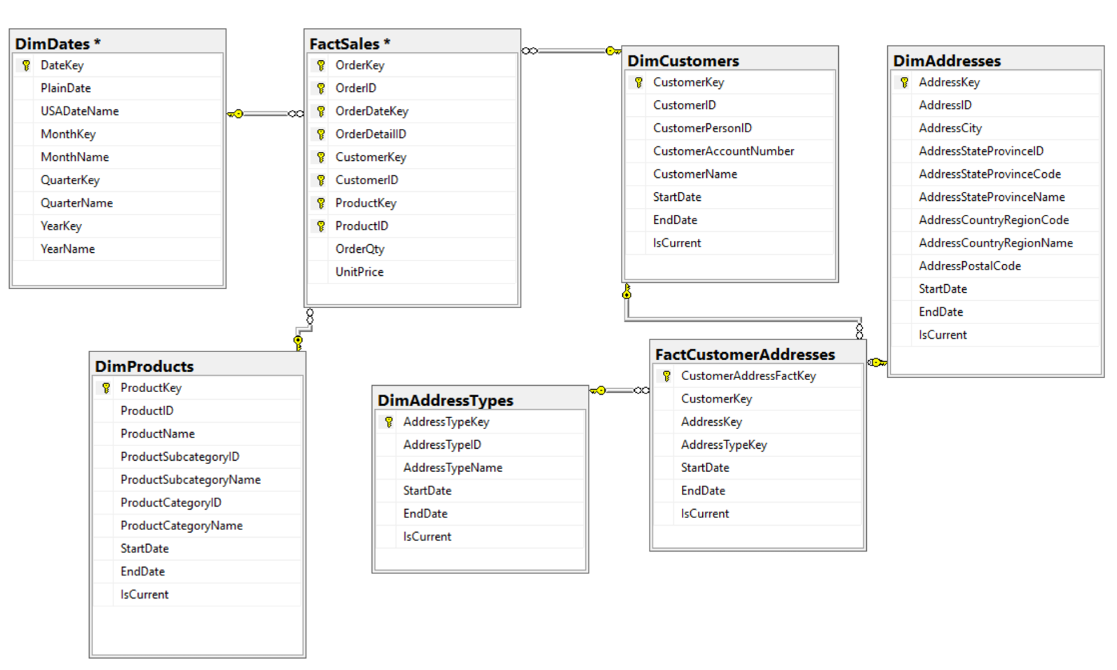

**SOME NOTES ON TABLE COMBINATION**

The source database has several unusual attributes. For one thing, it contained separate tables to hold Customers and Persons. Through examining the data, it was found that there is a one-to-one relationship between each Customer and each Person in the source database. For ease of reporting, the source Customer and Person tables were collapsed into one DimCustomers table.

Another unusual feature of the source database was the feature that each person could have many addresses, and each address could be associated with many people. Rather than continuing to collapse those tables down into one, this design keeps the many-to-many relationship between DimCustomers and DimAddresses through the use of the bridging “factless fact” table, FactCustomerAddresses.

Address Types were also considered as a candidate for collapsing into the main DimAddresses table, but we have chosen to keep the table separate as DimAddressTypes to reflect the fact that one address could, in theory, have more than one address type.

**DATES**

All of the tables except FactSales and DimDates have three Slowly Changing Dimension columns: StartDate, EndDate, and IsCurrent. FactSales has an OrderDateKey so we can find the date of the order.

In the DimDates dimension, unknown dates are handled with a separate “Unknown” record, to prevent confusion springing from NULL dates in the data warehouse.