easyFinance

- your team member names (EMAIL)

|  |  |
| --- | --- |
| Dominik Lange | [do-lange@gmx.de](mailto:do-lange@gmx.de) |
| Nico Rahm | [nicorahm99@gmx.de](mailto:nicorahm99@gmx.de) |
| Samuel Schlingheider | [s.schlingheider@web.de](mailto:s.schlingheider@web.de) |

- time sheet (hours spent for each person and their role)

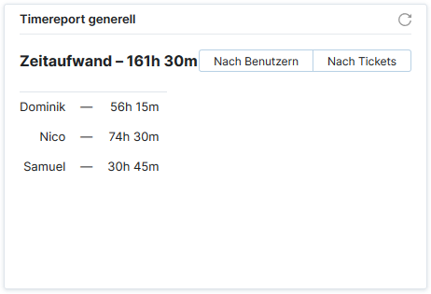

- the overall use case diagram with clearly marked scope!

