HPE SELF-DRIVING INNOVATION CHALLENGE · WHITE-PAPER ABSTRACT
Self-Securing 5G Core: An AI Closed-Loop for Autonomous Threat Mitigation on Juniper SRX
An always-on ML sensor gates an agentic-AI decision layer that autonomously enforces GTP/PFCP policy on HPE–Juniper SRX — a guardrailed, self-securing capability for the 5G user plane.
Andy Leung · [Team / Organization]
1 · The opportunity
The 5G user plane — GTP-U on N3 and PFCP on N4, terminated at the UPF — is a high-value, exposed attack surface, and private-5G and multi-access edge computing (MEC) push UPFs into physically less-trusted locations. Volumetric tunnel floods, malformed-packet parser attacks, and PFCP session/association abuse can degrade or drop service within seconds. The conventional response loop — detect, ticket, human triage, manual firewall change — takes minutes to hours. The opportunity is an autonomous, closed-loop capability that detects a user-plane attack and reconfigures enforcement in seconds, with no human in the critical path: a self-securing 5G core that cuts mean-time-to-mitigate from minutes to seconds and relieves the SOC for operators running private 5G.
2 · The innovation — a self-securing closed loop
The capability is a closed control loop — detect → decide → enforce → verify → learn — wrapped around the 5G core (Figure 1). An always-on machine-learning sensor scores N3/N4 traffic; on a genuine anomaly an agentic-AI layer classifies it and selects a graduated response; a Juniper SRX firewall enforces the policy; the loop then verifies the action reduced the anomaly without harming benign traffic and feeds the outcome back to the model. Unlike a conventional IDS, which stops at an alert, this system decides, enforces natively on SRX, verifies, and learns — autonomously and within guardrails.
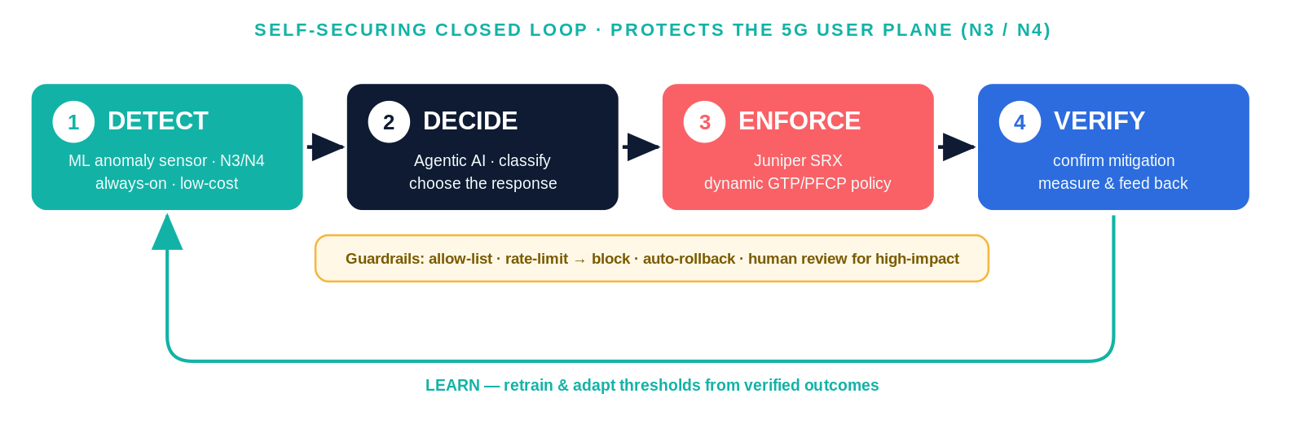
Figure 1 — The self-securing closed loop: an ML sensor gates an agentic decision layer that enforces on SRX, then verifies and learns, all behind safety guardrails.
3 · Architecture and HPE portfolio fit
Every stage maps to an HPE portfolio element (Figure 2). The ML sensor runs on GPU infrastructure (HPE Private Cloud AI). A token-efficiency gate sits between sensing and decision: the low-cost detector gates the costly LLM agent, which is invoked only when an anomaly is real. The agentic decision layer is built on HPE’s agentic AIOps framework (e.g., OpsRamp) rather than from scratch. Enforcement uses Juniper SRX — physical, vSRX, or cSRX — applying dynamic, GTP/PFCP-aware policy. The whole capability is delivered and monetized through HPE GreenLake, so a single loop spans HPE security, AI infrastructure, and consumption businesses — a natural cross-sell / up-sell motion.
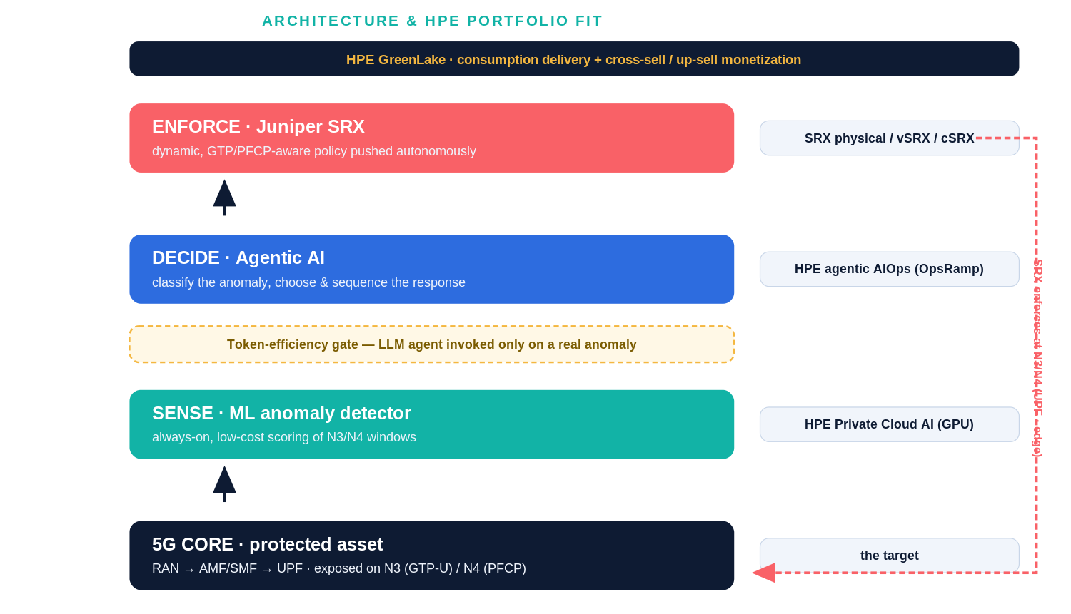
Figure 2 — Each loop stage maps to an HPE product; the token-efficiency gate ensures the agent runs only on real anomalies.
4 · How the loop responds
Detection maps to a graduated, least-disruptive enforcement action, executed on SRX and then verified:
Attack (interface) | Detector signal | Autonomous response on SRX
GTP-U flood (N3) | packet/byte-rate spike | apply rate-limit screen; escalate to block the source
Malformed GTP-U (N3) | structural feature anomaly | drop malformed flows by policy; quarantine source
PFCP session flood (N4) | N4 message-rate spike | rate-limit N4; restrict PFCP to the SMF source only
PFCP association abuse (N4) | association-churn pattern | throttle; flag for human review (high-impact)

5 · Safety guardrails
- Action allow-list — the agent may issue only pre-approved SRX policy templates.
- Graduated response — least-disruptive first — rate-limit before block before slice isolation.
- Human-in-the-loop — high-impact actions (e.g., isolating a slice) require operator approval.
- Verify-and-rollback — every action is measured and auto-reverts if it fails to reduce the anomaly or harms benign traffic.
- Scoped blast radius — actions are confined per UPF / slice / edge, with a full audit trail.
6 · Proof of feasibility
A running proof of concept already exists: an Open5GS 5G-SA core with a UERANSIM RAN, a curated corpus of N3/N4 attacks, an ML anomaly detector, and SRX (cSRX) enforcement, all on a single GPU host. Trained only on benign traffic, the detector separates benign from attack at ROC-AUC 1.000 (GPU autoencoder) and 0.989 (IsolationForest), with 100% recall across four attack classes and ~5% benign false-alarm; SRX screens rate-limit volumetric floods. This de-risks the two hardest elements of the loop — detection and enforcement — leaving the agentic decision layer and framework integration as the primary remaining build.
7 · Customer value and competitive differentiation
For operators, the loop cuts mean-time-to-mitigate from minutes to seconds and offloads repetitive triage from the SOC; for HPE support, the same telemetry becomes a self-reporting, self-healing signal. Crucially, unlike cloud-hosted control offerings, this capability runs where the data plane runs — on-premises or at the edge — so detection and enforcement stay local (low latency, data sovereignty) and are carried out by SRX the operator already owns. It is self-contained per site rather than dependent on a vendor’s control cloud — a direct, defensible counter to cloud-control marketing.
8 · Token efficiency, scaling and production use
Token efficiency is designed in: because a non-LLM detector pre-filters, the agent consumes tokens only on genuine incidents — orders of magnitude fewer than always-on LLM monitoring. Tiered models (a small model for routine classification, escalating only when needed), cached response templates, per-tenant token budgets, and usage dashboards keep spend observable and bounded. The design scales out linearly: per-UPF / slice / edge sensors score locally with GPU batching and report to a central agent that pushes policy to the nearest SRX — new sites add sensors, not bottlenecks.
9 · Monetization and path to commercialization
Monetization follows HPE’s consumption model: an “AI-Security for 5G” subscription add-on to SRX on GreenLake, priced per site or slice, or a managed private-5G security service bundling SRX, Private Cloud AI, and GreenLake. The path to market reuses existing HPE frameworks to shorten time-to-market and sharpen the competitive answer to cloud-control offerings:
- Phase 1 · Prove (today) — 5G core, N3/N4 attacks, ML detection, and SRX enforcement demonstrated on a GPU host.
- Phase 2 · Close the loop — agentic decision layer on HPE’s agentic AIOps framework, with certified guardrails.
- Phase 3 · Pilot — design-partner trials with private-5G / MEC operators; measure mean-time-to-mitigate reduction.
- Phase 4 · Productize — GreenLake catalog offering with per-site / per-slice subscription and managed-service option.
Challenge fit: scope / architecture / guardrails (§2–5) · customer & support benefits (§1, §7) · scope across HPE businesses (§3) · monetization & commercialization (§9) · complements HPE’s agentic framework (§3) · token-usage management (§8) · production scaling (§8).

