Self-Securing 5G Core: An AI Closed-Loop for Autonomous Threat Mitigation on Juniper SRX
Andy Leung
HPE Networking
aleung@hpe.com

Self-Securing 5G Core: An AI Closed-Loop for Autonomous Threat Mitigation on Juniper SRX
Abstract
We present a self-securing 5G core: a closed AI control loop — detect → decide → enforce → verify → learn — that autonomously defends the 5G user plane. An always-on machine-learning sensor scores N3 (GTP-U) and N4 (PFCP) traffic; on a genuine anomaly an agentic-AI layer classifies it and selects a graduated response; a Juniper SRX firewall enforces the policy; the loop then verifies the outcome and adapts. Our contributions are (i) closing the loop from detection to native SRX enforcement with verification and learning, behind explicit safety guardrails, and (ii) a token-efficiency design in which the low-cost ML detector gates the costly LLM agent so it runs only on real incidents. A running proof of concept demonstrates the sensing and enforcement stages on a 5G testbed.
Problem statement
The 5G user plane, terminated at the User Plane Function (UPF), is a high-value and exposed attack surface: GTP-U floods and malformed packets on N3, and PFCP session and association abuse on N4, can degrade or drop service within seconds [7]. Private-5G and multi-access edge computing (MEC) push UPFs into physically less-trusted locations, widening this surface [8]. Yet the conventional response — detect, ticket, human triage, manual firewall change — takes minutes to hours. This matters directly to HPE: with the completed acquisition of Juniper Networks, the SRX firewall is now an HPE product and security is central to HPE’s networking strategy [1][2]; and HPE’s broader push toward self-driving operations calls for autonomous, closed-loop defenses that a manual SOC cannot deliver at machine speed.
Our solution
Our capability is a closed control loop wrapped around the 5G core (Figure 1). It differs from a conventional intrusion-detection system, which stops at an alert: our system decides, enforces natively on SRX, verifies that the action reduced the anomaly without harming benign traffic, and learns from the outcome — autonomously and within guardrails. The sensor is a semi-supervised anomaly detector (an autoencoder and an Isolation Forest [5]) trained only on benign traffic, so it flags novel attacks it was never shown [6].
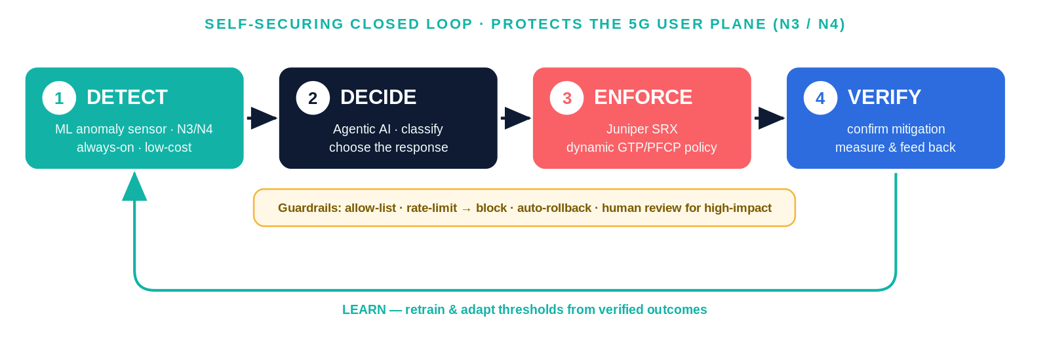
Figure 1. The self-securing closed loop: an ML sensor gates an agentic decision layer that enforces on SRX, then verifies and learns, behind safety guardrails.
Each stage maps to an HPE portfolio element (Figure 2). The detector runs on GPU infrastructure (HPE Private Cloud AI); a token-efficiency gate ensures the agentic layer — built on HPE’s agentic AIOps framework rather than from scratch — is invoked only when an anomaly is real; enforcement uses Juniper SRX (physical, vSRX, or cSRX) with dynamic, GTP/PFCP-aware policy; and the capability is delivered through HPE GreenLake, spanning HPE security, AI-infrastructure, and consumption businesses. Detections map to graduated, least-disruptive SRX actions (Table 1).
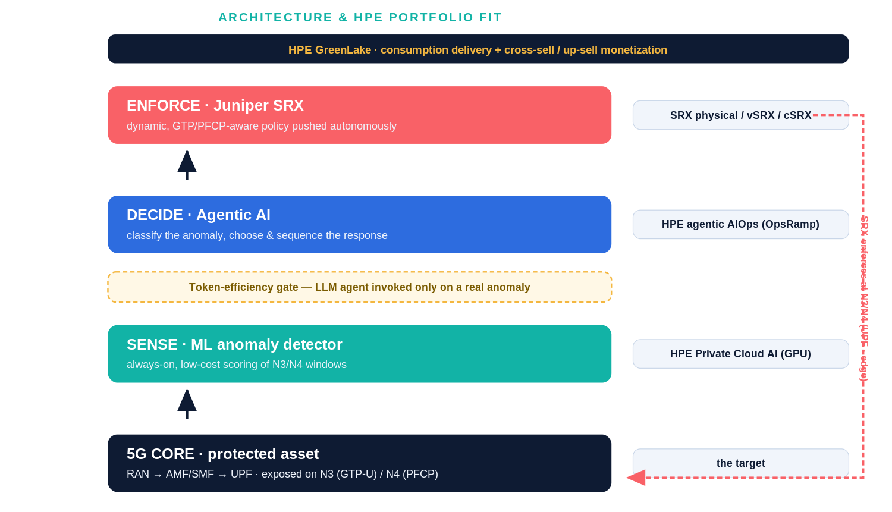
Figure 2. Each loop stage maps to an HPE product; the token-efficiency gate invokes the agent only on real anomalies.
Attack (interface) | Detector signal | Autonomous response on SRX
GTP-U flood (N3) | packet/byte-rate spike | rate-limit screen; escalate to block source
Malformed GTP-U (N3) | structural feature anomaly | drop malformed flows; quarantine source
PFCP session flood (N4) | N4 message-rate spike | rate-limit N4; restrict PFCP to SMF source
PFCP association abuse (N4) | association-churn pattern | throttle; flag for human review
Table 1. Detection-to-enforcement mapping across the four demonstrated attack classes.
Safety is built into the decision layer: the agent may issue only pre-approved SRX policy templates; responses escalate least-disruptive-first (rate-limit → block → isolate); high-impact actions require human approval; every action is verified and auto-reverts on failure; and actions are scoped per UPF, slice, or edge with a full audit trail.
Evidence the solution works
We built a running proof of concept: an Open5GS 5G-SA core [3] with a UERANSIM RAN [4], a curated corpus of N3/N4 attacks, the ML detector, and SRX (cSRX) enforcement, on a single GPU host. Trained only on benign traffic, the detector separates benign from attack at ROC-AUC 1.000 (GPU autoencoder) and 0.989 (Isolation Forest), with 100% recall across four attack classes and roughly 5% benign false-alarm; SRX screens rate-limit volumetric floods. This substantiates the two hardest stages of the loop — detection and enforcement — on real captured traffic.
Competitive approaches
Cloud-managed security control planes (e.g., Cisco’s cloud-managed networking) centralize policy in a vendor cloud; for an edge-resident user plane they add latency and a data-sovereignty and availability dependency, and they are not GTP/PFCP-aware. Traditional IDS/IPS detects but alerts rather than autonomously enforcing and verifying. Our approach runs where the data plane runs — on-premises or at the edge — enforces natively on SRX the operator already owns [2], and closes the loop with verification and token-efficient agent gating. Its main disadvantages, addressed as future work, are that the agentic decision layer is still maturing and that semi-supervised detection assumes a representative benign baseline.
Current status
The proof of concept runs today on GPU (DGX-class) hardware, with the detection and enforcement stages demonstrated and recorded. The agentic decision layer that closes the loop is in design on HPE’s agentic AIOps framework. By Tech Con we expect an integrated closed-loop demonstration with certified guardrails, and initial design-partner discussions with private-5G operators.
Next steps
Near-term work extends coverage to network slicing and MEC edge breakout — per-slice and per-edge detection with slice-scoped isolation — and hardens the detector against larger, noisier captures and subtle low-and-slow attacks. Production work adds tiered models, per-tenant token budgets and usage dashboards, and a GreenLake catalog offering with per-site or per-slice subscription. The principal remaining research is maturing and certifying the autonomous decision layer and tuning operating thresholds to each operator’s false-alarm budget.
Acknowledgements
This work was assisted by Anthropic’s Claude, used through an agentic coding and document assistant environment, which helped debug the 5G lab deployment on ARM/GPU hardware, generate the figures, and draft and edit this abstract. The author reviewed and is responsible for all technical content and for verifying the references below. [Add colleagues or reviewers who provided guidance.]
References
[1] Futurum Group, “HPE Closes Juniper Acquisition, Combining AI-Native Networking Portfolios,” 2024. https://futurumgroup.com/insights/hpe-closes-juniper-acquisition-combining-ai-native-networking-portfolios/
[2] Hewlett Packard Enterprise, “Juniper SRX Series Firewalls,” HPE. https://www.hpe.com/us/en/juniper-srx-firewall.html
[3] S. Lee, “Open5GS — Open source implementation of 5G Core and EPC,” open5gs.org. https://open5gs.org
[4] A. Güngör, “UERANSIM — Open source 5G UE and RAN (gNodeB) simulator,” GitHub. https://github.com/aligungr/UERANSIM
[5] F. T. Liu, K. M. Ting, and Z.-H. Zhou, “Isolation Forest,” Proc. IEEE Int. Conf. Data Mining (ICDM), 2008. https://doi.org/10.1109/ICDM.2008.17
[6] R. Chalapathy and S. Chawla, “Deep Learning for Anomaly Detection: A Survey,” arXiv:1901.03407, 2019. https://arxiv.org/abs/1901.03407
[7] 3GPP, “TS 33.501: Security architecture and procedures for 5G System,” 3rd Generation Partnership Project. https://www.3gpp.org/DynaReport/33501.htm
[8] ETSI, “GS MEC 003: Multi-access Edge Computing (MEC); Framework and Reference Architecture,” ETSI. https://www.etsi.org/committee/mec

