Table of Contents
GRADE 5 • MODULE 5
Addition and Multiplication with Volume and Area

Module Overview 2

Topic A: Concepts of Volume 11

Topic B: Volume and the Operations of Multiplication and Addition 52

Mid Module Assessment and Rubric 128

Topic C: Area of Rectangular Figures with Fractional Side Lengths 138

Topic D: Drawing, Analysis, and Classification of Two-Dimensional Shapes 219

End-of-Module Assessment and Rubric 311

Answer Key 321
NOTE: Student sheets should be printed at 100% scale to preserve the intended size of figures for accurate measurements. Adjust copier or printer settings to actual size, and set page scaling to none.
Grade 5 • Module 5
Addition and Multiplication with Volume and Area
OVERVIEW
In this 25-day module, students work with two- and three-dimensional figures. Volume is introduced to students through concrete exploration of cubic units and culminates with the development of the volume formula for right rectangular prisms. The second half of the module turns to extending students’ understanding of two-dimensional figures. Students combine prior knowledge of area with newly acquired knowledge of fraction multiplication to determine the area of rectangular figures with fractional side lengths. They then engage in hands-on construction of two-dimensional shapes, developing a foundation for classifying the shapes by reasoning about their attributes. This module fills a gap between Grade 4’s work with two-dimensional figures and Grade 6’s work with volume and area.
In Topic A, students extend their spatial structuring to three dimensions through an exploration of volume. Students come to see volume as an attribute of solid figures and understand that cubic units are used to measure it (5.MD.3). Using improvised, customary, and metric units, they build three-dimensional shapes, including right rectangular prisms, and count units to find the volume (5.MD.4). By developing a systematic approach to counting the unit cubes, students make connections between area and volume. They partition a rectangular prism into layers of unit cubes and reason that the number of unit cubes in a single layer corresponds to the number of unit squares on a face. They begin to conceptualize the layers themselves, oriented in any one of three directions, as iterated units. This understanding allows students to reason about containers formed by box templates and nets, reasonably predict the number of cubes required to fill them, and test their predictions by packing the containers.
Concrete understanding of volume and multiplicative reasoning (5.MD.3) come together in Topic B as the systematic counting from Topic A leads naturally to formulas for finding the volume of a right rectangular prism (5.MD.5). Students solidify the connection between volume as packing and volume as filling by comparing the amount of liquid that fills a container to the number of cubes that can be packed into it. This connection is formalized as students see that 1 cubic centimeter is equal to 1 milliliter. Complexity increases as students use their knowledge that volume is additive to partition and calculate the total volume of solid figures composed of non-overlapping, rectangular prisms. Word problems involving the volume of rectangular prisms with whole number edge lengths solidify understanding and give students the opportunity to reason about scaling in the context of volume. Topic B concludes with a design project that gives students the opportunity to apply the concepts and formulas they have learned throughout Topics A and B to create a sculpture of a specified volume composed of varied rectangular prisms with parameters given in the project description.
In Topic C, students extend their understanding of area as they use rulers and set squares to construct and measure rectangles with fractional side lengths and find their areas. Students apply their extensive knowledge of fraction multiplication to interpret areas of rectangles with fractional side lengths (5.NF.4b) and solve real-world problems involving these figures (5.NF.6), including reasoning about scaling through contexts in which volumes are compared. Visual models and equations are used to represent the problems through the Read-Draw-Write (RDW) protocol.
In Topic D, students draw two-dimensional shapes to analyze their attributes and use those attributes to classify them. Familiar figures, such as parallelograms, rhombuses, squares, trapezoids, etc., have all been defined in earlier grades and, in Grade 4, students have gained an understanding of shapes beyond the intuitive level. Grade 5 extends this understanding through an in-depth analysis of the properties and defining attributes of quadrilaterals. Grade 4’s work with the protractor is applied to construct various quadrilaterals. Using measurement tools illuminates the attributes used to define and recognize each quadrilateral (5.G.3). Students see, for example, that the same process they used to construct a parallelogram also produces a rectangle when all angles are constructed to measure $\text{90°}$. Students then analyze defining attributes and create a hierarchical classification of quadrilaterals (5.G.4).

Notes on Pacing for Differentiation
If pacing is a challenge, consider the following modifications and omissions. Omit Lessons 8 and 9, in which students create sculptures out of multiple rectangular prisms. Instead, consider asking the art teacher to complete a similar project with students. Lessons 14 and 15 can be consolidated since they share the same objective. Use Problems 1 and 2 from Lesson 14 and Problems 1 and 2 from Lesson 15. Problem 3 from Lesson 15 can be an extension for early finishers. Omit Lesson 21, and instead, use it in a center or periodically as morning work.
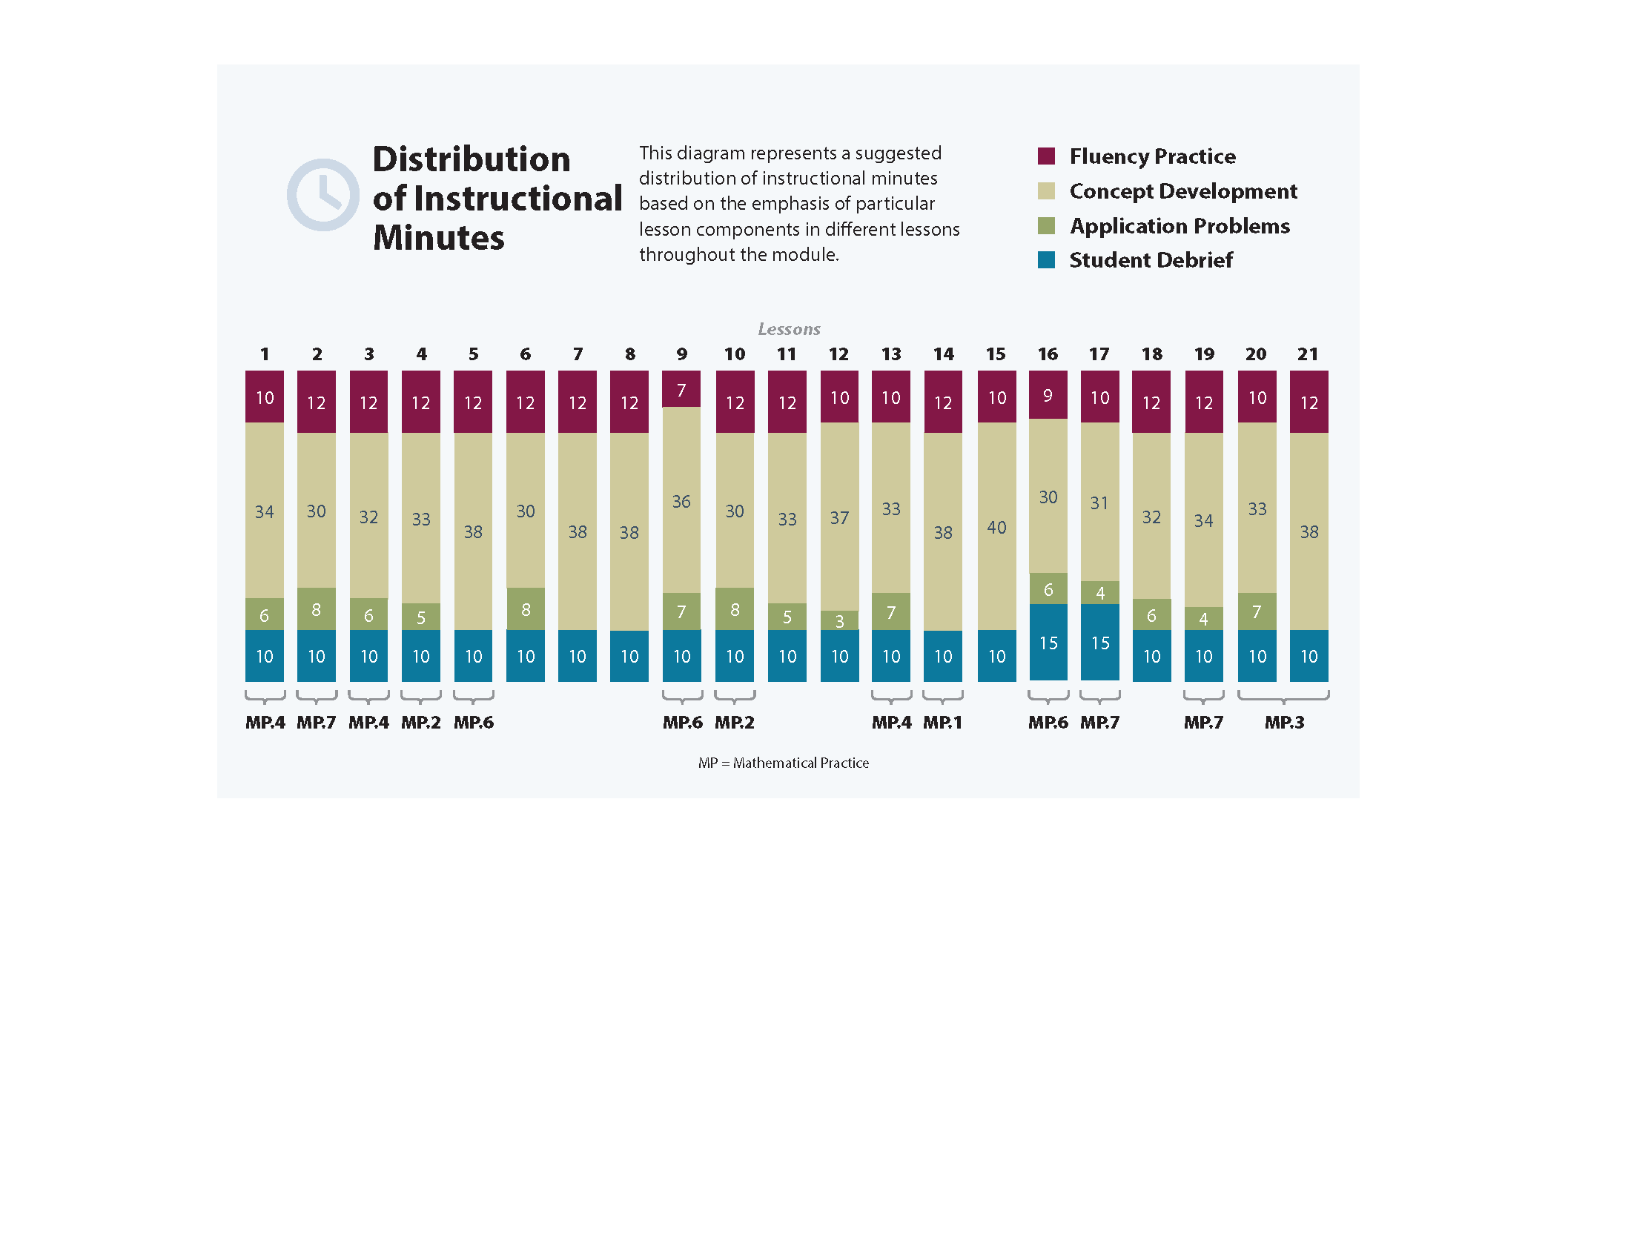
Note: If the drawing for Module 5, Topic D was done during Module 4, as suggested above, consolidate Lessons 16, 17, 18, and 19.
Focus Grade Level Standards
Apply and extend previous understandings of multiplication and division to multiply and divide fractions.
5.NF.4 Apply and extend previous understandings of multiplication to multiply a fraction or whole number by a fraction.
a. Find the area of a rectangle with fractional side lengths by tiling it with unit squares of the appropriate unit fraction side lengths, and show that the area is the same as would be found by multiplying the side lengths. Multiply fractional side lengths to find areas of rectangles, and represent fraction products as rectangular areas.
5.NF.6 Solve real world problems involving multiplication of fractions and mixed numbers, e.g., by using visual fraction models or equations to represent the problem.
Geometric measurement: understand concepts of volume and relate volume to multiplication and to addition.
5.MD.3 Recognize volume as an attribute of solid figures and understand concepts of volume measurement.
a. A cube with side length 1 unit, called a “unit cube,” is said to have “one cubic unit” of volume, and can be used to measure volume.
b. A solid figure which can be packed without gaps or overlaps using n unit cubes is said to have a volume of n cubic units.
5.MD.4 Measure volumes by counting unit cubes, using cubic cm, cubic in, cubic ft, and improvised units.
5.MD.5 Relate volume to the operations of multiplication and addition and solve real world and mathematical problems involving volume.
a. Find the volume of a right rectangular prism with whole-number side lengths by packing it with unit cubes, and show that the volume is the same as would be found by multiplying the edge lengths, equivalently by multiplying the height by the area of the base. Represent threefold whole-number products as volumes, e.g., to represent the associative property of multiplication.
b. Apply the formulas V = l × w × h and V = b × h for rectangular prisms to find volumes of right rectangular prisms with whole-number edge lengths in the context of solving real world and mathematical problems.
c. Recognize volume as additive. Find volumes of solid figures composed of two
non-overlapping right rectangular prisms by adding the volumes of the non-overlapping parts, applying this technique to solve real world problems.
Classify two-dimensional figures into categories based on their properties.
5.G.3 Understand that attributes belonging to a category of two-dimensional figures also belong to all subcategories of that category. For example, all rectangles have four right angles and squares are rectangles, so all squares have four right angles.
5.G.4 Classify two-dimensional figures in a hierarchy based on properties.
Foundational Standards
3.MD.5 Recognize area as an attribute of plane figures and understand concepts of area measurement.
a. A square with side length 1 unit, called “a unit square,” is said to have “one square unit” of area, and can be used to measure area.
b. A plane figure which can be covered without gaps or overlaps by n unit squares is said to have an area of n square units.
4.MD.3 Apply the area and perimeter formulas for rectangles in real world and mathematical problems. For example, find the width of a rectangular room given the area of the flooring and the length, by viewing the area formula as a multiplication equation with an unknown factor.
4.MD.5 Recognize angles as geometric shapes that are formed wherever two rays share a common endpoint, and understand concepts of angle measurement:
a. An angle is measured with reference to a circle with its center at the common endpoint of the rays, by considering the fraction of the circular arc between the points where the two rays intersect the circle. An angle that turns through 1/360 of a circle is called a
“one-degree angle,” and can be used to measure angles.
b. An angle that turns through n one-degree angles is said to have an angle measure of
n degrees.
4.MD.6 Measure angles in whole-number degrees using a protractor. Sketch angles of specified measure.
4.MD.7 Recognize angle measure as additive. When an angle is decomposed into non-overlapping parts, the angle measure of the whole is the sum of the angle measures of the parts. Solve addition and subtraction problems to find unknown angles on a diagram in real world and mathematical problems, e.g., by using an equation with a symbol for the unknown angle measure.
3.G.1 Understand that shapes in different categories (e.g., rhombuses, rectangles, and others) may share attributes (e.g., having four sides), and that the shared attributes can define a larger category (e.g., quadrilaterals). Recognize rhombuses, rectangles, and squares as examples of quadrilaterals, and draw examples of quadrilaterals that do not belong to any of these subcategories.
4.G.1 Draw points, lines, line segments, rays, angles (right, acute, obtuse), and perpendicular and parallel lines. Identify these in two-dimensional figures.
4.G.2 Classify two-dimensional figures based on the presence or absence of parallel or perpendicular lines, or the presence or absence of angles of a specified size. Recognize right triangles as a category, and identify right triangles.
5.NF.4 Apply and extend previous understandings of multiplication to multiply a fraction or whole number by a fraction.
a. Interpret the product (a/b) × q as a parts of a partition of q into b equal parts; equivalently, as the result of a sequence of operations a × q ÷ b. For example, use a visual fraction model to show (2/3) × 4 = 8/3, and create a story context for this equation. Do the same with (2/3) × (4/5) = 8/15. (In general, (a/b) × (c/d) = ac/bd.)
Focus Standards for Mathematical Practice
MP.1 Make sense of problems and persevere in solving them. Students work toward a solid understanding of volume through the design and construction of a three-dimensional sculpture within given parameters.
MP.2 Reason abstractly and quantitatively. Students make sense of quantities and their relationships when they analyze a geometric shape or real life scenario and identify, represent, and manipulate the relevant measurements. Students decontextualize when they represent geometric figures symbolically and apply formulas.
MP.3 Construct viable arguments and critique the reasoning of others. Students analyze shapes, draw conclusions, and recognize and use counterexamples as they classify two-dimensional figures in a hierarchy based on properties.
MP.4 Model with mathematics. Students model with mathematics as they make connections between addition and multiplication as applied to volume and area. They represent the area and volume of geometric figures with equations (and vice versa) and represent fraction products with rectangular areas. Students apply concepts of volume and area and their knowledge of fractions to design a sculpture based on given mathematical parameters. Through their work analyzing and classifying two-dimensional shapes, students draw conclusions about their relationships and continuously see how mathematical concepts can be modeled geometrically.
MP.6 Attend to precision. Mathematically proficient students try to communicate precisely with others. They endeavor to use clear definitions in discussion with others and their own reasoning. Students state the meaning of the symbols they choose, including using the equal sign (consistently and appropriately). They are careful about specifying units of measure and labeling axes to clarify the correspondence with quantities in a problem. They calculate accurately and efficiently express numerical answers with a degree of precision appropriate for the problem context. In the elementary grades, students give carefully formulated explanations to each other. By the time they reach high school, students have learned to examine claims and make explicit use of definitions.
MP.7 Look for and make use of structure. Students discern patterns and structures as they apply additive and multiplicative reasoning to determine volumes. They relate multiplying two of the dimensions of a rectangular prism to determining how many cubic units would be in each layer of the prism, as well as relate the third dimension to determining how many layers there are in the prism. This understanding supports students in seeing why volume can be computed as the product of three length measurements or as the product of one area by one length measurement. Additionally, recognizing that volume is additive allows students to find the total volume of solid figures composed of more than one non-overlapping right rectangular prism.
Overview of Module Topics and Lesson Objectives
Standards | Topics and Objectives |  | Days
5.MD.3  5.MD.4 | A | Concepts of Volume  Lesson 1: Explore volume by building with and counting unit cubes.  Lesson 2: Find the volume of a right rectangular prism by packing with cubic units and counting.  Lesson 3: Compose and decompose right rectangular prisms using layers. | 3
5.MD.3  5.MD.5 | B | Volume and the Operations of Multiplication and Addition  Lesson 4: Use multiplication to calculate volume.  Lesson 5: Use multiplication to connect volume as packing with volume as filling.  Lesson 6: Find the total volume of solid figures composed of two  non-overlapping rectangular prisms.  Lesson 7: Solve word problems involving the volume of rectangular prisms with whole number edge lengths.  Lessons 8–9: Apply concepts and formulas of volume to design a sculpture using rectangular prisms within given parameters. | 6
 |  | Mid-Module Assessment: Topics A–B (assessment 1 day, return ½ day, remediation or further applications ½ day) | 2
5.NF.4b  5.NF.6 | C | Area of Rectangular Figures with Fractional Side Lengths  Lesson 10: Find the area of rectangles with whole-by-mixed and  whole-by-fractional number side lengths by tiling, record by drawing, and relate to fraction multiplication.  Lesson 11: Find the area of rectangles with mixed-by-mixed and  fraction-by-fraction side lengths by tiling, record by drawing, and relate to fraction multiplication.  Lesson 12: Measure to find the area of rectangles with fractional side lengths.  Lesson 13: Multiply mixed number factors, and relate to the distributive property and the area model.  Lessons 14–15: Solve real-world problems involving area of figures with fractional side lengths using visual models and/or equations. | 6

Standards | Topics and Objectives |  | Days
5.G.3  5.G.4 | D | Drawing, Analysis, and Classification of Two-Dimensional Shapes  Lesson 16: Draw trapezoids to clarify their attributes, and define trapezoids based on those attributes.  Lesson 17: Draw parallelograms to clarify their attributes, and define parallelograms based on those attributes.  Lesson 18: Draw rectangles and rhombuses to clarify their attributes, and define rectangles and rhombuses based on those attributes.  Lesson 19: Draw kites and squares to clarify their attributes, and define kites and squares based on those attributes.  Lesson 20: Classify two-dimensional figures in a hierarchy based on properties.  Lesson 21: Draw and identify varied two-dimensional figures from given attributes. | 6
 |  | End-of-Module Assessment: Topics A–D (assessment 1 day, return ½ day, remediation or further applications ½ day) | 2
Total Number of Instructional Days |  |  | 25
Terminology
New or Recently Introduced Terms
- Base (one face of a three-dimensional solid—often thought of as the surface on which the solid rests)
- Bisect (divide into two equal parts)
- Cubic units (cubes of the same size used for measuring volume)
- Height (adjacent layers of the base that form a rectangular prism)
- Hierarchy (series of ordered groupings of shapes)
- Unit cube (cube whose sides all measure 1 unit; cubes of the same size used for measuring volume)
- Volume of a solid (measurement of space or capacity)
Familiar Terms and Symbols
- Angle (the union of two different rays sharing a common vertex)
- Area (the number of square units that covers a two-dimensional shape)
- Attribute (given quality or characteristic)
- Cube (three-dimensional figure with six square sides)
- Degree measure of an angle (subdivide the length around a circle into 360 arcs of equal length; a central angle for any of these arcs is called a one-degree angle and is said to have an angle measure of 1 degree)
- Face (any flat surface of a three-dimensional figure)
- Kite (quadrilateral with two pairs of two equal sides that are also adjacent; a kite can be a rhombus if all sides are equal)
- Parallel lines (two lines in a plane that do not intersect)
- Parallelogram (four-sided closed figure with opposite sides that are parallel and equal)
- Perpendicular (two lines are perpendicular if they intersect, and any of the angles formed between the lines are 90° angles)
- Perpendicular bisector (line that cuts a line segment into two equal parts at 90°)
- Plane (flat surface that extends infinitely in all directions)
- Polygon (closed figure made up of line segments)
- Quadrilateral (closed figure with four sides)
- Rectangle (parallelogram with four 90° angles)
- Rectangular prism (three-dimensional figure with six rectangular sides)
- Rhombus (parallelogram with four equal sides)
- Right angle (angle formed by perpendicular lines; angle measuring 90°)
- Right rectangular prism (rectangular prism with only 90° angles)
- Solid figure (three-dimensional figure)
- Square units (squares of the same size—used for measuring)
- Three-dimensional figures (solid figures)
- Trapezoid (quadrilateral with at least one pair of parallel sides)
- Two-dimensional figures (figures on a plane)
Suggested Tools and Representations
- Area model
- Centimeter cubes
- Centimeter grid paper
- Isometric dot paper
- Patty paper (measuring 5.5 in $×$ 5.5 in)
- Protractor
- Ruler
- Set square or right angle template
- Tape diagram

Scaffolds
The scaffolds integrated into A Story of Units give alternatives for how students access information as well as express and demonstrate their learning. Strategically placed margin notes are provided within each lesson elaborating on the use of specific scaffolds at applicable times. They address many needs presented by English language learners, students with disabilities, students performing above grade level, and students performing below grade level. Many of the suggestions are organized by Universal Design for Learning (UDL) principles and are applicable to more than one population. To read more about the approach to differentiated instruction in A Story of Units, please refer to “How to Implement A Story of Units.”
Assessment Summary
Type | Administered | Format | Standards Addressed
Mid-Module Assessment Task | After Topic B | Constructed response with rubric | 5.MD.3  5.MD.4  5.MD.5
End-of-Module Assessment Task | After Topic D | Constructed response with rubric | 5.NF.4b  5.NF.6  5.MD.3  5.MD.4  5.MD.5  5.G.3  5.G.4

The balance of this cluster is addressed in Module 4.
These are terms and symbols students have seen previously.
Students with disabilities may require Braille, large print, audio, or special digital files. Please visit the website www.p12.nysed.gov/specialed/aim for specific information on how to obtain student materials that satisfy the National Instructional Materials Accessibility Standard (NIMAS) format.

