Lesson 2
Objective: Find the volume of a right rectangular prism by packing with cubic units and counting.

Suggested Lesson Structure
 Fluency Practice (12 minutes)
 Application Problem (8 minutes)
 Concept Development (30 minutes)
 Student Debrief (10 minutes)
Total Time (60 minutes)
Fluency Practice (12 minutes)
- Multiply a Fraction and a Whole Number 5.NF.3 (4 minutes)
- Find the Area 4.MD.3 (4 minutes)
- Find the Volume 5.MD.3 (4 minutes)
Multiply a Fraction and a Whole Number (4 minutes)
Materials: (S) Personal white board
Note: This fluency activity reviews Module 4 Lessons 6─8.
T: (Write 15 ÷ 3 = ____.) Say the complete division sentence.
S: 15 ÷ 3 = 5.
T: (Write $\frac{1}{3}$ $\text{×}$ 15 = ____.) Say the complete multiplication sentence.
S: $\frac{1}{3}$ $\text{×}$ 15 = 5.
T: (Write $\frac{2}{3}$ $\text{×}$ 15 = ____.) On your personal white board, write the complete multiplication sentence.
S: (Write $\frac{2}{3}$ $\text{×}$ 15 = 10.)
T: (Write 15 $\text{×}$ $\frac{2}{3}$ = ____.) Write the complete multiplication sentence.
S: (Write 15 $\text{×}$ $\frac{2}{3}$= 10.)
Continue with the following possible sequence: 18 ÷ 6, $\frac{1}{6}$ $\text{×}$ 18, $\frac{5}{6}$ $\text{×}$ 18, 18 $\text{×}$ $\frac{5}{6}$, $\frac{1}{8}$ $\text{×}$ 32, 32 $\text{×}$ $\frac{1}{8}$, 32 $\text{×}$ $\frac{5}{8}$ , $\frac{2}{3}$ $\text{×}$18, and 24 $\text{×}$ $\frac{3}{4}$.
Find the Area (4 minutes)
Materials: (S) Personal white board
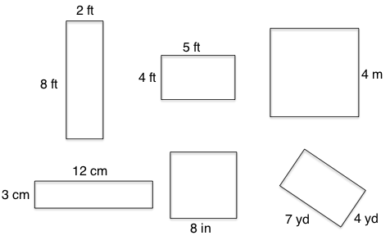
Note: Reviewing this Grade 4 concept prepares students to calculate volume.
T: (Project an 8 ft by 2 ft rectangle.) Name the shape.
S: Rectangle. Parallelogram.
Trapezoid. Quadrilateral.
T: (Write ____ ft $\text{×}$ ____ ft = ____ ft².) This shape is a rectangle, although we could also call it a parallelogram, trapezoid, or quadrilateral. On your personal white board, write the area of the rectangle as a multiplication sentence starting with the length of the longest side.
S: (Write 8 ft $\text{×}$ 2 ft = 16 ft².)
T: (Project a square with side lengths 4 m.) Name the shape.
S: Square. Rhombus. Rectangle. Parallelogram. Trapezoid. Quadrilateral.
T: (Write ____ m $\text{×}$ ____ m = ____ m².) On your personal white board, write the area of the square as a multiplication sentence using the measure of the square’s sides.
S: (Write 4 m $\text{×}$ 4 m = 16 m².)
Continue the process for the other squares and rectangles.
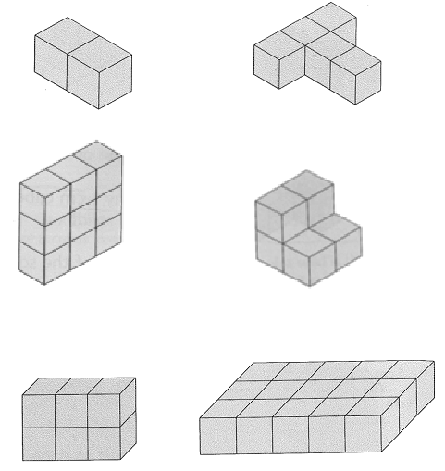
Find the Volume (4 minutes)
Materials: (S) Personal white board
Note: This fluency activity reviews Lesson 1.
T: (Project the first of the images to the right.)
Each cube is 1 cubic centimeter.
T: (Write Volume = ____ cubic cm.) On your personal white board, complete the equation.
S: (Write Volume = 2 cubic cm.)
Continue the process for the remaining images.

Application Problem (8 minutes)
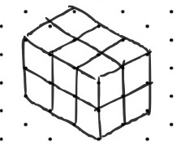
Mike uses 12 centimeter cubes to build structures. Use centimeter cubes to build at least 3 different structures with the same volume as Mike’s. Record one of your structures on dot paper.
Note: This Application Problem is designed to bridge from the previous lesson. Students work with different factors of 12 to discover different ways of arranging the cubes. This leads to a better understanding of how rectangular prisms are constructed from identical cubes and toward developing an understanding of volume. Students may work with a partner if desired.
Concept Development (30 minutes)
Materials: (S) Pencil, centimeter grid paper (Lesson 1 Template 1, also needed for Homework), scissors, tape, 50 centimeter cubes, net (Template), Problem Set
Note: This lesson uses the Problem Set as part of the lesson.
Problem 1(a)

 | NOTES ON  MULTIPLE MEANS  OF ENGAGEMENT:
Breaking down a tissue or cereal box to show how the sides form a flat shape and then building it back into a box may be helpful for students to understand the figures used in the lesson to make the boxes.
Be aware that spatial skills and fine motor skills vary widely among fifth graders. Some may require more time to cut, fold, and tape the boxes. Proximity to the teacher and the demonstration can support students whose spatial skills are developing.

Project the image from Problem 1(a) from the Problem Set.
T: To make a box, copy this image on grid paper by first shading the bottom of the box and then outlining the figure. (If necessary, model how to draw onto grid paper.)
T: Now, cut around the outside. The bottom is shaded, so fold up the flaps to make the sides of the box.
Crease well, and tape to make the edges of the box. (Model cutting and folding as necessary.)
T: Fill the box with cubic centimeters to find how many cubes fill the box up.
S: Eight cubes.
T: What is the volume of the box?
S: 8 cubic centimeters. 8 centimeters cubed.
T: Talk to your partner about different ways to pack and count the cubic centimeters.
S: You can just count one by one. You can put in a row of two on the bottom and then another row on top of that to have four. It looks like a slice. Another slice makes four more. You can put four on the bottom and another four on top of that. 2 × 4 is 8. You can count by two or by four.
Problem 1(b)
T: Let’s fold to make another box with rectangular sides, or a rectangular prism.
Follow the same procedure as with Problem 1(a) to have students make the prism and pack the cubes into the box.
T: What is the volume of this box?
S: 16 cubic centimeters.
T: How does its volume compare with the volume of the first rectangular prism?
MP.7
S: It doubled.
T: Interesting. Why do you think that might be? Turn and talk.
S: It was like two of the first box laid side by side. The bottom was twice as long, but it had the same number of layers, so it was 16. The sides of the box were the same height. Just the cubic centimeters on the bottom doubled.
T: Look at the image on the board. Talk to your partner about how you might find the volume without packing it.
Problem 1(c)
T: (Project or show the next figure.) This time, put in the first layer of cubes on the bottom without cutting to actually make the box. (Pause.) What do you think the volume of this box will be?
S: The flaps show the number of layers. The bottom has 16 cubes, and there are 3 layers. The bottom is 4 by 4, and it looks like it will be 3 layers, so … 4 × 4 is 16, and double is 32, and another 16 is 48, so 48. I think it will be 48 cubic centimeters because 16 × 3 is 48.
Allow students to answer Problems 2(a) and 2(b) independently. Check the answers and students’ thinking together following the sequence above. Then, distribute the box patterns on the Template for students to cut out, and have them work independently on Problem 3.

Student Debrief (10 minutes)

 | NOTES ON  MULTIPLE MEANS  OF ENGAGEMENT:
Encourage students who easily grasp this concept and move quickly through the Problem Set to think about the results of the same problems if the units were 2 cm cubes, 3 cm cubes, and so on.

Lesson Objective: Find the volume of a right rectangular prism by packing with cubic units and counting.
The Student Debrief is intended to invite reflection and active processing of the total lesson experience.
Invite students to review their solutions for the Problem Set. They should check work by comparing answers with a partner before going over answers as a class. Look for misconceptions or misunderstandings that can be addressed in the Debrief. Guide students in a conversation to debrief the Problem Set and process the lesson.
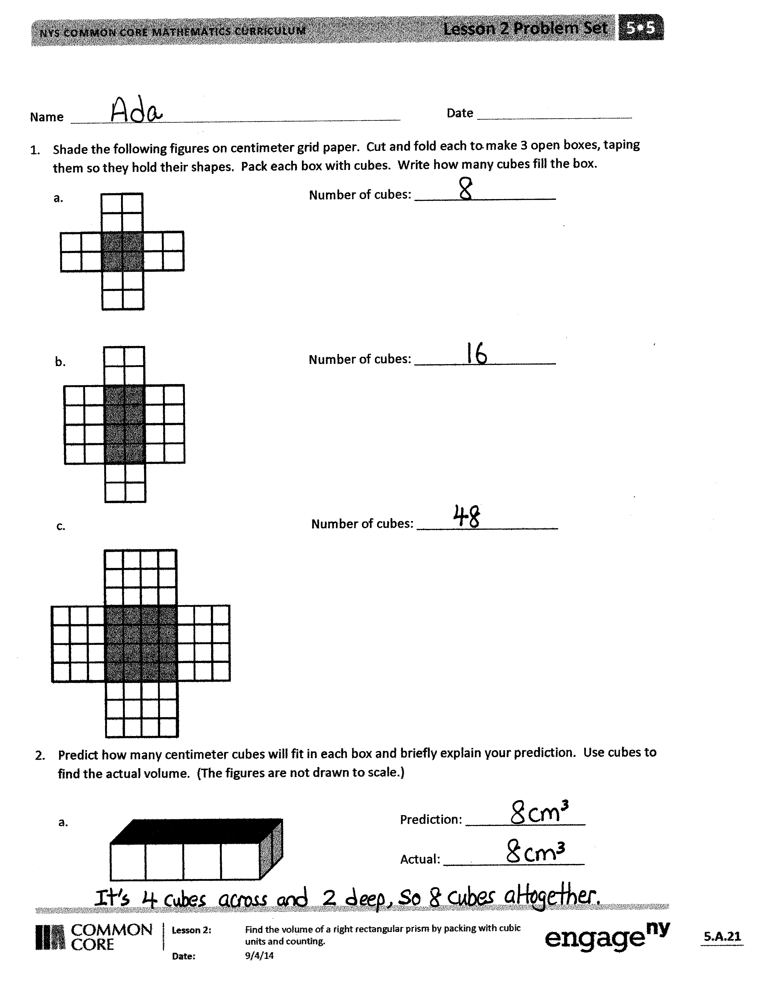
Any combination of the questions below may be used to lead the discussion.
- How did you pack your boxes in Problem 1 (a), (b), and (c)? Cube by cube, row by row, or layer by layer? Did the way you packed your boxes change from problem to problem? If so, how and why did your thinking change?
- In Problem 2, how did you verify your prediction? Did your prediction change between 2 (a) and (c)? Why or why not?
- What did you discover in Problem 3? Did your discovery match your prediction? Could you have used fewer cubes to make your prediction?
Why or why not?
- How has your understanding of the term volume changed from yesterday to today?

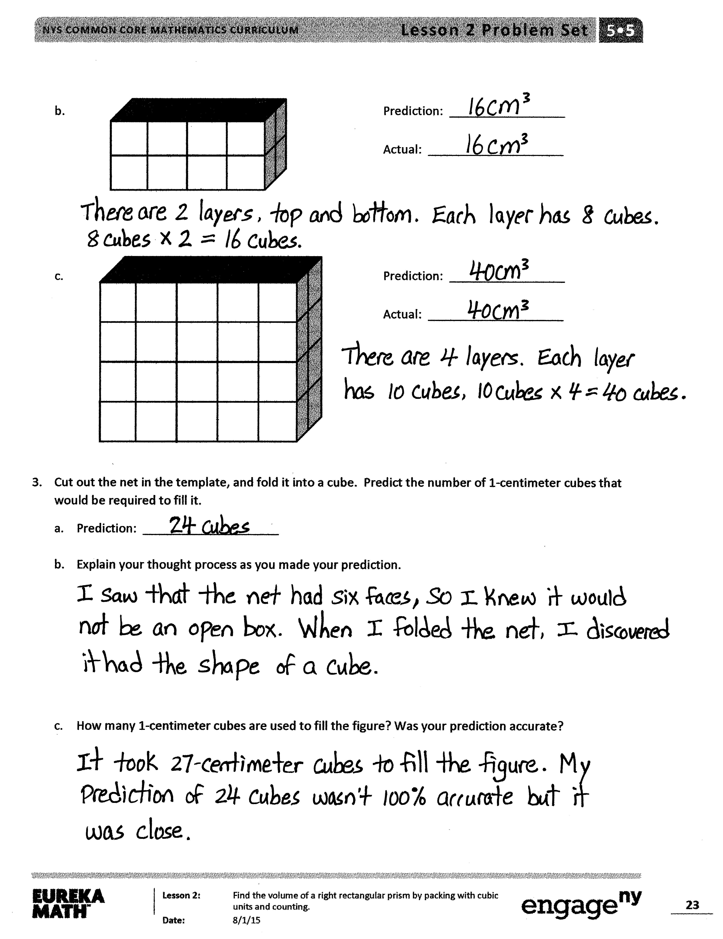
Exit Ticket (3 minutes)
After the Student Debrief, instruct students to complete the Exit Ticket. A review of their work will help with assessing students’ understanding of the concepts that were presented in today’s lesson and planning more effectively for future lessons. The questions may be read aloud to the students.

Name Date
- Shade the following figures on centimeter grid paper. Cut and fold each to make 3 open boxes, taping them so they hold their shapes. Pack each box with cubes. Write how many cubes fill each box.
a. Number of cubes: ____________________

b. Number of cubes: ____________________

c. Number of cubes: ____________________

- Predict how many centimeter cubes will fit in each box, and briefly explain your predictions. Use cubes to find the actual volume. (The figures are not drawn to scale.)
Prediction: _________________

Actual: ____________________

Prediction: _________________

Actual: ____________________

Prediction: _________________

Actual: ____________________

- Cut out the net in the template, and fold it into a cube. Predict the number of 1-centimeter cubes that would be required to fill it.
- Prediction: ____________________

- Explain your thought process as you made your prediction.

- How many 1-centimeter cubes are used to fill the figure? Was your prediction accurate?

Name Date
- If this figure were to be folded into a box, how many cubes would fill it?
Number of cubes: ____________________

- Predict how many centimeter cubes will fit in the box, and briefly explain your prediction. Use cubes to find the actual volume. (The figure is not drawn to scale.)
Prediction: _________________

Actual: ____________________

Name Date
- Make the following boxes on centimeter grid paper. Cut and fold each to make 3 open boxes, taping them so they hold their shapes. How many cubes would fill each box? Explain how you found the number.
Number of cubes: ____________________

Number of cubes: ____________________

Number of cubes: ____________________

- How many centimeter cubes would fit inside each box? Explain your answer using words and diagrams on each box. (The figures are not drawn to scale.)
Number of cubes: ____________________

Explanation:

Number of cubes: ____________________

Explanation:

Number of cubes: ____________________

Explanation:

- The box pattern below holds 24 1-centimeter cubes. Draw two different box patterns that would hold the same number of cubes.

net

