Lesson 5
Objective: Use multiplication to connect volume as packing with volume as filling.

Suggested Lesson Structure
 Fluency Practice (12 minutes)
 Concept Development (38 minutes)
 Student Debrief (10 minutes)
Total Time (60 minutes)
Fluency Practice (12 minutes)
- Count by Cubic Centimeters 5.MD.1 (2 minutes)
- Find the Area 4.MD.3 (4 minutes)
- Find the Volume 5.MD.3 (6 minutes)
Count by Cubic Centimeters (2 minutes)
Note: This fluency activity prepares students for today’s lesson.
T: Count by 100 cubic centimeters to 1,000 cubic centimeters. (Write as students count.)
100 cm³ 200 cm³ 300 cm³ 400 cm³ 500 cm³ 600 cm³ 700 cm³ 800 cm³ 900 cm³ 1,000 cm³
100 mL 200 mL 300 mL 400 mL 500 mL 600 mL 700 mL 800 mL 900 mL 1 liter

S: 100 cm³, 200 cm³, 300 cm³, 400 cm³, 500 cm³, 600 cm³, 700 cm³, 800 cm³, 900 cm³, 1,000 cm³.
T: Count by 100 mL. (Write as students count.)
S: 100 mL, 200 mL, 300 mL, 400 mL, 500 mL, 600 mL, 700 mL, 800 mL, 900 mL, 1,000 mL.
T: 1,000 mL = 1 liter. Count by 100 mL again. This time, when you come to 1,000 mL, say 1 liter. (Write as students count.)
S: 100 mL, 200 mL, 300 mL, 400 mL, 500 mL, 600 mL, 700 mL, 800 mL, 900 mL, 1 liter.
Find the Area (4 minutes)
Materials: (S) Personal white board
Note: Reviewing this Grade 4 concept prepares students to calculate volume. Images not drawn to scale.
T: (Project a rectangle with side lengths of 6 cm and 4 cm.) What is the length of the rectangle’s longest side?
9 cm
4 cm
6 cm
9 cm
3 cm
7 in
7 in
5 in
3 in
12 in
S: 6 cm.
T: What is the length of the rectangle’s shortest side?
S: 4 cm.
T: (Write __ cm × __ cm = __ cm².) On your personal white board, write the area of the rectangle as a multiplication sentence including the units.
S: (Write 6 cm × 4 cm = 24 cm².)
T: (Project a square with a given length of 9 cm.) Name the shape.
S: Square.
T: What is the length of the square’s sides?
S: 9 cm.
T: (Write __ cm × __ cm = __ cm².) Write the area of the square as a multiplication sentence including the units.
S: (Write 9 cm × 9 cm = 81 cm².)
Continue this process for the other rectangles and squares.
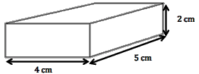
Find the Volume (6 minutes)
Materials: (S) Personal white board
Note: This fluency exercise reviews Lesson 4. Images not drawn to scale.
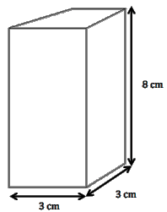
T: (Project the 4 cm by 5 cm by 2 cm rectangular prism illustrated to the right.) What’s the length of the rectangular prism?
S: 4 cm.
T: What’s the width?
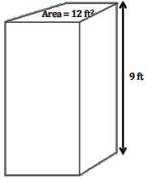
S: 5 cm.
T: What’s the height?
S: 2 cm.
T: (Write __ cm × __ cm × __ cm = __ cm³.) On your personal white board, calculate the volume.
S: (Write 4 cm × 5 cm × 2 cm = 40 cm³.)
Repeat this process for the 3 cm by 3 cm by 8 cm rectangular prism.
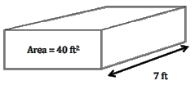
T: (Project the rectangular prism to the right.) Say the given area of the rectangular prism’s front face.
S: 40 ft².
T: Say the given width.
S: 7 ft.
T: (Write V = __ft³.) On your personal white board, calculate the volume.
S: (Write V = 280 ft³.)
Repeat this process for the rectangular prism with a face of 12 ft² and a height of 9 ft.
Concept Development (38 minutes)

 | NOTES ON  MULTIPLE MEANS  OF REPRESENTATION AND MATERIALS:
Fancy toothpicks, straight pins, and some office supplies come in clear rectangular boxes suitable for this activity. The horizontal fill line for the water can be drawn at a height that matches the number of cubes that can be packed into the box. If these are not readily available, small rectangular breath mint boxes or metal spice boxes can be used. However, students may have to estimate if the corners are rounded. It is best to test the boxes and volumes before implementing this lesson.
An alternative approach is to gather a collection of small gift boxes and use salt rather than water to fill them. While salt is not a liquid, it does behave like one for the purposes of the first activity.
The second activity must be done with water and a centimeter cube that sinks. If a dense cube is not available, students should use a drinking straw or coffee stirrer to submerge the cube completely.
If resources are limited, this may be done as a demonstration and then as a center over the course of a few days in small groups.
Materials: (S) Per group: centimeter cubes, several small watertight containers (preferably right rectangular prisms) marked with a horizontal line for measuring, small pitcher of water, graduated cylinder labeled with mL, class data recording sheet poster, ruler or tape measure, Problem Set (Problems 1-3)
Note: Because today’s lesson is a hands-on exploration, time for the Application Problem has been given to the Concept Development.
Before class, prepare a large poster or sheet for groups to record their findings. Be sure to use cubes that are denser than water for the displacement exploration.
Problem 1
Investigate 1 cm³ = 1 mL.
T: What are some ways that we can determine the volume of the box you’ve been given using the materials on your table?
S: We can pack it with cubes and count. We can pack the bottom layer and then use the cubes to find how many layers. We could find the area of any base and then count the layers. We can measure the sides and then multiply the three dimensions.
T: Measure the inside dimensions of your box using the line that’s drawn as the height, and multiply to find the volume. Then, confirm the measurement by packing the box to the line that’s drawn. Record the volume in cubic centimeters on Problem #1 of your Problem Set.
S: (Work.)
T: Now I would like you to find the amount of liquid your container will hold. Any ideas how you might do this using the materials on your table? Turn and talk.
S: We could pour in some water and then measure the water with the graduated cylinder. We could fill the container with water and then use a measuring cup to measure the water. That would tell us the amount it will hold.
T: What units are used on the graduated cylinder?
MP.6
S: Milliliters.
T: Pour the water to the fill line. Then, measure the amount of water by carefully pouring it into the graduated cylinder. Record the liquid volume on Problem #2 of your Problem Set. Once your group is done, have a member of your group record your data onto the class poster.
S: (Work and record.)
T: (Circulate, asking students to describe what they’re doing. Encourage use of the terms volume, capacity, and other unit language.)
T: Now that we’ve recorded our findings, let’s look at the volume data. What do you notice about the volume as measured by the cubes and the liquid volume?
S: They are the same. Our box packed 36 cubes, and it held 36 mL of water. Although our prism was a different size than the first group’s, our packing and filling amounts were the same. Ours was really close—just one cubic centimeter more than the milliliters.
T: What can you say about the relationship of 1 milliliter to 1 cubic centimeter?
S: They seem to be the same. I think they are equal.
T: There’s a way we can show that these two measurements are equal. Put water into your graduated cylinder to any measuring point other than the fill line. Be careful to fill it exactly to the line you choose. For example, you might fill your graduated cylinder to 15 mL.
S: (Pour.)

 | NOTES ON  MULTIPLE MEANS  OF ENGAGEMENT:
When dividing students into groups, be sure to choose members with different strengths. Try to assign tasks such as recorder, builder, pourer, and measurer.

T: Now, pour in 1 more milliliter of water, and describe what happens to the water level.
S: The water went up one more line. The water rose because we put more in.
T: Record the new amount of water on Problem #3 of your Problem Set. What will happen to the water level if we place 1 cube in the graduated cylinder? Tell your partner.
S: It will go up again. The water will rise because the cube pushes some of the water out of the way.
T: Let’s find out how far the water will rise. Place 1 centimeter cube into the water. Describe what happens to your partner.
S: (Work and discuss.)
T: How did the water level change?
S: The water rose. It looks like there’s more water in the graduated cylinder. The water went up 1 mL.

T: We didn’t actually put more water in, and yet the cube caused a rise in the water level equal to when we put 1 mL of water in the graduated cylinder. From this investigation and from our work with the boxes, what can we say about the relationship between 1 mL of water and 1 cubic cm?
S: They are equal. I know they are equal because I measured my box and got the same number of cubes as milliliters. I know they are equal because one cube made the water go up 1 milliliter.
T: Yes. We have seen that 1 cm3 = 1 mL. (Write 1 cm3 = 1 mL on the board.) This is an important relationship that will help us solve problems.
Problem 2
A rectangular tank measures 30 cm by 20 cm by 40 cm. How many milliliters of water are in the tank when it is full? How many liters is that?
T: Let’s use what we’ve learned about volume as filling to solve this problem. We need to find the volume of the water in the tank. What do we know about the tank that can help us?
20 cm
40 cm
30 cm
S: We know the size of the tank. Since the water is filled to the top, the volume of the tank will be the same as the volume of the water.
T: Find the volume of the tank.
S: (Work to find 24,000 cubic centimeters.)
T: We discovered today that 1 cubic centimeter is equal to 1 mL. Since this is true, how many milliliters of water are in the tank when it is full?
S: 24,000 mL.
T: How many liters is that?
S: 24 liters.
Problem 3
15 cm
10 cm
10 cm
- A small fish tank is filled to the top with water. If the tank measures 15 cm by 10 cm by 10 cm, what is the volume of water in the tank? Express your answer in mL.
- After a week, water evaporates out of the tank, so the water is 9 cm high. What is the volume of the water in the tank?
T: (Project Problem 3(a) and the accompanying image onto the board.) Using what we’ve talked about today, turn and talk to your partner, and find the volume of water in the tank in cubic centimeters and in milliliters.
S: All we need to do is multiply the sides because the water is all the way to the top. Since the water fills the whole tank, we can just multiply 15 $\text{×}$ 10 $\text{×}$ 10. That’s 1,500 cubic centimeters. It’s easy to find the volume. It’s 1,500 cubic centimeters. We have to say it in milliliters. That’s exactly the same number, so it’s 1,500 mL.
T: (Project Problem 3(b).) Let’s imagine that some of the water evaporated out of the tank. Now the water is only 9 cm deep. Does this change the height of the tank? Why or why not?
S: No, because the tank doesn’t change size.
T: Does this change the area of the bottom of the tank?
S: No. The tank is still the same size.
T: Will the volume of the water change? Why or why not?

 | NOTES ON  MULTIPLE MEANS  OF ENGAGEMENT:
While the relationship of 1 cm³ = 1 mL seems a simple one numerically, the concept behind this relationship—that of volume as filling as well as packing (especially when comparing a rectangular container to a cylindrical one)—is more complex. Be sure to offer many opportunities for students to encounter this concept beyond today’s lesson. Ask often if an amount of liquid will fit into rectangular containers and how it might be confirmed without pouring.
S: The volume in the tank will be less because some of the water is gone. The water won’t be as high.
The water level will go down by 1 cm, so that’s like pouring out a layer of 15 by 10 centimeters.
T: Find the volume of the water in the tank now. Turn and talk.
S: The bottom of the tank is the same, so the water is spread out on the bottom the same way as before. The only thing that is different is the height of the water. I’ll multiply 15 and 10 and then multiply by 9. That’s 1,350 cubic centimeters of water. The part of the water that is gone is 15 × 10 × 1. That’s 150 cubic centimeters. I can subtract that from 1,500. That will be 1,350 cubic centimeters still in the tank.
T: What is the volume of the water in the tank now?
S: 1,350 cubic centimeters.
T: Express that in milliliters.
S: 1,350 mL.
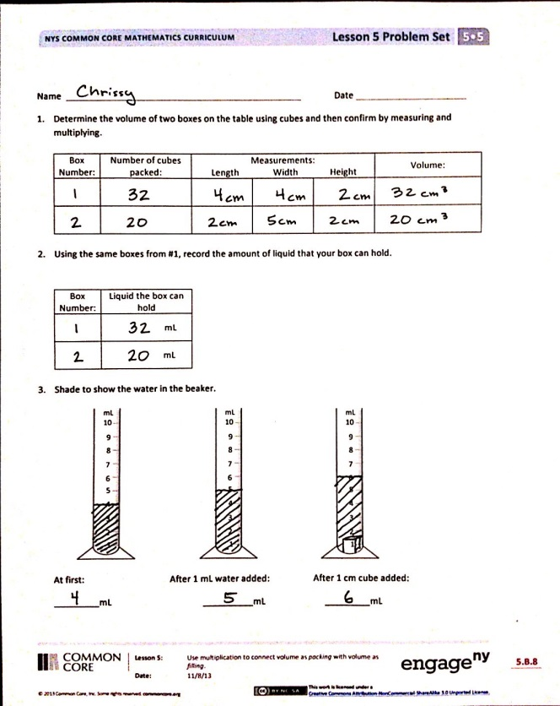
Problem Set (10 minutes)
Students should do their personal best to complete the Problem Set within the allotted 10 minutes. For some classes, it may be appropriate to modify the assignment by specifying which problems they work on first. Some problems do not specify a method for solving. Students should solve these problems using the RDW approach used for Application Problems.
Student Debrief (10 minutes)
Lesson Objective: Use multiplication to connect volume as packing with volume as filling.
The Student Debrief is intended to invite reflection and active processing of the total lesson experience.
Invite students to review their solutions for the Problem Set. They should check work by comparing answers with a partner before going over answers as a class. Look for misconceptions or misunderstandings that can be addressed in the Debrief. Guide students in a conversation to debrief the Problem Set and process the lesson.
Any combination of the questions below may be used to lead the discussion.
- Have you ever heard the term cc’s on TV or in real life? In what context have you heard the term? What do you think cc’s means? (Students might say that medicines, intravenous fluids, and injections are often ordered in cc’s. Explain that a cc is a cubic centimeter, equivalent to 1 milliliter.)
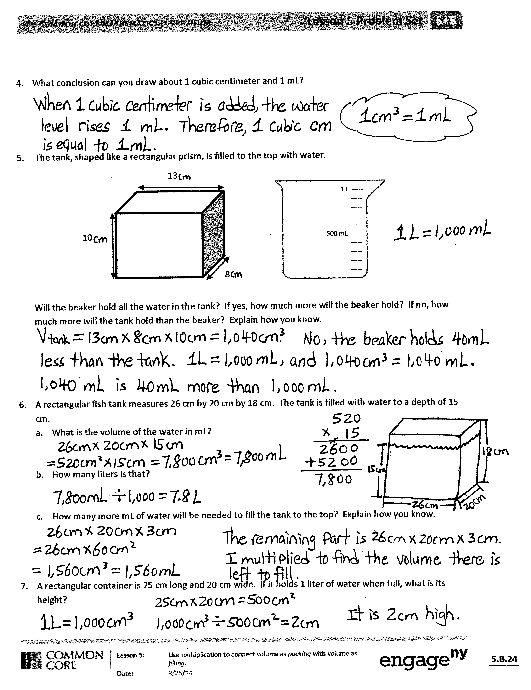
- Problem 6 describes the height of the water using the word depth. Discuss the connection between these two terms. How is height like depth? When might you use the word height to describe a figure, and when might depth be more appropriate? Can the words be used interchangeably? (Have students rephrase problems from the Problem Set to test. English language learners especially will benefit from such a discussion.)
- (Problem 7 asks students to extend their knowledge of cubic centimeters and milliliters to liters. Allow students to work together to think through this task if necessary and then explain their thinking to another partner group. Discuss other connections as well.) If 1 cubic centimeter is equal to 1 milliliter, to what liquid measure is
1 cubic meter equivalent? How could you find out? (Students can draw to investigate using
100 cm = 1 m. Building a cubic container from meter sticks in the classroom helps students visualize the actual volume of 1 kiloliter. They might also imagine pouring 1,000 liter bottles of water or 500 2-liter soft drinks into that single container.)
- (Ask students to generate as many rectangular prisms with whole number sides as they can that would hold 1 liter of liquid. Although the dimensions are all factors of 1,000, the shapes of the containers may be drastically different. Students might even be encouraged to draw the containers on isometric dot paper for comparison.) What do the sides of all these containers have in common? (All are factors of 1,000.) Because they all have the same factors, are they all the same shape? Why or why not?
Exit Ticket (3 minutes)
After the Student Debrief, instruct students to complete the Exit Ticket. A review of their work will help with assessing students’ understanding of the concepts that were presented in today’s lesson and planning more effectively for future lessons. The questions may be read aloud to the students.

Name Date
- Determine the volume of two boxes on the table using cubes, and then confirm by measuring and multiplying.
Box Number | Number of Cubes Packed | Measurements  Length Width Height |  |  | Volume

- Using the same boxes from Problem 1, record the amount of liquid that your box can hold.
Box Number | Liquid the Box Can Hold
 | mL
 | mL

- Shade to show the water in the beaker.
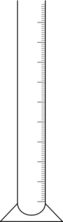


mL
10

9

8

7

6

5

3

2

1

4

mL
10

9

8

7

6

5

3

2

1

4

mL
10

9

8

7

6

5

3

2

1

4

At first: After 1 mL water added: After 1 cm cube added:
_________ mL _________ mL _________ mL

- What conclusion can you draw about 1 cubic centimeter and 1 mL?

- The tank, shaped like a rectangular prism, is filled to the top with water.
8 cm
13 cm
10 cm
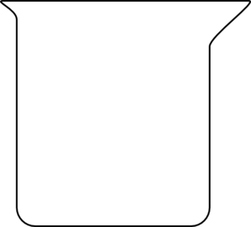
1 L -----
----- -----
-----
-----
500 mL -----
-----
-----
-----
-----

Will the graduated cylinder hold all the water in the tank? If yes, how much more will the beaker hold?
If no, how much more will the tank hold than the beaker? Explain how you know.

- A rectangular fish tank measures 26 cm by 20 cm by 18 cm. The tank is filled with water to a depth of
15 cm.
- What is the volume of the water in mL?

- How many liters is that?

- How many more mL of water will be needed to fill the tank to the top? Explain how you know.

- A rectangular container is 25 cm long and 20 cm wide. If it holds 1 liter of water when full, what is its height?

Name Date

3 cm
15 cm
5 cm
250 mL ----
---- 200 mL ----
----
150 mL ----
----
100 mL ----
----
50 mL ----
----

- Find the volume of the prism.

- Shade the beaker to show how much liquid would fill the box.

Name Date

- Johnny filled a container with 30 centimeter cubes. Shade the beaker to show how much water the container will hold. Explain how you know.
100 mL ----
----- 80 mL -----
-----
60 mL -----
-----
40 mL -----
-----
20 mL -----
-----

- A beaker contains 250 mL of water. Jack wants to pour the water into a container that will hold the water. Which of the containers pictured below could he use? Explain your choices.
2 cm
25 cm
C

6 cm
12 cm
12 cm
A
5 cm

3 cm

5 cm
D
Area =
75 cm²
3 cm
E
Area = 20 cm²
12 cm
B

15 cm
10 cm

- On the back of this paper, describe the details of the activities you did in class today. Include what you learned about cubic centimeters and milliliters. Give an example of a problem you solved with an illustration.

