Lesson 8
Objective: Apply concepts and formulas of volume to design a sculpture using rectangular prisms within given parameters.

Suggested Lesson Structure
 Fluency Practice (12 minutes)
 Concept Development (38 minutes)
 Student Debrief (10 minutes)
Total Time (60 minutes)
Fluency Practice (12 minutes)
- Multiply Whole Numbers and Decimals 5.NBT.7 (4 minutes)
- Mixed Numbers to Improper Fractions 4.NF.4 (4 minutes)
- Multiply Mixed Numbers 5.NF.4 (4 minutes)
Multiply Whole Numbers and Decimals (4 minutes)
Materials: (S) Personal white board
Note: This fluency exercise reviews Module 4 Lesson 17.
T: (Write 3 × 2 = ____.) Say the complete number sentence.
S: 3 × 2 = 6.
3 × 2 = 6 3 × 0.2 = 0.6 0.3 × 0.2 = 0.06 0.03 × 0.2 = 0.006
2 × 7 = 14 2 × 0.7 = 1.4 0.2 × 0.7 = 0.14 0.02 × 0.7 = 0.014
5 × 3 = 15 0.5 × 3 = 1.5 0.5 × 0.3 = 0.15 0.5 × 0.03 = 0.015

T: (Write 3 × 0.2= ____.) On your personal white board, write the complete number sentence.
S: (Write 3 × 0.2 = 0.6.)
T: (Write 0.3 × 0.2= ____.) Write the complete number sentence.
S: (Write 0.3 × 0.2 = 0.06.)
T: (Write 0.03 × 0.2= ____.) Write the complete number sentence.
S: (Write 0.03 × 0.2 = 0.006.)
Continue with the following possible sequence: 2 × 7, 2 × 0.7, 0.2 × 0.7, 0.02 × 0.7, 5 × 3, 0.5 × 3, 0.5 × 0.3, and 0.5 × 0.03.

Mixed Numbers to Improper Fractions (4 minutes)
Materials: (S) Personal white board
Note: This fluency activity prepares students for Lesson 10.

 | NOTES ON  MULTIPLE MEANS  OF REPRESENTATION:
If students are having trouble with fractions, give them fraction tiles to work with. Have them build 1 whole from halves, then 2 wholes, and so on. Then, have them build 3 wholes plus
1 half, and have them count how many halves are in $\text{3}\frac{1}{2}$. Continue with other fractional units.

T: How many halves are in 1?
S: 2.
T: How many halves are in 2?
S: 4.
T: How many halves are in 3?
S: 6.
T: (Write $\text{3}\frac{1}{2}$ = ____.) How many halves are in $3\frac{1}{2}$?
Write $\text{3}\frac{1}{2}$ as an improper fraction on your personal white board.
S: (Write $\text{3}\frac{1}{2}$ = $\frac{7}{2}$.)
Continue with the following possible sequence: $\text{5}\frac{1}{2}$, $\text{4}\frac{1}{3}$, $\text{4}\frac{2}{3}$, $\text{2}\frac{1}{4}$, $\text{2}\frac{3}{4}$, and $\text{4}\frac{5}{6}$.
Multiply Mixed Numbers (4 minutes)
Materials: (S) Personal white board
$\text{3}\frac{1}{2}$ × 2 =
= (3 × 2) + ($\frac{1}{2}$ × 2)
= 6 + 1
= 7
Note: This fluency activity prepares students for Lesson 10.
Format as illustrated to the right.
T: (Write $\text{3}\frac{1}{2}\text{×} \text{2}\text{,}$ and below it, (3 × 2) + ($\frac{1}{2}$ × 2).)
T: (Point to 3 × 2.) Tell me the complete multiplication sentence.
S: 3 × 2 = 6.
T: (Point to $\frac{1}{2}$ × 2.) Tell me the complete multiplication sentence.
S: $\frac{1}{2}$ × 2 = 1.
T: Tell me the addition sentence combining the products.
S: 6 + 1 = 7.
Continue with the following possible sequence: $\text{4}\frac{1}{3}$ × 2, $\text{3}\frac{1}{5}$ × 4, and $\text{4}\frac{2}{3}$ × 3.

Concept Development (38 minutes)

 | NOTE ON  MATERIALS:
When printing the box and lid patterns, be sure the printer is set to actual size.
Materials: (S) Problem Set, project requirements (Template 1), box patterns (a–c) (Templates 2–4), lid patterns (Template 5) (at least three of each template per group), evaluation rubric (Template 6), scissors, tape, rulers
Note: The time for the Application Problem has been allocated to the Concept Development for this lesson.

 | NOTES ON  MULTIPLE MEANS  OF ENGAGEMENT:
Some students may be overwhelmed by the amount of reading and interpretation of directions required for the project. Reading the requirements as a class and having discussion after each one can be helpful. Or place accomplished readers with those who struggle.
Some students may benefit from having cubes to actually construct a model of their structures first.
Copy the flattened boxes on the thickest paper available. Each student or group needs three to five copies of each box, but they may not all be used.
Students cut the templates to form boxes of a certain volume by adjusting the height of the sides. They should construct the boxes by taping edges together and then turn the boxes open side down to create their sculptures. They may also tape lids on the open ends of their boxes to make construction easier.
Please also note the evaluation rubric included in this lesson. The rubric can be shared with students so they understand how their work will be judged.
This activity can be done individually or in pairs.
T: Today, we will be putting our math sense and geometric skills to work as each of you designs a sculpture created from a collection of rectangular prisms. Read the requirements and the rubric with a neighbor.

 | NOTES ON  MULTIPLE MEANS  OF ENGAGEMENT:
Students who struggle may be encouraged to use only three prisms or be given more latitude in total volume or in the relationships between the prisms. Alternatively, those whose spatial skills are well developed may be given additional restrictions to meet or requirements to fulfill or may be asked to use more prisms to construct their designs.
Distribute the project requirements (Template 1), the Problem Set, and the evaluation rubric (Template 6). Allow students time to read all three.
T: Now that you’ve had an opportunity to read the requirements and the way your work will be evaluated, share your ideas about what you might like to design.
S: I want to make a shape using five prisms and make it as random as possible. I want to see if I can do a capital F, for my name. I was going to do a scaled version of my tree house, but I’m not sure if I’ll be able to scale the dimensions right.
T: Here are the boxes, like the ones we used in Lesson 2, that you can use to build your rectangular boxes. There are three different bases to choose from. You may adjust the volume by adjusting the height of the sides of your box. Watch me cut one of the box patterns and make a box. (Demonstrate cutting the 6 cm $\text{×}$ 3 cm box pattern, Template 2.) If I want to build this first prism to have a volume of 36 cubic centimeters, what height will I need to measure and cut the sides?
S: They would need to be 2 cm high.
T: Yes. I’ll measure all my side flaps 2 cm from the base. Then, I’ll cut, fold, and tape them. (Demonstrate.) Talk with your neighbor about how you’ll construct your first box and calculate the volume.
S: Cut the base with rectangles attached on each side that are the same height, and fold them up. Then, calculate the volume. Decide on the volume, and find the area of the base. Then, cut the height to give the volume you need.
T: It might be a good idea to draw a very rough sketch of the design you’re thinking of creating.
S: (Draw.)

 | NOTES ON  MULTIPLE MEANS  OF EXPRESSION:
Students whose fine motor skills are less developed may enjoy producing a virtual version of this project. They might use computer-based drawing tools to draw the prisms (e.g., Google’s SketchUp). These can be printed and then measured to fulfill the requirements of the project.
T: Reread the third prompt with a friend. Share your ideas about how you’ll meet its requirements.
S: (Share.)
T: What were your ideas?
S: I’m going to make Prism A and then try to cut one of the other prisms to make it half the volume of Prism A and call it Prism D. I can make the biggest prism possible and then divide the volume in half and try to make another prism one-half of that volume. I’ll make a prism and then use the same base to make another prism but cut the height in half. That will give me half of the original volume.
T: Reread the fourth prompt with a friend. Share your ideas about how you’ll meet its requirements.
S: I will take Prism B and cut it up to create a prism with one-third the volume. I can use the same big prism as before and divide the volume by 3 and find a prism with dimensions that will equal that number. I can take one of the first three prisms and make the height one-third of the original height, and this will give me one-third of the volume.
T: The final prompt says that the total volume of your design must not exceed 1,000 cubic centimeters. Share your ideas.
S: What’s the biggest prism I can do? We can do a total of five prisms, but they can’t be more than 200 cubic centimeters. One has to be half of another. Another has to be a third of another; this is going to require some thinking! Let’s just say we do one prism that’s 420 cubic cm and one that’s half of that (210 cubic cm) and then one that’s a third of that (140 cubic cm). That’s 770 cubic centimeters. That means I still have 230 cubic units and two prisms to play with. I can make one
3 cm by 6 cm by 4 cm and one 5 cm x 5 cm x 4 cm for a total of 942 cubic centimeters.
T: Once you’ve finalized your boxes, cut a lid with tabs that will fit, and tape it to your box. This will give your boxes stability, so they’ll be easier to tape together. I can tell that you’re excited to get started. Be sure to check your math as you progress, and feel free to share your ideas with a neighbor as you work. (Circulate around the room to ask clarifying questions or provide support to struggling learners as students work.)
Student Debrief (10 minutes)
Lesson Objective: Apply concepts and formulas of volume to design a sculpture using rectangular prisms within given parameters.
The Student Debrief is intended to invite reflection and active processing of the total lesson experience.
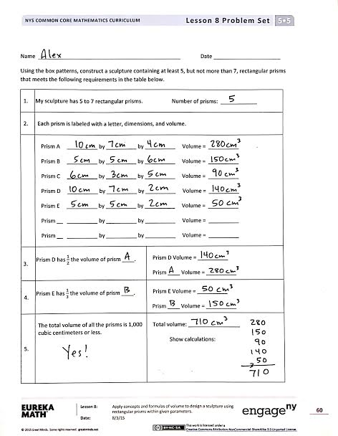
Invite students to review their solutions for the Problem Set. They should check their work by comparing answers with a partner before going over answers as a class. Look for misconceptions or misunderstandings that can be addressed in the Debrief. Guide students in a conversation to debrief the Problem Set and process the lesson.
Any combination of the questions below may be used to lead the discussion.
- What was your thought process as you designed your sculpture? Was your sculpture inspired by something you have seen or owned?
- Which figure did you cut into halves or thirds when creating another shape? What was your thought process as you created a shape one-half or one-third the size? Did you cut one dimension into halves or thirds, or did you scale the entire volume first and then select dimensions to meet that volume?
- What was your biggest challenge in designing your sculpture? Explain.
Exit Ticket (3 minutes)
After the Student Debrief, instruct students to complete the Exit Ticket. A review of their work will help with assessing students’ understanding of the concepts that were presented in today’s lesson and planning more effectively for future lessons. The questions may be read aloud to the students.

Name Date
Using the box patterns, construct a sculpture containing at least 5, but not more than 7, rectangular prisms that meets the following requirements in the table below.
1. | My sculpture has 5 to 7 rectangular prisms. Number of prisms: ____________
2. | Each prism is labeled with a letter, dimensions, and volume.
Prism A __________ by __________ by __________ Volume = __________

Prism B __________ by __________ by __________ Volume = __________

Prism C __________ by __________ by __________ Volume = __________

Prism D __________ by __________ by __________ Volume = __________

Prism E __________ by __________ by __________ Volume = __________

Prism __ __________ by __________ by __________ Volume = __________

Prism __ __________ by __________ by __________ Volume = __________

3. | Prism D has $\frac{1}{2}$ the volume of Prism ____. | Prism D Volume = __________  Prism ____ Volume = __________
4. | Prism E has $\frac{1}{3}$ the volume of Prism ____. | Prism E Volume = __________  Prism ____ Volume = __________
5. | The total volume of all the prisms is 1,000 cubic centimeters or less. | Total volume: _________________  Show calculations:

Name Date
Sketch a rectangular prism that has a volume of 36 cubic cm. Label the dimensions of each side on the prism. Fill in the blanks that follow.

Height: _______ cm
Length: _______ cm
Width: _______ cm
Volume: _______ cubic cm

Name Date
- I have a prism with the dimensions of 6 cm by 12 cm by 15 cm. Calculate the volume of the prism, and then give the dimensions of three different prisms that each have $\frac{1}{3}$ of the volume.
 | Length | Width | Height | Volume
Original Prism | 6 cm | 12 cm | 15 cm
Prism 1
Prism 2
Prism 3

- Sunni’s bedroom has the dimensions of 11 ft by 10 ft by 10 ft. Her den has the same height but double the volume. Give two sets of the possible dimensions of the den and the volume of the den.

Project Requirements
- Each project must include 5 to 7 rectangular prisms.
- All prisms must be labeled with a letter (beginning with A), dimensions, and volume.
- Prism D must be $\frac{1}{2}$ the volume of another prism.
- Prism E must be $\frac{1}{3}$ the volume of another prism.
- The total volume of all of the prisms must be 1,000 cubic centimeters or less.

--------------------------------------------------------------------------------------------------------------------------------------------

Project Requirements
- Each project must include 5 to 7 rectangular prisms.
- All prisms must be labeled with a letter (beginning with A), dimensions, and volume.
- Prism D must be $\frac{1}{2}$ the volume of another prism.
- Prism E must be $\frac{1}{3}$ the volume of another prism.
- The total volume of all of the prisms must be 1,000 cubic centimeters or less.

--------------------------------------------------------------------------------------------------------------------------------------------

Project Requirements
- Each project must include 5 to 7 rectangular prisms.
- All prisms must be labeled with a letter (beginning with A), dimensions, and volume.
- Prism D must be $\frac{1}{2}$ the volume of another prism.
- Prism E must be $\frac{1}{3}$ the volume of another prism.
- The total volume of all of the prisms must be 1,000 cubic centimeters or less.

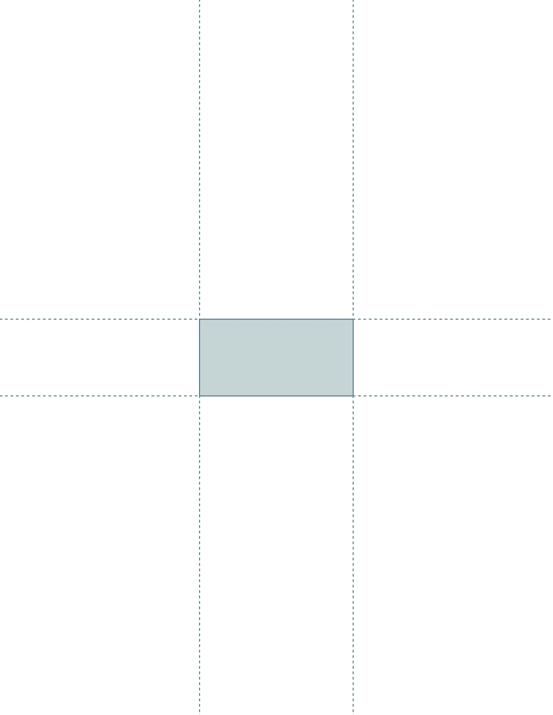
Note: Be sure to set printer to actual size before printing.

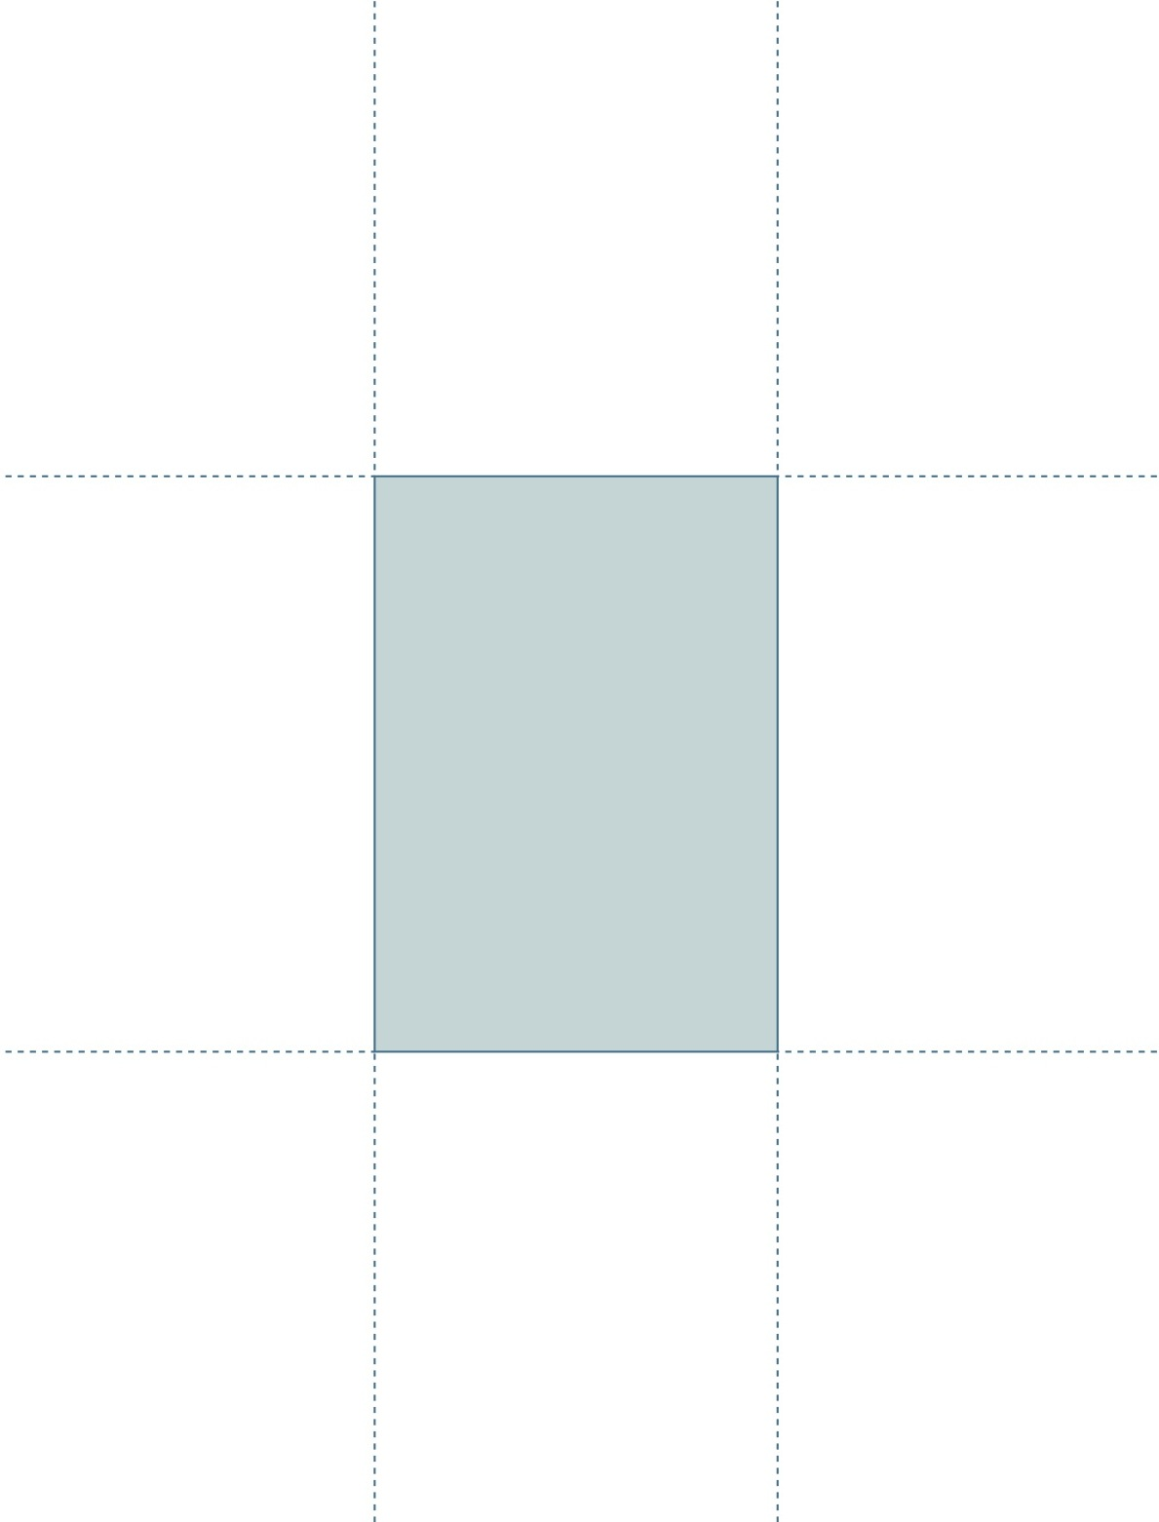

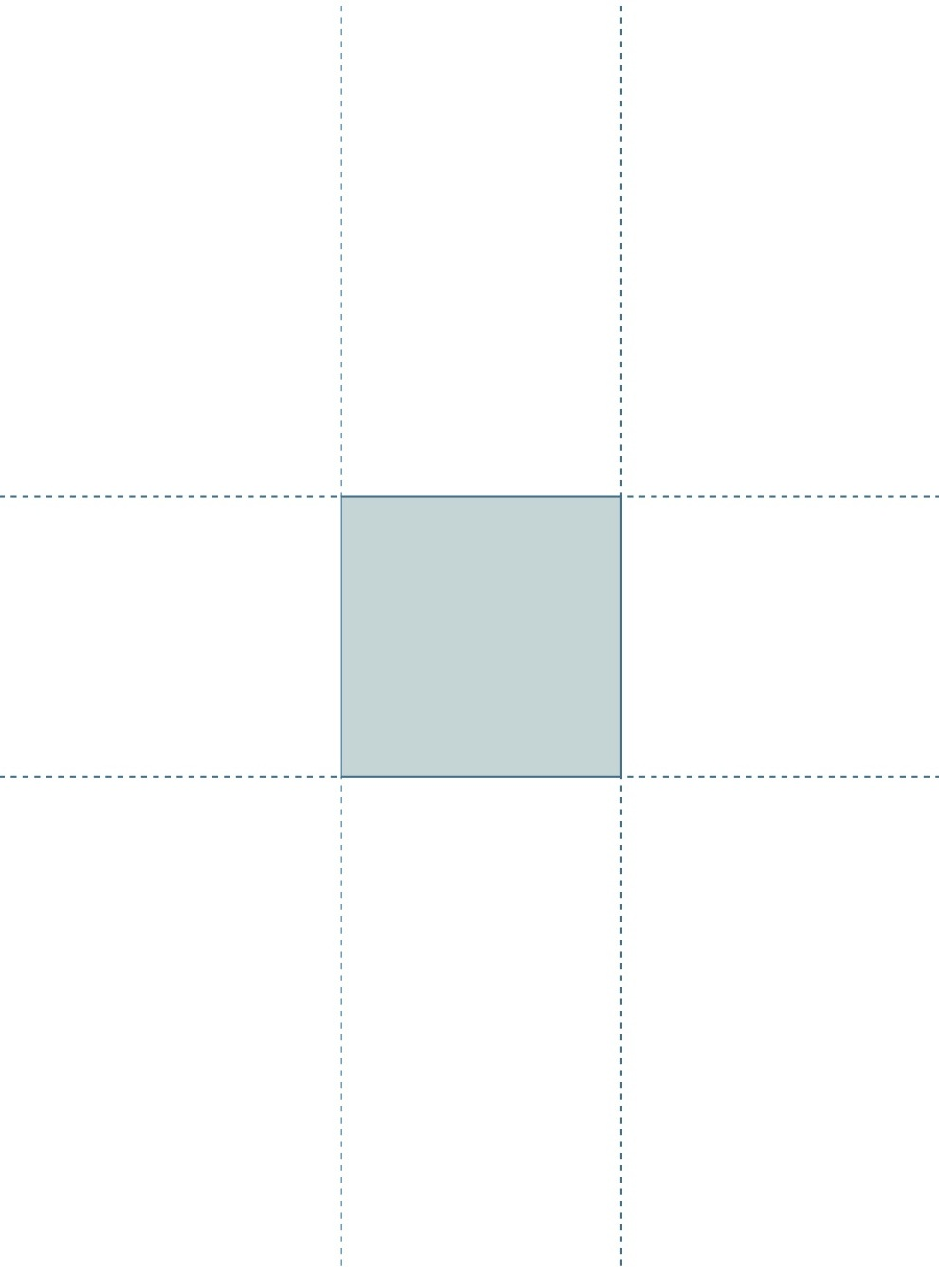

Name Date
Evaluation Rubric
CATEGORY | 4 | 3 | 2 | 1 | Subtotal
Completeness of Personal Project  and Classmate Evaluation | All components of the project are present and correct, and a detailed evaluation of a classmate’s project has been completed. | Project is missing 1 component, and a detailed evaluation of a classmate’s project has been completed. | Project is missing 2 components, and an evaluation of a classmate’s project has been completed. | Project is missing 3 or more components, and an evaluation of a classmate’s project has been completed. | (× 4)  _____/16
Accuracy of Calculations | Volume calculations for all prisms are correct. | Volume calculations include 1 error. | Volume calculations include 2–3 errors. | Volume calculations include 4 or more errors. | (× 5)  ______/20
Neatness and Use of Color | All elements of the project are carefully and colorfully constructed. | Some elements of the project are carefully and colorfully constructed. | Project lacks color or is not carefully constructed. | Project lacks color and is not carefully constructed. | (× 2)  ______/4
TOTAL:

_____ /40

project requirements
box pattern (a)
box pattern (b)
box pattern (c)
lid patterns
evaluation rubric

