Lesson 9
Objective: Apply concepts and formulas of volume to design a sculpture using rectangular prisms within given parameters.

Suggested Lesson Structure
 Fluency Practice (7 minutes)
 Application Problem (7 minutes)
 Concept Development (36 minutes)
 Student Debrief (10 minutes)
Total Time (60 minutes)
Fluency Practice (7 minutes)
- Multiply Decimals 5.NBT.7 (3 minutes)
- Multiply Mixed Numbers 5.NF.4 (4 minutes)
Multiply Decimals (3 minutes)
Materials: (S) Personal white board
Note: This fluency exercise reviews Module 4’s Lessons 17 and 18.
T: (Write 4 × 2 = ____.) Say the number sentence.
S: 4 × 2 = 8.
4 × 2 = 8 4 × 0.2 = 0.8 0.4 × 0.2 = 0.08 0.04 × 0.2 = 0.008
2 × 9 = 18 2 × 0.9 = 1.8 0.2 × 0.9 = 0.18 0.02 × 0.9 = 0.018
4 × 3 = 12 0.4 × 3 = 1.2 0.4 × 0.3 = 0.12 0.4 × 0.03 = 0.012

T: (Write 4 × 0.2 = ____.) On your personal white board, write the number sentence.
S: (Write 4 × 0.2 = 0.8.)
T: (Write 0.4 × 0.2 = ____.) Write the number sentence.
S: (Write 0.4 × 0.2 = 0.08.)
T: (Write 0.04 × 0.2 = ____.) Write the number sentence.
S: (Write 0.04 × 0.2 = 0.008.)
Continue with the following possible sequence: 2 × 9, 2 × 0.9, 0.2 × 0.9, 0.02 × 0.9, 4 × 3, 0.4 × 3, 0.4 × 0.3, and 0.4 × 0.03.

Multiply Mixed Numbers (4 minutes)
Materials: (S) Personal white board
Note: This fluency exercise prepares students for Lesson 10. Format writing as illustrated to the right.
$\text{4}\frac{1}{3}$ × 2
= (4 × 2) + ($\frac{1}{3}$ × 2)
= 8 + $\frac{2}{3}$
= 8 $\frac{2}{3}$
T: (Write 4 $\frac{1}{3}$ × 2 and below it (4 × 2) + ($\frac{1}{3}$ × 2).)
T: (Point to 4 × 2.) Tell me the complete multiplication sentence.
S: 4 × 2 = 8.
T: (Point to $\frac{1}{3}$ × 2.) Tell me the complete multiplication sentence.
S: $\frac{1}{3}$ × 2 = $\frac{2}{3}$.
T: Tell me the addition sentence combining the two products.
S: 8 + $\frac{2}{3}$ = 8 $\frac{2}{3}$.
Continue with the following possible sequence: $\text{7}\frac{1}{5}$ × 3 and $\text{5}\frac{2}{3}$ × 2.
Application Problem (7 minutes)
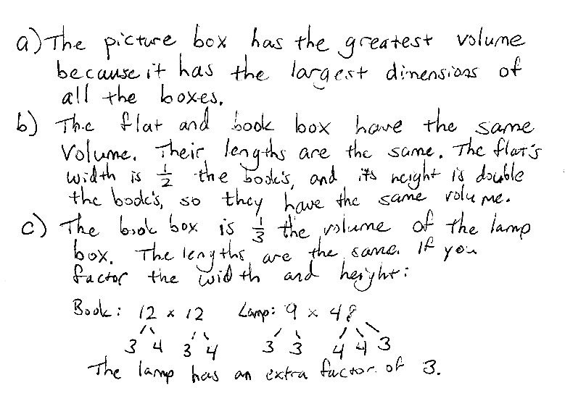
The chart below shows the dimensions of various rectangular packing boxes. If possible, answer the following without calculating the volume.
- Which box will provide the greatest volume?
- Which box has a volume that is equal to the volume of the book box? How do you know?
- Which box is $\frac{1}{3}$ the volume of the lamp box?
Box Type | Dimensions  (l × w × h)
Book Box | 12 in × 12 in × 12 in
Picture Box | 36 in × 12 in × 36 in
Lamp Box | 12 in × 9 in × 48 in
The Flat | 12 in × 6 in × 24 in
Note: This Application Problem builds on students’ understanding of a scaling principle. Students can use their sense of part–whole and scaling knowledge to answer these questions without finding the volume of the boxes.
Concept Development (36 minutes)
Materials: (T) Copy of student work from Lesson 8, evaluation rubric (Lesson 8 Template 6) (S) Rulers,
2 copies of Problem Set (1 for use during Concept Development and 1 for independent work)
Note: Before class, the projects should be labeled only with a number and no student names. The review process in today’s lesson should proceed anonymously.
T: (Post the image of the shape below on the board.)
Here is a student’s project designed according to the directions we used yesterday. I’ve measured the boxes, and the measurements that you see on the diagram are correct. The volume of Prism A is given. (Distribute a copy of the Problem Set to each student.) Your job is to use the rubric to see if this student met all the requirements of the assignment.

 | NOTES ON  MULTIPLE MEANS  OF ENGAGEMENT:
The high number of measurements recorded on the diagram may be overwhelming to students with visual acuity difficulties. These students may benefit from a second diagram with figures slightly separated and units listed on each dimension or a larger print version of the diagram.

T: Before we can do that, we must confirm the volumes that the student recorded are correct. Work with a neighbor to check the work this student did to find the volumes of the prisms. (Allow students time to work and share their results.)
T: What did you find? Are the recorded volumes correct?
S: They are correct. Prisms A and C have volumes of 36 cm³. Prism B has a volume of 420 cm³.
Prism E has a volume of 140 cm³. Prism D’s volume is 18 cm³.
B
A
C
D
E
Prism A: 6 cm × 3 cm × 2 cm = 36 cm³
Prism B: 10 cm × 7 cm × 6 cm = 420 cm³
Prism C: 6 cm × 3 cm × 2 cm = 36 cm³
Prism D: 6 cm × 3 cm × 1 cm = 18 cm³
Prism E: 10 cm × 7 cm × 2 cm = 140 cm³
T: Now we are ready to begin our review. Look at the first item on the list. How many prisms are in this design?
S: 5.
T: Check the Element Present? box, and record the number of prisms used under Specifics of Element.
S: (Check the box and record 5 prisms.)
T: The Notes box is for any positive comments we might like to give to this student on this particular element. This is also the place to tell him anything that might be missing in the design. Since this student has met this requirement, turn and talk to your partner about what positive comment you might make.
S: I like the way the prisms are sort of symmetrical. The way the boxes are stacked from big to little looks good. Putting the skinny box in the middle makes the design look really big even though he only used 5 boxes.

T: Let’s look at our next requirement. Are all the parts labeled with a letter? Record your answer.

 | NOTES ON  MULTIPLE MEANS  OF ENGAGEMENT:
Have students who easily grasp this concept and move quickly through the Problem Set double one or more dimensions and calculate the new volume of the figure. Another option is to ask them if the units were centimeters instead of inches, how many liters of liquid the structure would hold.

S: Yes. They all have letters.
T: Are all prisms labeled with their dimensions and volume? Record your response.
S: Yes. All the prisms have dimensions and volume recorded.
T: Do all recorded measurements have the correct units? What are the units for the dimensions and volume?
S: Yes. All dimensions are in centimeters, and the volumes are in cubic centimeters.
T: Write that down. What’s next on our list? How will we find out if this student met the requirements? Turn and talk.
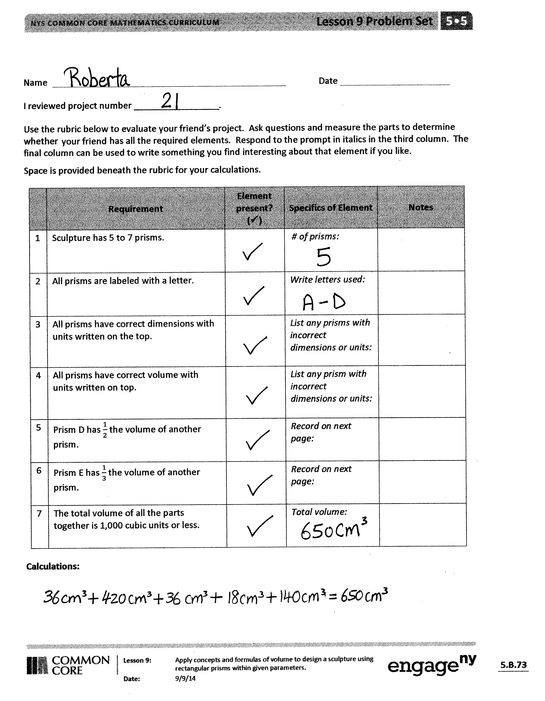
S: We need to find out if Prism D is one-half of one of the other prisms and if Prism E is
one-third of another prism. We need to calculate the volume of all of the prisms first and then check if Prism D has one-half the volume of one of the other prisms and if Prism E has
one-third the volume of one prism. Prism D has a volume of 18 cm³, which is one-half of Prism A’s volume. Prism E has a volume of 140 cm³, which is one-third of Prism B’s volume.
T: Record your findings. Check the Requirement boxes, and use the second page to record your calculations. (Circulate to make sure students are using the correct parts of the rubric to record the information.)
MP.6
S: (Record.)
T: What is the total volume of this shape?
S: (Work and show that 36 cm³ + 36 cm³+ 18 cm³ + 140 cm³ + 420 cm³ = 650 cm³.)
T: Did this student meet all the requirements of the assignment? Tell me how you know.
S: Yes, she did. The volume is 650 cm³, which is less than 1,000 cm³. There are 5 prisms, and they had to have 5 to 7 prisms. The volume of Prism D is one-half the volume of Prism A.
The volume of Prism E is one-third the volume of Prism B.
T: Remember, if there’s something that doesn’t meet a requirement in the project that you review, you will record that in the Notes column. You may also use the Notes box to say something that you notice about their work.
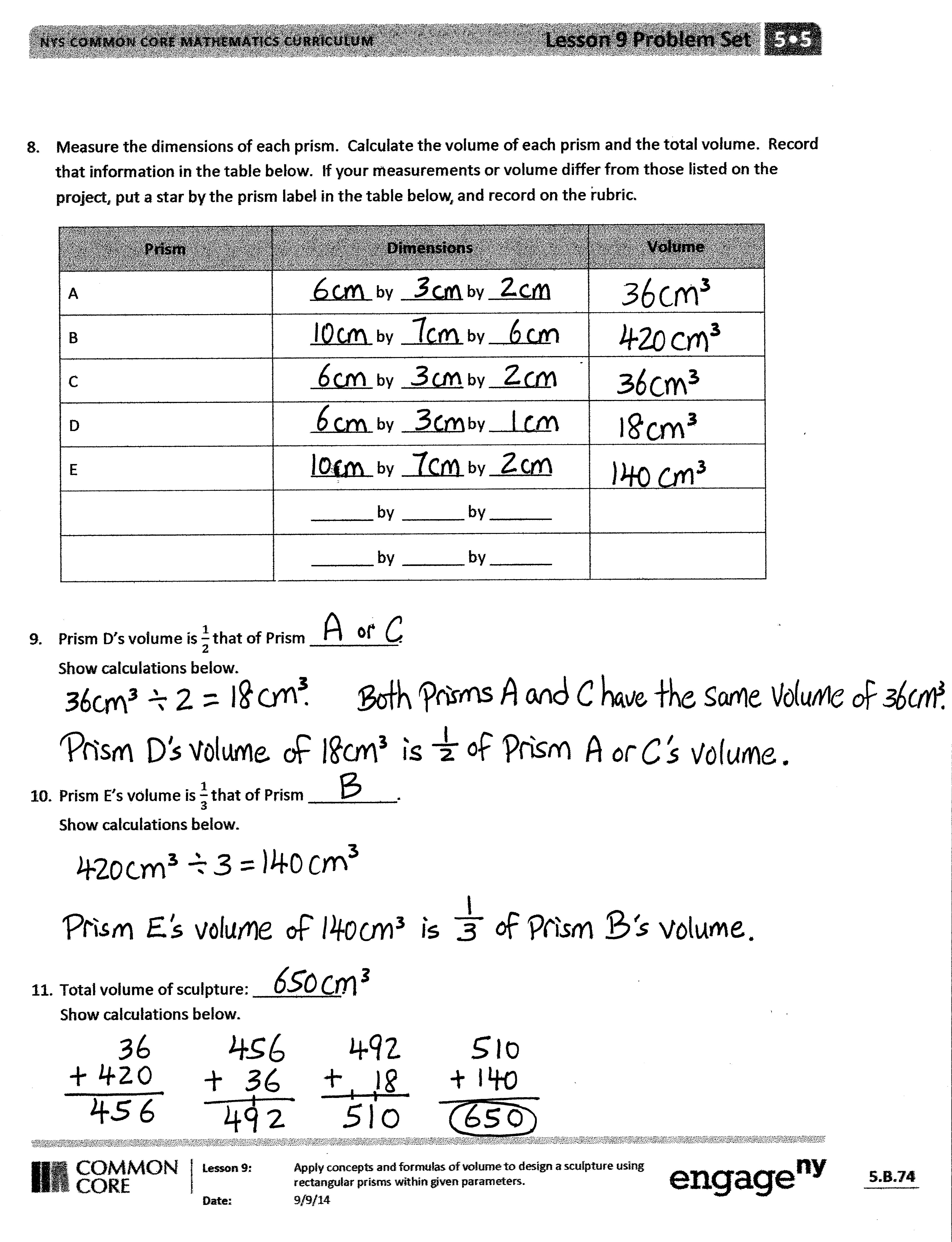
T: I’m assigning each of you the sculpture of a fellow classmate (or pair) to review independently just as we did this one. Write the number of the project that you review on your Problem Set. Begin by confirming the measurements and volumes calculated by your classmate. (Distribute one sculpture to each student, and circulate to answer questions that arise.)
Student Debrief (10 minutes)
Lesson Objective: Apply concepts and formulas of volume to design a sculpture using rectangular prisms within given parameters.
The Student Debrief is intended to invite reflection and active processing of the total lesson experience.
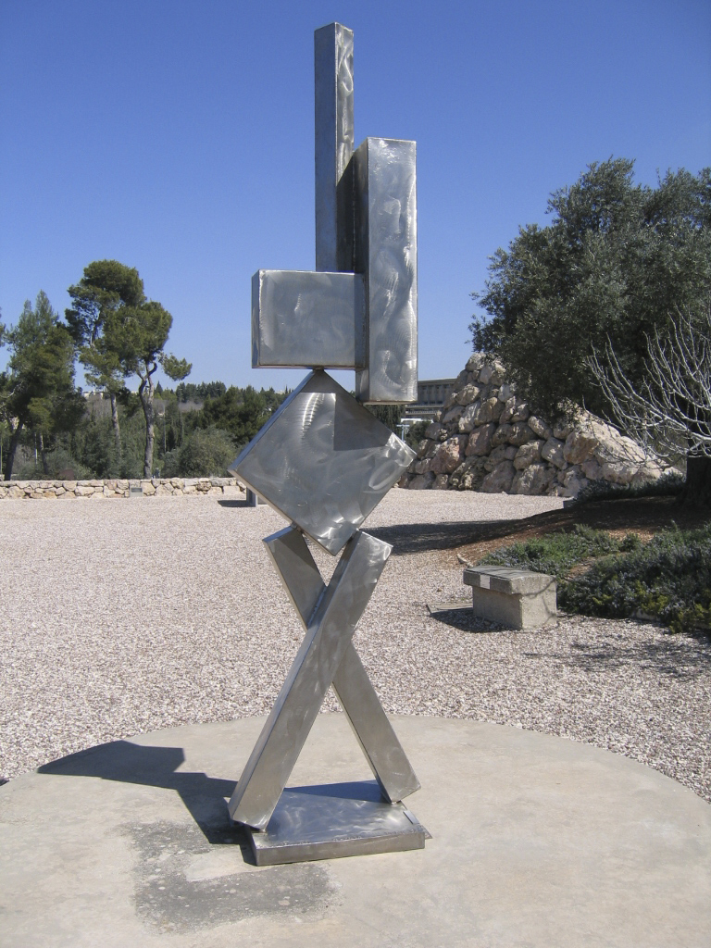
Invite students to review their solutions for the Problem Set. They should check their work by comparing answers with a partner before going over answers as a class. Look for misconceptions or misunderstandings that can be addressed in the Debrief. Guide students in a conversation to debrief the Problem Set and process the lesson.
Any combination of the questions below may be used to lead the discussion.
- How was the student work you assessed similar to and different from the design you created?
- If the work that you assessed did not meet the requirements, what feedback did you provide to help the student be successful?
- How was assessing student work different from creating your design yesterday? If you could go back and change your design, would you? In what ways?
- Students might enjoy investigating the sculptures of David Smith, particularly his Cubi series (as shown to the right). Many in this series of sculptures are composed exclusively of rectangular prisms.
David Smith (1906-1965), Cubi VI, 1963, stainless steel. Art © Estate of David Smith/Licensed by VAGA, New York, NY.
Photo: Yair Talmor.
Exit Ticket (3 minutes)
After the Student Debrief, instruct students to complete the Exit Ticket. A review of their work will help with assessing students’ understanding of the concepts that were presented in today’s lesson and planning more effectively for future lessons. The questions may be read aloud to the students.

Name Date
I reviewed project number _________________.
Use the rubric below to evaluate your friend’s project. Ask questions and measure the parts to determine whether your friend has all the required elements. Respond to the prompt in italics in the third column.
The final column can be used to write something you find interesting about that element if you like.
Space is provided beneath the rubric for your calculations.
 | Requirement | Element Present?  () | Specifics of Element | Notes
1. | The sculpture has 5 to 7 prisms. |  | # of prisms:
2. | All prisms are labeled with a letter. |  | Write letters used:
3. | All prisms have correct dimensions with units written on the top. |  | List any prisms with incorrect dimensions or units:
4. | All prisms have correct volume with units written on the top. |  | List any prism with incorrect dimensions or units:
5. | Prism D has $\frac{1}{2}$ the volume of another prism. |  | Record on next page:
6. | Prism E has $\frac{1}{3}$ the volume of another prism. |  | Record on next page:
7. | The total volume of all the parts together is 1,000 cubic units or less. |  | Total volume:
Calculations:

- Measure the dimensions of each prism. Calculate the volume of each prism and the total volume.
Record that information in the table below. If your measurements or volume differ from those listed on the project, put a star by the prism label in the table below, and record on the rubric.
Prism | Dimensions | Volume
A | _______ by _______ by _______
B | _______ by _______ by _______
C | _______ by _______ by _______
D | _______ by _______ by _______
E | _______ by _______ by _______
 | _______ by _______ by _______
 | _______ by _______ by _______

- Prism D’s volume is $\frac{1}{2}$ that of Prism __________.
Show calculations below.

- Prism E’s volume is $\frac{1}{3}$ that of Prism __________.
Show calculations below.

- Total volume of sculpture: __________.
Show calculations below.

Name Date
A student designed this sculpture. Using the dimensions on the sculpture, find the dimensions of each rectangular prism. Then, calculate the volume of each prism.
Z
6 in
10 in
18 in
16 in6
Y
10 in
6 in
  - Rectangular Prism Y

Height: ______________ inches
Length: ______________ inches
Width: ______________ inches
Volume: ______________ cubic inches

- Rectangular Prism Z
Height: ______________ inches
Length: ______________ inches
Width: ______________ inches
Volume: ______________ cubic inches

- Find the total volume of the sculpture. Label the answer.

Name Date
- Find three rectangular prisms around your house. Describe the item you are measuring (cereal box, tissue box, etc.), and then measure each dimension to the nearest whole inch, and calculate the volume.
  - Rectangular Prism A
Item:
Height: ______________ inches

Length: ______________ inches

Width: ______________ inches

Volume: ______________ cubic inches

  - Rectangular Prism B
Item:

Height: ______________ inches

Length: ______________ inches

Width: ______________ inches

Volume: ______________ cubic inches

  - Rectangular Prism C
Item:

Height: ______________ inches

Length: ______________ inches

Width: ______________ inches

Volume: ______________ cubic inches

