Lesson 10
Objective: Find the area of rectangles with whole-by-mixed and
whole-by-fractional number side lengths by tiling, record by drawing,
and relate to fraction multiplication.

Suggested Lesson Structure
 Fluency Practice (12 minutes)
 Application Problem (8 minutes)
 Concept Development (30 minutes)
 Student Debrief (10 minutes)
Total Time (60 minutes)
Fluency Practice (12 minutes)
- Multiply Decimals 5.NBT.7 (4 minutes)
- Change Mixed Numbers to Fractions 4.NF.4 (4 minutes)
- Multiply Mixed Numbers and Fractions 5.NF.4 (4 minutes)
Multiply Decimals (4 minutes)
Materials: (S) Personal white board
Note: This fluency activity reviews Module 4 Lessons 17–18.
T: (Write 2 × 2 = .) Say the multiplication sentence with the answer.
S: 2 × 2 = 4.
T: (Write 2 × 0.2 = .) On your personal white board, write the number sentence and the answer.
2 × 2 = 4 2 × 0.2 = 0.4 0.2 × 0.2 = 0.04 0.02 × 0.2 = 0.004
3 × 4 = 12 3 × 0.4 = 1.2 0.3 × 0.4 = 0.12 0.03 × 0.4 = 0.012
5 × 7 = 35 0.5 × 7 = 3.5 0.5 × 0.7 = 0.35 0.5 × 0.07 = 0.035
S: (Write 2 × 0.2 = 0.4.)
T: (Write 0.2 × 0.2 = .) Try this problem.
S: (Write 0.2 × 0.2 = 0.04.)
T: (Write 0.02 × 0.2 = .) Try this problem.
S: (Write 0.02 × 0.2 = 0.004.)
Continue with the following possible sequence: 3 × 4, 3 × 0.4, 0.3 × 0.4, 0.03 × 0.4, 5 × 7, 0.5 × 7, 0.5 × 0.7, and 0.5 × 0.07.
Change Mixed Numbers to Fractions (4 minutes)
Materials: (S) Personal white board
Note: This fluency activity prepares students for today’s lesson.
T: How many fourths are in 1?
S: 4.
T: How many fourths are in 2?
S: 8.
T: (Write $\text{2}\frac{1}{4}$ = .) How many fourths are in $2\frac{1}{4}$? Write $\text{2}\frac{1}{4}$ as an improper fraction on your
personal white board.
S: (Write $\text{2}\frac{1}{4}$ = $\frac{9}{4}$.)
Continue with the following possible sequence: $\text{2}\frac{3}{4}$, $\text{2}\frac{1}{2}$, $\text{4}\frac{2}{3}$, $\text{3}\frac{3}{4}$, $\text{2}\frac{5}{6}$, $3\frac{3}{8}$, $\text{4}\frac{5}{8}$, and $\text{5}\frac{7}{8}$.
Multiply Mixed Numbers and Fractions (4 minutes)
Materials: (S) Personal white board
Note: This fluency activity prepares students for today’s lesson.
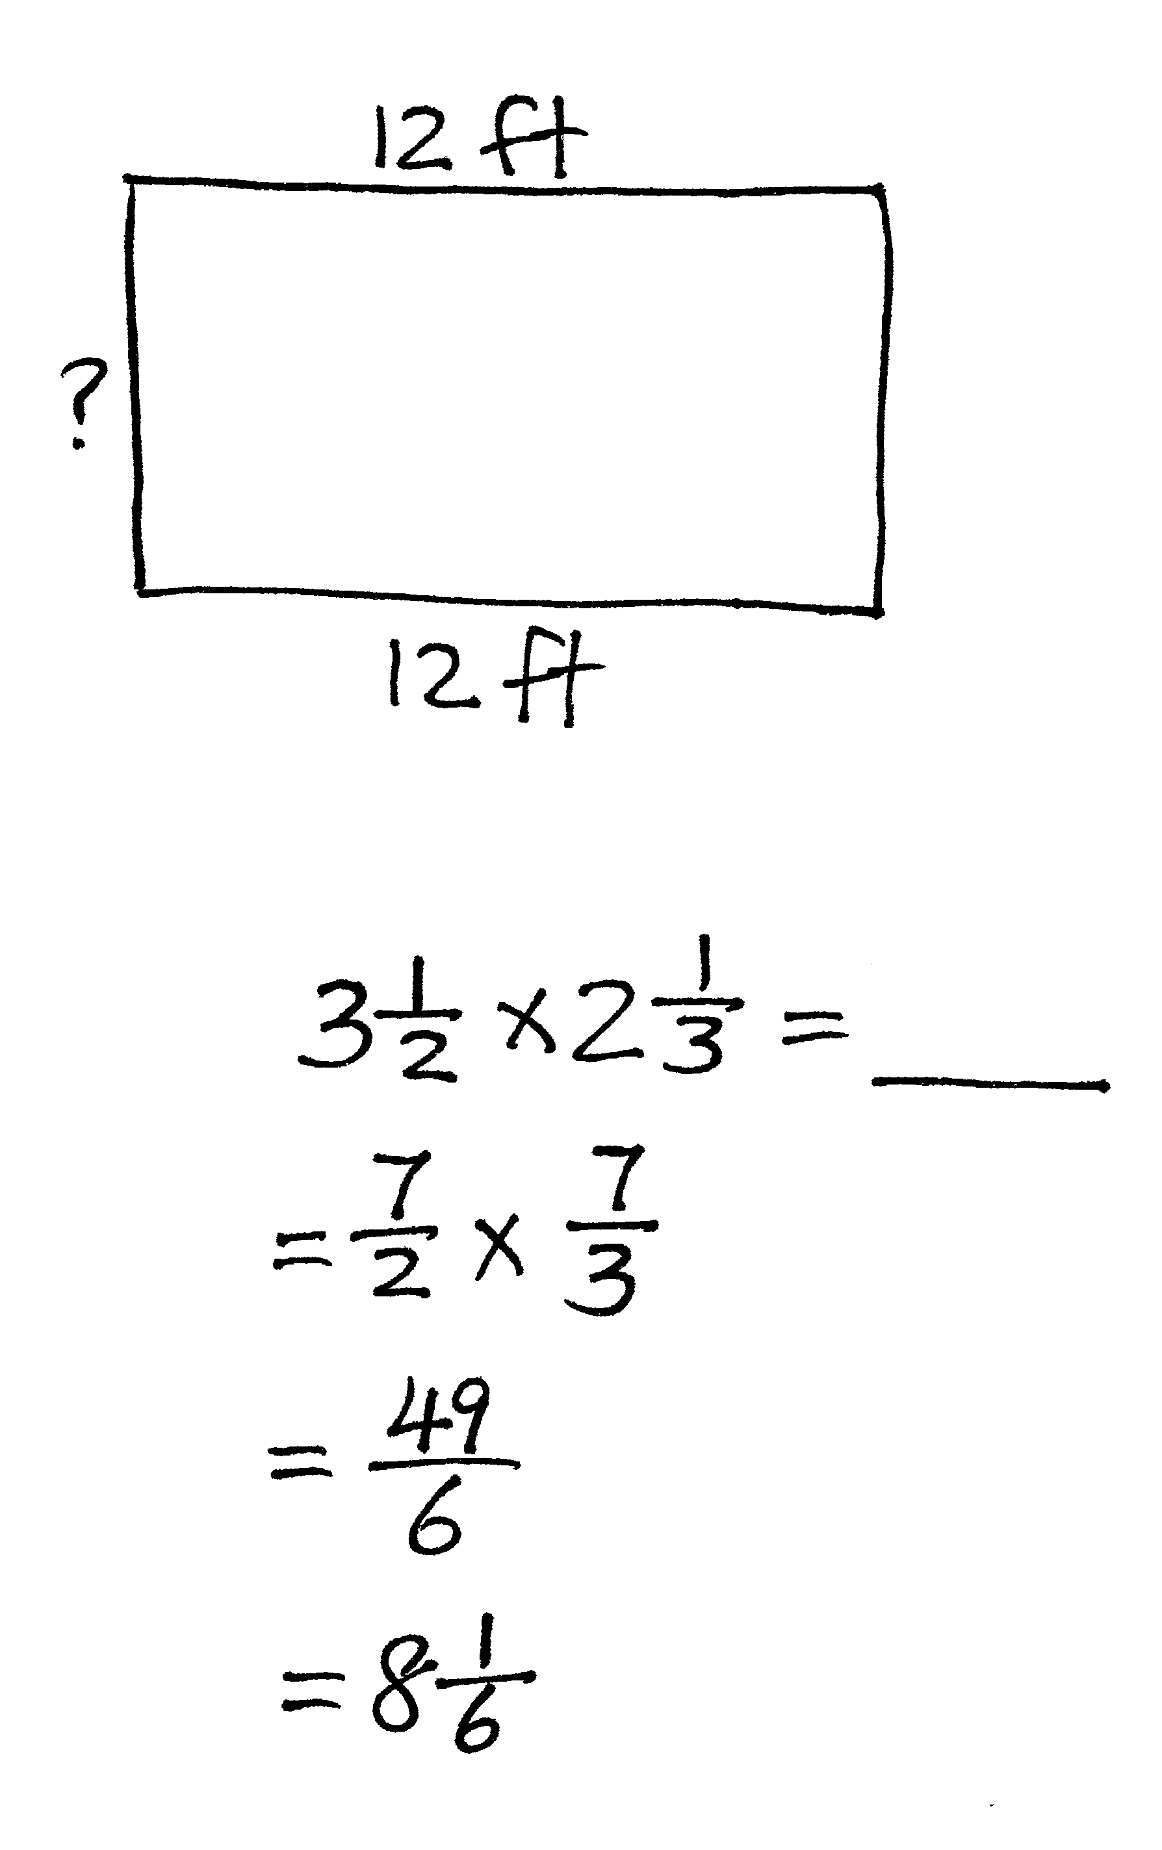
T: (Write $\text{3}\frac{1}{2}$ × $\text{2}\frac{1}{3}$ = . Point to $\text{3}\frac{1}{2}$.) Say $\text{3}\frac{1}{2}$ as a fraction greater than one.
S: $\frac{7}{2}$.
T: (Write = $\frac{7}{2}$ × $\text{2}\frac{1}{3}$. Point to $\text{2}\frac{1}{3}$.) Say $\text{2}\frac{1}{3}$ as a fraction greater than one.
S: $\frac{7}{3}$.
T: (Write = $\frac{7}{2}$ × $\frac{7}{3}$. Beneath it, write = . Beneath it, write = .)
Multiply the fractions. Then, write the answer as a mixed number.
S: (Write $\text{3}\frac{1}{2}$ × $\text{2}\frac{1}{3}$ = . Beneath it, write $=\frac{7}{2}$ × $\frac{7}{3}$. Beneath it, write $=\frac{49}{6}$. Beneath it, write $=\text{8}\frac{1}{6}$.)
Continue with the following possible sequence: $\text{3}\frac{1}{3}$ × $\text{2}\frac{3}{4}$ and $\text{3}\frac{4}{5}$ × $\text{4}\frac{2}{3}$.
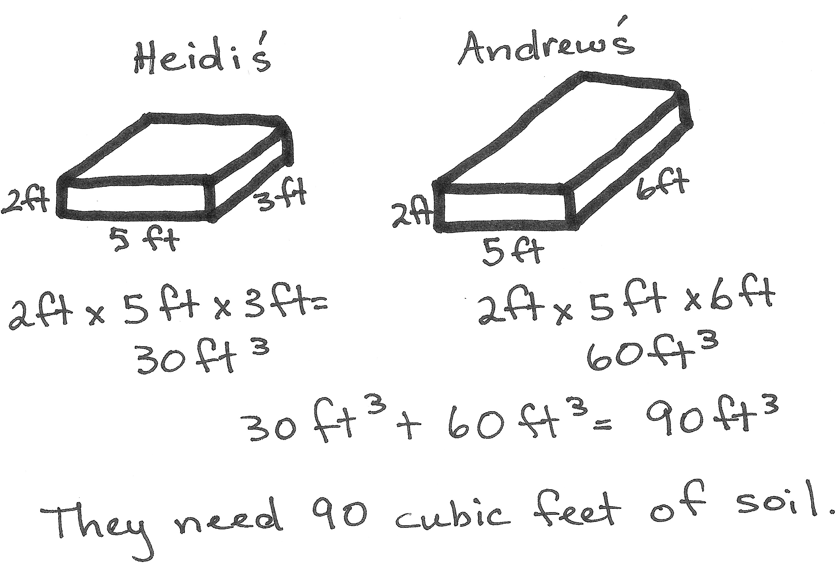
Application Problem (8 minutes)
Heidi and Andrew designed two raised flowerbeds for their garden. Heidi’s flowerbed was 5 feet long by 3 feet wide, and Andrew’s flowerbed was the same length but twice as wide. Calculate how many cubic feet of soil they need to buy to have soil to a depth of
2 feet in both flowerbeds.
Note: This Application Problem reviews the volume work from Topic B.
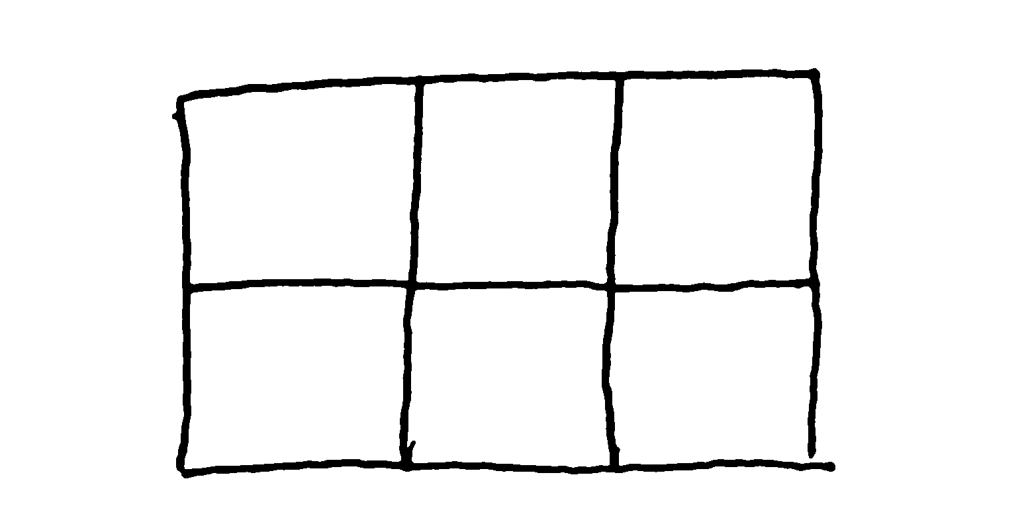
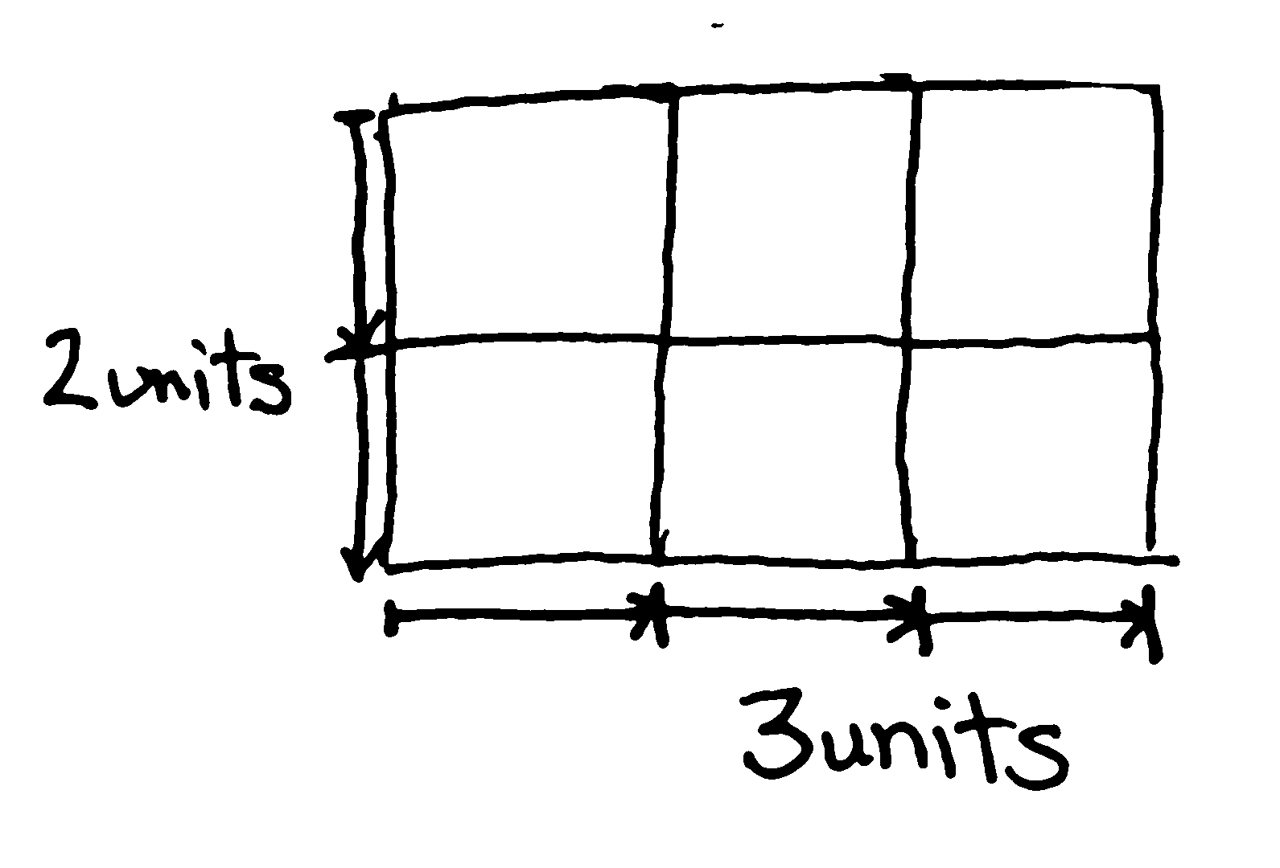
Concept Development (30 minutes)
Rectangle A
Materials: (T) 3-unit × 2-unit rectangle, patty paper (units for tiling), large chart paper (for recording dimensions of rectangles), personal white board (S) 5 large mystery rectangles lettered A–E (1 of each size per group), patty paper (units for tiling),
Problem Set
Note: The lesson is written such that the length of one standard patty paper (5 $\frac{1}{2}$ inches by 5 $\frac{1}{2}$ inches) is one unit. Hamburger patty paper (available from big box discount stores in boxes of 1,000) is the ideal square unit for this lesson due to its translucence and size. Measurements for the mystery rectangles are given in generic units so that any size square unit may be used to tile, as long as the tiling units can be folded. Any paper may be used if patty paper is not available. Consider color-coding Rectangles A–E for easy reference.

 | NOTES ON  MULTIPLE MEANS  OF REPRESENTATION:
Folding the square units allows students to clearly see the relationship of the fractional square unit while maintaining the relationship to the whole square unit. Consequently, if students become confused about the size of the fractional square unit, the paper may be easily unfolded as a reminder.

Preparation: Each group needs one copy of Rectangles A–E. The most efficient way of producing these rectangles is to use the patty paper to measure and trace the outer dimensions of one rectangle. Then, use that rectangle as a template to cut the number required for the class. Rectangles should measure as follows:
Demo Rectangle A: 3 units × 2 units
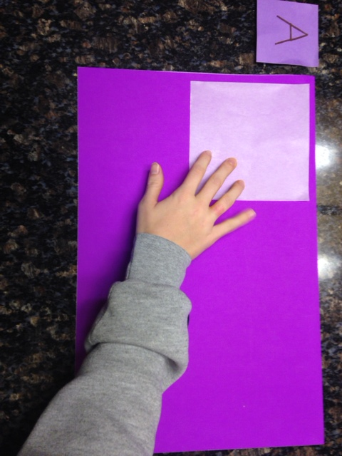
Rectangle B: 3 units × $\text{2}\frac{1}{2}$ units
Rectangle C: $\text{1}\frac{1}{2}$ units × 5 units
Rectangle D: 2 units × $1\frac{3}{4}$ units
Rectangle E: $\frac{3}{4}$unit × 5 units
T: We want to determine the areas of some mystery rectangles today. Find the rectangle at your table labeled A. (Allow students time to find the rectangle.)
T: If we want to find the area of this mystery rectangle, what kind of units would we use to measure it?
S: Square units.
T: (Hold up a patty paper tile.) This will be the square unit we will use to find the area of Rectangle A. Work with your partner to find the number of squares that will cover this rectangle with no space between the units and no overlaps. Please start at the top left-hand corner to place your first tile. (Allow students time to work.)
T: How many square units covered the rectangle?

 | NOTES ON  MULTIPLE MEANS  OF ACTION AND EXPRESSION:
Students may use the tiles to measure the outside dimensions of the rectangle before tiling. For some, marking the length and width with tick marks to show the lengths of the units may help them visualize the linear measurement more easily.
The dimensions can then be recorded on the Problem Set prior to drawing the rectangle and partial products.

S: 6 square units.
T: Let’s sketch a picture of what our tiling looks like. Draw the outside of your rectangle first. (Model as students draw.)
T: Now, show the six tiles. (Allow students time to draw.)
T: Look at the longest side of your rectangle. If we wanted to measure this side with a piece of string, how many units long would the string need to be? Explain how you know to your partner.
S: It is 3 units long. I can look at the edge of the units and count. To measure the length of the side, I’m not looking at the whole tile; I only need to count the length of each unit. There are 3 equal units on the edge, so the string would need to be 3 units long.
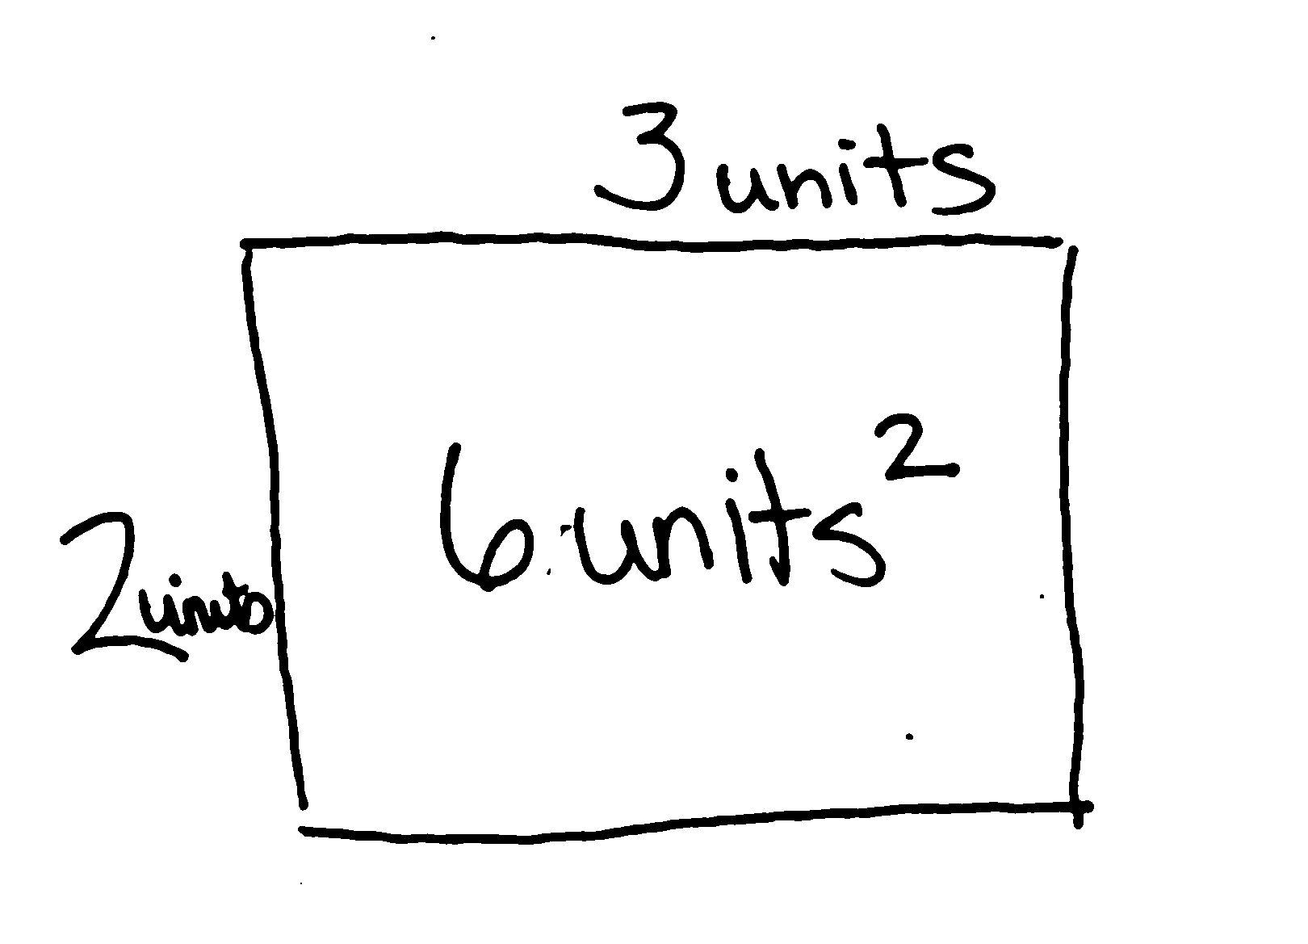
T: Let’s record that. (Write the length of Rectangle A in the chart.) What is the length of the shorter side?
MP.2
S: 2 units.
T: Let’s record that in our chart.
T: What is the area of Rectangle A?
S: 6 square units.
T: If we had only labeled the length and the width in our sketch, could we still know the area? Why or why not?
Rectangle | Length | Width | Area
A | 3 units | 2 units | 6 units²
B | 3 units | $\text{2}\frac{1}{2}$ units | $\text{7}\frac{1}{2}$ units²

S: Yes. We know the square units are there even if we do not draw them all. We still just multiply the sides together. We can imagine the tiles.
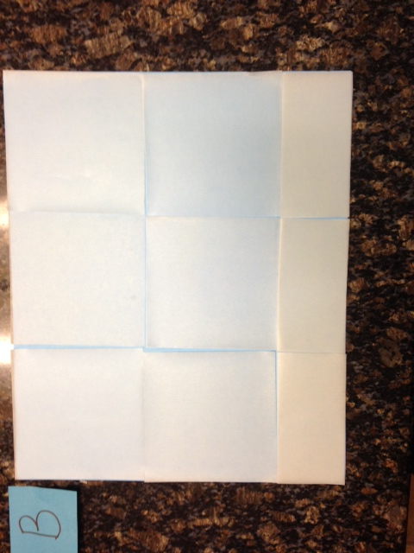
T: What would a sketch of this look like? Draw it with your partner. (Allow students time to draw.)
T: Now, find Rectangle B. Compare its size to Rectangle A. Will its area be greater than or less than that of Rectangle A?
S: Greater.
T: We see that Rectangles A and B are the same length. What about the width?
S: Rectangle B is wider than two tiles but not as wide as three tiles.
T: Fold your tiles to decide what fraction of another tile we need to cover the extra width. Work with your partner. (Allow students time to fold.)
T: What fraction of the tile do you need to cover this part of the rectangle? How do you know?
S: I need half a tile. I laid a whole tile over the extra part, and it looked like half to me. After I folded up the part of the tile that was hanging off the rectangle, I could see that the fold split the tile into two equal parts. That means it is halves.
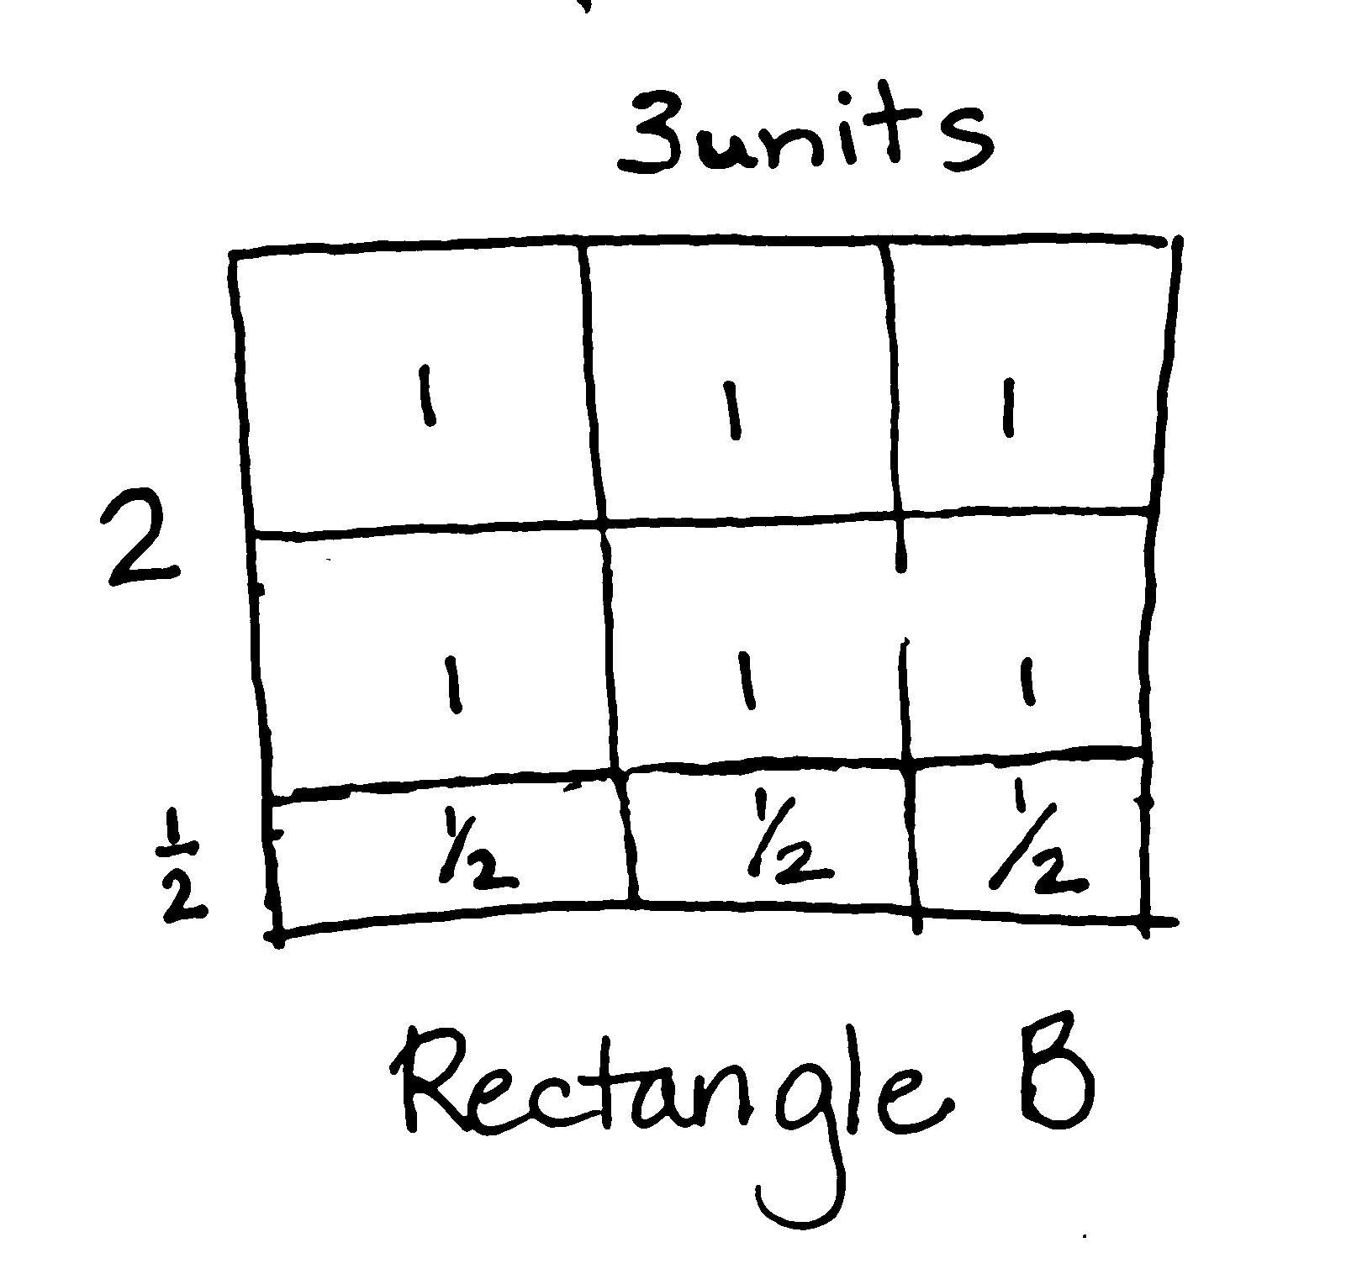
T: Finish folding enough tiles to completely cover the width of Rectangle B.
S: (Fold to cover the rectangle completely.)
T: Let’s record by sketching and filling in the blanks on the Problem Set.
I will record in the chart. What is the length of Rectangle B?
S: 3 units. (Record on the Problem Set.)
T: What is the width?
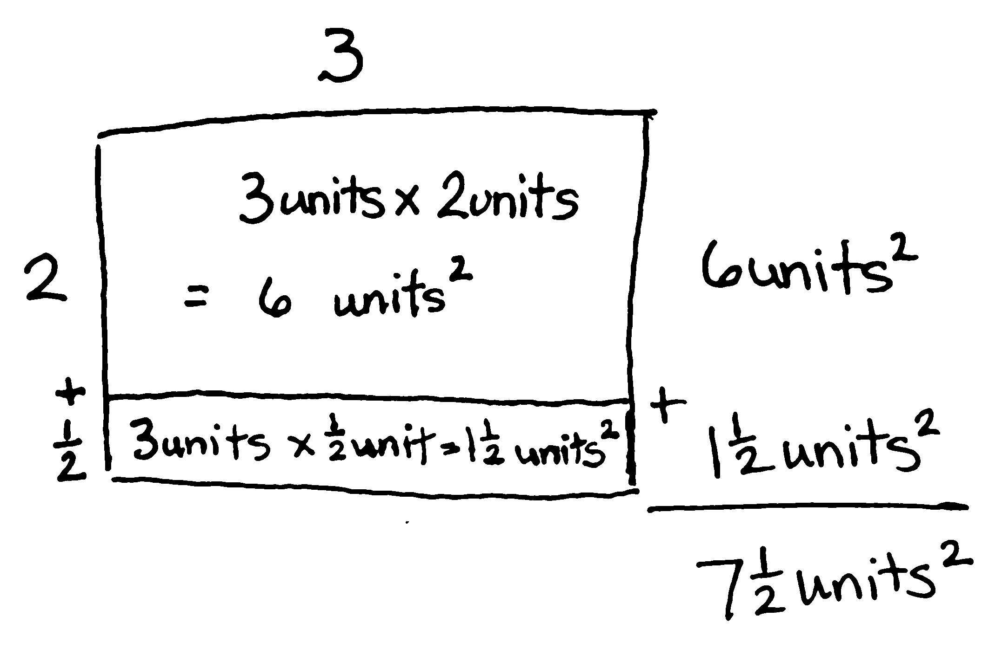
S: $\text{2}\frac{1}{2}$ units.
T: What is the area? How do you know?
S: The area is $\text{7}\frac{1}{2}$ units squared. I counted all of the whole square units first and then added on the halves.
I knew it was at least 6 square units, and then we had 3 more halves, so that’s $\text{7}\frac{1}{2}$ square units. 3 × $\text{2}\frac{1}{2}\text{=} \text{6}\frac{3}{2}\text{=} \text{7}\frac{1}{2}$.
T: When we record our tiling, is it necessary to sketch each tile? Why or why not?
S: No. We can just write down how many there are.
We can show just the side lengths of 3 and $\text{2}\frac{1}{2}$.
I’ll know that means three squares across and two and a half squares down. It is like the area model with whole numbers. If I know the sides, I can show the total area by just multiplying.

 | NOTES ON  MULTIPLE MEANS  OF ENGAGEMENT:
The spatial and visualization skills involved in Lessons 10 and 11 are quite natural for some students and quite challenging for others. Consequently, the time needed to accomplish the tasks varies, but all students should be given the opportunity to tile all the rectangles. Both lessons offer two challenging questions at the end of the Problem Sets for those who finish the tiling quickly.

T: Let’s sketch this rectangle again but without the individual tiles. Draw the rectangle, and label the length. (Allow students time to draw.)
T: Now, let’s decompose the $\text{2}\frac{1}{2}$ units on the width as
2 + $\frac{1}{2}$. (Label and draw a horizontal line across the rectangle as pictured. Allow students time to draw.)
T: Let’s record the first partial product. (Point.) Three units long by 2 units wide is what area?
S: 6 square units.
T: Let’s record the second partial product. (Point.) What is the length of this portion?
S: 3 units.
T: What is the width of this portion?
S: 1 half unit.
T: What is the area of this part? How do you know?
S: The area is $\text{1}\frac{1}{2}$ square units because 3 copies of $\frac{1}{2}$ is 3 halves. 3 units long by $\frac{1}{2}$ unit wide is $\text{1}\frac{1}{2}$ square units.
T: Does this $\text{7}\frac{1}{2}$ unit squared area make sense given our prediction? Why or why not?
S: It does make sense. It is only a little wider than the first rectangle, and $\text{7}\frac{1}{2}$ is not that much more than 6. You can see the first rectangle inside this one. There was a part that was 3 units by
2 units, and then a smaller part was added on that was 3 units by just half another unit. That is where the extra $\text{1}\frac{1}{2}$ square units come from. Three times two was easy, and then I know that half of 3 is $\text{1}\frac{1}{2}$. By decomposing the mixed number, it was easy to find the total area.
T: Work with your partner to find the length, width, and area of Rectangles C, D, and E using the patty paper and recording with the area model. Record your findings on your Problem Set, and then answer the last two questions in the time remaining. You may record your tiling without drawing each tile if you wish.
S: (Work.)
Problem Set (5 minutes)
Students should do their personal best to complete the remainder of the Problem Set within the allotted five minutes if they have finished the tiling problems. Some problems do not specify a method for solving. Students should solve these problems using the RDW approach used for Application Problems.
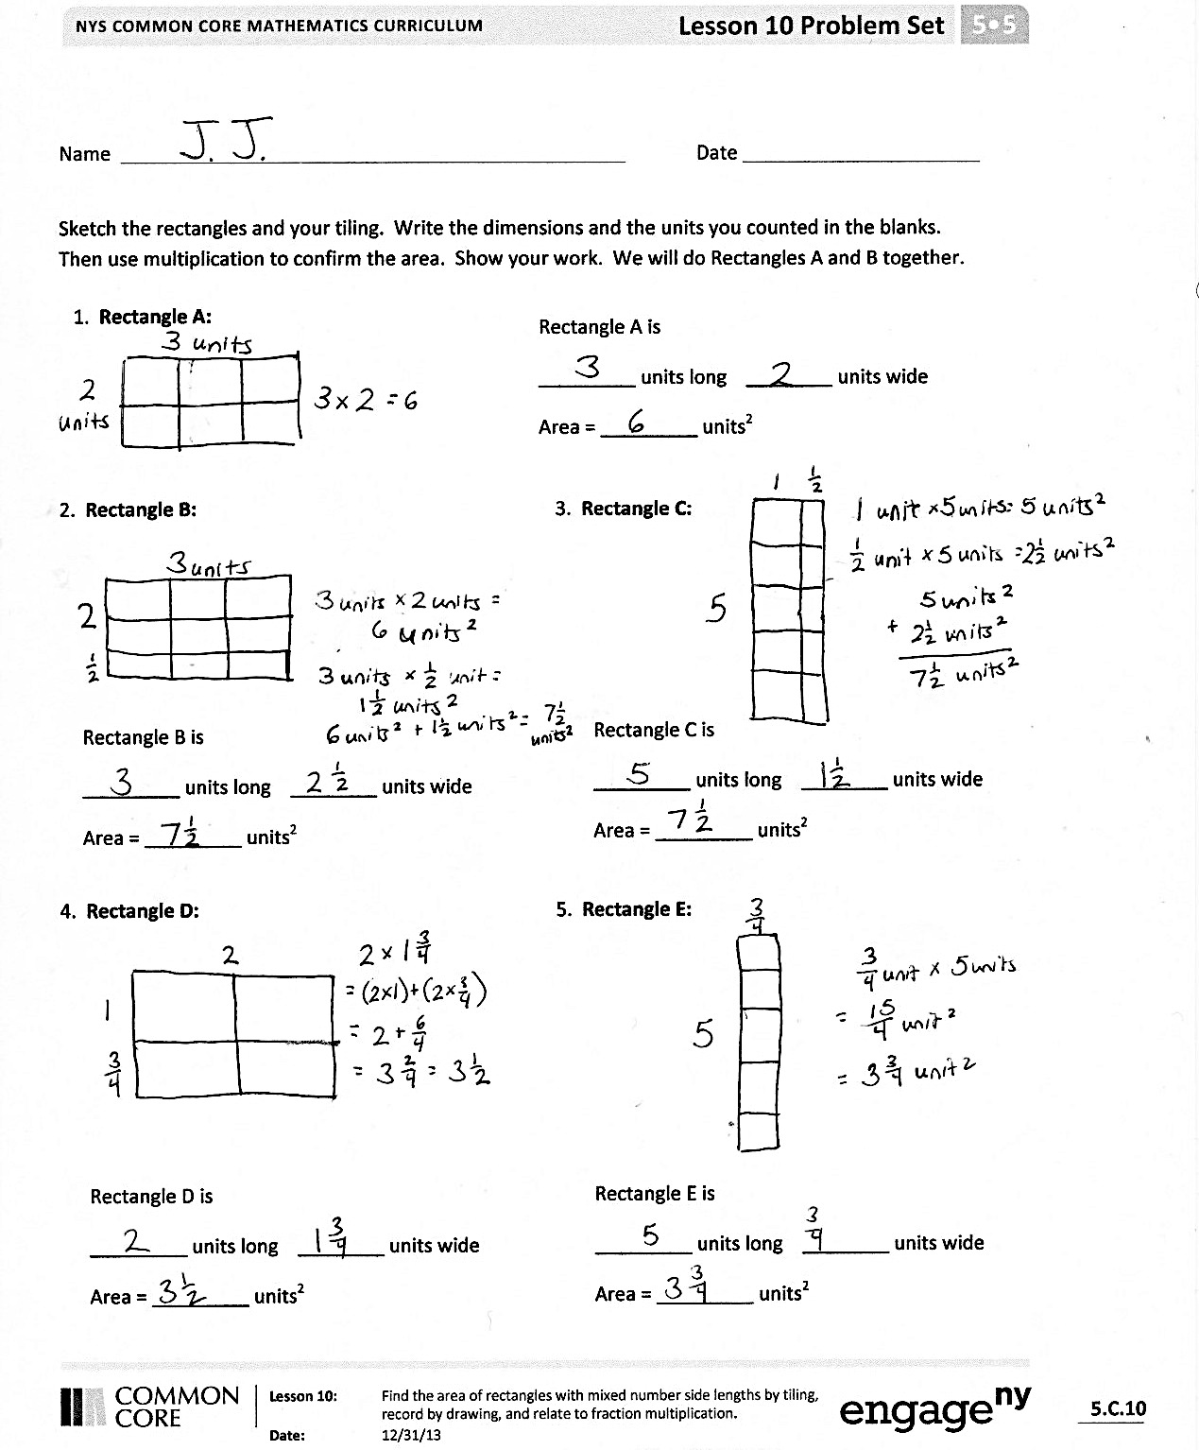
Student Debrief (10 minutes)
Lesson Objective: Find the area of rectangles with
whole-by-mixed and whole-by-fractional number side lengths by tiling, record by drawing, and relate to fraction multiplication.
The Student Debrief is intended to invite reflection and active processing of the total lesson experience.
Invite students to review their solutions for the Problem Set. They should check work by comparing answers with a partner before going over answers as a class. Look for misconceptions or misunderstandings that can be addressed in the Debrief. Guide students in a conversation to debrief the Problem Set and process the lesson.

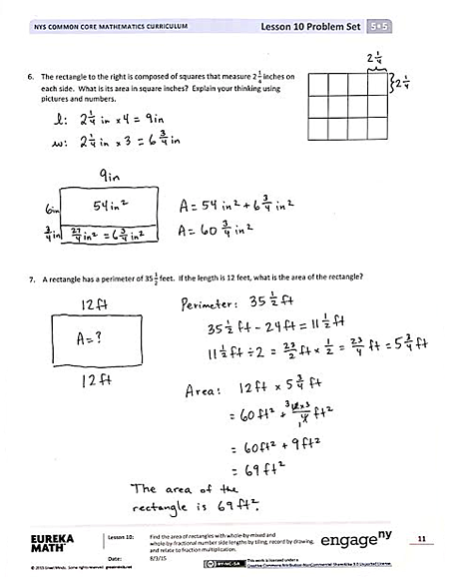
Any combination of the questions below may be used to lead the discussion.
Record students’ answers to Problem 1 to complete the class chart as answers are reviewed.
- What relationship did you notice between the areas of Rectangle C and Rectangle E? What accounts for this relationship?
- How was Rectangle E different from the other rectangles you tiled? Describe how you tiled it.
- How did you determine the area of Rectangle E? Did you count the single units? Add repeatedly? Multiply the sides?
- Could you place these rectangles in order of greatest to least area by using relationships among the dimensions but without actually performing the calculations? Why or why not?
- How did you determine the area of the rectangle in Problem 6?
- Analyze and compare different solution strategies for Problem 7.
Exit Ticket (3 minutes)
After the Student Debrief, instruct students to complete the Exit Ticket. A review of their work will help with assessing students’ understanding of the concepts that were presented in today’s lesson and planning more effectively for future lessons. The questions may be read aloud to the students.

Name Date
Sketch the rectangles and your tiling. Write the dimensions and the units you counted in the blanks.
Then, use multiplication to confirm the area. Show your work. We will do Rectangles A and B together.
Rectangle A is
units long units wide
Area = units²

- Rectangle A:

2. Rectangle B: 3. Rectangle C:

Rectangle C is
units long units wide
Area = units²

Rectangle B is
units long units wide
Area = units²

4. Rectangle D: 5. Rectangle E:

Rectangle D is
units long units wide
Area = units²

Rectangle E is
units long units wide
Area = units²

- The rectangle to the right is composed of squares that measure $\text{2}\frac{1}{4}$ inches on each side. What is its area in square inches? Explain your thinking using pictures and numbers.

- A rectangle has a perimeter of $\text{35}\frac{1}{2}$ feet. If the length is 12 feet, what is the area of the rectangle?

Name Date
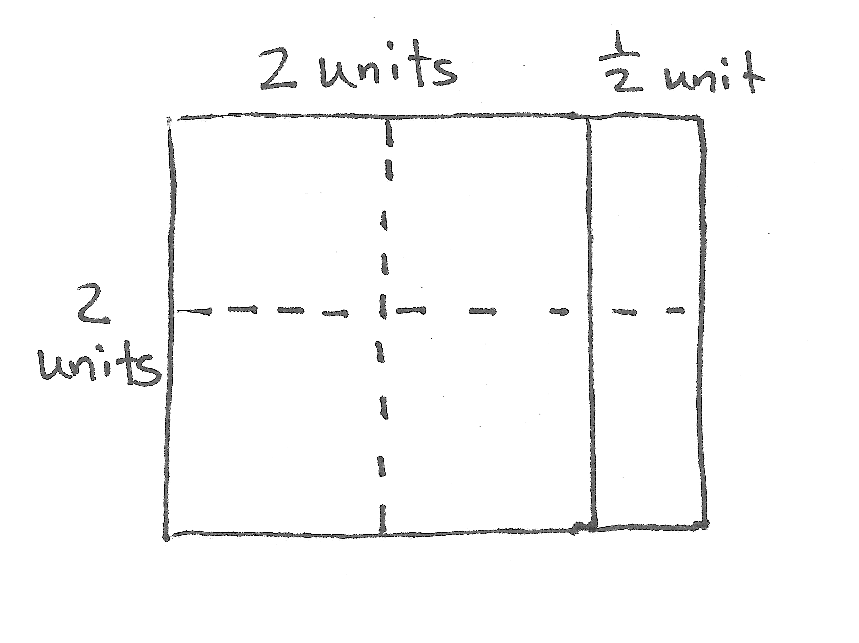
Emma tiled a rectangle and then sketched her work. Fill in the missing information, and multiply to find the area.
Emma’s Rectangle:
units long units wide
Area = units²

Name Date
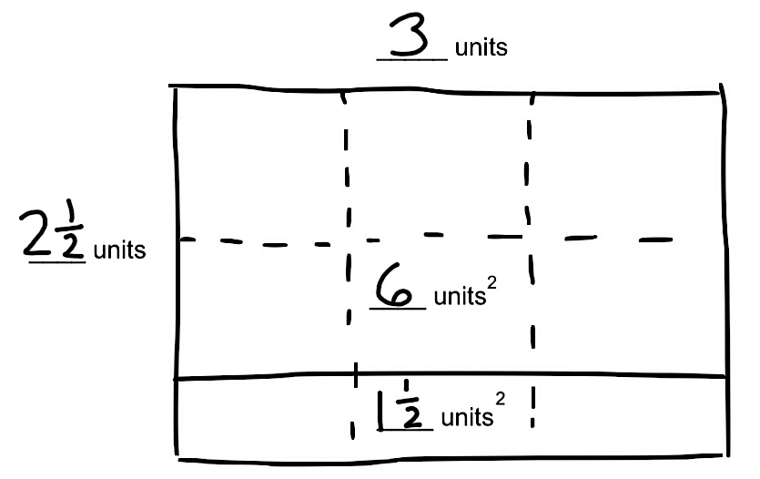
- John tiled some rectangles using square units. Sketch the rectangles if necessary. Fill in the missing information, and then confirm the area by multiplying.
Rectangle A is

units long units wide

Area = units²
a. Rectangle A:
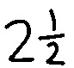


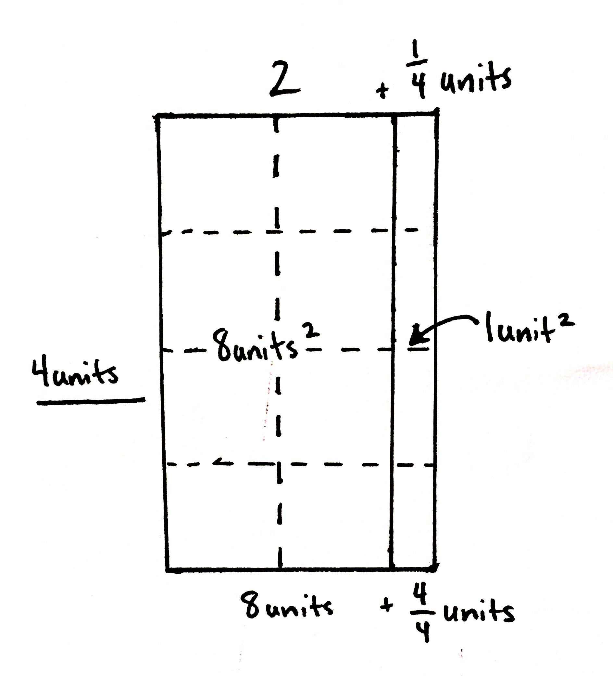
Rectangle B is

units long units wide

Area = units²

b. Rectangle B:

Rectangle C is

units long units wide

Area = units²
c. Rectangle C:
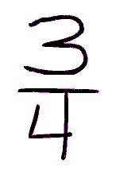
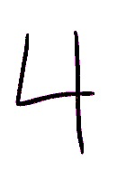

d. Rectangle D:
Rectangle D is

units long units wide

Area = units²
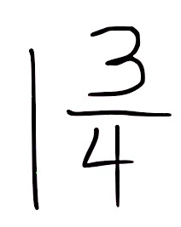
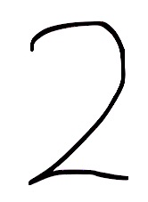

- Rachel made a mosaic from different color rectangular tiles. Three tiles measured $\text{3}\frac{1}{2}$ inches × 3 inches. Six tiles measured 4 inches × $\text{3}\frac{1}{4}$ inches. What is the area of the whole mosaic in square inches?

- A garden box has a perimeter of $\text{27}\frac{1}{2}$ feet. If the length is 9 feet, what is the area of the garden box?

