Lesson 11
Objective: Find the area of rectangles with mixed-by-mixed and fraction-by-fraction side lengths by tiling, record by drawing, and relate to fraction multiplication.

Suggested Lesson Structure
 Fluency Practice (12 minutes)
 Application Problem (5 minutes)
 Concept Development (33 minutes)
 Student Debrief (10 minutes)
Total Time (60 minutes)

Fluency Practice (12 minutes)
- Sprint: Multiply Decimals 5.NBT.7 (8 minutes)
- Multiplying Fractions 5.NF.4 (4 minutes)

Sprint: Multiply Decimals (8 minutes)

Materials: (S) Multiply Decimals Sprint
Note: This fluency activity reviews Module 4.

Multiplying Fractions (4 minutes)

Materials: (S) Personal white board
Note: This fluency activity prepares students for Lesson 13.
T: (Write $\frac{1}{2}$ $\text{×}$ $\frac{1}{3}$ = .) Say the multiplication equation with the answer.
S: $\frac{1}{2}$ $\text{×}$ $\frac{1}{3}$ = $\frac{1}{6}$.
T: (Write $\frac{1}{2}$ $\text{×}$ $\frac{3}{4}$ = .) Say the multiplication equation with the answer.
S: $\frac{1}{2}$ $\text{×}$ $\frac{3}{4}$ = $\frac{3}{8}$.
T: (Write $\frac{2}{5}$ $\text{×}$ $\frac{2}{3}$ = .) On your personal white board, write the multiplication equation and the answer.
S: (Write $\frac{2}{5}$ $\text{×}$ $\frac{2}{3}$= $\frac{4}{15}$.)
Continue with the following possible sequence: $\frac{1}{2}$ $\text{×}$ $\frac{1}{5}$,$\frac{1}{2}$ $\text{×}$ $\frac{3}{5}$, $\frac{3}{4}$ $\text{×}$ $\frac{3}{5}$, $\frac{4}{5}$ $\text{×}$ $\frac{2}{3}$, and $\frac{3}{4}$ $\text{×}$ $\frac{5}{6}$.

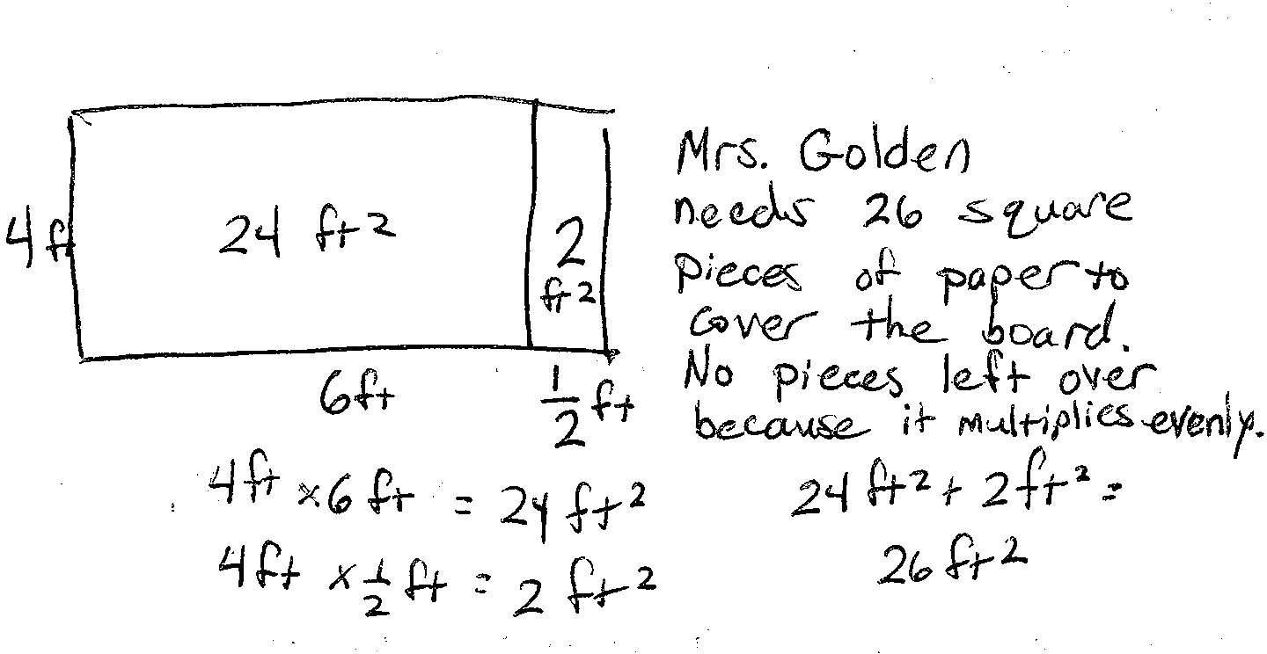
Application Problem (5 minutes)
Mrs. Golden wants to cover her 6.5-foot by 4-foot bulletin board with silver paper that comes in 1-foot squares. How many squares does Mrs. Golden need to cover her bulletin board? Will there be any fractional pieces of silver paper left over? Explain why or why not. Draw a sketch to show your thinking.
Note: This Application Problem reviews Lesson 10’s concept of tiling, now with one dimension as a decimal fraction.

Concept Development (33 minutes)
Materials: (T) Rectangles, patty paper units for tiling, personal white board (S) 1 demonstration and
5 mystery rectangles lettered A–E (1 of each size per group), patty paper units for tiling,
Problem Set
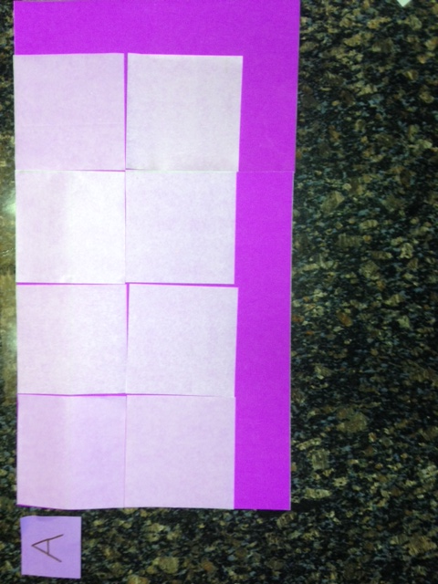
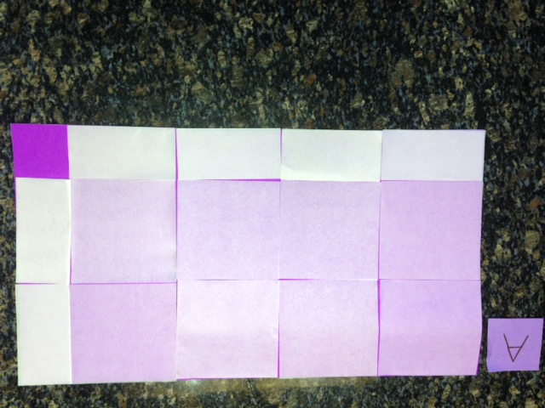
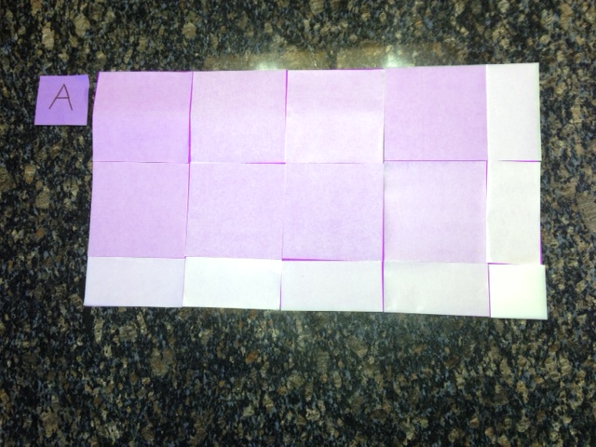
Note: Today’s lesson parallels the structure of Lesson 10. Rectangles for each group should be prepared in advance following yesterday’s instructions. The dimensions of today’s rectangles are given below.
Rectangle A: $\text{4}\frac{1}{2}$ units $\text{×}$ $\text{2}\frac{1}{2}$ units
Rectangle B: $\text{1}\frac{3}{4}$ units $\text{×}$ $\text{3}\frac{3}{4}$ units
Rectangle C: $\frac{3}{4}$ unit $\text{×}\text{ 1}\frac{\text{1}}{\text{2}}$ units
Rectangle D: $\frac{3}{4}$ unit $\text{×}$ $\frac{1}{2}$ unit
Rectangle E: $\frac{2}{3}$ unit $\text{×}$ $\frac{2}{3}$ unit
The added complexities of today’s lesson involve the inclusion of two mixed number or fractional side lengths. This is an application of the fraction multiplication lessons of Module 4. Students record partial products rather than draw
individual tiles.

T: Let’s start with Rectangle A. Work with your partner
to place as many whole tiles on Rectangle A as you
can. Remember to start at the top left corner of
the rectangle.

 | NOTES ON  MULTIPLE MEANS  OF ENGAGEMENT:
Include Rectangle E as an optional challenge. Folding and tiling Rectangle E requires students to fold thirds and to reason about another area less than
1 square tile. Recording for Rectangle E should be done on a separate piece of paper, as it is not included on the Problem Set.
The last two problems on the Problem Set also offer extensions for students who finish the tiling and multiplication quickly.

S: (Place whole tiles on Rectangle A.)
T: How many whole tiles fit?
S: 8.
T: Is this the area of the rectangle?
S: No.
T: Fold some of your square units to cover the rest of
the rectangle’s length. (Allow time for students to work.)
T: What fractional unit do you need to do this?
How many?
S: I needed 2 half units. The unit was halves. I needed 2 of them.

 | NOTES ON  MULTIPLE MEANS  OF ACTION AND EXPRESSION:
For some students, it may be more effective to place a whole square unit over the last corner of the rectangle and then trace the outline or shade the corner of the rectangle on the patty paper. (Because the patty paper is translucent, the edge of the rectangle is clearly visible.) Students may then fold until only the outlined portion of the paper is visible. When the paper is unfolded, only 1 of the 4 equal parts is bordered (or shaded).

Also, guide students to isolate the last corner of the rectangle and use a single piece of patty paper to model the multiplication of a fraction by a fraction to produce a double-shaded area (as in Module 4). This double-shaded portion can then be laid on top of the rectangle’s corner, fitting perfectly.

T: Now, fold some units to cover the rest of the rectangle’s width. (Allow time for students to work.)
T: What fractional unit did you use this time, and
how many?
S: I needed halves again. This time, it was 4. It was
4 half units.
T: I see that we have covered almost all of the rectangle, but there seems to be a part at the bottom that is even smaller than the halves we just placed. How can we find the fractional unit that will fit here? Turn and talk.
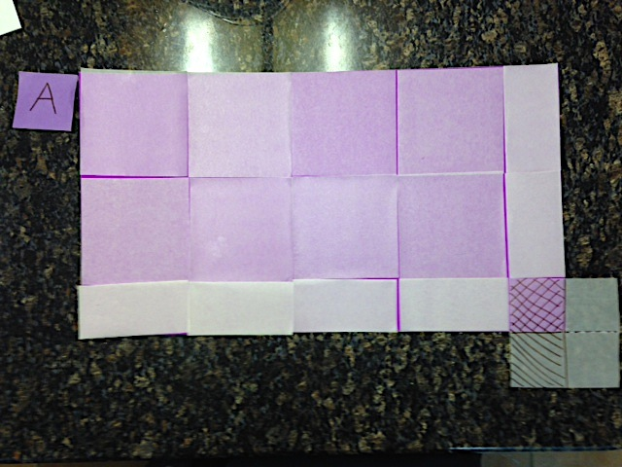
S: I can see that if I fold a square unit in half, it fits in one direction, but it is too long in the other direction. Maybe if I fold it again, it will fit. If I fold it in half, it fits the length. Then, if I fold that half in half again, it fits perfectly in the space. The part is half the size of half a square unit. Half of a half is 1 fourth of a
square unit.
T: Unfold the paper that you have made to fit in this part. What fraction of a whole square unit covers this part?
S: 1 fourth of a square unit.
T: Work with your partner to count the tiles to determine the area.
S: (Count the tiles with partners.)

T: What is the area? How did you count it?
S: I counted the 8 squares first. I added 6 halves or 3 more squares. Then, I added $\frac{1}{4}$ to 11. That’s $\text{11}\frac{1}{4}$square units. I could see 2 rows of 4 $\frac{1}{2}$ units. That is 9. Then, there were 4 halves and $\frac{1}{4}$ in a row. That is $\text{2}\frac{1}{4}$ + 9 = $\text{11}\frac{1}{4}$. The area is $\text{11}\frac{1}{4}$ square units.
T: Let’s record our thinking. I will work on the board.
You record on your Problem Set. Sketch the rectangle first. Decompose the length and width into ones and fractional parts.

 | NOTES ON  MULTIPLE MEANS  OF REPRESENTATION:
Please note that the algorithm is provided so that students are exposed to a more formal representation of the distribution. However, students should not be required to be as formal in their own calculations. Using an area model to keep track of students’ thinking is sufficient.

S: (Sketch and decompose the length and width.)
T: How did you decompose the length?
S: 4 + $\frac{1}{2}$.
T: (Record in the algorithm.) The width?
S: 2 + $\frac{1}{2}$.
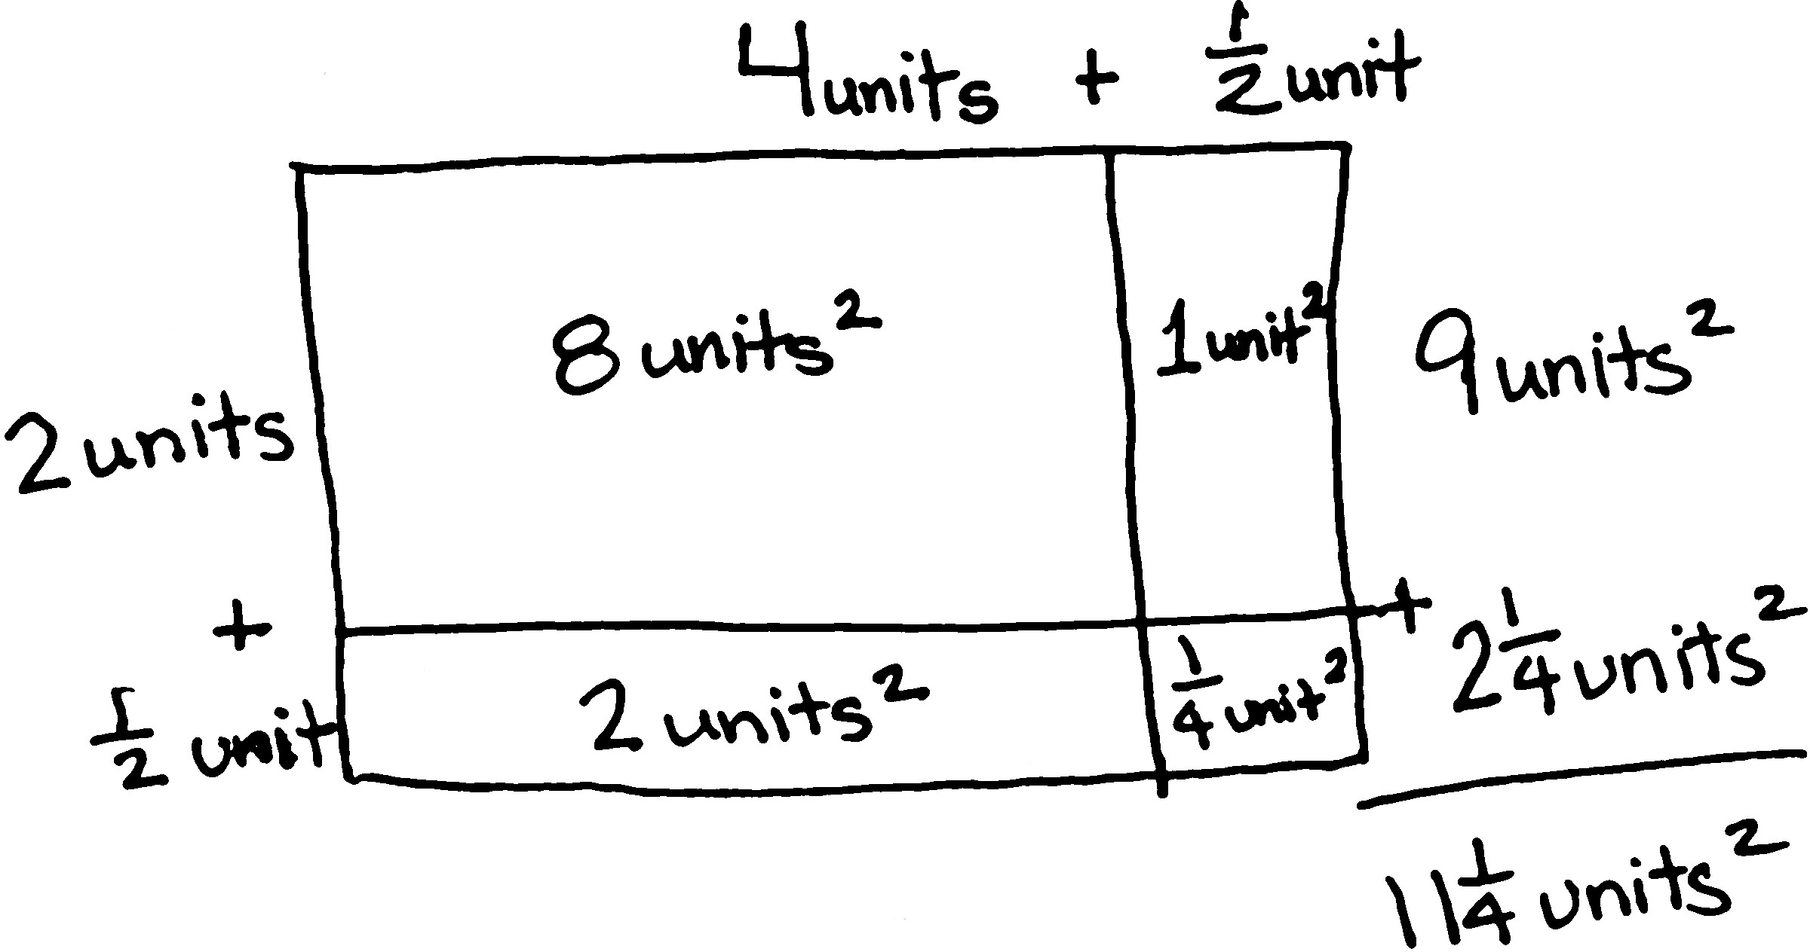
T: (Record in the algorithm.) Let’s use multiplication to confirm the area we found with counting. Let’s start with the ones. (Point, and then record each partial product in the rectangle and in the algorithm.)
2 units $×$ 4 units equals …?
S: 8 square units.
T: (Point and record.) 2 units $×$ $\frac{1}{2}$ unit equals…?
S: 2 half square units. 1 square unit.
T: (Point and record.) $\frac{1}{2}$ unit $×$ 4 units equals…?
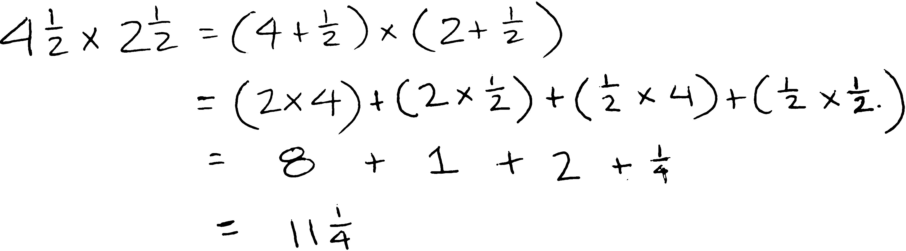
S: 4 half square units. 2 square units.
T: (Point and record.) $\frac{1}{2}$ unit $×$ $\frac{1}{2}$ unit equals…?
S: $\frac{1}{4}$ square unit.
T: Find the sum.
S: (Work to find $\text{11}\frac{1}{4}$ units2.)
T: Was the area the same using multiplication and the area model?
S: Yes!
T: Use your tiles to determine the area and dimensions of the other rectangles. Record your findings on your Problem Set. Then, multiply to confirm the area.

Problem Set (10 minutes)
Students should do their personal best to complete the remainder of the Problem Set within the allotted
10 minutes if they have finished the tiling problems. Some problems do not specify a method for solving. Students should solve these problems using the RDW approach used for Application Problems.

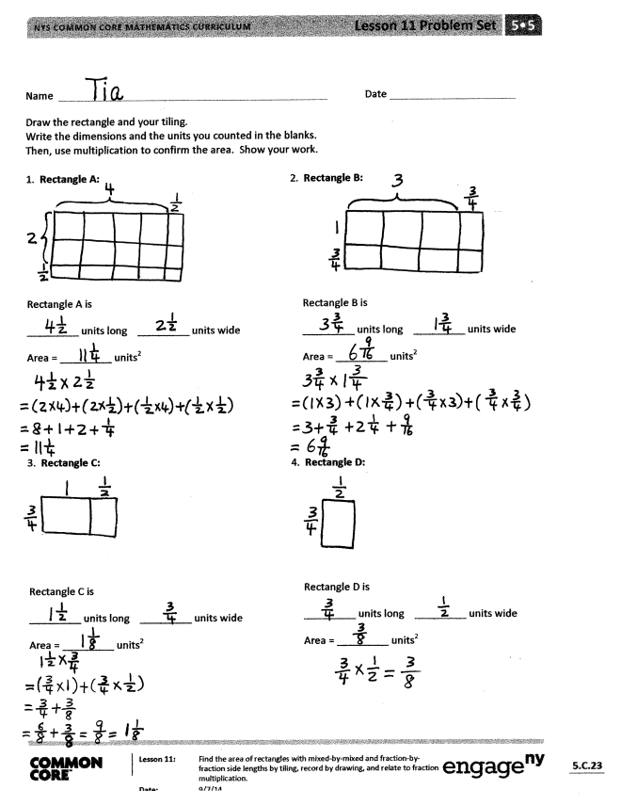
Student Debrief (10 minutes)
Lesson Objective: Find the area of rectangles with mixed-by-mixed and fraction-by-fraction side lengths by tiling, record by drawing, and relate to fraction multiplication.
The Student Debrief is intended to invite reflection and active processing of the total lesson experience.
Invite students to review their solutions for the Problem Set. They should check work by comparing answers with a partner before going over answers as a class. Look for misconceptions or misunderstandings that can be addressed in the Debrief. Guide students in a conversation to debrief the Problem Set and process
the lesson.
Any combination of the questions below may be used to lead the discussion.
- Compare the rectangles we tiled today to the rectangles we tiled yesterday. What do you notice? How did that change the way we had
to tile?
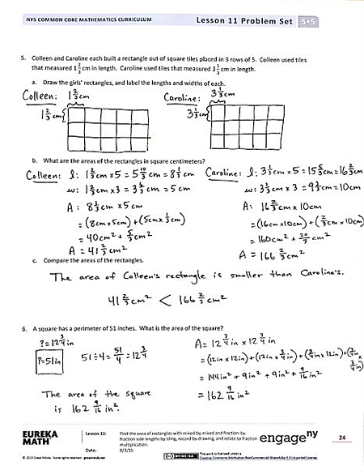
- Which rectangle was the easiest to tile? Which was the hardest? Why?
- Explain your strategy for tiling Rectangle D (and Rectangle E, where applicable). How was finding the area of this rectangle similar to the fraction multiplication we did in Module 4? How was
it different?
- Explain your strategy for finding the areas of the rectangles in Problem 5 and how you
compared them.
- How is Problem 6 in today’s Problem Set like Problem 7 in yesterday’s Problem Set (Lesson 10), and how is it different? Yesterday’s problem read: A rectangle has a perimeter of $\text{35}\frac{1}{2}$ feet.
If the length is 12 feet, what is the area of the rectangle?

Exit Ticket (3 minutes)
After the Student Debrief, instruct students to complete the Exit Ticket. A review of their work will help with assessing students’ understanding of the concepts that were presented in today’s lesson and planning more effectively for future lessons. The questions may be read aloud to the students.

Number Correct: _______
A
Multiply Decimals
 | 3 × 2 = |  |  |  | 0.6 × 2 =
 | 3 × 0.2 = |  |  |  | 0.6 × 0.2 =
 | 3 × 0.02 = |  |  |  | 0.6 × 0.02 =
 | 3 × 3 = |  |  |  | 0.2 × 0.06 =
 | 3 × 0.3 = |  |  |  | 5 × 7 =
 | 3 × 0.03 = |  |  |  | 0.5 × 7 =
 | 2 × 4 = |  |  |  | 0.5 × 0.7 =
 | 2 × 0.4 = |  |  |  | 0.5 × 0.07 =
 | 2 × 0.04 = |  |  |  | 0.7 × 0.05 =
 | 5 × 3 = |  |  |  | 2 × 8 =
 | 5 × 0.3 = |  |  |  | 9 × 0.2 =
 | 5 × 0.03 = |  |  |  | 3 × 7 =
 | 7 × 2 = |  |  |  | 8 × 0.03 =
 | 7 × 0.2 = |  |  |  | 4 × 6 =
 | 7 × 0.02 = |  |  |  | 0.6 × 7 =
 | 4 × 3 = |  |  |  | 0.7 × 0.7 =
 | 4 × 0.3 = |  |  |  | 0.8 × 0.06 =
 | 0.4 × 3 = |  |  |  | 0.09 × 0.6 =
 | 0.4 × 0.3 = |  |  |  | 6 × 0.8 =
 | 0.4 × 0.03 = |  |  |  | 0.7 × 0.9 =
 | 0.3 × 0.04 = |  |  |  | 0.08 × 0.8 =
 | 6 × 2 = |  |  |  | 0.9 × 0.08 =
B
[KEY]

Number Correct: _______
Improvement: _______
Multiply Decimals
 | 4 × 2 = |  |  |  | 0.8 × 2 =
 | 4 × 0.2 = |  |  |  | 0.8 × 0.2 =
 | 4 × 0.02 = |  |  |  | 0.8 × 0.02 =
 | 2 × 3 = |  |  |  | 0.2 × 0.08 =
 | 2 × 0.3 = |  |  |  | 5 × 9 =
 | 2 × 0.03 = |  |  |  | 0.5 × 9 =
 | 3 × 3 = |  |  |  | 0.5 × 0.9 =
 | 3 × 0.3 = |  |  |  | 0.5 × 0.09 =
 | 3 × 0.03 = |  |  |  | 0.9 × 0.05 =
 | 4 × 3 = |  |  |  | 2 × 6 =
 | 4 × 0.3 = |  |  |  | 7 × 0.2 =
 | 4 × 0.03 = |  |  |  | 3 × 8 =
 | 9 × 2 = |  |  |  | 9 × 0.03 =
 | 9 × 0.2 = |  |  |  | 4 × 8 =
 | 9 × 0.02 = |  |  |  | 0.7 × 6 =
 | 5 × 3 = |  |  |  | 0.6 × 0.6 =
 | 5 × 0.3 = |  |  |  | 0.6 × 0.08 =
 | 0.5 × 3 = |  |  |  | 0.06 × 0.9 =
 | 0.5 × 0.3 = |  |  |  | 8 × 0.6 =
 | 0.5 × 0.03 = |  |  |  | 0.9 × 0.7 =
 | 0.3 × 0.05 = |  |  |  | 0.07 × 0.7 =
 | 8 × 2 = |  |  |  | 0.8 × 0.09 =

Name Date
Draw the rectangle and your tiling.
Write the dimensions and the units you counted in the blanks.
Then, use multiplication to confirm the area. Show your work.
- Rectangle A: 2. Rectangle B:

Rectangle B is
units long units wide
Area = units²

Rectangle A is
units long units wide
Area = units²

- Rectangle C: 4. Rectangle D:

Rectangle D is
units long units wide
Area = units²

Rectangle C is
units long units wide
Area = units²

- Colleen and Caroline each built a rectangle out of square tiles placed in 3 rows of 5. Colleen used tiles that measured $\text{1}\frac{2}{3}$cm in length. Caroline used tiles that measured $\text{3}\frac{1}{3}$ cm in length.

- Draw the girls’ rectangles, and label the lengths and widths of each.

- What are the areas of the rectangles in square centimeters?

- Compare the areas of the rectangles.

- A square has a perimeter of 51 inches. What is the area of the square?

Name Date
To find the area, Andrea tiled a rectangle and sketched her answer. Sketch Andrea’s rectangle, and find the area. Show your multiplication work.
Rectangle is
$\text{2}\frac{1}{2}$ units $× \text{2}\frac{1}{2}$ units
Area =

Name Date
- Kristen tiled the following rectangles using square units. Sketch the rectangles, and find the areas.
Then, confirm the area by multiplying. Rectangle A has been sketched for you.

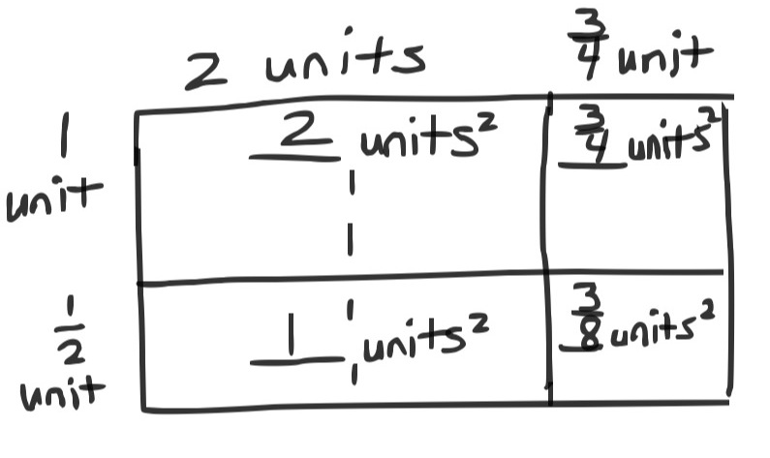
- Rectangle A:
Rectangle A is
__________ units long $×$ __________ units wide
Area = __________ units²

- Rectangle B:
Rectangle B is
$\text{2}\frac{1}{2}$units long $×$ $\frac{3}{4}$unit wide
Area = _________ units²

- Rectangle C:
Rectangle C is
$\text{3}\frac{1}{3}$units long $×$ $\text{2}\frac{1}{2}$units wide
Area = __________ units²

- Rectangle D:
Rectangle D is
$\text{3}\frac{1}{2}$units long $×$ $\text{2}\frac{1}{4}$units wide

Area = __________ units²

- A square has a perimeter of 25 inches. What is the area of the square?

