Lesson 12
Objective: Measure to find the area of rectangles with fractional side lengths.

Suggested Lesson Structure
 Fluency Practice (10 minutes)
 Application Problem (5 minutes)
 Concept Development (35 minutes)
 Student Debrief (10 minutes)
Total Time (60 minutes)
Fluency Practice (10 minutes)
- Multiplying Fractions 5.NF.4 (4 minutes)
- Find the Volume 5.MD.C (6 minutes)
Multiplying Fractions (4 minutes)
Materials: (S) Personal white board
Note: This fluency activity prepares students for Lesson 13.
T: (Write $\frac{1}{3}$ × $\frac{1}{4}=$ .) Complete the multiplication number sentence.
S: $\frac{1}{3}$ × $\frac{1}{4}$ = $\frac{1}{12}$.
T: (Write $\frac{1}{3}$ × $\frac{2}{5}=$ .) Complete the multiplication number sentence.
S: $\frac{1}{3}$× $\frac{2}{5}$ = $\frac{2}{15}$.
T: (Write $\frac{3}{5}$ × $\frac{2}{3}$. Beneath it, write = .) On your personal white board, write the complete multiplication number sentence. Then, simplify the fraction.
S: (Write $\frac{3}{5}$ × $\frac{2}{3}$ = $\frac{6}{15}$. Beneath it, write = $\frac{2}{5}$.)
Continue with the following possible sequence: $\frac{1}{2}$ × $\frac{1}{4}$, $\frac{1}{2}$ × $\frac{3}{4}$, $\frac{3}{4}$ × $\frac{2}{3}$, $\frac{5}{6}$ × $\frac{2}{3}$, and $\frac{3}{4}$ × $\frac{5}{6}$.

Find the Volume (6 minutes)
Materials: (S) Personal white board
Note: This fluency activity reviews volume concepts and formulas.
T: (Project a prism 5 units × 2 units × 4 units. Write V = units × units × units.)
Find the volume.
S: (Write 5 units × 2 units × 4 units = 40 units³.)
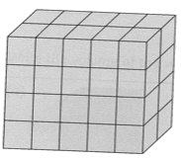
T: How many layers of 10 cubes are in the prism?
S: 4 layers.
T: (Write 4 × 10 units³ = .) Four copies of 10 cubic units is…?
S: 40 cubic units.
T: How many layers of 8 cubes are there?
S: 5 layers.
T: (Write 5 × 8 units³ = .) Five copies of 8 cubic units is…?
S: 40 cubic units.
T: How many layers of 20 cubes are there?
S: 2 layers.
T: Write a multiplication sentence to find the volume of the prism, starting with the number of layers. (Point.)
S: (Write 2 units × 20 units² = 40 units³.)
Repeat the process with the following prisms.
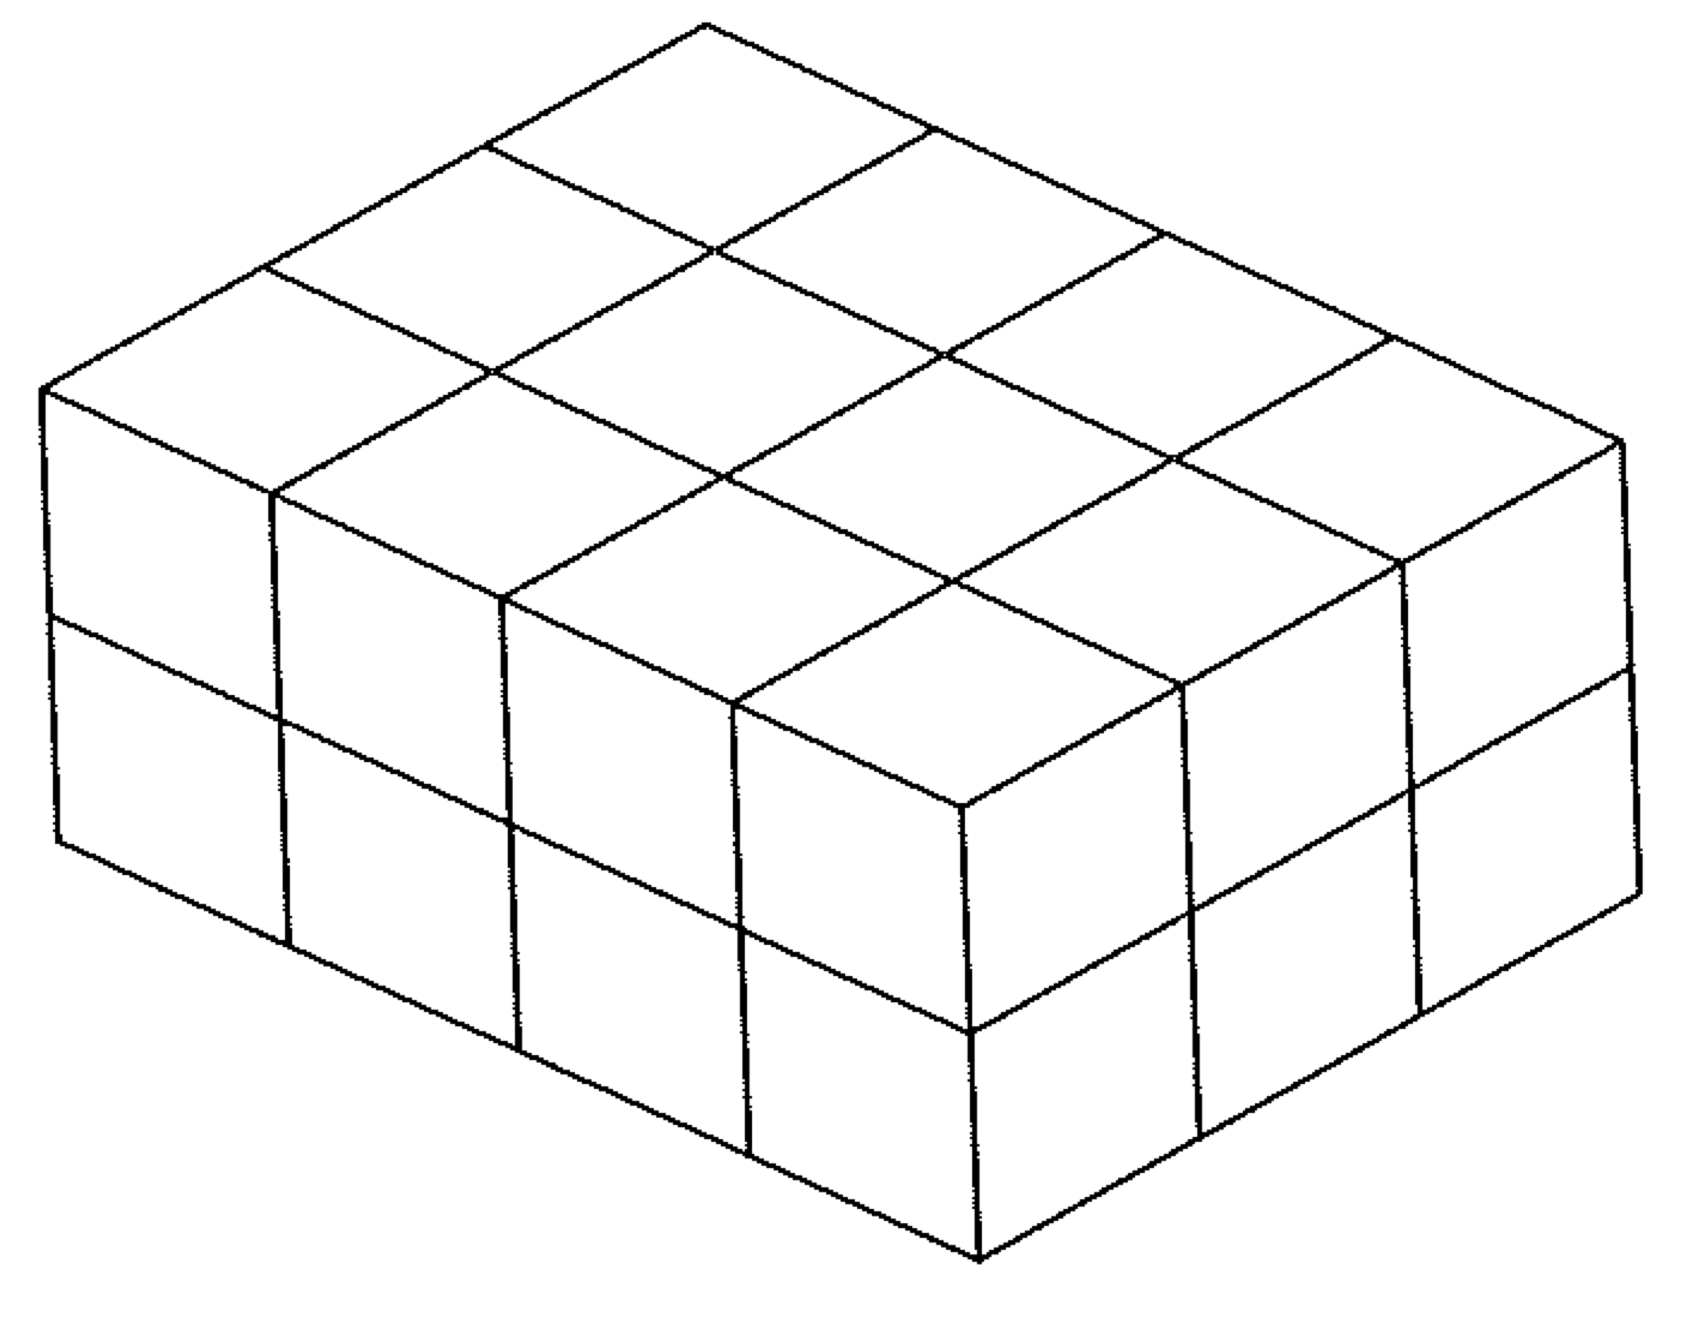
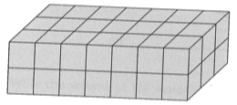

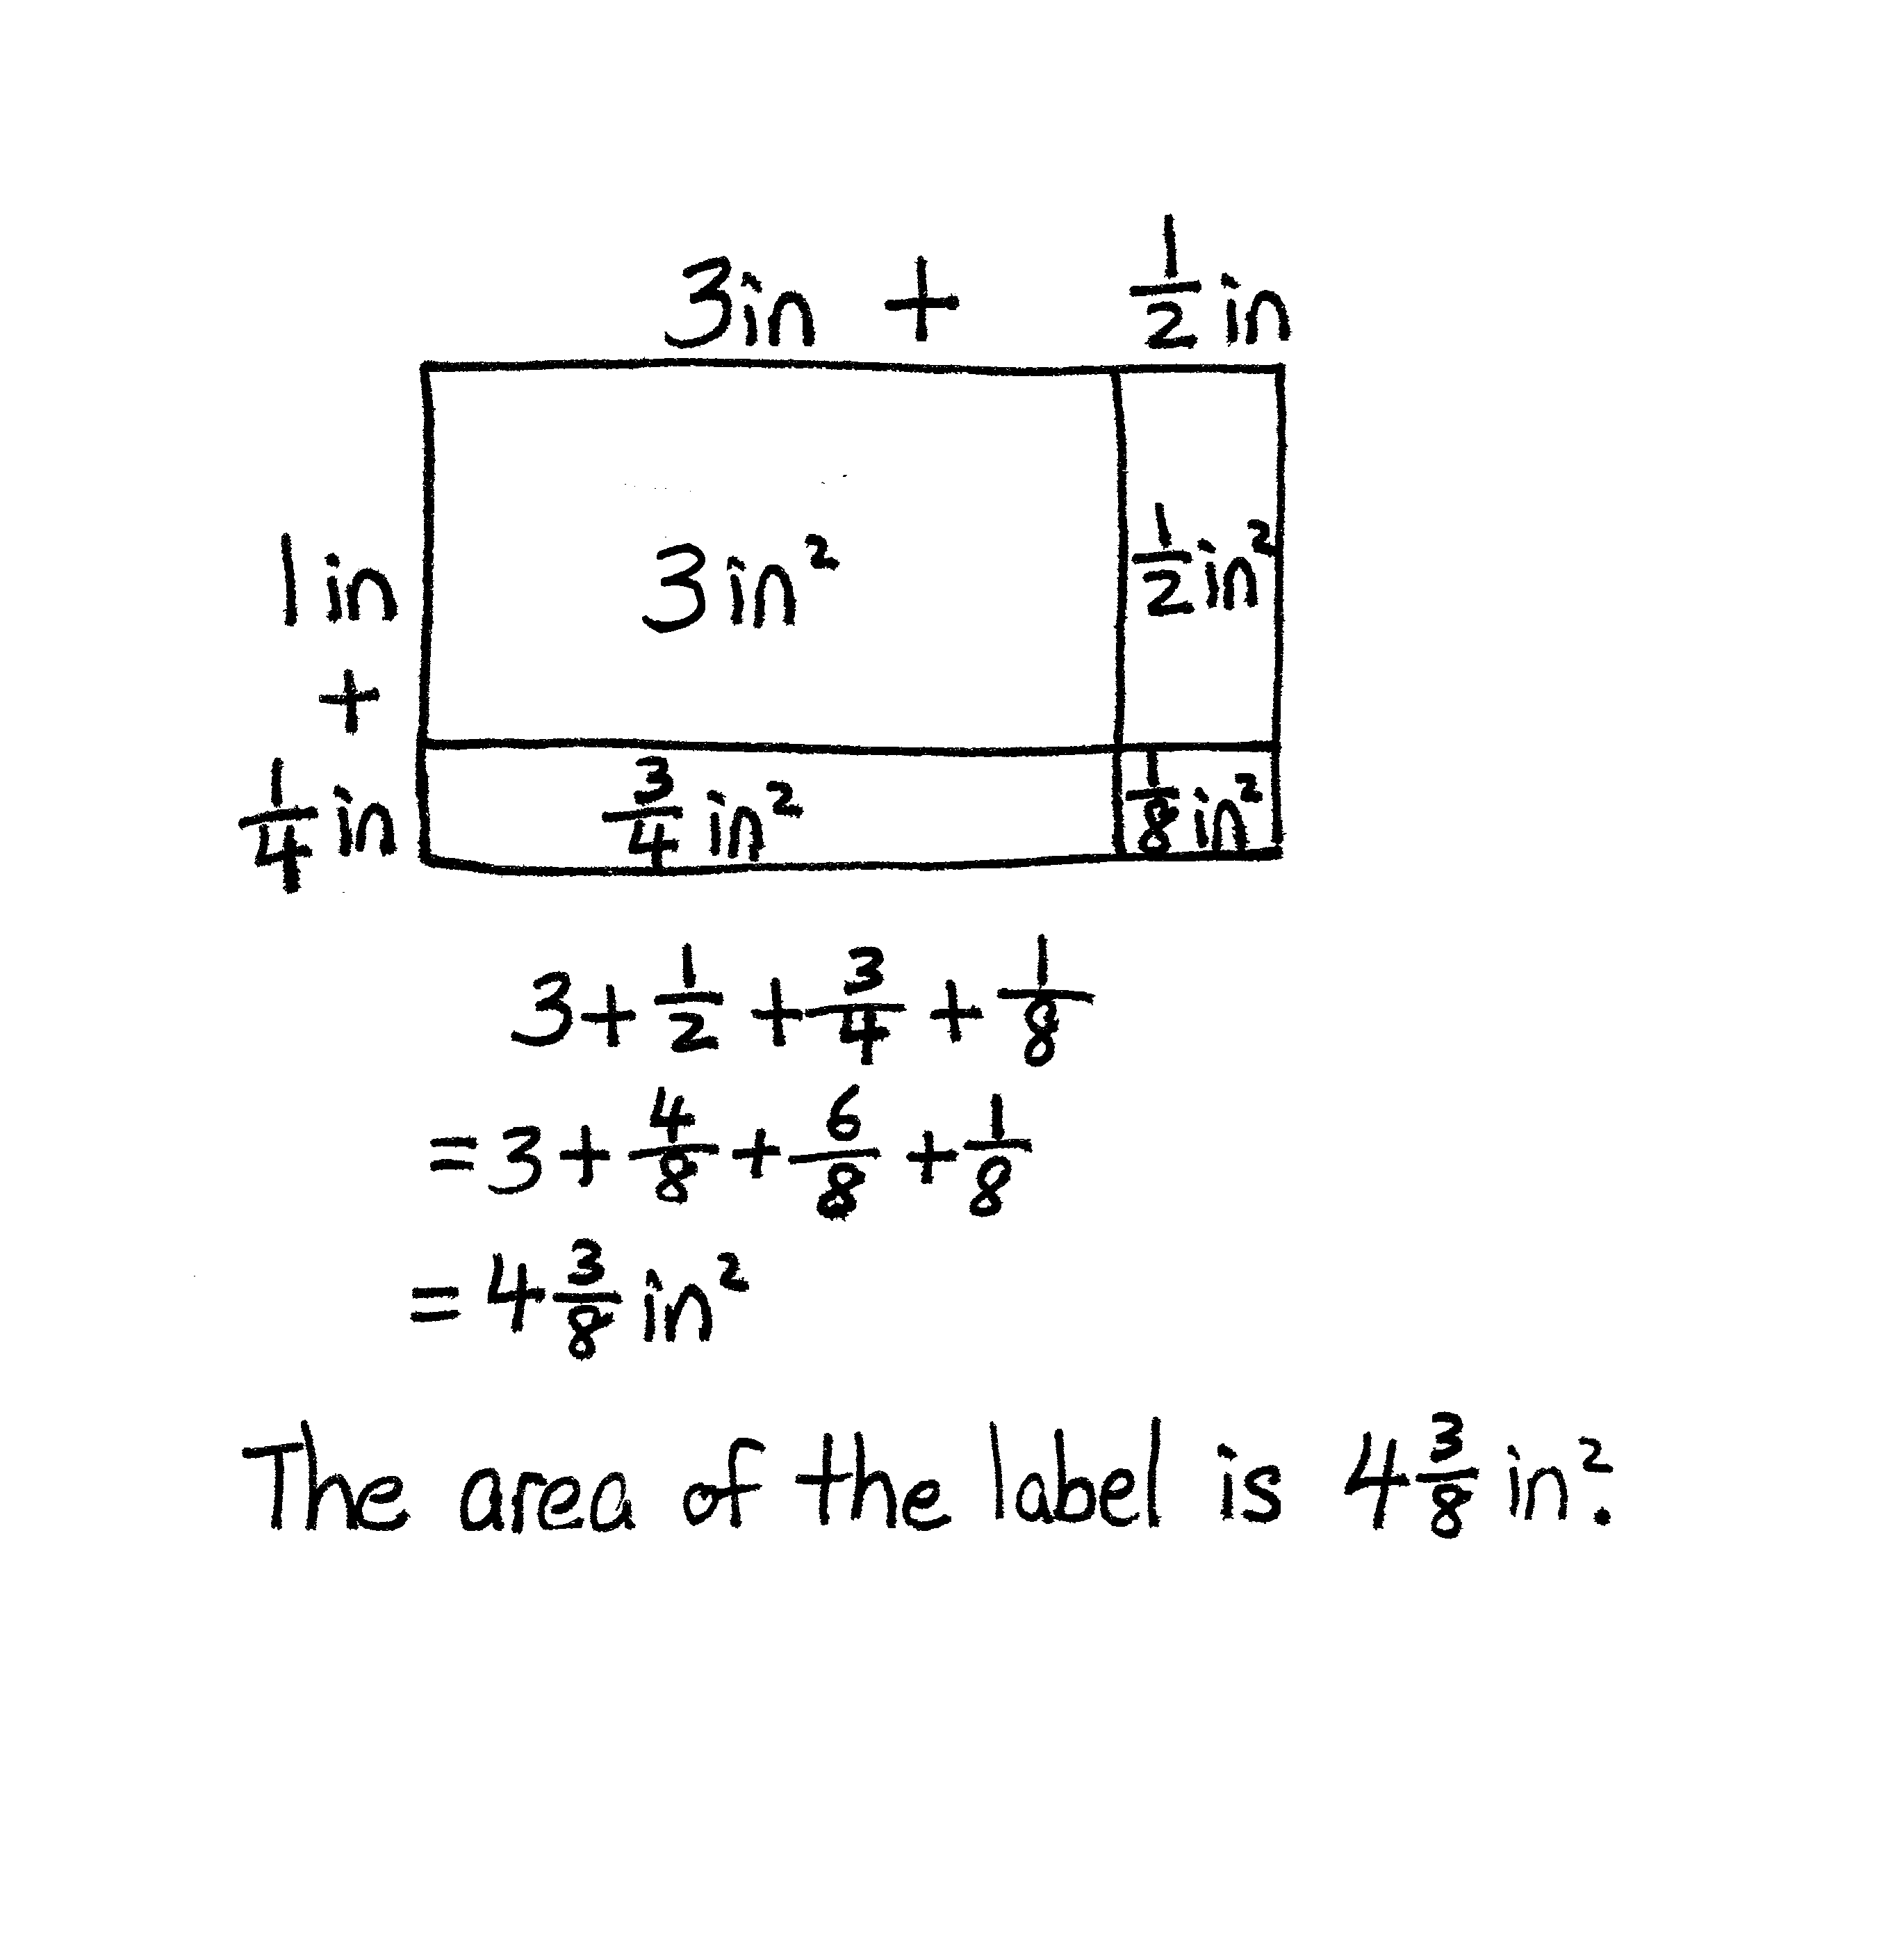
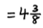
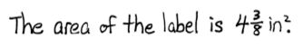
Application Problem (5 minutes)
Margo is designing a label. The dimensions of the label
are $\text{3}\frac{1}{2}$ inches by $\text{1}\frac{1}{4}$ inches. What is the area of the label? Use the RDW process.
Note: Students can use the area model used in Module 4 and in Module 5 Lessons 10–11 to solve. This bridges to today’s lesson, which extends the use of the area model.
Concept Development (35 minutes)
Materials: (T) Ruler, projector (S) Ruler, Problem Set
Problem 1(a)
Project the first rectangle in the Problem Set.
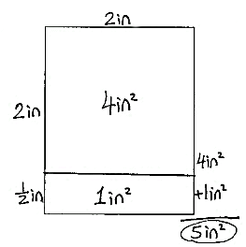
T: We will find the areas of more mystery rectangles today. What was the relationship between the areas we found using square tiles and the areas we found using multiplication?
S: We got the same answers. Tiling or finding partial products using multiplication will always give the same area because the rectangle we are using is the same.
T: Today, we will use a ruler to help us find area. Turn and talk to your partner about how you think a ruler might be useful in finding the area of a rectangle.
S: It’s not square units, but we can measure the edges. The ruler lets us measure the sides to find out the lengths we need to multiply.
T: Work with your partner to measure in inches the lengths of the first rectangle of the Problem Set. Compare your measurements.

 | NOTES ON  MULTIPLE MEANS  OF REPRESENTATION:
Some students will benefit from drawing each square inch as a tile, connecting back to the tiling process. Others may need to use inch tile manipulatives to understand this process. (Remember that concrete materials should be foldable.)
Encourage students to return to pictorial or concrete representations as needed during any lesson to scaffold understanding.

S: (Measure the first rectangle.)
T: What are the lengths of the sides?
S: 2 inches and $\text{2}\frac{1}{2}$ inches.
T: Estimate the area of this rectangle. Turn and talk.
S: If this was just a 2-inch square, the area would be
4 square inches. It’s a little longer than that, so it will be a little more than 4. The longer side is between 2 and 3 inches, so the area should be somewhere between 4 square inches and 6 square inches.
T: Let’s find the actual area. Decompose the longer side by marking the end of the 2 whole inches and labeling the wholes and the half inch on our rectangles.
(Model on the board as shown.)
S: (Decompose and label.)
T: Now, let’s use this decomposition to find the area of smaller parts of the rectangle. Using your ruler, draw a line separating the ones from the fractional units. (Model.)
S: (Separate the ones with a line.)

T: Now, let’s multiply to find the areas of these sections. Let’s start with the ones by ones part.
Talk with your partner. What is the area of the part that is 2 inches by 2 inches? If it helps, imagine or draw tiles in your rectangle.
S: There are 2 going across and 2 rows of them, so 4 altogether. I remember that I can multiply the sides, so 2 inches × 2 inches is 4 square inches.
T: What is the area?
S: 4 square inches.
T: Record that.
T: Turn and talk. What is the area of the smaller part? How do you know?
S: Half of 2, so 1. Two times $\frac{1}{2}$. Two halves make 1, so 1. 1 square inch.
T: Yes, the area is 1 square inch. Let’s write that, too. (Model as shown in the image on the previous page.)
T: What is the total area of the rectangle? Does our answer make sense?
S: 5 square inches. It makes sense because we said the area should be between 4 and 6 square inches, and it is.
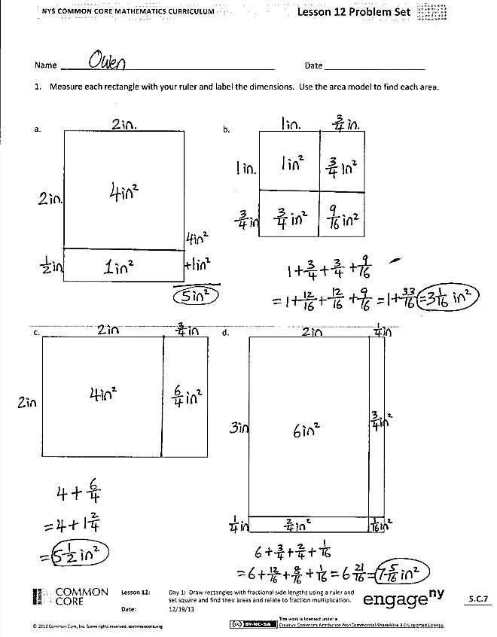


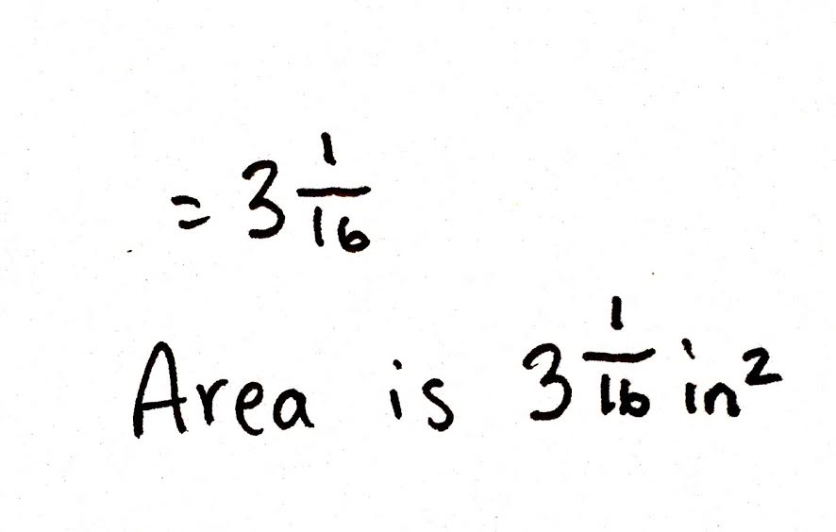
Problem 1(b)
Project the second rectangle in the Problem Set.
T: Measure the next rectangle with your ruler.
T: What is the length?
S: $\text{1}\frac{3}{4}$ inches.
T: And the width?
S: $\text{1}\frac{3}{4}$ inches. This is a square, so the width is also $\text{1}\frac{3}{4}$ inches.
T: Estimate the area with your partner.
S: It’s almost 2 inches by 2 inches. The area should be less than
4 square inches. The area will be between 1 square inch and 4 square inches but closer to 4 because the sides are almost 2 inches long.
T: Decompose the sides into ones and fractional parts, and record that on your Problem Set.
Circulate and assist students. Then, project a student’s work, or record on the board as shown.

 | NOTES ON  MULTIPLE MEANS  OF ENGAGEMENT:
For students who need to review fraction multiplication, model the shaded area models from Module 4 to show a fraction times a fraction or a fraction of a fraction.

T: Work with your partner to find the area of each of these four parts.
S: (Find the area of each of the four parts.)
T: What is the area of the part that is 1 inch on each side?
S: 1 square inch.
T: Then, we have two parts with 1 inch on one side and $\frac{3}{4}$ inch on the other. What is the area of each of those parts? How do you know?
S: It is not a whole square inch. A whole tile would not fit in either of these places. We would have to fold it to make it fit. Three-fourths of a square inch because 3 fourths times 1 is 3 fourths.
T: (Record the measurements in each part of the area model.) Now we are left with the last little square. It is $\frac{3}{4}$ of an inch on each side. Is this area greater or less than the other parts?
How do you know?
S: It is smaller because both sides are shorter than the other parts. It is only part of an inch on each side, so it will be less area. The area is a fraction of a fraction. We want 3 fourths of 3 fourths.
It is a fraction of an inch on each side. Three-fourths of a square inch would be like splitting a whole into 4 parts and taking 1 part off.
T: What do we need to do to find the area of this last section of our square?
S: Just like before, we need to multiply the length times the width. We need to multiply $\frac{3}{4}$ by $\frac{3}{4}.$
T: What is the area of the small square?
S: $\frac{9}{16}$ square inch.
T: How will we find the total area?
S: Add all the parts. Add across each row, and then add the rows together.
Circulate and support students as they add the partial products. Review the need for common denominators as necessary.
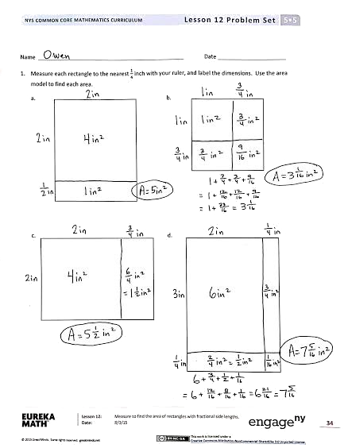
T: What is the total area of the square?
S: $\text{3}\frac{1}{16}$ square inches!
Repeat this sequence of questioning with each problem as necessary. As students understand the concept, release them to work independently.
Problem Set (10 minutes)
Students should do their personal best to complete the remainder of the Problem Set within the allotted
10 minutes. Some problems do not specify a method for solving. Students should solve these problems using the RDW approach used for Application Problems.

Student Debrief (10 minutes)
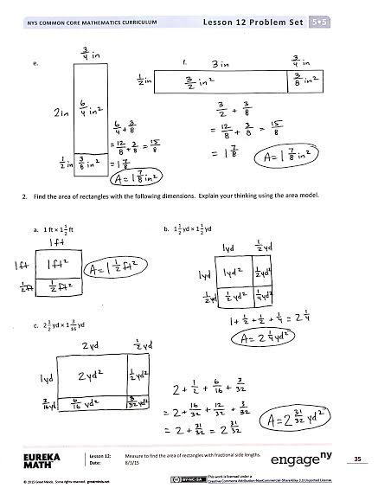
Lesson Objective: Measure to find the area of rectangles with fractional side lengths.
The Student Debrief is intended to invite reflection and active processing of the total lesson experience.
Invite students to review their solutions for the Problem Set. They should check work by comparing answers with a partner before going over answers as a class. Look for misconceptions or misunderstandings that can be addressed in the Debrief. Guide students in a conversation to debrief the Problem Set and process
the lesson.
Any combination of the questions below may be used to lead the discussion.
- Look back at the area model we did together in Problem 1(b) ($\text{1}\frac{3}{4}$ × $\text{1}\frac{3}{4}$). How many squares do you see in your area model? What patterns do you see whenever you have an area model of a square?
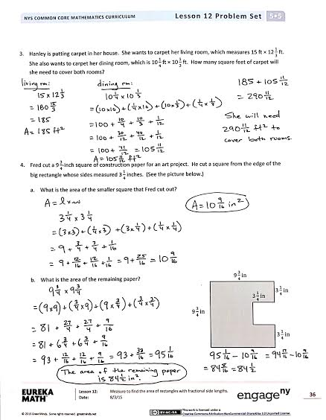
- What is the relationship between Problem 1(e) and Problem 1(f) in the Problem Set? (Both rectangles have the same area. The length of Problem 1(f) is 5 times the length of Problem 1(e). The width of Problem 1(f) is one-fifth the width of Problem 1(e).)
- Using mental math, how can you find $\frac{1}{2}$ times any fraction? (Double the denominator.)
- How is Problem 2(b) like the example we did together, $\text{1}\frac{3}{4}$ × $\text{1}\frac{3}{4}$? (Both have two factors that are the same.)
Exit Ticket (3 minutes)
After the Student Debrief, instruct students to complete the Exit Ticket. A review of their work will help with assessing students’ understanding of the concepts that were presented in today’s lesson and planning more effectively for future lessons. The questions may be read aloud to the students.
Name Date
- Measure each rectangle to the nearest $\frac{1}{4}$ inch with your ruler, and label the dimensions. Use the area model to find each area.
a. | b.
c. | d.
e. | f.

- Find the area of rectangles with the following dimensions. Explain your thinking using the area model.

a. 1 ft × $\text{1}\frac{1}{2}$ ft | b. $\text{1}\frac{1}{2}$ yd × $\text{1}\frac{1}{2}$ yd
c. $\text{2}\frac{1}{2}$ yd × $\text{1}\frac{3}{16}$ yd

- Hanley is putting carpet in her house. She wants to carpet her living room, which measures 15 ft × $\text{12}\frac{1}{3}$ ft. She also wants to carpet her dining room, which is $\text{10}\frac{1}{4}$ft × $\text{10}\frac{1}{3}$ ft. How many square feet of carpet will she need to cover both rooms?

- Fred cut a $\text{9}\frac{3}{4}$-inch square of construction paper for an art project. He cut a square from the edge of the big rectangle whose sides measured $\text{3}\frac{1}{4}$ inches. (See the picture below.)

- What is the area of the smaller square that Fred cut out?

- What is the area of the remaining paper?
$\text{9}\frac{3}{4}$ in
$\text{3}\frac{1}{4}$ in
$\text{9}\frac{3}{4}$ in
$\text{3}\frac{1}{4}$ in
$\text{3}\frac{1}{4}$ in

$\text{3}\frac{1}{4}$ in
Name Date
Measure the rectangle to the nearest $\frac{1}{4}$ inch with your ruler, and label the dimensions. Find the area.

Name Date
- Measure each rectangle to the nearest $\frac{1}{4}$ inch with your ruler, and label the dimensions. Use the area model to find the area.
a. b.

c.

d.

e.

- Find the area of rectangles with the following dimensions. Explain your thinking using the area model.

a. $\text{2}\frac{1}{4}$ yd × $\frac{1}{4}$ yd b. $\text{2}\frac{1}{2}$ ft × $\text{1}\frac{1}{4}$ ft

- Kelly buys a tarp to cover the area under her tent. The tent is 4 feet wide and has an area of 31 square feet. The tarp she bought is $\text{5}\frac{1}{3}$ feet by $\text{5}\frac{3}{4}$ feet. Can the tarp cover the area under Kelly’s tent? Draw a model to show your thinking.

- Shannon and Leslie want to carpet a $\text{16}\frac{1}{2}$-ft by $\text{16}\frac{1}{2}$-ft square room. They cannot put carpet under an entertainment system that juts out. (See the drawing below.)
$\text{16}\frac{1}{2}$ ft
$\text{2}\frac{1}{2}$ ft
$\text{16}\frac{1}{2}$ ft
$\text{2}\frac{1}{2}$ ft
Entertainment
System
- In square feet, what is the area of the space with no carpet?

- How many square feet of carpet will Shannon and Leslie need to buy?

