Lesson 13
Objective: Multiply mixed number factors, and relate to the distributive property and the area model.

Suggested Lesson Structure
 Fluency Practice (10 minutes)
 Application Problem (7 minutes)
 Concept Development (33 minutes)
 Student Debrief (10 minutes)
Total Time (60 minutes)
Fluency Practice (10 minutes)
- Multiplying Fractions 5.NF.4 (4 minutes)
- Find the Volume 5.MD.C (6 minutes)
Multiplying Fractions (4 minutes)
Materials: (S) Personal white board
Note: This fluency activity prepares students for today’s lesson.
T: (Write $\frac{1}{3}$ × $\frac{1}{5}$ = .) Say the complete multiplication number sentence..
S: $\frac{1}{3}$ × $\frac{1}{5}$ = $\frac{1}{15}$.
T: (Write $\frac{2}{3}$ × $\frac{2}{5}$ = .) Say the complete multiplication number sentence.
S: $\frac{2}{3}$ × $\frac{2}{5}$ = $\frac{4}{15}$.
T: (Write $\frac{3}{4}$ × $\frac{2}{3}$ = . Beneath it, write = .) On your personal white board, write the complete multiplication sentence. Then, simplify the fraction.
S: (Write $\frac{3}{4}$ ×$\frac{2}{3}$ = $\frac{6}{12}$. Beneath it, write = $\frac{1}{2}$.)
Continue with the following possible sequence: $\frac{1}{2}$ × $\frac{3}{4}$, $\frac{2}{3}$ × $\frac{3}{5}$, $\frac{3}{4}$ × $\frac{4}{5}$, $\frac{5}{6}$ × $\frac{3}{4}$, and $\frac{3}{5}$ × $\frac{5}{6}$.

Find the Volume (6 minutes)
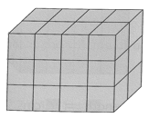
Materials: (S) Personal white board
Note: This fluency activity reviews volume concepts and formulas.
T: (Project a prism 4 units × 2 units × 3 units.
Write V = ____ units × ____ units × ____ units.) Find the volume.
S: (Write 4 units × 2 units × 3 units = 24 units³.)
T: How many layers of 6 cubes are in the prism?
S: 4 layers.
T: (Write 4 × 6 units³.) Four copies of 6 cubic units is…?
S: 24 cubic units.
T: How many layers of 8 cubes are there?
S: 3 layers.
T: (Write 3 × 8 units³.) Three copies of 8 cubic units is…?
S: 24 cubic units.
T: How many layers of 12 cubes are there?
S: 2 layers.
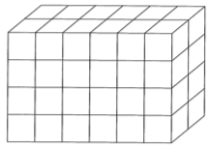
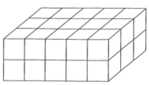
T: Write a multiplication equation to find the volume of the prism, starting with the number of layers.
S: (Write 2 × 12 units³ = 24 units³.)
Repeat the process for the prisms pictured.
Application Problem (7 minutes)
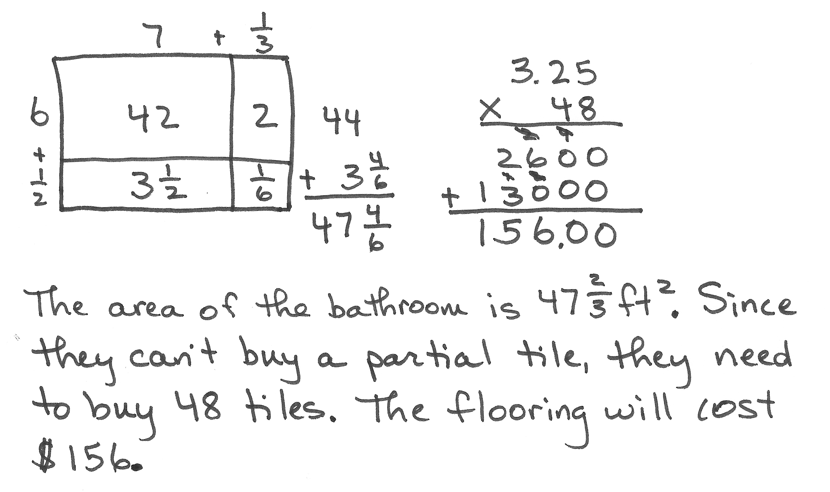
The Colliers want to put new flooring in a $\text{6}\frac{1}{2}$-foot by
$\text{7}\frac{1}{3}$-foot bathroom. The tiles they want come in 12-inch squares. What is the area of the bathroom floor? If the tiles cost $3.25 per square foot, how much will they spend on the flooring?
Note: This type of tiling applies the work from Lessons 10–12 and bridges to today’s lesson on the distributive property.

Concept Development (33 minutes)
Materials: (S) Personal white board
In this lesson, students reason about the most efficient strategy to use for multiplying mixed numbers: distributing with the area model or multiplying improper fractions and canceling to simplify.
Problem 1
$\text{1}\frac{1}{3}$ in
Find the area of a rectangle $\text{1}\frac{1}{3}$inches × $\text{3}\frac{3}{4}$ inches, and discuss strategies for solving.
T: (Project Rectangle 1.) How is this rectangle different from the rectangles we have been working with?
S: We know the dimensions of this one. The side lengths are given to us, so we don’t need to tile or measure.
$\text{3}\frac{3}{4}$ in
T: Find the area of this rectangle. Use an area model to show
your thinking.
S: (Find the area using a model.)
T: What is the area of this rectangle?
S: 5 inches squared.
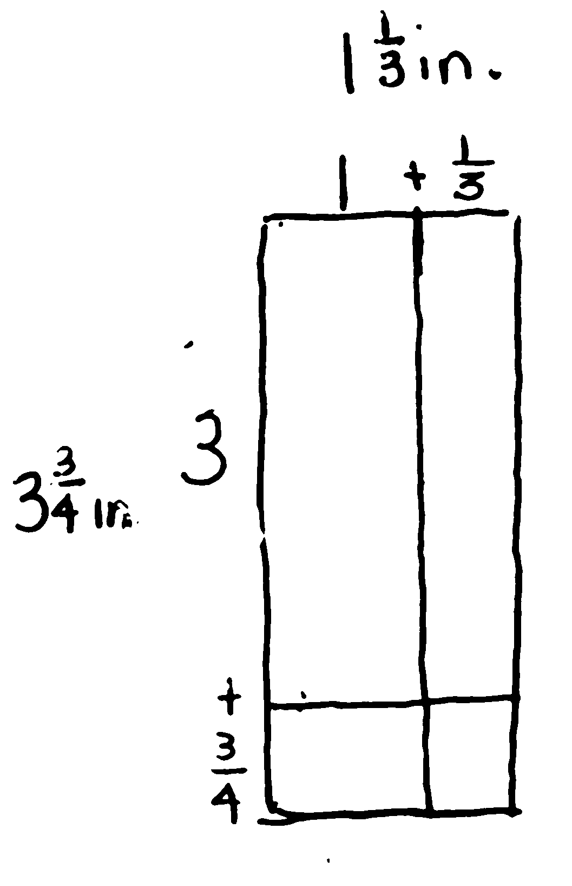
T: We have used the area model many times in Grade 5 to help us multiply numbers with mixed units. How are these side lengths like multi-digit numbers?
Turn and talk.
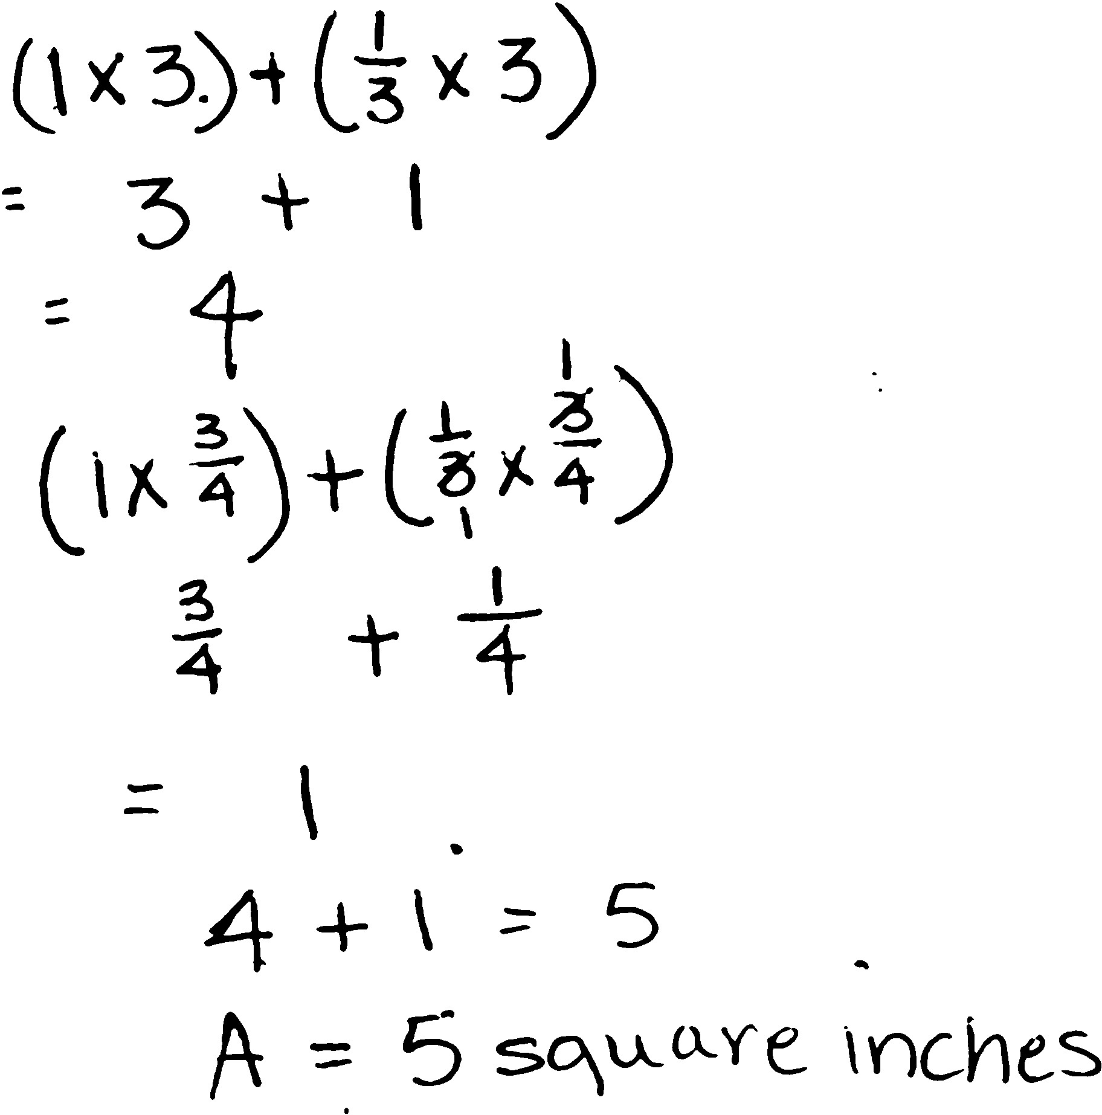
S: A two-digit number has two different size units in it. The ones are the smaller units, and the tens are the bigger units. These mixed numbers are like that.
The ones are the bigger units, and the fractions are the smaller units.
Mixed numbers are another way to write decimals. Decimals have ones and fractions, and so do these.
MP.4
T: (Point to the model and calculations.) When we add partial products, what property of multiplication are
we using?
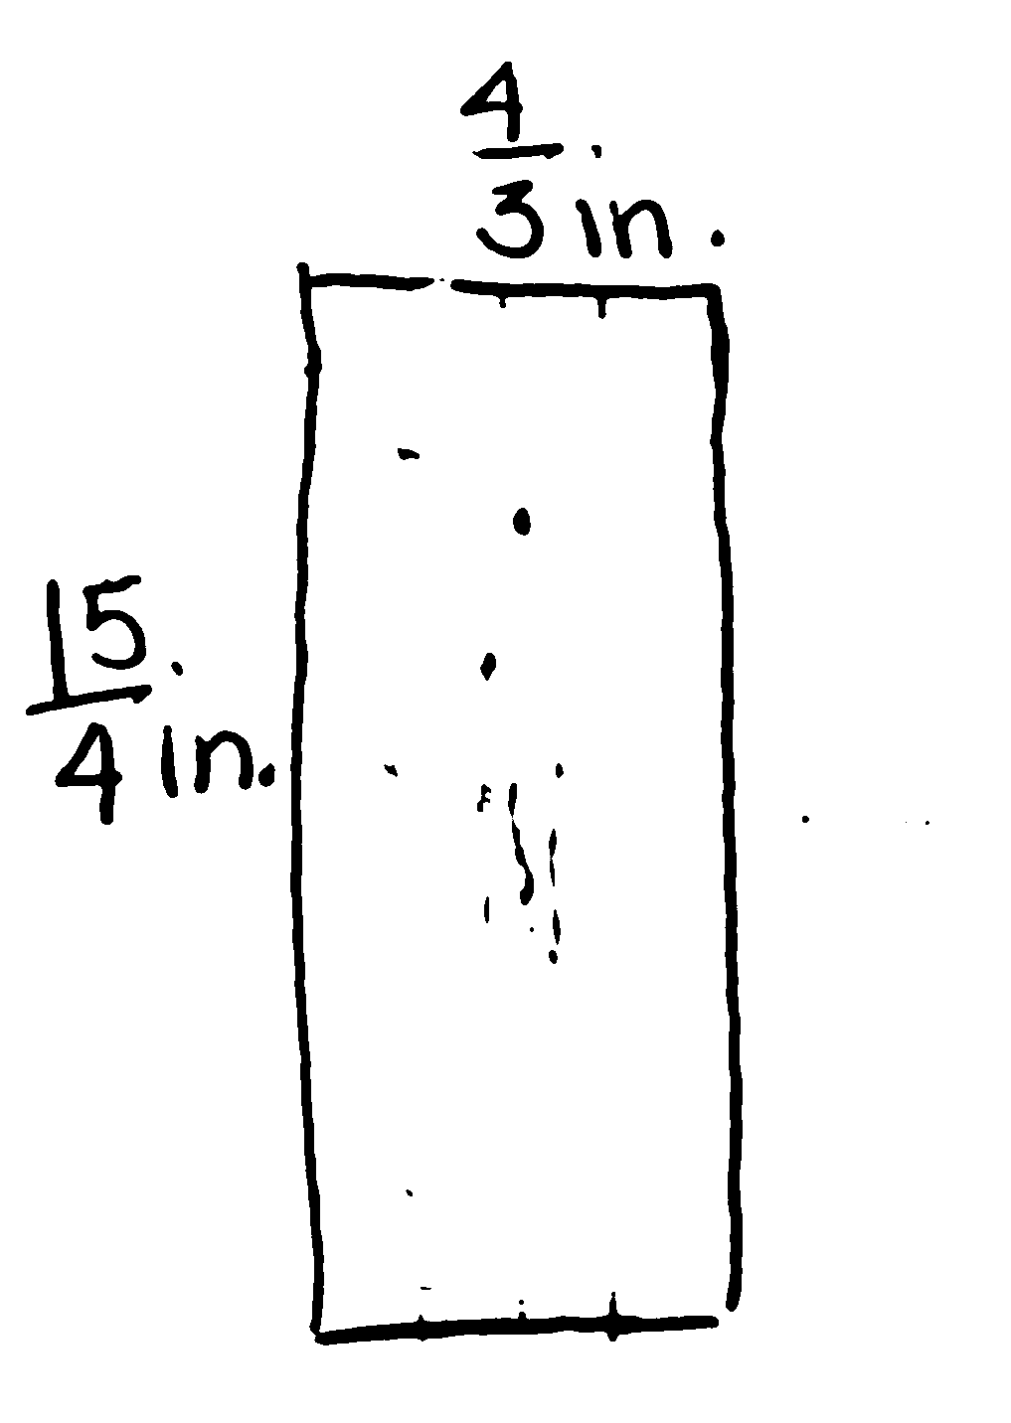
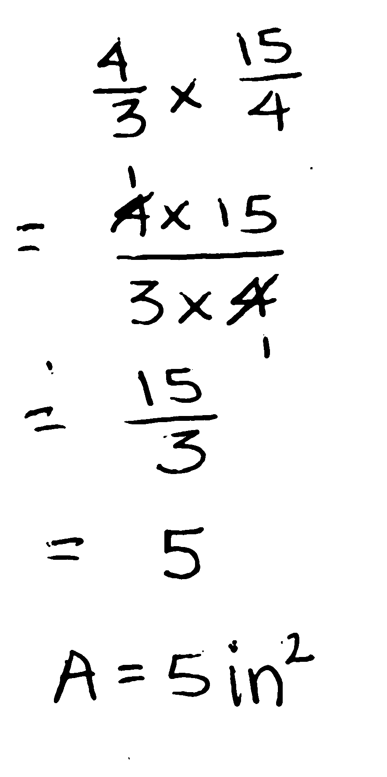
S: The distributive property.
T: Let’s find the area of this rectangle again. This time, let’s use a single unit to express each of the side lengths.
What is $\text{1}\frac{1}{3}$ expressed in thirds?
S: 4 thirds.
T: (Record on the rectangle.) Express $\text{3}\frac{3}{4}$ using only fourths.
S: 15 fourths.
T: (Record on the rectangle.) Multiply these fractions to find the area.

 | NOTES ON  MULTIPLE MEANS  OF ENGAGEMENT:
Some students may need a quick refresher on changing mixed numbers to improper fractions or vice versa. Students should be reminded that a mixed number is an addition sentence. So, when converting to an improper fraction, the whole number can be expressed in the unit of the fractional part and then both like fractions added.
S: (Multiply to find the area.)
T: What is the area?
S: 5 in².
T: Which strategy did you find to be more efficient? Why?
S: I like the strategy of expressing the dimensions as a fraction greater than one. This way was a lot faster for me! These fractions were easy to simplify before I multiplied, so there were fewer calculations to do to find the area.
T: Do you think it will always be true that multiplying the fractions will be the most efficient? Why or why not?
S: This seems easier because it’s multiplying whole numbers. I like the distributive property better because the numbers stay smaller doing one part at a time. I’m not sure—some larger mixed numbers might be a lot more challenging.
T: There are lots of different viewpoints here. Let’s try another example to test these strategies again.
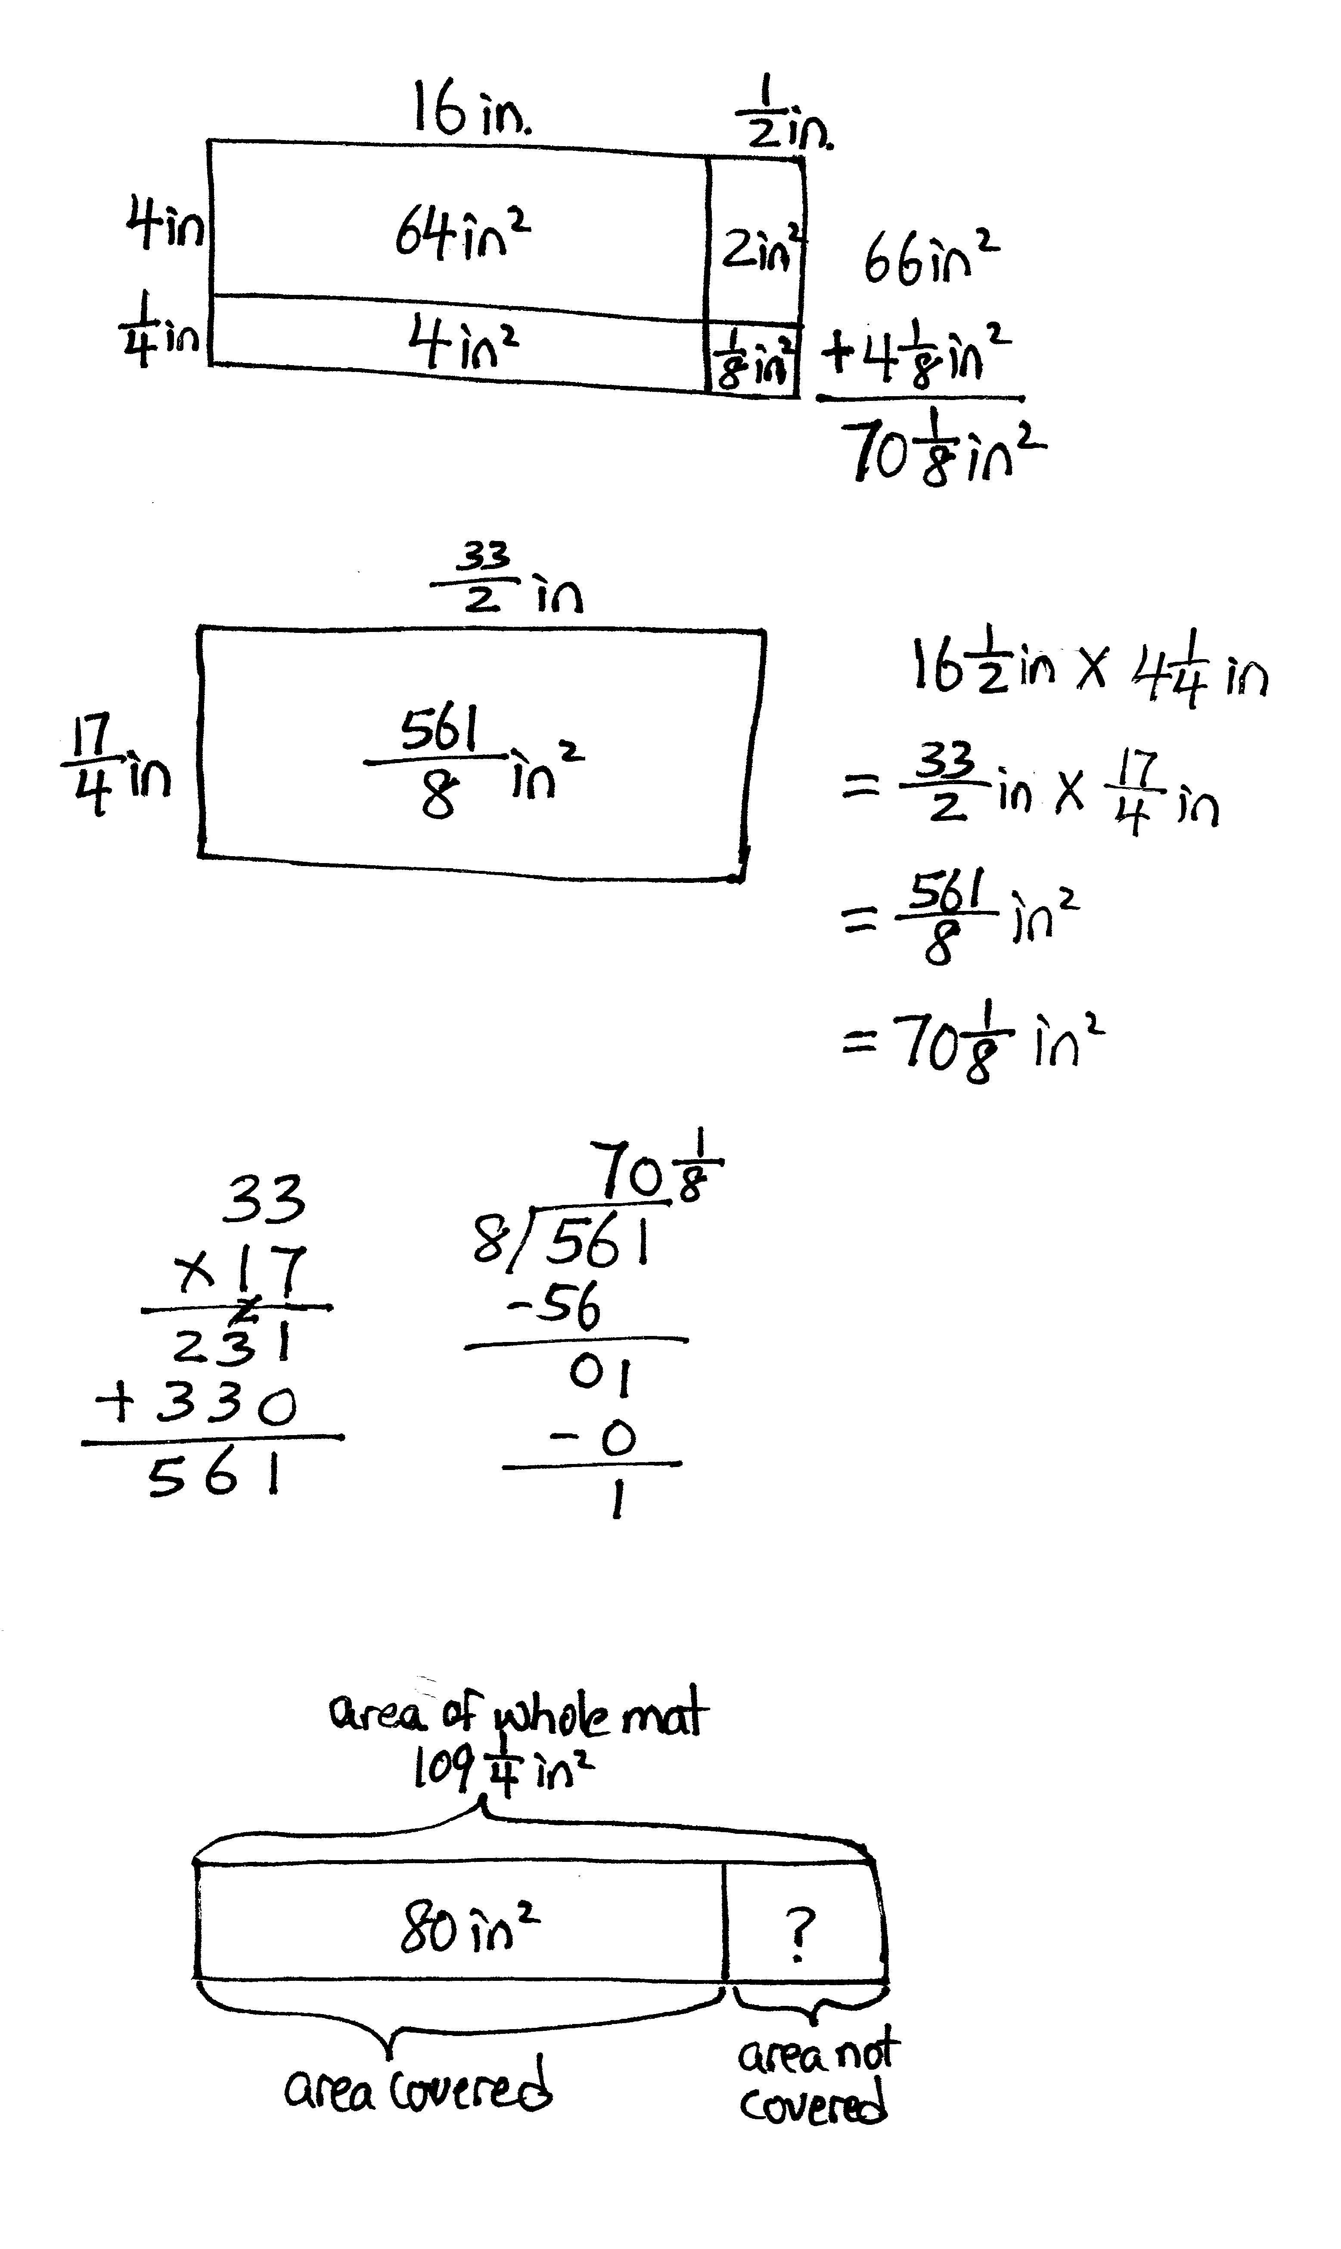
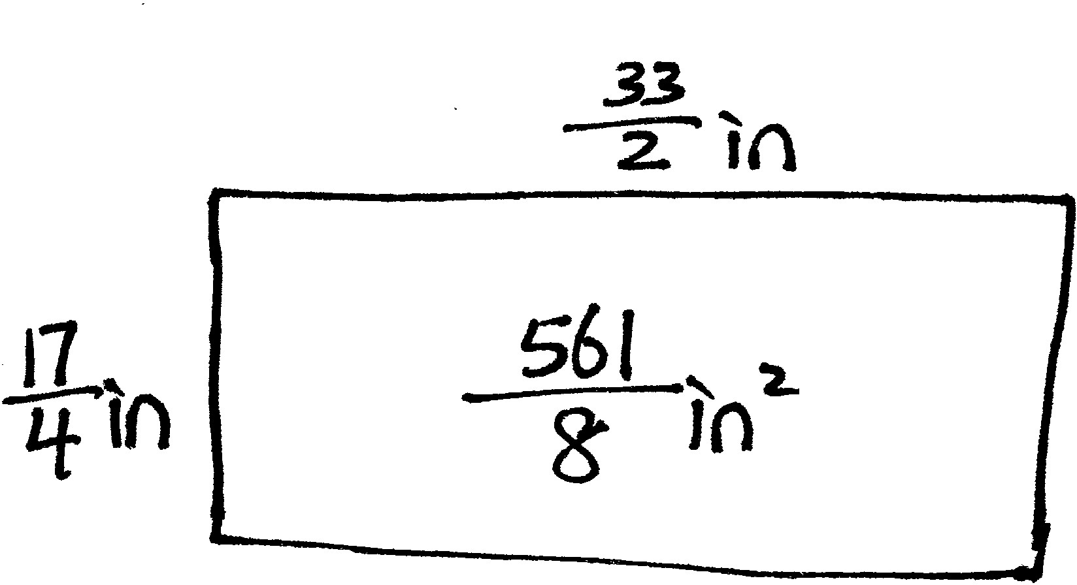


Problem 2
Determine when the distributive property or the multiplication of fractions is more efficient to solve for area.
T: (Draw a rectangle with side lengths $\text{16}\frac{1}{2}$inches and $\text{4}\frac{1}{4}$ inches.) Which strategy do you think might be more efficient to find the area of this rectangle?
Turn and talk.
S: The fractions are pretty easy, so I think the distributive property will be quicker. The numerators will be big. I think distributing will be easier. I like to simplify fractions, so I think it would be easier to work with improper fractions.
T: Work with a partner to find the area of this rectangle. Partner A, use the distributive property with an area model. Partner B, express the sides using fractions greater than 1.
(Allow students time to work.)
T: What is the area? Which strategy was more efficient?
S: The improper fractions were messy. When I converted to improper fractions, the numerators were 33 and 17, and there weren’t any common factors to help me simplify. The area is $\frac{561}{8}$ in², which is right, but it’s weird. I had to use long division to figure out that the area was $\text{70}\frac{1}{8}$ square inches.
The distributive property was much easier on this one. The partial products were all easy to do in my head. I just added the sums of the rows and got $\text{70}\frac{1}{8}$ square inches.
T: Does the method that you choose matter? Why or why not? Turn and talk.
S: Either way, we got the right answer. Depending on the numbers, sometimes distributing is easier, and sometimes just multiplying the improper fractions is easier.
Repeat the process to find the area of a square with side length $\text{3}\frac{2}{3}$ m.
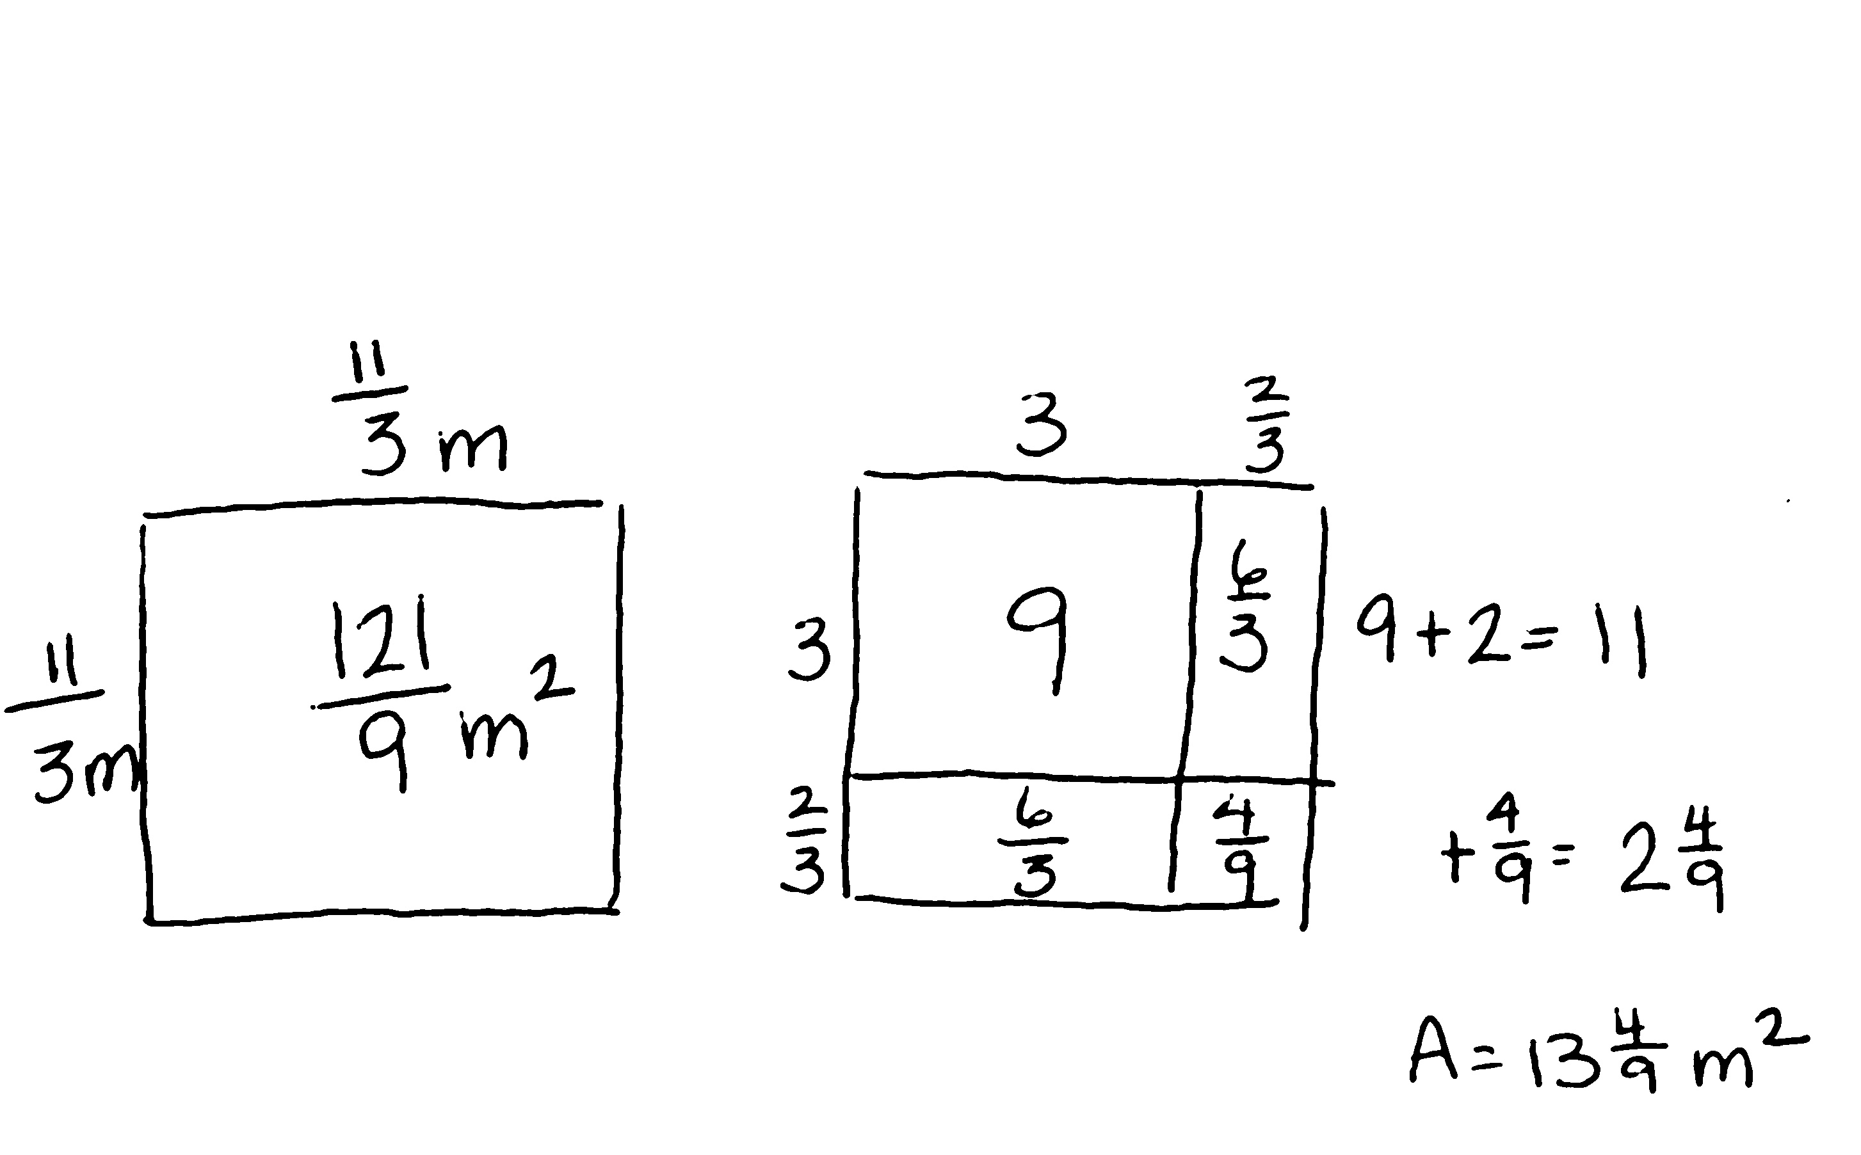

T: When should you use each strategy?
Talk to your partner.
S: If the numbers are small, fraction multiplication might be better, especially if some factors can be simplified. For large mixed numbers, I think the area model is easier, especially if some of the partial products are whole numbers or have common denominators. You can always start with one strategy and change to the other if it gets too hard.
Problem 3
8 in
10 in
$\frac{3}{4}$ in
An 8-inch by 10-inch picture is resting on a mat. Three-fourths inch of the mat shows around the entire edge of the picture. Find the area of the mat not covered by the picture.
T: Compare this problem to others we have done. Turn and talk.
S: There are two rectangles to think about here. We have to think about how to get just the part that is the mat—not the area of the whole thing. It is a little bit of a mystery rectangle because they are asking about the mat. They gave us the measurements of the picture and only what we see of the mat.
T: Work with your partner, and use RDW to solve. (Allow students time to work.)
T: What did you think about to solve this problem?
S: I started by imagining the mat without the picture on top. I added the extra part of the mat
($\text{1}\frac{1}{2}$ inches) to the picture to find the length and width of the mat. Then, I multiplied and found the area of the mat. I subtracted the picture’s area from the mat and got the answer. I started to use improper fractions, but the numbers were really large, so I used the area model. I used the area model for the mat’s area because I saw the measurements were going to have fractions. Then, I just multiplied 8 × 10 to find the area of the picture. After I figured out the area of the mat, I drew a tape diagram to show the part I knew and the part I needed to find. I visualized 4 rectangles and then added their areas.
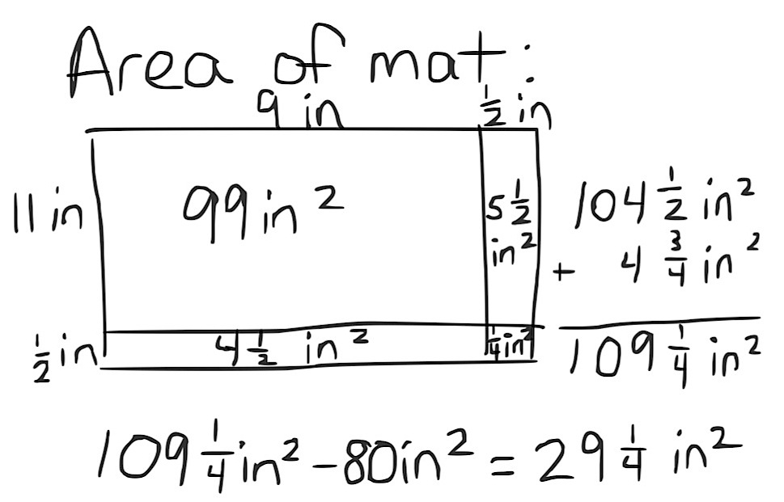

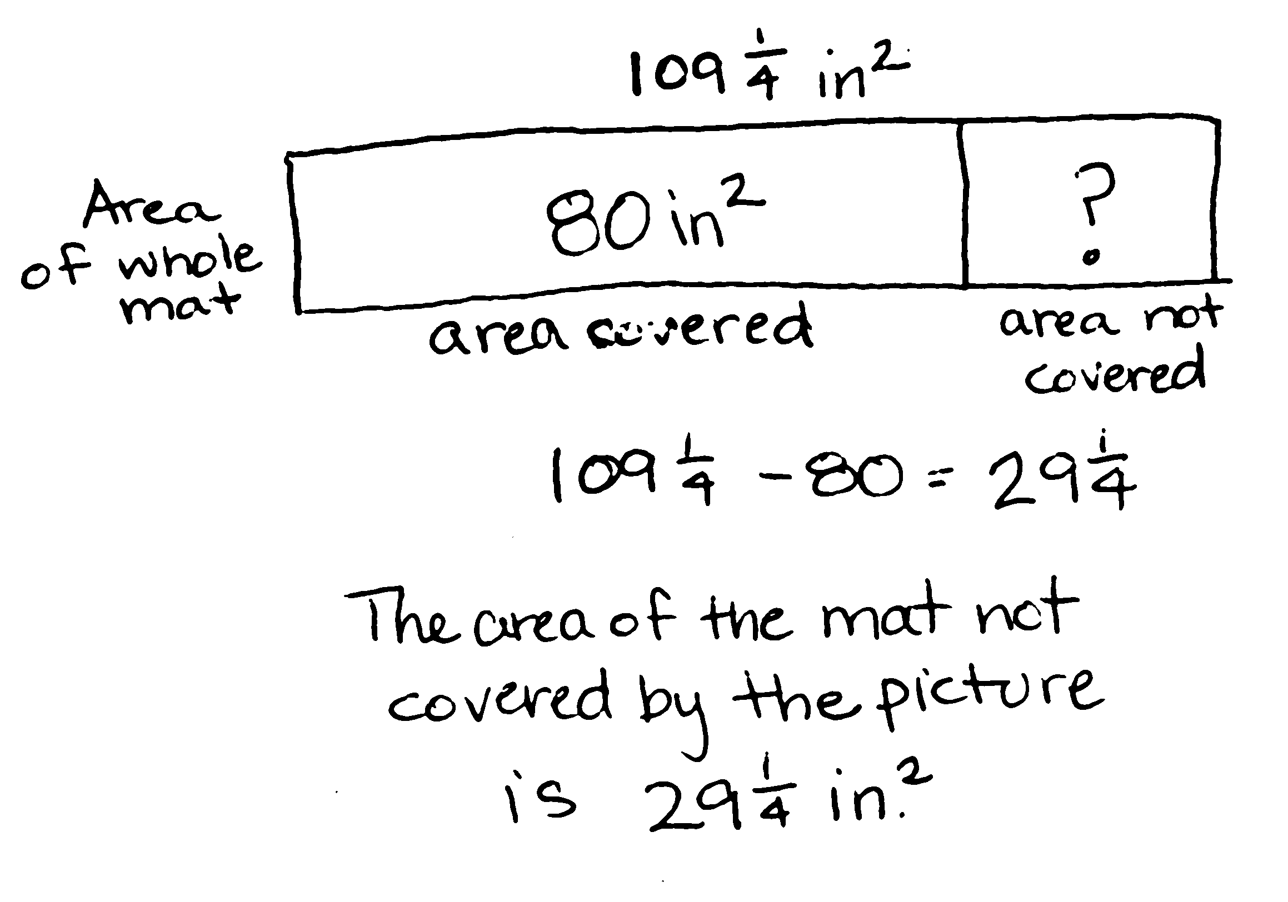

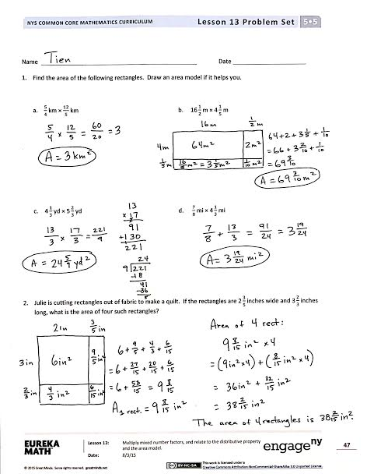
Problem Set (10 minutes)
Students should do their personal best to complete the Problem Set within the allotted 10 minutes. For some classes, it may be appropriate to modify the assignment by specifying which problems they work on first. Some problems do not specify a method for solving. Students should solve these problems using the RDW approach used for Application Problems.
Student Debrief (10 minutes)
Lesson Objective: Multiply mixed number factors, and relate to the distributive property and the area model.
The Student Debrief is intended to invite reflection and active processing of the total lesson experience.
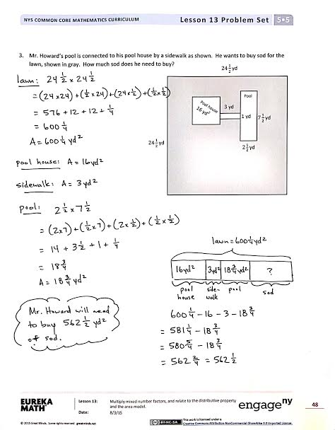
Invite students to review their solutions for the Problem Set. They should check work by comparing answers with a partner before going over answers as a class. Look for misconceptions or misunderstandings that can be addressed in the Debrief. Guide students in a conversation to debrief the Problem Set and process the lesson.
Any combination of the questions below may be used to lead the discussion.
- What are the strategies that we have used to find the area of a rectangle? Which one do you find the easiest? The most difficult? How do you decide which strategy you will use for a given problem? What kinds of things do you think about when deciding?
- In the Problem Set, when did you use the distributive property, and when did you multiply improper fractions? Why did you make those choices?
- How did you solve Problem 3?
- What are some situations in real life where finding the area of something would be needed or useful?

Exit Ticket (3 minutes)
After the Student Debrief, instruct students to complete the Exit Ticket. A review of their work will help with assessing students’ understanding of the concepts that were presented in today’s lesson and planning more effectively for future lessons. The questions may be read aloud to the students.

Name Date
- Find the area of the following rectangles. Draw an area model if it helps you.

- $\frac{5}{4}$ km ×$\frac{12}{5}$km | - $\text{16}\frac{1}{2}$m × $\text{4}\frac{1}{5}$ m
- $\text{4}\frac{1}{3}$ yd × $\text{5}\frac{2}{3}$ yd | - $\frac{7}{8}$ mi × $\text{4}\frac{1}{3}$ mi

- Julie is cutting rectangles out of fabric to make a quilt. If the rectangles are $\text{2}\frac{3}{5}$ inches wide and $\text{3}\frac{2}{3}$ inches long, what is the area of four such rectangles?

- Mr. Howard’s pool is connected to his pool house by a sidewalk as shown. He wants to buy sod for the lawn, shown in gray. How much sod does he need to buy?
3 yd
1 yd
$2\frac{1}{2}$yd
$7\frac{1}{2}$yd
Pool
Pool house 16 yd²
$24\frac{1}{2}$ yd
$24\frac{1}{2}$ yd

Name Date
Find the area of the following rectangles. Draw an area model if it helps you.
- $\frac{7}{2}$mm × $\frac{14}{5}$ mm 2. $\text{5}\frac{7}{8}$km × $\frac{18}{4}$ km

Name Date
- Find the area of the following rectangles. Draw an area model if it helps you.

- $\frac{8}{3}$ cm × $\frac{24}{4}$cm | - $\frac{32}{5}$ft × $\text{3}\frac{3}{8}$ ft
- $\text{5}\frac{4}{6}$ in × $\text{4}\frac{3}{5}$ in | - $\frac{5}{7}$ m × $\text{6}\frac{3}{5}$ m

- Chris is making a tabletop from some leftover tiles. He has 9 tiles that measure $\text{3}\frac{1}{8}$ inches long and $\text{2}\frac{3}{4}$ inches wide. What is the greatest area he can cover with these tiles?

- A hotel is recarpeting a section of the lobby. Carpet covers the part of the floor as shown below in gray. How many square feet of carpeting will be needed?
$\text{19}\frac{1}{2}$ ft

$\text{13}\frac{3}{5}$ ft
$\text{11}\frac{3}{4}$ ft
$\text{3}\frac{3}{4}$ ft

12 ft
17 ft

$2\frac{1}{2}$ ft
$\text{31}\frac{7}{8}$ ft

