Lesson 16
Objective: Draw trapezoids to clarify their attributes, and define trapezoids based on those attributes.

Suggested Lesson Structure
 Fluency Practice (9 minutes)
 Application Problem (6 minutes)
 Concept Development (30 minutes)
 Student Debrief (15 minutes)
Total Time (60 minutes)
Fluency Practice (9 minutes)
- Divide Whole Numbers by Unit Fractions and Unit Fractions by Whole Numbers 5.NF.7 (5 minutes)
- Quadrilaterals 3.G.1 (4 minutes)
Divide Whole Numbers by Unit Fractions and Unit Fractions by Whole Numbers (5 minutes)
Materials: (S) Personal white board
Note: This fluency activity reviews Module 4.
T: (Write 1 ÷ $\frac{1}{2}$.) Say the division expression.
S: 1 ÷ $\frac{1}{2}$.
T: How many halves are in 1 one?
S: 2.
T: (Write 1 ÷ $\frac{1}{2}$ = 2. Beneath it, write 2 ÷ $\frac{1}{2}$ = .) How many halves are in 2 ones?
S: 4.
T: (Write 2 ÷ $\frac{1}{2}$ = 4. Beneath it, write 3 ÷ $\frac{1}{2}$ = .) How many halves are in 3 ones?
S: 6.
T: (Write 3 ÷ $\frac{1}{2}$ = 6. Beneath it, write 7 ÷ $\frac{1}{2}=$ .) Complete the division sentence.
S: (Write 7 ÷ $\frac{1}{2}$ = 14.)
Continue with the following possible problems: 1 ÷ $\frac{1}{4},$ 2 ÷ $\frac{1}{4},$ 9 ÷ $\frac{1}{4},$ and 3 ÷$\frac{1}{5}$.
T: (Write $\frac{1}{2}$ ÷ 2 = ____.) Say the division sentence with the answer.
S: $\frac{1}{2}$ ÷ 2 = $\frac{1}{4}$.
T: (Write $\frac{1}{2}$ ÷ 2 = $\frac{1}{4}$. Beneath it, write $\frac{1}{2}$ ÷ 3 = ____.) Say the division sentence with the answer.
S: $\frac{1}{2}$ ÷ 3 = $\frac{1}{6}$.
T: (Write $\frac{1}{2}$ ÷ 3 = $\frac{1}{6}$. Beneath it, write $\frac{1}{2}$ ÷ 4 = ____.) Say the division sentence with the answer.
S: $\frac{1}{2}$ ÷ 4 = $\frac{1}{8}$.
T: (Write $\frac{1}{2}$ ÷ 9 = ____.) Complete the number sentence.
S: (Write $\frac{1}{2}$ ÷ 9 = $\frac{1}{18}$.)
Continue with the following possible sequence: $\frac{1}{5}$ ÷ 2, $\frac{1}{5}$ ÷ 3, $\frac{1}{5}$ ÷ 5, and $\frac{1}{8}$ ÷ 4.
Quadrilaterals (4 minutes)
Materials: (T) Shape sheet (Lesson 15 Template) (S) Personal white board
Note: This fluency activity reviews Grade 3 geometry concepts in anticipation of Module 5 content.
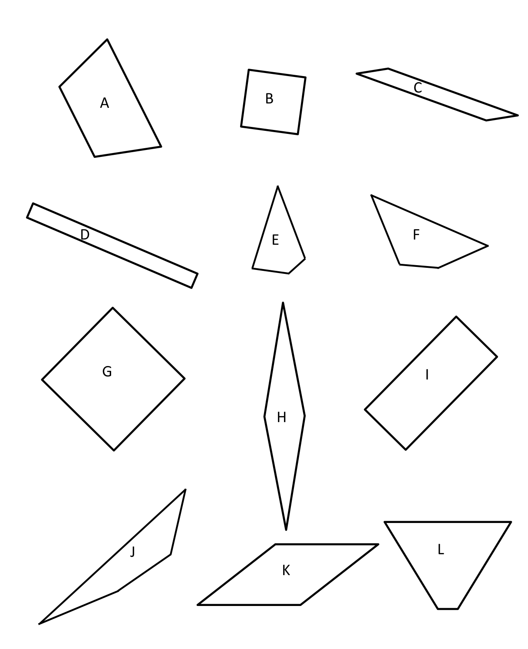
T: (Project the shape sheet that includes the following: square; rhombus that is not a square; rectangle that is not a square; and several quadrilaterals that are not squares, rhombuses, or rectangles.) How many sides are in each polygon?
S: 4.
T: On your personal white board, write down the name for any four-sided polygon.
S: (Write quadrilateral.)
T: (Point to Shape B.) This quadrilateral has four equal sides and four right angles. On your board, write the name of this quadrilateral that is the most specific.
S: (Write square.)
T: Rhombuses are parallelograms with four equal sides. (Point to Shape G.) Is this polygon a rhombus?
S: Yes.
T: Is it a rectangle?
S: Yes.
T: Is a square also a rhombus?
S: Yes!
T: (Point to Shape K.) This polygon has four equal sides. Is it a square?
S: No.
T: Is a rhombus always a square?
S: No!
T: (Point to Shape I.) This polygon has four equal angles, but the sides are not equal. Write the name of this quadrilateral. There is more than one answer.
S: (Write rectangle. Parallelogram. Trapezoid.)
T: Draw a quadrilateral that is not a square, rhombus, or rectangle.
S: (Draw.)
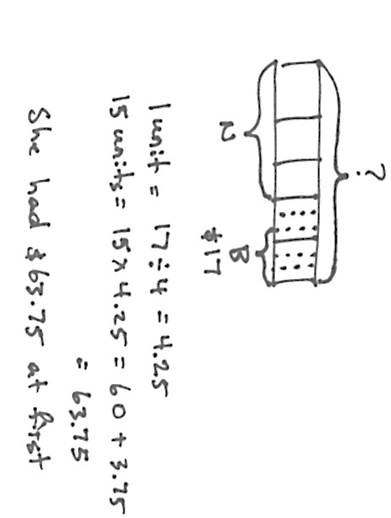
Application Problem (6 minutes)
Kathy spent 3 fifths of her money on a necklace and 2 thirds of the remainder on a bracelet. If the bracelet cost $17, how much money did she have at first?
Note: Today’s Application Problem should be a quick review of a fraction of a set, as well as decimal multiplication from Modules 2 and 4.
Concept Development (30 minutes)
Materials: (T) Collection of polygons (Template 1), ruler, protractor, set square (or right angle template), quadrilateral hierarchy: color (Template 3) (S) Collection of polygons (Template 1, 1 per pair of students); ruler; protractor; set square (or right angle template); scissors; crayons, markers, or colored pencils; blank paper for drawing; quadrilateral hierarchy (Template 2)

Note: The color hierarchy of quadrilaterals may be used to make color-coded cut-outs of each quadrilateral.
Problem 1
- Sort polygons by the number of sides.

 | NOTES ON  MULTIPLE MEANS  OF ENGAGEMENT:
Problem 1 in the Concept Development provides an opportunity for a quick formative assessment. If students have difficulty sorting and articulating attributes, consider a review of concepts from Grade 4 Module 4.

- Sort quadrilaterals into trapezoids and non-trapezoids.
T: Work with your partner to sort the collection of polygons by the number of sides they have.
S: (Sort.)
T: What are polygons with four sides called?
S: Quadrilaterals.
T: Which shapes are quadrilaterals?
S: Shapes A, B, D, F, G, H, J, K, and N.
T: What attribute do you need to consider to separate the quadrilaterals into two groups—trapezoids and non-trapezoids?
S: We look for sides that are parallel. Trapezoids have at least one set of parallel sides, so quadrilaterals with parallel sides go in the trapezoid pile.

 | NOTES ON  DRAWING FIGURES:
If students need specific scaffolding for drawing figures, please see Grade 4 Module 4.
To draw parallel lines with a set square:
- Draw a line.
- Line up one side of the set square on the line.
- Line up a ruler with the perpendicular side of the set square.
- Slide the set square along the ruler until the desired place for a second line is reached.
- Draw along the side of the set square to mark the second, parallel line.
- Remove the set square, and extend the second line with the ruler, if necessary.

T: Separate the trapezoids in your collection of quadrilaterals from the non-trapezoids.
S: (Sort. The trapezoid set includes Shapes A, B, D, J,
and K.)
T: Talk to your partner. How are the shapes in the trapezoid group alike? How are they different?
S: They all have four straight sides, but they don’t all look the same. They are all quadrilaterals, but they have different side lengths and angle measures. Some of the trapezoids are rhombuses, rectangles, or squares. They all have at least one pair of sides that are parallel.
Problem 2
- Draw a trapezoid according to the definition of a trapezoid.
- Measure and label its angles to explore their relationships.
T: Look at the sorted shapes. I am going to ask you to draw a trapezoid in a minute. What attributes do you need to include? Turn and talk.
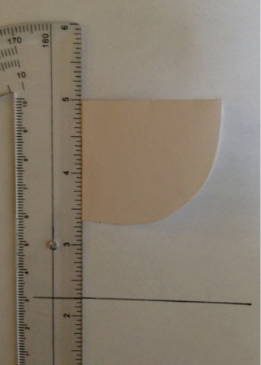
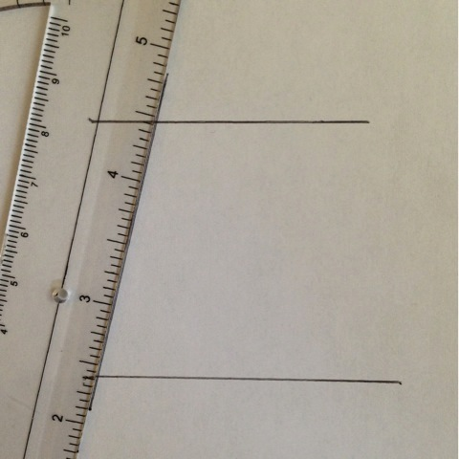
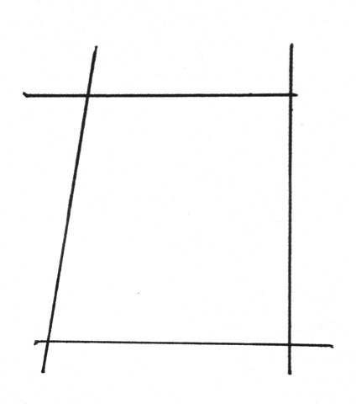
S: We have to draw four straight sides. Two of the sides need to be parallel to each other. We could draw any of the shapes in our trapezoid pile. If we have one set of parallel sides, it will be a trapezoid.
T: Use your ruler and set square (or right angle template) to draw a pair of parallel lines on your blank paper positioned at any angle on the sheet.
MP.6
S: (Draw.)
T: Finish your trapezoid by drawing a third and fourth segment that cross the parallel pair of lines. Make sure they do not cross each other.
S: (Draw.)

T: Compare your trapezoid with your partner’s. What is alike? What is different?
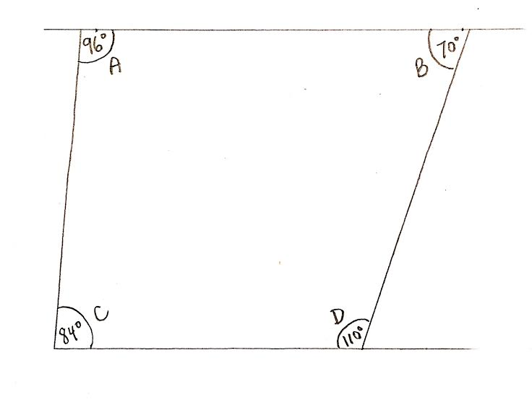
S: My horizontal parallel sides are closer together than my partner’s. My trapezoid is a rectangle, but my partner’s isn’t. My trapezoid is taller than my partner’s. I have right angles in mine, but my partner does not. My trapezoid is a square, but my partner’s
is not.
T: Label the angles of one of the trapezoids as A, B, C, and D on the inside of the shape. Label the top left angle as angle A. Label the top right angle as angle B. On the bottom, label the left angle as angle C, and finally, label the last angle on the bottom right as angle D. Now, measure these four interior angles of your trapezoid with your protractor, and write the measurements inside each angle.
S: (Measure.)
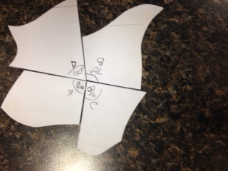
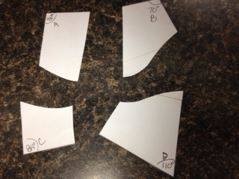
T: Cut out your trapezoid.
S: (Cut.)
T: Cut your trapezoid into two parts by cutting between the parallel sides with a wavy cut (as shown to the right).
S: (Cut.)
T: Place $∠A$ alongside $∠C$. (See the image.) What do you notice in your trapezoid and in your partner’s?
S: The angles line up. The two angles make a straight line.
If I add the angles together, it is 180 degrees. It is a straight line, but my angles only add up to something close to 180 degrees. My partner’s trapezoid did the same thing.
T: I heard you say that the angles make a straight line. What is the measure of a straight angle?
S: 180 degrees.
T: I also heard a few of you say that your angles did not add up to exactly 180 degrees. How do you explain that?
S: It sure looked like a straight line, so maybe we read our protractor a little bit wrong. I might not have lined up the protractor exactly with the line I was using to measure.
T: Place $∠B$ alongside $∠D$. (See the image.) What do you notice?
S: It’s the same as before. The angles make a straight line. These angles add up to 180 degrees, too.
T: How many pairs of angles add up to 180 degrees?
S: Two pairs.

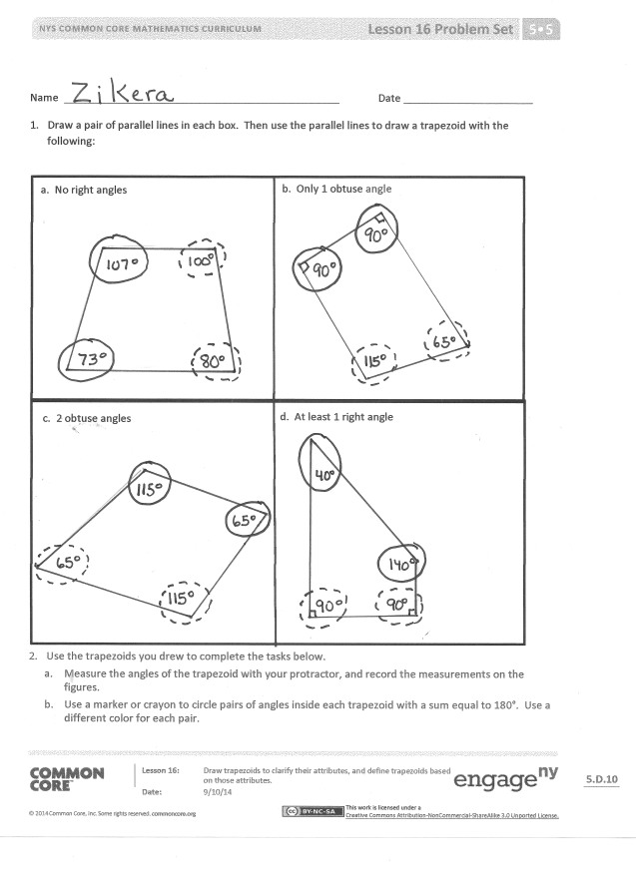
T: Cut each part of your trapezoid into two pieces using a wavy cut.
S: (Cut.)
T: Place all four of your angles together at a point. (Demonstrate. See the image.) What do you notice about the angles?
S: They all fit together like a puzzle. The angles go all the way around. Angles $A$ and $C$ made a straight line, and angles $B$ and $D$ made a straight line. I could put the straight lines together. The two straight angles make 360 degrees.
T: How does this compare to your partner’s trapezoid? Turn and talk.
S: It’s the same in my partner’s trapezoid. The angles in my partner’s trapezoid weren’t the same size as mine, but they still all fit together all the way around.
T: (Distribute the Problem Set to students.) Let’s practice drawing more trapezoids and thinking about their attributes by completing the Problem Set.
S: (Complete the Problem Set.)
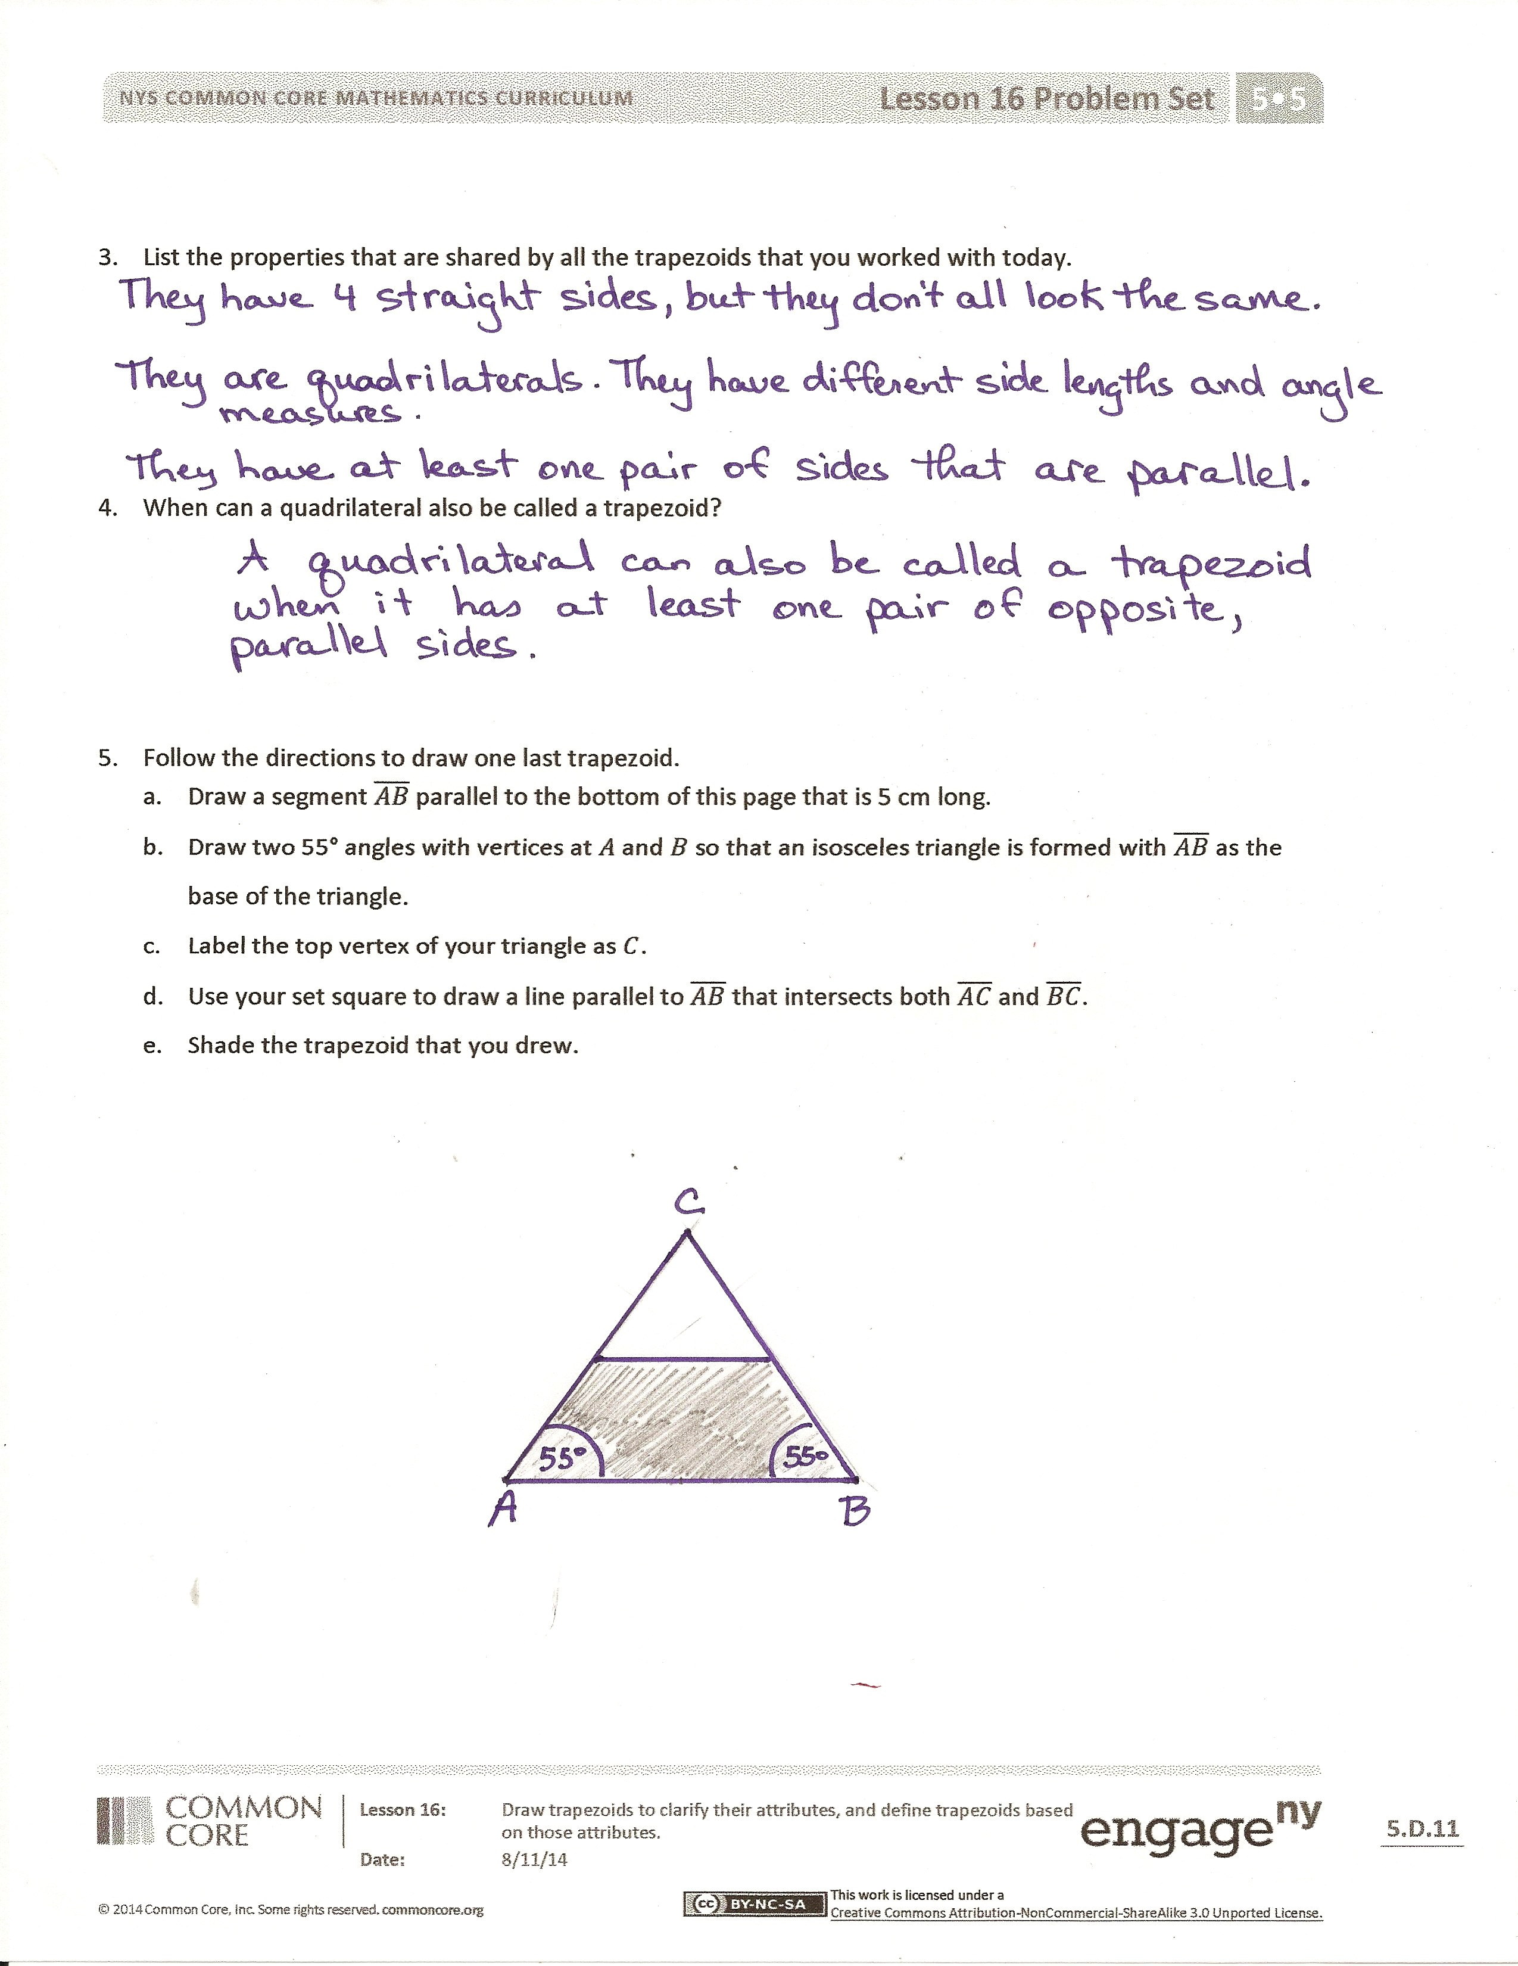
Please note the extended time designated for the Student Debrief of today’s lesson.
Problem Set (10 minutes)
Students should do their personal best to complete the Problem Set within the allotted 10 minutes. For some classes, it may be appropriate to modify the assignment by specifying which problems they work on first. Some problems do not specify a method for solving. Students should solve these problems using the RDW approach used for Application Problems.
Note: Today’s Problem Set should be kept for use in
the Lesson 17 Student Debrief.
Student Debrief (15 minutes)
Lesson Objective: Draw trapezoids to clarify their attributes, and define trapezoids based on those attributes.
The Student Debrief is intended to invite reflection and active processing of the total lesson experience.
Invite students to review their solutions for the Problem Set. They should check work by comparing answers with a partner before going over answers as a class. Look for misconceptions or misunderstandings that can be addressed in the Debrief. Guide students in a conversation to debrief the Problem Set and process the lesson.
Any combination of the questions below may be used to lead the discussion.
- (Allow students to share the myriad of trapezoids that are produced in Problem 1 of the Problem Set. Consolidate the lists of attributes students generated for trapezoids in Problem 3.) Where do these pairs seem to occur consistently? Is this true for all quadrilaterals? Just trapezoids?
- (Use the trapezoids that students produce in Problem 1 to articulate the formal definition of trapezoids. Post these definitions in the classroom for reference as Topic D proceeds.)
A trapezoid:
- Is a quadrilateral in which at least one pair of opposite sides is parallel.

- (Begin the construction of the hierarchy diagram, see Template 2 following this lesson. Students might draw or glue examples of trapezoids and quadrilaterals and/or list attributes within the diagram.) Explain how you decided to place each of the figures on the hierarchy. What are questions you asked yourself as you classified them?
- Respond to the following statements with true or false. Explain your reasoning.
  - All trapezoids are quadrilaterals. (True. All trapezoids have 4 straight sides.)
  - All quadrilaterals are trapezoids. (False. A trapezoid must have at least one pair of opposite, parallel sides, but quadrilaterals need only 4 sides. No side needs to be parallel to another.)
- The trapezoid you drew in Problem 5 is called an isosceles trapezoid. Think back to what you know about isosceles triangles. Why is this a good name for this quadrilateral? (Isosceles triangles have
2 equal sides. The quadrilateral drawn in Problem 5 has 2 equal sides.) How is it like some of the other trapezoids that you drew today? How is it different?
- (Over the course of several days, students explore the formal definition of a quadrilateral, see the boxed text below, through the examination of counter examples.)
Formal Definition of a Quadrilateral:
(Only the first bullet is introduced today.)
- Consists of four different points ($A, B, C, D$) in the plane and four segments ($\overline{AB}, \overline{BC}, \overline{CD}, \overline{DA}$).
- Is arranged so that the segments intersect only at their endpoints.
- Has no two adjacent segments that are collinear.
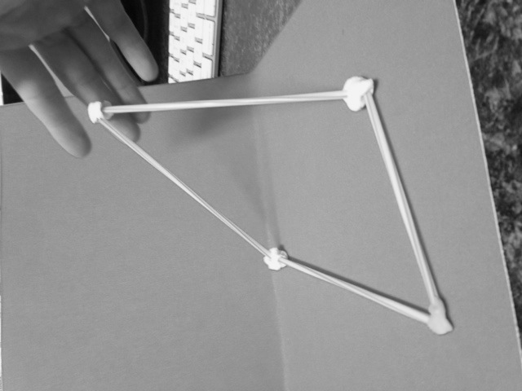
Step 1: Ask students to tell what they know about a quadrilateral. The response is most likely a polygon with four straight sides.
Step 2: Use straws joined with sticky tack to represent two segments on the plane and two segments off the plane. Ask: “Is this figure also a quadrilateral? What must we add to our definition to eliminate the possibility of this figure?”
Step 3: Lead students to see that a four-sided figure is only a quadrilateral if all four segments lie in the same plane. Then, provide only the first part of the formal definition (first bullet above).
Exit Ticket (3 minutes)
After the Student Debrief, instruct students to complete the Exit Ticket. A review of their work will help with assessing students’ understanding of the concepts that were presented in today’s lesson and planning more effectively for future lessons. The questions may be read aloud to the students.

Name Date
- Draw a pair of parallel lines in each box. Then, use the parallel lines to draw a trapezoid with the following:
a. No right angles. | b. Only 1 obtuse angle.
c. 2 obtuse angles. | d. At least 1 right angle.

- Use the trapezoids you drew to complete the tasks below.

- Measure the angles of the trapezoid with your protractor, and record the measurements on the figures.

- Use a marker or crayon to circle pairs of angles inside each trapezoid with a sum equal to 180$°$.
Use a different color for each pair.

- List the properties that are shared by all the trapezoids that you worked with today.

- When can a quadrilateral also be called a trapezoid?

- Follow the directions to draw one last trapezoid.

- Draw a segment $\overline{AB}$parallel to the bottom of this page that is 5 cm long.

- Draw two 55$°$ angles with vertices at $A$ and $B$ so that an isosceles triangle is formed with $\overline{AB}$as the base of the triangle.

- Label the top vertex of your triangle as $C$.

- Use your set square to draw a line parallel to $\overline{AB}$ that intersects both $\overline{AC}$ and $\overline{BC}$.

- Shade the trapezoid that you drew.

Name Date
a. Use a ruler and a set square to draw a trapezoid.

- What attribute must be present for a quadrilateral to also be a trapezoid?

Name Date
- Use a straightedge and the grid paper to draw:

- A trapezoid with exactly 2 right angles. b. A trapezoid with no right angles.



- Kaplan incorrectly sorted some quadrilaterals into trapezoids and non-trapezoids as pictured below.

- Circle the shapes that are in the wrong group, and tell why they are sorted incorrectly.
Trapezoids | Non-Trapezoids

- Explain what tools would be necessary to use to verify the placement of all the trapezoids.


- a. Use a straightedge to draw an isosceles trapezoid on the grid paper.

- Why is this shape called an isosceles trapezoid?

A
B
C
D
E
F
G
H
I
J
K
L
M
N
O

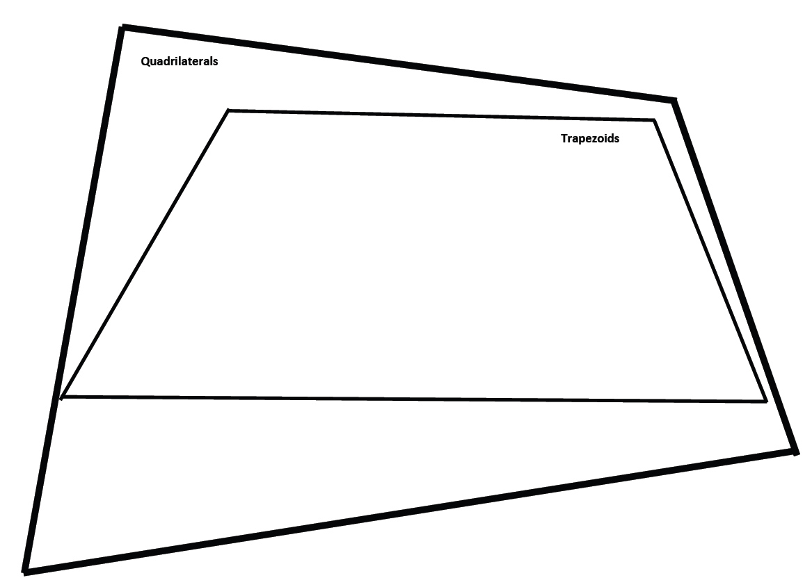

Quadrilaterals
Trapezoids

collection of polygons
quadrilateral hierarchy
quadrilateral hierarchy: color

