Lesson 17
Objective: Draw parallelograms to clarify their attributes, and define parallelograms based on those attributes.

Suggested Lesson Structure
 Fluency Practice (10 minutes)
 Application Problem (4 minutes)
 Concept Development (31 minutes)
 Student Debrief (15 minutes)
Total Time (60 minutes)
Fluency Practice (10 minutes)
- Multiply by Multiples of 10 and 100 5.NBT.2 (4 minutes)
- Divide Whole Numbers by Unit Fractions and Fractions by Whole Numbers 5.NF.7 (6 minutes)
Multiply by Multiples of 10 and 100 (4 minutes)
Note: This fluency activity reviews Modules 1 and 2.
T: (Write 31 $\text{×}$ 10 = .) Say the multiplication sentence.
S: 31 $\text{×}$ 10 = 310.
T: (Write 31 $\text{×}$ 10 = 310. Below it, write 310 $\text{×}$ 2 = .) Say the multiplication sentence.
S: 310 $\text{×}$2 = 620.
T: (Write 310 $\text{×}$ 2 = 620. Below it, write 31 $\text{×}$ 20 = 31 $\text{×}$ $\text{×}$ = .) Say 31 $\text{×}$ 20 as a three-factor multiplication sentence with 10 as one factor.
S: 31 $\text{×}$ 10 $\text{×}$2 = 620.
Follow the same process for 21 $\text{×}$40.
T: (Write 32 $\text{×}$ 30 = 32 $\text{×}$ $\text{×}$ = .) Write 32 $\text{×}$ 30 as a three-factor multiplication sentence, and solve.
S: (Write 32 $\text{×}$ 30 = 32 $\text{×}$ 10 $\text{×}$ 3 = 960.)
Repeat the process for 241 $\text{×}$ 20.
T: (Write 21 $\text{×}$ 100 = .) Say the multiplication sentence.
S: 21 $\text{×}$ 100 = 2,100.
T: (Write 21 $\text{×}$ 100 = 2,100. Below it, write 2,100 $\text{×}$ 3 = .) Say the multiplication sentence.
S: 2,100 $\text{×}$ 3 = 6,300.
T: (Write 2,100 $\text{×}$3 = 6,300. Below it, write 21 $\text{×}$ 300 = .) Say 21 $\text{×}$ 300 as a three-factor multiplication sentence with 100 as one factor.
S: 21 $\text{×}$ 3 $\text{×}$ 100 = 6,300.
T: (Write 21 $\text{×}$ 300 = 6,300.)
Direct students to solve using the same method for 42 $\text{×}$ 400 and 34 $\text{×}$ 300.
Divide Whole Numbers by Unit Fractions and Fractions by Whole Numbers (6 minutes)
Materials: (S) Personal white board
Note: This fluency activity reviews Module 4 Lessons 25–27 and prepares students for today’s lesson.
T: (Write 2 ÷ $\frac{1}{3}$= .) Say the complete division sentence.
S: 2 ÷ $\frac{1}{3}$ = 6.
T: (Write 2 ÷ $\frac{1}{3}$ = 6. Beneath it, write 3 ÷ $\frac{1}{5}=$ .) Say the complete division sentence.
S: 3 ÷ $\frac{1}{5}$ = 15.
T: (Write 3 ÷ $\frac{1}{5}$ = 15. Beneath it, write 6 ÷ $\frac{1}{2}=$ .) On your personal white board, complete the division sentence.
S: (Write 6 ÷ $\frac{1}{2}$ = 12.)
Continue this process for 3 ÷ $\frac{1}{4}$, 9 ÷ $\frac{1}{3}$, 1 ÷ $\frac{1}{10}$, 2 ÷ $\frac{1}{10}$, 8 ÷ $\frac{1}{10 }$, and 10 ÷ $\frac{1}{10}$.
T: (Write $\frac{1}{2}$ ÷ 2 = .) Say the complete division sentence.
S: $\frac{1}{2}$ ÷ 2 = $\frac{1}{4}$.
T: (Write $\frac{1}{2}$ ÷ 2 = $\frac{1}{4}$. Beneath it, write $\frac{1}{3}$ ÷ 5 = .) Say the complete division sentence.
S: $\frac{1}{3}$ ÷ 5 = $\frac{1}{15}$.
T: (Write $\frac{1}{3}$ ÷ 5 = $\frac{1}{15}$. Beneath it, write $\frac{1}{6}$ ÷ 5 = .) On your personal white board, write the complete division sentence.
S: (Write $\frac{1}{6}$ ÷ 5 = $\frac{1}{30}$.)
T: (Write $\frac{1}{4}$ ÷ 4 = .) Say the complete division sentence.
S: $\frac{1}{4}$ ÷ 4 = $\frac{1}{16}$.
Continue this process for the following possible sequence: 9 ÷ $\frac{1}{4}$, $\frac{1}{4}$ ÷ 9, 5 ÷ $\frac{1}{8}$, $\frac{1}{8}$ ÷ 5, $\frac{1}{7}$ ÷ 8, and 8 ÷ $\frac{1}{7}$.

Application Problem (4 minutes)
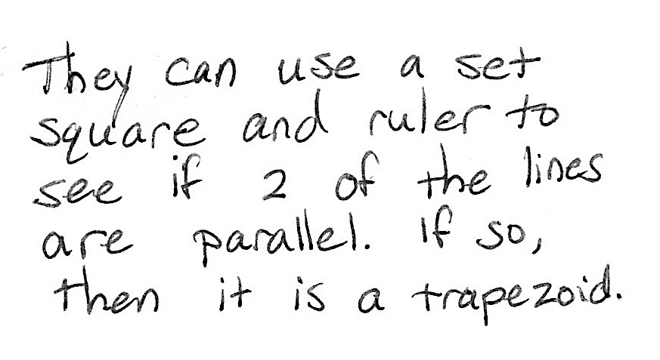
Ava drew the quadrilateral to the right and called it a trapezoid. Adam said Ava is wrong. Explain to your partner how a set square can be used to determine who is correct. Support your answer using the properties of trapezoids.
Concept Development (31 minutes)

 | NOTES ON  MULTIPLE MEANS  OF ENGAGEMENT:
If students need specific scaffolding for drawing figures, please see Grade 4 Module 4.

Materials: (T) Ruler, protractor, set square (or right angle template), quadrilateral hierarchy with parallelogram: color (Template 2) (S) Ruler; protractor; set square (or right angle template); scissors; crayons, markers, or colored pencils; blank paper for drawing; quadrilateral hierarchy with parallelogram (Template 1)
Problem 1
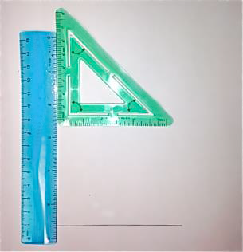
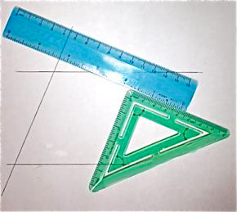
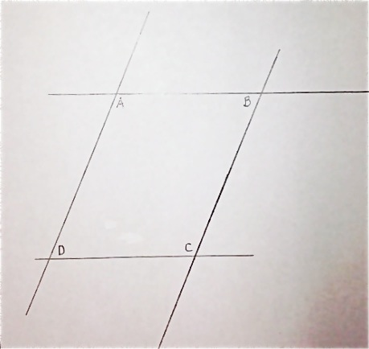
- Draw a parallelogram, and articulate the definition.
- Measure and label its angles to explore their relationships.
- Measure to explore diagonals of parallelograms.
T: What name could we give to all of the shapes we drew yesterday?
S: Quadrilateral. Trapezoid.
T: Use your ruler and set square to draw a pair of parallel lines on your blank paper positioned at any angle on the sheet.
S: (Draw.)
T: Because we are about to draw a quadrilateral beginning with one pair of parallel sides, what name can we give every figure we will draw today?
S: Trapezoid.
MP.7
T: If I want to draw a trapezoid that can also be called a parallelogram, what will I need to draw next?
S: Parallelograms have two sets of parallel sides, so you have to draw another pair of parallel lines. Draw another pair of parallel lines that cross the first ones.
T: Use your tools to draw a second pair of parallel lines that intersect your first pair.
S: (Draw.)
T: Measure the sides of your parallelogram, and compare your parallelogram with your partner’s. What is alike? What is different?
S: The opposite sides in my parallelogram are the same lengths, and my partner’s are, too. My parallel sides are closer together than my partner’s. My parallelogram is a rectangle, but my partner’s isn’t. My parallelogram has four equal sides, and my partner’s has two different pairs of equal sides. I have right angles in mine, but my partner does not. I drew a square, and my partner drew a rectangle.
MP.7
T: Label the angles of your parallelogram inside the shape$.$ Label the upper angle on the left as angle $A$ and the upper angle on the right as angle$B.$ Continue clockwise by labeling the lower right angle as angle$C$ and the angle directly below $A$ as angle$D.$ Then, measure the angles of your parallelogram with your protractor, and write the measurements inside each angle.
S: (Measure.)
T: Cut out your parallelogram.
S: (Cut.)
T: Make a copy of your parallelogram on another blank sheet by tracing it and labeling the vertices with the same letters.
S: (Trace and label.)
T: Cut your first parallelogram into four parts by cutting between each set of parallel sides with a wavy cut.
S: (Cut.)

 | NOTES ON  MULTIPLE MEANS  OF ENGAGEMENT:
The discussion of parallelograms as special trapezoids is based on the inclusive definition of a trapezoid as a quadrilateral with at least one set of parallel sides. That is, trapezoids may have more than one set of parallel sides.
Also note that the dialogue as written here assumes recall of Grade 4 geometric concepts. Additionally, scaffolded questions may be necessary for students to verbalize the conditions necessary to classify a trapezoid as a parallelogram.

T: Put angle $A$on top of angle $C$, and put angle $B$ on top of angle $D$. What do you notice about your parallelogram’s angles and about your partner’s?
Turn and talk.
S: Angles $A$ and $C$ are the same size, and so are angles $B$ and $D$. Our parallelograms don’t look anything alike, but the angles opposite each other in each of our parallelograms are equal.
T: Place your angles alongside each other, and find as many combinations that form straight lines as you can.
S: (Work.)
T: Compare your findings with your partner’s. What do you notice? How many pairs did you find?
S: We both found four pairs that make straight lines. Yesterday, some of us only had two pairs of angles that made straight lines. Today, all of us have
four pairs.
T: So, thinking about what we drew and what we have discovered about these angles, when can a trapezoid also be called a parallelogram? Turn and talk.
S: When a trapezoid has more than one pair of parallel sides, it can be called a parallelogram.
Trapezoids have at least two pairs of angles that add up to 180 degrees. When they have more than that, they can also be called a parallelogram.
T: Place all four of your angles together at a point. What do you notice about the angles in your parallelogram and in your partner’s?
S: (Work.) All four of my angles add up to 360 degrees. My parallelogram was different than my neighbors, but the angles go all the way around again, like they did with our trapezoids.
T: Use your ruler to draw the diagonals on the copy you made of your parallelogram.
S: (Draw.)
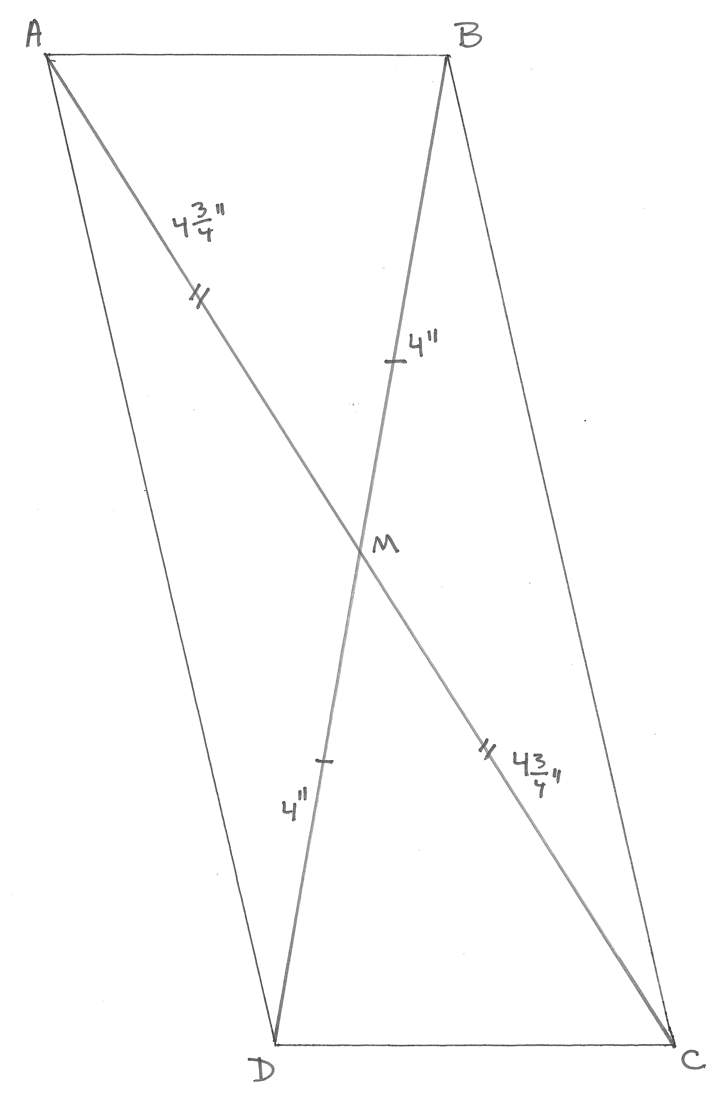
T: Measure each diagonal, and record the measurements on your paper. Are these segments equal to each other?
S: I drew a long skinny parallelogram, and my diagonals aren’t the same length. But my partner drew a square, and his are the same length. Some people have equal diagonals, and some people don’t.
T: I hear you saying that the diagonals of a parallelogram may or may not be equal to each other. Label the point where your diagonals intersect as point $M$.
S: (Draw and label.)
T: Measure from each corner of your parallelogram to point $M.$ Record all of the measurements on the figure. Compare your measurements to those of your partner.
S: (Measure and compare.)
T: What do you notice about the diagonals of your parallelogram now?
S: The length from opposite corners to point $M$ on the same diagonal is equal. The diagonals cut each other into two equal parts. One diagonal crosses the other at its midpoint. $M$ is the midpoint of both diagonals. Even though our parallelograms look really different, our diagonals still cross at their midpoints.
T: The diagonals of a parallelogram bisect each other. Say, “bisect.”
S: Bisect.
T: Let’s break down this word into parts. Think about the first part, bi-. How many wheels are on a bicycle?
S: Two.

 | NOTES ON  MULTIPLE MEANS  OF ENGAGEMENT:
For early finishers of the Problem Set, offer this challenge:
In parallelogram $ABCD$, $∠A$is $\frac{1}{3}$the measure of $∠B$. Find the measures of all the angles of the figure.

T: What does the word section mean?
S: Parts of something.
T: Sect also means to cut. Turn and talk to your partner about why bisect is a good name for what you see in all the parallelograms’ diagonals.
S: Bi- means two. These segments are cut in two equal parts. Bi- means two, and sect means cut, so bisect means to cut in two equal parts.
T: (Distribute the Problem Set to students.) Let’s practice drawing more parallelograms and thinking about their attributes by completing the Problem Set.
Please note the extended time designated for the Student Debrief of today’s lesson.
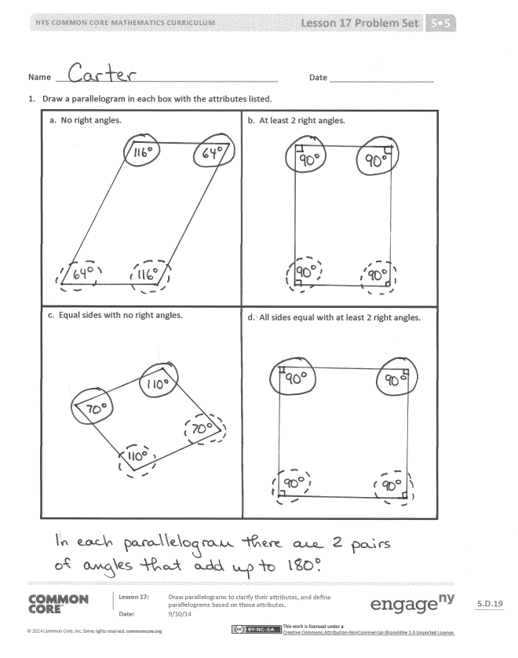
Problem Set (10 minutes)
Students should do their personal best to complete the Problem Set within the allotted 10 minutes. For some classes, it may be appropriate to modify the assignment by specifying which problems they work on first. Some problems do not specify a method for solving. Students should solve these problems using the RDW approach used for Application Problems.
Note: Today’s Problem Set from Lessons 16 and 17 should be kept for use in Lesson 18’s Student Debrief as well.
Student Debrief (15 minutes)
Lesson Objective: Draw parallelograms to clarify their attributes, and define parallelograms based on those attributes.
The Student Debrief is intended to invite reflection and active processing of the total lesson experience.
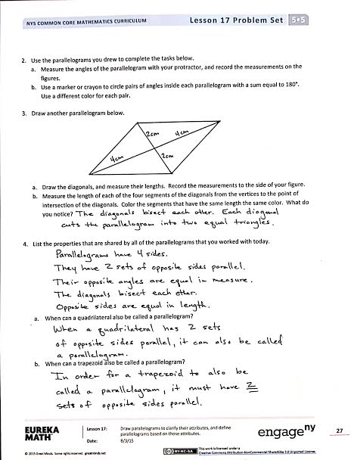
Invite students to review their solutions for the Problem Set. They should check work by comparing answers with a partner before going over answers as a class. Look for misconceptions or misunderstandings that can be addressed in the Debrief. Guide students in a conversation to debrief the Problem Set and process the lesson.
Any combination of the questions below may be used to lead the discussion.
- (Allow students to share all the different parallelograms that are produced in Problem 1 of the Problem Set. Consolidate the lists of attributes students generated for parallelograms in Problem 4.) What attributes do all parallelograms share? Where do these pairs seem to occur consistently? Is this true for all quadrilaterals? Trapezoids? Parallelograms?
- (Use the parallelograms that students produce in Problem 1 to articulate the formal definition of a parallelogram. Continue posting these definitions in the classroom for reference as Topic D proceeds.)
- When can a quadrilateral also be called a parallelogram? When can a trapezoid also be called a parallelogram? Respond to the following statements with true or false. Explain your reasoning.
  - All parallelograms are trapezoids. (True. The defining attribute of a trapezoid is that it has at least one set of parallel sides. Since parallelograms have two sets of parallel sides, they also fit the definition of a trapezoid.)
  - All trapezoids are parallelograms. (False. If the trapezoid has only one set of parallel sides, it is not also a parallelogram.)
  - All parallelograms are quadrilaterals. (True. All parallelograms have four straight sides.)
  - All quadrilaterals are parallelograms. (False. There are many four-sided shapes that do not have two pairs of parallel sides.)
A quadrilateral:
- Consists of four different points $A, B, C, D$in the plane and four segments, $\overline{AB}, \overline{BC}, \overline{CD}, \overline{DA}$,
- Is arranged so that the segments intersect only at
their endpoints, and
- Has no two adjacent segments that are collinear.
A parallelogram:
- Is a quadrilateral in which both pairs of opposite sides are parallel.

- (Continue the construction of the hierarchy diagram from Lesson 16. Students might draw or glue examples of parallelograms and/or list attributes within the diagram. Encourage students to explain their placements of the figures in the hierarchy.)
- (Continue exploring the formal definition of a quadrilateral through the examination of counter-examples. See the boxed text above.)
Step 1: Begin by asking students to tell what they know about a quadrilateral. Today’s response should be a polygon with four straight sides that lie in the same plane.
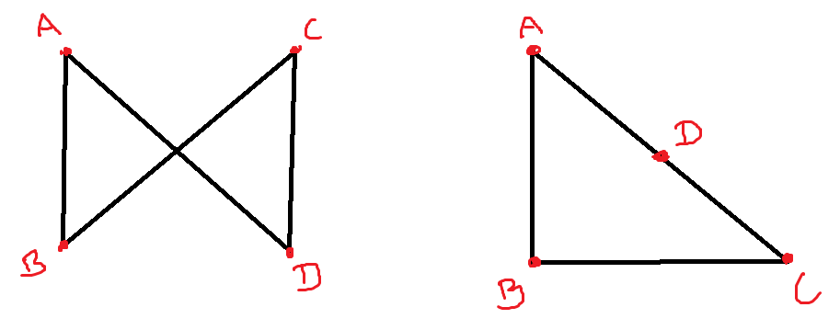
Step 2: Follow the first bullet in the definition verbatim to draw four straight segments in the same plane, but have the segments intersect as shown to the right.
Ask, “Is this figure also a quadrilateral? What must we add to our definition to eliminate the possibility of this figure?”
Step 3: Lead students to see that a four-sided figure is only a quadrilateral if all four segments lie in the same plane and the segments intersect only at their endpoints. Then, add the second bullet of the definition to that written in Lesson 16.
Exit Ticket (3 minutes)
After the Student Debrief, instruct students to complete the Exit Ticket. A review of their work will help with assessing students’ understanding of the concepts that were presented in today’s lesson and planning more effectively for future lessons. The questions may be read aloud to the students.
Name Date
- Draw a parallelogram in each box with the attributes listed.
a. No right angles. | b. At least 2 right angles.
c. Equal sides with no right angles. | d. All sides equal with at least 2 right angles.

- Use the parallelograms you drew to complete the tasks below.

- Measure the angles of the parallelogram with your protractor, and record the measurements on the figures.

- Use a marker or crayon to circle pairs of angles inside each parallelogram with a sum equal to 180$°$. Use a different color for each pair.

- Draw another parallelogram below.

- Draw the diagonals, and measure their lengths. Record the measurements to the side of your figure.

- Measure the length of each of the four segments of the diagonals from the vertices to the point of intersection of the diagonals. Color the segments that have the same length the same color. What do you notice?

- List the properties that are shared by all of the parallelograms that you worked with today.

- When can a quadrilateral also be called a parallelogram?

- When can a trapezoid also be called a parallelogram?

Name Date
- Draw a parallelogram.

- When is a trapezoid also called a parallelogram?

Name Date
- $∠A$ measures 60$°$.
$$A$$

- Extend the rays of $∠A$, and draw parallelogram $ABCD$ on the grid paper.

- What are the measures of $∠B$, $∠C$, and $∠D$?

- $WXYZ$ is a parallelogram not drawn to scale.

- Using what you know about parallelograms, give the measure of sides $XY$ and $YZ$.
$$W$$
$$X$$
$$Y$$
$$Z$$
$$M$$
6 cm
3 cm

- $∠WXY$ = 113$°$. Use what you know about angles in a parallelogram to find the measure of the other angles.

$∠XYZ$ = $°$ $∠YZW$ = __________$°$ $∠ZWX$ = __________$°$

- Jack measured some segments in Problem 2. He found that $\overline{WY}$ = 8 cm and $\overline{MZ}$ = 3 cm.
Give the lengths of the following segments:

$WM$ = cm $MY$ = cm
$XM$ = cm $XZ$ = cm

- Using the properties of shapes, explain why all parallelograms are trapezoids.

- Teresa says that because the diagonals of a parallelogram bisect each other, if one diagonal is 4.2 cm, the other diagonal must be half that length. Use words and pictures to explain Teresa’s error.

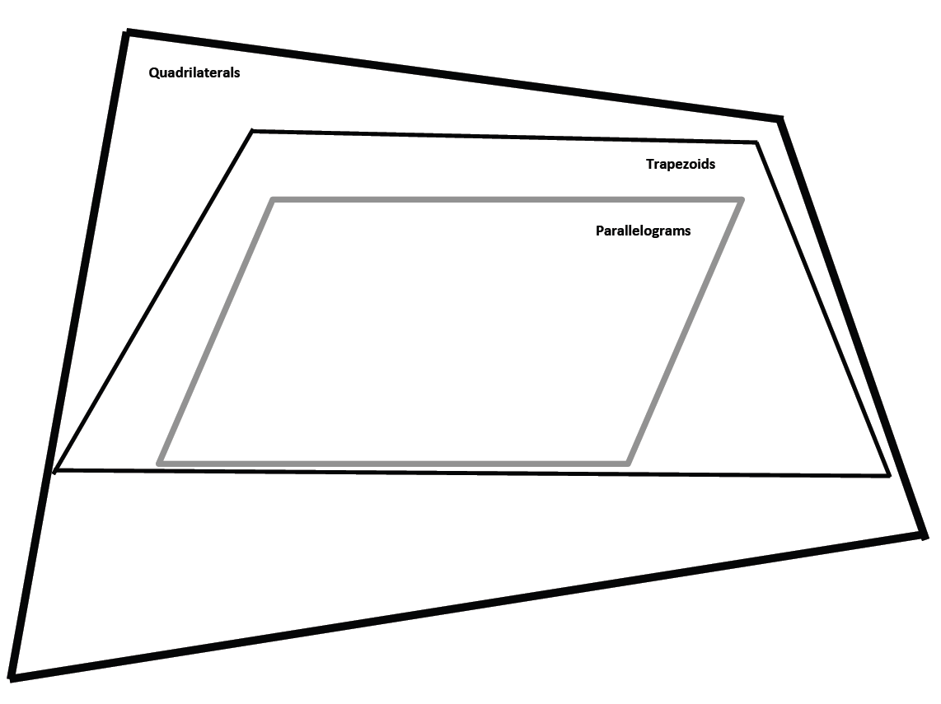

Quadrilaterals
Trapezoids
Parallelograms

quadrilateral hierarchy with parallelogram
quadrilateral hierarchy with parallelogram: color

